Supplementary Material

Figures

Figure A - The figure shows the distribution of articles collected for the analysis across genders, years, and countries in the sample.

Figure B - illustrates changes in the proportion of women representatives in the lower or single chambers of parliaments of countries in the sample.

Tables

Supplementary Table 1. Output of eMFDscore Python Package
Country | Title | Loyalty  vice | Sanctity  vice | Authority  vice | Loyalty  virtue | Sanctity  virtue | Authority  virtue | Moral Rhetoric Score
Kenya | Parents Reject Sex Education for Kids | 0.005 | 0.063 | 0.012 | 0.0127 | 0.005 | 0.002 | 0.0997
Table 1: The article analyzed in Table 1 reports about parents staging a protest against a sex education bill proposed by Senator Judith Sijeny. According to the report, families called for the removal of Senator Sijeny from office. They believed that their authority as parents had been undermined, sex education would increase incidents of immorality among children, and families should be included in educational decisions. As can be seen in Table 1, scores for vices of sanctity (morality of kids) and authority (of parents) and the virtue of loyalty (family) are higher compared to negligible values of other aspects.

Table 2 - Within-Between Random Effects Model for The Effect of Quota Adoption on Conservative Moral Rhetoric in News Coverage of Women Politicians (complete Results)
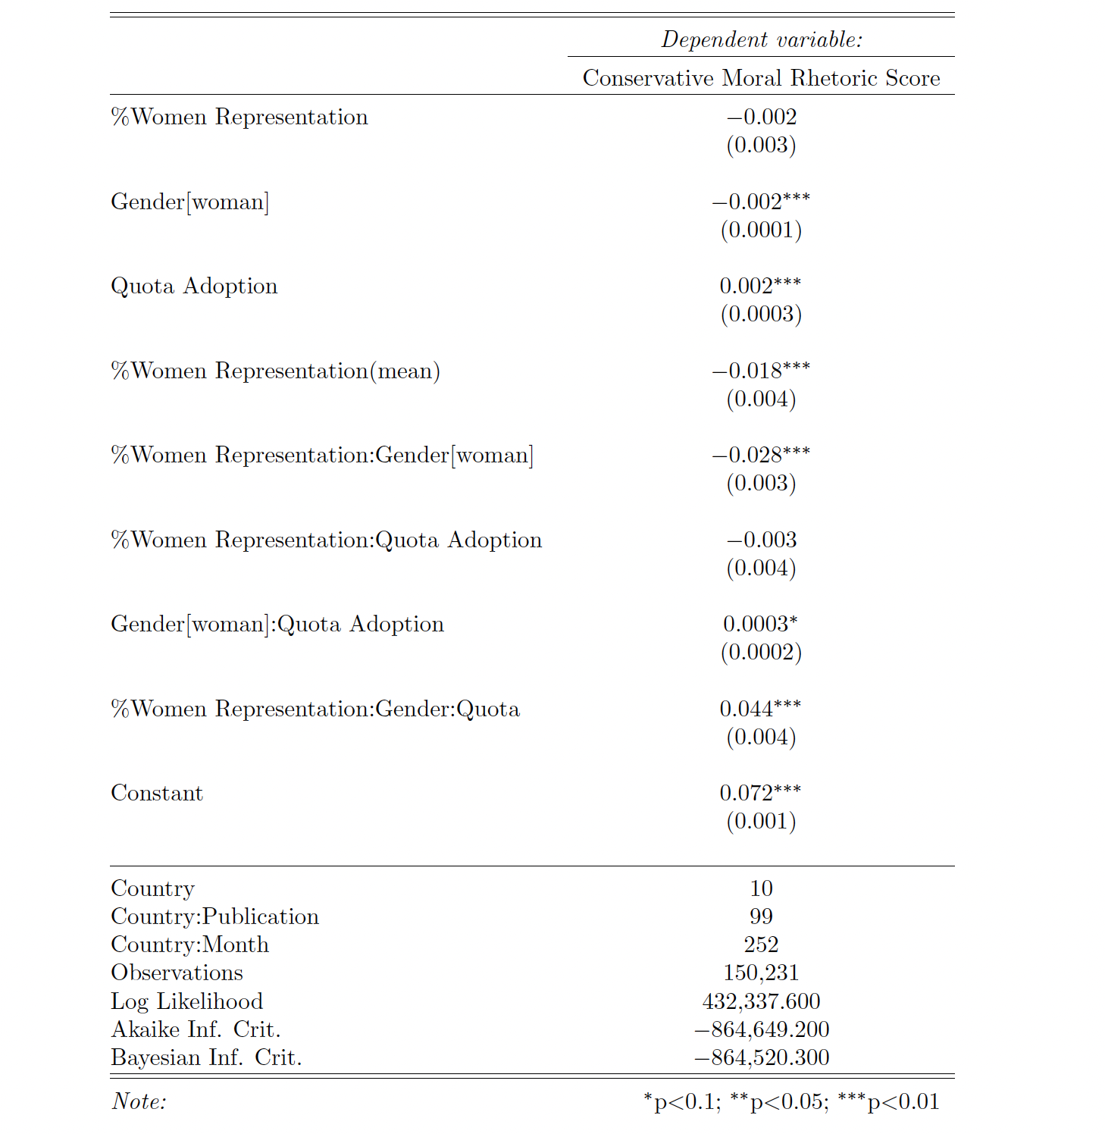

Table 3 - Within-Between Random Effects Model for Relationship between Quota Type and Conservative Moral Rhetoric in New Coverage of Women Politicians (complete results)
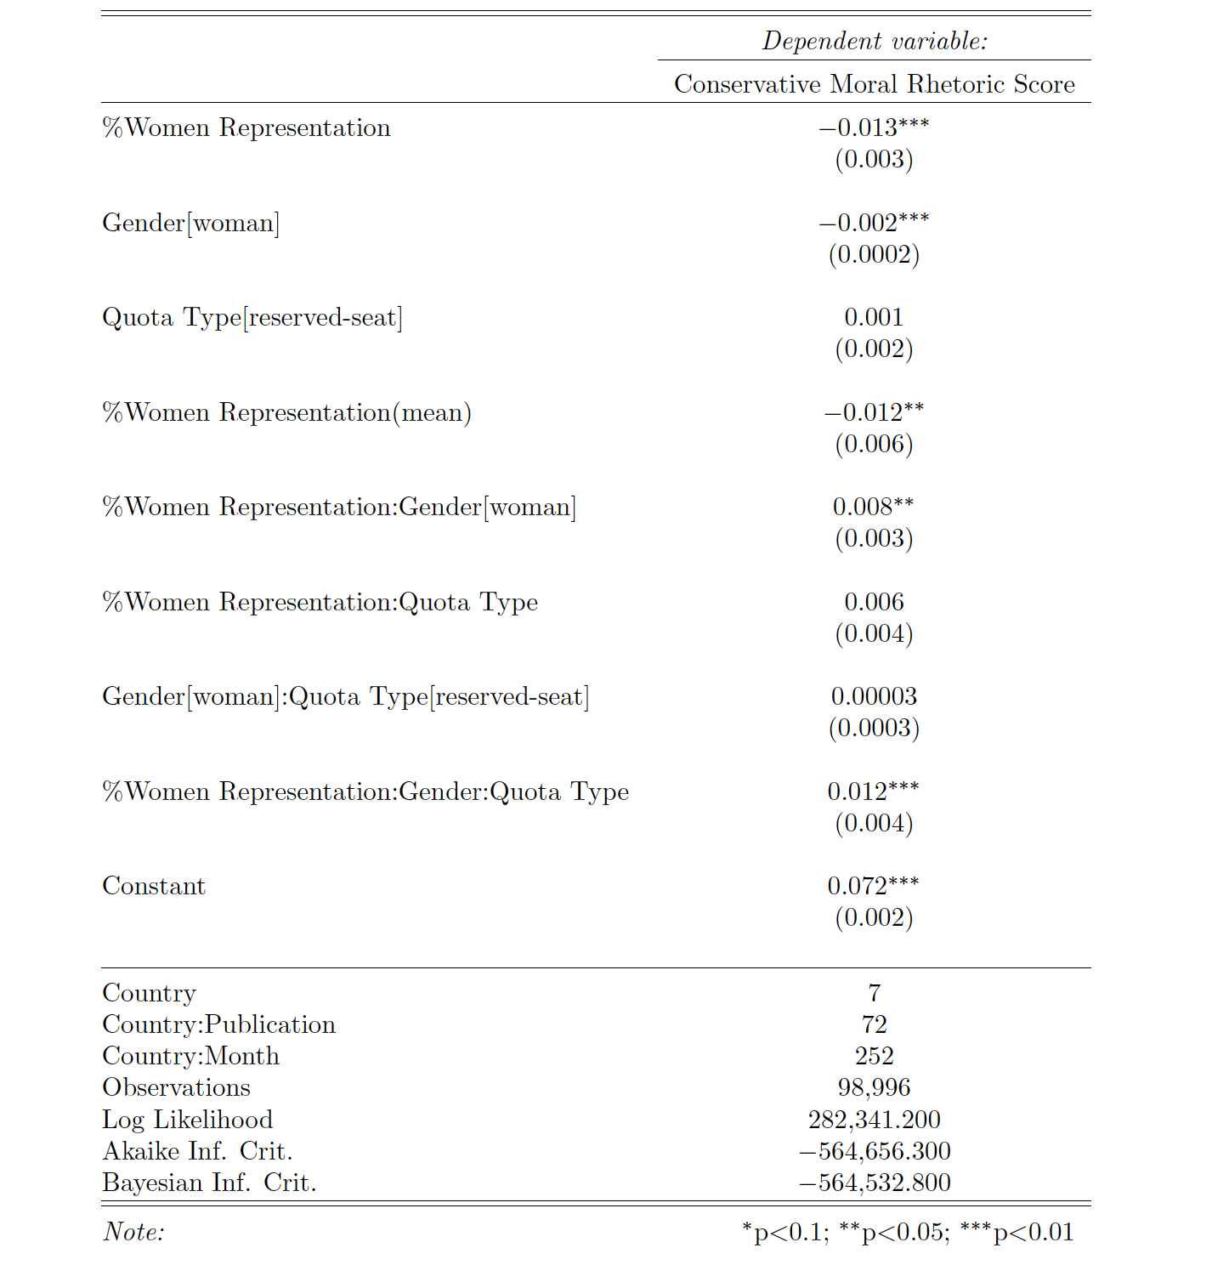

Table 4 - Fixed-effects model for Relationship between Quota Adoption and Conservative Moral Rhetoric in New Coverage of Women Politicians
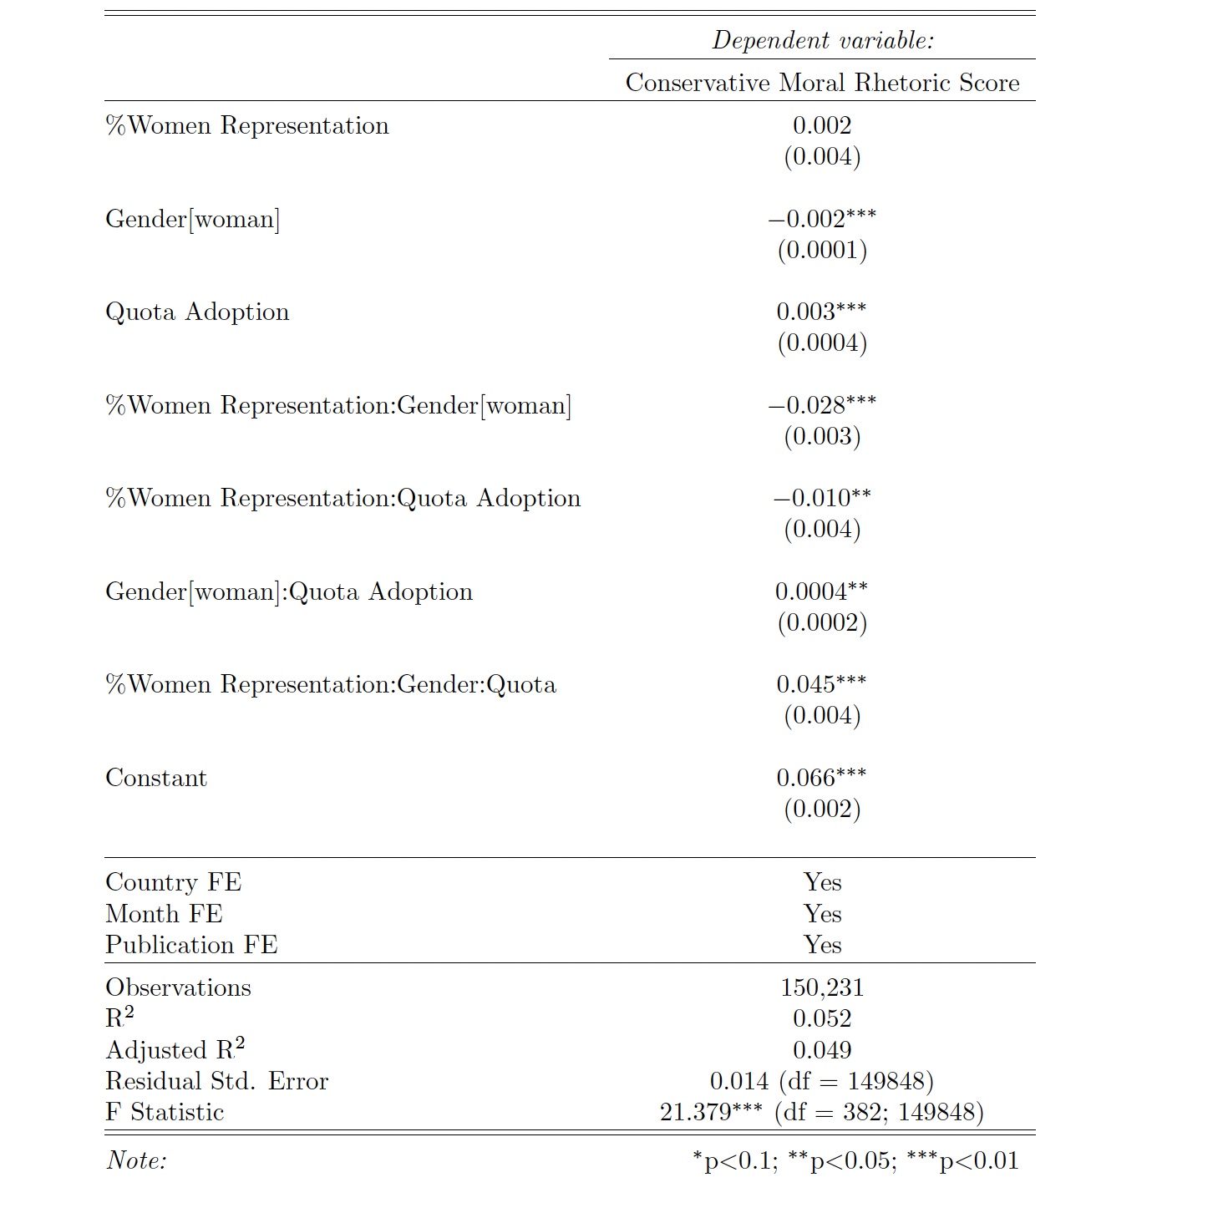
In estimating the fixed-effects models, I employed a similar specification as the random-effects models.

Table 5 - Fixed-effects model for Relationship between Quota Type and Conservative Moral Rhetoric in New Coverage of Women Politicians
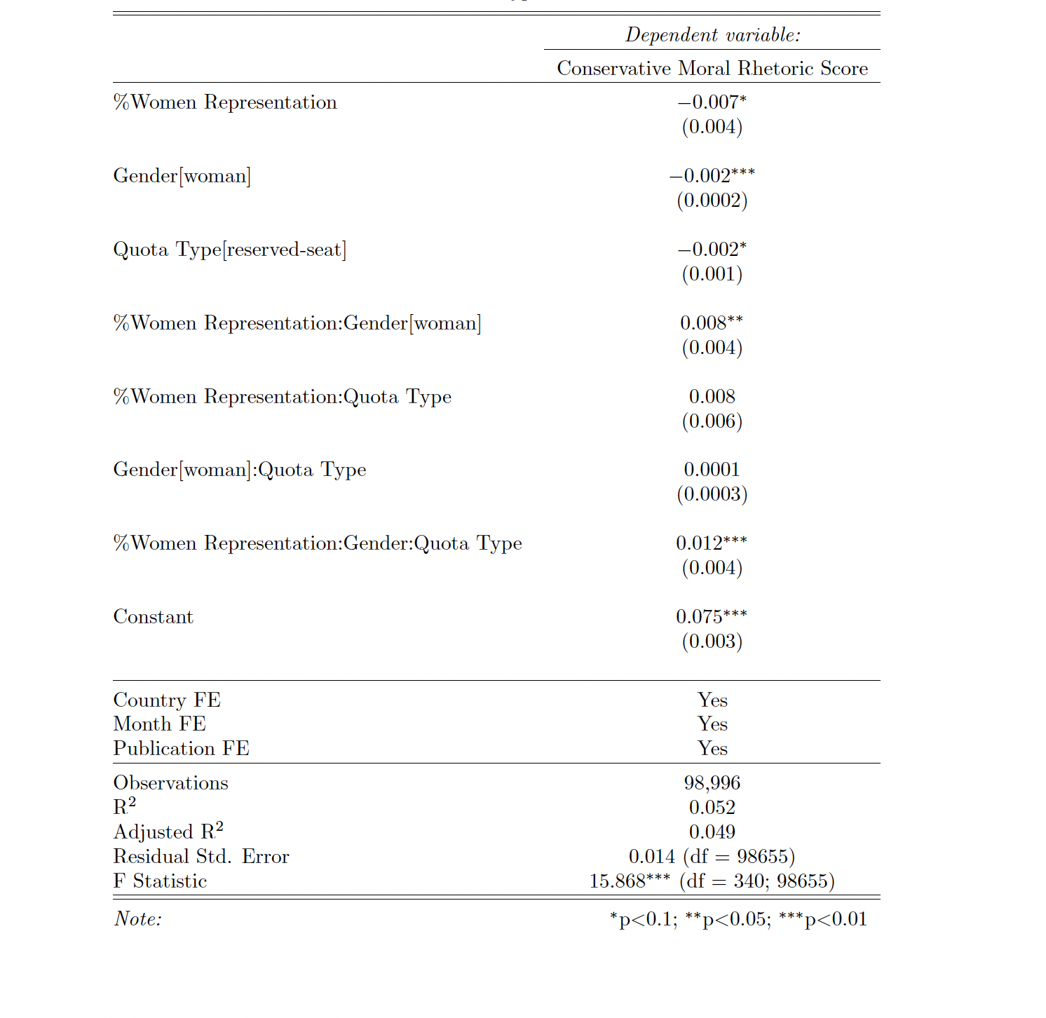

Table 6 - Within-Between Random Effects Model for The Effect of Quota Adoption on Conservative Moral Rhetoric (vice) in News Coverage of Women Politicians
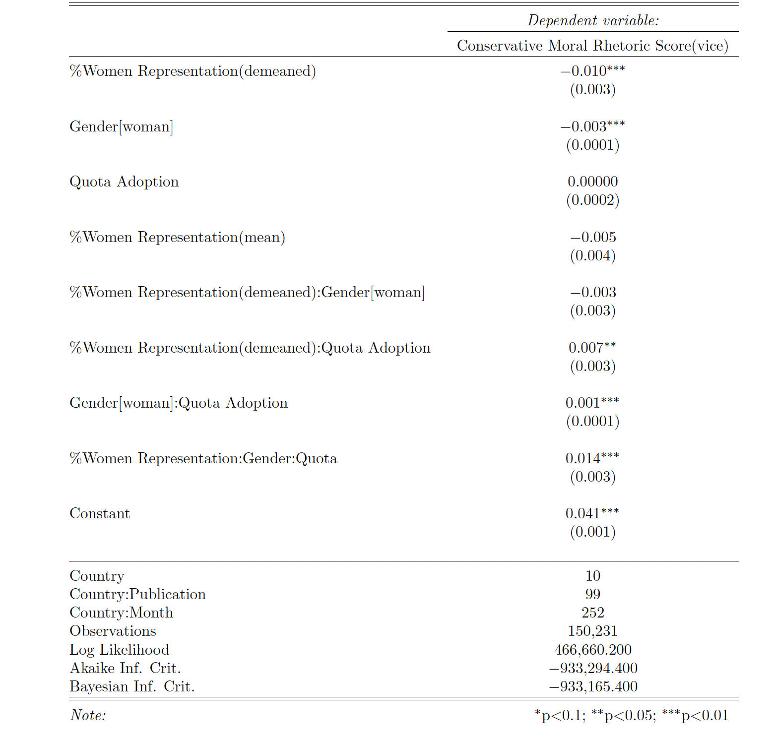

Table 7 - Within-Between Random Effects Model for The Effect of Quota Adoption on Conservative Moral Rhetoric (virtue) in News Coverage of Women Politicians
