Appendix

Alternative Model Specifications
The models in Table 4 were selected from multiple specifications using model diagnostics such as AIC and BIC. Other models considered are presented in Table A1. These include the models from Table 4 without brief gender-norm compliance included (Models 1 & 2). Models 3 & 4 are identical to those in Table 4, except the federal government and opposes federal government variables replaced with party capability scores for the attorney’s party and the party she opposes. These terms are not included in-text because party capability is correlated with the federal government measures. Models 5 & 6 are the same Models 3 & 4, although they lack the brief gender-norm compliance measure. Across all specifications, the results are substantively unchanged.
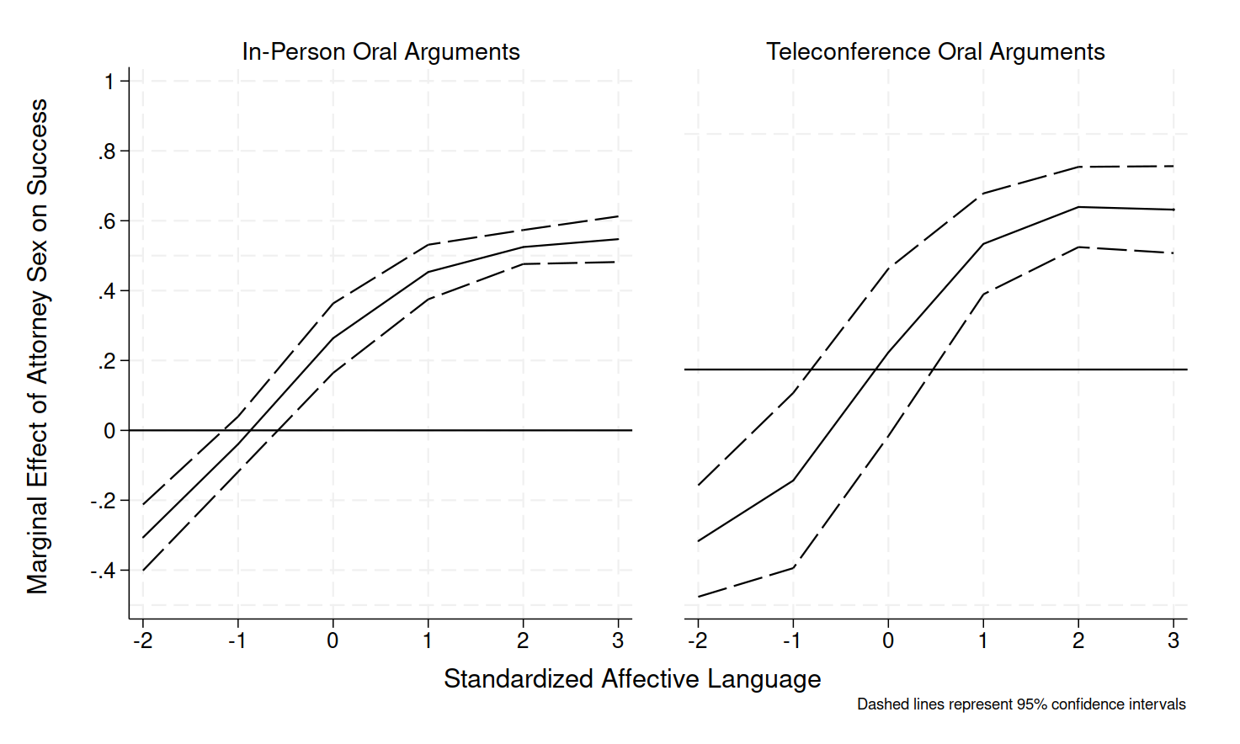
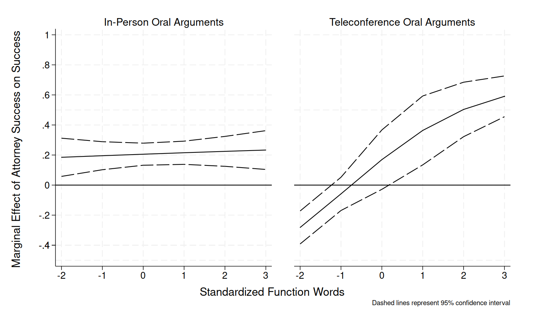
Figure A1. Interactive effects for consolidated model.

Consolidated Model
I run a model with both in-person and teleconference arguments included. This model differs from that in Table 4 in two ways. First, there is a binary variable marking whether the argument was in-person (0) or teleconference (1). Second, the interaction terms are three-way interactions between attorney sex, affective language (function words) and argument modality. The results are presented in Table A2. The subsequent interactions are presented in Figure A1, which closely mirror those presented in Figures 1 and 2.
Table A1. Alternative specifications
 | (1) | (2) | (3) | (4) | (5) | (6)
Function Words | 0.121∗ (0.057) | -0.224∗ (0.111) | 0.250∗∗ (0.081) | 0.108 (0.163) | 0.290∗∗∗ (0.068) | 0.233 | (0.128)
Female Attorney | 1.084∗∗ (0.412) | 2.207∗ (1.017) | 0.925∗ (0.375) | 3.633∗ (1.549) | 0.783 (0.400) | 3.347∗∗ | (1.035)
Female Attorney × Function Words | -0.090 (0.151) | 2.218∗∗ (0.710) | -0.048 (0.158) | 2.218∗∗ (0.861) | -0.230 (0.145) | 1.794∗∗ | (0.692)
Affective Language | -0.168∗ (0.069) | 0.630∗∗∗ (0.145) | -0.104 (0.066) | 0.696∗∗∗ (0.147) | -0.097 (0.069) | 0.788∗∗∗ | (0.141)
Female Attorney × Affective Language | 1.963∗∗∗ (0.369) | 2.156∗∗∗ (0.397) | 1.575∗∗∗ (0.292) | 1.856∗∗∗ (0.528) | 1.502∗∗∗ (0.293) | 2.287∗∗∗ | (0.397)
Experience Advantage | -0.008∗∗∗ (0.002) | 0.001 (0.005) | -0.013∗∗∗ (0.003) | -0.003 (0.005) | -0.015∗∗∗ (0.003) | -0.006 | (0.005)
Federal Party | 1.411∗∗∗ (0.163) | -1.510∗∗ (0.498) | - | - | - | -
Opposes Federal Party | -1.711∗∗∗ (0.190) | -3.770∗∗∗ (0.722) | - | - | - | -
Own Party Capability | - | - | 0.229∗ (0.090) | -0.163 (0.103) | 0.209∗∗ (0.078) | -0.332∗∗∗ | (0.092)
Opposing Party Capability | - | - | -0.202∗∗∗ (0.036) | -0.762∗∗∗ (0.087) | -0.188∗∗∗ (0.026) | -0.843∗∗∗ | (0.077)
Former Clerk | 0.203 (0.212) | 0.890∗∗∗ (0.195) | 0.080 (0.288) | 0.560∗∗ (0.189) | 0.043 (0.273) | 0.204 | (0.189)
Petitioner | 0.878∗∗∗ (0.192) | 1.347∗∗∗ (0.268) | 1.159∗∗∗ (0.265) | 1.040∗∗∗ (0.207) | 1.201∗∗∗ (0.254) | 1.557∗∗∗ | (0.195)
Amicus Brief Advantage | 0.111∗∗∗ (0.011) | 0.110∗∗∗ (0.021) | 0.180∗∗∗ (0.038) | 0.201∗∗∗ (0.022) | 0.138∗∗∗ (0.013) | 0.172∗∗∗ | (0.019)
Ideological Congruence | 0.271∗∗∗ (0.057) | 0.351∗∗∗ (0.049) | 0.268∗∗∗ (0.048) | 0.372∗∗∗ (0.059) | 0.273∗∗∗ (0.046) | 0.364∗∗∗ | (0.059)
Female Justice | -0.088 (0.134) | 0.048 (0.050) | -0.119 (0.121) | 0.017 (0.051) | -0.109 (0.130) | 0.094 | (0.063)
Female Justice × Female Attorney | 1.708∗∗∗ (0.265) | 0.230 (0.757) | 1.698∗∗∗ (0.265) | 0.033 (0.664) | 1.678∗∗∗ (0.258) | 0.037 | (0.680)
Cognitive Complexity | 0.078∗ (0.036) | 0.758∗∗∗ (0.147) | 0.104∗ (0.044) | 0.767∗∗∗ (0.104) | 0.062 (0.037) | 1.000∗∗∗ | (0.118)
Brief Gender Norm Compliance | - | - | -0.030 (0.043) | 0.072 (0.078) | - | -
Justice Interruptions | -0.157∗∗∗ (0.035) | -0.061 (0.104) | -0.131∗∗∗ (0.029) | -0.122 (0.102) | -0.144∗∗∗ (0.030) | -0.082 | (0.100)
May 2020 Argument | - | -0.284 (0.256) | - | -0.439∗ (0.215) | - | -0.318 | (0.215)
Civil Rights | 0.309∗∗ (0.099) | -1.129∗∗ (0.386) | 0.385∗∗∗ (0.069) | 1.046∗∗∗ (0.170) | 0.344∗∗∗ (0.099) | 0.927∗∗∗ | (0.121)
First Amendment | 0.571∗∗∗ (0.125) | -1.892∗∗∗ (0.489) | 0.562∗∗∗ (0.125) | 1.863∗∗∗ (0.448) | 0.513∗∗∗ (0.138) | 1.832∗∗∗ | (0.337)
Due Process | 0.649∗∗∗ (0.153) | -1.165∗∗ (0.406) | 0.531∗∗∗ (0.108) | 0.728∗∗ (0.276) | 0.501∗∗∗ (0.121) | 0.363∗∗ | (0.135)
Attorneys | 0.277∗ (0.130) | - | 0.555∗∗∗ (0.108) | - | 0.519∗∗∗ (0.125) | -
Unions | 0.082 (0.081) | -4.841∗∗∗ (0.915) | 0.150 (0.116) | -2.719∗∗∗ (0.602) | 0.124 (0.070) | -2.580∗∗∗ | (0.488)
Economic Activity | 0.387∗∗∗ (0.086) | -1.075∗∗ (0.333) | 0.374∗∗∗ (0.090) | 1.234∗ (0.487) | 0.358∗∗∗ (0.069) | 1.491∗∗∗ | (0.266)
Judicial Power | 0.424∗∗∗ (0.098) | -1.647∗∗∗ (0.366) | 0.528∗∗∗ (0.092) | 1.303∗∗∗ (0.295) | 0.461∗∗∗ (0.103) | 0.486 | (0.275)
Federalism | 0.521∗∗ (0.181) | - | 0.718∗∗∗ (0.153) | - | 0.687∗∗∗ (0.158) | -
Private Action | 0.216∗ (0.094) | - | - | - | 0.028 (0.116)
Privacy | - | -1.105∗ (0.439) | - | - 2.351∗∗∗ (0.456) |  | 2.248∗∗∗ | (0.349)
Federal Taxation | - | -1.885∗∗∗ (0.515) | - | - 1.764∗∗∗ (0.425) |  | 2.090∗∗∗ | (0.276)
Constant | -0.556∗∗∗ (0.163) | 0.276 (0.343) | -0.938∗∗ (0.297) | 1.504∗∗ (0.513) | -0.771∗∗∗ (0.232) | 2.060∗∗∗ | (0.396)
AIC  BIC | 896.529  934.358 | 466.620  503.723 | 843.894  881.023 | 412.912  449.080 | 920.249  958.080 | 448.273  485.375
Observations | 836 | 456 | 766 | 411 | 836 | 456
Standard errors clustered on justice ∗ p < 0.05, ∗∗ p < 0.01, ∗∗∗ p < 0.001

Table A2. Predictors of attorney success consolidated model

Variable | Coefficient | Std. Error
Function Words | 0.076 | (0.053)
Female Attorney | 1.023∗∗ | (0.359)
Female Attorney × Function Words | 0.075 | (0.150)
Teleconference Argument | -0.175 | (0.098)
Teleconference Argument × Function Words | -0.297∗ | (0.122)
Female Attorney × Teleconference Argument | -0.362 | (0.684)
Female Attorney × Teleconference Argument × Function Words | 1.670∗∗ | (0.633)
Affective Language | -0.005 | (0.082)
Female Attorney × Affective Language | 1.681∗∗∗ | (0.310)
Teleconference Argument × Affective Language | 0.257∗ | (0.122)
Female Attorney × Teleconference Argument × Affective Language | 0.089 | (0.468)
Experience Advantage | -0.001 | (0.002)
Federal Party | 0.991∗∗∗ | (0.145)
Opposes Federal Party | -1.828∗∗∗ | (0.165)
Former Clerk | 0.399∗∗ | (0.137)
Petitioner | 0.729∗∗∗ | (0.161)
Amicus Brief Advantage | 0.129∗∗∗ | (0.012)
Ideological Congruence | 0.286∗∗∗ | (0.048)
Female Justice | -0.091 | (0.068)
Female Justice × Female Attorney | 1.419∗∗∗ | (0.366)
Cognitive Complexity | 0.196∗∗∗ | (0.036)
Brief Gender Norm Compliance | 0.073∗ | (0.033)
Justice Interruptions | -0.121∗∗ | (0.045)
May 2020 Argument | 0.022 | (0.155)
Civil Rights | 0.333∗∗∗ | (0.086)
First Amendment | 0.181 | (0.138)
Due Process | 0.468∗∗∗ | (0.113)
Privacy | 0.469∗∗ | (0.180)
Attorneys | 0.271∗∗∗ | (0.063)
Unions | -0.659∗∗∗ | (0.174)
Economic Activity | 0.288∗∗ | (0.097)
Judicial Power | 0.392∗∗∗ | (0.076)
Federalism | 0.427∗∗∗ | (0.128)
Federal Taxation | 0.022 | (0.174)
Constant | -0.292 | (0.196)
Observations | 1,177
AIC | 1279.868
BIC | 1325.504
Standard errors clustered on justice

Standard errors clustered on justice p < 0.05, ∗∗ p < 0.01, ∗∗∗ p < 0.001

Table 4 With Issue Area Variables
I exclude criminal procedure. The private action issue area has no observations in my data.
Table A3. Table 1 models with issue area variables displayed
 | (1) | (2)
Function Words | 0.107 | -0.629∗∗∗
 | (0.081) | (0.163)
Female Attorney | 1.168∗∗ (0.382) | 2.645∗ (1.324)
Female Attorney × Function Words | -0.010 | 2.903∗∗∗
Affective Language  Female Attorney × Affective Language | (0.150)  -0.158∗  (0.074)  2.112∗∗∗  (0.358) | (0.802) 0.437∗  (0.176)  1.936∗∗∗  (0.551)
Experience Advantage | -0.003 | 0.004
Federal Party  Opposes Federal Party | (0.003)  1.696∗∗∗  (0.215)  -2.089∗∗∗  (0.241) | (0.005)  -1.561∗∗∗  (0.442)  -3.813∗∗∗  (0.738)
Former Clerk | 0.096 | 1.413∗∗∗
Petitioner  Amicus Brief Advantage Ideological Congruence | (0.241) 0.645∗∗  (0.241)  0.155∗∗∗  (0.021)  0.274∗∗∗  (0.051) | (0.201) 0.717∗∗  (0.275)  0.113∗∗∗  (0.025)  0.358∗∗∗  (0.053)
Female Justice | -0.099 | -0.050
 | (0.126) | (0.059)
Female Justice × Female Attorney | 1.776∗∗∗ | 0.300
Cognitive Complexity | (0.280) 0.115∗∗  (0.041) | (0.766)  0.637∗∗∗  (0.111)
Brief Gender Norm Compliance | 0.017 | 0.052
 | (0.044) | (0.083)
Justice Interruptions | -0.142∗∗∗ | -0.103
May 2020 Argument | (0.037)  - | (0.108)  -0.459∗
Civil Rights | 0.353∗∗∗ | (0.233)  -1.149∗∗∗
First Amendment Due Process Attorneys | (0.095)  0.581∗∗∗  (0.081)  0.723∗∗∗  (0.141)  0.338∗ | (0.337)  -1.727∗∗∗  (0.474)  -1.159∗∗  (0.409)  -
 | (0.145)
Unions | -0.007 | -5.265∗∗∗
Economic Activity | (0.115)  0.437∗∗∗  (0.121) | (0.858)  -1.420∗∗∗  (0.350)
Judicial Power | 0.450∗∗∗ | -0.407
Federalism | (0.078)  0.596∗∗ | (0.332)  -
Privacy | (0.189)  - | -0.873∗
Federal Taxation | - | (0.381)  -2.376∗∗∗
 |  | (0.533)
Constant | -0.407 | 0.456
 | (0.226) | (0.414)
AIC  BIC  Observations | 808.975  846.104  766 | 436.580  472.745  411

Standard errors clustered on justice ∗ p < 0.05, ∗∗ p < 0.01, ∗∗∗ p < 0.001

7

