More Money, Less Credit? Legislator Gender and the Effectiveness of Congressional Credit Claiming

Appendix

Table A1: Demographics of Survey Sample
Gender | Race/Ethnicity | Ideology
53% Women | 69% White | 10% Very liberal
47% Men | 11% Black | 13% Liberal
 | 7% Latino | 9% Slightly liberal
 | 6% Mixed | 37% Moderate
 | 4% Asian | 9% Slightly conservative
 | 2% Other | 13% Conservative
 |  | 9% Very conservative
Party | Region | Religious Attendance
37% Democrats | 37% South | 40% Never
31% Republicans | 23% West | 26% Few times a year
31% Independents | 20% Northeast | 8% Once or twice a month
 | 19% Midwest | 8% Almost every week
 |  | 17% Every week
Income | Age | Education
Median: $40,000-$49,999 | Median: 45 | 3% Less than high school diploma
 |  | 27% High school graduate
 |  | 22% Some college
 |  | 7% 2-year degree
 |  | 24% 4-year degree
 |  | 16% Post-graduate education

Table A2: MC Gender Treatment Balance
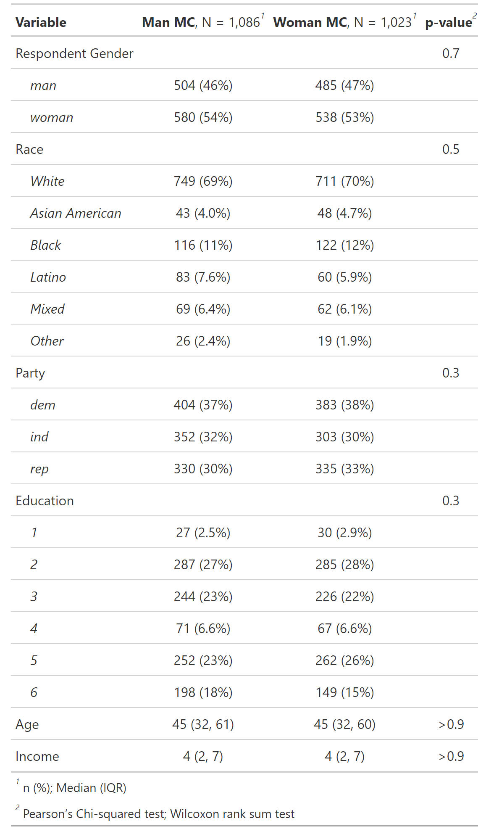
NOTE: The table shows a balance test of MC Gender assignment.

Table A3: Message Treatment Balance
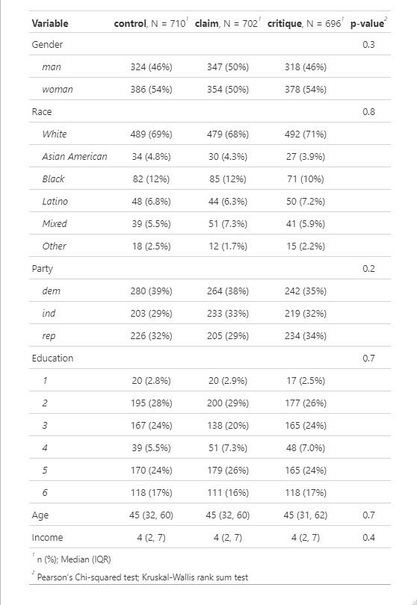
NOTE: The table shows a balance test of MC message assignment.
Pre-treatment questionnaire
Which racial group(s) do you consider yourself to be a part of? (Mark all that apply)
Asian American (1)
Black or African American (2)
Hispanic or Latino (3)
Native American or American Indian (4)
White (5)
Other (6)

In general, how would you describe your own political viewpoint?
Very Liberal (0)
Liberal (1)
Slightly Liberal (2)
Moderate (3)
Slightly Conservative (4)
Conservative (5)
Very Conservative (6)

How often do you attend religious services, apart from occasional weddings, baptisms or funerals?
Every week (4)
Almost every week (3)
Once or twice a month (2)
A few times a year (1)
Never (0)

What is the highest level of education you have completed?
▼ Less than high school diploma (0) ... Post-graduate education (5)

What is your annual household income for all members of your family? This figure should include salaries, wages, pensions, dividends, interest, and all other income.
▼ Under $10,000 (0) ... Over $200,000 (11)

The Supreme Court is currently deciding on a number of important cases. We would like to know whether people actually read survey questions. Please answer "slightly interested" to show us that you read this question.
Extremely interested (1)
Very interested (2)
Moderately interested (3)
Slightly interested (4)
Not interested at all (5)

Generally speaking, do you think of yourself as a...?
Strong Republican (0)
Not very strong Republican (1)
Independent (2)
Not very strong Democrat (3)
Strong Democrat (4)
If you had to choose, do you think of yourself as more similar to Republicans or Democrats?
More similar to Republicans than Democrats (0)
More similar to Democrats than Republicans (1)

Treatment Messages
Control
Please read the following news excerpt about a member of Congress. After which, you will be asked to evaluate the member.
{Congresswoman/Congresswoman} Anderson Announces Winner of Art Competition

Today, Congresswoman/Congressman Madeline/Matthew Anderson (D/R | MN) announced that 17-year-old Nate Beyer won first place in the annual congressional district art competition. Nate's winning entry, "Sunsets," was created using colored pencils and will now be displayed in the U.S. Capitol with other winning entries. More than 30 students competed is this year's art competition.

Credit Claim
Please read the following news excerpt about a member of Congress. After which, you will be asked to evaluate the member.
{Congresswoman/Congresswoman} Anderson Secures $44 Million for Local Road and Highway Projects

Today, Congresswoman/Congressman Madeline/Matthew Anderson (D/R | MN)) released the following statement after securing more than $44 million in funding within the Fiscal Year 2023 appropriations bill for local road and highway projects in her district.

"I am proud of our efforts to secure this funding, which will play a critical role in uplifting our people and unlocking our region's full potential," said Congresswoman Anderson. "The millions of dollars coming home will support good-paying jobs, revitalize neighborhoods, and drive our economy forward."

Credit Claim with Spending Critique
Please read the following news excerpt about a member of Congress. After which, you will be asked to evaluate the member.
{Congresswoman/Congresswoman} Anderson Secures $44 Million for Local Road and Highway Projects

Today, Congresswoman/Congressman Madeline/Matthew Anderson (D/R | MN) released the following statement after securing more than $44 million in funding within the Fiscal Year 2023 appropriations bill for local road and highway projects in her district.
"I am proud of our efforts to secure this funding, which will play a critical role in uplifting our people and unlocking our region's full potential," said Congresswoman Anderson. "The millions of dollars coming home will support good-paying jobs, revitalize neighborhoods, and drive our economy forward."

The nonpartisan Committee for a Responsible Federal Budget reported that the appropriations bill is wasteful and contributes to the growing federal deficit. "Given that the national debt has grown by $1.1 trillion since January, lawmakers' decision to add more spending and borrowing in this appropriations package is a tremendous mistake. The full spending package is estimated to cost $1.6 trillion and makes our debt and inflationary problems worse."

Post-treatment questionnaire

How pleased would you be if Madeline/Matthew Anderson was your representative in Congress?
Very Pleased (6)
Pleased (5)
Slightly Pleased (4)
Neither Pleased Nor Displeased (3)
Slightly Displeased (2)
Displeased (1)
Very Displeased (0)

How effective do you think Madeline/Matthew Anderson is at passing legislation that helps his community?
Very Effective (6)
Effective (5)
Slightly Effective (4)
Neither Effective Nor Ineffective (3)
Slightly Ineffective (2)
Ineffective (1)
Very Ineffective (0)

How responsible do you think Madeline/Matthew Anderson is when it comes to governmental spending?
Very Responsible (6)
Responsible (5)
Slightly Responsible (4)
Neither Responsible Nor Irresponsible (3)
Slightly Irresponsible (2)
Irresponsible (1)
Very Irresponsible (0)

If you lived in Madeline/Matthew Anderson's congressional district, would you approve or disapprove of his performance in office?
Approve (1)
Disapprove (0)

How would you rate Madeline/Matthew Anderson's political ideology?
Very liberal (6)
Liberal (5)
Somewhat liberal (4)
Middle of the road (3)
Somewhat conservative (2)
Conservative (1)
Very conservative (0)

If you lived in Madeline/Matthew Anderson's congressional district, how likely would you be to vote for him?
Very Likely (6)
Likely (5)
Slightly Likely (4)
Neither Likely Nor Unlikely (3)
Slightly Unlikely (2)
Unlikely (1)
Very Unlikely (0)

How would you rate Madeline/Matthew Anderson's political ideology?
Very Liberal (6)
Liberal (5)
Somewhat Liberal (4)
Middle of the Road (3)
Somewhat Conservative (2)
Conservative (1)
Very Conservative (0)

General Support Analysis:

Table A4: Difference of Means Tests of MC Gender: General Support
Substantive Treatment | Man MC | Woman MC | Diff. of Means | P-value
Control | 4.802 | 5.012 | -0.210 | 0.047 | **
Credit Claim | 5.302 | 5.393 | -0.090 | 0.354
Credit Claim with Critique | 4.542 | 4.601 | -0.059 | 0.635
* p < 0.1, ** p < 0.05, *** p < 0.01
NOTE: Dependent variable = MC General Support (1-7).

Table A5: ANOVA with Tukey Comparisons: General Support (Woman MC Subset)
Contrast | Diff. of Means | Adjusted P-value
Control / Woman - Claim / Woman | -0.380 | 0.001 | ***
Critique / Woman - Claim / Woman | -0.792 | 0.000 | ***
Critique / Woman - Control / Woman | -0.411 | 0.001 | ***
* p < 0.1, ** p < 0.05, *** p < 0.01
NOTE: Dependent variable = MC General Support (1-7).

Table A6: ANOVA with Tukey Comparisons: General Support (Man MC Subset)
Contrast | Diff. of Means | Adjusted P-value
Control / Man - Claim / Man | -0.500 | 0.000 | ***
Critique / Man - Claim / Man | -0.760 | 0.000 | ***
Critique / Man - Control / Man | -0.260 | 0.040 | **
* p < 0.1, ** p < 0.05, *** p < 0.01
NOTE: Dependent variable = MC General Support (1-7).

Table A7: ANOVA with Tukey Comparisons: General Support
Contrast | Diff. of Means | Adjusted P-value
Control / Woman - Control / Man | 0.210 | 0.385
Claim / Woman - Claim / Man | 0.090 | 0.963
Critique / Woman - Critique / Man | 0.059 | 0.995
Control / Woman - Claim / Woman | -0.380 | 0.007 | ***
Critique / Woman - Control / Woman | -0.411 | 0.004 | ***
Critique / Woman - Claim / Woman | -0.792 | 0.000 | ***
Control / Man - Claim / Man | -0.500 | 0.000 | ***
Critique / Man - Control / Man | -0.260 | 0.135
Critique / Man - Claim / Man | -0.760 | 0.000 | ***
* p < 0.1, ** p < 0.05, *** p < 0.01
NOTE: Comparisons that vary on both substance condition and MC gender were included in the analysis but removed from the table for interpretation clarity. Dependent variable = MC General Support (1-7).

Table A8: Difference of Means Tests of MC Gender: General Support (Partisan Subsets)
Substantive Treatment | Man MC | Woman MC | Diff. of Means | P-value
Republican MC / Copartisan
Control | 4.864 | 5.075 | -0.210 | 0.315
Credit Claim | 5.460 | 5.429 | 0.032 | 0.852
Credit Claim with Critique | 4.623 | 4.534 | 0.089 | 0.728
Republican MC / Non-copartisan
Control | 4.565 | 5.114 | -0.549 | 0.025 | **
Credit Claim | 5.138 | 5.267 | -0.129 | 0.499
Credit Claim with Critique | 4.347 | 4.841 | -0.494 | 0.052 | *
Democratic MC / Copartisan
Control | 5.178 | 5.167 | 0.012 | 0.949
Credit Claim | 5.657 | 5.633 | 0.024 | 0.900
Credit Claim with Critique | 5.011 | 4.912 | 0.099 | 0.631
Democratic MC / Non-copartisan
Control | 4.590 | 4.658 | -0.068 | 0.741
Credit Claim | 4.861 | 5.225 | -0.364 | 0.101
Credit Claim with Critique | 4.245 | 4.030 | 0.215 | 0.429
* p < 0.1, ** p < 0.05, *** p < 0.01
NOTE: Dependent variable = MC General Support (1-7).

Effectiveness Measure Analysis:

Table A9: Difference of Means Tests of MC Gender: Effectiveness
Substantive Treatment | Man MC | Woman MC | Diff. of Means | P-value
Control | 4.642 | 4.727 | -0.085 | 0.373
Credit Claim | 5.321 | 5.451 | -0.130 | 0.166
* p < 0.1, ** p < 0.05, *** p < 0.01
NOTE: Dependent variable = MC Effectiveness (1-7).

Table A10: Difference of Means Test of Message: Effectiveness (Woman MC Subset)
Credit Claim | Control | Diff. of Means | P-value
5.451 | 4.727 | 0.724 | 0.000 | ***
* p < 0.1, ** p < 0.05, *** p < 0.01
NOTE: Dependent variable = MC Effectiveness (1-7).

Table A11: Difference of Means Test of Message: Effectiveness (Man MC Subset)
Credit Claim | Control | Diff. of Means | P-value
5.321 | 4.642 | 0.679 | 0.000 | ***
* p < 0.1, ** p < 0.05, *** p < 0.01
NOTE: Dependent variable = MC Effectiveness (1-7).

Table A12: ANOVA with Tukey Comparisons: MC Effectiveness
Contrast |  | Diff. of Means |  | Adjusted P-value
Claim / Woman - Claim / Man | 0.130 |  | 0.519
Control / Woman - Control / Man | 0.085 |  | 0.803
Control / Woman - Claim / Woman | -0.724 |  | 0.000 |  | ***
Control / Man - Claim / Man | -0.679 |  | 0.000 |  | ***
* p < 0.1, ** p < 0.05, *** p < 0.01
NOTE: Comparisons that vary on both substance condition and MC gender were included in the analysis but removed from the table for interpretation clarity. Dependent variable = MC Effectiveness (1-7).

Figure A1: Mean MC Effectiveness Across Treatment Group and Party Affiliation
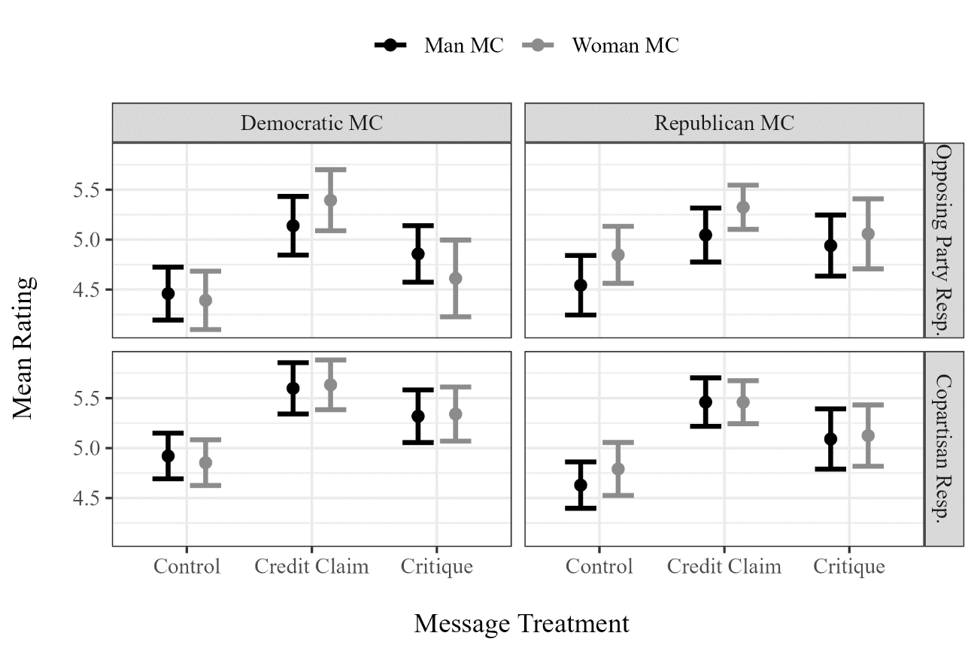

Table A13: Difference of Means Tests of MC Gender: MC Effectiveness (Partisan Subsets)
Substantive Treatment | Man MC | Woman MC | Diff. of Means | P-value
Republican MC / Copartisan
Control | 4.630 | 4.791 | -0.161 | 0.371
Credit Claim | 5.460 | 5.459 | 0.001 | 0.995
Credit Claim with Critique | 5.091 | 5.125 | -0.034 | 0.877
Republican MC / Non-copartisan
Control | 4.543 | 4.848 | -0.305 | 0.149
Credit Claim | 5.046 | 5.324 | -0.278 | 0.120
Credit Claim with Critique | 4.941 | 5.058 | -0.117 | 0.621
Democratic MC / Copartisan
Control | 4.921 | 4.854 | 0.067 | 0.687
Credit Claim | 5.598 | 5.633 | -0.035 | 0.847
Credit Claim with Critique | 5.319 | 5.341 | -0.022 | 0.909
Democratic MC / Non-copartisan
Control | 4.460 | 4.392 | 0.068 | 0.737
Credit Claim | 5.139 | 5.394 | -0.255 | 0.239
Credit Claim with Critique | 4.857 | 4.612 | 0.245 | 0.316
* p < 0.1, ** p < 0.05, *** p < 0.01
NOTE: Dependent variable = MC Effectiveness (1-7).

Fiscal Responsibility Measure Analysis

Table A14: Difference of Means Tests of MC Gender: Fiscal Responsibility
Substantive Treatment | Man MC | Woman MC | Diff. of Means | P-value
Credit Claim | 5.009 | 5.168 | -0.158 | 0.109
Credit Claim with Critique | 4.420 | 4.513 | -0.093 | 0.470
* p < 0.1, ** p < 0.05, *** p < 0.01
NOTE: Dependent variable = MC Fiscal Responsibility (1-7).

Table A15: Difference of Means Test of Message: Responsibility (Woman MC Subset)
Credit Claim | Credit Claim with Critique | Diff. of Means | P-value
5.168 | 4.513 | 0.655 | 0.000 | ***
* p < 0.1, ** p < 0.05, *** p < 0.01
NOTE: Dependent variable = MC Fiscal Responsibility (1-7).

Table A16: Difference of Means Test of Message: Responsibility (Man MC Subset)
Credit Claim | Credit Claim with Critique | Diff. of Means | P-value
5.009 | 4.420 | 0.590 | 0.000 | ***
* p < 0.1, ** p < 0.05, *** p < 0.01
NOTE: Dependent variable = MC Fiscal Responsibility (1-7).

Table A17: ANOVA with Tukey Comparisons: MC Fiscal Responsibility
Contrast | Diff. of Means | Adjusted P-value
Critique Woman - Critique Man | 0.093 | 0.848
Claim Woman - Claim Man | 0.158 | 0.506
Critique Woman - Claim Woman | -0.655 | 0.000 | ***
Critique Man - Claim Man | -0.590 | 0.000 | ***
* p < 0.1, ** p < 0.05, *** p < 0.01
NOTE: Comparisons that vary on both substance condition and MC gender were included in the analysis but removed from the table for interpretation clarity. Dependent variable = MC Fiscal Responsibility (1-7).

Figure A2: Mean MC Fiscal Responsibility Across Treatment Group and Party Affiliation
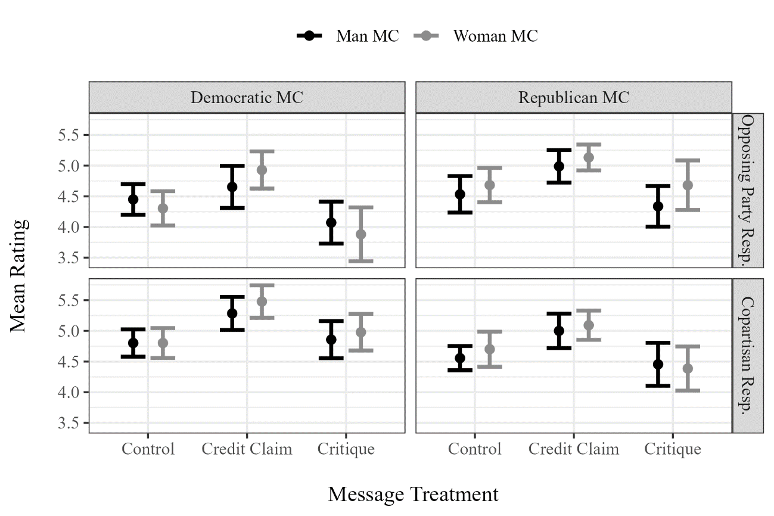

Table A18: Difference of Means Tests of MC Gender: Responsibility (Partisan Subsets)
Substantive Treatment | Man MC | Woman MC | Diff. of Means | P-value
Republican MC / Copartisan
Control | 4.556 | 4.701 | -0.146 | 0.412
Credit Claim | 5.000 | 5.092 | -0.092 | 0.625
Credit Claim with Critique | 4.455 | 4.386 | 0.068 | 0.790
Republican MC / Non-copartisan
Control | 4.533 | 4.684 | -0.151 | 0.469
Credit Claim | 4.989 | 5.133 | -0.145 | 0.403
Credit Claim with Critique | 4.337 | 4.681 | -0.345 | 0.198
Democratic MC / Copartisan
Control | 4.802 | 4.802 | -0.000 | 1.000
Credit Claim | 5.284 | 5.478 | -0.193 | 0.317
Credit Claim with Critique | 4.857 | 4.978 | -0.121 | 0.578
Democratic MC / Non-copartisan
Control | 4.450 | 4.304 | 0.146 | 0.445
Credit Claim | 4.653 | 4.930 | -0.277 | 0.238
Credit Claim with Critique | 4.071 | 3.881 | 0.191 | 0.502
* p < 0.1, ** p < 0.05, *** p < 0.01
NOTE: Dependent variable = MC Fiscal Responsibility (1-7).

Perceived Ideology Analysis

Figure A3: Mean MC Effectiveness Ratings

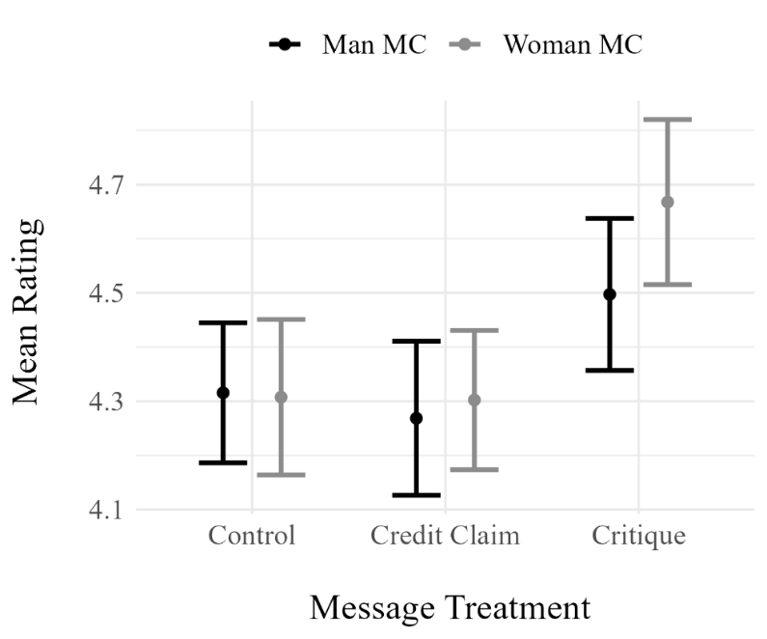

Table A19: Difference of Means Tests of MC Gender: Perceived Ideology
Substantive Treatment | Man MC | Woman MC | Diff. of Means | P-value
Control | 4.316 | 4.307 | 0.008 | 0.935
Credit Claim | 4.269 | 4.302 | -0.034 | 0.731
Credit Claim with Critique | 4.497 | 4.668 | -0.170 | 0.107
* p < 0.1, ** p < 0.05, *** p < 0.01
NOTE: Dependent variable = MC Ideology (1-7).

Table A20: ANOVA with Tukey Comparisons: Perceived Ideology (Woman MC Subset)
Contrast | Diff. of Means | Adjusted P-value
Control / Woman - Claim / Woman | 0.005 | 0.998
Critique / Woman - Claim / Woman | 0.366 | 0.001 | ***
Critique / Woman - Control / Woman | 0.360 | 0.002 | ***
* p < 0.1, ** p < 0.05, *** p < 0.01
NOTE: Dependent variable = MC Ideology (1-7).

Table A21: ANOVA with Tukey Comparisons: Perceived Ideology (Man MC Subset)
Contrast | Diff. of Means | Adjusted P-value
Control / Man - Claim / Man | 0.047 | 0.886
Critique / Man - Claim / Man | 0.229 | 0.060 | *
Critique / Man - Control / Man | 0.182 | 0.146
* p < 0.1, ** p < 0.05, *** p < 0.01
NOTE: Dependent variable = MC Ideology (1-7).

Figure A4: Mean MC Perceived Ideology Across Treatment Group and Party Affiliation
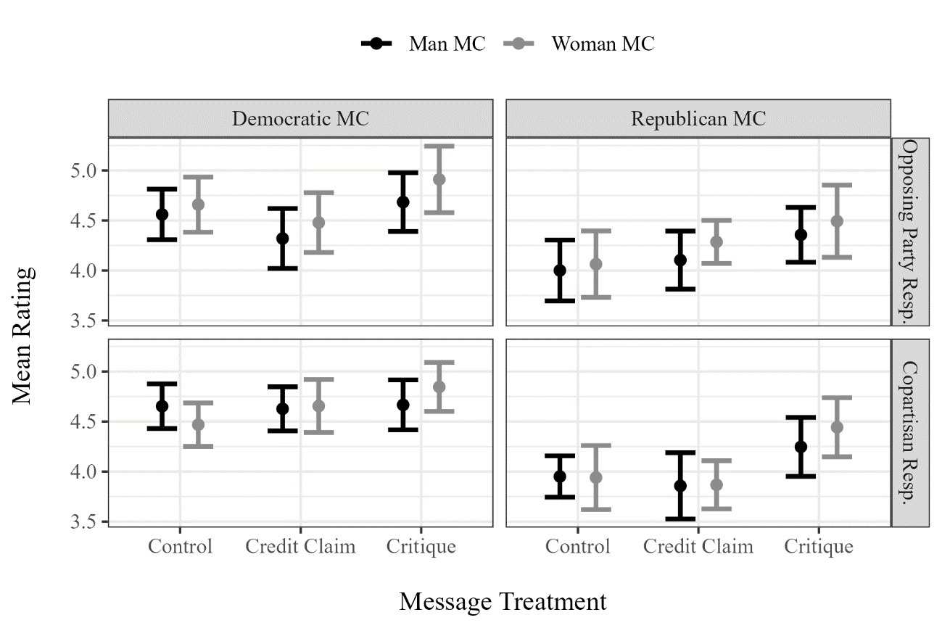

Table A22: Difference of Means Tests of MC Gender: Perceived Ideology (Partisan Subsets)
Substantive Treatment | Man MC | Woman MC | Diff. of Means | P-value
Republican MC / Copartisan
Control | 3.951 | 3.940 | 0.010 | 0.958
Credit Claim | 3.857 | 3.867 | -0.010 | 0.961
Credit Claim with Critique | 4.247 | 4.443 | -0.196 | 0.357
Republican MC / Non-copartisan
Control | 4.000 | 4.063 | -0.063 | 0.783
Credit Claim | 4.103 | 4.286 | -0.182 | 0.324
Credit Claim with Critique | 4.356 | 4.493 | -0.136 | 0.556
Democratic MC / Copartisan
Control | 4.653 | 4.469 | 0.185 | 0.246
Credit Claim | 4.627 | 4.656 | -0.028 | 0.873
Credit Claim with Critique | 4.667 | 4.846 | -0.179 | 0.316
Democratic MC / Non-copartisan
Control | 4.560 | 4.658 | -0.098 | 0.607
Credit Claim | 4.319 | 4.479 | -0.159 | 0.462
Credit Claim with Critique | 4.684 | 4.910 | -0.227 | 0.318
* p < 0.1, ** p < 0.05, *** p < 0.01
NOTE: Dependent variable = MC Ideology (1-7).

To explore whether MC perceived ideology mediates the press release message (control vs. critique) or MC gender (man vs. woman) treatments on general MC support, I conduct mediation analysis using the “mediate” package (Tingley et al. 2014). The substantively small and statistically insignificant mediate results shown below (ACME) indicate that perceived MC ideology is not a causal pathway for the experimental treatments on MC favorability.

Table A23: Perceived Ideology Mediation Analysis

 | Message Mediation | MC Gender Mediation
ACME | 0.004 | 0.000
 | [-0.013, 0.022] | [-0.007, 0.007]
ADE | -0.335*** | 0.138
 | [-0.495, -0.176] | [-0.023, 0.296]
Total Effect | -0.331*** | 0.138
 | [-0.486, -0.170] | [-0.023, 0.297]
Prop. Mediated | -0.010 | 0.000
 | [-0.074, 0.043] | [-0.090, 0.139]
* p < 0.1, ** p < 0.05, *** p < 0.01
NOTE: Dependent variable = MC General Support (1-7).

Vote Intention Analysis

Figure A5: Mean MC Vote Intention Ratings

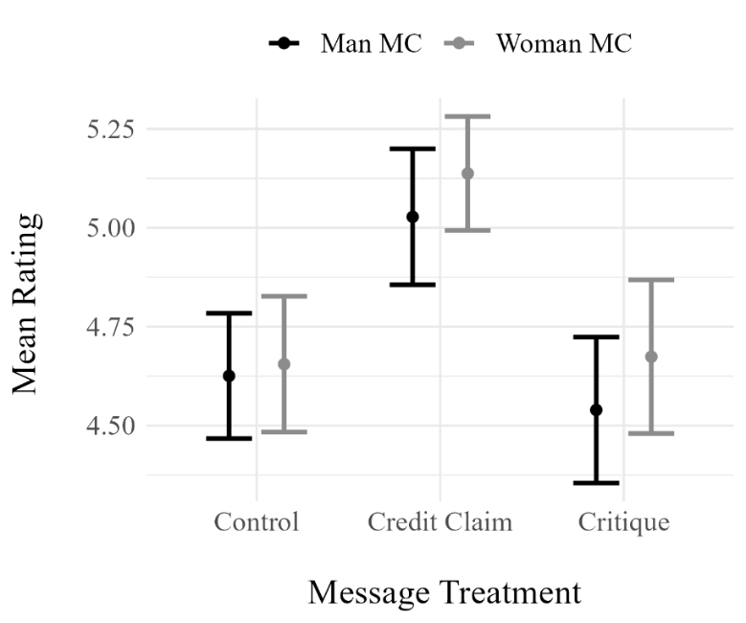

Table A24: Difference of Means Tests of MC Gender: Vote Intention
Substantive Treatment | Man MC | Woman MC | Diff. of Means | P-value
Control | 4.626 | 4.655 | -0.030 | 0.804
Credit Claim | 5.028 | 5.137 | -0.110 | 0.338
Credit Claim with Critique | 4.540 | 4.674 | -0.135 | 0.325
* p < 0.1, ** p < 0.05, *** p < 0.01
NOTE: Dependent variable = MC Vote Intention (1-7).

Table A25: ANOVA with Tukey Comparisons: Vote Intention (Woman MC Subset)
Contrast | Diff. of Means | Adjusted P-value
Control / Woman - Claim / Woman | -0.482 | 0.000 | ***
Critique / Woman - Claim / Woman | -0.463 | 0.000 | ***
Critique / Woman - Control / Woman | 0.019 | 0.988
* p < 0.1, ** p < 0.05, *** p < 0.01
NOTE: Dependent variable = MC Vote Intention (1-7).

Table A26: ANOVA with Tukey Comparisons: Vote Intention (Man MC Subset)
Contrast | Diff. of Means | Adjusted P-value
Control / Man - Claim / Man | -0.402 | 0.004 | ***
Critique / Man - Claim / Man | -0.488 | 0.000 | ***
Critique / Man - Control / Man | -0.086 | 0.758
* p < 0.1, ** p < 0.05, *** p < 0.01
NOTE: Dependent variable = MC Vote Intention (1-7).

Figure A6: Mean Vote Intention Across Treatment Group and Party Affiliation
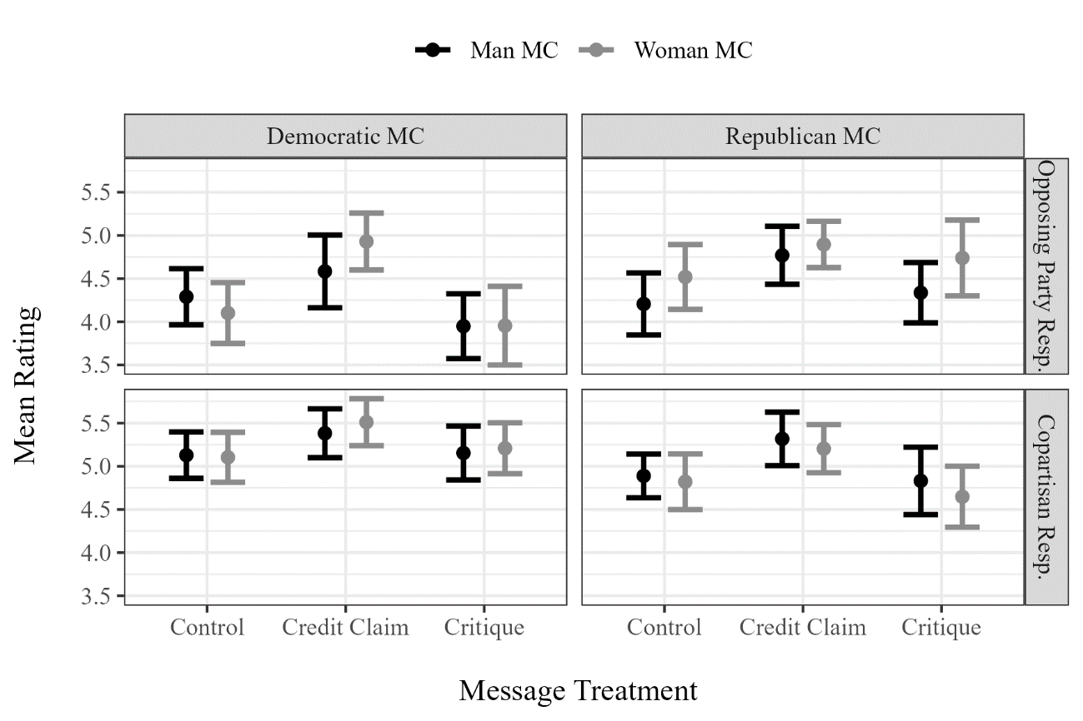

Table A27: Difference of Means Tests of MC Gender: Vote Intention (Partisan Subsets)
Substantive Treatment | Man MC | Woman MC | Diff. of Means | P-value
Republican MC / Copartisan
Control | 4.889 | 4.821 | 0.068 | 0.746
Credit Claim | 5.317 | 5.204 | 0.113 | 0.595
Credit Claim with Critique | 4.831 | 4.648 | 0.183 | 0.496
Republican MC / Non-copartisan
Control | 4.207 | 4.519 | -0.312 | 0.240
Credit Claim | 4.770 | 4.895 | -0.125 | 0.569
Credit Claim with Critique | 4.337 | 4.739 | -0.402 | 0.162
Democratic MC / Copartisan
Control | 5.129 | 5.104 | 0.025 | 0.903
Credit Claim | 5.382 | 5.511 | -0.129 | 0.521
Credit Claim with Critique | 5.154 | 5.209 | -0.055 | 0.802
Democratic MC / Non-copartisan
Control | 4.290 | 4.101 | 0.189 | 0.442
Credit Claim | 4.583 | 4.930 | -0.346 | 0.206
Credit Claim with Critique | 3.949 | 3.955 | -0.006 | 0.983
* p < 0.1, ** p < 0.05, *** p < 0.01
NOTE: Dependent variable = MC Vote Intention (1-7).

Approval Analysis

Figure A7: Mean MC Approval Ratings

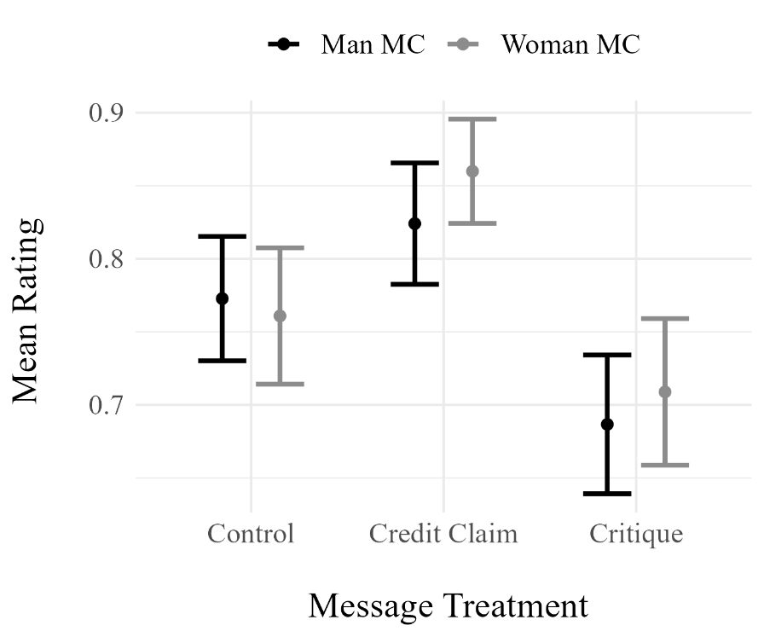

Table A28: Difference of Proportions Tests of MC Gender: Approval
Substantive Treatment | Man MC | Woman MC | P-value
Control | 0.773 | 0.761 | 0.780
Credit Claim | 0.824 | 0.860 | 0.236
Credit Claim with Critique | 0.687 | 0.709 | 0.585
* p < 0.1, ** p < 0.05, *** p < 0.01
NOTE: Dependent variable = MC Approval (0/1).

Table A29: ANOVA with Tukey Comparisons: Approval (Woman MC Subset)
Contrast | Diff. of Means | Adjusted P-value
Control / Woman - Claim / Woman | -0.099 | 0.005 | ***
Critique / Woman - Claim / Woman | -0.151 | 0.000 | ***
Critique / Woman - Control / Woman | -0.052 | 0.245
* p < 0.1, ** p < 0.05, *** p < 0.01
NOTE: Dependent variable = MC Approval (0/1).

Table A30: ANOVA with Tukey Comparisons: Approval (Man MC Subset)
Contrast | Diff. of Means | Adjusted P-value
Control / Man - Claim / Man | -0.051 | 0.249
Critique / Man - Claim / Man | -0.137 | 0.000 | ***
Critique / Man - Control / Man | -0.086 | 0.016 | **
* p < 0.1, ** p < 0.05, *** p < 0.01
NOTE: Dependent variable = MC Approval (0/1).

Figure A8: Mean Approval Across Treatment Group and Party Affiliation
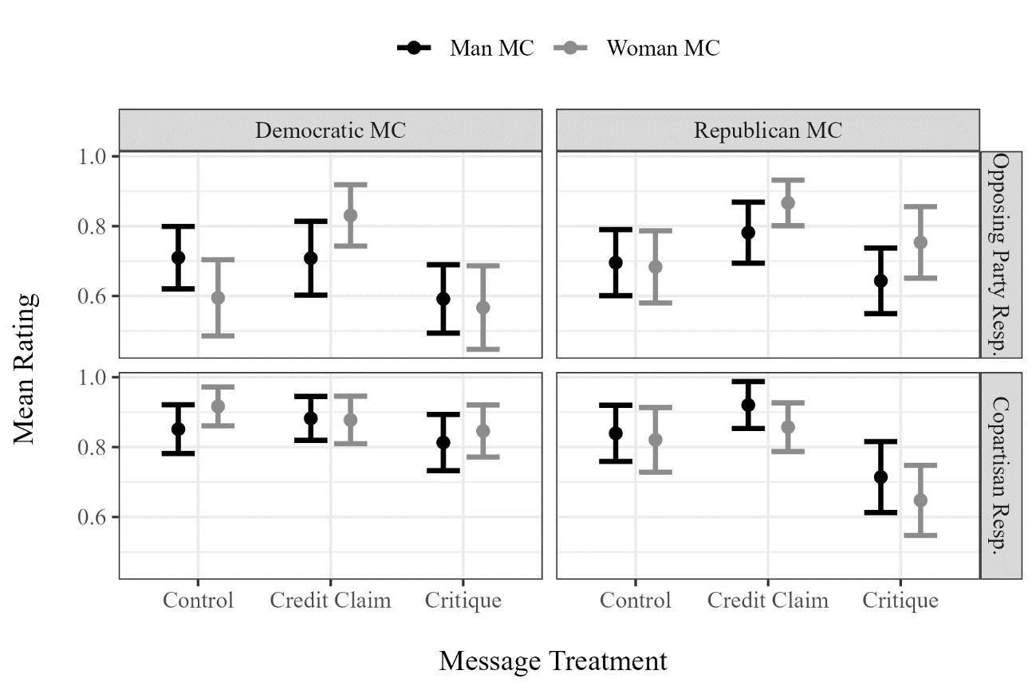

Alternative Regression Modeling Strategies:

I remove the critique message observations from the Effective model and control message observations from the Fiscal Responsibility model for an alternative test of Hypothesis 1 and 2. Results do not meaningfully change from those presented in Table 1.

Table A31: Regression with MC gender and message treatment interaction
 | General Support | Effectiveness | Fiscal Responsibility
Message: Claim | 0.517*** | 0.718***
 | (0.107) | (0.093)
Message: Critique | -0.228** |  | -0.565***
 | (0.104) |  | (0.112)
MC Gender: Woman | 0.199* | 0.089 | 0.154
 | (0.107) | (0.093) | (0.112)
Partisan Match | 0.191*** | 0.131*** | 0.184***
 | (0.038) | (0.039) | (0.048)
Resp. Gender: Woman | -0.007 | 0.040 | -0.031
 | (0.062) | (0.066) | (0.080)
Resp. Party: Ind | -0.498*** | -0.512*** | -0.581***
 | (0.076) | (0.079) | (0.096)
Resp. Party: Rep | -0.358*** | -0.113 | -0.514***
 | (0.075) | (0.079) | (0.097)
Credit Claim X Woman MC | -0.118 | 0.014
 | (0.152) | (0.132)
Critique X Woman MC | -0.174 |  | -0.092
 | (0.153) |  | (0.159)
Constant | 5.062*** | 4.798*** | 5.368***
 | (0.090) | (0.083) | (0.106)
Num.Obs. | 2064 | 1382 | 1369
R2 | 0.083 | 0.114 | 0.085
* p < 0.1, ** p < 0.05, *** p < 0.01
NOTE: Ordinary least squares models. Dependent variable = MC ratings. Standard errors in parentheses.

I control for demographic variables in the regressions below. Results do not meaningfully change from those presented in Table 1.

Table A32: Regression with Demographic Variables
 | General Support | Effectiveness | Fiscal Responsibility
Message: Claim | 0.524*** | 0.720*** | 0.458***
 | (0.107) | (0.098) | (0.105)
Message: Critique | -0.238** | 0.431*** | -0.124
 | (0.104) | (0.095) | (0.101)
MC Gender: Woman | 0.194* | 0.101 | 0.049
 | (0.107) | (0.098) | (0.105)
Partisan Match | 0.194*** | 0.144*** | 0.144***
 | (0.038) | (0.034) | (0.037)
Respondent Gender: Woman | 0.015 | -0.006 | 0.017
 | (0.063) | (0.058) | (0.062)
Respondent Party: Ind | -0.458*** | -0.412*** | -0.508***
 | (0.078) | (0.071) | (0.076)
Respondent Party: Rep | -0.339*** | -0.157** | -0.310***
 | (0.078) | (0.071) | (0.076)
Credit Claim X Woman MC | -0.134 | -0.009 | 0.084
 | (0.153) | (0.139) | (0.149)
Critique X Woman MC | -0.156 | -0.102 | 0.019
 | (0.154) | (0.140) | (0.149)
Education | 0.018 | 0.024 | 0.023
 | (0.023) | (0.021) | (0.022)
Age | 0.001 | 0.002 | -0.007***
 | (0.002) | (0.002) | (0.002)
Respondent Race: Asian | -0.014 | 0.101 | 0.206
 | (0.158) | (0.144) | (0.153)
Respondent Race: Black | 0.205* | 0.252*** | 0.444***
 | (0.106) | (0.097) | (0.103)
Respondent Race: Latino | -0.118 | 0.023 | 0.255**
 | (0.132) | (0.120) | (0.128)
Respondent Race: Mixed | 0.045 | -0.033 | 0.146
 | (0.132) | (0.120) | (0.128)
Respondent Race: Other | -0.321 | -0.260 | -0.155
 | (0.217) | (0.198) | (0.211)
Income | 0.022* | 0.033*** | 0.014
 | (0.011) | (0.010) | (0.011)
Constant | 4.789*** | 4.464*** | 4.879***
 | (0.156) | (0.143) | (0.152)
Num.Obs. | 2053 | 2053 | 2053
R2 | 0.091 | 0.089 | 0.093
* p < 0.1, ** p < 0.05, *** p < 0.01
NOTE: Ordinary least squares models. Dependent variable = MC ratings. Standard errors in parentheses.

Power Analysis

As referenced in endnote ix, I conduct a power analysis with the “pwrss” package (Bulus and Polat 2023) to assess the ability of the experimental design to distinguish gender differences. Assuming a small effect (0.30 gender difference) for the general support measure, the difference of means tests are well powered (0.89) to distinguish this effect.
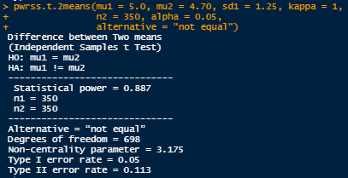

Examples of Attacks on Grants as Irresponsible Spending

Comprehensive Attacks on Congressional Grants

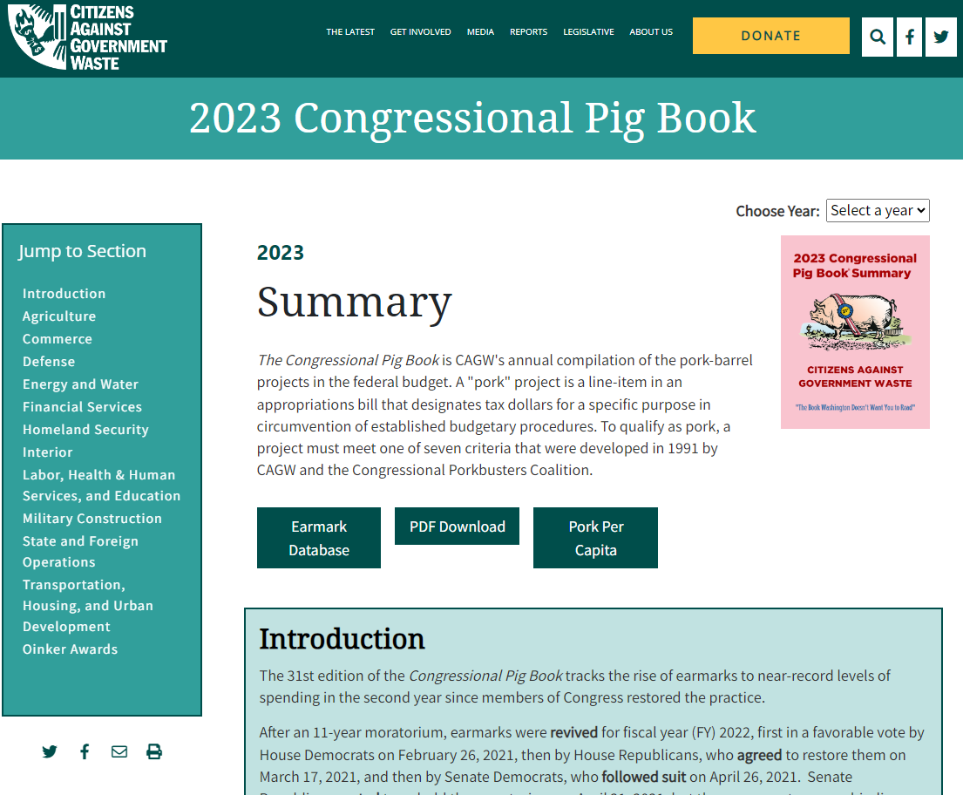
- https://www.cagw.org/reporting/pig-book

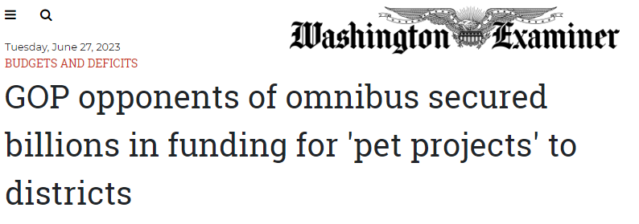
- https://www.washingtonexaminer.com/news/house/gop-omnibus-opponents-secured-billions-pet-projects-districts-funding

Attacks on Specific Members of Congress for Irresponsible Grants

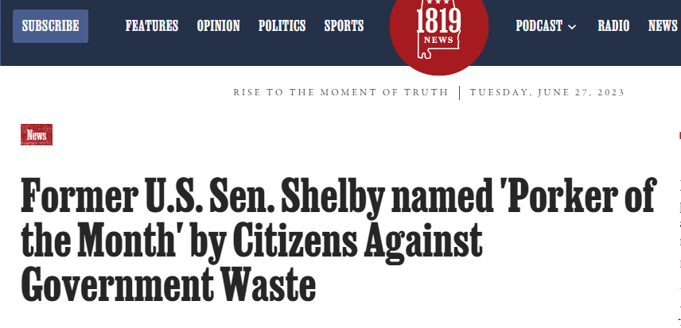
- https://1819news.com/news/item/former-u-s-sen-shelby-named-porker-of-the-month-by-citizens-against-government-waste

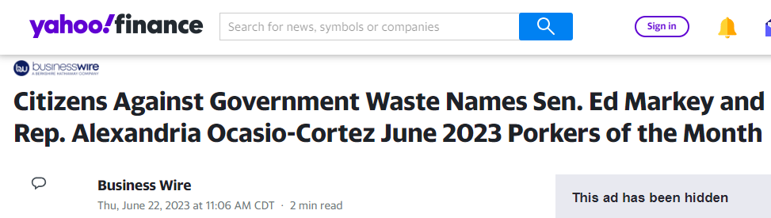
- https://finance.yahoo.com/news/citizens-against-government-waste-names-160600689.html

Attacks on Specific Grants

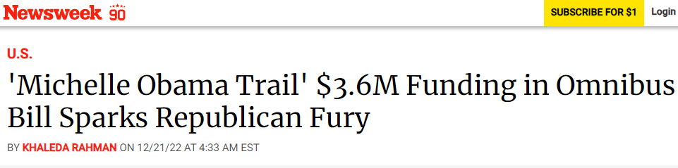
- https://www.newsweek.com/michelle-obama-trail-funding-omnibus-bill-republican-fury-1768635

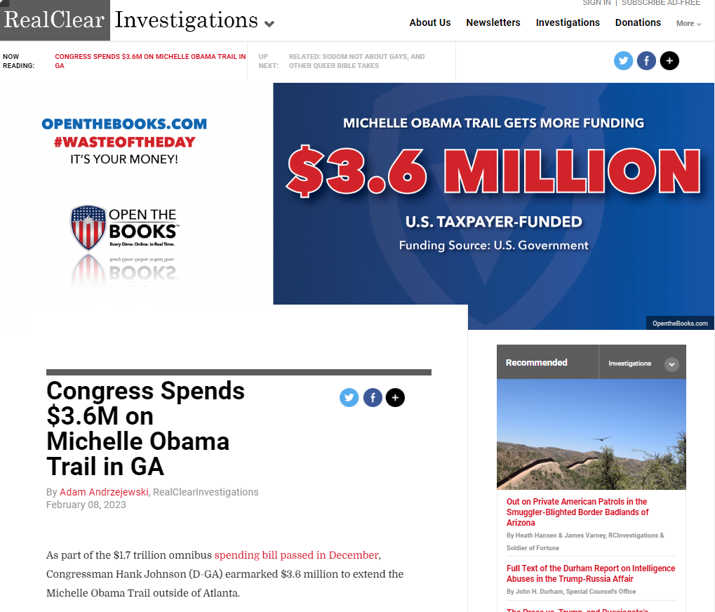
- https://www.realclearinvestigations.com/articles/2023/02/08/congress_spends_36m_on_michelle_obama_trail_in_ga_879685.html

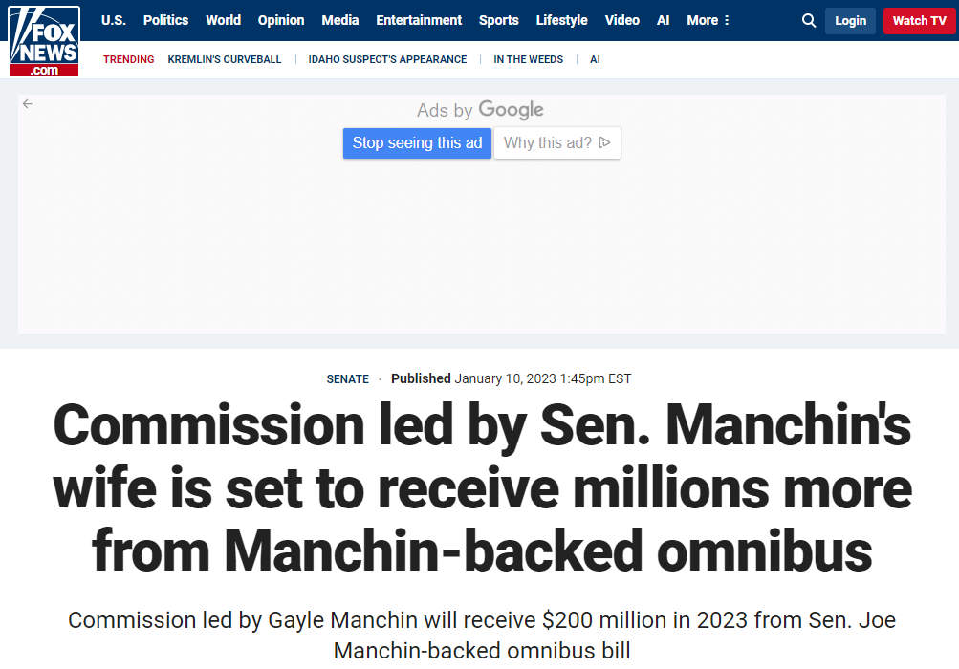
- https://www.foxnews.com/politics/commission-led-sen-manchins-wife-set-receive-millions-more-manchin-backed-omnibus

- https://www.realclearpolicy.com/articles/2023/02/01/maine_irish_heritage_center_gets_3m_for_renovations_878321.html

References

Tingley, D., Yamamoto, T., Hirose, K., Keele, L. and Imai, K., 2014. “Mediation: R package for causal mediation analysis.”
Bulus, M. and Polat, C., 2023. “Statistical Power Analysis with pwrss R Package.”

