Online Appendix:

**Vignettes and Questionnaire:**

**Control 1: No condition:**

Respondents answer questions without reading a vignette.

**Control 2: Vignette without information on women’s police station:**

Angelita suffered domestic violence for many years because she was afraid for her children and of retaliation if she tried to escape. But when her husband hit her so hard it left visible bruises on her face and threatened to kill her, she decided to run away with her children. She traveled to the nearby town to stay with a distant relative who agreed to help her**.** She is currently hiding at her relative’s house.

**Treatment 1: Distributive fairness & no information about procedural fairness:**

Angelita suffered domestic violence for many years because she was afraid for her children and of retaliation if she tried to escape. But when her husband hit her so hard it left visible bruises on her face and threatened to kill her, she decided to run away with her children. She traveled to the nearby town to stay with a distant relative who agreed to help her. [**Angelita went to the local women’s police station to obtain legal advice for how to proceed in cases of domestic violence. The sheriff at the women’s police station provided Angelita with useful advice and information.**  She is currently hiding at her relative’s house**.**]

**Treatment 2: Lack of distributive fairness & no information about procedural fairness:**

Angelita suffered domestic violence for many years because she was afraid for her children and of retaliation if she tried to escape. But when her husband hit her so hard it left visible bruises on her face and threatened to kill her, she decided to run away with her children. She traveled to the nearby town to stay with a distant relative who agreed to help her. [**Angelita went to the local women’s police station to obtain legal advice for how to proceed in cases of domestic violence.**  **The sheriff at the women’s police station did not provide Angelita with useful advice and information.** She is currently hiding at her relative’s house.]

**Treatment 3: Lack of distributive fairness & procedural fairness**

Angelita suffered domestic violence for many years because she was afraid for her children and of retaliation if she tried to escape. But when her husband hit her so hard it left visible bruises on her face and threatened to kill her, she decided to run away with her children. She traveled to the nearby town to stay with a distant relative who agreed to help her. [**Angelita went to the local women’s police station to obtain legal advice for how to proceed in cases of domestic violence.**  **The sheriff at the women’s police station did not provide Angelita with useful advice and information. But he believed her right away, listening to her story with concern and care.** She is currently hiding at her relative’s house.]

**Treatment 4: Distributive Fairness & procedural fairness:**

Angelita suffered domestic violence for many years because she was afraid for her children and of retaliation if she tried to escape. But when her husband hit her so hard it left visible bruises on her face and threatened to kill her, she decided to run away with her children. She traveled to the nearby town to stay with a distant relative who agreed to help her. [**Angelita went to the local women’s police station to obtain legal advice for how to proceed in cases of domestic violence. The sheriff at the women’s police station provided Angelita with useful advice and information. He also believed her right away, listening to her story with concern and care.** She is currently hiding at her relative’s house.]

**Treatment 5: Distributive fairness & no procedural unfairness**

Angelita suffered domestic violence for many years because she was afraid for her children and of retaliation if she tried to escape. But when her husband hit her so hard it left visible bruises on her face and threatened to kill her, she decided to run away with her children. She traveled to the nearby town to stay with a distant relative who agreed to help her. [**Angelita went to the local women’s police station to obtain legal advice for how to proceed in cases of domestic violence. The sheriff at the women’s police station provided Angelita with useful advice and information. But he did not believe her right way, asking her repeatedly to tell her story, and what she did to provoke her husband.** She is currently hiding at her relative’s house.]

**Questions**:

To what extent do you agree with the following statements (1 = totally disagree; 7 = totally agree):

[**These were randomized**]:

Women who suffer domestic violence can count on support from the government.

Brazilian laws do a very good job of protecting women from domestic violence.

Women who experience domestic violence can expect to receive justice in Brazil.

Women are victimized again when pressing charges against domestic violence.

I trust the police to do what is right.

The police in Brazil treat people fairly and with dignity and respect.

How police treat women who experience domestic violence depends on where they live in Brazil.

If you witnessed a case of domestic violence, how likely would you do each of the following? (very unlikely 1, somewhat unlikely 2, somewhat likely 3, very likely 4)

1. Call a women’s police station.
2. Call the regular police station.
3. Contact the Church.
4. Contact friends and family.
5. Contact a Crisis Center for Women in Situations of Violence.
6. Contact a Non-Governmental Organization.
7. Nothing. Because domestic violence is a private matter.
8. Other

**Control questions:[1]**

What is your gender? (1= female; 0=male)

Have you personally been a victim of domestic violence committed by a partner or ex-partner or experienced sexual violence? (0 = no; 1 = yes)

Have you personally experienced sexual harassment committed by a known or unknown person? (0=no; 1=yes)

To what extent do you agree with the following statements (1 = totally disagree; 7 = totally agree):

In a husband-and-wife fight, you don't dip your spoon. [famous Brazilian saying; used to gauge tolerance towards IPV]

What happens to other women in this country affects what happens in my life.

**Table A1: Descriptive Statistics: NetQuest Compared to Latin American Public Opinion Project (LAPOP) 2021**

|  |  |  |  |  |  |  |  |
| --- | --- | --- | --- | --- | --- | --- | --- |
| **Netquest:** | Obs. | Percent | **LAPOP 2021:** | Obs. | Percent | **IBGE: Population based on 2022 Census:[2]** | Percent |
| Gender | 1,510 | Female= 50.93  Male=49.07 | Gender | 3,016 | Female= 45.92  Male=53.65  Other=0.43 |  |  |
| Age | 1,510 | 16-24=20.66  25-34=21.26  35-44=19.40  45-54=15.63  +55=23.05 | Age | 3,016 | 16-24=14.39  25-34=24.64  35-44=24.87  45-54=18.90  +55=17.2 |  |  |
| Area of Residency | 1,510 | North 1= 8.54  Northeast 2=27.55  Center east 3= 7.75  South east 4= 41.85  South 5=14.30 | Area of Residency | 3,014 | 1=17.02  2=14.60  3=9.79  4=43.33  5=15.26 | Area of Residency | 1= 8.58  2=26.66  3= 7.93  4 = 42.04  5= 14.77 |
| Social Class[3] | 1,500 | 1-Lowest SES= 14.77  2= 17.68  3=35.96  4=15.96  5=10.00  6- Highest SES=5.63 |  |  |  | Social Class | 1-Lowest SES=50.7  2= 33.3  3=13.2  4-Highest SES= 2.8 |

**Figure A1: Knowledge of Domestic Violence Legislation Adopted in 2006:**

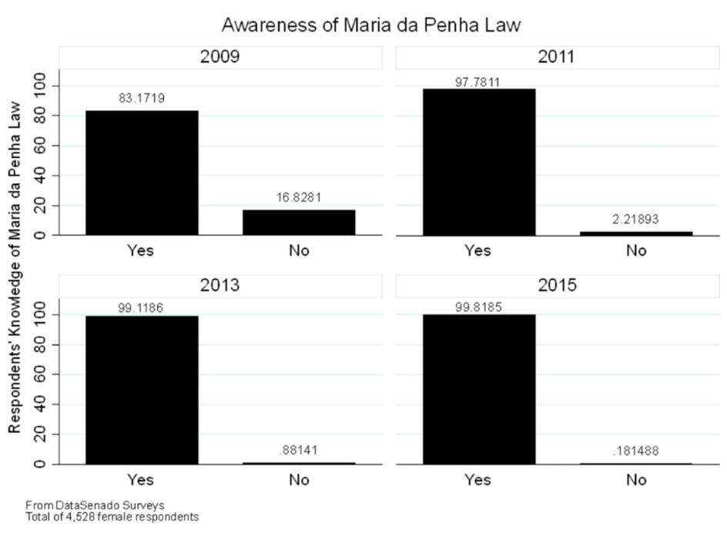

**Figure A2: Knowledge of Women’s Police Stations.**

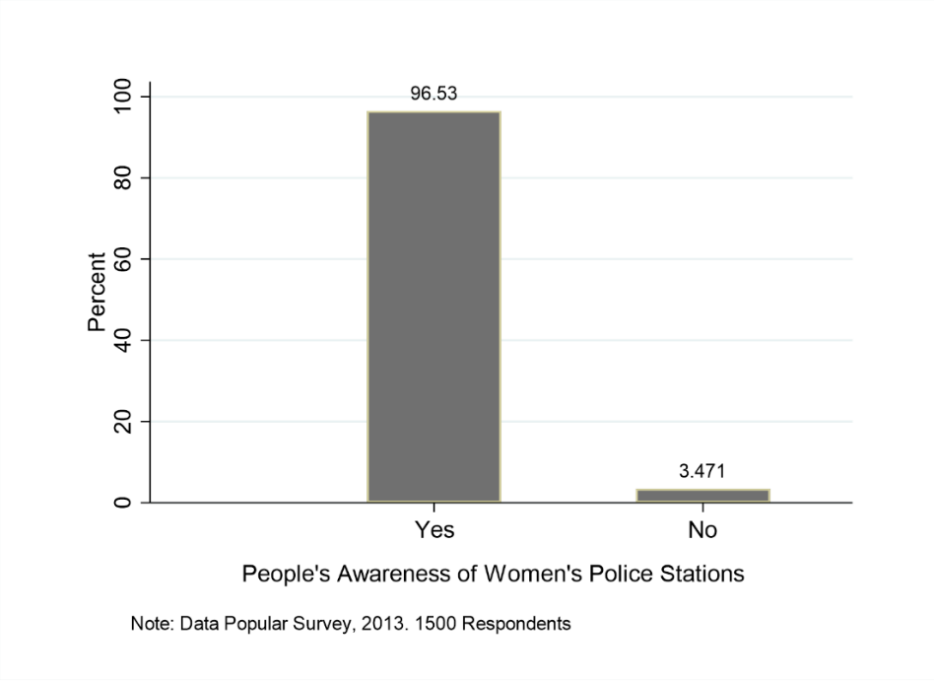

**Figure A3:** **Distribution of Responses Across Treatment Groups:**



**Figure A4: Distribution of Responses Across Treatment Groups:**



**Table A2: Fieldwork in Brazil:**

|  |
| --- |
| For the design of the vignettes, I relied on the findings from the extensive fieldwork I  carried out in the south of Brazil in the summer of 2019. During fieldwork, I conducted 5 in-depth, semi-structured interviews with survivors of IPV and 35 interviews with VAW public service providers, for a total of 40 interviews. Among the service providers, I interviewed lawyers, officers of the military and civil police, sheriffs of different women’s police stations, therapists, social workers, project coordinators, and community activists. The qualitative interview questions and procedures were reviewed and approved by the Institutional Review Board (IRB) of the University of Kentucky.  The interviews were conducted across 12 municipalities in the Southern Brazilian states  of São Paulo, Santa Catarina, and Rio Grande do Sul. Participants were recruited using an email and phone script. I contacted all public organizations that offer services to women in situations of violence in those municipalities and requested an interview with a service provider. Survivors were recruited through two nongovernmental organizations for victims. I visited all institutions in which interviews were conducted. But to protect the privacy and safety of survivors, I interviewed victims using video calls from the platform WhatsApp.  The themes of all interviews were victims’ access to public services and their quality, the  challenges service providers face in combating VAW, the condition of facilities, and the fluctuations in funding and personnel following changes of political parties in power in the state and local legislatures. Mental health and trauma were topics that emerged in every single interview. Last, I asked all participants about survivors’ experience with seeking help in general, their knowledge of the Maria da Penha Law, and their perceptions of state support for victims and trust in government. Interviews lasted between one-three hours. |

**Table A3: Complete Table from Main Analysis:**

|  |  |  |  |  |  |  |
| --- | --- | --- | --- | --- | --- | --- |
| Government Support for Victims Laws Protect Women Bystander Intervention | | | | | | |
|  | Model 1 | Model 2 | Model 3 | Model 4 | Model 5 | Model 6 |
|  | Baseline | Interaction | Baseline | Interaction | WPS | Friends/Family |
|  |  |  |  |  |  |  |
| No Vignette | -0.0118 |  | 0.0701 |  | -0.119 | 0.257 |
|  | (0.171) |  | (0.168) |  | (0.204) | (0.175) |
| Pos Distributive Fairness | 0.0693 |  | 0.400* |  | -0.0630 | 0.113 |
|  | (0.171) |  | (0.170) |  | (0.203) | (0.174) |
| Neg Distributive Fairness | -0.265 |  | -0.161 |  | -0.186 | -0.0134 |
|  | (0.171) |  | (0.170) |  | (0.202) | (0.173) |
| Neg Distributive/ Pos Procedural | -0.247 |  | -0.123 |  | -0.147 | 0.285 |
|  | (0.173) |  | (0.171) |  | (0.203) | (0.177) |
| Pos Distributive/Pos Procedural | 0.0648 |  | 0.171 |  | -0.170 | 0.173 |
|  | (0.171) |  | (0.168) |  | (0.201) | (0.175) |
| Pos Distributive/ Neg Procedural | -0.415* |  | -0.422* |  | -0.184 | 0.509** |
|  | (0.171) |  | (0.171) |  | (0.203) | (0.177) |
|  |  |  |  |  |  |  |
| IPV Victim (=1) | -0.283* | -0.331* | -0.442*** | -0.521*** | -0.151 | -0.0837 |
|  | (0.131) | (0.152) | (0.129) | (0.149) | (0.151) | (0.135) |
| Pos Distributive Fairness X IPV |  | 0.189 |  | 0.251 |  |  |
| Victim |  | (0.373) |  | (0.377) |  |  |
| Pos Distributive/ Neg Procedural X |  | 0.161 |  | 0.352 |  |  |
| IPV Victim |  | (0.379) |  | (0.373) |  |  |
| No Vignette |  | -0.0126 |  | 0.0685 |  |  |
|  |  | (0.171) |  | (0.168) |  |  |
| Neg Distributive Fairness |  | -0.266 |  | -0.163 |  |  |
|  |  | (0.171) |  | (0.170) |  |  |
| Neg Distributive/Pos Procedural |  | -0.243 |  | -0.118 |  |  |
|  |  | (0.173) |  | (0.171) |  |  |
| Pos Distributive/Pos Procedural |  | 0.0660 |  | 0.172 |  |  |
|  |  | (0.171) |  | (0.168) |  |  |
| Pos Distributive Fairness |  | 0.0417 |  | 0.363* |  |  |
|  |  | (0.180) |  | (0.179) |  |  |
| Pos Distributive/ Neg Procedural |  | -0.438* |  | -0.475** |  |  |
|  |  | (0.180) |  | (0.180) |  |  |
| Female (=1) | -0.282** | -0.281** | -0.295** | -0.294** | -0.0381 | 0.101 |
|  | (0.101) | (0.101) | (0.100) | (0.100) | (0.119) | (0.105) |
| Age | 0.00332 | 0.00330 | 0.00404 | 0.00405 | 0.0111** | 0.00152 |
|  | (0.00318) | (0.00318) | (0.00317) | (0.00317) | (0.00375) | (0.00326) |
| Tolerance Towards IPV | 0.174*** | 0.174*** | 0.175*** | 0.176*** | -0.203*** | -0.0440+ |
|  | (0.0269) | (0.0270) | (0.0268) | (0.0268) | (0.0288) | (0.0265) |
| Linked Fate | -0.0516* | -0.0516* | 0.0348 | 0.0352 | 0.115*** | 0.0920*** |
| Region of Residency: | (0.0244) | (0.0244) | (0.0243) | (0.0244) | (0.0277) | (0.0247) |
| Northeast | -0.315+ | -0.310+ | -0.421* | -0.416* | -0.0239 | -0.0552 |
|  | (0.182) | (0.183) | (0.183) | (0.184) | (0.213) | (0.187) |
| Southeast | -0.669*** | -0.664*** | -0.573** | -0.564** | -0.157 | -0.137 |
|  | (0.176) | (0.176) | (0.177) | (0.178) | (0.205) | (0.182) |
| South | -0.125 | -0.121 | -0.0969 | -0.0929 | 0.219 | -0.133 |
|  | (0.197) | (0.198) | (0.198) | (0.199) | (0.238) | (0.208) |
| Center-West | -0.206 | -0.202 | -0.166 | -0.169 | 0.606* | -0.109 |
|  | (0.228) | (0.229) | (0.234) | (0.235) | (0.290) | (0.236) |
| /cut1 | -1.579*** | -1.581*** | -1.313*** | -1.316*** | -2.626*** | -1.441*** |
|  | (0.282) | (0.282) | (0.285) | (0.286) | (0.343) | (0.295) |
| /cut2 | -0.812** | -0.814** | -0.621* | -0.623* | -1.832*** | -0.491+ |
|  | (0.279) | (0.279) | (0.283) | (0.283) | (0.335) | (0.291) |
| /cut3 | -0.146 | -0.147 | 0.0508 | 0.0495 | -0.269 | 1.064*** |
|  | (0.279) | (0.279) | (0.282) | (0.283) | (0.330) | (0.292) |
| /cut4 | 0.634* | 0.632* | 0.821** | 0.820** |  |  |
|  | (0.280) | (0.281) | (0.284) | (0.284) |  |  |
| /cut5 | 1.401*** | 1.399*** | 1.631*** | 1.630*** |  |  |
|  | (0.284) | (0.284) | (0.287) | (0.288) |  |  |
| /cut6 | 2.044*** | 2.042*** | 2.425*** | 2.424*** |  |  |
|  | (0.289) | (0.289) | (0.293) | (0.294) |  |  |
|  |  |  |  |  |  |  |
| Observations | 1,510 | 1,510 | 1,510 | 1,510 | 1,510 | 1,510 |

Notes: Standard errors in parentheses, *** p<0.001, ** p<0.01, * p<0.05, + p<0.10

**Figure A5: Predicted Probabilities for “Government Supports”:**



**Figure A6: Predicted Probabilities for “Laws Protect”:**



**Table A4**: **Results from Main Paper using OLS:**

|  |  |  |  |  |  |  |
| --- | --- | --- | --- | --- | --- | --- |
| Government Support for Victims Laws Protect Women Bystander Intervention | | | | | | |
|  | Model 1 Baseline | Model 2 Interaction | Model 3 Baseline | Model 4 Interaction | Model 5  WPS | Model 6 Friends/Family |
|  |  |  |  |  |  |  |
| No Vignette | -0.0752 | -0.0753 | 0.0624 | 0.0600 | -0.0484 | 0.141 |
|  | (0.179) | (0.180) | (0.181) | (0.181) | (0.0798) | (0.0973) |
| Pos Distributive Fairness  Neg Distributive Fairness | 0.0596  (0.179)  -0.260 | 0.0516  (0.188)  -0.261 | 0.440*  (0.181)  -0.114 | 0.412*  (0.190)  -0.115 | -0.00969  (0.0797)  -0.0436 | 0.0565  (0.0971)  -0.00728 |
|  | (0.179) | (0.179) | (0.181) | (0.181) | (0.0797) | (0.0972) |
| Neg Distributive/Pos Procedural | -0.232 | -0.231 | -0.104 | -0.1000 | -0.0539 | 0.118 |
|  | (0.179) | (0.179) | (0.181) | (0.181) | (0.0797) | (0.0972) |
| Post Distributive/ Pos Procedural | 0.0707 | 0.0709 | 0.189 | 0.190 | -0.0323 | 0.0747 |
|  | (0.179) | (0.179) | (0.181) | (0.181) | (0.0797) | (0.0972) |
| Pos Distributive/Neg Procedural | -0.465** | -0.464* | -0.415* | -0.460* | -0.0967 | 0.256** |
|  | (0.179) | (0.188) | (0.181) | (0.190) | (0.0797) | (0.0972) |
| Pos Distributive/Neg Procedural |  | -0.00963 |  | 0.311 |  |  |
| *x* IPV Victim  Post Distributive Fairness *x* IPV Victim |  | (0.396)  0.0571  (0.396) |  | (0.400)  0.190  (0.400) |  |  |
| IPV Victim (=1)  Female (=1) | -0.243+  (0.134)  -0.287** | -0.249  (0.155)  -0.287** | -0.433**  (0.136)  -0.324** | -0.497**  (0.156)  -0.323** | -0.100+  (0.0598)  -0.00649 | -0.0792  (0.0729)  0.0572 |
|  | (0.106) | (0.106) | (0.107) | (0.107) | (0.0472) | (0.0576) |
| Age | 0.00375 | 0.00374 | 0.00516 | 0.00511 | 0.00357* | 0.000819 |
|  | (0.00331) | (0.00331) | (0.00334) | (0.00334) | (0.00147) | (0.00180) |
| Tolerance Towards IPV | 0.173*** | 0.173*** | 0.166*** | 0.167*** | -0.0712*** | -0.0254+ |
|  | (0.0266) | (0.0267) | (0.0269) | (0.0269) | (0.0119) | (0.0145) |
| Linked Fate | -0.0521* | -0.0520* | 0.0294 | 0.0291 | 0.0413*** | 0.0449*** |
|  | (0.0246) | (0.0246) | (0.0248) | (0.0248) | (0.0109) | (0.0133) |
| Northeast | -0.302 | -0.300 | -0.451* | -0.450* | -0.000703 | -0.0225 |
|  | (0.188) | (0.189) | (0.190) | (0.191) | (0.0839) | (0.102) |
| Southeast | -0.719*** | -0.717*** | -0.612*** | -0.608** | -0.0374 | -0.0669 |
|  | (0.183) | (0.183) | (0.184) | (0.185) | (0.0813) | (0.0992) |
| South | -0.139 | -0.137 | -0.119 | -0.118 | 0.0923 | -0.103 |
|  | (0.207) | (0.208) | (0.209) | (0.210) | (0.0923) | (0.113) |
| Center west | -0.179 | -0.176 | -0.196 | -0.200 | 0.214* | -0.0551 |
|  | (0.238) | (0.239) | (0.240) | (0.241) | (0.106) | (0.129) |
| Constant | 3.721*** | 3.720*** | 3.514*** | 3.524*** | 3.345*** | 2.730*** |
|  | (0.291) | (0.292) | (0.294) | (0.294) | (0.130) | (0.158) |
|  |  |  |  |  |  |  |
| Observations | 1,510 | 1,510 | 1,510 | 1,510 | 1,510 | 1,510 |
| R-squared | 0.095 | 0.095 | 0.086 | 0.086 | 0.054 | 0.021 |

Notes: Control 2, with no information about Women’s Police Stations (WPS), Distributive or Procedural Fairness, is the reference category in all models. Standard errors in parentheses, *** p<0.001, ** p<0.01, * p<0.05, + p<0.10

**Table A5: Bystander Intervention:**

|  |  |  |  |  |  |  |  |
| --- | --- | --- | --- | --- | --- | --- | --- |
| Bystander Intervention | | | | | | | |
|  | WPS | Regular Police | Church | Friends/Family | Crisis Centers | NGOs | Do Nothing (Private Matter) |
|  |  |  |  |  |  |  |  |
| No Vignette | -0.119 | 0.0752 | 0.202 | 0.257 | 0.107 | -0.156 | 0.101 |
|  | (0.204) | (0.185) | (0.191) | (0.175) | (0.179) | (0.175) | (0.241) |
| Pos Distributive | -0.0630 | 0.178 | 0.133 | 0.113 | -0.0191 | -0.206 | 0.195 |
|  | (0.203) | (0.180) | (0.192) | (0.174) | (0.177) | (0.172) | (0.239) |
| Neg Distributive | -0.186 | 0.0425 | 0.131 | -0.0134 | -0.0106 | -0.281 | 0.313 |
|  | (0.202) | (0.181) | (0.192) | (0.173) | (0.179) | (0.175) | (0.237) |
| Neg Distributive/Pos Procedural | -0.147 | 0.204 | 0.0571 | 0.285 | -0.273 | -0.484** | 0.0628 |
|  | (0.203) | (0.183) | (0.194) | (0.177) | (0.179) | (0.177) | (0.241) |
| Pos Distributive/Pos Procedural | -0.170 | 0.185 | 0.137 | 0.173 | 0.00281 | -0.0379 | 0.406+ |
|  | (0.201) | (0.185) | (0.192) | (0.175) | (0.178) | (0.176) | (0.234) |
| Post Distributive/ Neg Procedural | -0.184 | 0.138 | 0.243 | 0.509** | 0.0403 | -0.191 | 0.515* |
|  | (0.203) | (0.183) | (0.191) | (0.177) | (0.180) | (0.175) | (0.229) |
| Female (=1) | -0.0381 | -0.299** | 0.0714 | 0.101 | 0.264* | 0.00715 | 0.232+ |
|  | (0.119) | (0.109) | (0.113) | (0.105) | (0.107) | (0.103) | (0.137) |
| IPV Victims (=1) | -0.151 | -0.153 | -0.0599 | -0.0837 | -0.216 | -0.0949 | 0.260 |
|  | (0.151) | (0.137) | (0.144) | (0.135) | (0.136) | (0.131) | (0.171) |
| Age | 0.0111** | -0.00272 | 0.00726* | 0.00152 | 0.0155*** | 0.0130*** | 0.00360 |
|  | (0.00375) | (0.00338) | (0.00345) | (0.00326) | (0.00340) | (0.00321) | (0.00422) |
| Tolerance Towards IPV | -0.203*** | -0.133*** | 0.115*** | -0.0440+ | -0.110*** | -0.0193 | 0.382*** |
|  | (0.0288) | (0.0272) | (0.0284) | (0.0265) | (0.0272) | (0.0265) | (0.0321) |
| Linked Fate | 0.115*** | 0.0772** | 0.0287 | 0.0920*** | 0.114*** | 0.162*** | -0.124*** |
|  | (0.0277) | (0.0255) | (0.0264) | (0.0247) | (0.0256) | (0.0249) | (0.0313) |
| Northeast | -0.0239 | -0.162 | -0.310 | -0.0552 | 0.0959 | 0.129 | 0.162 |
|  | (0.213) | (0.194) | (0.194) | (0.187) | (0.198) | (0.184) | (0.234) |
| Southeast | -0.157 | -0.203 | -0.574** | -0.137 | -0.190 | -0.0737 | -0.224 |
|  | (0.205) | (0.188) | (0.190) | (0.182) | (0.192) | (0.179) | (0.231) |
| South | 0.219 | 0.0650 | -0.487* | -0.133 | -0.0348 | -0.110 | -0.294 |
|  | (0.238) | (0.214) | (0.216) | (0.208) | (0.216) | (0.203) | (0.263) |
| Center west | 0.606* | 0.264 | 0.0404 | -0.109 | 0.235 | 0.190 | -0.339 |
|  | (0.290) | (0.249) | (0.243) | (0.236) | (0.251) | (0.235) | (0.306) |
| /cut1 | -2.626*** | -2.739*** | 0.801** | -1.441*** | -1.295*** | 0.241 | 1.983*** |
|  | (0.343) | (0.310) | (0.308) | (0.295) | (0.307) | (0.282) | (0.374) |
| /cut2 | -1.832*** | -1.711*** | 1.740*** | -0.491+ | -0.285 | 1.386*** | 2.819*** |
|  | (0.335) | (0.302) | (0.310) | (0.291) | (0.303) | (0.285) | (0.379) |
| /cut3 | -0.269 | -0.245 | 3.033*** | 1.064*** | 1.152*** | 2.781*** | 4.069*** |
|  | (0.330) | (0.299) | (0.320) | (0.292) | (0.304) | (0.292) | (0.393) |
|  |  |  |  |  |  |  |  |
| Observations | 1,510 | 1,510 | 1,510 | 1,510 | 1,510 | 1,510 | 1,510 |

Notes: Ordered Logit. Standard errors in parentheses, *** p<0.001, ** p<0.01, * p<0.05, + p<0.10

**Figure A7: Predicted Probabilities based on Model 1, Table A7:**



**Table A6: Structural Equation Models**:

|  |  |  |
| --- | --- | --- |
|  | Model 1 | Model 2 |
|  | State Action on GBV | Bystander Intervention: Calling Friends and Family |
|  |  |  |
| Police treat People | 0.941*** | 0.0434** |
| Respectfully | (0.0501) | (0.0154) |
| Secondary | 0.0130 | 0.0244+ |
| Victimization | (0.0406) | (0.0138) |
| Pos Distributive/ | -0.542* | 0.202** |
| Neg Procedural | (0.215) | (0.0726) |
| Tolerance towards | 0.206*** | -0.0306* |
| IPV | (0.0453) | (0.0151) |
| Linked Fate |  | 0.0420** |
|  |  | (0.0136) |
| Victim of IPV | -0.398+ |  |
|  | (0.211) |  |
| Female | -0.680*** |  |
|  | (0.156) |  |
| Age |  |  |
| Constant | 4.019***  (0.303) | 2.548***  (0.116) |
| DV: Police treat People Respectfully | | |
| Pos Distributive/ Neg Procedural | |  | | --- | | -0.375**  (0.124) | |  | | -0.375**  (0.124) |
| Tolerance towards  IPV  Victim of IPV  Age  Constant | 0.159***  (0.0254)  -0.382***  (0.115)  0.00893**  (0.00279)  2.394***  (0.130) | 0.159***  (0.0256)  -0.382***  (0.115)  0.00893**  (0.00277)  2.394***  (0.131) |
| DV: Secondary Victimization | | |
| Pos Distributive/ Neg Procedural | 0.463**  (0.141) | 0.463***  (0.140) |
| Linked Fate | 0.100*** | 0.100*** |
| Constant | (0.0264)  4.305*** | (0.0265)  4.305*** |
|  | (0.135) | (0.133) |
| Observations  Chi2 | 1,510  p= 0.333 | 1,510  P=0.684 |

Note: Models generated using SEM command on Stata17. Dependent variable in

model 1 is an additive index of the two measures of state action on GBV

used in the main models in the manuscript. Bootstrap standard errors in parentheses,

based on 10,000 bootstraps samples (e.g., Hayes 2018).

*** p<0.001, ** p<0.01, * p<0.05, + p<0.10

**Figure A8: Visual Representation of Structural Equation Model 1, Table A8:**



Note: Generated through SEM Builder in Stata (e.g., Acock 2013).

Neg Proc: Pos Distributive/ Neg Procedural treatment

Gov GBV: Additive Index of both variables on state action addressing GBV

Police: Procedural Fairness (Police treat People with Dignity and Respect)

Sec Vic: Women Experience Secondary Victimization when Seeking help

Linked: Linked Fate with Women

**Table A7: Mediating Measures as Dependent Variables.**

|  |  |  |  |
| --- | --- | --- | --- |
| Police Treat People Secondary Victimization  with Dignity and Respect | | | |
|  | Model 1 | Model 2 | Model 3 |
|  |  |  |  |
| No Vignette | 0.0929 | -0.354* |  |
| (Control 1) | (0.173) | (0.170) |  |
| No Info about services |  |  | 0.354* |
| (Control 2) |  |  | (0.170) |
| Pos Distributive Fairness | 0.315+ | -0.0332 | 0.321+ |
|  | (0.169) | (0.167) | (0.170) |
| Neg Distributive Fairness | -0.124 | -0.0511 | 0.303+ |
|  | (0.171) | (0.171) | (0.174) |
| Neg Distributive/ Pos | 0.0128 | -0.142 | 0.212 |
| Procedural | (0.171) | (0.169) | (0.172) |
| Pos Distributive/ Pos Procedural | 0.144 | -0.301+ | 0.0525 |
|  | (0.169) | (0.169) | (0.171) |
| Pos Distributive/ | -0.349* | 0.307+ | 0.661*** |
| Neg Procedural | (0.173) | (0.171) | (0.174) |
| Female (=1) | -0.0777 | 0.144 | 0.144 |
|  | (0.101) | (0.101) | (0.101) |
| IPV Victim (=1) | -0.406** | 0.0818 | 0.0818 |
|  | (0.131) | (0.129) | (0.129) |
| Age | 0.00634* | 0.00441 | 0.00441 |
|  | (0.00318) | (0.00313) | (0.00313) |
| Tolerance Towards IPV | 0.168*** | 0.0136 | 0.0136 |
|  | (0.0266) | (0.0259) | (0.0259) |
| Linked Fate | -0.00380 | 0.103*** | 0.103*** |
|  | (0.0244) | (0.0245) | (0.0245) |
| Northeast | 0.00782 | 0.0654 | 0.0654 |
|  | (0.178) | (0.181) | (0.181) |
| Southeast | -0.0786 | 0.123 | 0.123 |
|  | (0.170) | (0.176) | (0.176) |
| South | 0.471* | -0.0713 | -0.0713 |
|  | (0.194) | (0.196) | (0.196) |
| Center West | 0.211 | 0.136 | 0.136 |
|  | (0.229) | (0.230) | (0.230) |
| /cut1 | -0.404 | -1.465*** | -1.111*** |
|  | (0.278) | (0.284) | (0.288) |
| /cut2 | 0.291 | -0.940*** | -0.586* |
|  | (0.277) | (0.281) | (0.285) |
| /cut3 | 0.989*** | -0.398 | -0.0439 |
|  | (0.278) | (0.278) | (0.283) |
| /cut4 | 2.011*** | 0.361 | 0.714* |
|  | (0.283) | (0.278) | (0.284) |
| /cut5 | 3.134*** | 0.973*** | 1.327*** |
|  | (0.294) | (0.280) | (0.286) |
| /cut6 | 3.973*** | 1.662*** | 2.016*** |
|  | (0.310) | (0.282) | (0.288) |
|  |  |  |  |
| Observations | 1,510 | 1,510 | 1,510 |

Note: Ordered Logit. Control 2 has no information about Women’s Police Stations (WPS), Distributive or Procedural Fairness; only about victim leaving the abusive relationship. Models 2 and 3 demonstrate the effect of each treatment group on perceptions that victims experience secondary victimization when seeking formal help. The treatment on procedural injustice is significant when the baseline is the control 2 (model 3). Standard errors in parentheses, *** p<0.001, ** p<0.01, * p<0.05, + p<0.10

**Figure A9: Predicted Probabilities for completely disagreeing with statement that “the police treat people with dignity and respect” (Based on Model 1 table A7)**



Note: Treatment Groups are the following: 1 and 2 are controls, 3=positive distributive fairness, 4=negative distributive fairness, 5=negative distributive/positive procedural, 6=positive distributive/positive procedural, and 7=positive distributive/ negative procedural. Predicted Probabilities, 87% CIs (for a discussion on CIs and significance see Payton et al., 2003).

**Figure A10: Predicted Probabilities for completely agreeing with statement that “the police treat people with dignity and respect” (Based on Model 1 table A7)**



Note: Treatment Groups are the following: 1 and 2 are controls, 3=positive distributive fairness, 4=negative distributive fairness, 5=negative distributive/positive procedural, 6=positive distributive/positive procedural, and 7=positive distributive/ negative procedural. Predicted Probabilities, 87% CIs.

**Figure A11: Predicted Probabilities for completely agreeing with statement that “women are victimized again when pressing charges against IPV” (Based on Model 3 table A7)**



Note: Treatment Groups are the following: 1 and 2 are controls, 3=positive distributive fairness, 4=negative distributive fairness, 5=negative distributive/positive procedural, 6=positive distributive/positive procedural, and 7=positive distributive/ negative procedural. Predicted Probabilities, 87% CIs.

**Figure A12: Sensitivity Analysis of Structural Equation Model**:



**Table A8: Discussion of Sensitivity Analysis:**

|  |
| --- |
| Mediation analysis relies on sequential ignorability, which consists of two assumptions: 1) the treatment is independent of all potential values of the outcome and mediating variables, and 2) the observed mediator is independent of all potential outcomes given the observed treatment and pretreatment covariates. In the present study, the first ignorability assumption is satisfied because respondents were randomly assigned to the treatment and control groups. However, the ignorability of the mediator is harder to establish even in randomized experiments. In this study, the post-treatment evaluations of the statement “the police treat people with dignity and respect” was not randomly assigned (see discussion by Imai, Tingley, and Keele 2010).  Because of the challenges with establishing the ignorability of the mediator, the sensitivity analysis in figure A12 quantifies the robustness of the empirical findings from the mediation analysis (e.g., add). The sensitivity analysis shows how large p must be for the mediation effect to be zero. In the figure the gray areas represent the 95% confidence interval for the mediation effects at each value of p. The solid line represents the estimated average mediation effect at different values of p. The confidence internal covers the value of zero (mediation effects) only when p is at .46 (see Imai, Keele, and Yamamoto 2010; Hicks and Tingley 2011). |

**References used in the Appendix:**

Acock, Alan C. 2013. *Discovering Structural Equation Modeling Using Stata*. State Press.

Hayes, Andrew F. 2018. *Introduction to Mediation, Moderation, and Conditional Process Analysis (Second Edition).* NY: The Guilford Press.

Hicks, Raymond and Dustin Tingley. 2011. Mediation: Stata package for causal mediation analysis. *The Stata Journal* 11(4): 605–619

Imai, Kosuke, Luke Keele, and Teppei Yamamoto. 2010. Identification, Inference and Sensitivity Analysis for Causal Mediation Effects. *Statistical Science* 25(1): 51-71.

Payton, Mark E., Matthew H. Greenstone, and Nathaniel Schenker. 2003. Overlapping confidence intervals or standard error intervals: what do they mean in terms of statistical significance? *Journal of Insect Science* 3.1.

1. For a discussion of order of covariates in survey experiments, see Klar, Samara, Thomas Leeper and Joshua Robison. 2020. Studying Identities with Experiments: Weighing the Risk of Posttreatment Bias Against Priming Effects. *Journal of Experimental Political Science*, 7, 56–60.
2. Instituto Brasileiro de Geografia e Estatística. 2022. Censo Demográfico. [POP2022_Brasil_e_UFs.pdf (ibge.gov.br)](https://ftp.ibge.gov.br/Censos/Censo_Demografico_2022/Previa_da_Populacao/POP2022_Brasil_e_UFs.pdf)
3. NetQuest calculates socio-economic status based on assets—including number of bathrooms in one’s households, car ownership, computers, dishwasher, and washing machines. While these criteria are inspired by IBGE, they disaggregate SES into more categories and do not use personal income. IBGE criteria are based on income, including personal income and government benefits. IBGE then generates income brackets based on income compared to the minimum wage (e.g., 20 times minimum wage)