**Supplementary Material**

**No yield advantage of biodynamic compost preparations in a long-term field trial**

by Dietrich et al. (2024) Renewable Agriculture and Food Systems

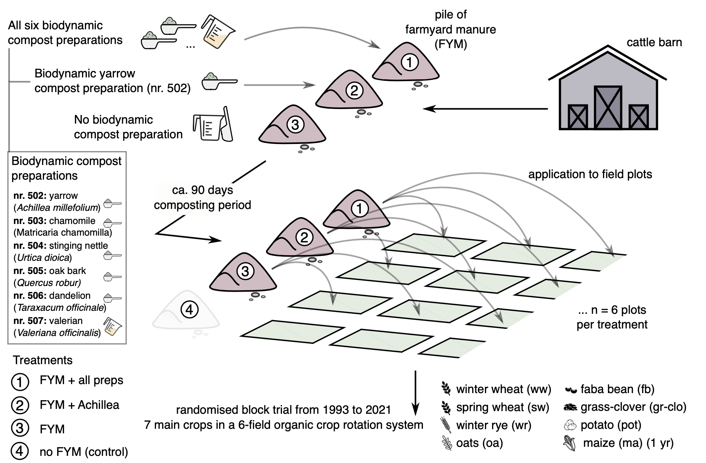

Supplementary Figure 1 Experimental design of the Wiesengut long-term trial on biodynamic compost preparations.

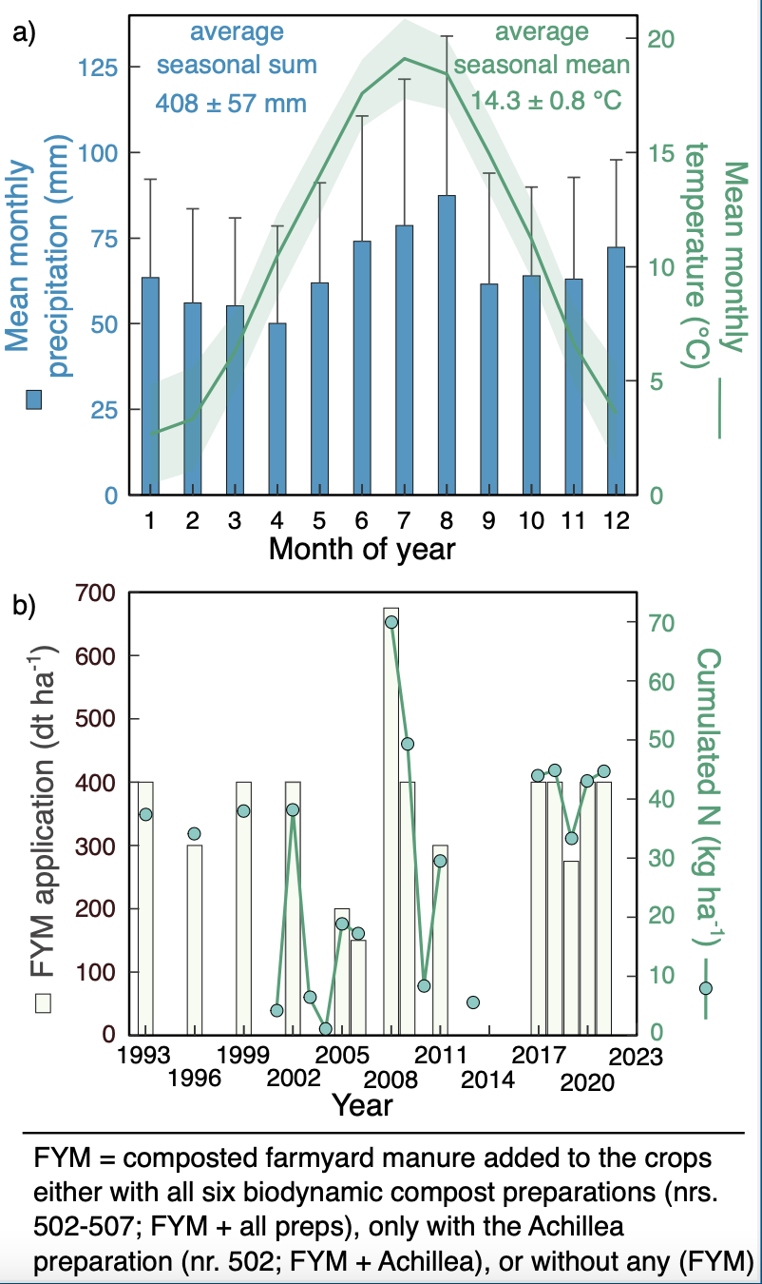

Supplementary Figure 2 (a) Mean monthly precipitation and mean monthly temperature of the years 1993 to 2022 (mean ± SD) for the experimental study site Wiesengut near Bonn, Germany. Seasonal (Mar-Aug) mean temperature and seasonal precipitation sum refer to the months Mar to Aug. (b) Applied amount of composted farmyard manure (FYM) to the treated plots during the experimental period and the amount of cumulated nitrogen (N) in the topsoil (b).



Supplementary Figure 3 Normalized yields of the different cultivated crops and treatments during the year 2019 (mean ± SE; n = 6 plots per treatment and year). Yield amounts were normalized on the mean value of the control in each year. No statistical differences among treatment groups were found.



Supplementary Figure 4 Correlation for the calculated coefficient of variation and adjusted coefficient of variation in the clover/grass and spring wheat crops over the years of the experiment (± 95 % confidence interval).