Supplemental Information:
Supplemental Information 1. English-language survey distributed to cranberry growers.
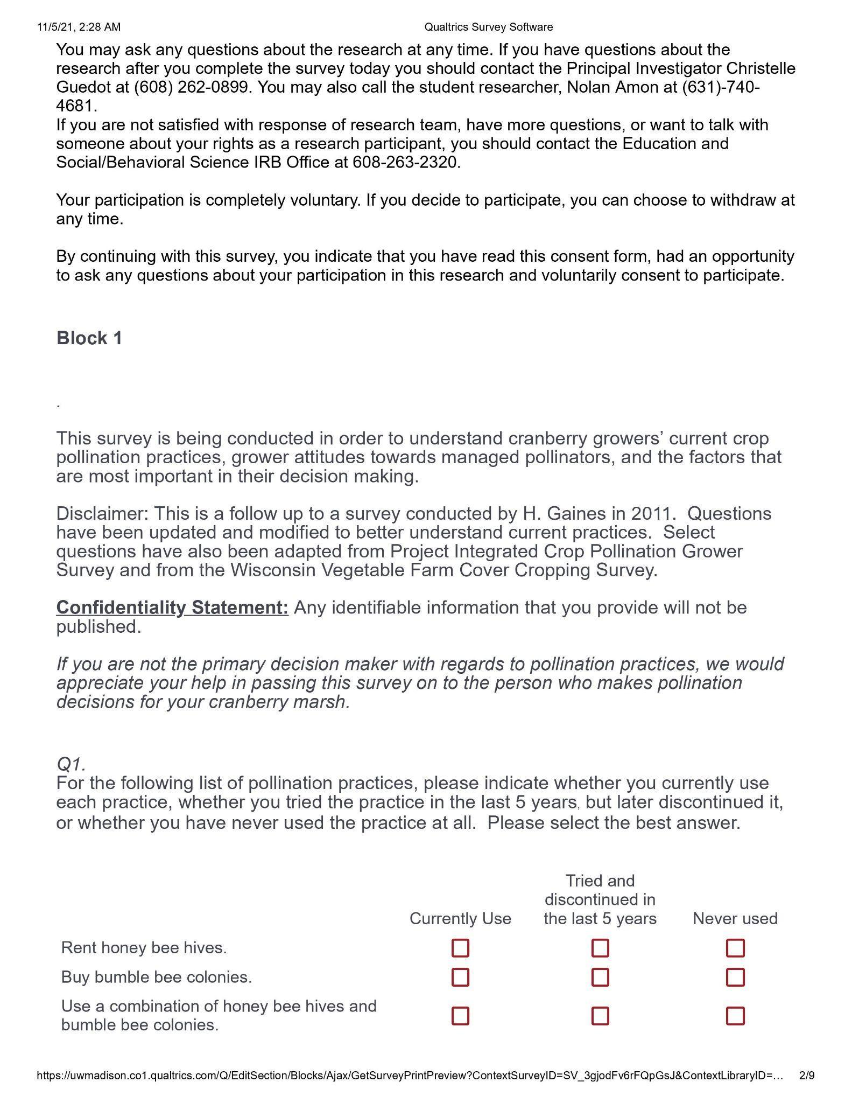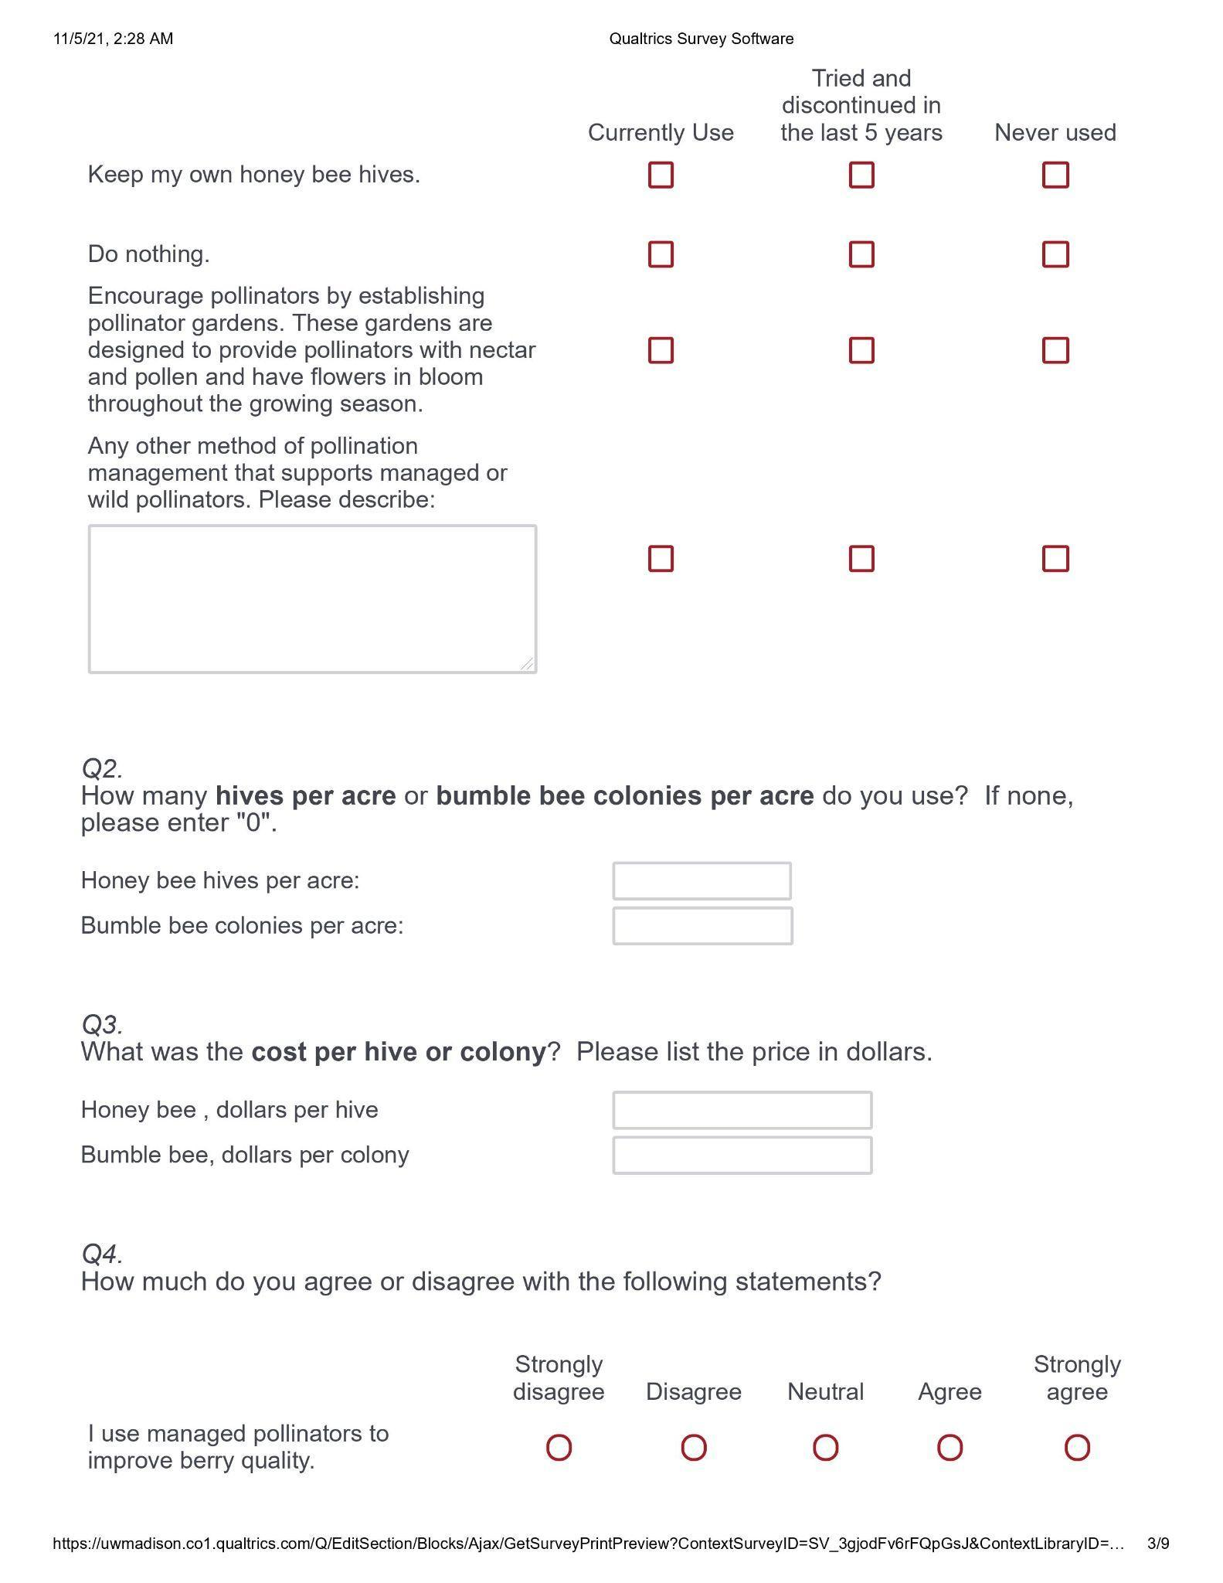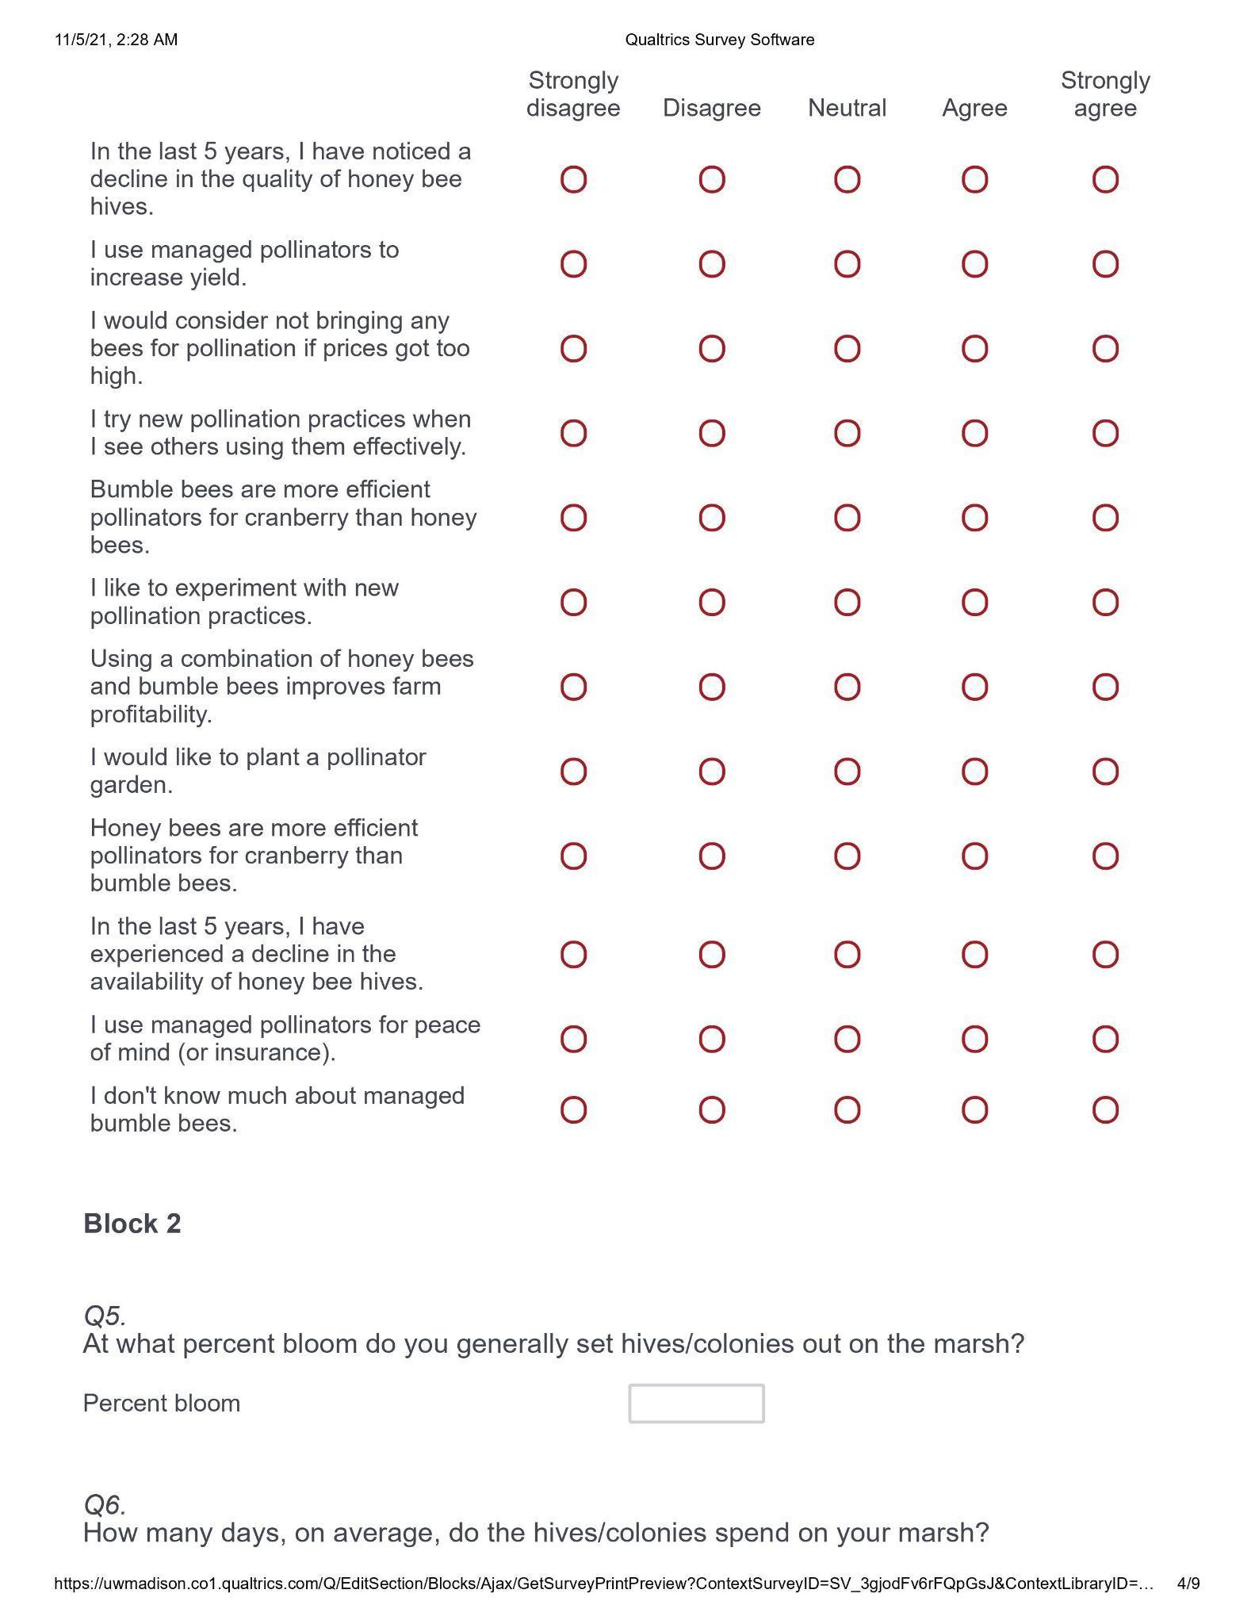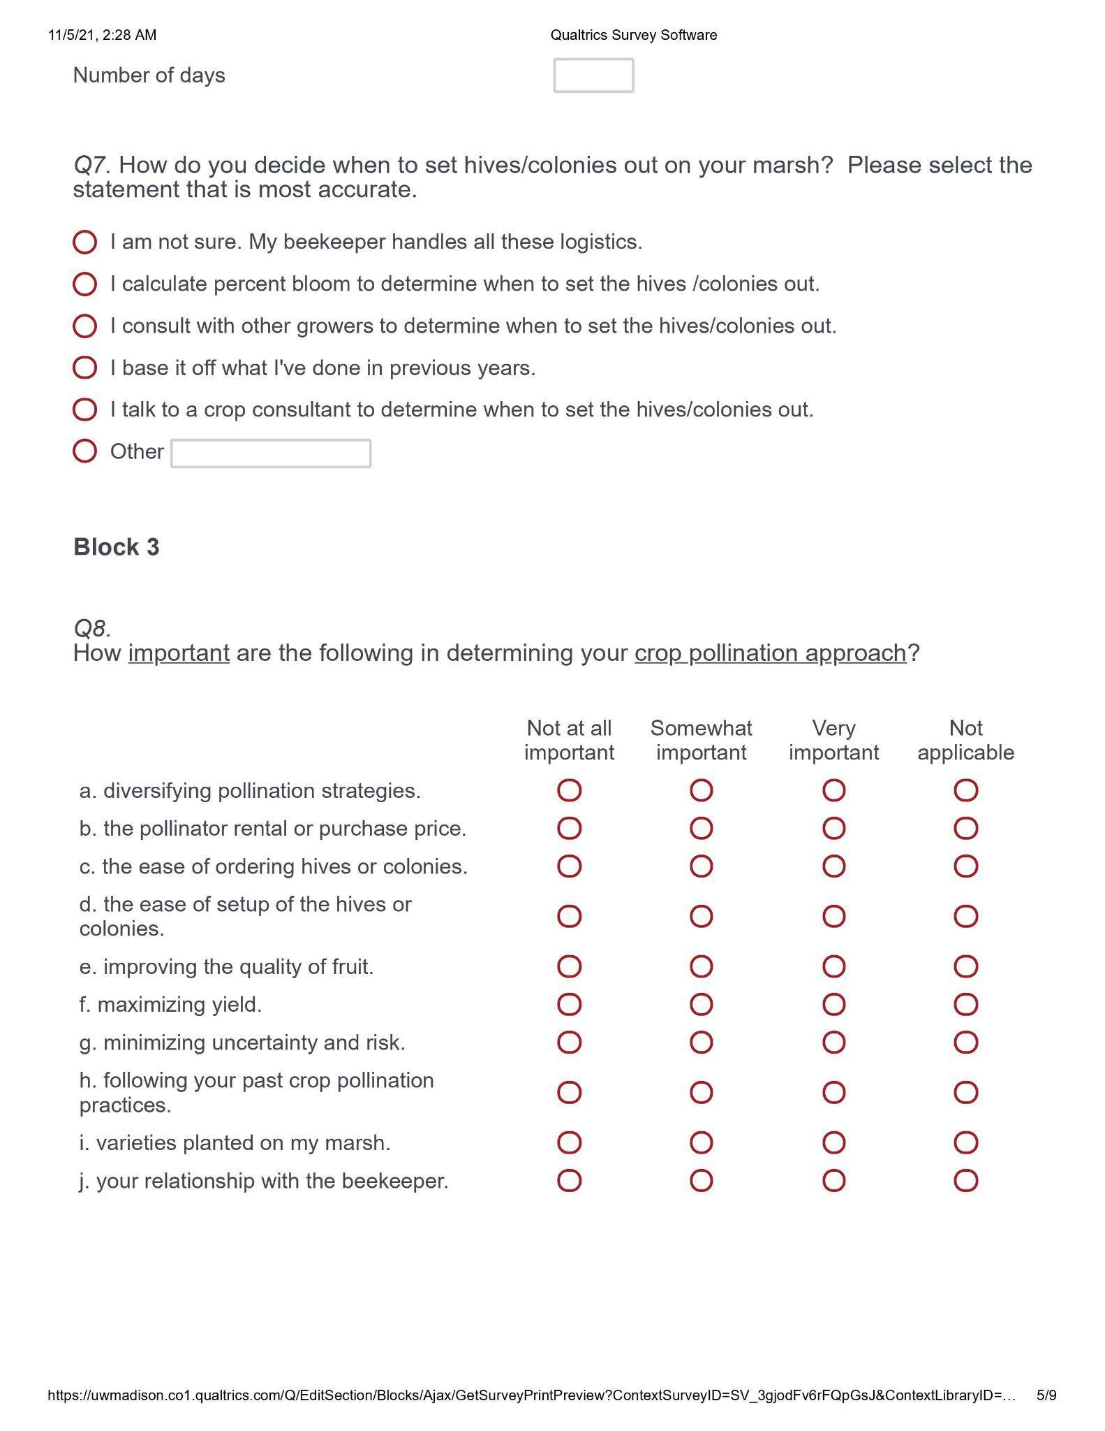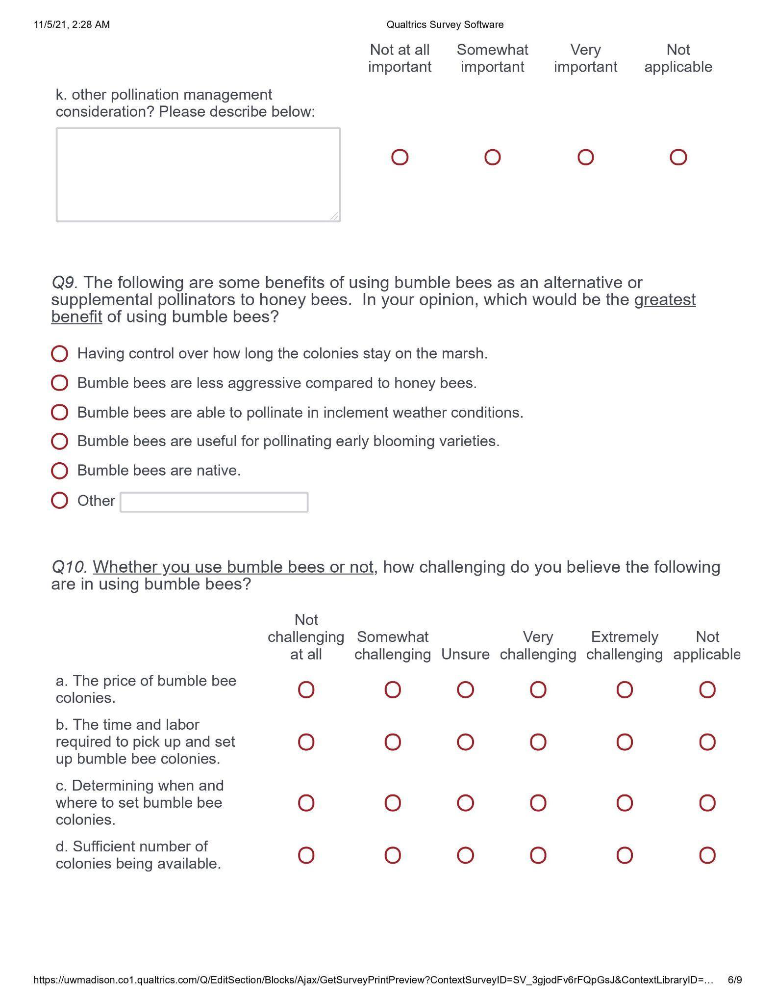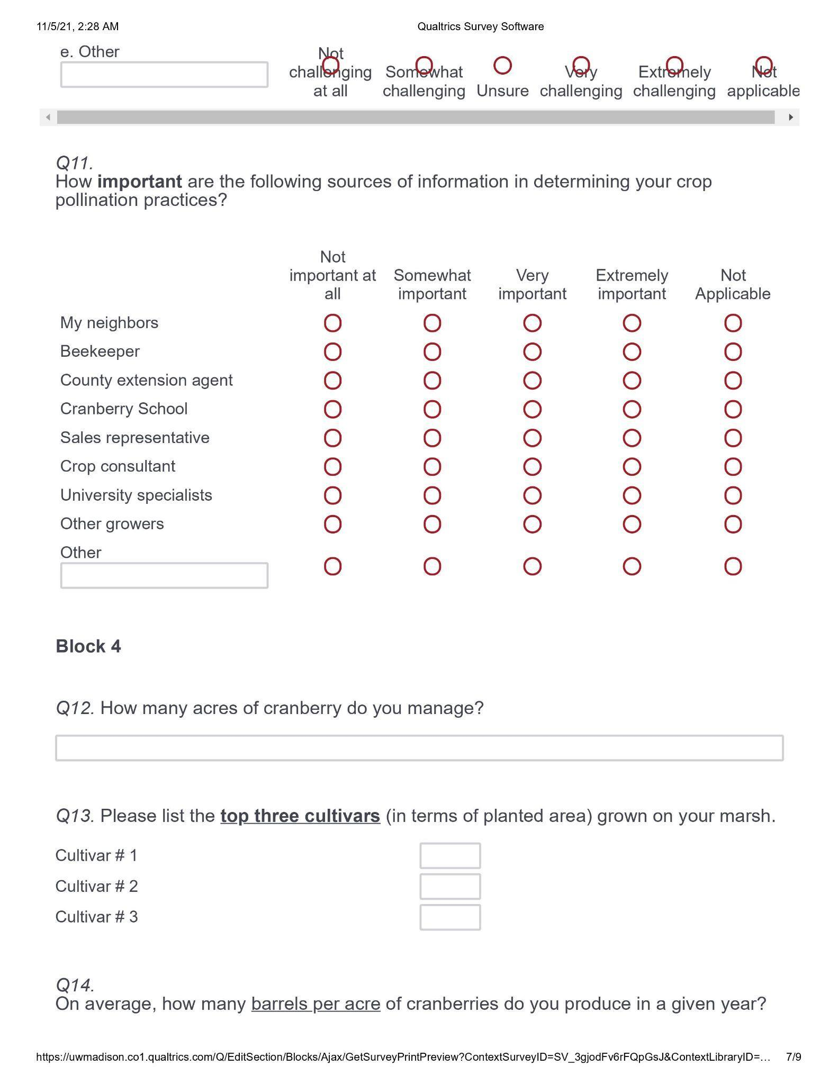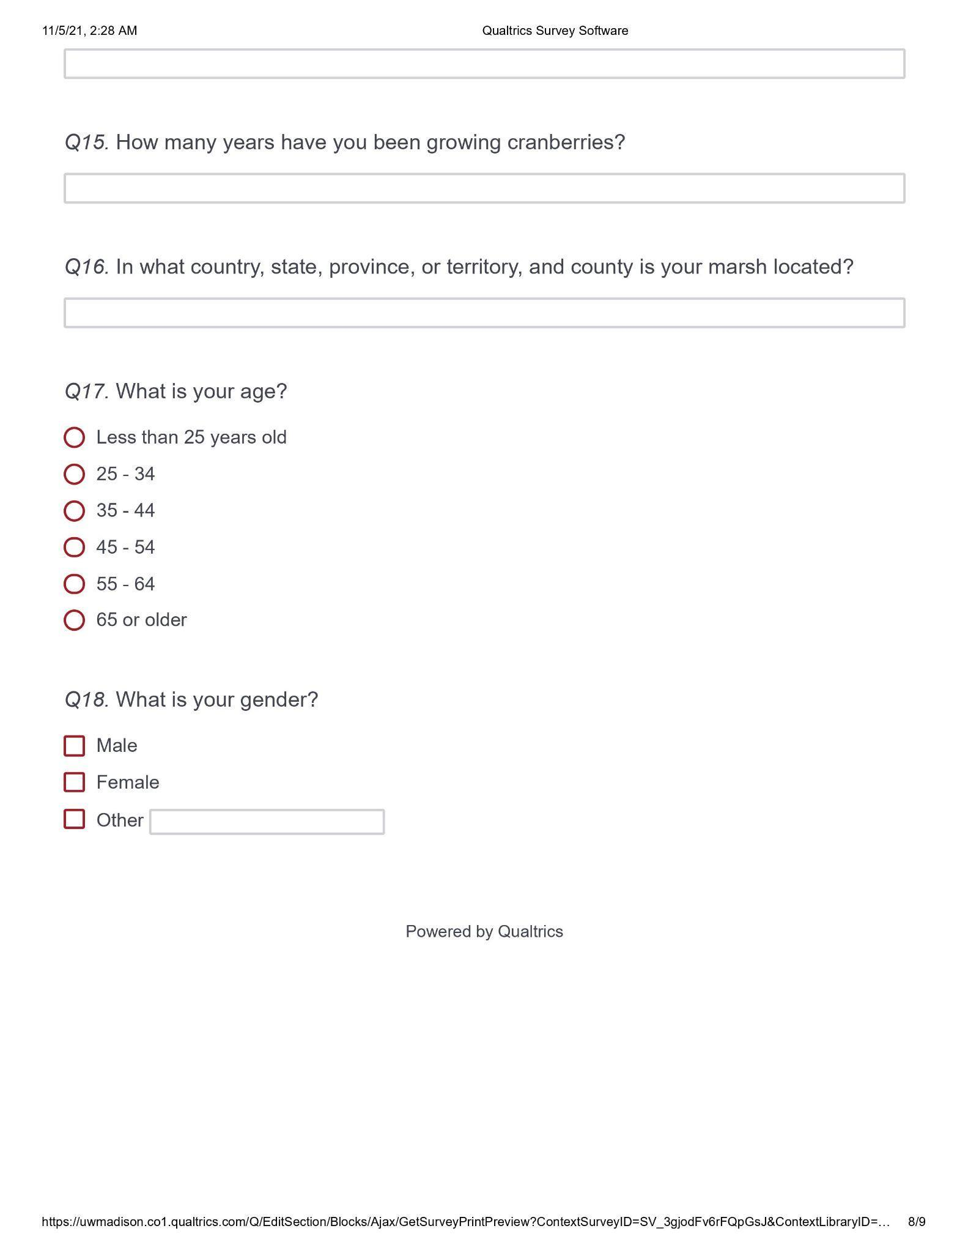

Supplemental Information 2. Top cranberry cultivars planted on farms in Wisconsin and Quebec.
 | N responding |  | Percent responses
What are the most common cranberry cultivars grown on your farm? | WI | QC | WI | QC
Most planted cultivar | 52 | 21 | Stevens: 94.23%  BG: 1.92%  GH1: 1.92%  Mullica Queen: 1.92% | Stevens: 100.00%
Second most planted cultivar | 45 | 20 | Mullica Queen: 26.68%  GH1: 15.56%  Ben Lear: 8.89%  Pilgrim: 8.89%  Crimson Queen: 6.67%  Sundance: 6.67%  Granite Red: 4.44%  Hyred: 4.44%  Macfarlin: 4.44%  Searles: 4.44%  BG: 2.22%  Demoranville: 2.22%  Grygleski: 2.22%  Stevens: 2.22% | Mullica Queen: 45.00%  Ben Lear: 25.00%  Pilgrim: 10.00%  Sundance: 10.00%  Demoranville: 5.00%  HyRed: 5.00%

Supplemental Information 3. Assortment of questions that did not fit precisely into another table or figure.
 | N responding |  | Percent responses
Statement | WI | QC | WI | QC
In the last 5 years, I have noticed a decline in the availability of honey bee hives. | 56 | 22 | Disagree/strongly disagree: 50.00%  Neutral: 28.57%  Agree/strongly agree: 21.43% | Disagree/strongly disagree: 63.64%  Neutral: 27.27%  Agree/strongly agree: 9.09%
In the last 5 years, I have noticed a decline in the quality of honey bee hives. | 56 | 22 | Disagree/strongly disagree: 50.00%  Neutral: 32.14%  Agree/strongly agree: 17.86% | Disagree/strongly disagree: 18.18%  Neutral: 40.91%  Agree/strongly agree: 40.91%
I use managed pollinators for peace of mind/insurance. | 55 | 22 | Disagree/strongly disagree: 14.55%  Neutral:27.27%  Agree/strongly agree: 58.18% | Disagree/strongly disagree: 0.00%  Neutral: 4.55%  Agree/strongly agree: 95.45%

Supplemental Information 4. Grower perceptions of factors influencing cranberry crop pollination approaches.
 | N responding |  | Percent responses
How important are the following in determining your crop pollination approach? | WI | QC | WI | QC
Diversifying pollination strategies | 56 | 22 | Not important: 3.57%  Somewhat important: 51.79%  Very important: 32.14%  Not applicable: 12.50% | Not important: 0.00%  Somewhat important: 50.00%  Very important: 45.45%  Not applicable: 4.55%
Pollinator rental or purchase price | 56 | 22 | Not important: 7.14%  Somewhat important: 53.57%  Very important: 37.50%  Not applicable: 1.79% | Not important: 13.64%  Somewhat important: 45.45%  Very important: 40.91%  Not applicable: 0.00%
Ease of ordering pollinators | 56 | 22 | Not important: 8.93%  Somewhat important: 44.64%  Very important: 41.07%  Not applicable: 5.36% | Not important: 4.55%,  Somewhat important: 45.45%  Very important: 50.00%  Not applicable: 0.00%
Ease of setting up pollinators | 56 | 22 | Not important: 8.93%  Somewhat important: 48.21%  Very important: 41.07%  Not applicable: 1.79% | Not important: 9.09%  Somewhat important: 31.82%  Very important: 45.45%  Not applicable: 13.64%
Improving fruit quality | 56 | 22 | Not important: 1.79%  Somewhat important: 14.29%  Very important: 80.33%  Not applicable: 3.57% | Not important: 4.55%  Somewhat important: 45.45%  Very important: 45.45%  Not applicable: 4.55%
Improving yield | 56 | 22 | Not important: 0.00%  Somewhat important: 1.79%  Very important: 98.21%  Not applicable: 0.00% | Not important: 0.00%  Somewhat important: 18.18%  Very important: 81.82%  Not applicable: 0.00%
Minimizing uncertainty/risk | 56 | 22 | Not important: 5.36%  Somewhat important: 23.21%  Very important: 67.86%  Not applicable: 3.57% | Not important: 0.00%  Somewhat important: 45.45%  Very important: 50.00%  Not applicable: 4.55%
Following past practices | 56 | 22 | Not important: 12.50%  Somewhat important: 58.93%  Very important: 26.78%  Not applicable: 1.79% | Not important: 45.45%  Somewhat important: 31.82%  Very important: 13.64%  Not applicable: 9.09%,
Varieties planted on farm | 56 | 22 | Not important: 10.71%  Somewhat important: 44.64%  Very important: 41.08%  Not applicable: 3.57% | Not important: 9.09%  Somewhat important: 45.45%  Very important: 31.82%  Not applicable: 13.64%
Your relationship with your beekeeper | 56 | 22 | Not important: 7.14%  Somewhat important: 30.36%  Very important: 57.14%  Not applicable: 5.36% | Not important: 0.00%  Somewhat important: 22.73%  Very important: 68.18%  Not applicable: 9.09%
Other considerations | 26 | 6 | Not important: 0.00%  Somewhat important: 11.54%  Very important: 11.54%  Not applicable: 76.92% | Not important: 0.00%  Somewhat important: 16.67%  Very important: 33.33%  Not applicable: 50.00%

Supplemental Information 5.Grower perceived importance of information sources on crop pollination.
 | N responding |  | Percent responses
How important are the following sources of information on crop pollination? | WI | QC | WI | QC
My neighbors | 55 | 17 | Not important: 38.18%  Somewhat important: 50.91%  Very/extremely important: 10.91% | Not important: 41.18%  Somewhat important: 41.18%  Very/extremely important: 17.65%
My beekeeper | 55 | 21 | Not important: 14.55%  Somewhat important: 27.27%  Very/extremely important: 58.18% | Not important: 0.00%  Somewhat important: 9.52%  Very/extremely important: 90.48%
Grower conferences, field days, extension clinics | 54 | 20 | Not important: 7.41%  Somewhat important: 57.41%  Very/extremely important: 35.18% | Not important: 0.00%  Somewhat important: 30.00%  Very/extremely important: 70.00%
Sales representatives | 55 | 15 | Not important: 43.64%  Somewhat important: 45.45%  Very/extremely important 10.91% | Not important: 40.00%  Somewhat important: 40.00%  Very/extremely important: 20.00%
Crop consultants | 54 | 21 | Not important: 20.37%  Somewhat important: 37.04%  Very/extremely important: 42.59% | Not important: 0.00%  Somewhat important: 19.05%  Very/extremely important: 80.95%
University specialists | 56 | 21 | Not important: 3.57%  Somewhat important: 33.93%  Very/extremely important: 62.50% | Not important: 0.00%  Somewhat important: 28.57%  Very/extremely important: 71.43%
Other cranberry growers | 55 | 18 | Not important: 14.55%  Somewhat important: 61.81%  Very/extremely important: 23.64% | Not important: 5.56%  Somewhat important: 55.56%  Very/extremely important: 38.88%

