Appendix for “Influence or Support? Member Perspectives on Youth Wings in Political Parties”

Table A1. Survey populations and response rates by youth wing
 | CUF | GU | KDU | LUF | MUF | SSU | US | UV | Total
Total number of members | 1070 | 998 | 4897 | 1150 | 8902 | 5621 | 1290 | 1119 | 25047
Members with email addresses | 907 | 918 | 4677 | 890 | 2746 | 4855 | 998 | 1113 | 17104
Responses | 212 | 215 | 261 | 178 | 606 | 620 | 318 | 496 | 2906
Response rate (%) | 23.4 | 23.4 | 5.6 | 20.0 | 22.1 | 12.8 | 31.9 | 44.6 | 17.0
Note: Swedish abbreviations and mother party in brackets. CUF: Centerns ungdomsförbund (Centre Party); GU: Grön ungdom (Green Party); KDU: Kristen demokratisk ungdom (Christian Democrats); LUF: Liberala ungdomsförbundet (Liberals); MUF: Moderata ungdomsförbundet (Moderates); SSU: Socialdemokratiska ungdomsförbundet (Social Democrats); US: Ungsvenskarna (Sweden Democrats); UV: Ung vänster (Left Party)

Table A2. Descriptive statistics
Item | Name | Min | Max | Mean | N
‘The most important role of the youth organisation is to influence the policies of the mother party | influence | 1 | 4 | 3.21 | 1895
‘The most important role of the youth organisation is to support the decisions taken by the mother party’ | support | 1 | 4 | 2.01 | 1878
Career incentive index | career | 0 | 10 | 6.10 | 1695
Political incentive index | political | 0 | 10 | 7.63 | 1720
Social incentive index | social | 0 | 10 | 7.64 | 1696
Ideological distance from member to mother party | distance | 0 | 10 | 1.48 | 2332
Member’s ideological distance from the centre | radicalism | 0 | 5 | 2.93 | 2343
Member’s ideological left–right placement | left–right | 0 | 10 | 5.20 | 2343
Political interest | interest | 0 | 10 | 8.30 | 2389
Highest level of education | education | 1 | 10 | 4.49 | 2487
Age | age | 15 | 77 | 20.89 | 2707
Gender is female | gender | 0 | 1 | 0.46 | 2646
Youth wing (categorical) | organisation | 0 | 7 | N/A | 2707

Table A3. Multinomial regression predicting members’ perception of the youth wing as influencer of senior party
 | ‘The most important role of the youth organisation wing is to influence the policies of the mother party’
 | Disagree somewhat vs disagree completely  Model 4 | Agree somewhat vs disagree somewhat  Model 5 | Agree completely vs agree somewhat  Model 6
career index | 0.16* | 0.13 | 0.14*
political index | -0.14 | -0.02 | 0.17*
social index | -0.02 | -0.04 | -0.04
distance | -0.16 | -0.22* | 0.02
radicalism | -0.10 | -0.17 | -0.23
leftright | -0.06 | -0.07 | -0.08
interest | -0.09 | -0.07 | -0.04
education | 0.22 | 0.22* | 0.18
age | -0.08 | -0.02 | -0.01
gender = woman | 0.03 | 0.17 | 0.04
Observations | 1,477
McFadden R² | 0.11
Notes: Significance levels *** p<0.001, ** p<0.01, * p<0.05. Youth wing dummies included in all models, not shown in table.

Table A4. Multinomial regression predicting members’ perception of the youth wing as supporter of senior party
 | ‘The most important role of the youth organisation wing is to support decisions taken by the mother party’
 | Disagree somewhat vs disagree completely  Model 1 | Agree somewhat vs disagree somewhat  Model 2 | Agree completely vs agree somewhat  Model 3
career index | 0.13*** | 0.25*** | 0.30***
political index | -0.08* | -0.10* | 0.03
social index | -0.00 | -0.15*** | -0.15*
distance | -0.36*** | -0.45*** | -0.43**
radicalism | -0.11* | -0.03 | 0.27*
leftright | -0.02 | 0.03 | 0.15*
interest | -0.22*** | -0.33*** | -0.35***
education | -0.08 | -0.19** | -0.32***
age | 0.01 | 0.03 | 0.08*
gender = woman | 0.22 | 0.46** | 0.19
Observations | 1,474
McFadden R² | 0.13
Notes: Significance levels *** p<0.001, ** p<0.01, * p<0.05. Youth wing dummies included in all models, not shown in table.

Figure A1. Effect of members’ incentives on the role of the youth wing as influencer (logistic regression)
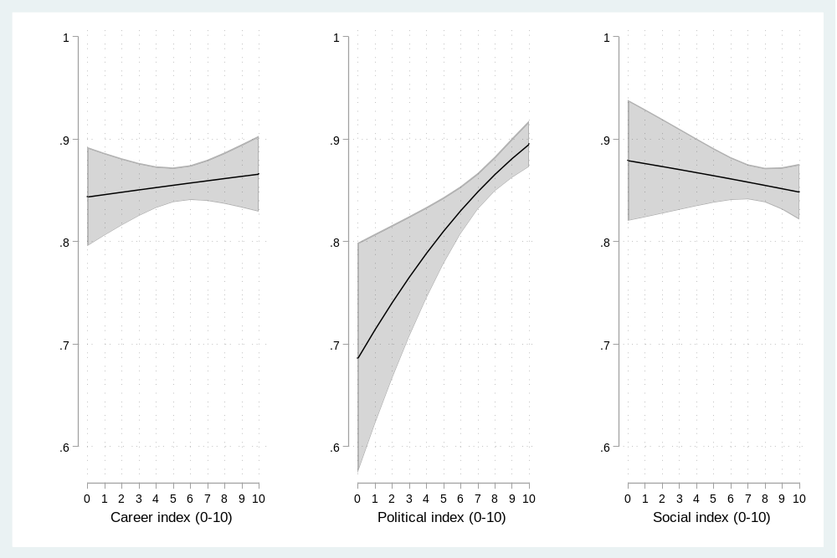
Notes: The figure is based on a logistic regression where the four different levels of the dependent variable have been transformed into a binary variable indicating whether the respondent disagrees or agrees with the statement.

Figure A2. Effect of members’ incentives on the role of the youth wing as supporter (logistic regression)
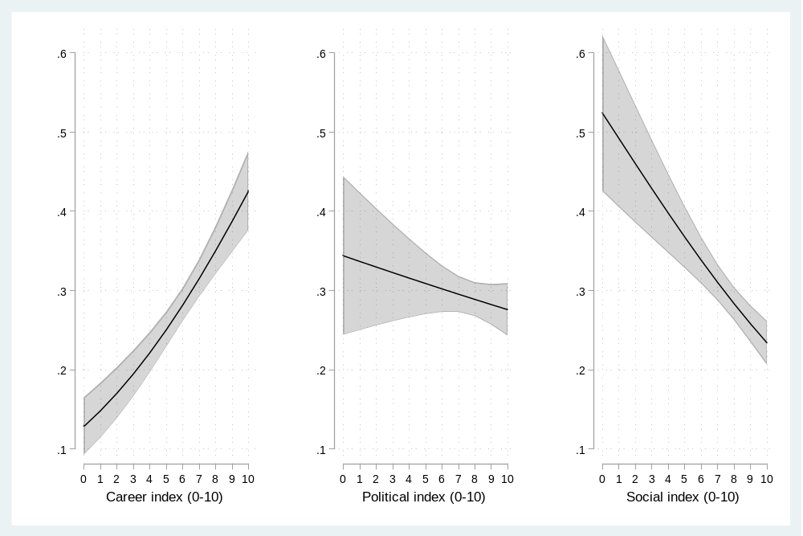
Notes: The figure is based on a logistic regression where the four different levels of the dependent variable have been transformed into a binary variable indicating whether the respondent disagrees or agrees with the statement.

