Supplementary Materials
Cultural Polarization in Taiwan: The Emergence of Moral Issue Partisanship, 2000–2024
Louis Liang-Yu Ko

TABLE A: Descriptive Statistics of Variables
 | Total |  | 2000 |  | 2005 |  | 2010 |  | 2015 |  | 2020
 | Mean | sd | Mean | sd | Mean | sd | Mean | sd | Mean | sd | Mean | sd
N | 9890 |  | 1960 |  | 2146 |  | 1895 |  | 2034 |  | 1855
Party Support  KMT | 0.30 | (0.46) | 0.33 | (0.47) | 0.32 | (0.47) | 0.38 | (0.49) | 0.29 | (0.45) | 0.20 | (0.4)
Independent | 0.38 | (0.49) | 0.31 | (0.46) | 0.35 | (0.48) | 0.36 | (0.48) | 0.41 | (0.49) | 0.49 | (0.5)
DPP | 0.31 | (0.46) | 0.36 | (0.48) | 0.33 | (0.47) | 0.26 | (0.44) | 0.30 | (0.46) | 0.31 | (0.46)
Issues Attitudes
CS_indp_ifpeace | 3.38 | (1.13) | 3.51 | (1.02) | 3.25 | (1.12) | 3.38 | (1.2) | 3.38 | (1.15) | 3.40 | (1.1)
CS_unify_ifsame | 3.24 | (1.12) | 2.73 | 1.05 | 3.05 | (1.06) | 3.40 | (1.13) | 3.44 | (1.11) | 3.59 | (1.01)
CR_order_worse | 2.44 | (1.07) | 2.16 | (0.89) | 2.30 | (0.98) | 2.53 | (1.12) | 2.49 | (1.12) | 2.73 | (1.14)
CR_thoughtchaos | 2.67 | (1.12) | 2.71 | (1.07) | 2.65 | (1.06) | 2.63 | (1.16) | 2.74 | (1.17) | 2.62 | (1.14)
CR_govtcontopn | 3.47 | (1.07) | 3.36 | (1.03) | 3.37 | (1.08) | 3.54 | (1.08) | 3.58 | (1.07) | 3.50 | (1.09)
CR_groupchaos | 2.72 | (1.08) | 2.70 | (1.04) | 2.71 | (1.04) | 2.72 | (1.11) | 2.75 | (1.12) | 2.72 | (1.09)
CR_partychaos | 3.04 | (1.16) | 3.14 | (1.1) | 2.97 | (1.13) | 3.06 | (1.2) | 3.01 | (1.19) | 3.04 | (1.17)
CR_harshpunish | 2.42 | (1.19) | 2.42 | (1.12) | 2.44 | (1.17) | 2.47 | (1.25) | 2.31 | (1.21) | 2.46 | (1.2)
FV_noneedchild | 3.18 | (1.2) | . | . | 3.03 | (1.17) | 3.11 | (1.24) | 3.27 | (1.21) | 3.35 | (1.14)
FV_noneedmarry | 3.54 | (1.06) | . | . | 3.34 | (1.08) | 3.47 | (1.12) | 3.63 | (1.03) | 3.72 | (0.95)
FV_motilawfight | 3.72 | (1.21) | . | . | 3.53 | (1.17) | 3.63 | (1.22) | 3.79 | (1.23) | 3.94 | (1.17)
FV_ealderlyhouse | 3.24 | (1.53) | . | . | 2.87 | (1.45) | 3.02 | (1.56) | 3.35 | (1.51) | 3.77 | (1.44)
FV_getdivorce | 4.09 | (1.28) | . | . | 3.81 | (1.34) | 3.94 | (1.36) | 4.22 | (1.21) | 4.44 | (1.07)
FV_noneedworship | 2.53 | (1.09) | . | . | 2.49 | (1.03) | 2.41 | (1.09) | 2.49 | (1.11) | 2.76 | (1.1)
ED_equallazy | 3.23 | (1.07) | 3.11 | (1.06) | 3.27 | (1.04) | 3.31 | (1.08) | 3.21 | (1.13) | 3.23 | (1.07)
ED_welfaremore | 3.79 | (0.95) | 3.36 | 1.02 | 4.11 | (0.78) | 4.09 | (0.82) | 3.66 | (0.99) | 3.69 | (0.89)
Female | 0.50 | (0.5) | 0.49 | (0.5) | 0.50 | (0.5) | 0.49 | (0.5) | 0.49 | (0.5) | 0.55 | (0.5)
Age  Under 35 | 0.30 | (0.46) | 0.31 | (0.46) | 0.34 | (0.47) | 0.34 | (0.47) | 0.28 | (0.45) | 0.22 | (0.41)
35 to 60 | 0.48 | (0.5) | 0.50 | (0.5) | 0.47 | (0.5) | 0.46 | (0.5) | 0.47 | (0.5) | 0.48 | (0.5)
above 60 | 0.23 | (0.42) | 0.19 | (0.39) | 0.20 | (0.4) | 0.20 | (0.4) | 0.25 | (0.43) | 0.30 | (0.46)
Edu year | 11.21 | (4.61) | 9.72 | (4.7) | 10.82 | (4.73) | 11.77 | (4.37) | 11.72 | (4.58) | 12.14 | (4.24)

TABLE B: Coding of Party Affiliations Responses
Party / Year | 2000 | 2005 | 2010 | 2015 | 2020
Kuomintang (KMT) | KMT | KMT | KMT | KMT | KMT
Democratic Progressive Party (DPP) | DPP | DPP | DPP | DPP | DPP
People First Party (PFP) | KMT | KMT | KMT | KMT | KMT
Taiwan Solidarity Union (TSU) | - - | DPP | DPP | DPP | DPP
New Party (NP) | KMT | - - | KMT | KMT | KMT
New Power Party (NPP) [1] | - - | - - | - - | - - | Independent
Taiwan People's Party (TPP) | - - | - - | - - | - - | Independent
Green Party | - - | - - | - - | - - | Independent
Taiwan Statebuilding Party [2] | - - | - - | - - | - - | DPP
[1] Ho and Huang (2017) argue that the New Power Party (NPP) emerged as a third-force party due to the Sunflower Movement, representing a group of voters who felt unrepresented by the mainstream political establishment at that time and desired candidates who were more progressive and uncompromising than those from the Democratic Progressive Party (DPP). The political energy that flowed into both the DPP and other emerging parties after the Sunflower Movement is seen as a reflection of differing paths among the protest participants. Therefore, this study classifies the small third-force parties that emerged after the Sunflower Movement, including the New Power Party (NPP), the Taiwan People's Party (TPP), and the Green Party, as independent voters.
[2] The Taiwan Statebuilding Party, formerly known as the Radical Wings, has frequently expressed during elections that it shares a “political specialisation” with the DPP, serving as the DPP's more radical wing and allowing the DPP to maintain a moderate stance for stable governance. Therefore, this study codes supporters of the Taiwan Statebuilding Party as leaning towards the DPP.

TABLE C: Corresponding Questionnaire Items for the Four Major Societal Issue Domains
Domain | Taiwan Social Change Survey (TSCS) Items | Remarks
Cross-Strait Relations | - Some people argue that "If Taiwan can maintain a peaceful relationship with the Chinese Communist Party after declaring independence, then Taiwan should become a new country." Do you agree with this view?  - Some people argue that "If the economic, social, and political conditions of mainland China and Taiwan become equivalent, then the two sides should unite." Do you agree with this view?
Civil Rights | Here are some statements about social phenomena/democratic concepts. Do you agree with the following statements?  - Some people say that Taiwanese society is becoming increasingly chaotic, and no one follows the laws or rules.  - If everyone doesn't have the same ideas, society will be chaotic.  - Whether a kind of speech or opinion can be circulated in society should be decided by the government.  - If there are many different opinion groups in a place, it will affect local stability.  - If a country has several political parties, it will lead to political chaos.  - Cruel criminals should be punished immediately, without waiting for the slow court trial. | Average of the six items , alpha = 0.6863.
Family Values | Do you agree with the following statements?  - A marriage without children is incomplete.  - People can have a fulfilling life without marriage.  - It’s better to have descendants to perform ancestral rites after one passes away.  The following questions have no standard answers; we only want to understand your perspective. Do you think the following behaviors are wrong?  - A daughter-in-law argues with her mother-in-law due to differences of opinion.  - Sending parents to a nursing home without taking care of them personally.  - Divorce due to marital discord. | Average of the six items , alpha = 0.6419.
Economic Distribution | - Do you think the current social welfare protection is sufficient or inadequate?  - If everyone’s income was more equal, people would work less hard. Do you agree with this statement?
Cross-Strait Relations — Robustness Check | - What do you think our country should be called at present, based on your personal view? (Options: Republic of China (R.O.C) / R.O.C in Taiwan / Taiwan / Republic of Taiwan / Taiwan, China / People’s Republic of China / R.O.C Taiwan)  - An increasing number of Taiwanese are investing or working in mainland China. Do you think this is good or bad for Taiwan’s future development?  - Do you agree with the following statements? Taiwanese culture today can no longer be considered a part of Chinese culture.

FIGURE D: Subgroup Heterogeneity Check
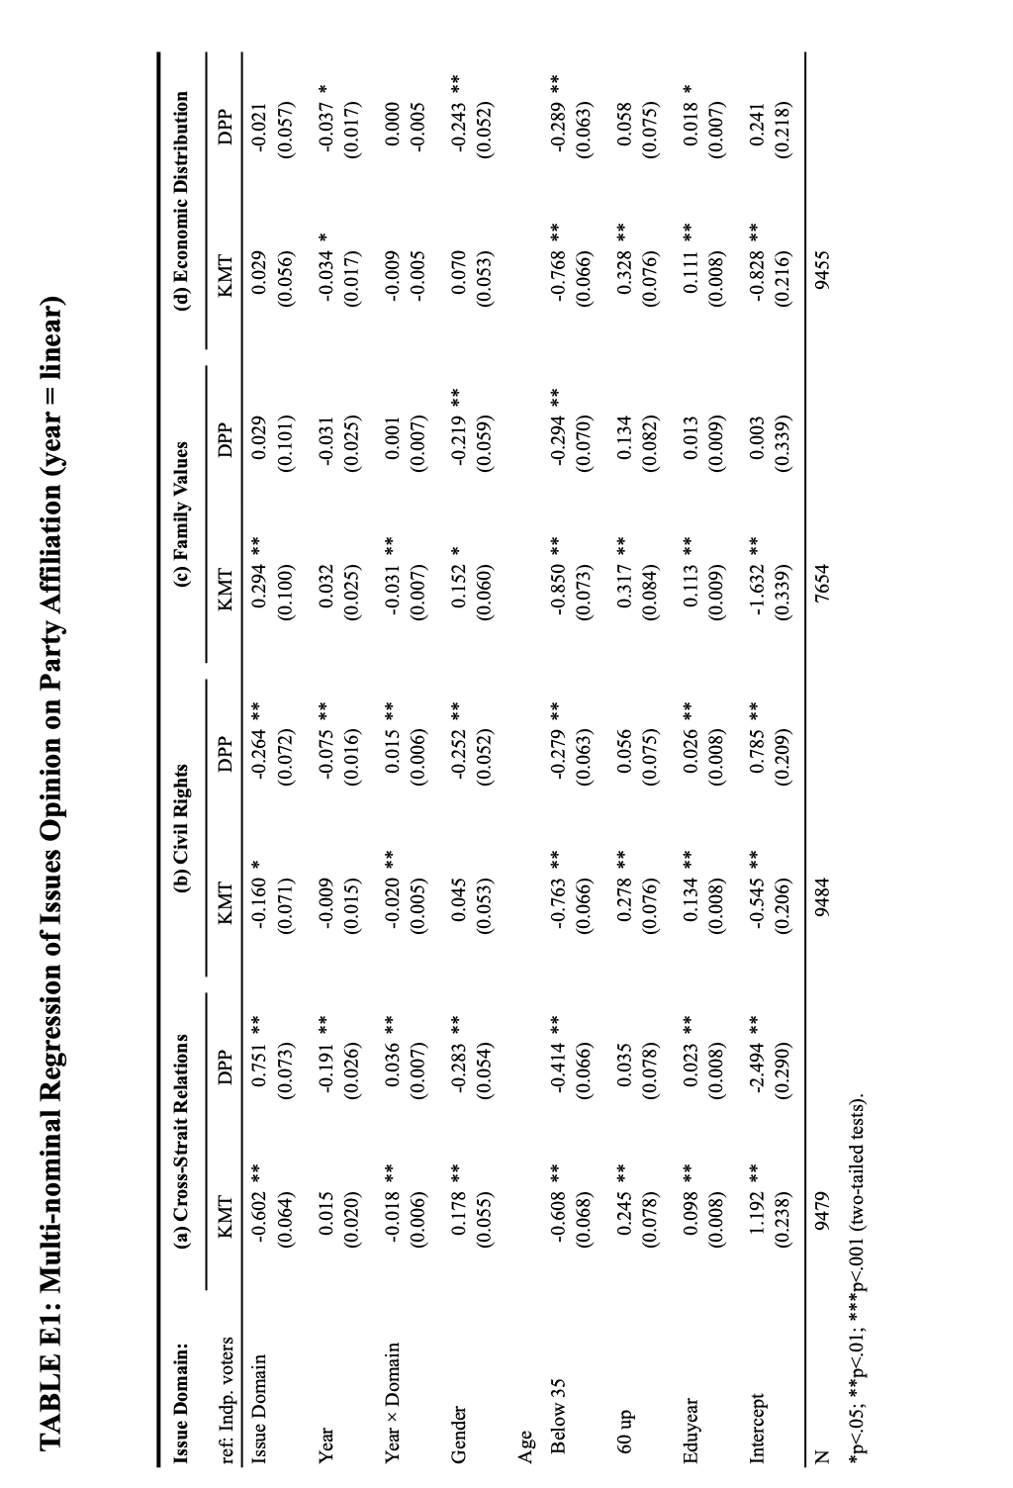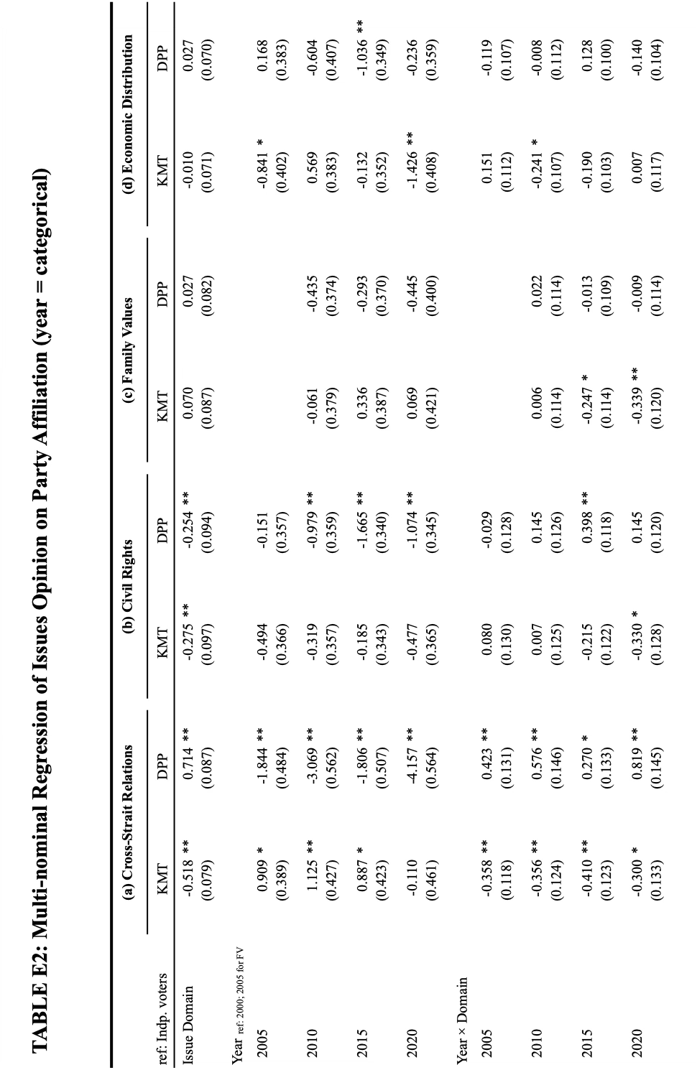
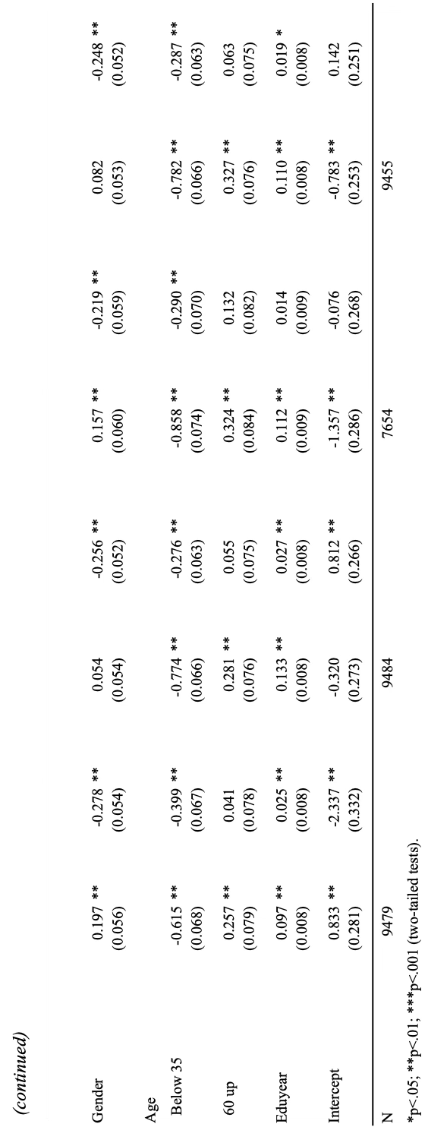

FIGURE F: Predicted Probability of Parties Supporters on Societal Issue Scores

Appendix G: Robustness Check — Multi Dimensions of Cross-Strait issues
Restricted by the questions asked in the TSCS, the main analysis measures public opinion about Cross-Strait relations only by respondents’ preference for unification versus independence. While the measurement captures an important aspect, it lacks consideration of cultural identity, interaction among people, and the complex historical entanglement across the strait.
To provide a multifaceted measurement to capture a comprehensive view of public opinions toward Cross-Strait relations, I conducted a robustness check using data from the TSCS special edition for national identity. These are also repeated cross-sectional datasets spanning from 2003 to 2023 (3 waves) (Fu 2016a; Wu 2024; Chang 2005). As a special edition, it includes more extensive and multidimensional questions specifically focused on national identity and citizenship. I selected three measurements, including questions about the nation’s name (national identity), thoughts on Taiwanese workers in Mainland China (economic exchanges), and perceptions of Taiwanese culture as distinct from Chinese culture (cultural distinction) (see the online supplement, Table C).
The concept of nationhood extends beyond mere material possessions, encompassing symbolic representations that confer legitimacy and power. Being a nation steeped in a complex and highly politicized history, the nation’s name is consistently a contentious issue in its political landscape (Chen 2023). During elections, political elites often invoke loyalty and patriotism towards different names for this country. “Republic of China” (R.O.C.) is the constitutional name which infers the legacy and cultural identity success from Mainland China. On the other hand, Taiwan is originally the geological name of the island, and it implies a history closely associated with the natives and colonial periods, memories happening on the island. In the middle ground, some people advocate for a fusion of these two symbols, proposing names such as “R.O.C. in Taiwan” or “R.O.C./Taiwan.” By preferring different nation names, individuals embrace distinct historical narratives and sovereign legitimacy.
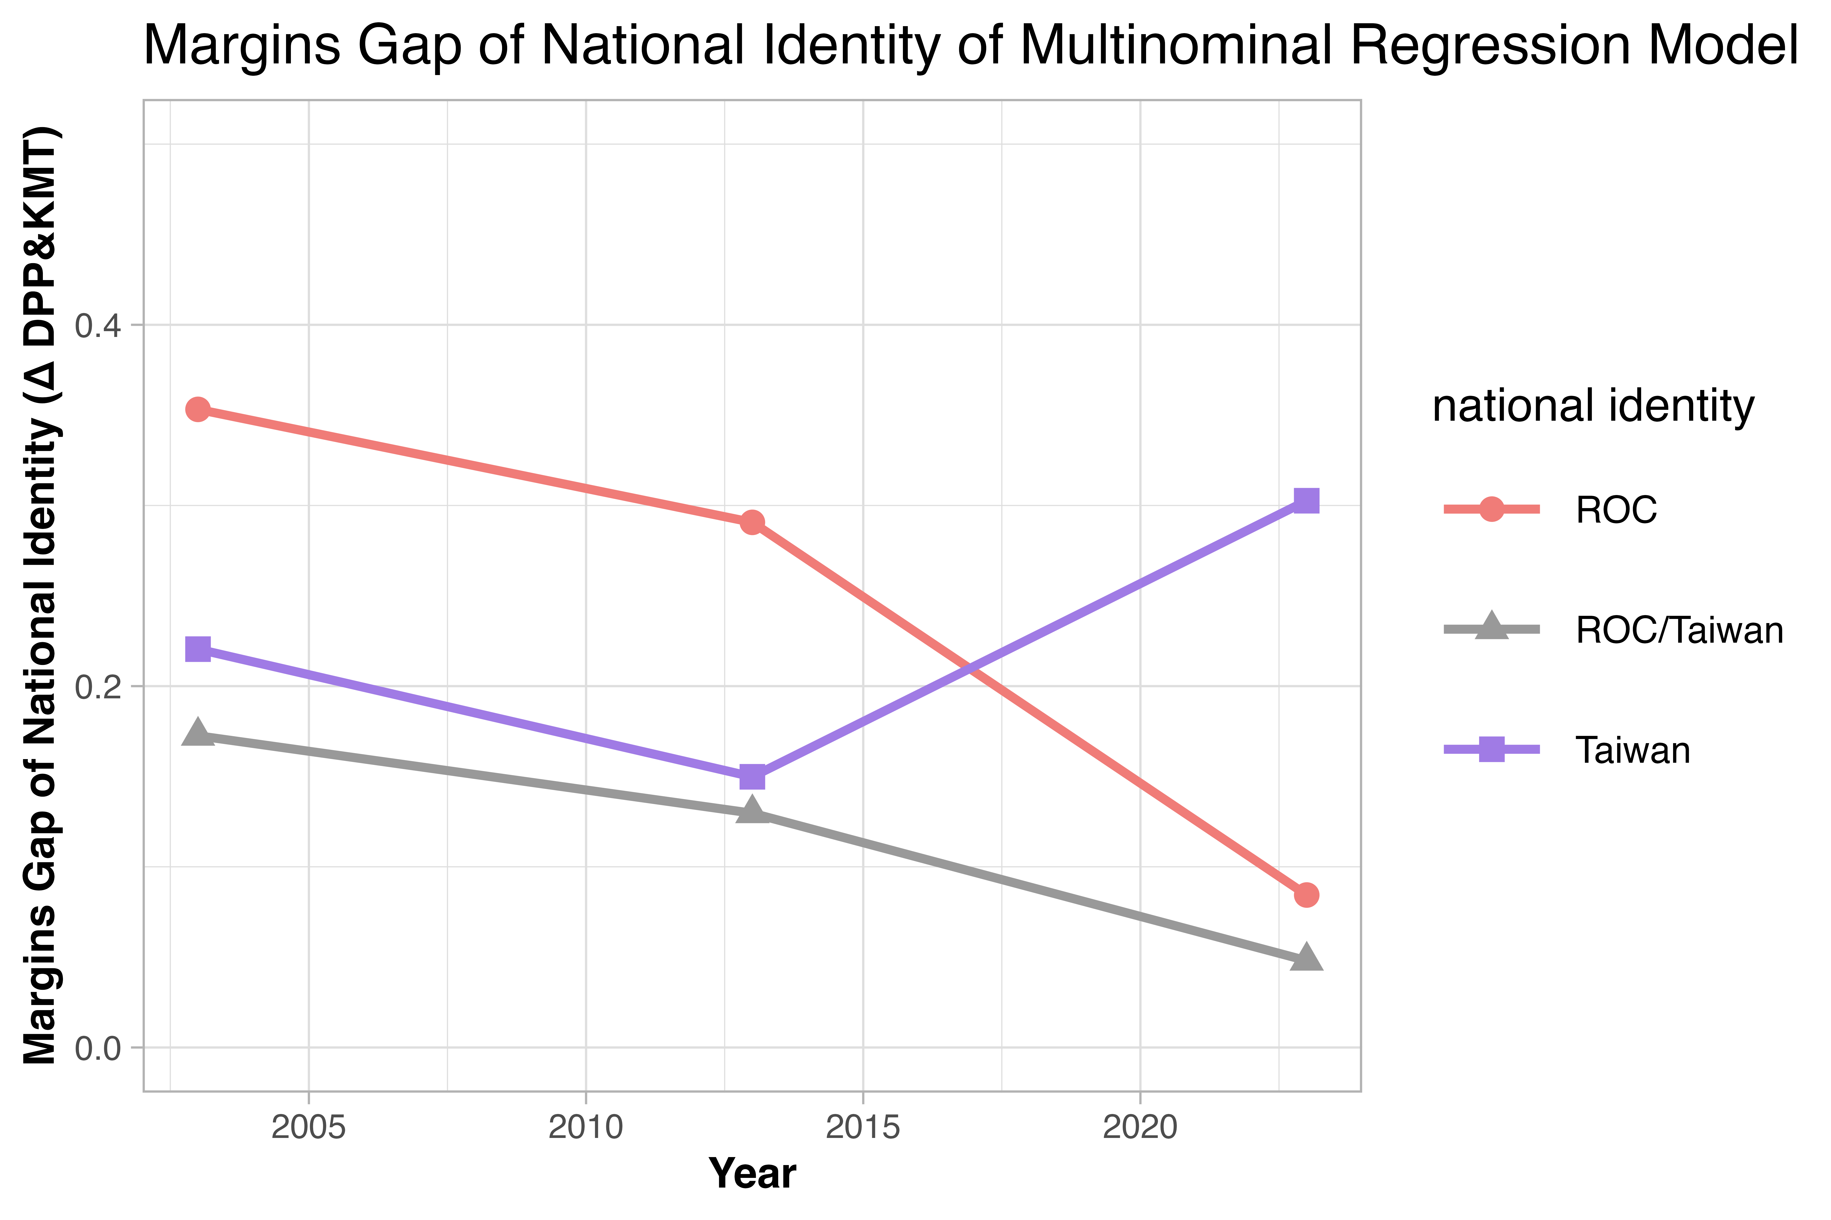
As figure F1 illustrates, the distribution of support for the nation’s names by both KMT, DPP, and independent voters has undergone some changes over the past two decades. In 2003, over 71% of KMT supporters recognized the name of R.O.C. as the nation’s name, while only 7.8% accepted the name R.O.C./Taiwan. However, in 2023, the percentage of R.O.C. identity has decreased to 57%, while the acceptance of the name R.O.C./TW has seen a significant increase, reaching 25.9%. On the other hand, DDP supporters, who had a high proportion of them embracing the name of Taiwan (69.5%), saw a slight decline in support (63.2%). This decline was accompanied by an increase in the number of DDP supporters who identified as R.O.C./TW, from 5.6% to 19.8%. Individuals who identified as independent voters also exhibited similar trends, with a rise in the number of people who identified as R.O.C./TW from 5.6% to 17.9%. Overall, if seeing R.O.C./TW as the middle ground between the two opposing identities, it appears that people from all three political camps are gradually moving toward a consensus.

FIG. F1. — Distribution of three national identities (R.O.C/ Both R.O.C.. and Taiwan/ Taiwan) by KMT, DPP supporters, and independent voters through three waves of surveys.

FIG. F3. — Absolute gap of the predicted probabilities of three national identities (R.O.C./ Both R.O.C.. and Taiwan/ Taiwan) between KMT and DPP supporters. When the Y-axis is zero, it indicates that the national name preference doesn’t predict which party the respondent favors.

FIG. F2. — Average marginal effects (AME) of economic exchange—supports of Taiwanese to work at Mainland China—(Left) and cultural distinction—Taiwan holds a special culture different from Mainland China—(Right) on party affiliation. The regression model consider the interaction between the main independent variables and years of survey.
Next, I built a regression model in the same manner as the primary analysis. I include the time variable and three Cross-Strait relevant variables as independent variables, aiming to explain the variance in party affiliation. The regression model considers the interaction between the main independent variables and years of survey, with gender, age, and education as control variables. The results are presented in figures 8 and 9.
Figure F2 illustrates how two economic exchanges and cultural identity attitudes influence party affiliation over time. On the left, the average marginal effects of cultural distinction on party affiliation remain consistent over time. On the right, the effects of supporting Taiwanese work in Mainland China increase. Especially, this factor becomes crucial in influencing DPP supporters. In other words, the opinion on Cross-Strait interactions, particularly economic exchanges, has not diminished in importance but has even become a more significant factor in shaping some people’s political choices.
Figure F3 shows the predicted probabilities gap of supporting KMT and DPP among different national name supporters. A significant decline in both R.O.C. and R.O.C./Taiwan supporters indicates that when “R.O.C.” or “R.O.C./Taiwan” is recognized as the country’s name, respondents gradually have a fair likelihood to support KMT and DPP over time. This, to some extent, suggests that the national identities of supporters of these two parties are becoming more similar. However, in 2023, the predicted probability of the “Taiwan” identifier reversed, becoming significantly more likely to support DPP, which may be due to the loss of moderate voters for the KMT (Wang 2019).
To sum up, the multifaceted nature of Cross-Strait issues shows a diverse pattern of influencing the public’s party affiliation. This trend can be roughly categorized into two distinct dimensions: policy and identity. Regarding the policy dimension, opinions on unification and economic exchange exhibit a growing partisan divide in the 2020s. This phenomenon may be a reflection of the DPP supporters’ negative response to the increasing military and economic challenges posed by the PRC regime. Conversely, the partisan gap regarding issues related to cultural identity, such as the nation’s name and cultural distinctions, does not widen but even narrows.

