A Survey Questions

The following is the translation of the online survey form.
This questionnaire will be used in a research project called “Think Differently, Wisely”. We would like to thank you for participating in this survey. All questions are aimed at collecting your general information and attitudes. We will not ask for your name, address, or any personal information, and all your responses will be kept confidential. We will only process your responses in aggregate to benefit research on social conflicts, which may lead to the design of policies that benefit both you and the broader community.
When filling out this questionnaire, please choose the answer that most closely matches your feelings. If you do not understand or find the question irrelevant to you, you may choose ”Prefer not to answer.”

A.1 Social Quality
- How much do you agree with the following statements: (1 = Strongly disagree, 2 = Somewhat disagree, 3 = Neither agree nor disagree, 4 = Somewhat agree, 5 = Strongly agree)
  - You feel secure when you are with your family.
  - You feel safe in your society.
  - You are satisfied with your household’s financial situation.
  - You and your family members care and love each other.
  - You feel that Thai people are united and harmonious.
  - You have the freedom to choose and determine your own life path.
  - You can drive changes in your society.
- In the past 12 months, how often did you or your family experience the following situations:
(1 = Never, 2 = Rarely, 3 = In some months, 4 = Every month or more often)
  - Go without food
  - Feel that your residence is unsafe from external factors such as crime or natural disasters
  - Did not receive medication or medical treatment when needed
  - Lack of income
- How much can you trust majority of people in the society: (1 = Not at all trustworthy, 2 = Not very trustworthy, 3 = Moderately trustworthy, 4 = Quite trustworthy, 5 = Completely trustworthy)
- How much you can trust the following people: (1 = Not at all trustworthy, 2 = Not very trustworthy, 3 = Moderately trustworthy, 4 = Quite trustworthy, 5 = Completely trustworthy)
  - Family members
  - Neighbor / Members of the community
  - Close friend
  - Acquaintance
  - Foreigner
- How much can you trust the following organization or institution: (1 = Not at all trustworthy, 2 = Not very trustworthy, 3 = Moderately trustworthy, 4 = Quite trustworthy, 5 = Completely trustworthy)
- Religious institutions such as temples, churches, mosques
- The military
- The media
- The police
- The judiciary (lower courts, appellate courts, Supreme Court, excluding the Constitutional Court)
- The Constitutional Court
- The government
- Political parties
- Civil servants
- The Election Commission
- The National Anti-Corruption Commission
- Large corporations
- Banks
- The central bank (Bank of Thailand)
- How important are the following things to you: (1 = Not important at all, 2 = Not very important, 3 = Moderately important, 4 = Quite important, 5 = Very important)
    - Family
    - Work
    - Friends
    - Politics
    - Religion
    - Personal time and relaxation
    - Social activities
- How worried are you about the following situations: (1 = Not worried at all, 2 = Slightly worried, 3 = Quite worried, 4 = Very worried)
    - Unemployment/cannot find a job
    - Cannot provide good education for children
    - Home or residence being unsafe
- Have you ever participated in any of the following activities: (1 = Yes, 2 = No, but might consider, 3 = No, and do not intend to)
      - Signed a petition for changing a policy or law you consider inappropriate
      - Provided feedback on local policy-making
      - Contacted government agencies to file complaintsalign with the excel file.
      - Participated in a protest
      - Donated to political or social campaigns
      - Encouraged others to participate in any activities listed above
A.2 Political stance and feelings toward members of the opposing group The following are the definitions of the two groups in the questionnaire:

Passion Fruits  “Embrace the new and the different.”  Passion Fruits emphasize individualism, freedom, and equality. Passion Fruits often agree with policies that promote social justice, human rights, and equality. | Bananas  “Embrace the old and the familiar.”  Bananas emphasize tradition, stability, and the importance of maintaining the status quo. Bananas often agree with policies that have been in place for a long time and follow social norms.
    - Which group do you most closely identify with? (1 = Extreme Passion Fruit, 2 = Moderate PassionFruit, 3=Neutral, butleaningtowardPassionFruit, 4=Neutral, butleaningtowardBanana, 5 = Moderate Banana, 6 = Extreme Banana)
    - How much do you agree with the following statements: (1 = Strongly disagree, 2 = Somewhat disagree, 3 = Neither agree nor disagree, 4 = Somewhat agree, 5 = Strongly agree)
      - I dislike a member of the other group.
      - If you are a lawyer and you realize that a member of the other group is innocent, you would represent them.
      - You would offer help to a member of the other group if they were in an accident.
      - You could trust a member of the other group in policy making.
      - You feel comfortable exchanging political ideas with a member of the other group.

A.3 Values and opinions on public matters
- How important are the following values to you, and how important do you think these values are to people in the other group? (1 = Not important at all, 2 = Not very important, 3 =
Moderately important, 4 = Quite important, 5 = Very important)
  - Democracy
  - Human equality
  - Virtue and morality
  - Respect for individual privacy
  - Non-violence toward people and property
  - Equal opportunities for all
  - Equal treatment by rules of law
  - Freedom of expression without infringing on others’ rights (Those who value this will disagree with some laws that restrict certain expressions)
  - Religion as a moral anchor
  - Obedience to elders or those in higher positions
- How much do you agree with the following statements, and how much do you think people in the other group agree with the following statements? (1 = Strongly disagree, 2 = Somewhat disagree, 3 = Neither agree nor disagree, 4 = Somewhat agree, 5 = Strongly agree)
  - A military coup is acceptable.
  - Having a good, moral leader is more important than having a system that can hold leaders accountable.
  - It is acceptable for a government to engage in espionage activities to maintain national security.
  - It is acceptable for a government to use violence against citizens or their property to maintain national security.
  - Everybody’s vote should have equal value in an election.
  - Gray businesses such as prostitution and gambling should be legalized.
  - If there were no corruption, the government should increase taxes to improve basic services such as healthcare and education for people of all income levels.
  - Using personal connections to gain advantage over other people is acceptable.
  - Even if you believe a superior’s order is morally wrong (e.g. lie to a customer, hurting an innocent person), you would still carry out the order because it is your duty.
- How much do you agree with the following statements: (1 = Strongly disagree, 2 = Somewhat disagree, 3 = Neither agree nor disagree, 4 = Somewhat agree, 5 = Strongly agree)
  - Evading import taxes, and selling goods online without paying VAT are acceptable.
  - Environmental conservation is the responsibility of all parties, including the government, private sector, and citizens, regardless of their income level.
  - The state should legalize gambling and prostitution.

A.4 Demographics
- How old are you? (1 = Under 20 years, 2 = 20–29 years, 3 = 30–39 years, 4 = 40–49 years, 5 = 50–59 years, 6 = 60 years or older)
- How do you describe your current gender identity? (1 = Female, 2 = Male, 3 = LGBTQ+, 4 = Prefer not to say)
- What is your highest level of education? (1 = Less than primary education, 2 = Primary education, 3 = Secondary education / Vocational Certificate, 4 = Associate Degree / Higher Vocational
Certificate, 5 = Bachelor’s Degree, 6 = Master’s Degree, 7 = Doctoral Degree)
- How many people are in your household? (A household refers to people who live together regularly) (1 = Live alone, 2 = 2 people, 3 = 3 people, 4 = 4 people, 5 = 5 people, 6 = More than 5 people)
- What is your household’s total income level? (1 = Less than 10,000 Baht per month, 2 = 10,000–25,000 Baht per month, 3 = 25,001–50,000 Baht per month, 4 = 50,001–80,000 Baht per month, 5=80,001–120,000Bahtpermonth, 6=120,001–200,000Bahtpermonth, 7=200,001–500,000 Baht per month, 8 = More than 500,000 Baht per month)
- Please choose the occupation that best describes you (1 = Government official / State employee / State enterprise employee, 2 = Full-time employee / Private company employee, 3 = Business owner / self-employed in agriculture and fishing, 4 = Business owner / self-employed not in agriculture and fishing, 5 = Casual laborer / General laborer / Freelance worker, 6 = Student, 7 = Unpaid work at home such as family business, housewife, 8 = Retired government official, 9 = Retired (not a retired government official), 10 = Unemployed)
- If you own a business, does your business have employees? (1 = No employees, 2 = No more than 5 employees, 3 = More than 5 employees)
- In which region did you mostly live before the age of 18? (1 = Bangkok and surrounding areas, 2 = Central region, 3 = Northern region, 4 = Northeastern region, 5 = Southern region)
- Did you mostly live in or outside a municipal area before the age of 18? (1 = In a municipal area, 2 = Outside a municipal area, 3 = In Bangkok or its surrounding areas)
- In the past 12 months, where did you spend most of your time? (1 = Bangkok and surrounding areas, 2 = Central region, 3 = Northern region, 4 = Northeastern region, 5 = Southern region)
- In the past 12 months, did you mostly live in or outside a municipal area? (1 = In a municipal area, 2 = Outside a municipal area, 3 = In Bangkok or its surrounding areas)
- How much do family members differ in their political views? (1 = Completely the same views, 2 = Somewhat different views, 3 = Mostly different views)
- How often do you exchange political views with the following people: (1 = Never, 2 = Rarely,
3 = Once a month, 4 = Once a week or more)
  - With friends who share the same views
  - With friends who have different views
  - With family members who share the same views
  - With family members who have different views
  - Expressing political views on social media
- Which political party did you vote for in the 2019 election?
- How often do you follow news and current events through the following channels: (1 = Not at all / None, 2 = Less than once a month, 3 = Monthly, 4 = Weekly, 5 = Daily)
  - Newspapers
  - Television
  - Radio
  - SMS (text messages)
  - Email
  - Friends/colleagues/family through direct conversation
  - Friends/colleagues/family online, such as LINE
  - Various websites (visited directly, excluding forwarded links)
  - Facebook
  - Twitter
  - LINE Today from various news agencies
- Which news outlets do you follow?
- How did you learn about this survey? (1 = Email, 2 = Facebook, 3 = LINE, 4 = Twitter)

B Calculation of echo chamber index
To calculate echo chamber index, we first calculate political inclination score for each media outlet that would indicate which political side an outlet is leaning towards. We then use the inclination score to construct a measure of media consumption behavior. More specifically, for each respondent, we count the number of news agencies that are found to be on the same side, neutral, and on the opposite side of their political inclination. We finally calculate the echo chamber index as the percentage of same-side media consumed by an individual relative to their total media consumption.

Media inclination score
Following findings in Gentzkow and Shapiro (2006) and Ribeiro et al. (2018), we postulate that a media outlet that is consumed more by Orange (Yellow) group leans more toward Orange (Yellow). We then run the following multiple binary logistic regression model:
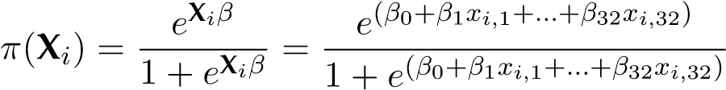,
where X_{i} is the vector of 32 indicator variables. x_{i,j} indicating whether respondent i consumes media j. The outcome variable y_{i} is the indicator variable for the political inclination of respondent i, where y_{i} = 1 if respondent i leans more toward Yellow, and 0 otherwise. We define π(X_{i}) as the probability of respondents i having political view leaning toward Yellow as a function of X_{i}. The likelihood function for multiple binary logistic regression of sample size n is given by:
.
We maximize this log-likelihood function to estimate the regression coefficients, β^{ˆ}, and the media’s political inclination score for each outlet j is given by β^{ˆ}_{j}. The positive and statistically significant coefficient β^{ˆ}_{j} suggests that media outlet j is more likely to be consumed by the Yellow group. Conversely, the negative and statistically significant coefficient indicates that the media outlet is more likely to be consumed by the Orange group.
To the best of our knowledge, our study is among the first to utilize this framework to comprehensively analyze media inclination score for Thai media outlets. There are a few other studies, such as McCargo (2017), that qualitatively analyzes media partisanship, but splits media outlets into pro-Thaksin and anti-Thaksin factions with limited number of media outlets at the time.
The media inclination score is shown in Table 6. We classify 8 media outlets with negative and statistically significant (at 0.1 level) coefficients as leaning Orange and 4 with positive and statistically significant coefficients as leaning Yellow. The remaining 20 media outlets are labeled as neutral. Most of the media outlets’ political inclination calculated using our method are consistent with the findings in McCargo (2017).

C Detailed breakdown of survey respondents’ demographic attributes
Table 7 presents summary statistics for the demographic and socioeconomic characteristics of our respondents. Each variable, except income, is reported as the mean of a corresponding indicator (e.g., the proportion of respondents meeting a certain criterion). The first two columns show the national average alongside our full sample average. Asterisks denote statistically significant differences between these two averages, as determined by one- or two-sample t-tests. In the last three columns, we provide subgroup averages, highlight their differences, and indicate statistical significance based on two-sample t-tests.
Table 6: Media inclination score for each major media outlet in Thailand.
Media | Coefficient | SE | p-Value
The Momentum | −0.045 | (0.215) | 0.835
The101.world | 0.005 | (0.241) | 0.983
PPTV | 0.008 | (0.157) | 0.960
Isara | 0.058 | (0.170) | 0.731
TNN | 0.151 | (0.149) | 0.311
News18 | 0.152 | (0.266) | 0.568
MCOT | 0.154 | (0.160) | 0.337
Spring News | 0.209 | (0.238) | 0.380
Prachachat | 0.218 | (0.217) | 0.316
Daily News | 0.317 | (0.235) | 0.176
Naew Na | 0.352 | (0.303) | 0.246
BLUESKY | 0.391 | (0.352) | 0.267
Nation∗ | 0.383 | (0.149) | 0.010
ThaiPost∗ | 0.434 | (0.224) | 0.053
Manager∗ | 0.606 | (0.173) | 0.000
Top News∗ | 1.416 | (0.164) | 0.000

Media | Coefficient | SE | p-Value
The Standard† | −0.805 | (0.146) | 0.000
Matichon† | −0.734 | (0.192) | 0.000
Prachathai† | −0.709 | (0.234) | 0.002
BBC Thai† | −0.662 | (0.157) | 0.000
The Reporter† | −0.579 | (0.186) | 0.002
VoiceTV† | −0.527 | (0.158) | 0.001
Khao Sod† | −0.466 | (0.221) | 0.035
Workpoint† | −0.272 | (0.156) | 0.081
The Matter | −0.231 | (0.204) | 0.257
Kom Chud Luek | −0.179 | (0.230) | 0.438
Thairath | −0.094 | (0.147) | 0.523
Channel 3 | −0.093 | (0.124) | 0.455
Bangkok Post | −0.092 | (0.193) | 0.633
ThaiPBS | −0.078 | (0.131) | 0.550
AmarinTV | −0.064 | (0.156) | 0.683
ThaiPublica | −0.054 | (0.210) | 0.796

Note: Media outlets indicated with negative coefficients and p-values less than 0.1 (indicated with †) are those we labeled as leaning toward Orange. Those with positive coefficients and p-values less than 0.1 (indicated with ∗) are labeled as leaning toward Yellow. The remaining media outlets are labeled as neutral.

Table 7: Summary statistics for demographic and socioeconomic variables
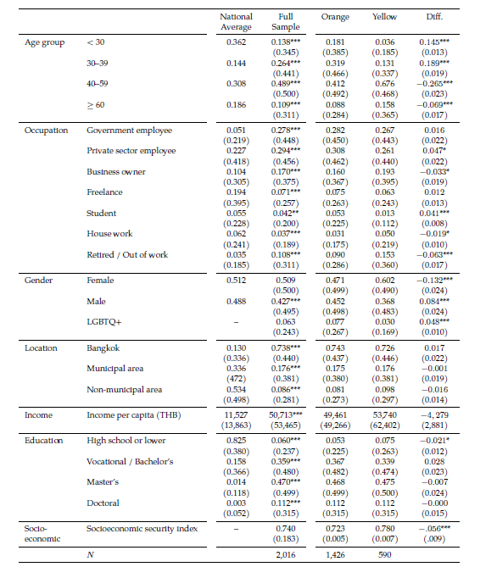
Note: Numbers reported are mean of each category’s indicator variable, except for income. For national averages, we use administrative population data from Ministry of Interior (2021) for age group and gender, and rely on survey data by National Statistical Office (2021) for other variables. Standard deviations and standard errors are shown in the parentheses. Markers *, **, and *** denote statistical significance at 5, 1, and 0.1 percent confidence levels respectively

D Correlation between out-group animosity and perceived ideological difference

Figure D.1 presents a heatmap illustrating the average levels of out-group animosity. The data is
categorized based on individuals’ self-reported ideological positions and their perceptions of the
ideological stance of the out-group.

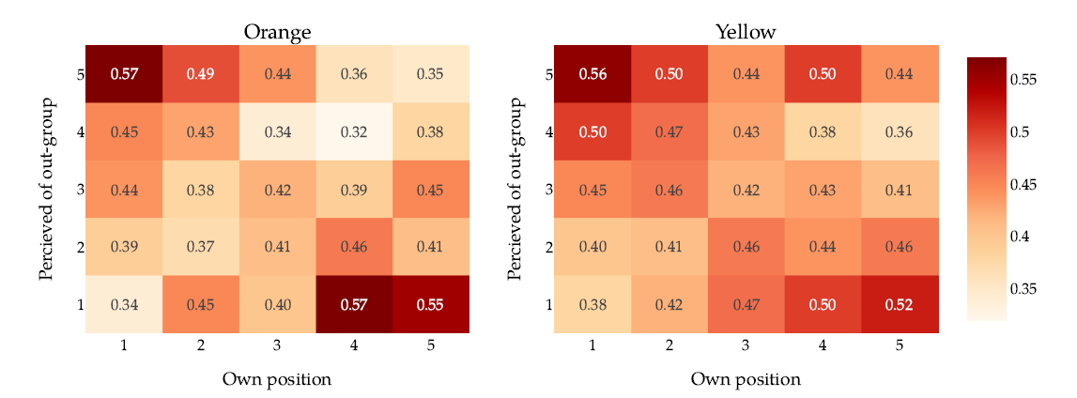

Figure D.1: The heat map displays out-group animosity scores of Orange (left panel) and Yellow
(right panel) based on their own ideological values (x-axis) and the perceived ideological values
of the out-group (y-axis). Each cell represents the level of out-group animosity, averaged across
all contextual questions.

Along the 45-degree diagonal from the bottom-left to the top-right, self-reported ideological
values match perceived out-group positions, indicating no perceived ideological difference. To-
ward the upper left and lower right corners, perceived ideological differences are greatest. The
figure reveals the highest degree of animosity in these corners, while on the diagonal where per-
ceived ideological differences are minimal, animosity is lowest.

This figure exhibits a striking correlation between out-group animosity and perceived ideo-
logical differences, supporting Hypothesis H1. However, in order to account for other potential
confounding factors that may be driving out-group animosity, we turn to regression analysis and
include additional related variables. These variables, discussed in Section 4.2, serve as control
variables and have been identified in the literature as drivers of AP.

McCargo (2017) studies a subset of the media outlets listed above. Most findings are consistent, except for Bangkok Post which is found to be anti-Thaksin, and Thairath, which is found to be pro-Thaksin. We label both of these outlets neutral. BLUESKY, a media strongly associated with the Yellow Shirt movement, is labeled as neutral in our study. Despite its large coefficient, the p-value is quite large. This could be due to the media’s declining popularity in recent years.

