Appendices

A few organizations account for most religious resentment
A major finding of previous research on religious grievances is that they are closely connected to specific organizations. The Islam Defenders’ Front (FPI) played a major role in the mobilizations of 2017, along with other right-wing religious organizations (Mietzner, Muhtadi, and Halida 2018). Other organizations have long been associated with encouraging religious tolerance—most notably the NU (Barton and Fealy 1996). We wanted to understand whether group membership played an important role in resentment, as we expected it would in the case of religious resentment.
We selected major religious groups—the Muslim NU, Muhammadiyah, and Persis organizations—as well as Christian churches, the Islamic study group Majelis Taklim, and the religio-political FPI. We also asked about membership in arts organizations, labor unions, youth groups, sports teams, community rotating credit organizations (arisan), and ethnic solidarity forums.
Our expectations for these groups differ. The of the Muslim organizations, the mainline NU and Muhammadiyah organizations explicitly endorse religious tolerance, while Persis is less explicitly pro-tolerance and the FPI is a well-documented driver of intolerance. Majelis Taklim groups are quite decentralized. NU and Muhammadiyah members should be far more tolerant than FPI and Persis members. Christian organizations should also be associated with high tolerance scores, while ethnic forums might be associated with anti-Java and regional resentments, as they usually reflect non-Javanese identities.
Figure 1 Resentment and membership
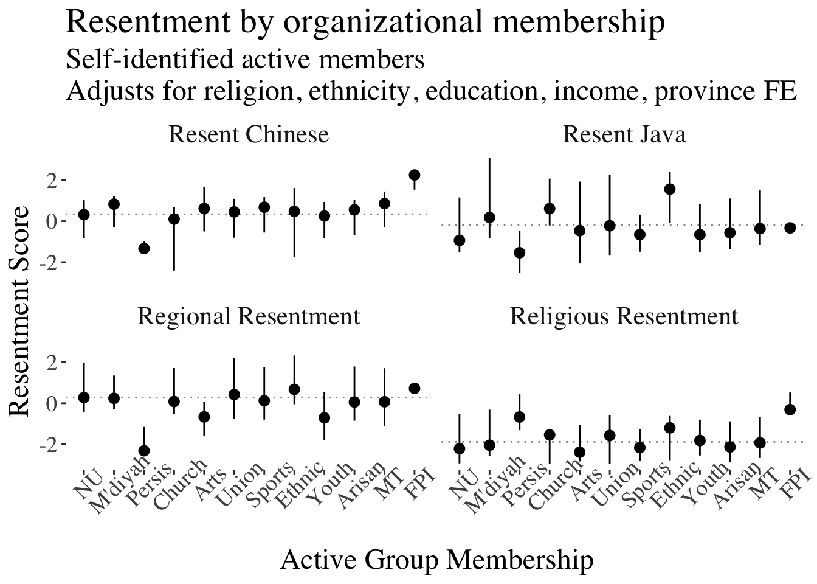
We found that anti-Chinese resentment, religious resentment, and regional resentment were all higher than the national average for members of the FPI. Active members of the conservative organization Persis scored high on religious resentment as well, but well below average on resentment of Java, regional resentment, and anti-Chinese resentment. Resentment of Java was higher among ethnic solidarity forum members and church attendees—groups more likely to have members who live in the Outer Islands. The mainline Muslim NU and Muhammadiyah respondents—members of organizations that advocate religious tolerance—scored near average for all resentments, though resentment of Java was higher among Muhammadiyah members, who are concentrated outside of Java.
Overall, we find that civil society group membership is an important correlate of resentment. Where groups are involved in grievance activism—as with the FPI—or where they inculcate awareness of the relationships between regions—as with ethnic solidarity forums—or where they have substantial membership in areas with high regional resentment—as with churches and forums in the Outer Islands—group membership is a powerful predictor of resentment. Conversely, membership in organizations that encourage tolerance, like the NU, is a predictor of lower resentment. If a latent resentment were to be activated, civil society organizations would be a key channel—maybe even the key channel—through which that mobilizing work could be done. This result also cuts against viewing resentment as a product of isolation. Membership in certain kinds of groups is strongly associated with higher resentment; resentment is likely not generated in a vacuum.

Social media use correlates consistently with anti-Chinese resentment
An important and ongoing debate in the literature is the degree to which media—both mass and social—are inflaming political anger. To test whether resentments are connected to consumption of particular social media, we first compare resentment by levels of social media use, looking at the four most widely-used social media platforms in Indonesia.
When we estimate the relationship between resentment and social media use, we find a strong positive relationship between increasing use of Facebook, Instagram, WhatsApp, and YouTube and anti-Chinese resentment. We find a moderate and negative relationship between those same services and regional resentment. We find a near-zero relationship between social media use and resentment of Java, with the exception of WhatsApp. We find an inconsistent relationship across sites for religious resentment.
Figure 2 Resentment and social media use by platform
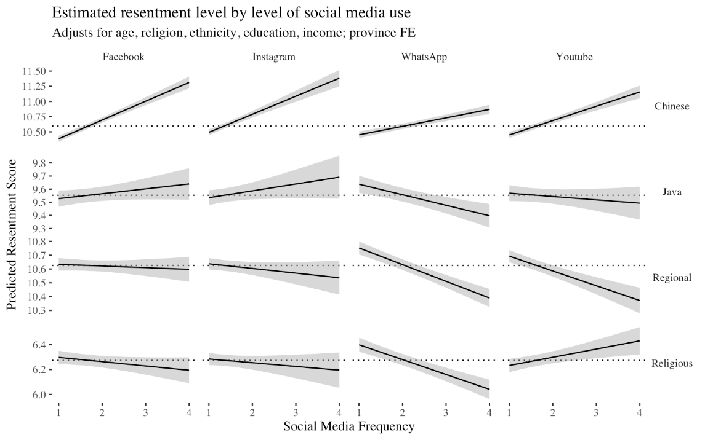
We take this as strong evidence that social media plays a role in the creation of narratives underlying resentment. However, our evidence suggests that this is not a general relationship that holds across media, but is instead specific to the claim being made. Anti-Chinese conspiracy theories have a long history in Indonesia, and have been common on the internet for many years. Their use by organized groups of social media users (so-called “buzzer teams”) in the 2017 Jakarta gubernatorial campaign and 2014 presidential campaign were well documented (Lim 2017), as was their use in the 2019 presidential election (Tapsell 2021). Anti-Chinese sentiments may be endemic to Indonesian social media.
It is notable, however, that the other resentments are not strongly tied to a particular social media platform. Since religious resentment was also deliberately activated in recent elections, we expected that it, too, would be positively associated with increased use of social media. Instead, we see a mixed result. Two explanations may be worth exploring further. One would be that religious resentment is organized through distinct channels—especially through social organizations like religious organizations and places of worship—and is not generally something one comes by through exposure to social media content. Another explanation may be that anti-Chinese sentiment, closely tied to longstanding conspiracy theories, feeds on modes of thought that are especially prevalent online.

Validating resentment indices
We used principal component analysis to determine whether the questions on the resentment indices were in fact picking up on distinct phenomena, and to determine whether they functioned as four distinct indices.
Our results showed that the ability of components to account for variance plateaus at four components, with some additional variance accounted for at the six and eight principal component marks. The fact that major gains disappear after four components indicate that the measures as currently divided are fairly appropriate.
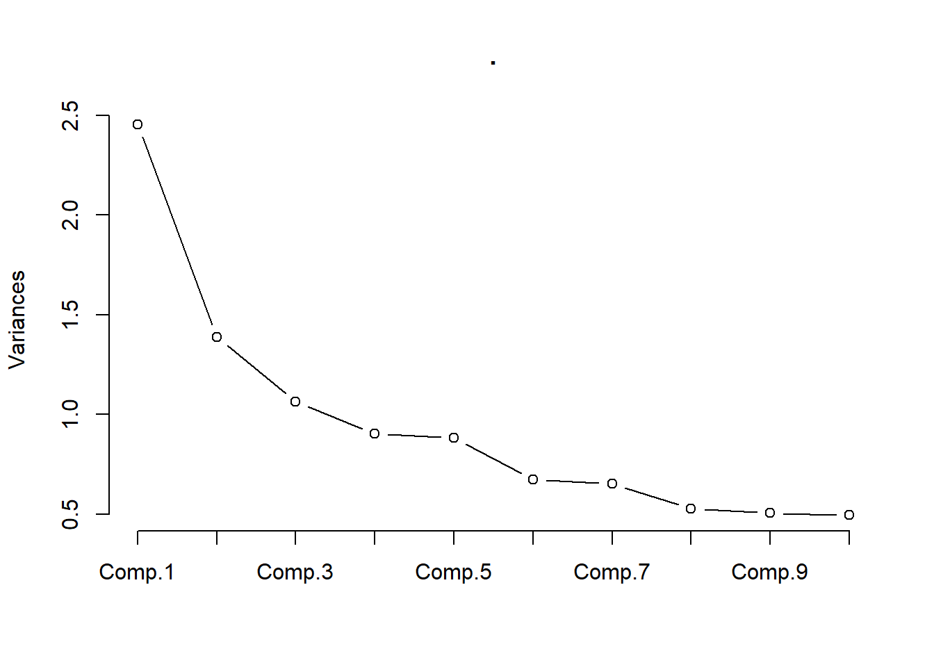
Using factor analysis, we found that in the four-index approach suggested by both the study design and the plateau of the component analysis, the different indices strongly load onto different factors.

Figure 3 Factor loadings of each question, highlighted when magnitude exceeds 0.3
 | Factor 1 | Factor 2 | Factor 3 | Factor 4
Regional: "Don’t care" |  | 0.18 |  | 0.556
Regional: "Don’t understand" |  |  | 0.123 | 0.719
Regional: "Not from here" |  | 0.282 | 0.118 | 0.356
Regional: "Minority spending" |  | 0.27 | 0.188 | 0.286
Chinese: "More chance" | 0.161 |  | 0.651 | 0.126
Chinese: "Seek money" |  |  | 0.504 | 0.137
Chinese: "Influential" | 0.2 | 0.106 | 0.621
Chinese: "Patriotic" | 0.141
Religious: "Poor" | 0.444 |  | 0.14
Religious: "Unfairly treated" | 0.807
Religious: Lack influence" | 0.668
Religious: "Discord" | 0.732
Java: "More people" |  | -0.451
Java: "More attention" | 0.182 | 0.621 |  | 0.124
Java: "Government influence" |  | 0.53 |  | 0.112
Java: "Good example |  | -0.397
Java: "Islam mixed" | 0.117 | 0.328 | 0.182 | 0.239

Alternative views of resentment and partisan preferences
The main text displays probabilities of vote choices at each index level. Here, we present the simple correlations between each resentment index and the choice of voting for either Jokowi or Prabowo. Each resentment index is positively correlated with Prabowo votes. Each index is negatively correlated with Jokowi votes. Anti-Chinese and religious resentment have the strongest correlations in both directions. The group-level estimates in the body allow for a view of the nonlinearities in the relationship.
 | Prabowo | Jokowi
Anti-Chinese resentment | 0.19 | -0.16
Anti-Java resentment | 0.15 | -0.12
Regional resentment | 0.11 | -0.09
Religious resentment | 0.15 | -0.15

An alternative to the continuous view presented in the body, we here present the estimated probability of a vote for each candidate (or refusal to answer) at each level of resentment for each resentment index.
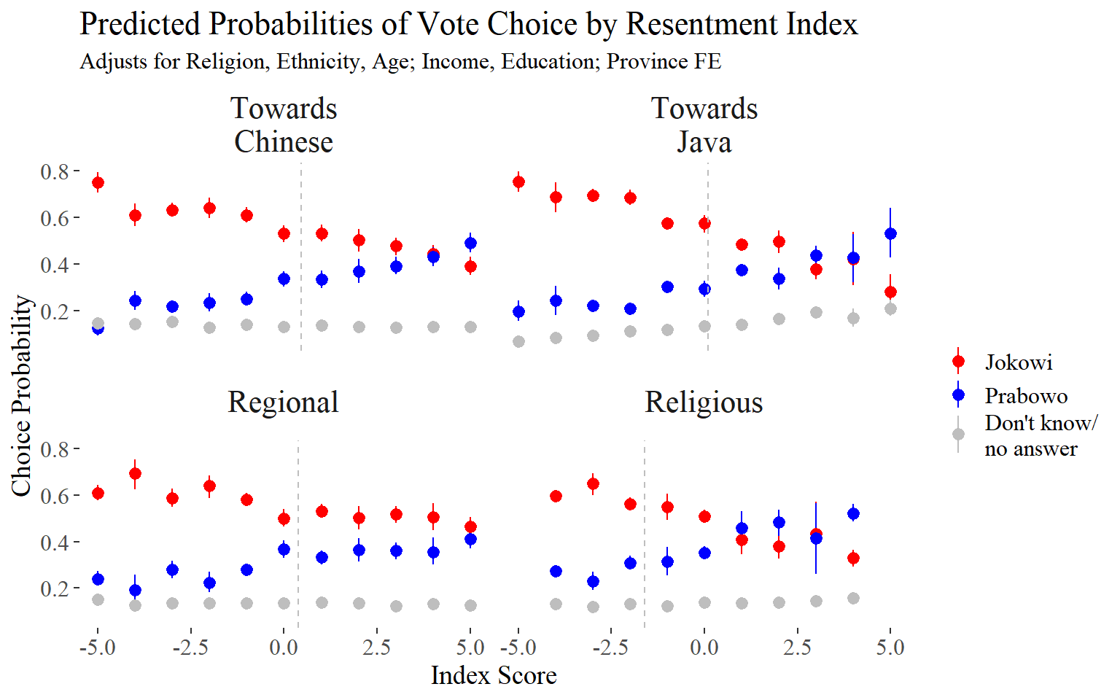
Viewed as regression coefficients, we see that each of the four resentment indices is positively and significantly associated with Prabowo vote intention. The figures present, from top to bottom, coefficients and confidence intervals for age, income (in dollars), education level (primary completion, lower secondary, upper secondary, some tertiary), religion (Muslim or non-Muslim), and the relevant resentment index.
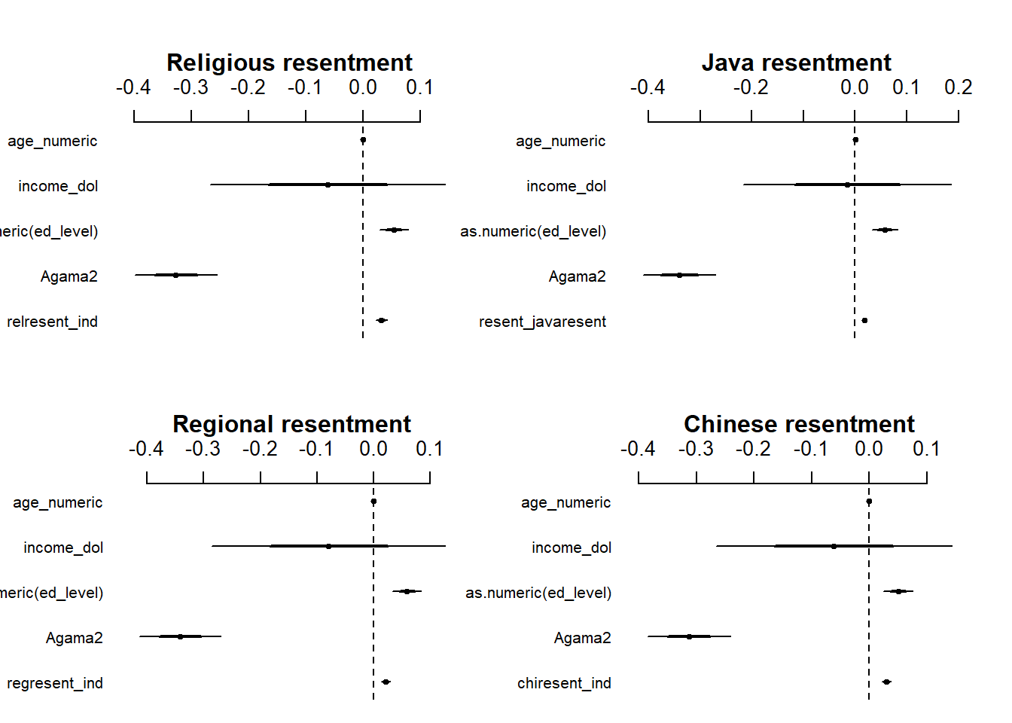

Resentment does not predict trust in democracy
We expected that respondents who scored high in resentment might be more likely to endorse anti-establishment views including distrust of democracy. The tight link between resentment and support for authoritarian populists in other parts of the world led us to this expectation. We find very little difference in the average resentment scores of those who do and do not support democracy, nor is there much difference in resentment between the respondents with a firm preference and respondents who see democracy and authoritarianism as interchangeable. Distrust of democracy is rare in Indonesia, and resentments do not seem to be associated with it.
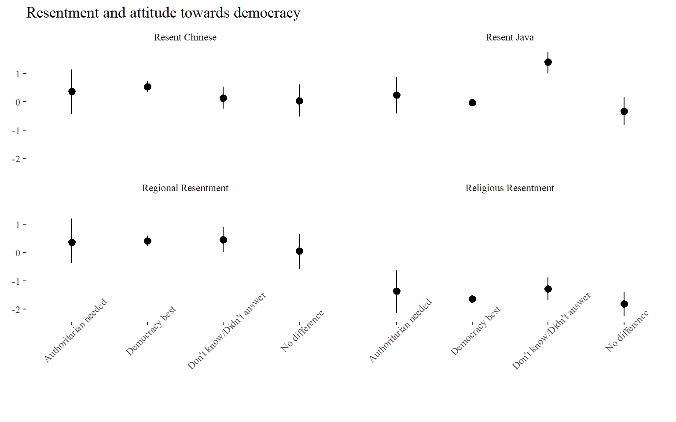

Party-level mean resentment scores
The higher average combined resentment scores of parties in the opposition coalition reflect the higher resentment scores of supporters of the two largest parties in Prabowo’s nominating coalition—Gerindra and PKS. Berkarya’s results should be taken with a grain of salt, as only three respondents indicated support for the party.
Average resentment scores in the Jokowi coalition are near average in most parties, with the moderately sized NasDem and very small PBB and PSI below the national mean.
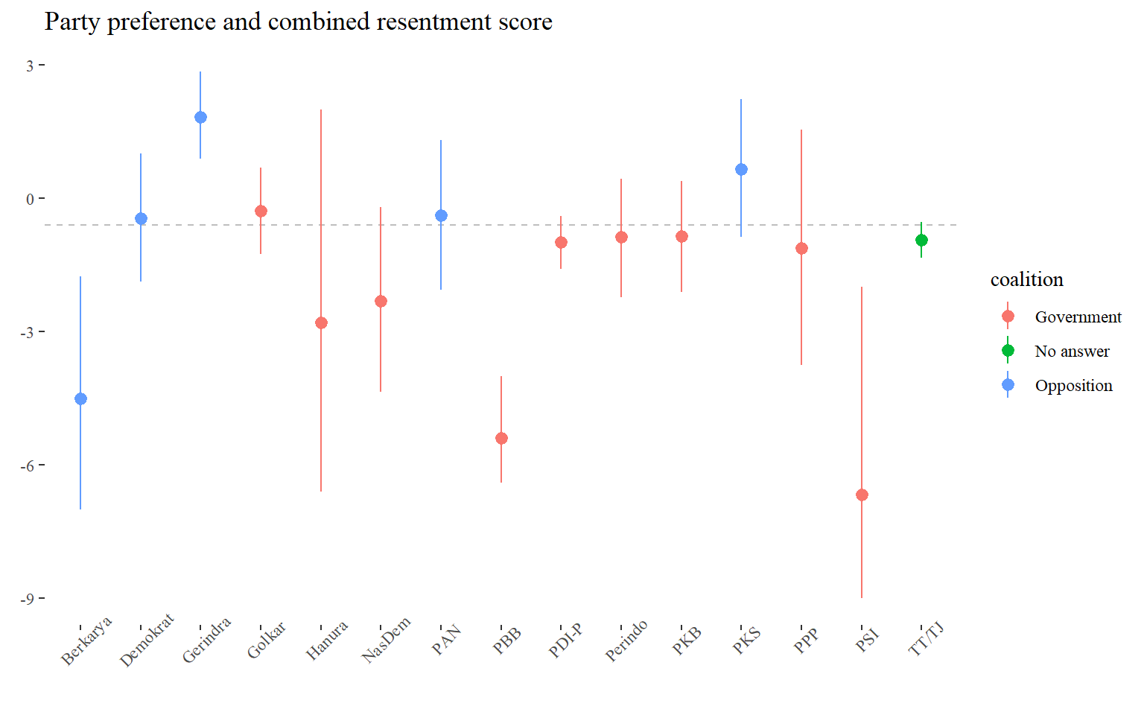

Regional resentment raw means and standard deviations
In the demographic sections, we present raw trends in the sample, rather than modeled coefficients or probabilities that result from models. With one exception—regional resentment is presented with modeled probabilities. This was done in the paper body because income and ethnicity are strongly correlated with district seat residence, and we wished to make sure that the result—consistently lower levels of resentment in district seats—was not the result of some other common demographic feature that we had overlooked. Here, we present the sample means and standard deviations. As with the modeled probabilities, regional resentment in particular is far lower among district seat residents (though not as low as the model median probability), while anti-Chinese and religious resentment are also meaningfully lower among district seat residents.
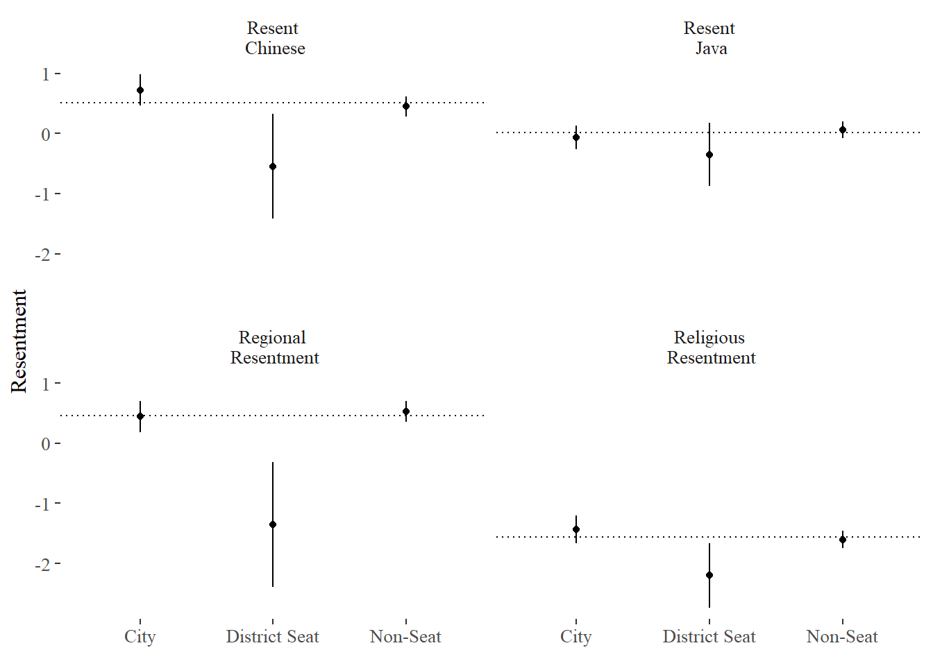

Age and resentment by political consciousness cohort
The body text presents trend lines with lines at important political dates—the advent of the full restrictions of the New Order in 1977, the beginning of democracy (reformasi) in 1999, and the election of Jokowi in 2014. Here, we pool the mean resentments scores for each age cohort. We note that the standard deviation on the post-Jokowi cohort is quite large, as this cohort is much smaller than the others—it consists of only five years of voters.
An important question in the paper is whether anti-Chinese and regional resentment are different today from their levels in the past. A two sample t-test indicates that, despite the large standard deviation on resentment in the post-Jokowi cohort, the mean resentment level is larger at a statistically significant level than all three previous cohorts. In the body, we present the continuous version of the variable, as it more clearly demonstrates that the difference is largely driven by the very youngest cohorts.
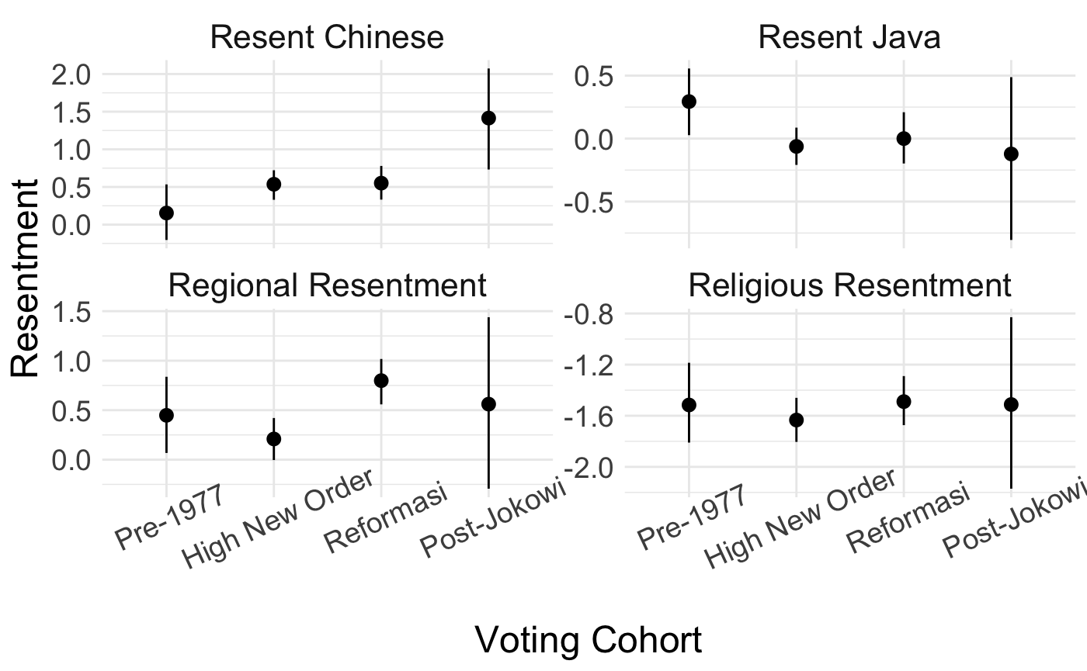

Is resentment dissatisfaction with the status quo?
At its most basic, resentment is the perception that an outgroup has received unfair advantages. The resentment approach is about measuring political attitudes associated with anger and blame attribution across preexisting social cleavage lines. Dissatisfaction with the status quo might or might not lead someone to blame a specific outgroup for the problems they observe. To understand whether resentment might largely be driven by dissatisfaction with the status quo, we turn to two general measures of attitudes about the current state of things. The first is a standard political question: “How would you rate the political situation in the country today?” The second is a standard economic question: “How would you rate the state of the economy today?”
It turns out that some having a low evaluation of the status quo makes one only marginally more likely to have high resentment. Conversely, the people with the best evaluations of the status quo do not always have the lowest resentment scores.
Figure 2 Resentment scores by evaluation of economy and political situation
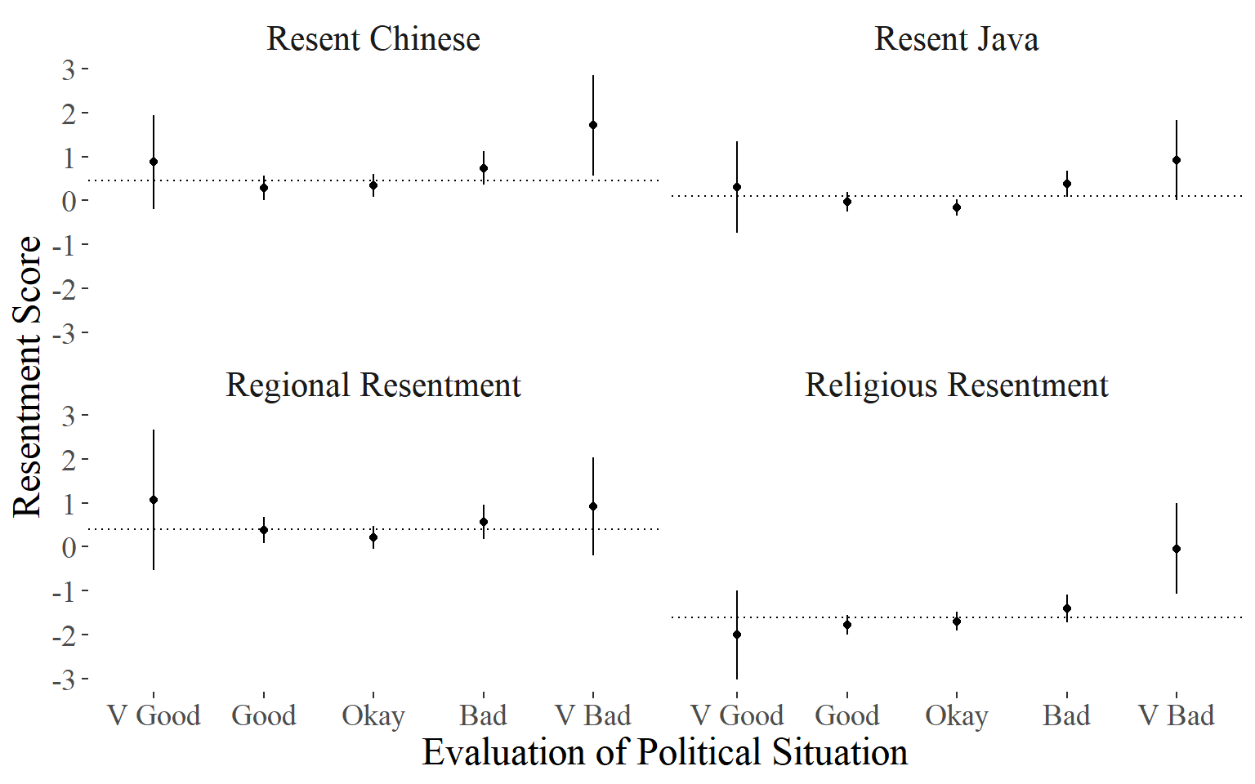
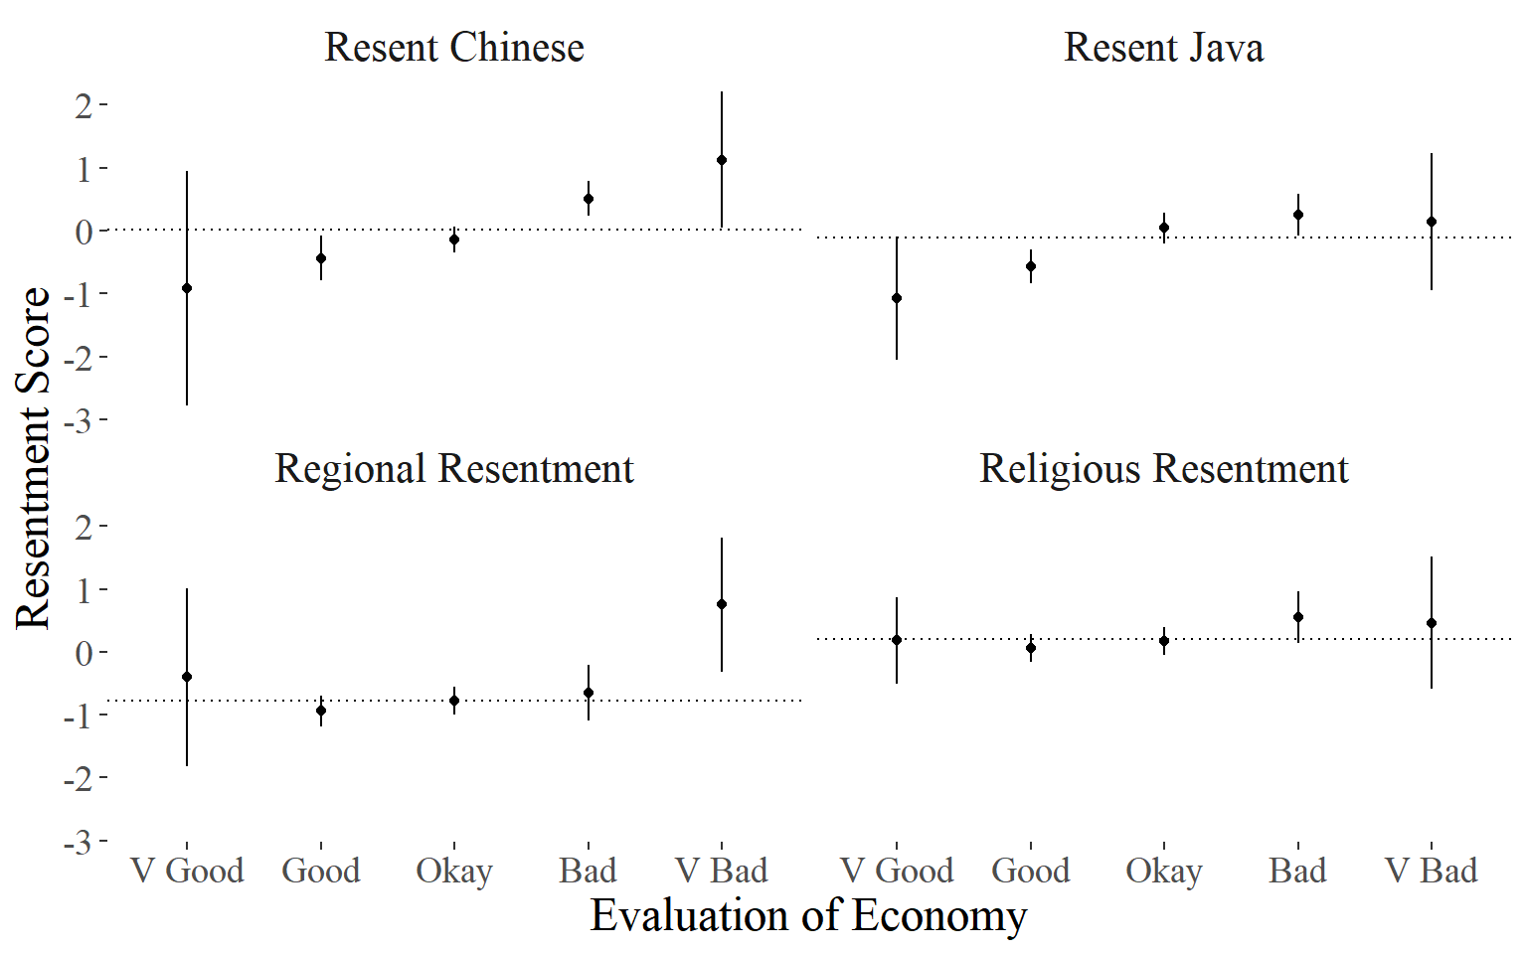
To the extent that a resentment index captures attitudes towards the government, as in the regional resentment question, we should expect strong correlation between general dissatisfaction and resentment. But it is not necessarily logical to conclude from the evaluation of the economy that a specific group of people is to blame. Thus, even though the religious resentment questions are explicitly about the economy, people with very pessimistic views of the economy have a slightly higher level of resentment that is still indistinguishable from the overall average—there is a lot of variance of religious resentment levels within the pessimistic group.
The wide variance on the “very good” and “very bad” conditions reflect the fact that few respondents choose “very” options on any surveys conducted in Indonesia. A more stringent approach might exclude these as people with clearly outlier views or personalities. Doing that yields positive but much smaller correlations between economy evaluation and resentment of Chinese Indonesians and of Java. The alternative approach of merging the “verys” with their milder counterparts moderately increases the average resentment level of pessimistic respondents in most but not all conditions.
It is telling that anti-Chinese resentment is consistently a strong predictor in these cases. This suggests that indeed, anti-Chinese resentment is connected to dissatisfaction with the status quo. But why should it be? The answer to that question is that a great deal of ideological work is being done (and for centuries has been done) to link ethnically Chinese Indonesians to the problems of the status quo. Having been told for most of their lives that the cause of their dissatisfaction is the Chinese, some Indonesians believe this, and we can see that in the data.
The key distinction between dissatisfaction with the status quo and resentment is that dissatisfaction does not have a target; resentment does. There might be reasons to be resentful other than dissatisfaction, but indeed, dissatisfaction should at least in some cases be common among people who are also resentful.
Our results indicate that whether the dissatisfied are resentful depends on the degree to which they see links between the target group of resentment and the causes of their dissatisfaction.

Youth (pemuda) organizations are often a kind of paramilitary organization.

