APPENDIX
Appendix A. Description of constructive and blind national pride
Appendix A1. Correlation coefficients
National pride | Constructive | Blind | General
Constructive | 1.000
Blind | -0.0068 | 1.0000
General | 0.2585** | 0.4132** | 1.0000
Note: ***p<0.01; **p<0.05; *p<0.1.
Appendix A2. Histogram of constructive and blind national pride
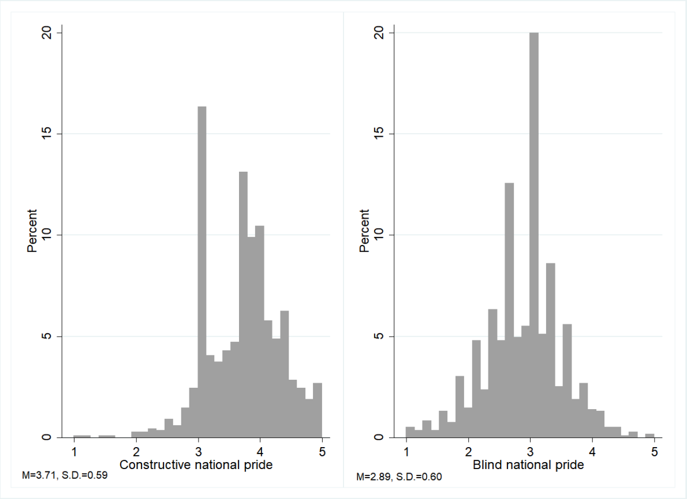
It is worth mentioning both constructive and blind national pride are subordinate concepts of general national pride. To reconfirm it, we present the correlation coefficients among constructive, blind, and general national pride (“How proud are you of being a Korean citizen?”; four-point-scale: 1 “not proud at all” to 4 “very proud”) in Appendix A1. It shows that the relationship among the three variables appears as expected in accordance with the conceptual distinction. Each subtype of national pride shows a significant and positive correlation coefficient with general national pride, which implies that the latter is the superordinate concept of the two. Also, the coefficient between constructive and blind national pride is negative though it does not reach the conventional significance level.
Next, to depict the distribution of the two types of national pride among Korean voters, we plot each histogram in Appendix A2. The figure shows that the mean value of constructive and blind national pride is 3.71 (SD = 0.59) and 2.89 (SD = 0.60), respectively, which suggests that Koreans have a higher level of constructive national pride than blind national pride (t = 33.88; p = 0.00).

Appendix B. Summary statistics
Variable | N | Mean | Std. dev. | Min. | Max.
Voter turnout | 1,236 | 0.87 | 0.33 | 0 | 1
Constructive national pride | 1,236 | 3.71 | 0.59 | 1 | 5
Blind national pride | 1,236 | 2.89 | 060 | 1 | 5
Political cohorts | 1,236 | 2.58 | 1.17 | 1 | 5
Political ideology | 1,198 | 4.65 | 2.05 | 0 | 10
Political knowledge | 1,236 | 2.79 | 1.12 | 0 | 4
Political interest | 1,236 | 2.72 | 0.73 | 1 | 4
Internal political efficacy | 1,236 | 2.48 | 0.57 | 1 | 4
External political efficacy | 1,236 | 2.27 | 0.67 | 1 | 4
Partisanship (independent) | 1,198 | 0.24 | 0.43 | 0 | 1
Strength of political ideology | 1,198 | 1.44 | 1.49 | 0 | 5
Age | 1,236 | 43.3 | 11.1 | 20 | 78
Gender (female) | 1,231 | 0.46 | 0.49 | 0 | 1
Education | 1,236 | 1.99 | 0.51 | 1 | 3
Income | 1,236 | 5.58 | 2.48 | 1 | 11
Employment | 1,236 | 0.75 | 0.41 | 0 | 1
Source: Survey data of Korea

Appendix C. Constructive and blind national pride and political psychological resources
Variable | Model A1  (Political knowledge) | Model A2  (Political interest) | Model A3  (Internal political efficacy) | Model A4  (External political efficacy) | Model A5  (Partisanship; Independent)
Constructive national pride | 0.44***  (0.05) | 0.29***  (0.03) | 0.16***  (0.02) | -0.05*  (0.03) | -0.65***  (0.13)
Blind national pride | -0.21***  (0.05) | 0.02  (0.03) | -0.18***  (0.02) | 0.10***  (0.03) | -0.56***  (0.13)
Political cohorts | 0.05*  (0.02) | 0.03*  (0.01) | 0.02  (0.01) | -0.04**  (0.01) | -0.01  (0.06)
Political ideology | -0.03**  (0.01) | -0.01  (0.00) | -0.00004  (000) | -0.03***  (0.00) | 0.13**  (0.05)
Strength of ideology | 0.02  (0.02) | 0.07***  (0.01) | 0.03***  (0.01) | 0.03**  (0.01) | -0.59***  (0.06)
Gender (female) | -0.42***  (0.0) | -0.14***  (0.04) | -0.17***  (0.03) | 0.007  (0.04) | 0.55***  (0.15)
Education | 0.02  (0.06) | 0.09**  (0.03) | 0.06**  (0.03) | 0.07**  (0.03) | -0.11  (0.15)
Income | 0.01  (0.01) | 0.005  (0.00) | 0.03***  (0.00) | 0.01**  (0.00) | -0.03  (0.03)
Employment | 0.05  (0.07) | 0.08  (0.05) | -0.01  (0.04) | 0.04  (0.05) | -0.27  (0.18)
Constant | 1.85***  (0.29) | 1.21***  (0.19) | 2.06***  (0.15) | 2.12***  (0.18) | 3.13***  (0.81)
R-squared  AIC  BIC  N | 0.1271  1,195 | 0.1460  1,195 | 0.1382  1,195 | 0.0433  1,195 | 1105.125  1155.984  1,195
Note: Coefficients and standard errors from OLS (Model A1-A4) or binary logistic models (Model A5). AIC: Akaike information criterion; BIC: Bayesian information criterion. ***p<0.01; **<0.05; *p<0.1 (two-tailed).

Appendix D. Blind national pride, age, and voter turnout
Appendix D1. Blind national pride, age, and voter turnout
Variable | Additive Models |  | Interactive Models
 | Model A6 | Model A7 | Model A8
Constructive national pride | 1.03***  (0.16) | 0.59***  (0.18) | 0.61***  (0.18)
Blind national pride | 0.40**  (0.17) | 0.36*  (0.19) | -1.46*  (0.76)
Age | 0.01  (0.009) | 0.005  (0.01) | -0.12**  (0.05)
Blind × Age |  |  | 0.04**  (0.01)
Political knowledge |  | 0.28***  (0.09) | 0.29***  (0.09)
Political interest |  | 0.71***  (0.15) | 0.74***  (0.15)
Internal political efficacy |  | 0.20  (0.22) | 0.23  (0.22)
External political efficacy |  | -0.12  (0.17) | -0.14  (0.18)
Partisanship (independent) |  | -1.19***  (0.22) | -1.17***  (0.22)
Political ideology | -0.06  (0.06) | -0.02  (0.06) | -0.02  (0.06)
Strength of political ideology | 0.29***  (0.07) | 0.10  (0.08) | 0.09  (0.08)
Gender (female) | -0.17  (0.19) | 0.20  (0.22) | 0.19  (0.22)
Education | 0.34*  (0.19) | 0.20  (0.20) | 0.19  (0.20)
Income | 0.03  (0.04) | 0.01  (0.04) | 0.02  (0.04)
Employment | 0.17  (0.23) | 0.02  (0.24) | 0.03  (0.24)
Constant | -4.18***  (1.01) | -4.25***  (1.17) | 0.67  (2.30)
Log-likelihood  AIC  BIC  N | -377.5988  775.1976  826.0566  1,195 | -334.0457  698.0914  774.3799  1,195 | -330.7788  693.5575  774.9319  1,195
Note: Coefficients and standard errors are from binary logistic models. AIC: Akaike information criterion; BIC: Bayesian information criterion. ***p<0.01; **<0.05; *p<0.1.

Appendix D2. Blind national pride, age, and voter turnout
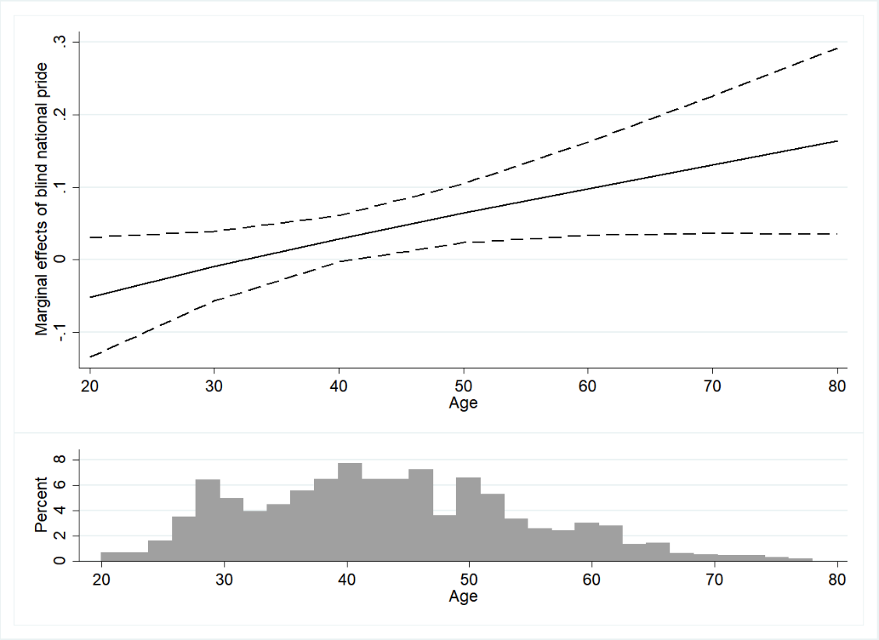
Note: Marginal effects are from Model A8 (Appendix D1). Other variables are fixed at their means or medians. Dashed lines indicate the 95% confidence intervals.

Appendix E. Constructive national pride and turnout conditional on cohorts and age
Variable | Model A9 | Model A10 | Model A11
Constructive national pride | 0.30  (0.39) | 0.007  (0.68) | 0.87*  (0.49)
Blind national pride | 0.38*  (0.19) | 0.36*  (0.19) | 0.38*  (0.19)
Political cohorts | -0.40  (0.53) |  | 0.02  (0.09)
Constructive national pride × Cohorts | 0.12  (0.15)
Age |  | -0.04  (0.05)
Constructive national pride × Age |  | 0.01  (0.01)
Political ideology | -0.02  (0.06) | -0.03  (0.06) | 0.15  (0.31)
Constructive national pride × Ideology |  |  | -0.05  (0.08)
Political knowledge | 0.28***  (0.09) | 0.28***  (0.09) | 0.28***  (0.09)
Political interest | 0.71***  (0.15) | 0.71***  (0.15) | 0.70***  (0.15)
Internal political efficacy | 0.19  (0.22) | 0.18  (0.22) | 0.22  (0.22)
External political efficacy | -0.11  (0.18) | -0.10  (0.18) | -0.12  (0.17)
Partisanship (independent) | -1.17***  (0.22) | -1.17***  (0.22) | -1.19***  (0.22)
Strength of political ideology | 0.10  (0.08) | 0.09  (0.08) | 0.09  (0.08)
Gender (female) | 0.20  (0.22) | 0.21  (0.22) | 0.18  (0.22)
Education | 0.19  (0.20) | 0.20  (0.20) | 0.20  (0.20)
Income | 0.02  (0.04) | 0.02  (0.04) | 0.02  (0.04)
Employment | 0.03  (0.24) | 0.03  (0.24) | 0.01  (0.24)
Constant | -3.17*  (1.63) | -2.24  (2.55) | -5.10**  (1.99)
Log-likelihood  AIC  BIC  N | -333.7901  699.5803  780.9547  1,195 | -333.6473  699.2947  780.6691  1,195 | -333.9607  699.9213  781.2958  1,195
Note: Coefficients and standard errors from binary logistic models. AIC: Akaike information criterion; BIC: Bayesian information criterion. ***p<0.01; **<0.05; *p<0.1 (two-tailed).

Appendix F. Alternative data: 2003 and 2013 International Social Survey Programme (ISSP)
Because the ISSP data contain a measure for blind national pride, the variable of our interest, we believe it is appropriate alternative data and thus use its South Korean sample. Our independent variable is blind national pride. The ISSP asked respondents to answer the following question: “How much do you agree or disagree with the following statement? People should support their country even if the country is in the wrong.” Respondents selected one of the five-point scale responses from “strongly agree” (1) to “strongly disagree” (5), and we reverse-coded so that higher values indicate stronger blind national pride. Though prior studies used multiple items and so did our analysis in the manuscript, we use a single measure when analyzing the ISSP because it is the only item that the ISSP contains (ISSP Research Group 2015). Nevertheless, the question wording taps the core components of blind national pride: “unquestioning endorsement of or unconditional support for one’s country” (Sumino 2021, 929). However, the ISSP does not include questions for constructive national pride. Nevertheless, the data is still useful to test the relationship between blind national pride and voter turnout.
The dependent variable is voter turnout. To measure it, we use the following question: “Did you vote in last election?” This variable is coded 1 if a respondent voted and 0 if not. Our models also include several control variables: gender (1 = “female”; 0 = “male”); education (years of schooling), socioeconomic class (self-placement of subjective class perception, 1 = “lowest”; 10 = “highest”), and employment (0 = “not employed”; 1 = “employed”). Summary statistics of all variables is presented in Appendix F1. However, due to the lack of an appropriate question to measure political ideology (Hypothesis 4), we present our findings regarding Hypothesis 2 and Hypothesis 3. As Appendix F2 and F3 show, those with higher levels of blind national pride are more likely to go to the polls (Hypothesis 2), and the positive relationship between blind national pride and voter turnout appears more robust among older cohorts (Hypothesis 3), even when analyzing with the alternative data.
Appendix F1. Summary statistics
Variable | N | Mean | Std. dev. | Min. | Max.
Voter turnout | 2,514 | 0.86 | 0.33 | 0 | 1
Blind national pride | 2,594 | 3.49 | 1.20 | 1 | 5
Gender (female) | 2,609 | 0.52 | 0.49 | 0 | 1
Education | 2,536 | 12.63 | 3.48 | 0 | 23
Socioeconomic class | 2,598 | 4.62 | 1.58 | 1 | 10
Employment | 2,605 | 0.54 | 0.49 | 0 | 1
Source: The 2003 and 2013 ISSP (South Korean sample)
Appendix F2. Blind national pride and voter turnout
Variable | Model A12 | Model A13
Blind national pride | 0.15***  (0.05) | 0.11  (0.13)
Political cohorts | 0.47***  (0.05) | 0.43***  (0.13)
Blind national pride × Cohorts |  | 0.01  (0.03)
Gender (female) | -0.14  (0.12) | -0.14  (0.12)
Education | 0.06***  (0.02) | 0.07***  (0.02)
Socioeconomic class | -0.02  (0.04) | -0.02  (0.04)
Employment | -0.16  (0.13) | -0.16  (0.13)
Constant | -1.23***  (0.46) | -1.09*  (0.60)
Year FE | Yes | Yes
Log-likelihood  AIC  BIC  N | -897.4686  1810.937  1857.266  2,419 | -897.4048  1812.81  1864.93  2,419
Note: Coefficients and standard errors from binary logistic models. AIC: Akaike information criterion; BIC: Bayesian information criterion. ***p<0.01; **<0.05; *p<0.1 (two-tailed).

Appendix F3. Blind national pride and voter turnout conditional on cohorts
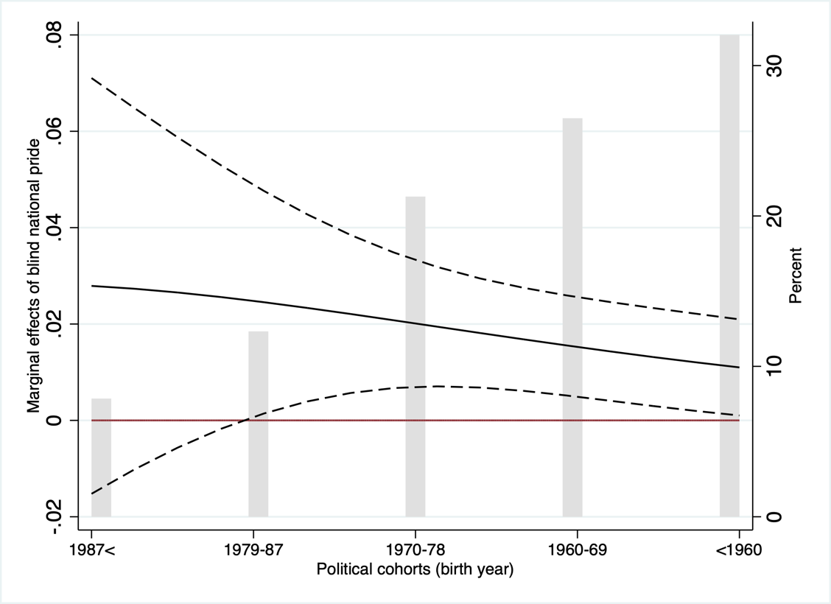
Note: Marginal effects are from Model A13 (Appendix F1). Other variables are fixed at their means or medians. Dashed lines indicate the 95% confidence intervals.

Appendix G. Blind national pride and voter turnout (older cohorts; birth year<1979)
Variable | Model A14 | Model A15
Constructive national pride | 0.84***  (0.31) | 0.82***  (0.31)
Blind national pride | 0.64*  (0.34) | 0.57*  (0.34)
Age |  | 0.03  (0.02)
Political knowledge | 0.27*  (0.15) | 0.25*  (0.15)
Political interest | 0.61**  (0.24) | 0.62**  (0.24)
Internal political efficacy | -0.15  (0.36) | -0.20  (0.36)
External political efficacy | -0.20  (0.29) | -0.13  (0.29)
Partisanship (independent) | -1.52***  (0.36) | -1.50***  (0.36)
Political ideology | -0.06  (0.10) | -0.07  (0.10)
Strength of political ideology | 0.10  (0.13) | 0.11  (0.13)
Gender (female) | -0.20  (0.36) | -0.16  (0.36)
Education | 0.36  (0.29) | 0.50  (0.31)
Income | -0.002  (0.07) | -0.01  (0.07)
Employment | -0.38  (0.43) | -0.25  (0.44)
Constant | -3.48*  (02.04) | -5.38**  (02.47)
Log-likelihood  AIC  BIC  N | -135.7801  299.5602  361.8003  630 | -134.7972  299.5945  366.2802  630
Note: Coefficients and standard errors from binary logistic models. AIC: Akaike information criterion; BIC: Bayesian information criterion. ***p<0.01; **<0.05; *p<0.1 (two-tailed).

Appendix H. Analysis using an alternative index of blind national pride
Appendix H1. Constructive and blind national pride and voter turnout in South Korea
Variable | Additive Models |  | Interactive Models
 | Model A16 | Model A17 | Model A18 | Model A19
Constructive national pride | 1.01***  (0.16) | 0.57***  (0.18) | 0.59***  (0.18) | 0.56***  (0.18)
Blind national pride | 0.48***  (0.16) | 0.45**  (0.18) | -0.30  (0.42) | -0.25  (0.48)
Political cohorts | 0.09  (0.08) | 0.02  (0.09) | -0.90*  (0.46) | 0.02  (0.09)
Blind × Cohorts |  |  | 0.33**  (0.16)
Political ideology | -0.05  (0.06) | -0.02  (0.06) | -0.02  (0.06) | -0.43  (0.26)
Blind × Political ideology |  |  |  | 0.14  (0.09)
Political knowledge |  | 0.28***  (0.09) | 0.29***  (0.09) | 0.29***  (0.09)
Political interest |  | 0.71***  (0.15) | 0.73***  (0.15) | 0.75***  (0.15)
Internal political efficacy |  | 0.20  (0.22) | 0.23  (0.22) | 0.20  (0.22)
External political efficacy |  | -0.14  (0.17) | -0.15  (0.18) | -0.16  (0.18)
Partisanship (independent) |  | -1.17***  (0.22) | -1.15***  (0.22) | -1.15***  (0.22)
Strength of political ideology | 0.29***  (0.07) | 0.10  (0.08) | 0.10  (0.08) | 0.13  (0.08)
Gender (female) | -0.17  (0.19) | 0.18  (0.22) | 0.19  (0.22) | 0.20  (0.22)
Education | 0.32*  (0.19) | 0.18  (0.20) | 0.18  (0.20) | 0.19  (0.20)
Income | 0.03  (0.04) | 0.02  (0.04) | 0.02  (0.04) | 0.01  (0.04)
Employment | 0.17  (0.23) | 0.01  (0.24) | 0.03  (0.24) | 0.02  (0.24)
Constant | -4.13***  (0.95) | -4.21***  (1.11) | -2.30  (1.47) | -2.27  (1.65)
Log-likelihood  AIC  BIC  N | -376.1165  772.2329  823.092  1,195 | -333.1077  696.2154  772.5039  1,195 | -331.0591  694.1182  775.4926  1,195 | -331.8159  695.6319  777.0063  1,195
Note: Coefficients and standard errors are from binary logistic models. AIC: Akaike information criterion; BIC: Bayesian information criterion. ***p<0.01; **<0.05; *p<0.1.

Appendix H2. Conditional effects of political cohorts and political ideology
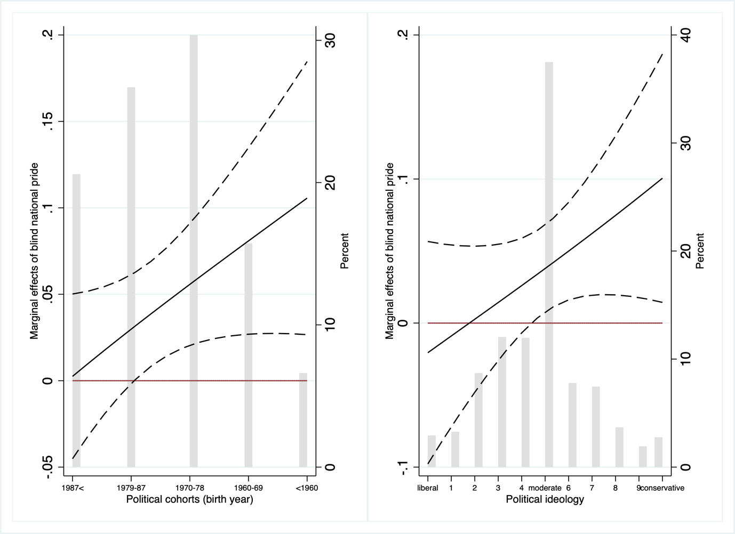
Note: Marginal effects are from Model A18 (left panel) and Model A19 (right panel). Dashed lines indicate 95% confidence intervals.

Appendix I. Pride in national economic achievement and blind national pride
Variable | Model A20 | Model A21 | Model A22
Pride in economic achievement | 0.18***  (0.01) | 0.16***  (0.01) | 0.16***  (0.01)
Political cohorts |  | 0.05***  (0.01) | 0.06***  (0.01)
Political ideology |  | -0.02***  (0.008) | -0.02***  (0.007)
Political knowledge |  |  | -0.06***  (0.01)
Political interest |  |  | 0.001  (0.02)
Internal political efficacy |  |  | -0.27***  (0.03)
External political efficacy |  |  | 0.13***  (0.02)
Partisanship (independent) |  |  | -0.12***  (0.04)
Strength of political ideology |  | 0.03***  (0.01) | 0.03***  (0.01)
Gender (female) |  | 0.03  (0.03) | -0.03  (0.03)
Education |  | -0.06*  (0.03) | -0.04  (0.03)
Income |  | -0.01  (0.007) | -0.001  (0.006)
Employment |  | 0.08*  (0.04) | 0.06  (0.04)
Constant | 2.23***  (0.06) | 2.32***  (0.11) | 2.81***  (0.14)
R-squared  N | 0.0737  1,236 | 0.1008  1,195 | 0.1857  1,195
Note: Coefficients and standard errors from OLS regression models. ***p<0.01; **<0.05; *p<0.1 (two-tailed).

