Appendix
Appendix Table A1 Event Evaluations
These event evaluation questions were only asked of participants post-deliberation. The questions E1 through E4 are on a 0 to 10 scale, where 0 is a waste of time and 10 is extremely valuable. The questions E5A through E5E are on a 1 to 5 scale, where 5 is strongly agree.

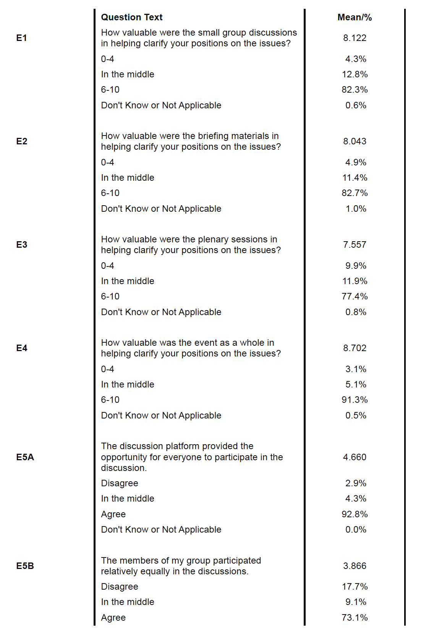

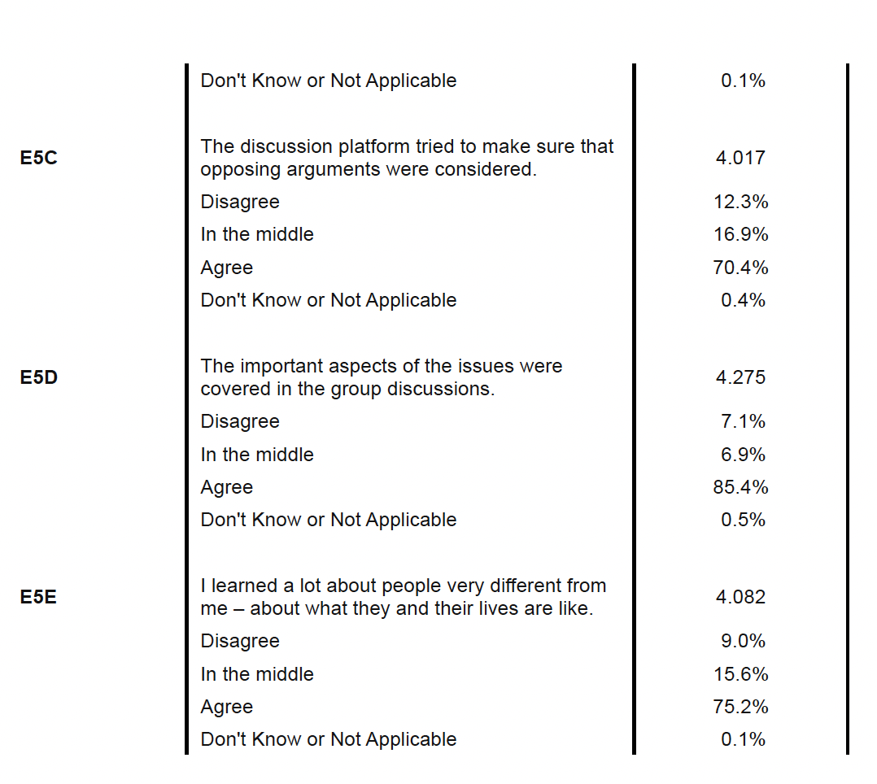

Appendix Table A2: Balance Table: Comparison of Treatment and Control Groups
 | (1) | (2) | (3)
 | Participant Group | Control Group | Difference (2)-(1)
 | Mean | mean | Diff. | p-value
Some College or Above | 0.66 | 0.59 | -0.07** | 0.010
Male | 0.48 | 0.49 | 0.01 | 0.739
Over 60 | 0.33 | 0.31 | -0.02 | 0.411
White | 0.61 | 0.63 | 0.02 | 0.453
Married | 0.49 | 0.52 | 0.02 | 0.400
Employed | 0.60 | 0.61 | 0.02 | 0.535
HH Inc. <$30,000 | 0.20 | 0.23 | 0.02 | 0.284
Home Owner | 0.66 | 0.74 | 0.07*** | 0.003
From Non-Metro | 0.13 | 0.14 | 0.01 | 0.573
Share Lean Democrat | 0.46 | 0.46 | 0.00 | 0.911
Share Lean Republican | 0.36 | 0.39 | 0.03 | 0.302
Policy-Based Score, T1 | 3.74 | 3.97 | 0.23* | 0.095
Policy-Based Score, T2 | 3.30 | 3.98 | 0.68*** | 0.000
Policy-Based Score, T3 | 3.75 | 4.29 | 0.54*** | 0.000
Intended to vote, T3 | 0.77 | 0.75 | -0.02 | 0.433
Observations | 845 | 574 | 1419
* p < 0.10, ** p < 0.05, *** p < 0.01

For respondents in treatment and control groups who completed all three waves.

Addendum on Causal Mediation Analysis

The traditional method of exploring relationships between a treatment and outcomes is by using a regression model. However, this method fails to disentangle underlying causes and effects that are indirect rather than direct. In our case, we know that there is an effect of participating in the deliberations on an individual’s climate preferences and it seems to have an impact on electoral preferences over a year out. It is, however, unsatisfactory to state that participating in the deliberations is the direct cause of these electoral preferences: surely there were intermediate steps caused by the deliberations that, when taken together, affect these outcomes.

When faced with the possibility of indirect effects, investigators may have prior knowledge that an explanatory variable plausibly exerts its effect on an outcome via direct and indirect pathways. In the indirect pathway, there exists a mediator that transmits the causal effect. In this section, we outline mediation analysis following along closely with the discussion of mediation analysis in Fishkin et al 2024.

Suppose we have variables T and Y indicating the treatment variable and outcome variable, respectively. Mediation in its simplest form involves adding a mediator M between T and Y. The sequential ignorability assumption, critical to causal mediation analysis, states that the treatment (explanatory variable T) is first assumed to be ignorable given the pre-treatment covariates, and then the mediator variable (M) is assumed to be ignorable given the observed value of the treatment as well as the pre-treatment covariates (Imai et al. 2010; Imai et al. 2011).

The first part is often satisfied by randomization, while the second part implies that there are no unmeasured confounding variables between mediator and outcome. The standard mediation analysis starts with three equations, usually modeled with continuous outcomes (though advances in methods now allow for most parametric modeling approaches for stage of the mediation):
Y = i₁ + cT + e₁ [1]
Y = i₂ + c'T + bM + e₂ [2]
M = i₃ + aT + e₃ [3]
where i₁, i_{2,} and i₃ denote intercepts, Y is the outcome variable, T is the treatment variable, M is the mediator, c is the coefficient linking T and Y (total causal effect), c' is the coefficient for the effect of T on Y adjusting for M (direct effect), b is the effect of M on Y adjusting for explanatory variables, and a is the coefficient relating to the effect of T on M. e₁, e_{2,} and e₃ are residuals that are uncorrelated with the variables in the right-hand side of the equation and are independent of each other. Under this specific model, the causal mediation effect (CME) is represented by the product coefficient of ab. Of note, Eq. [3] can be substituted into Eq. [2] to eliminate the term M:
Y = i₂ + bi₃ + (c' + ab)T + e₂ + be₃ [4]
It appears that the parameters related to direct (c') and indirect effect (ab) of T on Y are different from that of their total effect. That is, testing the null hypothesis c=0 is unnecessary since CME can be nonzero even when the total causal effect is zero (i.e., direct and indirect effects can be opposite), which reflects the effect cancellation from different pathways.

This standard setting for mediation analysis was refined and brought into the potential outcomes framework in Imai et al. (2011). The authors propose a set of methods that unifies the approach to identifying direct and indirect effects, relying on a set of assumptions that are more readily testable than classical mediation analysis provides.

For each mediator, we estimated:
1st stage:
Worry Climate Scale_{T1-T2} ~ c*Treatment + PBS_{T1} + Demographic Controls_{T1}
Worry Climate Scale_{T1-T3} ~ c*Treatment + PBS_{T1} + Demographic Controls_{T1}
Climate Belief Scale_{T1-T2} ~ c*Treatment + PBS_{T1} + Demographic Controls_{T1}
Climate Belief Scale_{T1-T3} ~ c*Treatment + PBS_{T1} + Demographic Controls_{T1}
Climate Knowledge Scale_{T1-T2} ~ c*Treatment + PBS_{T1} + Demographic Controls_{T1}
Climate Knowledge Scale_{T1-T3} ~ c*Treatment + PBS_{T1} + Demographic Controls_{T1}

2nd stage:
Outcome_{1,2} ~ Worry Climate Scale_{T1-T2} + c*Treatment + PBS_{T1} + Demographic Controls_{T1}
Outcome_{1,2} ~ Worry Climate Scale_{T1-T3} + c*Treatment + PBS_{T1} + Demographic Controls_{T1}
Outcome_{1,2} ~ Climate Belief Scale_{T1-T2} + c*Treatment + PBS_{T1} + Demographic Controls_{T1}
Outcome_{1,2} ~ Climate Belief Scale_{T1-T3} + c*Treatment + PBS_{T1} + Demographic Controls_{T1}
Outcome_{1,2} ~ Climate Knowledge Scale_{T1-T2} + c*Treatment + PBS_{T1} + Demographic Controls_{T1}
Outcome_{1,2} ~ Climate Knowledge Scale_{T1-T3} + c*Treatment + PBS_{T1} + Demographic Controls_{T1}

Where Outcome_{1,2} refers to Climate Importance on Vote Choice? (T3) and Support Democratic Control of Congress (T3), respectively. To estimate the mediation effects, we utilized a mixed effects regression framework, with demographic controls and random intercepts at the state level. Demographic controls include education; gender; age; race; marital status; employment status; income level; home ownership status; metro/rural area of residence, and party ID. For consistency, we use the same sets of controls and regression modeling specifications for each of the models.

Appendix Table A3: Average Causal Mediated Effect (ACME) of Participation in A1R (95% CI) Middle Only
 |  | Dependent Variable
Mediator |  |  | Climate Importance on Vote Choice? | Congress Control Vote Preference (GOP)
 | Worry Climate Scale  Δ T1 -> T2 |  | 0.0275  (-0.019, 0.091) | -0.0011  (-0.0121, 0.013)
 | Worry Climate Scale  Δ T1 -> T3 |  | 0.0537  (-0.019, 0.14) | 0.0014  (-0.006, 0.021)
 | Climate Belief Scale  Δ T1 -> T2 |  | 0.0136  (-0.061, 0.091) | -0.0156  (-0.0145, 0.014)
 | Climate Belief Scale  Δ T1 -> T3 |  | 0.0891*  (-0.0131, 0.21) | -0.0054  (-0.0171, 0.004)
 | Climate Knowledge Scale  Δ T1 -> T2 |  | 0.0678  (-0.061, 0.212) | -0.0084  (-0.014, 0.025)
 | Climate Knowledge Scale  Δ T1 -> T3 |  | 0.0181  (-0.021, 0.071) | -0.0041  (-0.0019, 0.011)
 | Observations |  | 409 | 425
*p < .1; **p < .05; ***p < .01
Note: Each model is fit using a generalized linear mixed effects model for both the mediators and the dependent variables—linear models for each of the mediators and for the dependent variables. Random intercepts were fit at the state level. Models include the same sets of demographic controls as well as respondent PBS. Observations include participants and control groups members. Models are fit using the ‘mediation’ package in R with 95% CI included in the parenthesis.

Ethical Issues and Recruitment
The deliberators and the pre/post control group were recruited by NORC from its AmeriSpeak probability based national panel. As NORC describes it, AmeriSpeak® is:
“A large probability-based panel funded and operated by NORC at the University of Chicago. AmeriSpeak® is designed to be representative of the U.S. household population, including all 50 states and the District of Columbia. U.S. households are randomly selected with a known, non-zero probability from the NORC National Frame as well as addressbased sample (ABS) frames, and then recruited by mail, telephone, and by field interviewers face to face. AmeriSpeak panelists participate in NORC studies or studies conducted by NORC on behalf of governmental agencies, academic institutions, the media, and commercial organizations. …The AmeriSpeak Panel expanded to approximately 30,000 households in 2018 and 35,000 households in 2019 through further recruitment efforts. The 2020 recruitment is expected to expand the panel by another 5,000 households. The current panel size is 48,900 panel members age 13 and over residing in over 40,000 households.”
Hard to reach populations are brought into the panel through “Non Response Follow Up” (NRFU):
“NRFU recruitment significantly improves the representation of the panel with respect to demographic segments that are under-represented among the respondents to the initial recruitment, including young adults (persons 18 to 34 years of age), African Americans, Hispanics, lower income households, renters, cell-phone only households, and persons with lower educational attainment (e.g., no college degree). To the extent that these demographic characteristics are correlated with substantive survey variables, NRFU helps to reduce potential non-response bias in the sample estimates.”
Participants in the deliberations were assisted by NORC’s “concierge method” to overcome any barriers to participation, such as the need for special assistance, internet connectivity, child care, extra support for those with special needs All deliberators were compensated the equivalent of $300 plus some meals (for delivery). Control groups and the follow up survey were compensated with NORC’s standard rewards for survey completions. Informed consent was obtained, not only from their membership in the panel but also for this specific project.
The project was approved not only by the IRB from NORC at the University of Chicago but also from the IRB from Stanford University 35343.

Sampling and Weighting for Treatment and Control Groups

A general population sample of U.S. adults aged 18 or older was selected from NORC’s AmeriSpeak Panel for the control group of this study. Because an oversample of adults living in Texas and California was being selected for the study, a second general population sample of U.S. adults aged 18 or older and a separate oversample of adults aged 18 or older living in California or Texas were selected for the treatment group of this study.
The U.S. adult samples for this study was selected from the AmeriSpeak Panel using probability proportional to size sampling, where the measure of size was calculated based on each panelist’s panel weight, average panelists’ historical survey completion rate, and previous AmeriSpeak A1R survey completion rates. The independent samples were drawn to create representative treatment and control samples that correspond to U.S adult population benchmarks derived from the February 2021 Current Population Survey.
- Age group (18-24, 25-49, 50+)
- Gender (2)
- Race/ethnicity (African American, Hispanic, Other)
- Census region (4)
- Rural/urban (2)
- Education (College, Other)
If the panel household had one more than one active adult panel member, only one adult in the household was eligible for selection (random within-household sampling). Previous A1R participants were eligible for selection.

Both surveys were offered in Spanish and English by web. The summary statistics on sample performance are shown below. Out of the 962 post-event survey completions in the treatment group 232 were from California and 99 from Texas. Out of the 671 post-event survey completions in the control group 73 were from California and 50 from Texas.

Appendix Table A4: Sample Performance Summary

Survey | No. of Sample Units Invited | No. of Survey Completions | Survey Completion Rate
Pre-Event Treatment Group | 24,519 | 7,980 | 32.5%
Post-Event Treatment Group | 1,0211 | 9622 | 94.22%
Pre-Event Control Group | 3,050 | 834 | 27.34%
Post-Event Control Group | 834 | 671 | 80.46%
1This is the number of respondents who completed the Pre-Event survey, attended two or more virtual events, and invited to the Post-Event survey
2This the number of respondents who completed the Pre-Event/Post-Event surveys and attended all virtual events

Weighting
The target population for this study is U.S. adults 18 years of age and older. The sampling frame is the full AmeriSpeak panel developed and maintained by NORC at the University of Chicago. Both the control and treatment samples are systematic samples with implicit demographic stratification. The treatment sample also features oversamples of Republicans, young adults 18-29, rural residents, and lower education adults. All AmeriSpeak panelists in California and Texas are included in the treatment sample to improve separate estimation for these two states.
NORC computed a final weight for each panelist who completed the both the pre- and post-event surveys to support design unbiased estimation. For both control and treatment groups, the final weight is developed in three general steps: (1) base weights to account for sample selection probabilities under the sample design, (2) nonresponse adjustments to compensate for sampled panelists who failed to complete the surveys, and (3) raking ratio adjustments to align the sample to key population benchmarks per census data. Data from the American Community Survey are used to derive the raking benchmarks.
The base weight is defined as the inverse of sample selection probabilities. It reflects the unequal selection probabilities associated with panel recruitments as well as sample selection for this study. The base weight compensates for population members that are not included in the sample. Nonresponse adjustments are computed by geographic and demographic variables. Key nonresponse adjustment variables include age, gender, race/ethnicity, and education. Finally, raking ratio adjustments align the weighted sample with the population, both nationally for the full sample and for California (CA) and Texas (TX) separately for the two area oversamples. The raking adjustments ensure that (1) the weighted national sample matches the national census population along the raking dimensions, and (2) the weighted CA and TX sample matches the respective state census population along the raking dimensions. The raking dimensions include interactions among geography (CA, TX, rest of US), race/ethnicity (Non-Hispanic White, Non-Hispanic Black, Hispanic, Non- Hispanic Other), age group (18-24, 25-29, 30-39, 40-49, 50-59, 60-64, 65+), education (high school or less, some college, college+), gender, and census division.
The treatment sample is also raked by a 7-category party ID variable, using the weighted party ID distribution of the control group sample as raking targets. This additional raking step is to make the two groups more comparable in their study related beliefs and attitudes prior to the deliberations.
Two normalized final weights are created from the population weights. The first normalized weights sum to the final sample size or number of complete surveys nationally. The second normalized weights sum to the final sample size or number of complete surveys both nationally and for CA, TX, and the rest of the U.S. The first weight should be used to support national estimation, and the second weight should be used to support estimation for CA, TX, and the rest of the U.S. separately.

Appendix Table A5 Difference in Difference Analysis
Participants vs Control [Weighted by Weight 1]
[DK/NA within Percentage Breakdown]

Participants |  |  | Participants | Difference | Control | Control | Difference | Diff of Diff
n = 962 |  |  | n = 671
ID | Prompt and Responses | T1 | T2 | T2-T1 | T1 | T2 | T2-T1 | Control- Participants
Q0A | How worried are you about the current condition of the natural environment in your local area? | 5.525 | 6.336 | 0.810 (0.000) | 5.493 | 5.405 | -0.089 (0.298) | -0.899 (0.000)
Q0B | How worried are you about the current condition of the natural environment in the United States? | 6.718 | 7.246 | 0.528 (0.000) | 6.544 | 6.574 | 0.030 (0.695) | -0.498 (0.000)
Q0C | How worried are you about the current condition of the natural environment in the earth as a whole? | 7.307 | 7.908 | 0.602 (0.000) | 7.009 | 7.030 | 0.021 (0.781) | -0.581 (0.000)
Q1A | Our planet is experiencing an increase in global temperatures that will greatly harm our quality of life. | 7.193 | 7.714 | 0.521 (0.000) | 7.020 | 6.913 | -0.107 (0.137) | -0.628 (0.000)
Q1B | Rising temperatures are caused by human activities that emit greenhouse gases, like carbon dioxide and methane, which trap heat in the atmosphere and warm the earth’s climate. | 6.925 | 7.683 | 0.758 (0.000) | 6.869 | 6.859 | -0.011 (0.886) | -0.769 (0.000)
Q1C | Failure to address these issues will threaten human life on earth within the next century. | 7.106 | 7.630 | 0.524 (0.000) | 6.987 | 6.672 | -0.315 (0.000) | -0.839 (0.000)
Q1D | In order to stop the increase in global temperatures, humans must stop adding to the total amount of climate-heating gases in the atmosphere, this is called Net Zero. | 6.808 | 7.630 | 0.822 (0.000) | 6.723 | 6.677 | -0.047 (0.582) | -0.869 (0.000)
Q1E | The U.S. must plan to reach net zero by 2050. | 6.475 | 6.998 | 0.524 (0.000) | 6.390 | 6.333 | -0.057 (0.532) | -0.581 (0.000)
Q2A | The U.S. should eliminate greenhouse gas emissions from coal as soon as possible, ideally by 2035. | 6.693 | 7.379 | 0.687 (0.000) | 6.401 | 6.330 | -0.071 (0.397) | -0.758 (0.000)
Q2B | The U.S. should eliminate greenhouse gas emissions from oil as soon as possible, ideally by 2050. | 6.428 | 6.950 | 0.522 (0.000) | 6.208 | 6.126 | -0.082 (0.361) | -0.604 (0.000)
Q2C | The U.S. should eliminate greenhouse gas emissions from natural gas as soon as possible, ideally by 2050. | 6.087 | 6.356 | 0.270 (0.001) | 5.892 | 5.906 | 0.014 (0.877) | -0.256 (0.033)
Q3A | The U.S. should eliminate the use of fossil fuels in the generation of electricity as soon as possible. | 6.498 | 6.983 | 0.486 (0.000) | 6.189 | 6.186 | -0.003 (0.975) | -0.488 (0.000)
Q3B | The U.S. should eliminate the use of fossil fuels in cement and steel production, as soon as new technologies permit. | 6.582 | 7.264 | 0.682 (0.000) | 6.361 | 6.484 | 0.123 (0.213) | -0.559 (0.000)
Q4A | Solar energy | 8.067 | 8.293 | 0.225 (0.000) | 7.803 | 7.724 | -0.079 (0.274) | -0.304 (0.002)
Q4B | Wind power on land | 7.600 | 7.832 | 0.232 (0.001) | 7.416 | 7.330 | -0.086 (0.215) | -0.318 (0.001)
Q4C | Offshore wind power | 7.490 | 7.924 | 0.434 (0.000) | 7.407 | 7.354 | -0.053 (0.537) | -0.486 (0.000)
Q4D | Geothermal energy (hot steam from the earth) | 7.619 | 7.781 | 0.162 (0.043) | 7.351 | 7.450 | 0.100 (0.278) | -0.063 (0.607)
Q4E | Hydroelectric power (harnessing the power of water in motion, generally with dams) | 7.535 | 7.753 | 0.218 (0.007) | 7.498 | 7.332 | -0.166 (0.073) | -0.385 (0.002)
Q5A | The U.S. should encourage building new generation nuclear plants that minimize waste and safety risks. | 6.874 | 7.132 | 0.257 (0.007) | 6.728 | 6.817 | 0.089 (0.419) | -0.168 (0.246)
Q5B | The U.S. should greatly increase investment in innovation and deployment of new fuels made from plants and crops, called biofuels… | 6.918 | 7.288 | 0.370 (0.000) | 7.002 | 6.918 | -0.084 (0.357) | -0.454 (0.001)
Q5D | The U.S. should increase investment in affordable hydrogen as an alternative source of fuel and electricity. | 6.735 | 7.365 | 0.630 (0.000) | 6.620 | 6.739 | 0.120 (0.257) | -0.510 (0.000)
Q5E | The U.S. should eliminate the sale of new gas and diesel powered cars and passenger trucks by 2035. | 5.484 | 5.809 | 0.324 (0.000) | 5.146 | 5.292 | 0.146 (0.123) | -0.179 (0.161)
Q5F | The U.S. government should reduce the level of allowable greenhouse gas emissions permitted from vehicles. | 6.614 | 7.287 | 0.673 (0.000) | 6.557 | 6.471 | -0.085 (0.349) | -0.758 (0.000)
Q5G | The U.S. government should expand financial incentives to vehicle manufacturers and consumers to accelerate development and adoption of electric cars and trucks. | 6.723 | 7.046 | 0.322 (0.000) | 6.336 | 6.396 | 0.060 (0.487) | -0.263 (0.035)
Q5H | All new buildings and major appliances should be required to use only electricity (not gas) by 2035. | 5.532 | 6.222 | 0.690 (0.000) | 5.496 | 5.651 | 0.155 (0.120) | -0.535 (0.000)
Q5I | Energy efficiency requirements for commercial and residential buildings should be increased, with mandatory annual energy-use reductions | 6.351 | 7.110 | 0.760 (0.000) | 6.240 | 6.377 | 0.137 (0.172) | -0.623 (0.000)
Q5J | The U.S. government, in coordination with all states, should make a major investment to expedite expansion of a reliable and secure energy grid. | 7.881 | 8.300 | 0.418 (0.000) | 7.609 | 7.723 | 0.114 (0.178) | -0.304 (0.007)
Q5K | Households and factories should be able to generate their own electricity, store it, and sell the excess back to the grid. | 8.158 | 8.628 | 0.470 (0.000) | 7.760 | 7.731 | -0.029 (0.738) | -0.499 (0.000)
Q5L | The U.S. government should create financial incentives for capturing and either reusing or storing carbon dioxide deep underground so it will not stay in the atmosphere. | 6.346 | 6.876 | 0.530 (0.000) | 6.454 | 6.313 | -0.141 (0.180) | -0.670 (0.000)
Q5M | The U.S. government should issue methane standards to reduce emissions from fossil fuel facilities. | 6.736 | 7.320 | 0.584 (0.000) | 6.620 | 6.392 | -0.227 (0.011) | -0.811 (0.000)
Q5N | In order to reduce methane emissions produced by livestock, the US should launch an educational campaign to encourage people to reduce their meat and dairy consumption. | 4.887 | 5.232 | 0.345 (0.000) | 4.716 | 4.767 | 0.051 (0.567) | -0.294 (0.020)
Q5O | The U.S. government should limit allowable greenhouse gas emissions including methane from large farms, just as it sets limits for industrial sources. | 5.882 | 6.090 | 0.207 (0.021) | 5.886 | 5.803 | -0.082 (0.407) | -0.289 (0.030)
Q5P | The U.S. government should create financial incentives for the development of climate-safe alternatives to Hydrofluorocarbons used primarily in refrigeration and air conditioning. | 7.069 | 7.531 | 0.462 (0.000) | 6.884 | 6.997 | 0.113 (0.228) | -0.349 (0.008)
Q5Q | Both at home and around the world, the U.S. should actively discourage the destruction of major forests and encourage planting trees and crops that absorb carbon. | 8.406 | 8.962 | 0.555 (0.000) | 8.101 | 8.102 | 0.001 (0.994) | -0.555 (0.000)
Q5R | The use of some fossil fuels should be allowed beyond a transition to Net Zero for the production of pharmaceuticals... and other products that currently can only be produced from fossil fuels. | 6.539 | 7.168 | 0.629 (0.000) | 6.626 | 6.701 | 0.075 (0.526) | -0.554 (0.000)
Q5S | The selection of locations to produce large- scale renewable energy should prioritize lands that would have little impact on wildlife and habitat. | 7.981 | 8.364 | 0.383 (0.000) | 7.682 | 7.773 | 0.091 (0.339) | -0.292 (0.018)
Q5T | Locations for large-scale solar energy should prioritize development on lands that do not impact prime agricultural land. | 7.588 | 8.174 | 0.586 (0.000) | 7.395 | 7.392 | -0.003 (0.977) | -0.589 (0.000)
Q5U | The U.S. should prioritize distributed energy resources, like solar on rooftops or over parking lots. | 7.698 | 8.232 | 0.534 (0.000) | 7.376 | 7.490 | 0.113 (0.178) | -0.420 (0.000)
Q5V | The U.S. should enact standards for utilities that limit the amount of greenhouse gases emitted during the production of electricity. | 6.828 | 7.597 | 0.770 (0.000) | 6.689 | 6.609 | -0.080 (0.326) | -0.850 (0.000)
Q6A | The U.S. Government should establish a uniform nationwide carbon pricing system. | 5.885 | 6.376 | 0.492 (0.000) | 6.015 | 5.819 | -0.196 (0.069) | -0.687 (0.000)
Q6B | If a price is attached to carbon, the price should start small and then start to increase. | 5.636 | 6.566 | 0.930 (0.000) | 5.640 | 5.724 | 0.084 (0.545) | -0.846 (0.000)
Q6C | If a carbon price is charged to companies operating in the U.S., the U.S. should charge producers of imported goods for the carbon they emit during the production and distribution... | 6.936 | 7.563 | 0.627 (0.000) | 6.468 | 6.804 | 0.337 (0.007) | -0.290 (0.076)
Q6D | The U.S. should allocate some of the revenues from carbon pricing to compensate low-and- middle-income earners to offset the economic impact of the transition to net zero. | 6.346 | 7.344 | 0.998 (0.000) | 6.072 | 6.291 | 0.219 (0.060) | -0.779 (0.000)
Q6E | The U.S. should allocate some of the revenues from carbon pricing to programs that help workers displaced from jobs in traditional (carbon-based) energy industries. | 7.077 | 7.744 | 0.667 (0.000) | 6.677 | 6.917 | 0.240 (0.036) | -0.428 (0.004)
Q6F | The U.S. should allocate some of the revenues from carbon pricing to incentives for innovation and widespread adoption of technologies to accelerate the U.S. transition to Net Zero. | 6.804 | 7.661 | 0.856 (0.000) | 6.642 | 6.611 | -0.031 (0.747) | -0.887 (0.000)
Q7A | The U.S. should work with other like-minded nations to adopt strong policies to achieve Net Zero, and to encourage all nations to contribute to a Net Zero global economy. | 7.131 | 8.087 | 0.956 (0.000) | 6.831 | 6.914 | 0.083 (0.336) | -0.873 (0.000)
Q7B | The U.S. should increase mining of its own essential minerals and metals needed to manufacture the technologies to reduce greenhouse gas emissions. | 7.067 | 7.667 | 0.600 (0.000) | 7.001 | 6.974 | -0.027 (0.795) | -0.628 (0.000)
Q7C | U.S. policies to reduce greenhouse gas emissions should ensure we don’t simply shift emission-producing activities to nations with lower emissions standards than our own. | 7.834 | 8.397 | 0.563 (0.000) | 7.381 | 7.448 | 0.067 (0.507) | -0.496 (0.000)
Q7D | A comprehensive plan for transition to Net Zero should require wealthier nations to use less energy over time, while recognizing that poorer nations need to increase... | 6.250 | 6.353 | 0.103 (0.299) | 6.150 | 6.116 | -0.034 (0.751) | -0.137 (0.345)
Q7E | International development assistance should work to slow global population growth by investing in initiatives that have been proven to lower birth rates… | 6.330 | 6.602 | 0.272 (0.011) | 6.197 | 6.347 | 0.150 (0.163) | -0.122 (0.423)
Q8A | The U.S. should plan to reach Net Zero by only using renewable energy sources (wind, sun, hydropower, geothermal and some forms of biomass). | 6.202 | 5.754 | -0.448 (0.000) | 6.220 | 6.239 | 0.019 (0.849) | 0.467 (0.001)
Q8B | The U.S. should include new generation nuclear energy that minimizes waste and safety risks to complement renewable energy sources. | 6.849 | 7.197 | 0.348 (0.000) | 6.560 | 6.770 | 0.210 (0.047) | -0.139 (0.319)
Q8C | In addition to renewables and nuclear, the U.S. should allow for some continued use of fossil fuels past 2050 coupled with carbon capture. | 6.303 | 6.908 | 0.605 (0.000) | 6.407 | 6.432 | 0.026 (0.821) | -0.579 (0.000)
Q8D | In addition to renewables, nuclear, and some fossil fuels, the U.S. should require allocating some agricultural lands from food to energy to significantly increase production of biofuels. | 4.984 | 4.883 | -0.101 (0.401) | 5.349 | 5.183 | -0.166 (0.158) | -0.064 (0.699)
Q8E | Rather than a single pathway, a comprehensive  U.S. plan should require that all states meet federally set goals but give states flexibility… | 6.530 | 7.756 | 1.226 (0.000) | 6.567 | 6.677 | 0.110 (0.321) | -1.115 (0.000)
Q9A | The U.S. government should declare a national emergency to enact a comprehensive national plan and mandate that clear goals be met. | 4.871 | 4.456 | -0.415 (0.000) | 4.738 | 4.728 | -0.011 (0.917) | 0.405 (0.006)
Q9B | The U.S. government should require the states to meet broad goals and measure progress, but allow states and the private sector maximum flexibility to achieve those goals. | 5.630 | 6.908 | 1.278 (0.000) | 5.748 | 6.169 | 0.422 (0.000) | -0.857 (0.000)
Q9C | The U.S. government should not play an active role in setting goals, timelines and monitoring progress, but rather let the free market make the needed changes. | 4.755 | 4.061 | -0.694 (0.000) | 4.816 | 4.999 | 0.183 (0.154) | 0.877 (0.000)
Q9D | The President should designate who is responsible for coordinating the development of a comprehensive public-private transition plan. | 5.122 | 5.115 | -0.007 (0.948) | 5.294 | 5.302 | 0.008 (0.943) | 0.015 (0.923)
Q9E | The President and the Congress should develop a long-term budget that shows how much the transition will cost, how the funding will be provided, and who will pay. | 6.956 | 6.977 | 0.021 (0.850) | 6.891 | 7.071 | 0.180 (0.109) | 0.159 (0.315)
Q9F | States and Congress should streamline regulations that slow or impede progress toward Net Zero. | 6.261 | 6.828 | 0.567 (0.000) | 6.130 | 6.163 | 0.033 (0.785) | -0.534 (0.001)
Q10A | Specify how the costs of the transition will be reduced for low-and-middle income Americans. | 7.738 | 8.259 | 0.521 (0.000) | 7.469 | 7.461 | -0.008 (0.936) | -0.529 (0.000)
Q10B | Specify how the transition will ensure a reliable supply of energy for all communities. | 8.126 | 8.607 | 0.481 (0.000) | 7.786 | 7.924 | 0.139 (0.123) | -0.342 (0.004)
Q10C | Specify how the transition will ensure that energy is affordable for low-and-middle-income Americans. | 8.038 | 8.401 | 0.364 (0.000) | 7.696 | 7.892 | 0.196 (0.039) | -0.167 (0.183)
Q10D | Minimize impacts on U.S. economic competitiveness, in particular job impacts for American workers during and after the transition. | 7.544 | 8.080 | 0.536 (0.000) | 7.266 | 7.432 | 0.167 (0.093) | -0.369 (0.006)
Q10E | Help remedy conditions in communities that have been harmed by past environmental practices. | 7.271 | 7.316 | 0.045 (0.631) | 7.147 | 7.224 | 0.076 (0.401) | 0.032 (0.810)
Q10F | Specify how states that currently depend on tax revenues from the fossil fuel industry can transition to other sources of revenue. | 7.297 | 7.697 | 0.400 (0.000) | 7.182 | 7.295 | 0.113 (0.301) | -0.287 (0.053)
Q10G | Create strong incentives for all other nations to join the U.S. in expediting the transition to a Net Zero global economy. | 6.939 | 7.346 | 0.406 (0.000) | 6.729 | 6.684 | -0.045 (0.678) | -0.451 (0.002)
Q11A | I would be willing to pay more in taxes and energy costs.] To what extent would you be willing… | 4.319 | 5.230 | 0.911 (0.000) | 4.189 | 4.401 | 0.212 (0.017) | -0.699 (0.000)
Q11B | I would be willing to use less electricity.] To what extent would you be willing… | 6.116 | 6.929 | 0.813 (0.000) | 6.140 | 6.093 | -0.047 (0.615) | -0.859 (0.000)
Q12A | The science is still unsettled and the costs of trying to transition to Net Zero are too great. | 4.928 | 4.494 | -0.433 (0.000) | 5.179 | 5.370 | 0.191 (0.110) | 0.624 (0.000)
Q12B | We should take serious action to reduce greenhouse gases in our atmosphere because waiting to do so is taking an irresponsible risk with our kids’ future. | 6.934 | 7.804 | 0.870 (0.000) | 6.710 | 6.671 | -0.038 (0.628) | -0.908 (0.000)
Q13A | Public officials care a lot about what people like me think. | 2.754 | 3.107 | 0.352 (0.000) | 3.157 | 3.103 | -0.054 (0.596) | -0.406 (0.003)
Q13B | Most public policy issues are so complicated that a person like me can’t really understand what’s going on. | 4.668 | 4.576 | -0.092 (0.393) | 4.940 | 5.016 | 0.076 (0.523) | 0.167 (0.299)
Q13C | People like me don't have any say about what the government does. | 6.267 | 5.994 | -0.273 (0.005) | 6.408 | 6.304 | -0.104 (0.377) | 0.168 (0.273)
Q13D | I have opinions about politics that are worth listening to. | 7.616 | 7.930 | 0.314 (0.000) | 6.794 | 6.824 | 0.031 (0.760) | -0.283 (0.026)
Q14A | They just don’t know enough] We’d like you to think about the people who disagree strongly with you about issues like those we’ve been asking you about. To what extent do you disagree/agree… | 6.486 | 6.484 | -0.001 (0.990) | 6.382 | 6.247 | -0.135 (0.192) | -0.134 (0.356)
Q14B | They believe some things that aren’t true] We’d like you to think about the people who disagree strongly with you about issues like those we’ve been asking you about. To what extent do you disagree/agree… | 7.603 | 7.711 | 0.108 (0.231) | 7.381 | 7.219 | -0.162 (0.109) | -0.269 (0.048)
Q14C | They are not thinking clearly] We’d like you to think about the people who disagree strongly with you about issues like those we’ve been asking you about. To what extent do you disagree/agree… | 6.251 | 5.903 | -0.348 (0.000) | 6.226 | 6.084 | -0.142 (0.202) | 0.206 (0.166)
Q14D | They have good reasons; there just are better ones on the other side] We’d like you to think about the people who disagree strongly with you about issues... To what extent do you disagree/agree… | 5.250 | 5.224 | -0.027 (0.800) | 5.523 | 5.426 | -0.098 (0.388) | -0.071 (0.650)
Q14E | They are looking out for their own interests] We’d like you to think about the people who disagree strongly with you about issues like those we’ve been asking you about. To what extent do you disagree/agree… | 7.082 | 7.036 | -0.046 (0.659) | 7.301 | 7.460 | 0.159 (0.128) | 0.205 (0.166)
Q15A | Keeping my way of life | 7.156 | 6.956 | -0.200 (0.009) | 7.171 | 7.197 | 0.025 (0.775) | 0.225 (0.056)
Q15B | Seeing to it that burdens are shared equally | 6.723 | 7.226 | 0.502 (0.000) | 6.619 | 6.935 | 0.316 (0.002) | -0.187 (0.190)
Q15C | Leaving people and companies free to compete economically | 6.341 | 6.118 | -0.222 (0.013) | 6.303 | 6.422 | 0.119 (0.231) | 0.342 (0.011)
Q15D | Making one’s own choices | 7.664 | 7.637 | -0.027 (0.728) | 7.615 | 7.628 | 0.013 (0.880) | 0.041 (0.732)
Q15E | Making sure that nobody suffers from lack of food or shelter | 8.357 | 8.699 | 0.342 (0.000) | 8.040 | 8.170 | 0.130 (0.094) | -0.212 (0.026)
Q15F | Earning as much money as possible | 5.867 | 5.528 | -0.339 (0.000) | 6.061 | 6.084 | 0.024 (0.813) | 0.362 (0.006)
Q15G | Preserving our natural environment | 8.485 | 8.733 | 0.248 (0.000) | 8.134 | 8.180 | 0.046 (0.518) | -0.203 (0.022)
Q15H | Providing for the next generations | 8.507 | 8.765 | 0.258 (0.000) | 7.999 | 8.089 | 0.090 (0.243) | -0.168 (0.075)
Q15I | Letting the environment work out any climate issues | 5.060 | 4.425 | -0.635 (0.000) | 5.305 | 5.489 | 0.185 (0.126) | 0.819 (0.000)
Q16A | Lack of companionship] How often do you have the following feelings? | 3.453 | 3.147 | -0.306 (0.001) | 3.731 | 3.707 | -0.024 (0.829) | 0.282 (0.053)
Q16B | Being left out] How often do you have the following feelings? | 3.425 | 3.152 | -0.273 (0.001) | 3.720 | 3.609 | -0.110 (0.300) | 0.163 (0.234)
Q16C | Isolated from others] How often do you have the following feelings? | 3.307 | 2.996 | -0.312 (0.000) | 3.535 | 3.459 | -0.076 (0.467) | 0.235 (0.089)

Note: The 27 questions that fit the criteria for extreme partisan polarization are: 2A, 2B,2C,3A, 3B, 5E,5F, 5G, 5H, 5I, 5N, 5O, 6A, 6B, 6D,6E, 6F, 7A, 7D, 7E, 8A, 9A, 9C, 9D, 9E, 9F,10G.

Figure A1: Comparison of PBS Time 1 Ideology Score with Factor Analytic Model
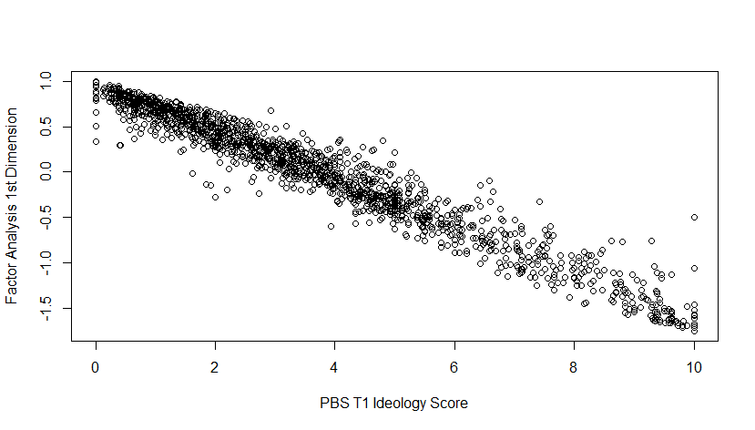
Above is a comparison between our PBS score as estimated in the paper, and a factor analytic based approach using Poole’s (1998) BasicSpace scaling method. We show that our measure and the first dimension are highly related to one another. The above scatterplot shows the tight relationship, with a Pearson’s correlation coefficient of -0.97 between the scales. The only difference is directional, which is unsurprising given the arbitrariness of left-versus-right scaling.

Appendix Table A6
Replication of Table 5 from main paper, but with an OLS specification rather than logistic regression. DV: Support Democratic Control of Congress (Time 3)
 | (1) | (2) | (3)
Delegate | -0.065 | -0.290 | -0.308
 | (0.044) | (0.708) | (0.649)
importance_climate3 | 0.005
 | (0.006)
delegate × importance_climate3 | 0.012*
 | (0.006)
importance_crime3 |  | -0.278***
 |  | (0.071)
delegate × importance_crime3 |  | 0.055
 |  | (0.090)
importance_democracy3 |  |  | 0.127*
 |  |  | (0.064)
delegate × importance_democracy3 |  |  | 0.058
 |  |  | (0.080)
SD (Observations) | 0.319
Num.Obs. | 1213 | 1215 | 1191
AIC | 794.3 | 746.8 | 738.2
BIC | 886.1 | 833.5 | 824.6
+ p < 0.1, * p < 0.05, ** p < 0.01, *** p < 0.001
Note: The model is an OLS regression with random intercepts for state. Models include demographic controls for respondent age, gender, race, income, education, and region, respondent party ID, as well as respondent T1 PBS.

Addendum on Group Level Diversity and Individual Change
If deliberation were to be scaled to very large population, how much group level diversity would need to be maintained in the small groups? One strategy would be to develop algortithms for stratified random assignment to the small groups. But it is not clear how important the diversity is for applications at the large scale of something like the Deliberative Polling design for deliberation. This project sheds light on the challenge for scaling.

If there is wide variation in the small group composition, will many of the groups be so homogenous that they will simply go further to the extreme positions indicated by the pre-deliberation means, as hypothesized by Sunstein’s “Law of Group Polarization” (Sunstein 2002; 2009)? In that case, the deliberations resulting from these distorted and unbalanced situations would lose some of their claim to deliberative quality. People would be apparently moving according to a predictable pattern of small group psychology rather than based on the merits of the argument.

This climate experiment offers an opportunity to test this issue, at least as it applies to the deliberative design with the automated moderator. There were nearly 1,000 deliberators who completed the process, randomly assigned to small groups of approximately 10. Hence there was wide variation in the composition of the 106 small groups.

To explore this issue, we first need a measure of small group diversity. Relying on the Gini-Simpson measure of group diversity for categories (see Baldwin and Huber 2010 for an example of using this for group level diversity measurements in political science), we can see exactly how different levels of group diversity—conceptualized in different ways – impacts the overall effectiveness of the group-level treatment. The Gini-Simpson measure can be thought of as the extent to which there are higher levels of dispersion amongst members of different groups. So more homogenous groups would have a lower Gini-Simpson score and less homogeneous groups would have higher scores.
To assess group level diversity, we derived Gini-Simpson index scores along 7 dimensions: Race, Education, Age groups, Income, Region, Party ID, and self-reported ideology. We also looked at the standard deviation of the groups PBS score at T1 for a scaled ideological comparison. The table below shows the correlation between the index scores – with higher equaling a more diverse set.
Table A7 Group Diversity Correlations
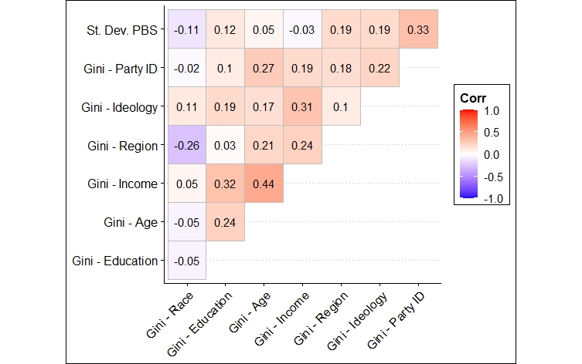
Note: Correlations between group level measure of diversity (for education, age, income, region, ideology and party ID) and the group level standard deviation of the group PBS score. There are 106 total groups.

We see that there is a high correlation between some of the measures of diversity, though not all. The partisan/ideological measures are moderately well correlated with one another. Income and age are strongly correlated with one another, as is income and education. These variables, initial position on the Policy Based Score (PBS), party ID, ideology, region and income are all factors of diversity that could be expected to affect the perspectives participants bring to the deliberations.
To get a better sense of how diversity impacts the overall treatment, we take the multiple Gini-Simpson -indices to create a singular metric by averaging over the 7 measures. That Gini-Simpson average has a correlation of 0.61 with age, 0.64 with ideology, 0.60 with party, 0.21 with race, 0.44 with education, 0.75 with income, and 0.32 with region. It also has a 0.21 correlation with the SD of the PBS. The correlations between the Gini-Simpson measures indicate the extent to which diversity along one dimension is related to diversity along the others. We use an aggregate measure of diversity, because we want to capture the full extent of how political and demographic features are distributed amongst our groups.
We now want to compare our aggregate measure of group level diversity with our outcomes of interest. First, in Figure A2, we look at the Gini-Simpson -average and the group level standard deviation of the PBS score and compare it to changes in the individual level PBS between T1 and T2.
Figure A2: Group Level Diversity and Individual Level Change in PBS
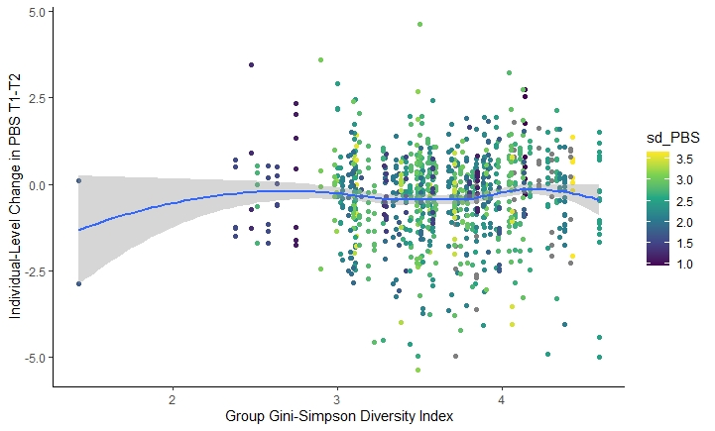
We find no evidence that group level measures of diversity have any impact on individual level changes in PBS score. There is a relatively flat relationship between observed group level diversity and overall changes in respondent PBS. For more analyses supporting this conclusion see the discussion of Figures A3 and A4.
Figure A3: Group Standard Deviations and Individual Level Change
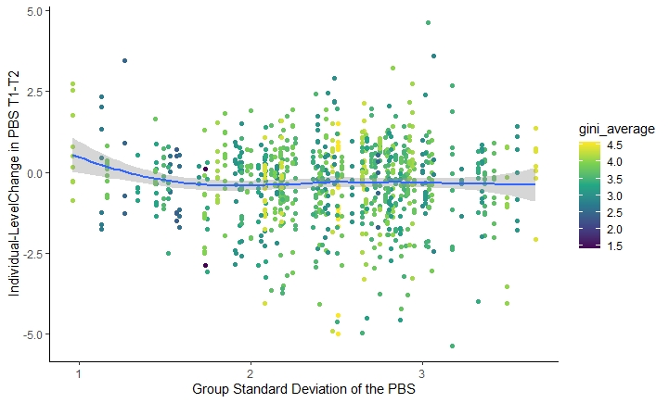
In Figure A4, we flip the axes and legend to see if there were any heterogeneities in the relationship between group-level diversity and individual shifts in respondent PBS based on group level policy based ideological diversity, to which we found no relationship. Shown either way, there is little visual evidence of a strong relationship between observed group level diversity and individual level changes.

Figure A4: Initial PBS and Individual Level Change
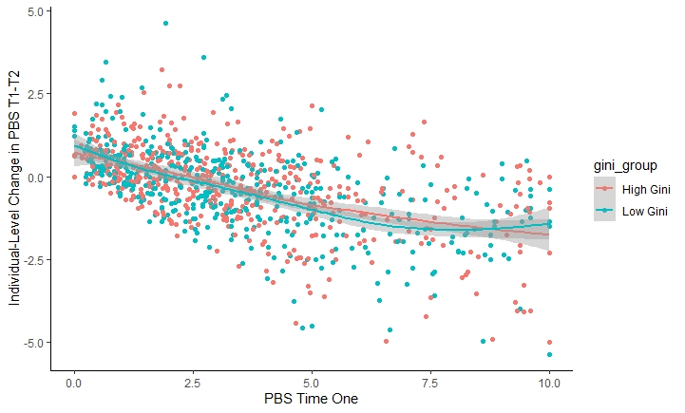
We also wanted to make sure this wasn’t an artifact of T1 policy scores so we broke the Gini-Simpson down into two groups (above median and below median) and compared PBS T1 to the change in PBS, which is shown in Figure A4. We found no relation between group composition and individual propensity to change in policy scores.

We next wanted to formally test if the group-level measure of diversity predicted any individual level changes in PBS score from times 1 to 2 in a regression framework. In Table A8, we regress changes in PBS score from times 1 to 2 on first, the group level diversity measure alone; second, the group level diversity measure plus individual level demographic controls (age, gender, race, income, education, and region). In our final model, we add to the individual level controls respondent party ID and their time 1 PBS score. In all three models, we fail to find significant differences caused by group level differences in diversity.

Table A8: Does Group Level Diversity Predict Individual Level Policy Change?
DV:
PBS Change T1-T2
 | (1) | (2) | (3)
Gini Average | 0.086 | 0.103 | 0.146
 | (0.099) | (0.098) | (0.116)
Demographic  Controls? | No | Yes | Yes
Party & Ideology | No | No | Yes
N | 956 | 956 | 828
R² | 0.001 | 0.032 | 0.319
F Statistic | 0.918  (df = 1; 954) | 1.528*  (df = 20; 935) | 1.038  (df =23; 804)
*p < .1; **p < .05; ***p < .01
Note: Individual linear regression fit on group level Gini-Simpson average as the DV. Demographic controls include age, gender, race, income, education, and region. Party and ideology indicate party ID and time 1 PBS score are included. All standard errors reported are cluster robust standard errors, with clusters at the group level. Regressions for each of the different measures of diversity included in the combined diversity metrics can be found in Table A5.

Hence the movement in the small groups was not predictable based on their diversity, demographic or attitudinal. While enclave deliberation may produce distorted results with one-sided advocacy in some designs, the Deliberative Polling design with the automated moderator appears to offer sufficient balance of argumentation and sufficient engagement with competing arguments that groups that differ greatly in their diversity move largely in the same direction.

This result might seem puzzling in light of the extensive literature on small group polarization from deliberation, mostly outside of Deliberative Polls. The balance of initial opinions is supposed to predict the balance of argumentation, and one might think that the balance of argumentation (if there are many more arguments voiced on one side of an issue rather than another) will predict the direction of movement (Sunstein 2002, Sunstein 2009, Sunstein et al, 2007). However, the Deliberative Polling design with human moderators is an exception to Sunstein’s “law” as demonstrated by a study of 2,600 small group/issue pairs in twenty one Deliberative Polls (Luskin et al 2022). Something similar seems to apply with deliberations on this model with the automated platform. Sunstein’s results come from a jury-like model in which discussions aim at a consensus if possible (as in a jury verdict). The Deliberative Polling model, by contrast, collects the final judgments only in confidential questionnaires.

Second differences representation of Marginal Effects for Figures 6 and 7
Here, we present two distinct representations of Figures 6 and 7, which are based on Models 1 and 2 from Table 3. These representations, known as the second differences representation, have been introduced to address a critique of the interpretation of the interaction terms' significance in our original regressions (Berry et al., 2010). Importantly, these new representations demonstrate that the results remain fundamentally unchanged from Figures 6 and 7 in the main paper, providing reassurance of the robustness of our findings.

Figure A5
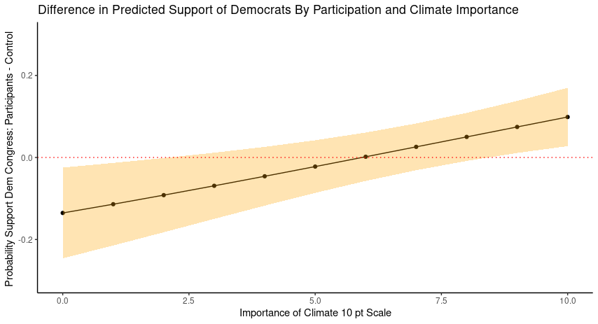
Marginal Effects plot based on Model 1 from Table 3. All control variables are held at either their median for continuous variables or their mode for categorical variables. These are the differences between the treatment and control group estimates of the probability of supporting Democratic control of Congress by the relative importance of climate. Treatment = straight line, Control = dotted line
Figure A6

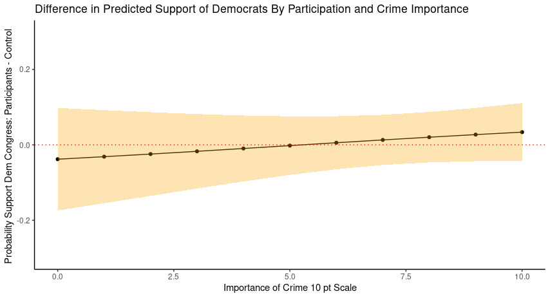
Marginal Effects plot based on Model 2 from Table 3. All control variables are held at either their median for continuous variables or their mode for categorical variables. These are the differences between the treatment and control group estimates of the probability of supporting Democratic control of Congress by the relative importance of crime. Treatment = straight line, Control = dotted line

State level random intercepts allow for heterogeneities in voting propensities by state level characteristics, similar to a regression strategy discussed in Gelman and Hill (2006).

