Appendix for
“Right to Work or Right to Vote?
Labor Policy and American Democracy”

Table 1A: Two-Way Fixed Effects Results
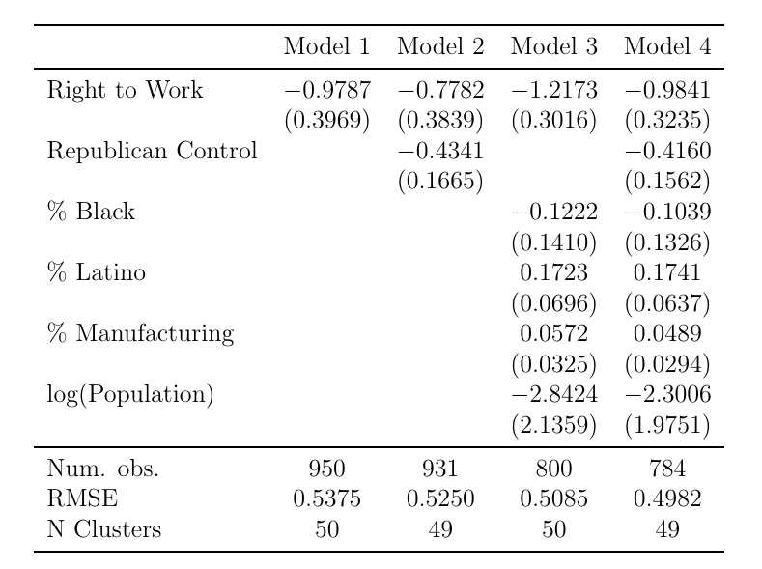

Additional Discussion of Worker-Based Mechanisms
By weakening union strength, RTW laws reduce unions’ capacity to provide information and political socialization to American workers. This information and socialization encourages and maintains civic norms through well-constructed social and political networks, all of which can serve to importantly counter authoritarian campaigns (Ahlquist and Levi 2013; Iversen and Soskice 2015; MacDonald 2021; Mosimann and Pontusson 2017; Western and Rosenfeld 2011). Unions directly provide information to their members, not only about collective bargaining but also about politics, such as the policy positions of electoral candidates and evidence about how policies affect workers’ lives (Stevens and Greer 2005; Western and Rosenfeld 2011). This role is core to the functioning of a democratic society, which depends on the ability of the public to make political decisions grounded in factual information (Achen and Bartels 2017). Unions disseminate this political information via regular emails, newsletters, flyers, and meetings of workers, as well as election-specific communications such as issue briefs, candidate endorsements, and get-out-the-vote information (Macdonald 2019; Jacobson 1999). Unions and union members have historically been more likely than other organized interest groups to discuss public policy issues (Schlozman, Verba, and Brady 2012). Through these efforts, union membership shapes individuals’ political knowledge (Macdonald 2019), policy preferences (Ahlquist et al. 2014; Ahlquist and Levi 2013; Kim and Margalit 2017; Mosimann and Pontusson 2016), and voting behavior (Francia and Bigelow 2010; Francia and Orr 2014; Leighley and Nagler 2007; Prysby 2020).
This political socialization through union membership can have profound impacts not just on preferences, but on how workers view their own group identities and relationships to other identity groups. Unions provide a shared space for individuals to socialize and, often through informal conversation, build a politicized “working class” group identity (Lipset et al. 1956; Macdonald 2019). Recent research has found that individuals who belong to unions are more likely to identify as working class, all else equal, and that this identification predicts support for redistribution and the welfare state (Franko and Witko 2023).
While working class identity affects economic policy preferences, it is more important for this study that the development of working-class identity may also reduce the salience of other countervailing identities, or increase solidarity toward workers with different racial, gender, religious, or national identities. Surveys of the American public in recent years have consistently shown that “ethnic antagonism” is central to antidemocratic attitudes in the mass public (e.g., Bartels 2020). US labor unions in recent years have explicitly linked considerations of racial justice and democracy in platforms and endorsements in recent years. A 2022 AFL-CIO resolution titled “The Urgent Fight for Racial Justice” endorsed congressional legislation to expand democratic institutions and the “revers[al] [of] state voter suppression laws passed in the wake of attempts to undermine the legitimacy of the 2020 presidential election.” There is also a growing comparative politics literature that finds that unions, by encouraging solidarity between workers, can mute the impact of far-right organizations on worker preferences (Arndt and Rennwald 2016; Mosimann et al. 2019; Rennwald and Pontusson 2021). Frymer and Grumbach (2021) find that union membership decreased racial resentment among white workers. Thus, it is plausible that union membership could increase support for a more inclusive democracy in the mass public by reducing the racial and ethnic conflict that often forms the foundation for calls to reduce the size of the electorate and rightwing populism that threatens democratic vitality.
In the context of the contemporary US party system, labor union membership also contributes to the maintenance of democracy by reducing Republican voting among workers. In the mid-20th century, most of the states that passed RTW laws were themselves under undemocratic Jim Crow regimes—and controlled by the Democratic Party. After partisan realignment in the South among white conservatives, in more recent years, RTW laws have been passed uniformly by Republican-led legislatures. Over the same period, Republican governments worked to pass laws making reduced the quality of electoral democracy in their states by making voting less accessible and drawing district maps with extreme partisan bias that enabled them to maintain often quite excessive legislative majorities with less than a majority of the state vote (Grumbach 2022). Unions, as central organizational members of the Democratic Party’s extended network (Bucci and Reuning 2021), increase voting for Democrats and decrease voting for Republicans. This mechanism of increasing Democratic and reducing Republican voting is partly direct, with a majority of unions endorsing and contributing to Democratic candidates. It is also partly indirect, as union membership increases workers’ support for redistribution (Macdonald 2019). Indeed, research has found that unions influence the political attitudes of their workers, particularly in areas such as support for the welfare state, job protections, and trade policy (Ahlquist et al. 2014; Kim and Margalit 2017). This influence on economic attitudes, in turn, should decrease voting for the party relatively more opposed to redistribution, the Republican Party.
Most specifically, Feigenbaum, Hertel-Fernandez, and Williamson (2018) find that RTW laws significantly decreased Democratic Party vote shares, and increased Republican control of state governments, in recent decades. The authors point to a number of mechanisms that likely undergird this overall effect: RTW reduced voter turnout; RTW reduced union voter mobilization capacity in RTW states such that Democratic voters were less likely to be contacted to vote; and RTW reduced the share of campaign spending by labor unions relative to control states. This finding from Feigenbaum, Hertel-Fernandez, and Williamson (2018) suggests that RTW laws might reduce democracy through the mechanism of increasing Republican control of state governments. However, these mechanisms could also affect democracy not only by bringing Republicans to power, but by making Republicans more supportive of weakening democratic institutions.
So far, the worker-centric mechanisms we have discussed are direct and informational, typically involving union leaders, organizers, and rank-and-file members sharing political information and appeals. We also argue that there are indirect effects of unions on democratic attitudes through an economic security mechanism. RTW laws hurt unions, which reduces workers’ job security and the reach of the union wage premium. Broadly, historical and comparative scholars point to economic decline and precarity—and particularly the scapegoating of minority groups for economic problems—as central to the rise of authoritarianism in the 20th century (Payne 1996). More specifically, recent behavioral research on the US shows that job losses increased white workers’ support for the candidacy of Donald Trump (Baccini and Weymouth 2021), as well as for Trump-associated policies such as mass deportations of undocumented immigrants (Hopkins, Margalit, and Solodoch 2023).
Union membership affects workers’ attitudes—and it also affects the frequency and intensity with which workers express those attitudes through political participation. This is accomplished by both influencing workers’ beliefs about the efficacy and social benefits of participation, as well as through subsidies to participate such as transportation to protest actions or information about how to register to vote. Social scientists have long considered labor unions to be important forces in mobilizing voter turnout (Delaney, Masters, and Schwochau 1988; Rosenfeld 2010). Leighley and Nagler (2007) find that the decline of labor unions in the late 20th century reduced voter turnout of workers and upwardly skewed the class distribution of the US electorate. There is also evidence that unions increase voter turnout especially among workers of color (Kim 2016).
Non-electoral participation is also central to union strategy. Unions are a leading source of mobilization for public protests, not simply and formally worker strikes, but broader public boycotts, rallies, and petition drives. The labor movement’s ability to send large numbers of bodies to public events should not be underestimated; unions have the pre-existing organization to mobilize quickly and impactfully in ways that are unique among organizations in American politics. Union organizational resources hover over the development of federal and local social policy, both broadly as an advocate for wage rights like the Fight for $15 and national worker civil rights like the Americans with Disabilities Act and the recent advocacy for nonunionized gig workers. They are arguably equally prominent as a mobilizer and backbone for many adjacent movements, from providing financial and organizational support for numerous civil rights groups in the 1950s and 60s to the anti-Iraq war movement in the 2000s to the recent mobilization around voting rights in conjunction with civil rights organizations.
In summary, RTW laws might weaken democratic institutions by reducing unions’ capacity to provide workers with information and political socialization, which affects their economic attitudes, racial attitudes, partisanship, and participation. However, we note that existing research suggests that RTW only reduces a state’s union membership by a few percentage-points. While decreasing union membership by approximately 3 percentage-points is meaningful, it is not clear that a decline in union membership of this size would have a substantial downstream effect on democratic institutions. If RTW affects democratic institutions, it is likely due to additional mechanisms beyond RTW’s direct effect on union membership, such as unions’ political spending and signals to elites about the balance of organizational power in a state’s political environment.
In the next section, we outline unions’ elite and organizational strategies that also might help to maintain democratic institutions in the contemporary US.

Elite Mechanisms
Thus far, we have explored ways in which unions influence workers in ways that might bolster democracy. But unions also promote democracy through elite-centered mechanisms, such as by financially supporting pro-democracy candidates and elected officials and by lobbying for public-interest policies (Burns et al. 2000). By making it harder to recruit and retain members, RTW laws limit unions’ ability to engage in these activities at the same scale and with the same effectiveness.
Political donations and lobbying are not commonly considered democracy-promoting activities. They tend to be dominated by an “unheavenly chorus” of highly informed and well-resourced individuals and interest groups that are distinctly unrepresentative of the broader American public (Schattschneider 1960). This presents a challenge for effective democratic governance, which is premised on the “equal consideration of the interests and preferences of all citizens” (Schlozman, Verba, and Brady 2012, 96). Unions have helped rectify this imbalance—if only somewhat—by repeatedly serving as a primary organizing force for the diffuse interests of American workers, counterbalancing the immense political influence of concentrated economic interests (e.g., Hacker and Pierson 2010), and by increasing the descriptive representation of the working class in elected office (Sojourner 2013). By reducing the financial resources at unions’ disposal, RTW laws limit the ability of unions to serve this critical organizing role on behalf of low- and middle-class workers.
Like most interest groups, unions make political contributions to elect friendly candidates and gain access to and influence over sitting legislators. This deployment of political contributions is strategic, with unions increasing or reducing their contributions to reward or punish policymakers for their legislative track record (Jansa and Hoyman 2018). Overwhelmingly, labor contributions in the U.S. support candidates from the Democratic Party; in the 2016 general election, for instance, nearly 90 percent of the labor sector’s $217 million in contributions supported Democratic candidates (Muller 2018). Even if unions did not serve the long-term interests of democracy by representing the interests of the (vastly underrepresented) working class, this skewing of contributions toward the relatively more pro-democracy major party in contemporary US politics would support the notion that present-day union contributions contribute to maintaining democracy.
A similar logic extends to unions’ lobbying of state and federal policymakers. Unions champion broad-based labor-market policies that shrink economic inequality by compressing the wage distribution across economic classes, standardizing pay and working conditions across racial, ethnic, and gender groups, and redistributing income via tax policy and social welfare programs, in addition to advocating for policies that directly benefit labor organizing and unionized workers (Ahlquist 2017). Union lobbying in the 1970s, for instance, played a significant role in the passage of the Occupational Safety and Health Act, which protected both union and non-union laborers from undue exposure to toxic substances and other workplace risks (Highfill and Weber 2016). To the extent that RTW laws limit unions’ capacity to engage in such public-interest lobbying, we argue they have a detrimental effect on democracy.
RTW laws also signal to the political elite that unions are losing power. This may lead pro-democratic lawmakers—those who abide by and promote democratic laws and norms—to assign less weight to union leaders’ lobbying efforts. More significantly, as we describe with case study evidence in the next section, RTW laws likely embolden and energize anti-democracy actors, potentially leading to more investment in anti-democracy activities.
This precise dynamic has been on display in recent decades. As business organizations and their coalition partners advocated for unpopular policies that were far to the right of constituency opinion in the states (Hertel-Fernandez 2019), RTW laws repeatedly limited unions’ ability to act as a countervailing force to challenge the political power of business organizations. More broadly, as the economic policy agenda of conservative organizations and the Republican Party grew increasingly unpopular, their incentive to weaken countervailing organizations like unions—and democratic institutions, themselves—increased (Hacker and Pierson 2020; for this general theory in the context of comparative democratization, see Ziblatt 2017).

AFL-CIO, “Resolution 3: The Urgent Fight for Racial Justice.” https://aflcio.org/resolutions/resolution3
It is important to note that, while some states have seen democratic backsliding in recent years, it has come nowhere close to the undemocratic nature of Jim Crow regimes.
https://www.nalc.org/government-affairs/legislative-updates/dmv-rally-for-john-lewis-voting-rights-advancement-act

