Online Supplemental Material for “Calibrating Confidence: Civic Education and the Relationship Between Objective Political Knowledge and Political Knowledge Confidence”

Part A: Survey Questions

Questions are listed in the order in which they are asked. The survey included additional questions for the purposes of separate studies.

Class Standing (wave 1 and wave 2)

What is your class standing?
  - High school (i.e., concurrent enrollment)
  - Freshman
  - Sophomore
  - Junior
  - Senior

Knowledge Confidence Questions (wave 1 and wave 2)

The five response options for the knowledge confidence questions were “not confident at all,” “slightly confident,” “moderately confident,” “very confident,” and “extremely confident.”

Please answer the following by selecting your level of confidence regarding each question below.

How confident are you that you understand how elections work?
How confident are you that you understand what the Constitution says?
How confident are you that you could explain what distinguishes the two parties from one another?
How confident are you that you understand how laws are made?
How confident are you that you understand how power is divided among the three branches of government?

Objective Political Knowledge Questions (wave 1 and wave 2)

Please answer the following questions to the best of your ability. Many people don’t know the answers to these questions. If you don’t know the answers, just move on to the next question.

To be elected president, a candidate must win which of the following?
  - More than half the electoral votes.
  - The most electoral votes, even it’s not more than half.
  - More than half of the votes cast by ordinary citizens.
  - The most votes cast by ordinary citizens, even if it’s not more than half.

Which of the following rights are protected by the First Amendment to the U.S. Constitution?
  - Right to bear arms
  - Right to due process
  - Right to vote
  - Right to free speech

Which of the two dominant U.S. political parties is more conservative?
  - Republican
  - Democratic
  - Neither. One party is not more conservative than the other.

How much of a majority is needed in the U.S. House and U.S. Senate to override a presidential veto?
  - 2/3
  - 1/2
  - 3/4
  - 3/5

In the U.S. system of government, who has the power to determine if a law is constitutional or not?
  - Supreme Court
  - Congress
  - President
  - Bureaucracy

Parents’ Education (wave 1)

Did at least one of your parents or guardians obtain a 4-year college degree (e.g., bachelor's degree)?
  - Yes
  - No
  - Unsure

GPA (wave 1)

Excluding this semester’s course work, what is your college GPA?
  - 3.50 to 4.00
  - 3.00 to 3.49
  - 2.50 to 2.99
  - 2.00 to 2.49
  - Less than 2.00

Female (wave 1)

Female is coded as 1 if response was female and 0 if response was male in the models reported in the main text.

What is your gender? (select all that apply)
  - Male
  - Female
  - Transgender
  - Other

Minority (wave 1)

Minority is coded as 1 if response included black, Hispanic, Asian, Native American, or other, and 0 if white.

What racial or ethnic group best describes you? (select all that apply)
  - White
  - Black
  - Hispanic
  - Asian
  - Native American
  - Middle Eastern
  - Other

Class Attendance (wave 2)

How would you describe your attendance in the course?
  - I never missed a lesson, whether in person or online
  - I missed very few lessons
  - I missed a few lessons
  - I missed many lessons

Part B: Distribution of Objective Knowledge at Wave 1 and Wave 2

Figure A1: Histogram of Objective Knowledge at Wave 1 and Wave 2
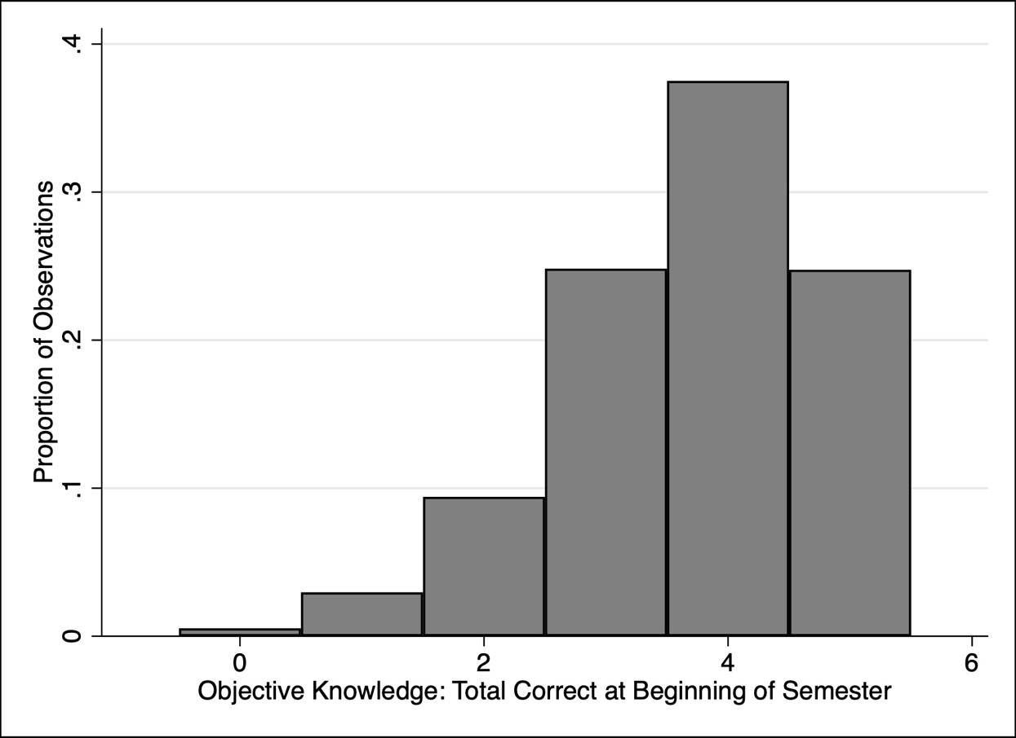

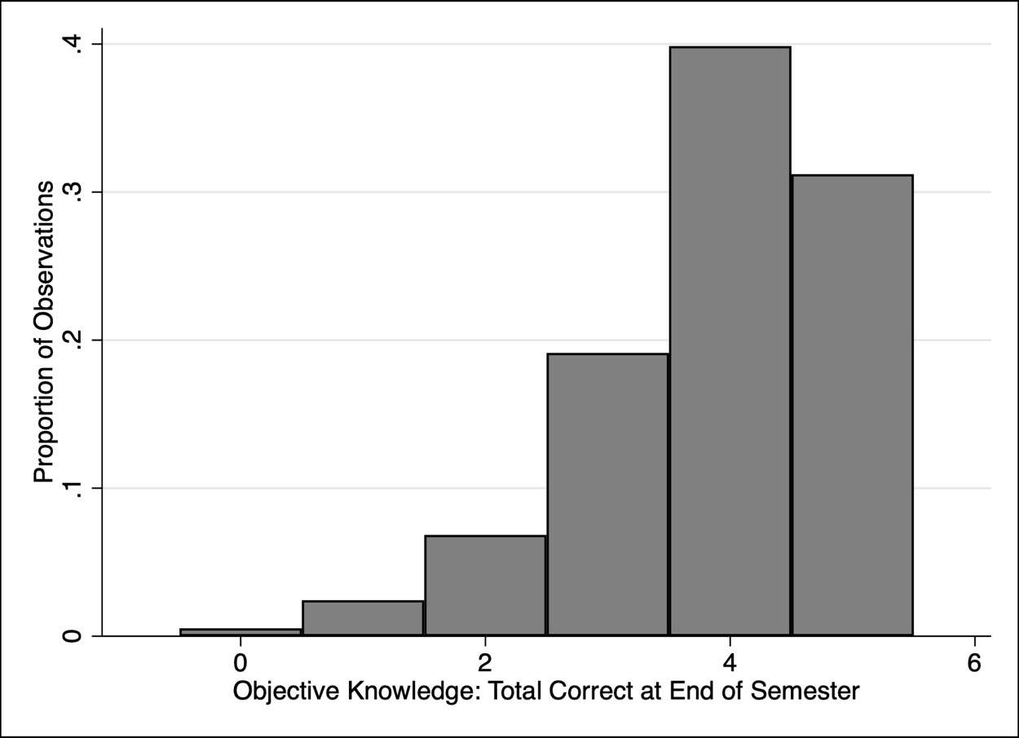

Part C: Relationship between Objective Knowledge and Knowledge Confidence by Item

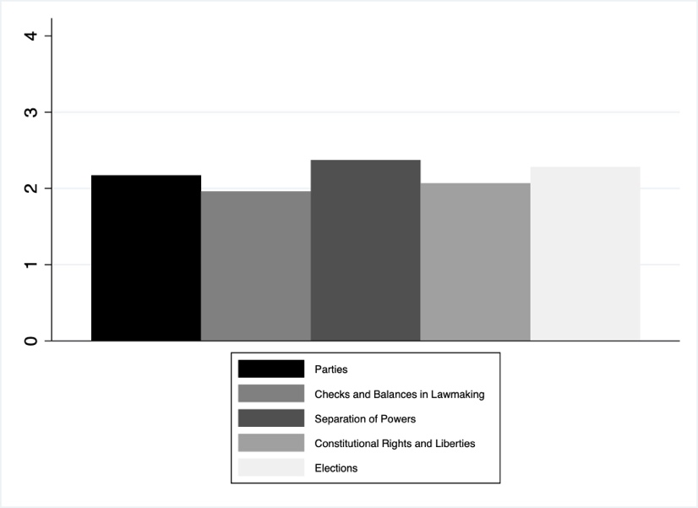
Figure A2: Knowledge Confidence by Item
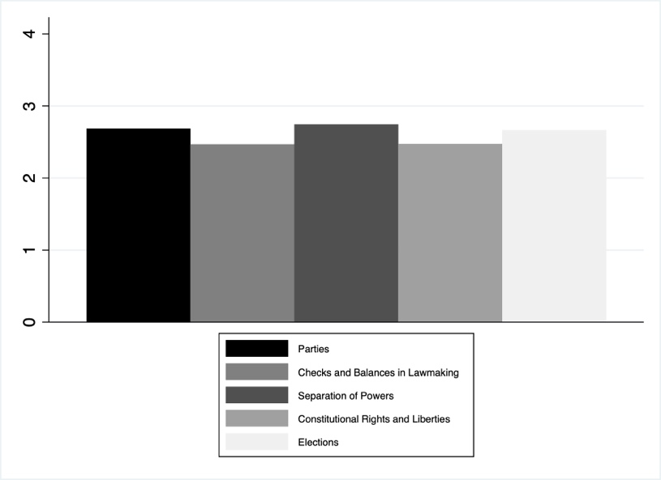

- Wave 1 (b) Wave 2

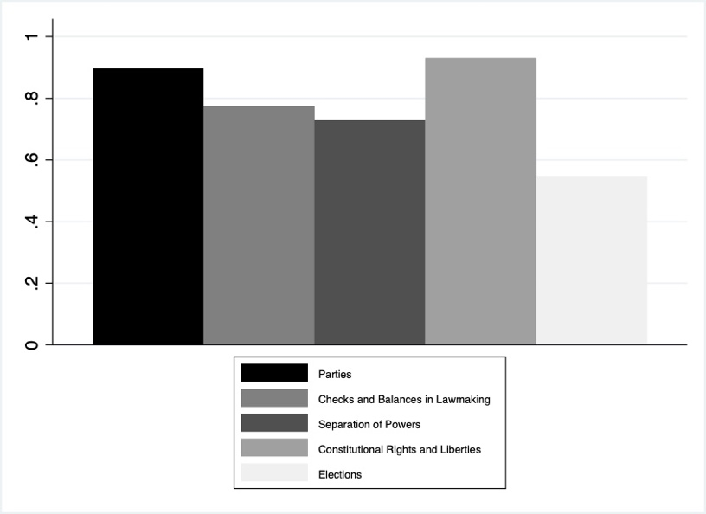
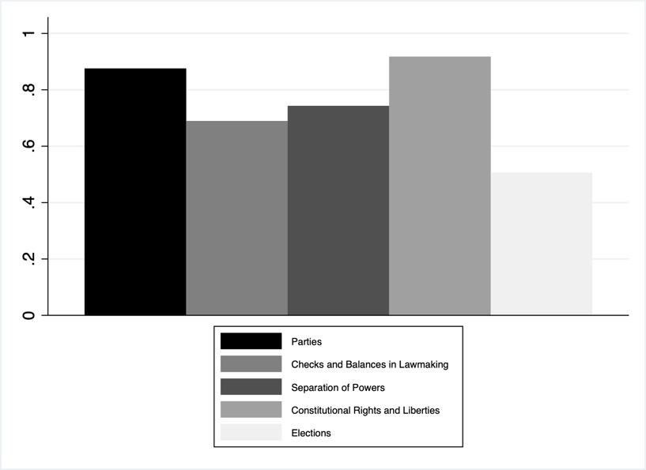
Figure A3: Objective Knowledge by Item

- Wave 1 (b) Wave 2

Chi-squared tests
We find evidence that knowledge confidence on a particular topic is not randomly distributed across correctness on that topic. Specifically, as expected, confidence is significantly higher for students who answered the question correctly than for students who answered the question incorrectly, at the p<0.05 level for seven of ten tests (5 pairs of items x 2 waves) and at the p<0.1 level for eight of ten tests. The exceptions were the elections items, which were the most difficult factual questions. Still, the results for the elections item are in the expected direction.

Table A1 a-j: Chi-squared tests of distribution of confidence across correctness

- Parties, Wave 1
Correct on Parties Question | Confidence in Describing Party Differences
 | Not Confident at All | Slightly Confident | Moderately Confident | Very Confident | Extremely Confident | Total
No | 43 | 44 | 65 | 20 | 4 | 176
 | 24.43 | 25.00 | 36.93 | 11.36 | 2.27 | 100.00
Yes | 74 | 188 | 448 | 250 | 180 | 1140
 | 6.49 | 16.49 | 39.30 | 21.93 | 15.79 | 100.00
Total | 117 | 232 | 513 | 270 | 184 | 1316
 | 8.89 | 17.63 | 38.98 | 20.52 | 13.98 | 100.00
Pearson Chi2 = 89.89 Prob = 0.00
First row has frequencies and second row has row percentages

- Parties, Wave 2
Correct on Parties Question | Confidence in Describing Party Differences
 | Not Confident at All | Slightly Confident | Moderately Confident | Very Confident | Extremely Confident | Total
No | 9 | 24 | 62 | 25 | 19 | 139
 | 6.47 | 17.27 | 44.60 | 17.99 | 13.67 | 100.00
Yes | 23 | 81 | 371 | 388 | 315 | 1178
 | 1.95 | 6.88 | 31.49 | 32.94 | 26.74 | 100.00
Total | 32 | 105 | 433 | 413 | 334 | 1317
 | 2.43 | 7.97 | 32.88 | 31.36 | 25.36 | 100.00
Pearson Chi2 = 51.04 Prob = 0.00
First row has frequencies and second row has row percentages

- Elections, Wave 1
Correct on Elections Question | Confidence in Understanding Elections
 | Not Confident at All | Slightly Confident | Moderately Confident | Very Confident | Extremely Confident | Total
No | 35 | 102 | 287 | 170 | 62 | 656
 | 5.34 | 15.55 | 43.75 | 25.91 | 9.45 | 100.00
Yes | 30 | 97 | 257 | 206 | 71 | 661
 | 4.54 | 14.67 | 38.88 | 31.16 | 10.74 | 100.00
Total | 65 | 199 | 544 | 376 | 133 | 1317
 | 4.94 | 15.11 | 41.31 | 28.55 | 10.10 | 100.00
Pearson Chi2 = 6.20 Prob = 0.18
First row has frequencies and second row has row percentages

- Elections, Wave 2
Correct on Elections Question | Confidence in Understanding Elections
 | Not Confident at All | Slightly Confident | Moderately Confident | Very Confident | Extremely Confident | Total
No | 11 | 50 | 210 | 223 | 106 | 600
 | 1.83 | 8.33 | 35.00 | 37.17 | 17.67 | 100.00
Yes | 7 | 60 | 221 | 279 | 150 | 717
 | 0.98 | 8.37 | 30.82 | 38.91 | 20.92 | 100.00
Total | 18 | 110 | 431 | 502 | 256 | 1317
 | 1.37 | 8.35 | 32.73 | 38.12 | 19.44 | 100.00
Pearson Chi2 = 5.54 Prob = 0.24
First row has frequencies and second row has row percentages

- Branches, Wave 1
Correct on Branches Question | Confidence in Understanding Division of Power
 | Not Confident at All | Slightly Confident | Moderately Confident | Very Confident | Extremely Confident | Total
No | 30 | 67 | 137 | 84 | 27 | 345
 | 8.70 | 19.42 | 39.71 | 24.35 | 7.83 | 100.00
Yes | 39 | 135 | 313 | 336 | 149 | 972
 | 4.01 | 13.89 | 32.20 | 34.57 | 15.33 | 100.00
Total | 69 | 202 | 450 | 420 | 176 | 1317
 | 5.24 | 15.34 | 34.17 | 31.89 | 13.36 | 100.00
Pearson Chi2 = 39.01 Prob = 0.00
First row has frequencies and second row has row percentages

- Branches, Wave 2
Correct on Branches Question | Confidence in Understanding Division of Power
 | Not Confident at All | Slightly Confident | Moderately Confident | Very Confident | Extremely Confident | Total
No | 10 | 34 | 132 | 106 | 63 | 345
 | 2.90 | 9.86 | 38.26 | 30.72 | 18.26 | 100.00
Yes | 11 | 58 | 256 | 408 | 239 | 972
 | 1.13 | 5.97 | 26.34 | 41.98 | 24.59 | 100.00
Total | 21 | 92 | 388 | 514 | 302 | 1317
 | 1.59 | 6.99 | 29.46 | 39.03 | 22.93 | 100.00
Pearson Chi2 = 35.49 Prob = 0.00
First row has frequencies and second row has row percentages

- Laws, Wave 1
Correct on Lawmaking Question | Confidence in Understanding How Laws are Made
 | Not Confident at All | Slightly Confident | Moderately Confident | Very Confident | Extremely Confident | Total
No | 37 | 123 | 174 | 72 | 17 | 423
 | 8.75 | 29.08 | 41.13 | 17.02 | 4.02 | 100.00
Yes | 56 | 201 | 412 | 163 | 62 | 894
 | 6.26 | 22.48 | 46.09 | 18.23 | 6.94 | 100.00
Total | 93 | 324 | 586 | 235 | 79 | 1317
 | 7.06 | 24.60 | 44.50 | 17.84 | 6.00 | 100.00
Pearson Chi2 = 13.47 Prob = 0.01
First row has frequencies and second row has row percentages

- Laws, Wave 2
Correct on Lawmaking Question | Confidence in Understanding How Laws are Made
 | Not Confident at All | Slightly Confident | Moderately Confident | Very Confident | Extremely Confident | Total
No | 6 | 39 | 125 | 77 | 38 | 285
 | 2.11 | 13.68 | 43.86 | 27.02 | 13.33 | 100.00
Yes | 12 | 112 | 409 | 360 | 139 | 1032
 | 1.16 | 10.85 | 39.63 | 34.88 | 13.47 | 100.00
Total | 18 | 151 | 534 | 437 | 177 | 1317
 | 1.37 | 11.47 | 40.55 | 33.18 | 13.44 | 100.00
Pearson Chi2 = 8.17 Prob = 0.09
First row has frequencies and second row has row percentages

- Constitution, Wave 1
Correct on Constitution Question | Confidence in Understanding the Constitution
 | Not Confident at All | Slightly Confident | Moderately Confident | Very Confident | Extremely Confident | Total
No | 13 | 30 | 49 | 12 | 7 | 111
 | 11.71 | 27.03 | 44.14 | 10.81 | 6.31 | 100.00
Yes | 63 | 247 | 536 | 275 | 85 | 1206
 | 5.22 | 20.48 | 44.44 | 22.80 | 7.05 | 100.00
Total | 76 | 277 | 585 | 287 | 92 | 1317
 | 5.77 | 21.03 | 44.42 | 21.79 | 6.99 | 100.00
Pearson Chi2 = 16.27 Prob = 0.00
First row has frequencies and second row has row percentages

- Constitution, Wave 2
Correct on Constitution Question | Confidence in Understanding the Constitution
 | Not Confident at All | Slightly Confident | Moderately Confident | Very Confident | Extremely Confident | Total
No | 5 | 18 | 34 | 21 | 14 | 92
 | 5.43 | 19.57 | 36.96 | 22.83 | 15.22 | 100.00
Yes | 27 | 133 | 456 | 433 | 173 | 1222
 | 2.21 | 10.88 | 37.32 | 35.43 | 14.16 | 100.00
Total | 32 | 151 | 490 | 454 | 187 | 1314
 | 2.44 | 11.49 | 37.29 | 34.55 | 14.23 | 100.00
Pearson Chi2 = 13.27 Prob = 0.01
First row has frequencies and second row has row percentages

Part D: Means and Statistical Significance of Differences from Wave 1 to Wave 2

Table A2: Mean and Range for Measures of Political Knowledge

 | Wave 1 (Start of Semester) | Wave 2 (End of Semester)
Objective Knowledge | 3.71  [0,5] | 3.89*  [0,5]
Knowledge Confidence | 2.66  [0,5] | 3.25*  [0,5]
Directional Confidence Gap | -1.04  [-4.5, 4.5] | -0.64*  [-4.25, 4.5]
Absolute Confidence Gap | 1.36  [0, 4.5] | 1.16*  [0, 4.5]
Note: Cells report means with minimum and maximum observed values in brackets; * indicates that the change from wave 1 to wave 2 is significant at p< 0.05 or less.

Part E: Factor Analysis of Knowledge Items

We find that all the objective knowledge (OK) items at wave 1 load together on a single factor; no other factors are retained. We find the same for the items at wave 2.

Table A3: Principal Factor Analysis for Objective Knowledge Wave 1

Factor analysis/correlation Number of obs = 1,317
Method: principal factors Retained factors = 1
Rotation: (unrotated) Number of params = 5
Factor | Eigenvalue | Difference | Proportion | Cumulative
Factor1 | 0.386 | 0.393 | 2.648 | 2.648
Factor2 | -0.007 | 0.012 | -0.047 | 2.601
Factor3 | -0.019 | 0.034 | -0.131 | 2.470
Factor4 | -0.054 | 0.107 | -0.367 | 2.103
Factor5 | -0.161 | . | -1.103 | 1.000
LR test: independent vs. saturated: chi2(10) = 102.84 Prob>chi2 = 0.00
Factor loadings (pattern matrix) and unique variances
Variable | Factor1 | Uniqueness
OK Parties Wave 1 | 0.290 | 0.916
OK Laws Wave 1 | 0.297 | 0.912
OK Branches Wave 1 | 0.314 | 0.901
OK Constitution Wave 1 | 0.273 | 0.926
OK Elections Wave 1 | 0.203 | 0.959

Note: gray highlighting indicates results for the one retained common factor.

Table A4: Principal Factor Analysis for Objective Knowledge Wave 2

Factor analysis/correlation Number of obs = 1,317
Method: principal factors Retained factors = 1
Rotation: (unrotated) Number of params = 5

Factor | Eigenvalue | Difference | Proportion | Cumulative
Factor1 | 0.530 | 0.543 | 2.214 | 2.214
Factor2 | -0.013 | 0.018 | -0.054 | 2.160
Factor3 | -0.031 | 0.039 | -0.129 | 2.032
Factor4 | -0.070 | 0.107 | -0.292 | 1.740
Factor5 | -0.177 | . | -0.740 | 1.000
LR test: independent vs. saturated: chi2(10) = 174.54 Prob>chi2 = 0.00
Factor loadings (pattern matrix) and unique variances
Variable | Factor1 | Uniqueness
OK Parties Wave 2 | 0.340 | 0.884
OK Laws Wave 2 | 0.304 | 0.908
OK Branches Wave 2 | 0.257 | 0.934
OK Constitution Wave 2 | 0.439 | 0.807
OK Elections Wave 2 | 0.251 | 0.937

Note: gray highlighting indicates results for the one retained common factor.

Part F: Linear Regression Models of the Confidence Gap

To account for the possibility that individual characteristics are driving calibration, we also modeled the differences across individual students’ directional confidence gap at wave 2 as a function of their change in objective political knowledge (wave 2-wave 1) and change in knowledge confidence (wave 2-wave 1) using linear regression. We also account for students’ overconfidence (dichotomous; 1 if wave 1 confidence gap > 0, 0 if wave 1 confidence gap <= 0) and objective knowledge at wave 1 (four groups; <=2 out of 5 correct, 3 out of 5 correct, 4 out of 5 correct, 5 out of 5 correct). It is important to control for overconfidence and wave 1 objective knowledge because we know that those who are lowest in objective knowledge are likely to be overconfident, but this is not universally so. How confidence gaps vary over the semester are likely different for students who are underconfident versus overconfident. Specifically, growth in objective knowledge should have a larger effect on the directional confidence gaps of the overconfident than underconfident, as we discuss in our theory section.
We see that likelihood of overconfidence and level of objective knowledge are related in the student sample. Students who scored 2 or fewer correct were disproportionately, though not universally, overconfident in their knowledge while those who scored 3 or more correct were disproportionately, but not universally, overconfident. The exception is those who scored 5 out of 5 who, by definition, cannot be overconfident. This distribution is reported in Table A5.
We also control for individual student demographics, specifically self-reported frequency of class attendance, their parents’ education level, their class standing in school (e.g., freshman, etc.), their GPA, identifying as female, and identifying as a racial/ethnic minority. Additionally, we control for variation across instructors and semesters by including instructor fixed effects and semester fixed effects.

Table A5: Distribution of Overconfidence
by Objective Knowledge Wave 1 Objective Knowledge

Objective Knowledge (w1) | Under-confident | Over-confident
<=2/5 Qs Correct | 61 | 109
3/5 Qs Correct | 249 | 78
4/5 Qs Correct | 447 | 47
5/5 Qs Correct | 326 | 0
Total | 1,083 | 234

Table A6: Explaining Discrepancies Between Knowledge Confidence and Objective Knowledge
Linear Regression Models with Directional Confidence Gap as DV
 | (1) | (2) | (3)
 | DV = Directional Confidence Gap w2
∆ Knowledge Confidence (w2-w1) | 0.63* | 0.85* | 0.82*
 | (0.03) | (0.05) | (0.06)
∆ Objective Knowledge (w2-w1) | -0.92* | -0.98* | -1.02*
 | (0.02) | (0.03) | (0.05)
Objective Knowledge w1 | -0.56* | -0.47* | -0.50*
 | (0.03) | (0.03) | (0.04)
Overconfidence w1 | 1.40* | 1.47* | 1.23*
 | (0.06) | (0.07) | (0.13)
Class Attendance | 0.04+ | 0.05+ | 0.05+
 | (0.02) | (0.02) | (0.02)
Parents’ Education | 0.06 | 0.07 | 0.07
 | (0.05) | (0.05) | (0.05)
Class Standing | -0.02 | -0.02 | -0.02
 | (0.03) | (0.03) | (0.03)
GPA | -0.03 | -0.04 | -0.03
 | (0.03) | (0.03) | (0.03)
Female | -0.25* | -0.24* | -0.24*
 | (0.04) | (0.04) | (0.04)
Minority | -0.16* | -0.14* | -0.14*
 | (0.05) | (0.05) | (0.05)
∆ Knowledge Confidence x Objective Knowledge w1 |  | -0.13* | -0.13*
 |  | (0.02) | (0.03)
Overconfident w1 x ∆ Knowledge Confidence |  |  | 0.04
 |  |  | (0.10)
Overconfident w1 x Objective Knowledge w1 |  |  | 0.20*
 |  |  | (0.09)
Overconfident w1 x ∆ Knowledge Confidence x Obj Knowledge w1 |  |  | 0.15
 |  |  | (0.09)
∆ Obj Knowledge x Objective Knowledge w1 |  | 0.04* | 0.06*
 |  | (0.02) | (0.02)
Overconfident w1 x ∆ Obj Knowledge |  |  | 0.14+
 |  |  | (0.07)
Overconfident w1 x ∆ Obj Knowledge x Obj Knowledge w1 |  |  | -0.16*
 |  |  | (0.06)
Constant | -0.09 | -0.24 | -0.20
 | (0.19) | (0.19) | (0.19)
Instructor FE | YES | YES | YES
Semester FE | YES | YES | YES
N | 1274 | 1274 | 1274
Adj R² | 0.681 | 0.688 | 0.690
BIC | 2928.20 | 2911.84 | 2932.85
Standard errors in parentheses; * p < 0.05 + p< 0.10

The results confirm our conclusions in the manuscript. While gains in knowledge confidence are associated with larger directional gaps (i.e., knowledge confidence outpaces objective knowledge; Models 1-3) and gains in objective knowledge are associated with lower directional gaps (i.e., objective knowledge outpaces knowledge confidence; Models 1-3), the nature of this relationship depends on 1) a student’s starting level of objective knowledge and 2) whether they are over or underconfident. This is evident through the interaction effects shown in Models 2 and 3. We draw marginal effects plots to illustrate. Figure A4 shows gains in knowledge confidence led to larger directional confidence gaps among both over- and underconfident low objective knowledge students, but this effect flattens as one increases in objective knowledge. For students who are high in objective knowledge and who are universally under-confident, gains in knowledge confidence reduce the directional gap between the two dimensions of knowledge. This is also true for the bulk of students who answered 4 out of 5 objective knowledge and who were underconfident.

Figure A4: Predicted Directional Confidence Gap Across Changes in Knowledge Confidence
by Starting Levels of Overconfidence and Objective Knowledge
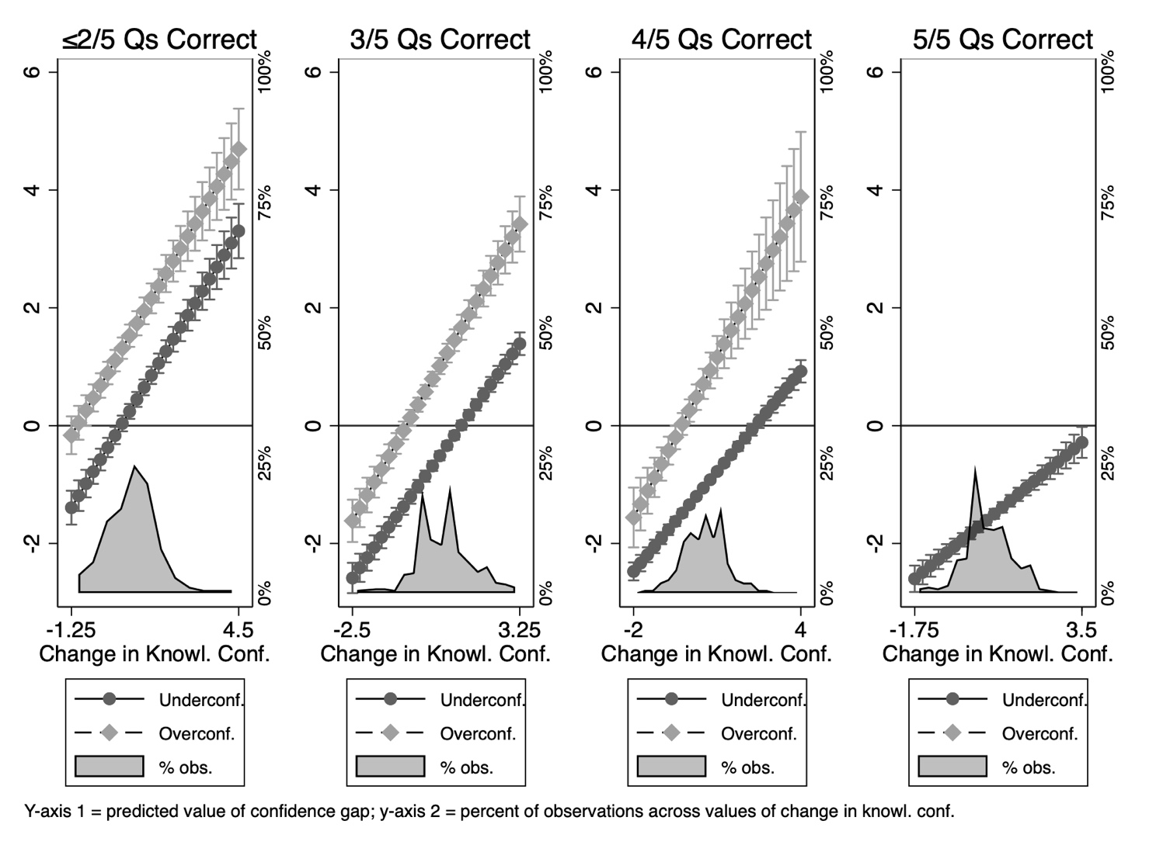

Figure A5: Predicted Directional Confidence Gap Across Changes in Objective Knowledge
by Starting Levels of Overconfidence and Objective Knowledge
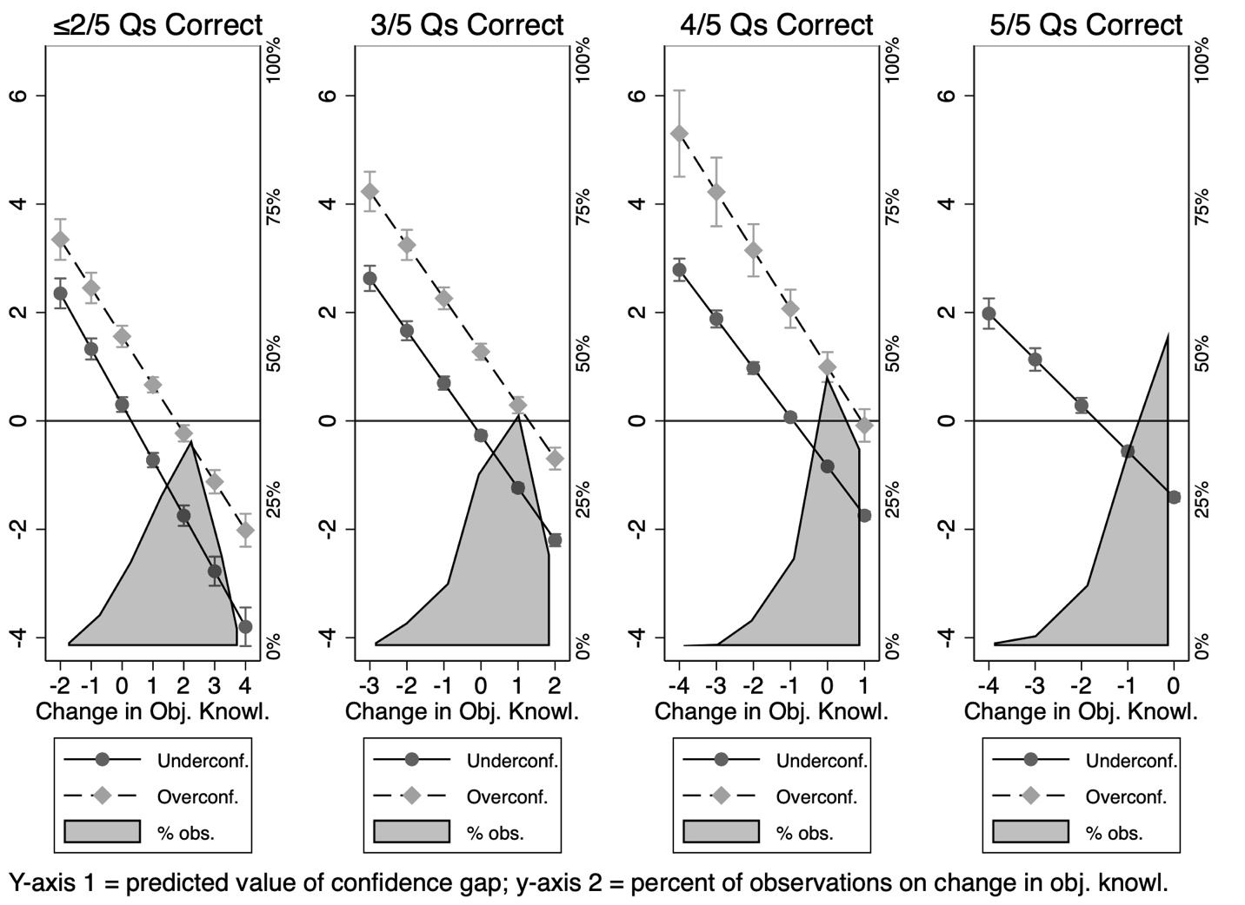

Similarly, students’ directional confidence gap wanes with gains in objective knowledge in Figure A5. This effect is most pronounced among students who start low (<=2 out of 5 questions correct) in objective knowledge. The bulk of students in this category experience moderate gains in objective knowledge and are predicted to have low directionality in their confidence gap. For students who start high in objective knowledge (5 out of 5 correct), gains in objective knowledge are not observed since they were already at the top of the objective knowledge scale. Instead, the bulk of students in this category experienced no change or moderate loss in objective knowledge, which are associated with negative but small directional confidence gaps (meaning they remain slightly underconfident).
The results hold when controlling for differences across students, instructors, and semesters. Interestingly, some demographic variables do matter as women and racial/ethnic minority students exhibit significantly smaller confidence gaps than their male and white counterparts; women and minority students’ knowledge confidence and objective knowledge appear to be better calibrated. Importantly, women and minorities may still experience underconfidence, as the literature, on balance, suggests (e.g., Bennett, 1997; Burns, Schlozman, & Verba, 2001; Wolak, 2020). Most fundamentally, the models signal that the degree to which knowledge confidence differs from objective political knowledge is smaller for women and minorities. Future research could explore this further. For example, it is possible that both men and women exhibit significant deviations between objective political knowledge and knowledge confidence, but that men tend to be substantially more overconfident than women are underconfident.
The best fitting model by adjusted r-squared appears to be the model with multiple 3-way interactions between overconfidence, objective knowledge, and changes in each dimension of knowledge (Model 3), but the Bayesian Information Criterion (BIC) which penalizes more harshly for adding additional variables to the model, suggests the model with 2-way interactions only (Model 2) is the best fitting.
We similarly estimate models of the absolute confidence gap, with the results shown in Table A7. Here, the results again confirm what we find with our paired t-tests even when controlling for student demographic, instructor, and semester variables. Specifically, gains in knowledge confidence are associated with less distance between the two dimensions of knowledge (Models 1-3) and gains in objective knowledge are associated with larger distance in confidence gaps (Models 1-3) but, again, the nature of this relationship depends on 1) a student’s starting level of objective knowledge and 2) whether they are over or underconfident. We draw marginal effects plots to illustrate the three-way interactions between overconfidence, starting objective knowledge, and changes in each dimension of knowledge. Figure A6 shows gains in knowledge confidence led to smaller absolute confidence gaps (i.e., more calibration) among underconfident low objective knowledge students but did not affect overconfident low objective students all that much. This effect remains strongly negative for underconfident students across levels of objective knowledge. The lack of change in the strength of the effect (i.e., the slope) across levels of objective knowledge is reflective of the non-significant three-way effect, but statistically significant lower order effects.
In Figure A7, we see lower absolute confidence gaps associated with gains in objective knowledge if the student is overconfident to begin with. These students’ objective knowledge is calibrating with their confidence levels. But we see a divergent effect for underconfident students who gain objective knowledge; these students are learning facts, but their newfound knowledge may lead to larger discrepancies between the two dimensions of knowledge, as we see in the manuscript results. Here, the three-way effect is significant.
Like above, we also see that women are more likely to have greater distance between the two dimensions of knowledge and we know from the above that the discrepancy is in the direction of being underconfident. We also find parents’ level of education is a significant predictor of lower absolute gaps (i.e., higher calibration) between the two types of political knowledge. These models are less well fitting than the directional gap models by adjusted r-squared and BIC though, like above, the three-way interaction model explains the most variance in the dependent variable despite penalties for using additional independent variables.

Table A7: Explaining Discrepancies Between Knowledge Confidence and Objective Knowledge
Linear Regression Models with Absolute Confidence Gap as DV
 | (1) | (2) | (3)
 | DV = Absolute Confidence Gap w2
∆ Knowledge Confidence (w2-w1) | -0.22* | -0.13* | -0.25*
 | (0.03) | (0.05) | (0.07)
∆ Objective Knowledge (w2-w1) | 0.13* | 0.03 | 0.20*
 | (0.02) | (0.04) | (0.05)
Objective Knowledge w1 | 0.02 | 0.05 | 0.13*
 | (0.03) | (0.04) | (0.04)
Overconfidence w1 | -0.20* | -0.14+ | 0.38*
 | (0.07) | (0.07) | (0.14)
Class Attendance | -0.00 | -0.00 | -0.01
 | (0.03) | (0.03) | (0.03)
Parents’ Education | -0.11* | -0.12* | -0.16*
 | (0.05) | (0.05) | (0.05)
Class Standing | -0.02 | -0.02 | -0.03
 | (0.04) | (0.04) | (0.03)
GPA | 0.05 | 0.05 | 0.04
 | (0.03) | (0.03) | (0.03)
Female | 0.21* | 0.22* | 0.22*
 | (0.05) | (0.05) | (0.05)
Minority | 0.06 | 0.08 | 0.06
 | (0.05) | (0.05) | (0.05)
∆ Knowledge Confidence x Objective Knowledge w1 |  | -0.05+ | -0.01
 |  | (0.03) | (0.03)
Overconfident w1 x ∆ Knowledge Confidence |  |  | 0.27*
 |  |  | (0.11)
Overconfident w1 x Objective Knowledge w1 |  |  | -0.32*
 |  |  | (0.10)
Overconfident w1 x ∆ Knowledge Confidence x Obj Knowledge w1 |  |  | -0.00
 |  |  | (0.10)
∆ Obj Knowledge x Objective Knowledge w1 |  | 0.07* | 0.04
 |  | (0.02) | (0.03)
Overconfident w1 x ∆ Obj Knowledge |  |  | -0.33*
 |  |  | (0.08)
Overconfident w1 x ∆ Obj Knowledge x Obj Knowledge w1 |  |  | -0.27*
 |  |  | (0.06)
Constant | 1.05* | 1.00* | 1.05*
 | (0.21) | (0.21) | (0.20)
Instructor FE | YES | YES | YES
Semester FE | YES | YES | YES
N | 1274 | 1274 | 1274
Adj R2 | 0.080 | 0.089 | 0.168
BIC | 3201.77 | 3202.62 | 3117.69
Standard errors in parentheses ⁺ p < 0.1, * p < 0.05

Figure A6: Predicted Absolute Confidence Gap Across Changes in Knowledge Confidence
by Starting Levels of Overconfidence and Objective Knowledge
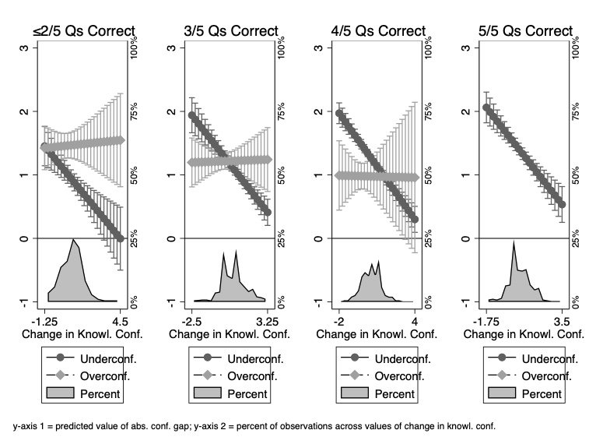

Figure A7: Predicted Absolute Confidence Gap Across Changes in Objective Knowledge by Starting Levels of Overconfidence and Objective Knowledge
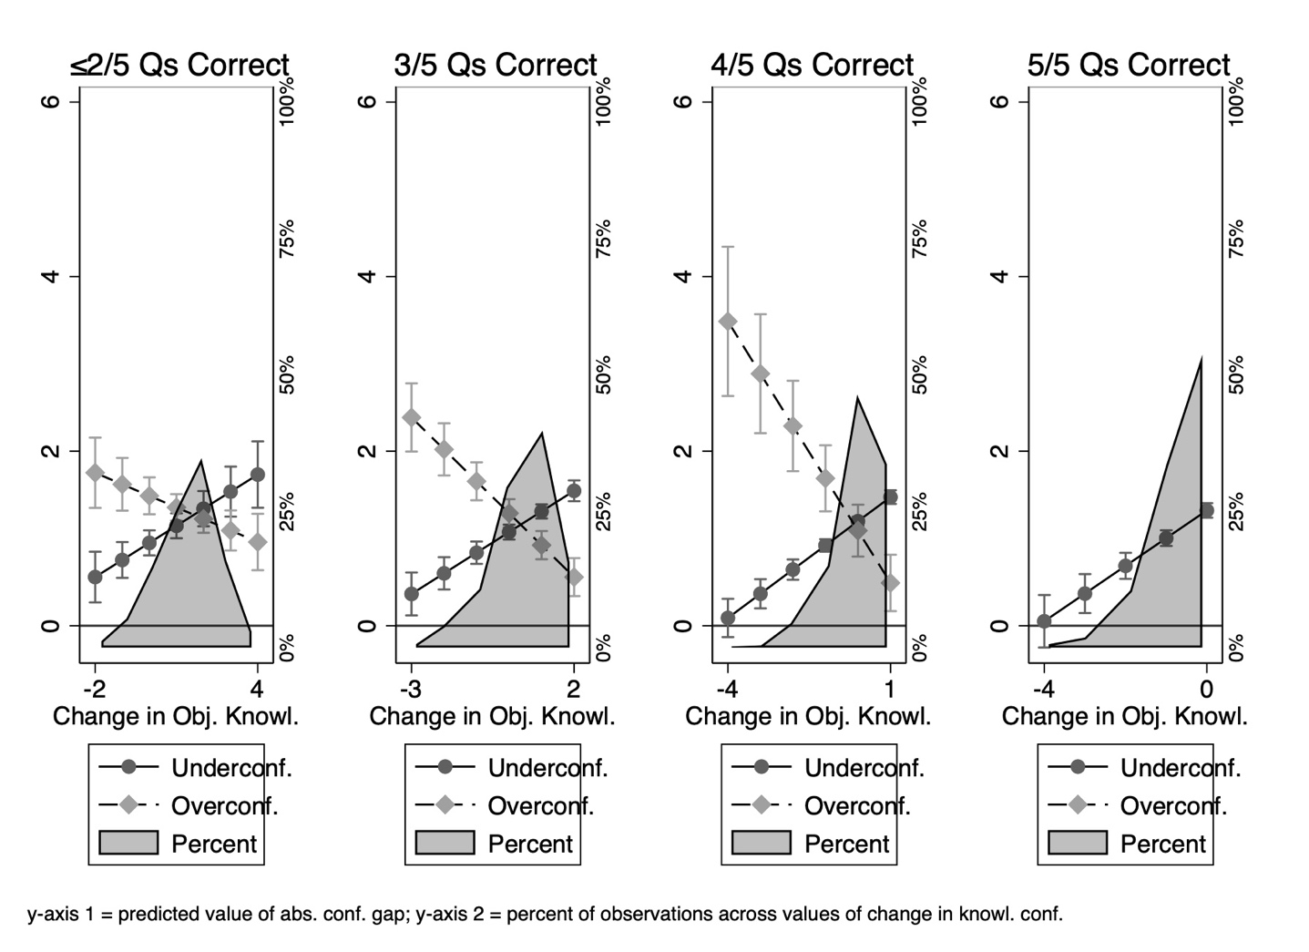

Part G: Using Overconfidence as the Primary Moderator Variable.

When we use overconfidence as our only moderator variable (i.e., dropping wave 1 objective knowledge as a moderator), we obtain similar substantive results. Replicating our t-tests in the manuscript, Table A8 shows significant reductions in both types of the confidence gap for those who started the semester underconfident. For the overconfident, the directional confidence gap decreases, but the absolute confidence gap increases. These changes are powered by significant gains in objective knowledge for the overconfident and no significant gain in objective knowledge for the underconfident. Both the underconfident and overconfident grow significantly in knowledge confidence, but this change in knowledge confidence drives the gap down for the underconfident. In sum, when we separate out students based on whether they were underconfident or overconfident at the beginning of the semester, we observe substantively similar findings to those reported in the main text using wave 1 objective knowledge to divide students into comparison groups. Table A9 replicates the regression models using overconfidence only, yielding the substantively similar conclusions.

Table A8: Difference in Means from Wave 1 to Wave 2
by Over/Under-confidence

 | Underconfident  Students  (N = 1,081) | Overconfident  Students  (N = 232)
Objective Knowledge (w1) | 3.95 | 2.54
Objective Knowledge (w2) | 3.98 | 3.47*
Knowledge Confidence (w1) | 2.49 | 3.45
Knowledge Confidence (w2) | 3.17* | 3.65*
Directional Confidence Gap (w1) | -1.46 | 0.91
Directional Confidence Gap (w2) | -0.81* | 0.19*
Absolute Confidence Gap (w1) | 1.46 | 0.92
Absolute Confidence Gap (w2) | 1.17* | 1.12*
Note: Cells report means; * indicates that the within group change from wave 1 to wave 2 is significant at p< 0.05 or less.

Table A9: Explaining the Gap between Knowledge Confidence and Objective Knowledge Using Overconfidence as the only Moderator

 | (1) | (2) | (3) | (4)
 | DV = Directional Confidence Gap w2 |  | DV = Absolute Confidence Gap w2
∆ Knowledge Confidence (w2-w1) | 0.71* | 0.66* | -0.23* | -0.30*
 | (0.03) | (0.03) | (0.03) | (0.03)
∆ Objective Knowledge (w2-w1) | -0.72* | -0.68* | 0.12* | 0.22*
 | (0.02) | (0.03) | (0.02) | (0.02)
Overconfidence w1 | 1.95* | 1.99* | -0.22* | -0.05
 | (0.07) | (0.08) | (0.07) | (0.07)
Class Attendance | 0.04 | 0.03 | -0.00 | -0.01
 | (0.03) | (0.03) | (0.03) | (0.03)
Parents’ Education | -0.01 | -0.02 | -0.11* | -0.13*
 | (0.06) | (0.06) | (0.05) | (0.05)
Class Standing | -0.06 | -0.06 | -0.02 | -0.02
 | (0.04) | (0.04) | (0.04) | (0.04)
GPA | -0.09* | -0.09* | 0.05 | 0.05
 | (0.03) | (0.03) | (0.03) | (0.03)
Female | -0.17* | -0.17* | 0.20* | 0.21*
 | (0.05) | (0.05) | (0.05) | (0.05)
Minority | -0.08 | -0.08 | 0.06 | 0.07
 | (0.05) | (0.05) | (0.05) | (0.05)
Overconfident w1 x ∆ Knowledge Confidence |  | 0.32* |  | 0.40*
 |  | (0.07) |  | (0.07)
Overconfident w1 x ∆ Obj Knowledge |  | -0.19* |  | -0.40*
 |  | (0.05) |  | (0.05)
Constant | -0.92* | -0.85* | 1.08* | 1.19*
 | (0.21) | (0.21) | (0.20) | (0.20)
Instructor FE | YES | YES | YES | YES
Semester FE | YES | YES | YES | YES
N | 1274 | 1274 | 1274 | 1274
adj. R2 | 0.584 | 0.593 | 0.081 | 0.138
BIC | 3259.64 | 3245.90 | 3195.07 | 3124.91
Standard errors in parentheses ⁺ p < 0.1, * p < 0.05

Part H: Analyzing the Confidence Gap by Topic

We replicate our paired t-tests of the confidence gap by each topic. Specifically, we create ten measures of the confidence gap, two (one absolute, and one directional) for each of the paired items: elections, constitutional rights and liberties, checks and balances in lawmaking, separation of powers among the branches of government, and political parties.
Using these new measures, we find the results are not driven by any one topic, or by students adjusting their confidence levels randomly; instead, we see significant reductions in the confidence gap broadly. As Table A10 shows, the directional gap was significantly smaller at wave 2 than wave 1 for rights and liberties, lawmaking, branches, and parties. It was not for elections. But, if we break out these comparisons by wave 1 objective knowledge, we see that this is because students who were initially very high in objective knowledge saw large reductions in their directional confidence gap as they gained knowledge confidence, while students who were initially low in objective knowledge saw a smaller reduction in their confidence gap as they still struggled to answer the objective knowledge question on elections. In other words, the directional gap on the elections question decreased across all levels of wave 1 objective knowledge, but it averaged out to a larger directional gap at wave 2 than at wave 1 due to differences in the size and directionality (i.e., some moving from overconfident to underconfident and vice versa) of the reduction across levels of wave 1 objective knowledge.
We observe similar results for the absolute confidence gap: the absolute gap was significantly smaller at wave 2 than wave 1 for rights and liberties, lawmaking, branches, and parties, though not for elections. The gap was reduced from wave 1 to wave 2 for elections, just not at traditional significance levels. When we break out these results by wave 1 objective knowledge, we find that low (<2/5) and high (5/5) wave 1 objective knowledge saw larger, though not significant, absolute confidence gaps at wave 2 while only students who answered 4/5 correct at wave 1 saw a significant reduction in absolute confidence gap at wave 2 on the elections question.

Table A10: Mean Directional Confidence Gap at Each Wave for Each Topic
 | Gap at Wave 1 | Gap at Wave 2
Laws | -0.20 | -0.17*
Elections | 0.06 | 0.12
Constitution | -0.41 | -0.31*
Branches | -0.16 | -0.05*
Parties | -0.33 | -0.22*
*p<0.05 on paired sample difference in means t-test

Table A11: Mean Absolute Confidence Gap at Each Wave for Each Topic
 | Gap at Wave 1 | Gap at Wave 2
Laws | 0.49 | 0.42*
Elections | 0.49 | 0.47
Constitution | 0.48 | 0.39*
Branches | 0.42 | 0.38*
Parties | 0.43 | 0.34*
*p<0.05 on paired sample difference in means t-test

Works Cited
Bennett, S. E. (1997). Knowledge of politics and sense of subjective political competence: The ambiguous connection. American Politics Quarterly, 25(2), 230-240.
Burns, N., Schlozman, K. L., & Verba, S. (2001). The private roots of public action: Gender, equality, and political participation. Harvard University Press.
Wolak, J. (2020). Self-confidence and gender gaps in political interest, attention, and efficacy. Journal of Politics, 82(4), 1490-1501.

Answers options were randomized.
“High school” was substituted for “college” for freshman and concurrently enrolled high school students.
The results are substantively unchanged if those identifying as transgender (3 students) and other (10 students) are included with those identifying as male, as well as if we do the opposite (i.e., code those identifying as transgender and other with those identifying as female).

