Shifting Patterns of Individual Donations in State Supreme Court Elections
Appendix

Table of Contents

Appendix A: Models with Non-Transformed Values of Individual Contributions pp. 2-4

Appendix B: Histograms of Dependent Variables and Descriptive Statistics pp. 5-6

Appendix C: Patterns of Donations by Individual Occupational Groups pp. 7-9

Appendix D: Marginal Effects Plots with Confidence Intervals pp. 10-14

Appendix A: Models with Non-Transformed Values of Individual Contributions
In Appendix A, we provide additional evidence of the robustness of our results. Appendix Table A1 presents the results of our models where we use non-transformed values of individual contributions and each of our occupational categories. Contributions are measured in $1,000 increments and we again use adjusted amounts (2023 dollars).

The results are very similar to those presented in Table 2. Each of the variables connected to our hypotheses is found to be substantively and directionally similar to Table 2. There is one exception - the result for quality candidates. We find no association between lower court experience and any donor group of individuals, including attorneys, where using the non-adjusted value of contributions. Our other measure of office experience, incumbent, remains statistically tied to individual contributions and strongly associated with attorney contributions.

We find one other minor difference relating to court size. Hypothesis 3 is confirmed with a strong relationship between court size and non-attorney donations and a marginally important connection between court size and business donations. With all individual and attorney donations, however, there is no longer a statistically strong relationship with court size. Hypothesis 3 notes that non-attorney and business donors will respond most strongly to larger courts with greater investment value.
Table A1: Models with Non-Transformed Values of Individual Contributions (2023 dollars)
 | Model 1 | Model 2 | Model 3 | Model 4
 | (Individual Donors) | (Attorney Donors) | (Non-Attorney Donors) | (Business Donors)
Candidate/Election Variables
Incumbent | 263.976** | 106.304** | 92.770** | 69.483**
 | (50.862) | (19.784) | (23.192) | (19.513)
Open seat | 188.560** | 37.194* | 74.438** | 58.355**
 | (47.457) | (18.059) | (21.644) | (18.217)
Quality candidate | 23.710 | 24.184 | -16.485 | -16.179
 | (46.960) | (18.120) | (21.415) | (18.021)
Democrat | 1.387 | 101.169** | -112.632** | -117.616**
 | (34.825) | (13.482) | (15.880) | (13.362)
Female | 28.637 | -3.907 | 12.441 | 8.549
 | (35.766) | (13.868) | (16.309) | (13.724)
Public funds | -479.026** | -94.211** | -197.927** | -141.855**
 | (85.059) | (31.761) | (38.807) | (32.679)
Chief justice race | 108.638 | 3.039 | 23.512 | 15.825
 | (66.176) | (25.606) | (30.176) | (25.391)
State Variables
District election | -422.898** | -76.704* | -248.396** | -173.260**
 | (123.891) | (32.942) | (56.877) | (48.314)
Partisan election | 110.804 | -26.691 | 3.305 | .735
 | (72.775) | (22.155) | (33.303) | (28.162)
Term length | 153.617** | 19.905** | 80.722** | 54.861**
 | (30.253) | (7.441) | (13.895) | (11.809)
Court size | 68.475 | -2.105 | 46.916* | 28.310†
 | (42.930) | (10.566) | (19.721) | (16.766)
Professionalization | -86.340 | 375.991** | -184.513 | -89.208
 | (389.958) | (95.346) | (179.119) | (152.255)
Lower appellate court | 390.785** | -.270 | 234.907** | 160.966**
 | (133.770) | (33.460) | (61.448) | (52.236)
Partisan takeover | 212.117** | 32.841* | 82.900** | 62.206**
 | (42.686) | (15.929) | (19.472) | (16.393)
Competitive court | -37.339 | -23.832 | -6.519 | -7.759
 | (41.382) | (15.165) | (18.881) | (15.900)
Contribution limits
26th–50th percentiles | 19.277 | -9.988 | -23.773 | -19.718
 | (75.190) | (25.339) | (34.350) | (28.977)
51st–75th percentiles | 108.846 | 57.980* | 38.542 | 34.270
 | (80.005) | (25.824) | (36.578) | (30.891)
76th percentile–max limit | 149.813† | 61.710* | 55.373 | 44.162
 | (88.139) | (25.647) | (40.344) | (34.125)
No limit | -213.861† | 13.168 | -93.272† | -55.712
 | (114.291) | (34.259) | (52.313) | (44.250)
Post-White clause | -100.449* | -95.962** | -78.330** | -67.220**
 | (46.379) | (16.678) | (21.171) | (17.840)
Solicitation limit | -262.097* | 61.768 | -68.322 | -36.038
 | (123.055) | (38.034) | (56.277) | (47.546)
South | -247.825* | 47.195 | -128.545** | -79.664†
 | (109.315) | (30.139) | (50.131) | (42.517)
Population | .001 | .002 | .001 | .002
 | (.008) | (.002) | (.004) | (.003)
Intercept | -1468.275** | -423.206** | -763.362** | -508.602**
 | (444.519) | (114.514) | (204.092) | (173.380)
N (level 1) | 576 | 576 | 576 | 576
N (level 2) | 22 | 22 | 22 | 22
log likelihood | -4273.50 | -3719.42 | -3821.32 | -3722.07
R² | .2984 | .2809 | .3335 | .3015
Wald x² | 153.31 | 188.99 | 195.39 | 198.23
Probability of x² | .000 | .000 | .000 | .000
AIC | 8599.00 | 7490.85 | 7694.64 | 7496.14
Notes: Dependent variable is amount raised from individual contributors (2023 dollars); standard errors are in parentheses, AIC = Akaike information criterion.
** p<.01, * p<.05, † p<.1, two-tailed test of significance.

Appendix B: Histogram of Individual Donations and Descriptive Statistics

To display the patterns of donations for individual contributors, we include in Appendix Figure B1 the overall distribution (by percentage) of the natural log of individual donations. We include four panels assigned to (1) all individual donors, (2) attorney donors, (3) non-attorney donors, and (4) business donors. With each panel, the histograms show that there was substantial variation in the money spent by individual contributors, as well as the separate occupational categories.

With all individual donors, we see the grouping of observations around the median value (12.451 or $255,404 in non-adjusted value). With attorneys, we see the observations clustered near the median for attorney donations (11.144 or $69,170). For non-attorneys, observations centered around the median (11.116 or $67,223). With business donors, observations converge on the median for business donations (10.806 or $49,310).

Table B1 provides descriptive statistics for each of our variables.

Figure B1: Histogram of Individual Donations
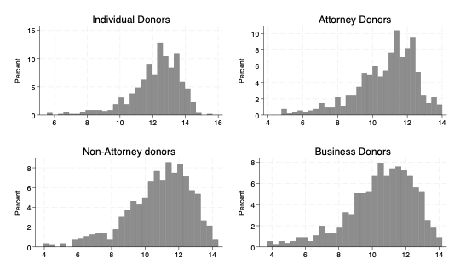
Table B1: Descriptive Statistics
Variable | Mean | Median | Std. Dev. | Min | Max
Dependent Variables
Individual donations | 12.159 | 12.451 | 1.528 | 5.537 | 15.650
Attorney donations | 10.779 | 11.144 | 1.735 | 4.768 | 14.003
Non-attorney donations | 10.835 | 11.116 | 1.872 | 3.917 | 14.345
Business donations | 10.506 | 10.806 | 1.981 | 3.697 | 14.170
Candidate/Election Variables
Incumbent | .365 | 0 | .482 | 0 | 1
Quality candidate | .429 | 0 | .495 | 0 | 1
Open seat | .345 | 0 | .476 | 0 | 1
Democrat | .451 | 0 | .498 | 0 | 1
Female | .372 | 0 | .484 | 0 | 1
Public funds | .063 | 0 | .242 | 0 | 1
Chief justice race | .073 | 0 | .260 | 0 | 1
State Variables
District election | .116 | 0 | .321 | 0 | 1
Partisan election | .375 | 0 | .485 | 0 | 1
Term length | 7.628 | 8 | 1.791 | 6 | 12
Court size | 7.365 | 7 | 1.197 | 5 | 9
Lower appellate court | .866 | 1 | .341 | 0 | 1
Professionalization | .661 | .638 | .120 | .290 | .938
Partisan takeover | .372 | 0 | .484 | 0 | 1
Competitive court | .552 | 1 | .498 | 0 | 1
Contribution limit: 26th-50th  percentiles | .217 | 0 | .413 | 0 | 1
Contribution limit: 51st-75th  percentiles | .220 | 0 | .415 | 0 | 1
Contribution limit: 76th  percentile - max limit | .234 | 0 | .424 | 0 | 1
Contribution limit: No limit | .148 | 0 | .355 | 0 | 1
Post-White clause | .359 | 0 | .480 | 0 | 1
Solicitation limit | .712 | 1 | .453 | 0 | 1
South | .481 | 0 | .500 | 0 | 1
Population | 8872.225 | 6816.143 | 7284.161 | 755.548 | 30113.490

Appendix C: Patterns of Donations by Individual Occupational Groups
To better understand which occupational groups are most active, we present in Appendix C patterns of giving for attorneys, non-attorneys, and business donors. Appendix Table C1 includes the total non-transformed amount spent (adjusted 2023 dollars) by each employment category of individual donors by state, as well as two ratios – (1) the ratio of attorney to non-attorney giving and (2) the ratio of attorney to business donor giving. Appendix Table C2 provides the same information, though for each two-year election cycle rather than by state. With Appendix Table C1, we can see both high and low levels of giving by attorneys, non-attorneys, and business donors in several states and considerable variation is observed. Among attorneys, the total amount donated was highest in Ohio from 2000-2023, followed by Michigan and Texas. Like the illustration of mean amounts donated in Figure 2, North Dakota ranked last among attorney giving, with Idaho and Minnesota also low in attorney spending. Among non-attorneys, Ohio ranked first, followed by Wisconsin and Michigan. North Dakota, Idaho, and New Mexico were the states with the smallest amount of non-attorney giving. Business donors generally followed the patterns observed for non-attorneys.

Where we consider the ratio of attorney to non-attorney giving, and the ratio of attorney to business donor giving, we see patterns where judicial campaign donations are dominated by attorneys or non-attorney/business donors. With attorneys and non-attorneys, non-attorneys gave more than attorneys across all states. Judicial campaigns in Georgia stand out as the most attorney dominated with $3.44 attorney dollars spent for every $1 of non-attorney contributions. Donations in Mississippi, New Mexico, and Louisiana also leaned heavily towards attorneys. Non-attorneys dominated fundraising for judicial campaigns in North Dakota, Wisconsin, and Ohio, among other states. Comparing money spent by attorneys to business donors, attorneys slightly outspent business donors. Georgia ranked first with attorneys outspending business donors by $4.44 for every dollar spent by business donors. Mississippi, New Mexico, and Kentucky were also dominated by attorney spending. North Dakota was most dominated by business donors, but business donors in Wisconsin, Ohio, and Minnesota were quite active, outspending attorneys.

Where we consider occupational spending and the ratio of spending by those groups by election cycle, we find that spending by attorneys was greatest towards the beginning of the century with attorney spending highest in the 2000, 2002, and 2004 election cycles. Attorney spending was least in 2022, 2018, and 2020. Non-attorney spending was largest in 2006, 2000, and 2022, and smallest in 2010, 2018, and 2012. Business donors contributed the largest amounts in 2014, 2000, and 2006, while gave the least in 2010, 2018, and 2012.

With the ratio of spending for (1) attorney and non-attorney donors and (2) attorney and business donors by specific election cycles, the 2000 election cycle was most dominated by attorneys - outspending non-attorneys by a 1.24 to 1 margin. More recent elections in 2022, 2020, and 2018 had higher levels of non-attorney spending relative to attorneys. With the ratio of spending between attorney and business donors, attorney money was the larger share in 2000, 2012, and 2010, where they gave larger sums than business donors. More recent elections in 2022, 2020, and 2018 have seen that tide turn with business donations outpacing those by attorneys.

Table C1: Sum and Ratio of Donations by State
State | Attorney | Non-Attorney | Business | Ratio of  Attorney to  Non-Attorney $ | Ratio of  Attorney to Business $
AL | $2,338,211 | $2,427,891 | $2,068,491 | 0.96 | 1.13
AR | $2,237,052 | $2,009,985 | $1,622,407 | 1.11 | 1.38
GA | $3,055,309 | $886,973 | $688,193 | 3.44 | 4.44
ID | $164,965 | $189,680 | $152,188 | 0.87 | 1.08
IL | $2,517,210 | $1,948,109 | $1,700,784 | 1.29 | 1.48
KY | $2,428,985 | $2,018,513 | $1,303,819 | 1.20 | 1.86
LA | $1,713,831 | $1,204,604 | $1,171,977 | 1.42 | 1.46
MI | $9,801,137 | $11,700,000 | $9,320,629 | 0.84 | 1.05
MN | $389,980 | $595,874 | $462,266 | 0.65 | 0.84
MS | $6,757,466 | $3,401,602 | $3,002,000 | 1.99 | 2.25
MT | $1,661,632 | $2,599,807 | $1,539,890 | 0.64 | 1.08
NC | $6,433,737 | $9,568,693 | $6,510,777 | 0.67 | 0.99
ND | $442 | $33,860 | $33,860 | 0.01 | 0.01
NM | $438,693 | $274,356 | $225,980 | 1.60 | 1.94
NV | $1,140,983 | $875,172 | $803,393 | 1.30 | 1.42
OH | $9,906,805 | $17,900,000 | $15,800,000 | 0.55 | 0.63
OR | $675,001 | $875,203 | $683,171 | 0.77 | 0.99
PA | $7,376,983 | $7,732,884 | $6,079,670 | 0.95 | 1.21
TX | $8,672,722 | $9,097,626 | $7,951,115 | 0.95 | 1.09
WA | $1,508,492 | $1,730,470 | $851,890 | 0.87 | 1.77
WI | $3,799,754 | $13,400,000 | $8,553,513 | 0.28 | 0.44
WV | $4,060,743 | $2,864,356 | $2,498,261 | 1.42 | 1.63
Total | $77,100,000 | $93,200,000 | $73,100,000 | 0.83 | 1.05

Table C2: Sum and Ratio of Donations by Election Cycle
Cycle | Attorney | Non-Attorney | Business | Ratio of  Attorney to  Non-Attorney $ | Ratio of  Attorney to Business $
2000 | $11,800,000 | $9,545,204 | $7,470,740 | 1.24 | 1.58
2002 | $8,634,685 | $7,983,110 | $6,822,220 | 1.08 | 1.27
2004 | $8,239,693 | $8,421,196 | $7,075,298 | 0.98 | 1.16
2006 | $7,261,088 | $10,300,000 | $7,225,079 | 0.70 | 1.00
2008 | $7,557,942 | $8,004,478 | $6,107,023 | 0.94 | 1.24
2010 | $4,517,267 | $4,390,877 | $3,458,198 | 1.03 | 1.31
2012 | $6,319,960 | $6,268,185 | $4,820,898 | 1.01 | 1.31
2014 | $7,012,614 | $9,000,865 | $7,521,959 | 0.78 | 0.93
2016 | $5,023,881 | $7,176,122 | $5,482,282 | 0.70 | 0.92
2018 | $3,427,624 | $5,854,783 | $4,139,096 | 0.59 | 0.83
2020 | $4,071,418 | $7,189,592 | $5,801,400 | 0.57 | 0.70
2022 | $3,193,172 | $9,126,450 | $7,149,119 | 0.35 | 0.45
Total | $77,100,000 | $93,200,000 | $73,100,000 | 0.83 | 1.05

Appendix D: Marginal Effects Plots with Confidence Intervals

Marginal effects plots for the theoretically important and statistically significant explanatory variables from Table 2 are provided below. Shaded regions reflect 95% confidence intervals.

Figure D1: Relationship between Incumbent Status and Individual Donations by Occupational Category
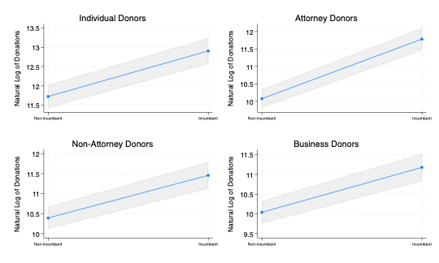
Figure D2: Relationship between Quality Candidate Status and Individual Donations by Occupational Category
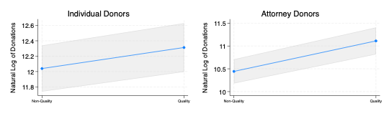
Note: Quality candidate is not statistically significant in Models 3 and 4.

Figure D3: Relationship between Open Seat Status and Individual Donations by Occupational Category
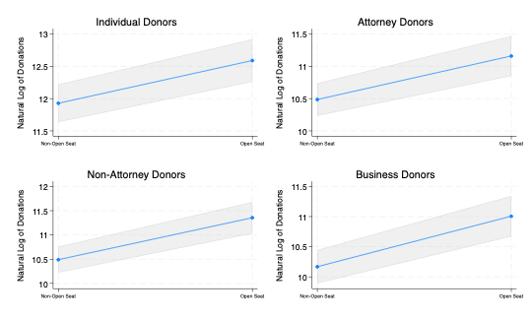
Figure D4: Relationship between Partisan Affiliation and Individual Donations by Occupational Category
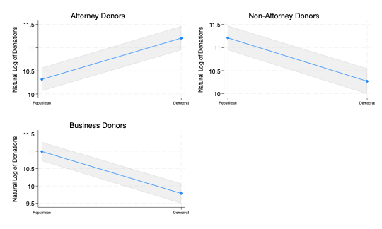
Note: Democrat is not statistically significant in Model 1.

Figure D5: Relationship between At-Large/District Election Format and Individual Donations by Occupational Category
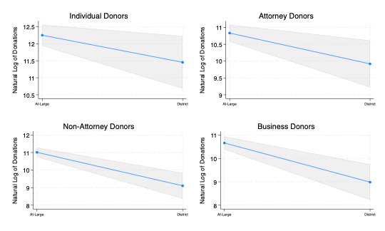
Note: District Election is marginally significant in Model 1.

Figure D6: Relationship between Term Length and Individual Donations by Occupational Category
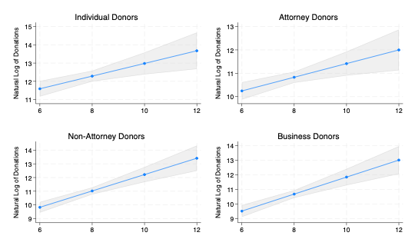

Figure D7: Relationship between Court Size and Individual Donations by Occupational Category
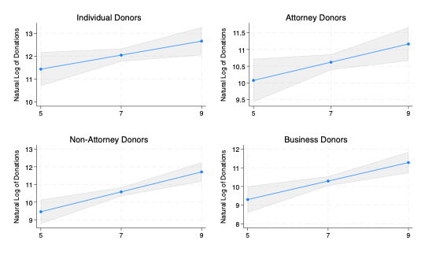
Note: Court Size is marginally significant in Model 1.

Figure D8: Relationship between Lower Appellate Court and Individual Donations by Occupational Category
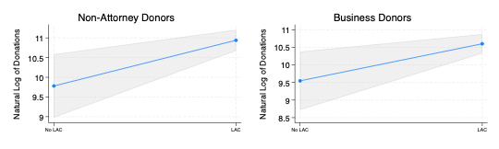
Note: Lower Appellate Court is not statistically significant in Models 1 and 2.
Figure D9: Relationship between Possibility of Partisan Takeover and Individual Donations by Occupational Category
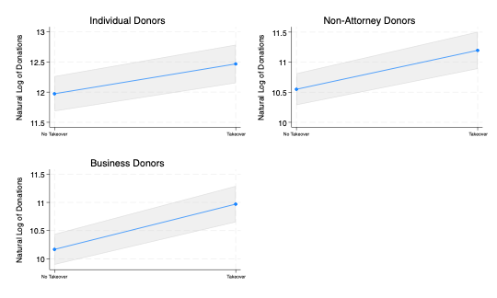
Note: Partisan Takeover is not statistically significant in Model 2.

