**Appendix**

***Strategic Candidates and Sacrificial Lambs?:***

***An Exploration of Gender and Race in State Executive Elections***

## **Appendix I:** *Summary Statistics for Outcome, Predictors, and Control Covariates*

|  | Mean | Std. Dev. | Obs. |
| --- | --- | --- | --- |
| Vote % | 45.246 | 19.905 | 21668 |
| Full WFI | 4.935 | 2.388 | 22158 |
| Candidate Democrat | 0.649 | 0.477 | 22174 |
| Candidate White | 0.768 | 0.422 | 22157 |
| Candidate Black | 0.150 | 0.357 | 22157 |
| Candidate Latino | 0.057 | 0.231 | 22157 |
| Candidate AAPI | 0.020 | 0.139 | 22157 |
| Candidate Other Race | 0.016 | 0.124 | 22157 |
| Post-Grad Degree | 0.663 | 0.473 | 20979 |
| Governor | 0.100 | 0.300 | 22174 |
| Cabinet Office | 0.366 | 0.482 | 22174 |
| Other Office | 0.534 | 0.499 | 22174 |

## **Appendix II:** *Full Regression Models*

The Effect of Women Friendliness on U.S. Statewide Executive Woman Candidate County-Level Vote Share, 2010-2019, Unmatched Data

|  |  |  |  |  |  |
| --- | --- | --- | --- | --- | --- |
|  | All | White  Democrats | Non-White  Democrats | White  Republicans | Non-White  Republicans |
| Intercept | 3.337 | -10.183** | -11.891** | 43.053*** | -6.380 |
|  | (2.563) | (3.334) | (3.726) | (3.583) | (58.399) |
| WFI | -0.556*** | -0.956*** | -2.066*** | 1.262*** | -0.965 |
|  | (0.166) | (0.223) | (0.324) | (0.280) | (1.377) |
| WFI Squared | 0.047** | 0.054* | 0.159*** | -0.063* | 0.126 |
|  | (0.016) | (0.021) | (0.029) | (0.027) | (0.119) |
| Democratic Candidate | -13.822*** | - | - | - | - |
|  | (0.502) | - | - | - | - |
| Winner | -0.181 | 1.768*** | -0.524 | -1.892*** | 31.215 |
|  | (0.367) | (0.330) | (0.953) | (0.393) | (39.687) |
| Incumbent | 3.438*** | 3.976*** | 4.429*** | 3.812*** | 0.514 |
|  | (0.238) | (0.421) | (0.482) | (0.200) | (6.605) |
| Post-Grad Degree | 0.923*** | -2.319*** | -1.818*** | 1.003*** | 12.844 |
|  | (0.239) | (0.282) | (0.325) | (0.224) | (11.491) |
| County Ideology | -1.173+ | 0.99 | -0.582 | -0.521 | 10.146* |
|  | (0.643) | (0.783) | (1.033) | (0.908) | (4.929) |
| County % Democrat | 25.645*** | 74.454*** | 85.931*** | -67.000*** | 10.46 |
|  | (1.498) | (1.569) | (2.001) | (1.654) | (9.246) |
| County % Female | -0.447 | -11.811* | 10.928* | 3.165 | 14.203 |
|  | (4.598) | (5.941) | (5.189) | (7.065) | (20.739) |
| County % Traditionalistic | -0.451 | 0.498 | 6.270*** | -1.399* | -49.451+ |
|  | (0.336) | (0.470) | (0.857) | (0.562) | (29.246) |
| County % Moralistic | -0.647* | 0.112 | 3.592*** | -0.734 | -12.73 |
|  | (0.279) | (0.377) | (0.721) | (0.477) | (18.207) |
| County % Catholic | -2.362* | -1.778 | -7.693*** | 5.906*** | 21.795*** |
|  | (0.934) | (1.211) | (1.573) | (1.443) | (6.178) |
| County % Evangelical | -0.534 | 1.397 | -2.008 | -1.08 | -5.114 |
|  | (0.874) | (1.338) | (1.403) | (1.356) | (4.549) |
| County IWPR Rank | 0.024* | 0.135*** | -0.058 | -0.109*** | 0.589 |
|  | (0.011) | (0.015) | (0.036) | (0.017) | (0.534) |
| State Candidate Vote % | 0.825*** | 0.521*** | 0.257*** | 0.754*** | 1.075 |
|  | (0.011) | (0.024) | (0.062) | (0.016) | (1.537) |
| County Total Votes (Millions) | 0.000 | 0.000 | 0.000 | 0.000 | 0.000 |
|  | (0.000) | (0.000) | (0.000) | (0.000) | (0.000) |
| Adjusted r2 | 0.609 | 0.716 | 0.834 | 0.761 | 0.645 |
| RMSE | 12.5 | 8 | 6.61 | 8.32 | 11.8 |
| Num. Obs. | 17982 | 8329 | 3073 | 6011 | 569 |

Notes: +p < 0.1, * p < 0.05, ** p < 0.01, *** p < 0.001. County-clustered standard errors reported in parentheses.

The Effect of Women-Friendliness on U.S. Statewide Executive Woman Candidate County-Level Vote Share, 2010-2019, Matched Data

|  |  |  |  |  |  |
| --- | --- | --- | --- | --- | --- |
|  | All | White  Democrats | Non-White  Democrats | White  Republicans | Non-White  Republicans |
| Intercept | -0.468 | 0.919 | -12.823** | 5.475 | -134.435*** |
|  | (4.664) | (5.011) | (4.243) | (49.436) | (25.015) |
| WFI | -0.591+ | -0.168 | -1.370*** | 0.443 | 5.492*** |
|  | (0.317) | (0.357) | (0.352) | (0.645) | (1.566) |
| WFI Squared | 0.019 | -0.023 | 0.081* | 0.035 | -0.512*** |
|  | (0.030) | (0.036) | (0.034) | (0.068) | (0.140) |
| Democratic Candidate | -11.380*** | - | - | - | - |
|  | (1.016) | - | - | - | - |
| Winner | -0.788 | 3.488*** | -1.167 | -13.994 | -42.029** |
|  | (0.539) | (0.610) | (0.929) | (14.476) | (14.236) |
| Incumbent | 2.352*** | 4.713*** | 4.734*** | 18.333*** | -12.205*** |
|  | (0.570) | (1.071) | (0.520) | (4.136) | (2.920) |
| Post-Grad Degree | -0.762* | -5.133*** | -1.411*** | 1.636 | 0.484 |
|  | (0.348) | (0.500) | (0.339) | (9.911) | (2.779) |
| County Ideology | -2.399* | -0.751 | -1.441 | -5.404 | 5.638 |
|  | (1.111) | (1.255) | (0.988) | (3.569) | (5.356) |
| County Pct Democrat | 63.876*** | 77.789*** | 82.991*** | -84.382*** | 7.593 |
|  | (2.179) | (2.421) | (2.155) | (4.303) | (10.279) |
| County % Female | 3.000 | -24.218** | 10.710+ | 14.986 | 49.385 |
|  | (7.632) | (9.316) | (6.157) | (20.310) | (33.298) |
| County % Traditionalistic | 0.743 | 3.664*** | 5.503*** | -3.839 | 3.172 |
|  | (0.533) | (0.620) | (0.803) | (8.645) | (10.167) |
| County % Moralistic | -1.446** | -3.269*** | 3.818*** | -0.162 | -47.350*** |
|  | (0.544) | (0.873) | (0.712) | (8.187) | (13.040) |
| County % Catholic | -6.706*** | 1.485 | -10.889*** | 4.037 | 47.268*** |
|  | (1.549) | (1.986) | (1.655) | (5.943) | (7.931) |
| County % Evangelical | -1.364 | -4.878** | -2.04 | -9.688* | 7.848 |
|  | (1.400) | (1.804) | (1.398) | (4.353) | (6.316) |
| County IWPR Rank | -0.009 | -0.011 | -0.048 | -0.148 | -0.451 |
|  | (0.026) | (0.033) | (0.034) | (0.302) | (0.300) |
| State Candidate Vote % | 0.552*** | 0.413*** | 0.290*** | 1.846* | 3.756*** |
|  | (0.040) | (0.040) | (0.064) | (0.785) | (0.622) |
| County Total Votes (Millions) | 0.000* | 0.000+ | 0.000* | 0.000 | 0.000 |
|  | (0.000) | (0.000) | (0.000) | (0.000) | (0.000) |
| ‍Adjusted r2 | 0.603 | 0.738 | 0.818 | 0.786 | 0.62 |
| ‍RMSE | 10 | 7.56 | 6.62 | 6.25 | 10.7 |
| Num. Obs. | 6260 | 2779 | 2779 | 351 | 351 |

Notes: +p < 0.1, * p < 0.05, ** p < 0.01, *** p < 0.001. County-clustered standard errors reported in parentheses.

The Effect of Women-Friendliness on U.S. Statewide Executive Woman Candidate County-Level Vote Share, 2010-2019, by District Type

|  |  |  |  |
| --- | --- | --- | --- |
|  | Safe Dem | Safe GOP | Competitive |
| Intercept | -30.884*** | -1.039 | -41.659*** |
|  | (6.715) | (5.569) | (6.203) |
| WFI | -2.090** | -1.934*** | -0.264 |
|  | (0.653) | (0.459) | (0.473) |
| WFI Squared | 0.135* | 0.146** | 0.024 |
|  | (0.053) | (0.045) | (0.046) |
| Winner | 9.329*** | 5.328** | 2.955* |
|  | (1.330) | (1.617) | (1.408) |
| Incumbent | -0.680* | - | -0.426 |
|  | (0.305) | - | (0.766) |
| Post-Grad Degree | -0.610 | 1.842*** | -0.953*** |
|  | (1.164) | (0.479) | (0.221) |
| County Ideology | -3.778* | -1.916 | 0.961 |
|  | (1.533) | (1.712) | (2.141) |
| County % Democrat | 87.596*** | 83.104*** | 94.092*** |
|  | (4.119) | (2.402) | (2.407) |
| County % Female | -35.337** | 21.304*** | 0.635 |
|  | (13.138) | (6.302) | (11.986) |
| County % Catholic | -1.333 | -8.575*** | -12.417** |
|  | (1.785) | (2.164) | (4.033) |
| County % Evangelical | 13.150*** | -7.265*** | 3.926* |
|  | (3.823) | (1.339) | (1.935) |
| County IWPR Rank | 0.231*** | -0.030 | 0.008 |
|  | (0.056) | (0.025) | (0.035) |
| State Candidate Vote % | 0.866*** | 0.129 | 0.926*** |
|  | (0.025) | (0.120) | (0.040) |
| County Total Votes (Millions) | 0.000 | 0.000+ | 0.000 |
|  | 0.000 | 0.000 | 0.000 |
| Adjusted r2 | 0.905 | 0.785 | 0.898 |
| RMSE | 4.26 | 7.40 | 4.86 |
| Num. Obs. | 614 | 1557 | 902 |

Notes: +p < 0.1, * p < 0.05, ** p < 0.01, *** p < 0.001. County clustered standard errors reported in parentheses. These coefficients are from a model that examines only non-white Democratic women candidates.

## **Appendix III:** *Alternative Specification of WFI Measure*

The women-friendliness index used in this paper and elsewhere is an additive measure of ten components; a county where none of these components is above the average (mean or median) level receives a score of zero, while a county above the average on all measures receives a score of ten. This creates an eleven-point scale. If we drop the two measures accounting for the proportion of Black and Hispanic voters, our coefficients change only slightly.

Notably, we no longer find statistically significant results for our models examining all candidates and non-white Republican candidates. In the case of the latter, this underscores the need to examine the data by race and party, as our coefficients for white candidates of both parties and non-white Democrats remain consistent with our expectations. Moreover, the small number of non-white Republicans in the data may drive the change in the association between context and candidate performance.

The Effect of Women-Friendliness on U.S. Statewide Executive Woman Candidate County-Level Vote Share, 2010-2019

|  |  |  |  |  |  |
| --- | --- | --- | --- | --- | --- |
|  | All | White  Democrats | Non-White  Democrats | White  Republicans | Non-White  Republicans |
| Intercept | 2.339 | -11.709*** | -13.950*** | 45.339*** | -9.619 |
|  | (2.595) | (3.340) | (3.785) | (3.597) | (57.918) |
| WFI (8) | -0.334 | -0.893** | -1.620*** | 1.275*** | 0.865 |
|  | (0.205) | (0.278) | (0.355) | (0.342) | (1.440) |
| WFI Squared | 0.041+ | 0.058+ | 0.159*** | -0.080+ | -0.029 |
|  | (0.025) | (0.033) | (0.042) | (0.041) | (0.168) |
| Democratic Candidate | -13.832*** | - | - | - | - |
|  | (0.502) | - | - | - | - |
| Winner | -0.183 | 1.761*** | -0.716 | -1.898*** | 31.331 |
|  | (0.367) | (0.331) | (0.957) | (0.393) | (39.687) |
| Incumbent | 3.447*** | 4.002*** | 4.673*** | 3.834*** | 0.559 |
|  | (0.238) | (0.422) | (0.481) | (0.201) | (6.579) |
| Post-Grad Degree | 0.922*** | -2.357*** | -1.852*** | 1.052*** | 12.497 |
|  | (0.239) | (0.283) | (0.328) | (0.224) | (11.448) |
| County Ideology | -1.023 | 1.212 | -0.545 | -0.887 | 10.093* |
|  | (0.647) | (0.782) | (1.054) | (0.918) | (4.920) |
| County % Democrat | 25.421*** | 74.238*** | 85.508*** | -66.624*** | 10.609 |
|  | (1.495) | (1.571) | (2.009) | (1.663) | (9.270) |
| County % Female | 0.362 | -9.232 | 13.262** | -0.669 | 14.613 |
|  | (4.630) | (5.944) | (5.091) | (7.068) | (20.396) |
| County % Traditionalistic | -0.580+ | 0.204 | 5.936*** | -1.039+ | -50.066+ |
|  | (0.333) | (0.468) | (0.857) | (0.557) | (29.281) |
| County % Moralistic | -0.703* | 0.074 | 3.277*** | -0.789+ | -13.496 |
|  | -0.277 | -0.379 | -0.722 | -0.472 | -18.155 |
| County % Catholic | -2.483** | -1.802 | -7.942*** | 5.858*** | 21.164*** |
|  | (0.939) | (1.221) | (1.587) | (1.457) | (6.152) |
| County % Evangelical | -0.521 | 1.13 | -2.521+ | -0.619 | -4.489 |
|  | (0.878) | (1.335) | (1.396) | (1.369) | (4.574) |
| County IWPR Rank | 0.023* | 0.131*** | -0.067+ | -0.107*** | 0.584 |
|  | (0.011) | (0.015) | (0.036) | (0.017) | (0.536) |
| State Candidate Vote % | 0.824*** | 0.519*** | 0.243*** | 0.756*** | 1.066 |
|  | (0.011) | (0.024) | (0.061) | (0.016) | (1.531) |
| County Total Votes (Millions) | 0.000 | 0.000 | 0.000 | 0.000 | 0.000 |
|  | (0.000) | (0.000) | (0.000) | (0.000) | (0.000) |
| Adjusted R2 | 0.609 | 0.714 | 0.832 | 0.759 | 0.645 |
| RMSE | 12.5 | 8.01 | 6.66 | 8.35 | 11.8 |
| Num. Obs. | 17982 | 8329 | 3073 | 6011 | 569 |

Notes: +p < 0.1, * p < 0.05, ** p < 0.01, *** p < 0.001. County-clustered standard errors reported in parentheses.

## **Appendix IV:** *Coefficients by Office Type*

Given that the types of offices across states vary, there might be some concern that our measures are obscuring critical differences between the groups. Therefore, we re-estimate our models by subdividing state-level executive races into three types of offices—governor, cabinet, and all other contests. In these estimations, we show these patterns are consistent by office type.

Distributions of Candidate County-Level Electoral Performance

Across the Range of the Women-Friendliness Index

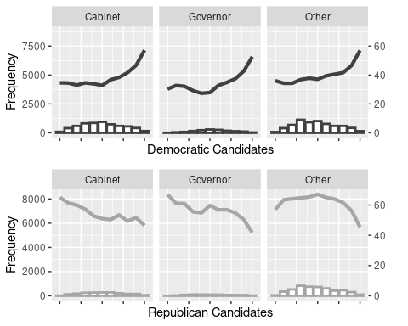

Notes: The line reports mean vote share for all candidates at each level of women friendliness, while the histogram reports the number of candidates at each level.

Estimated Marginal Effects of Women-Friendliness Index on

Candidate Performance, Matched Datasets

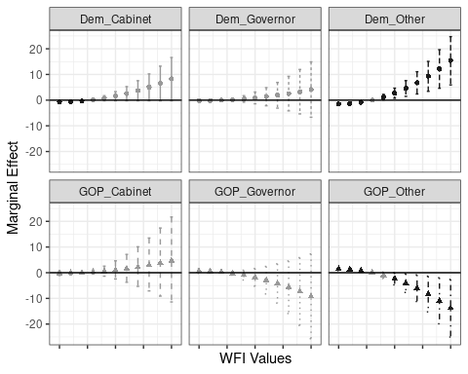

Notes: Each subgroup plotted with differing line type and shape. Simulated 90% confidence intervals are reported in vertical bars around the estimated marginal effect. Black indicates the confidence interval is statistically significantly different from zero.

These results show that at low levels of the women-friendliness index, there is a small but persistent advantage for Republican candidates, and a small but persistent disadvantage for Democratic candidates. These advantages are smallest for gubernatorial candidates but highest for non-cabinet, “other” offices. As WFI increases, this effect reverses: at WFI of six or higher, there is a statistically significant, positive effect for Democratic gubernatorial and “other” offices, and a negative effect for Republican “other” offices. These advantages increase, as expected following our quadratic modeling.

The Effect of Women-Friendliness on U.S. Statewide Executive Woman Candidate County-Level Vote Share, Governors 2010-2019

|  |  |  |
| --- | --- | --- |
|  | Democratic Governors | Republican Governors |
| Intercept | -35.636*** | 21.268* |
|  | (4.398) | (9.679) |
| WFI | -0.220 | 0.651 |
|  | (0.304) | (0.466) |
| WFI Squared | 0.022 | -0.049 |
|  | (0.030) | (0.044) |
| Winner | 9.981*** | 6.901*** |
|  | (0.747) | (0.974) |
| Incumbent | -1.520 | 19.089*** |
|  | (1.192) | (2.152) |
| Post-Grad Degree | -4.123*** | 18.695*** |
|  | (0.820) | (1.397) |
| County Ideology | 2.075+ | -2.354 |
|  | (1.255) | (1.821) |
| County % Democrat | 88.744*** | -88.341*** |
|  | (2.514) | (2.888) |
| County % Female | -4.203 | 48.741** |
|  | (6.036) | (17.676) |
| County % Traditionalistic | -1.694 | -36.986*** |
|  | (2.398) | (4.654) |
| County % Moralistic | 4.468* | -18.367*** |
|  | (2.273) | (2.371) |
| County % Catholic | -5.838*** | 6.42 |
|  | (1.676) | (3.901) |
| County % Evangelical | 1.98 | -9.163*** |
|  | (1.477) | (2.251) |
| County IWPR Rank | 0.334*** | 0.579*** |
|  | (0.037) | (0.095) |
| State Candidate Vote % | 0.743*** | 0.999*** |
|  | (0.040) | (0.090) |
| County Total Votes (Millions) | 0.000*** | 0.000 |
|  | (0.000) | (0.000) |
| Adjusted r2 | 0.863 | 0.821 |
| RMSE | 5.69 | 5.60 |
| Num. Obs. | 1368 | 674 |

Notes: +p < 0.1, * p < 0.05, ** p < 0.01, *** p < 0.001. County-clustered standard errors reported in parentheses.

The Effect of Women-Friendliness on U.S. Statewide Executive Woman Candidate County-Level Vote Share, Cabinet Officers 2010-2019

|  |  |  |
| --- | --- | --- |
|  | Democratic Cabinet | Republican Cabinet |
| Intercept | -23.631*** | 30.779*** |
|  | (3.036) | (6.889) |
| WFI | -0.698** | -0.218 |
|  | (0.234) | (0.443) |
| WFI Squared | 0.045* | 0.024 |
|  | (0.023) | (0.044) |
| Winner | -0.489 | 4.523*** |
|  | (0.476) | (0.745) |
| Incumbent | 2.856*** | -3.414*** |
|  | (0.460) | (0.606) |
| Post-Grad Degree | -0.450 | 8.219*** |
|  | (0.352) | (0.480) |
| County Ideology | 0.205 | -1.274 |
|  | (0.804) | (2.203) |
| County % Democrat | 78.540*** | -54.179*** |
|  | (1.733) | (5.465) |
| County % Female | 4.029 | 7.303 |
|  | (4.914) | (12.544) |
| County % Traditionalistic | -0.521 | -1.328 |
|  | (0.458) | (1.082) |
| County % Moralistic | 0.429 | -6.163*** |
|  | (0.381) | (0.669) |
| County % Catholic | -3.190** | 14.868*** |
|  | (1.089) | (3.661) |
| County % Evangelical | -3.922** | -17.138*** |
|  | (1.216) | (2.997) |
| County IWPR Rank | 0.147*** | -0.359*** |
|  | (0.017) | (0.051) |
| State Candidate Vote % | 0.561*** | 0.965*** |
|  | (0.036) | (0.044) |
| County Total Votes (Millions) | 0.000 | 0.000* |
|  | (0.000) | (0.000) |
| Adjusted r2 | 0.790 | 0.669 |
| RMSE | 7.00 | 9.86 |
| Num. Obs. | 4960 | 1667 |

Notes: +p < 0.1, * p < 0.05, ** p < 0.01, *** p < 0.001. County-clustered standard errors reported in parentheses.

The Effect of Women-Friendliness on U.S. Statewide Executive Woman Candidate County-Level Vote Share, Other Offices 2010-2019

|  |  |  |
| --- | --- | --- |
|  | Democratic Offices | Republican Offices |
| Intercept | 1.714 | 35.787*** |
|  | (3.749) | (4.138) |
| WFI | -1.527*** | 1.444*** |
|  | (0.271) | (0.318) |
| WFI Squared | 0.085*** | -0.076* |
|  | (0.025) | (0.030) |
| Winner | -0.075 | -4.434*** |
|  | (0.463) | (0.562) |
| Incumbent | 6.560*** | 4.105*** |
|  | (0.545) | (0.252) |
| Post-Grad Degree | -2.440*** | -0.358 |
|  | (0.276) | (0.329) |
| County Ideology | -0.357 | 1.407 |
|  | (0.878) | (1.112) |
| County % Democrat | 77.031*** | -58.409*** |
|  | (1.701) | (1.995) |
| County % Female | -10.552 | 3.852 |
|  | (6.787) | (7.975) |
| County % Traditionalistic | 3.835*** | -4.062*** |
|  | (0.546) | (0.791) |
| County % Moralistic | 2.213*** | -2.840*** |
|  | (0.425) | (0.540) |
| County % Catholic | -2.228 | 5.809** |
|  | (1.535) | (1.817) |
| County % Evangelical | 1.569 | 2.813+ |
|  | (1.349) | (1.662) |
| County IWPR Rank | 0.051** | 0.008 |
|  | (0.020) | (0.025) |
| State Candidate Vote % | 0.304*** | 0.769*** |
|  | (0.034) | (0.017) |
| County Total Votes (Millions) | 0.000 | 0.000* |
|  | (0.000) | (0.000) |
| Adjusted r2 | 0.696 | 0.759 |
| RMSE | 8.42 | 8.95 |
| Num. Obs. | 5074 | 4239 |

Notes: +p < 0.1, * p < 0.05, ** p < 0.01, *** p < 0.001. County-clustered standard errors in parenthesis.

## **Appendix V:** *Coefficients Employing County Fixed and Random Effects*

There is substantial reason to oppose the use of fixed or random effects by county in the model. First, these data form an imbalanced panel; the average county in a state where a woman ran for office appears in the dataset between seven and eight times, with a substantial right skew, as shown in the figure.

Second, our factors do not come from a common distribution. A large part of our argument implicitly assumes that statewide women candidates often select whether to run in their state based on characteristics of the state that are not common in other states, creating an uneven pool of candidacies and observations. For example, a Republican woman candidate may opt to wait to run for statewide executive office until a Republican-friendly electoral cycle such as 2014 and forego reelection in a Democratic-friendly electoral cycle.

Distribution of County Frequency in Dataset

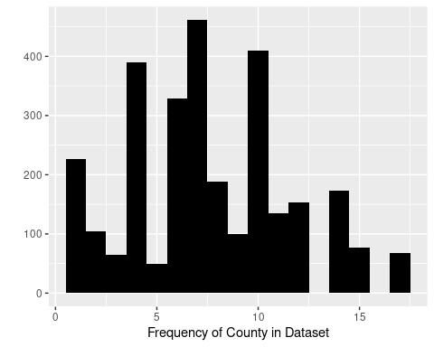

Note: The average county appears in our dataset seven or eight times, while multimodality in the distribution suggests that many counties are only in the dataset one time, four times, or ten times.

The inclusion of fixed effects is likely to inflate variance without adding substantially more detail. Our decision to disaggregate the data by party and race will exacerbate this issue. Nevertheless, there may be reasons to estimate coefficients for our main model by employing these effects. First, we consider the inclusion of county fixed effects in the following table.

The Effect of Women-Friendliness on U.S. Statewide Executive Woman Candidate County-Level Vote Share, 2010-2019, County and Year Fixed Effects

|  |  |  |  |  |  |
| --- | --- | --- | --- | --- | --- |
|  | All | White  Democrats | Non-White  Democrats | White  Republicans | Non-White  Republicans |
| Intercept | 14.742 | 2.052 | -591.391 | 42.132*** | 245.461 |
|  | (8.999) | (428.834) | (2344.483) | (12.216) | (217.795) |
| WFI | 5.957*** | -16.679 | 146.35 | 3.650 | 1.872 |
|  | (0.780) | (10.932) | (517.431) | (3.893) | (7.065) |
| WFI Squared | -0.757*** | 0.966 | -30.280 | 0.084 | -0.538 |
|  | (0.105) | (0.794) | (107.296) | (0.460) | (0.575) |
| Democratic Candidate | -13.674*** | - | - | - | - |
|  | (0.597) | - | - | - | - |
| Winner | -1.340** | 1.197** | 2.029 | -0.049 | 2.459 |
|  | (0.447) | (0.421) | (1.279) | (0.313) | (151.006) |
| Incumbent | 4.577*** | 3.691*** | 1.359* | 0.577* | -1.673 |
|  | (0.281) | (0.710) | (0.607) | (0.229) | (29.169) |
| Post-Grad Degree | 1.313*** | -2.235*** | -0.779* | -0.094 | -21.313 |
|  | (0.282) | (0.389) | (0.356) | (0.200) | (55.801) |
| County Ideology | 13.003*** | 290.07 | 204.279 | 52.998* | -72.350** |
|  | (0.410) | (248.205) | (831.462) | (20.833) | (27.917) |
| County % Democrat | -3.875 | 32.103*** | 34.205* | -26.257*** | 1.338 |
|  | (3.175) | (5.099) | (13.409) | (4.757) | (89.968) |
| County % Female | 48.073*** | 1522.372 | 1774.662 | 153.723 | -639.669** |
|  | (12.565) | (2042.542) | (7235.53) | (240.615) | (194.012) |
| County % Traditionalistic | 16.247*** | 965.226 | 1242.202 | 46.154 | 37.238 |
|  | (2.129) | (654.473) | (4408.208) | (65.640) | (140.984) |
| County % Moralistic | 12.034*** | -159.492 | 1343.718 | -67.804 | 55.474 |
|  | (2.732) | (131.303) | (4632.147) | (116.489) | (86.612) |
| County % Catholic | -57.450*** | -1062.648 | 2318.029 | -104.427+ | 18.817 |
|  | (2.048) | (933.400) | (7941.129) | (56.440) | (66.796) |
| County % Evangelical | -46.153*** | -725.033 | -84.307 | -79.364 | 13.459 |
|  | (6.342) | (552.635) | (375.905) | (112.308) | (114.109) |
| County IWPR Rank | -0.731*** | -34.063 | -36.11 | -3.445 | 1.450 |
|  | (0.052) | (25.097) | (132.696) | (3.654) | (1.981) |
| State Candidate Vote % | 0.834*** | 0.748*** | 0.696*** | 0.869*** | 1.549 |
|  | (0.013) | (0.044) | (0.118) | (0.019) | (6.523) |
| County Total Votes (Millions) | 0.000 | 0.000 | 0.000+ | 0.000* | 0.000 |
|  | (0.000) | (0.000) | (0.000) | (0.000) | (0.000) |
| RMSE | 11.5 | 8.64 | 12.1 | 4.7 | 1.06 |
| Adjusted r2 | 0.612 | 0.523 | -0.031 | 0.883 | 0.978 |
| Num. Obs. | 17982 | 8329 | 3073 | 6011 | 569 |

Notes: +p < 0.1, * p < 0.05, ** p < 0.01, *** p < 0.001. Clustered standard errors reported in parentheses.

As expected, the coefficients and standard errors reported are a result of inflated variance rather than an improvement in our model. Note that for white and non-white Democratic women, the estimates are out of line with any theoretical expectations. Further, adjusted r2 does not appreciably improve; our full model for all woman candidates in the manuscript has an adjusted r2 of 0.609, whereas in the fixed-effects model, it increases by an insubstantial amount to 0.612. In some cases, model fit is much poorer; for non-white Democrats, adjusted r2 declines to -0.031, while for non-white Republicans, it increases to 0.978, indicating overfitting.

Employing random effects does not have the same variance inflation issues, although there is an additional reason to not employ these as our primary estimations. As we have year- and county- grouped random effects, clustered standard errors are often biased (Moody and Marvell 2020); therefore, presenting naive standard errors may cause us to commit Type I errors. Nevertheless, we report coefficients from models estimated using random effects for both year and county.

The Effect of Women-Friendliness on U.S. Statewide Executive Woman Candidate County-Level Vote Share, 2010-2019, County and Year Random Effects

|  |  |  |  |  |  |
| --- | --- | --- | --- | --- | --- |
|  | All | White  Democrats | Non-White  Democrats | White  Republicans | Non-White  Republicans |
| Intercept | 4.865+ | -11.441*** | -15.780*** | 35.010*** | -84.904** |
|  | (2.572) | (3.434) | (4.398) | (4.466) | (27.105) |
| WFI | -0.521** | -0.856*** | -2.014*** | 1.407*** | -1.762 |
|  | (0.178) | (0.208) | (0.328) | (0.320) | (1.308) |
| WFI Squared | 0.044** | 0.047* | 0.140*** | -0.054+ | 0.147 |
|  | (0.017) | (0.020) | (0.031) | (0.031) | (0.114) |
| Democratic Candidate | -14.008*** | - | - | - | - |
|  | (0.220) | - | - | - | - |
| Winner | -0.514+ | 1.567*** | 1.703** | -0.062 | -29.164+ |
|  | (0.282) | (0.263) | (0.543) | (0.286) | (16.958) |
| Incumbent | 3.658*** | 4.093*** | 2.683*** | 1.118*** | -14.244 |
|  | (0.253) | (0.247) | (0.358) | (0.199) | (12.974) |
| Post-Grad Degree | 0.789*** | -2.860*** | -1.394*** | 0.194 | -0.307 |
|  | (0.209) | (0.209) | (0.251) | (0.188) | (5.904) |
| County Ideology | -1.250* | -0.349 | -3.921*** | 2.660* | 7.615* |
|  | (0.615) | (0.747) | (1.087) | (1.074) | (3.620) |
| County % Democrat | 25.526*** | 69.498*** | 69.803*** | -52.149*** | 22.750*** |
|  | (1.009) | (1.179) | (1.615) | (1.552) | (5.485) |
| County % Female | -0.217 | -8.117 | 23.328** | -8.731 | 7.85 |
|  | (4.751) | (5.921) | (7.963) | (8.565) | (20.747) |
| County % Traditionalistic | -0.801* | 1.277** | 6.299*** | -1.974** | -1.931 |
|  | (0.346) | (0.412) | (0.693) | (0.643) | (11.273) |
| County % Moralistic | -1.032*** | 0.233 | 3.041*** | -1.865*** | -29.245 |
|  | (0.301) | (0.368) | (0.738) | (0.554) | (20.449) |
| County % Catholic | -2.792** | -2.023+ | -10.230*** | 4.265** | 21.293*** |
|  | (0.868) | (1.084) | (1.577) | (1.543) | (4.661) |
| County Pct Evangelical | -0.134 | 0.996 | -4.518** | 2.659+ | -4.839 |
|  | (0.871) | (1.087) | (1.497) | (1.538) | (4.743) |
| County IWPR Rank | 0.023* | 0.129*** | -0.032 | -0.156*** | 0.001 |
|  | (0.011) | (0.013) | (0.024) | (0.019) | (0.317) |
| State Candidate Vote % | 0.845*** | 0.627*** | 0.483*** | 0.852*** | 3.093*** |
|  | (0.012) | (0.017) | (0.026) | (0.009) | (0.815) |
| County Total Votes (Millions) | 0.000 | 0.000 | 0.000 | 0.000*** | 0.000* |
|  | (0.000) | (0.000) | (0.000) | (0.000) | (0.000) |
| RMSE | 12.31 | 5.97 | 3.52 | 4.75 | 1.26 |
| Conditional r2 | 0.612 | 0.818 | 0.929 | 0.898 | 0.979 |
| Num. Obs. | 17982 | 8329 | 3073 | 6011 | 569 |

Notes: +p < 0.1, * p < 0.05, ** p < 0.01, *** p < 0.001. Standard errors reported in parentheses.

We are fortunate in that our new estimated coefficients do not substantially differ from those reported in the manuscript. While we still refer the reader to the models estimated in the manuscript, these show that our findings are robust to alternate model specifications and modelling choices.

**Appendix VI:** *Counties with Three Women-Friendliness Index Indicators*

In nearly all original and matched models, a WFI of 3—indicating a county where three of the measures used in index construction are present—is associated with higher women candidate performance. There are 398 such counties in the dataset, with an interesting assortment of traits. Median Obama vote percent in these counties is 39.2, with a range of 11.2 to 86.9. Only 56 of these counties are classified as urban. 147 are at or above median income, while 121 have an above average percentage of college graduates. Yet 40 flipped from voting Democratic in 2012 to voting Republican in 2016, nearly double the national average. This is interesting in that these counties are simultaneously the most favorable for women of any party or race, and yet more likely than the average U.S. county to trend towards the politics of Donald Trump.

Counties Scoring a Three in the Ten Item Women-Friendliness Index

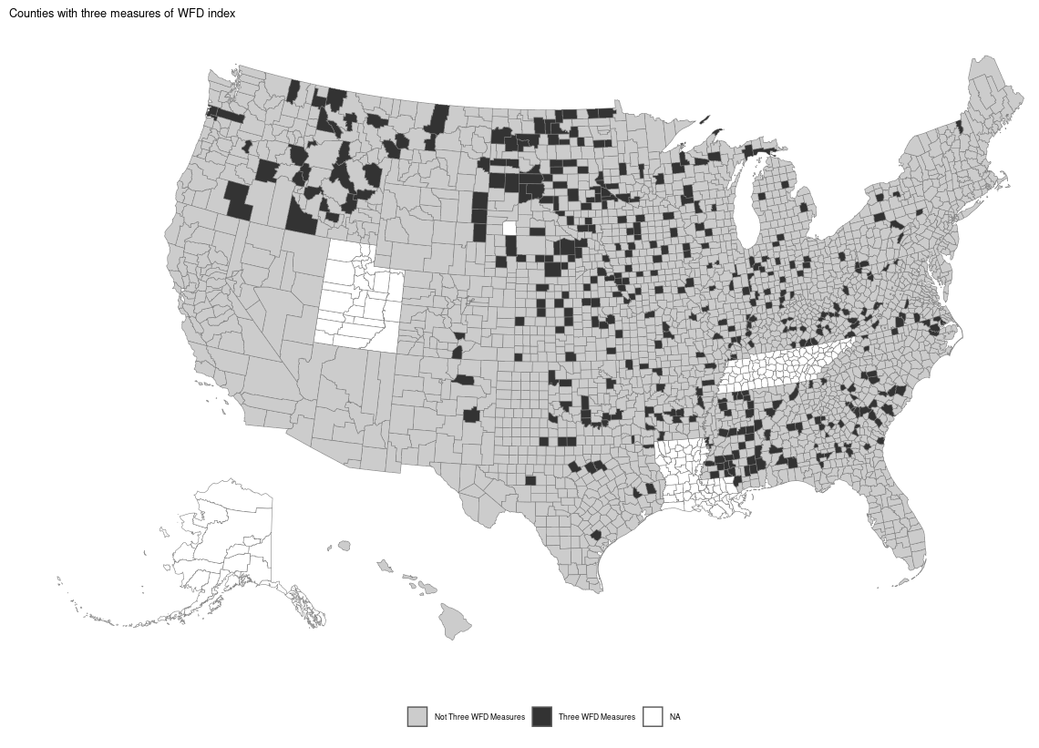

Note: Counties in white are not included in our dataset; no women candidates ran in the general election for statewide office in those counties from 2010 to 2019.

**Appendix VII:** *County-Wide Vote Share, Women Candidates by Party*

Vote Share of Democratic Women Candidates for Statewide

Executive Office by County, 2010-2019

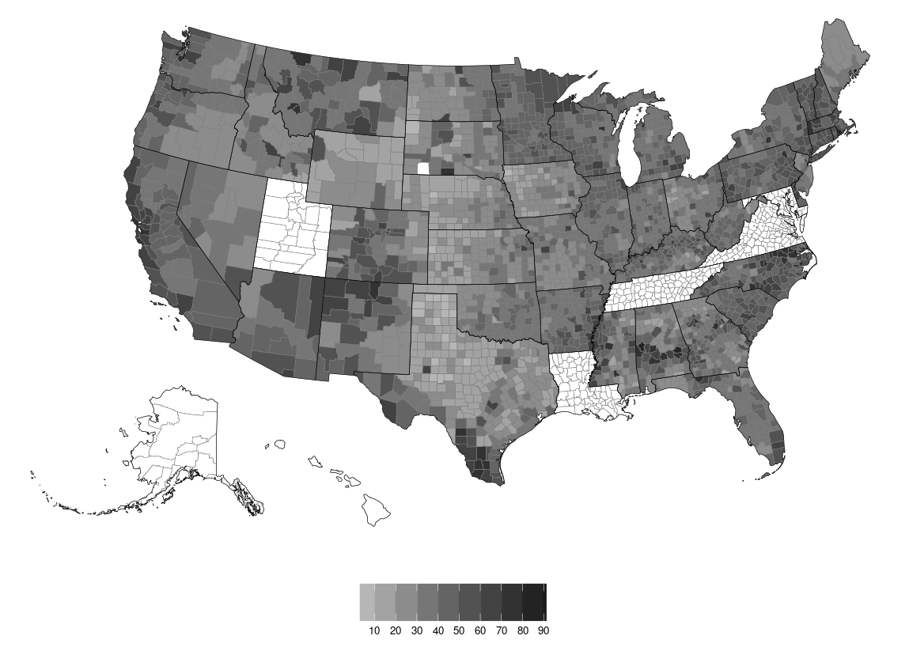

Vote Share of Republican Women Candidates for Statewide

Executive Office by County, 2010-2019

