Supplement: Comparing Three Measures of Legislative Professionalism

Table A1 provides information about each replication, including the model we chose, the number of observations, and the unit of analysis. Comments such as “includes state and year fixed effects” characterize the original model specification (as applied also to our replication) and do not indicate a change we have made to the specification unless stated explicitly otherwise. For longitudinal studies, we linearly interpolate Squire unless stated otherwise; since Squire’s (2024) scores for 2021 were not yet available when any of these studies conducted their analysis, we use his scores only through 2015 (Squire 2017). The final three columns present the coefficient (with standard error in parentheses) obtained for each measure, followed by the 84% and 95% confidence intervals. Some longitudinal studies observe states biennially, others annually. For annual studies, expenditures are measured as the rolling sum of the current and previous year’s values, while MDS1 (and MDS2) use the same value for both years of each legislative biennium.

Table A1: Replication Details

| Label | Article | Comments | Squire | MDS1 | Expend |
| --- | --- | --- | --- | --- | --- |
|  |  |  |  |  |  |
| Study A | Swift and VanderMolen (2016) | Table 1, model 1a (n=82 chambers). Original uses 2009 Squire values with other variables from 2011. Observations are 82 chambers within 41 states. We cluster standard errors by state though the original does not, causing their significant result for Squire to wane in our replication. | 0.05 (0.03) [0.01,0.10] [-0.01,0.12] | 0.05 (0.03) [0.01,0.09] [0.00,0.11] | 0.01 (0.03) [-0.03,0.05] [-0.05,0.07] |
| Study B | Wolak (2020) | Table A4 (n=1,049 respondents). Squire appears only in the supplemental appendix. Includes state random effects. | 0.02 (0.01) [0.00,0.03] [-0.01,0.04] | 0.00 (0.01) [-0.01,0.01] [-0.02,0.02] | 0.01 (0.01) [0.00,0.03] [-0.01,0.04] |
| Study C | Kettler, Fowler, and Witt (2022) | Table 2 (n=49 states). | -0.07 (0.06) [-0.16,0.02] [-0.20,0.06] | -0.03 (0.05) [-0.11,0.04] [-0.14,0.07] | -0.10 (0.05) [-0.17,-0.02] [-0.20,0.01] |
| Study D | Makse (2022) | Table 3, model 1 (n=196 state-biennia). Models span 4 biennia (2013-19), but Squire is measured cross-sectionally using 2015 values in original and in our replication. Standard errors clustered by state. | 0.06 (0.03) [0.02,0.11] [0.00,0.13] | 0.04 (0.03) [0.00,0.08] [-0.02,0.10] | -0.02 (0.03) [-0.07,0.03] [-0.09,0.05] |
| Study E | Brown and Garlick (2023) | Table 1, model c (n=178 state-biennia). Standard errors clustered by state. | -5.49 (1.84) [-8.12,-2.86] [-9.21,-1.78] | -5.51 (1.48) [-7.62,-3.40] [-8.48,-2.53] | -4.33 (1.78) [-6.87,-1.79] [-7.92,-0.74] |
| Study F | Leonard (2022) | Table 2, model 3 (n=869 bills). The model is a sequential logit. We report coefficients only for the final outcome (bill passage). Original used Squire, but values included in the replication data did not vary by year, nor did they seem to correspond with Squire’s data. We substitute linearly interpolated Squire. | 0.21 (0.18) [-0.04,0.45] [-0.14,0.55] | 0.38 (0.18) [0.13,0.63] [0.03,0.73] | 0.05 (0.24) [-0.29,0.39] [-0.42,0.52] |
| Study G | Bowra and Makse (2022) | Table 3, model 4 (n=5,153 incumbents). Includes state random effects. Original used 2009 Squire values for all observations (2003-16). We substitute interpolated Squire. | -0.17 (0.06) [-0.26,-0.09] [-0.29,-0.05] | -0.14 (0.06) [-0.22,-0.05] [-0.25,-0.02] | -0.21 (0.07) [-0.31,-0.11] [-0.35,-0.07] |
| Study H | Rogers (2017) | Table 1, model 1 (n=10,929 districts). Original includes separate measures of salary, staff, and session length; only salary was significant. Includes state random effects and year fixed effects. | 0.44 (0.21) [0.14,0.74] [0.02,0.86] | 0.19 (0.22) [-0.12,0.49] [-0.24,0.62] | 0.08 (0.30) [-0.35,0.51] [-0.52,0.68] |
| Study I | Hansen and Clark (2020) | Table 1, model 1 (n=331 chamber-biennia). Table 1 reports four models estimated simultaneously with seemingly unrelated regression. We report only the first dependent variable (“women”). Includes biennium fixed effects. | 1.13 (0.99) [-0.25,2.52] [-0.80,3.06] | 0.73 (0.92) [-0.55,2.02] [-1.06,2.53] | 2.34 (1.04) [0.88,3.80] [0.31,4.37] |
| Study J | Callaghan and Karch (2021) | Table 2 model 1 (n=3,109 bills). Includes state random effects and linear time trend. Original used 2009 Squire values for all years. We substitute interpolated Squire. | 0.11 (0.23) [-0.18,0.40] [-0.29,0.51] | 0.05 (0.21) [-0.15,0.25] [-0.23,0.33] | 0.17 (0.18) [-0.05,0.40] [-0.15,0.50] |
| Study K | Strickland and Crosson (2022) | Table 1 model 4 (n=352 state-biennia). Includes state and year fixed effects. Though on average there are 7.2 observations per state, few states have more than 4. | 0.80 (0.64) [-0.10,1.70] [-0.46,2.06] | -0.35 (0.77) [-1.43,0.73] [-1.86,1.16] | -0.97 (0.78) [-2.07,0.14] [-2.51,0.58] |
| Study L | Boehmke and Shipan (2015) | Table 2, model 3 (n=102,765 inspections). The dependent variable is the number of deficiencies found within individual nursing home inspections, with state and year fixed effects and standard errors clustered by year. Original reports a significant interaction of Squire with partisan control of the Legislature. We include (but do not report) this interaction in all replications; the interaction gains or loses significance jointly with the primary measure. | -0.47 (0.15) [-0.68,-0.26] [-0.76,-0.17] | -0.04 (0.11) [-0.20,0.12] [-0.26,0.18] | -0.19 (0.12) [-0.37,-0.02] [-0.43,0.05] |
| Study M | Emrich (2022) | Table 2, model 1 (n=192,821 bills). Original interpolates Squire by applying longitudinally proximate values; that is, the value for 2014 is copied from 2015, the nearest year with a Squire score, rather than calculated as a weighted average of nearby scores. The replication for Squire uses the author’s approach, standardized. Includes state and session random effects. | 1.34 (0.31) [0.89,1.78] [0.72,1.95] | -1.85 (0.33) [-2.31,-1.40] [-2.49,-1.21] | -1.18 (0.23) [-1.50,-0.86] [-1.63,-0.73] |
| Study N | Strickland (2019) | Table 3 model 4 (n=620 state-years). Includes state and year fixed effects. | -0.04 (0.06) [-0.13,0.04] [-0.17,0.08] | 0.21 (0.06) [0.12,0.29] [0.09,0.32] | 0.16 (0.06) [0.07,0.25] [0.04,0.28] |
| Study O | Barber, Bolton, and Thrower (2019) | Table 2, model 1 (n=752 state-years). Indicators in original are staff and salary only. | -0.09 (0.09) [-0.21,0.03] [-0.26,0.08] | 0.02 (0.23) [-0.30,0.34] [-0.43,0.47] | -0.09 (0.19) [-0.35,0.17] [-0.46,0.27] |
| Study P | Shay (2021) | Table 2, model 1 (n=847 state-biennia). Original is a time-series cross-sectional analysis spanning 1981-2015 but measuring Squire cross-sectionally using values from 2000; our Squire replication substitutes linearly interpolated scores. Includes state random effects and a linear time trend. | 0.10 (0.05) [0.03,0.17] [0.00,0.20] | 0.03 (0.06) [-0.06,0.11] [-0.09,0.15] | -0.24 (0.07) [-0.33,-0.14] [-0.37,-0.10] |
| Study Q | LaCombe and Boehmke (2021) | Table 2, model 1 (n=281,618 state-year-policies). Includes year fixed effects and policy area random effects. | -0.07 (0.02) [-0.09,-0.04] [-0.10,-0.03] | -0.06 (0.02) [-0.09,-0.03] [-0.11,-0.02] | 0.08 (0.02) [0.06,0.10] [0.05,0.11] |
| Study R | Caron (2022) | Table 1, model 1 (n=1,640 state-years). Includes linear and quadratic time trend with standard errors clustered by state. | 0.76 (0.51) [0.04,1.48] [-0.24,1.76] | 0.24 (0.42) [-0.35,0.84] [-0.59,1.07] | -0.85 (0.56) [-1.64,-0.06] [-1.95,0.25] |

Figures A1a and A1b are the same as the coefficient plots found in the main manuscript, except omitting California from all models. There are three notable differences relative to the plots from the main manuscript. For study D, the significant coefficient for Squire reported in the main manuscript loses significance here. For study K, a significant difference between the Squire and MDS1 coefficients that was not previously present emerges here. For study R, the significant difference between expenditures and MDS1 that was previously present loses significance here, largely due to movement in the estimated Squire coefficient.

Figures A2a and A2b are also the same as the coefficient plots from the main manuscript, except all models are constrained to a common set of observations—that is, observations for which all three professionalism measures are non-missing. Since MDS1 and MDS2 have the most missingness (after interpolating Squire), the practical effect is that the Squire and expenditures models are reduced to observations covered by MDS1 and MDS2. We omit study B, since the original replication materials fail to converge for Squire with this reduced pool of observations. The same changes observed in Figures A1a and A1b with respect to studies D and R are present here.

Figure A1a: Coefficient Plots when Omitting California

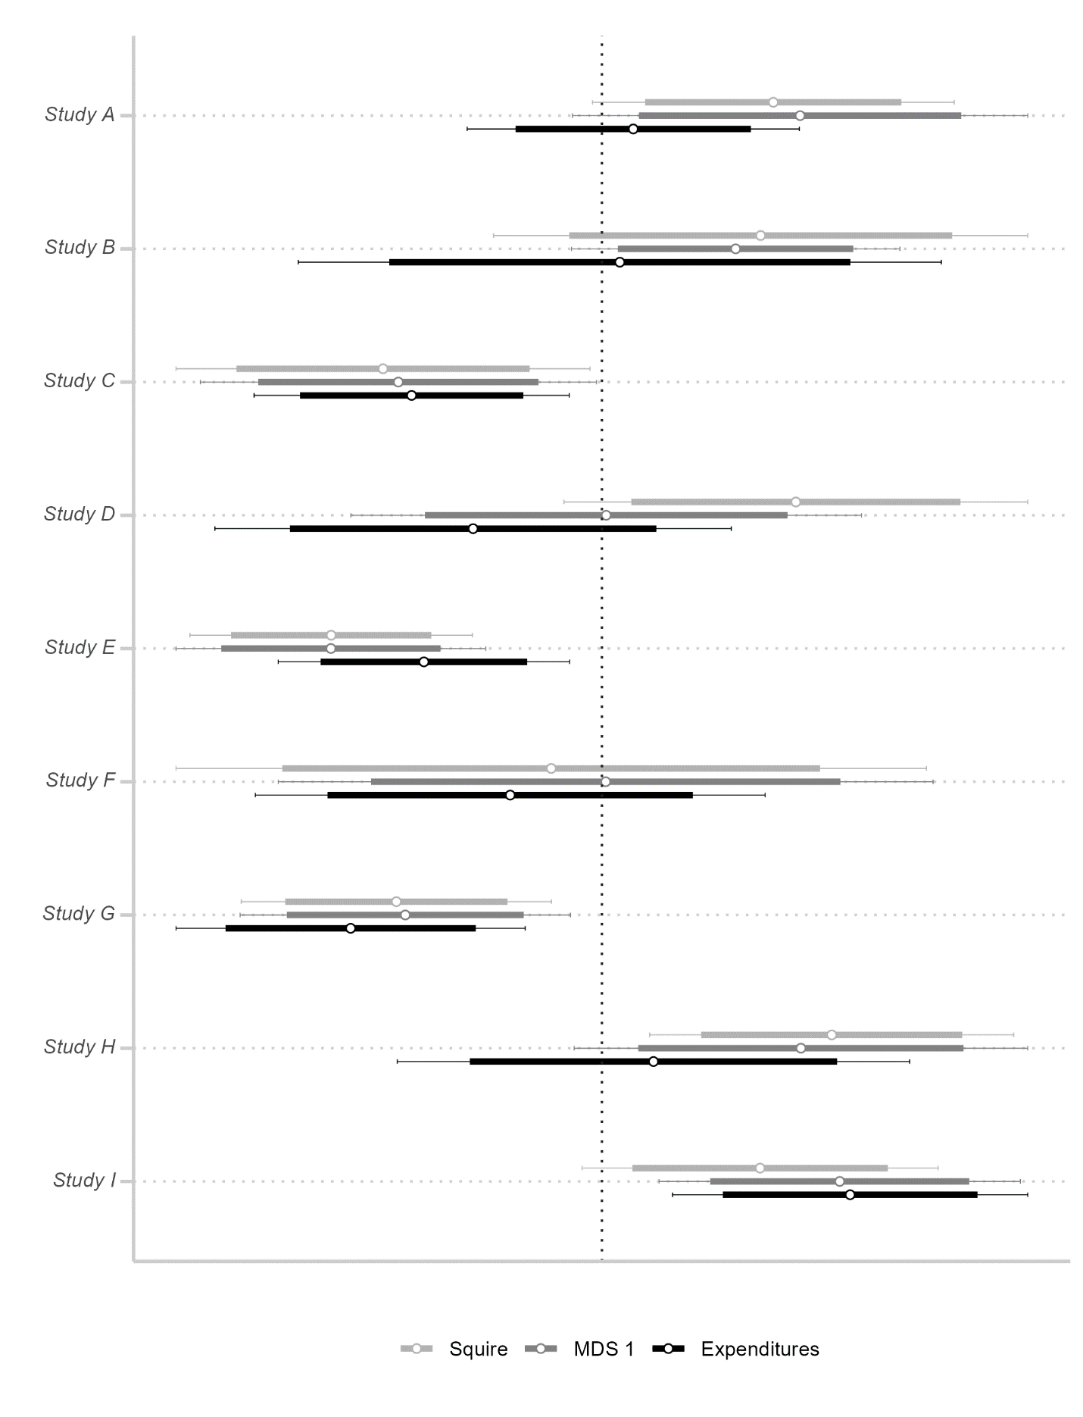

Figure A1b: Coefficient Plots when Omitting California

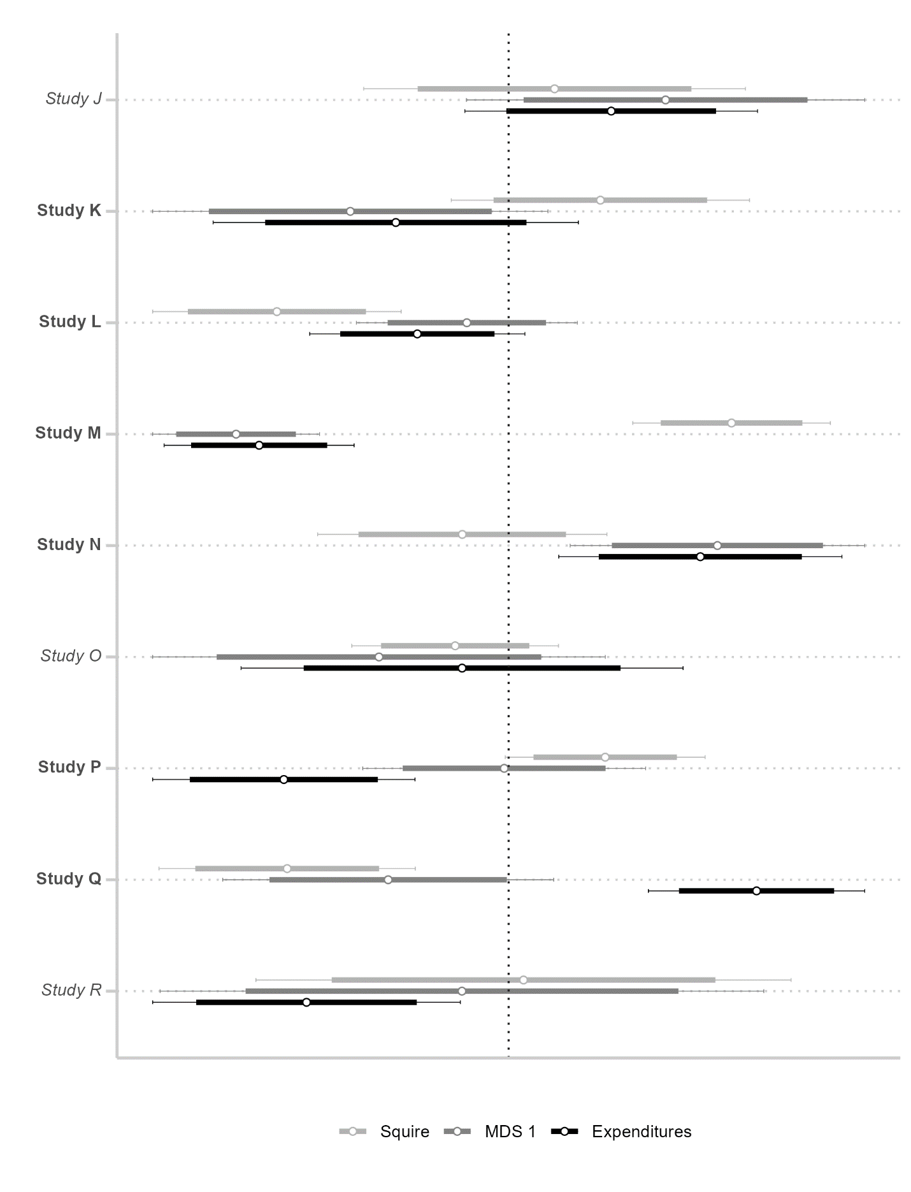

Figure A2a: Coefficient Plots with Common Observations

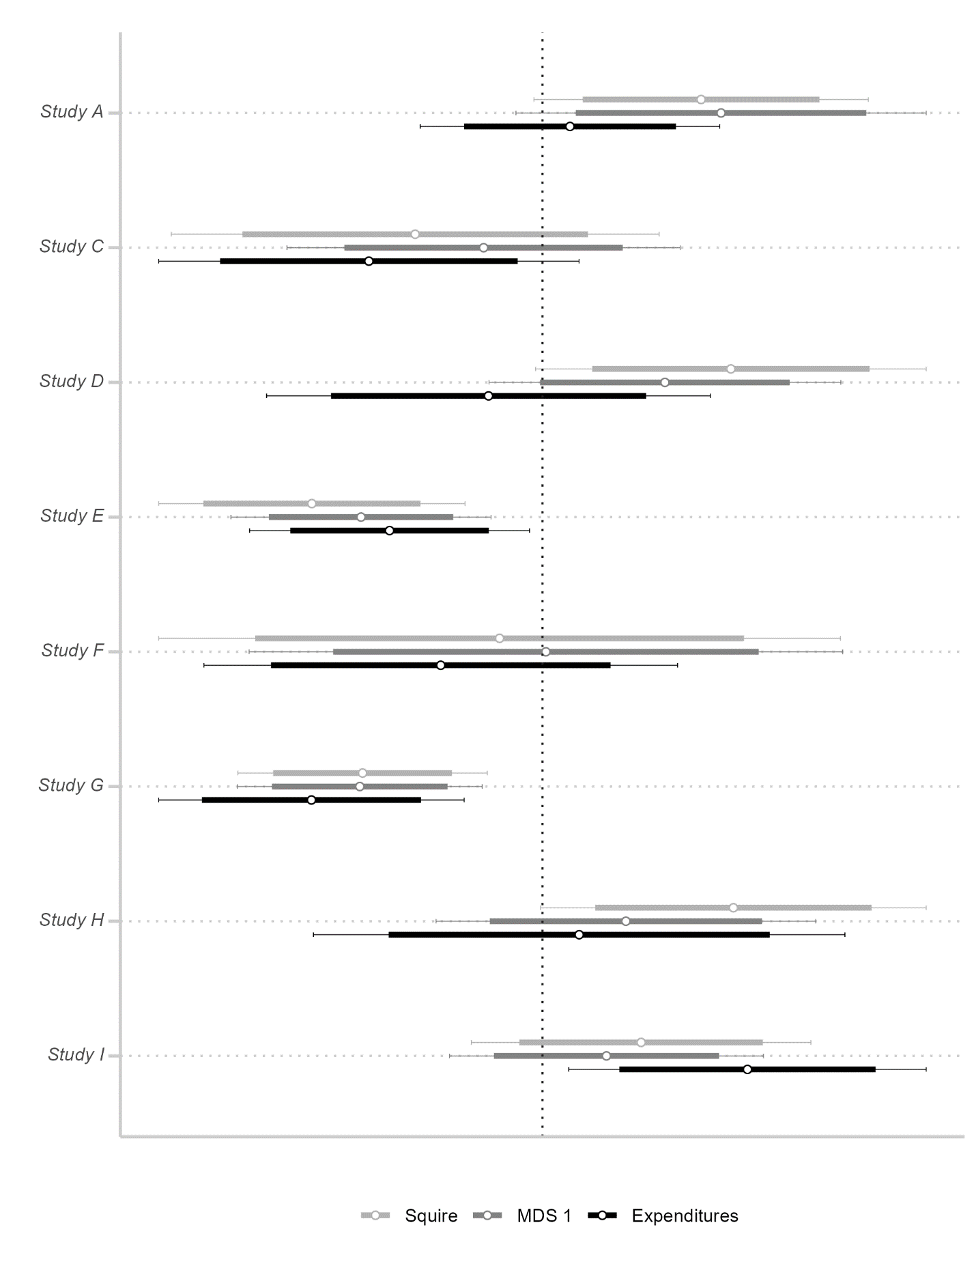

Figure A2b: Coefficient Plots with Common Observations

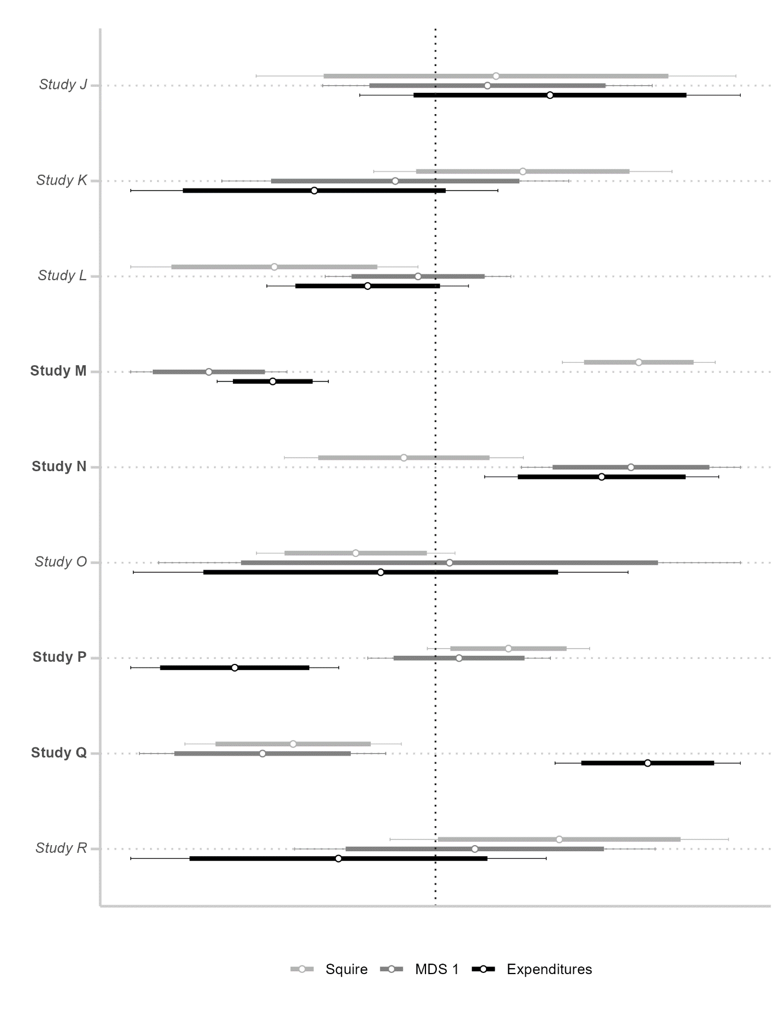

# References

Barber, Michael, Alexander Bolton, and Sharece Thrower. 2019. “Legislative Constraints on Executive Unilateralism in Separation of Powers Systems.” *Legislative Studies Quarterly* 44 (3): 515–48.

Boehmke, Frederick J., and Charles R. Shipan. 2015. “Oversight Capabilities in the States: Are Professionalized Legislatures Better at Getting What They Want?” *State Politics & Policy Quarterly* 15 (3): 366–86.

Bowra, Bethany, and Todd Makse. 2022. “Institutional Attachments and Patterns of Ambition in State Legislatures.” *Legislative Studies Quarterly*.

Brown, Adam R, and Alex Garlick. 2023. “Bicameralism Hinges on Legislative Professionalism.” *Legislative Studies Quarterly*.

Callaghan, Timothy, and Andrew Karch. 2021. “Bill Content, Legislative Outcomes, and State-Level Resistance to National Policies.” *State Politics & Policy Quarterly* 21 (4): 380–402.

Caron, Christian. 2022. “Partisan Strategy and the Adoption of Same-Day Registration in the American States.” *State Politics & Policy Quarterly* 22 (2): 140–60.

Emrich, Colin. 2022. “The Politics of Bicameral Agreement: Why and When Do State Lawmakers Go to Conference?” *State Politics & Policy Quarterly* 22 (3): 289–319.

Hansen, Eric R., and Christopher J. Clark. 2020. “Diversity in Party Leadership in State Legislatures.” *State Politics & Policy Quarterly* 20 (1): 81–107.

Kettler, Jaclyn J., Luke Fowler, and Stephanie L. Witt. 2022. “Is It Us? Is It Them? Or Is It This Place? Predicting Civility in State Legislatures.” *State Politics & Policy Quarterly* 22 (1): 50–69.

LaCombe, Scott J., and Frederick J. Boehmke. 2021. “The Initiative Process and Policy Innovation in the American States.” *State Politics & Policy Quarterly* 21 (3): 286–305.

Leonard, Meghan E. 2022. “New Data on Court Curbing by State Legislatures.” *State Politics & Policy Quarterly* 22 (4): 483–500.

Makse, Todd. 2022. “Bicameral Distinctiveness in American State Legislatures.” *State Politics & Policy Quarterly*, 1–19.

Rogers, Steven. 2017. “Electoral Accountability for State Legislative Roll Calls and Ideological Representation.” *American Political Science Review* 111 (3): 555–71.

Shay, Laine P. 2021. “Do Term Limits ‘Limit’ the Speaker? Examining the Effects of Legislative Term Limits on State Speaker Power.” *State Politics & Policy Quarterly* 21 (2): 139–64.

Squire, Peverill. 2017. “A Squire Index Update.” *State Politics & Policy Quarterly* 17 (4): 361–71.

———. 2024. “A Squire Index Update: Stability and Change in Legislative Professionalization, 1979–2021.” *State Politics & Policy Quarterly* 24 (1): 110–19.

Strickland, James M. 2019. “America’s Crowded Statehouses: Measuring and Explaining Lobbying in the US States.” *State Politics & Policy Quarterly* 19 (3): 351–74.

Strickland, James M., and Jesse M. Crosson. 2022. “K Street on Main: Legislative Turnover and Multi-Client Lobbying.” *Political Science Research and Methods*, 1–17.

Swift, Clint S., and Kathryn A. VanderMolen. 2016. “Term Limits and Collaboration across the Aisle: An Analysis of Bipartisan Cosponsorship in Term Limited and Non-Term Limited State Legislatures.” *State Politics & Policy Quarterly* 16 (2): 198–226.

Wolak, Jennifer. 2020. “Why Do People Trust Their State Government?” *State Politics & Policy Quarterly* 20 (3): 313–29.