Appendix
Figure 1a: Disparity between Black and White Life Expectancy at Birth in the American States
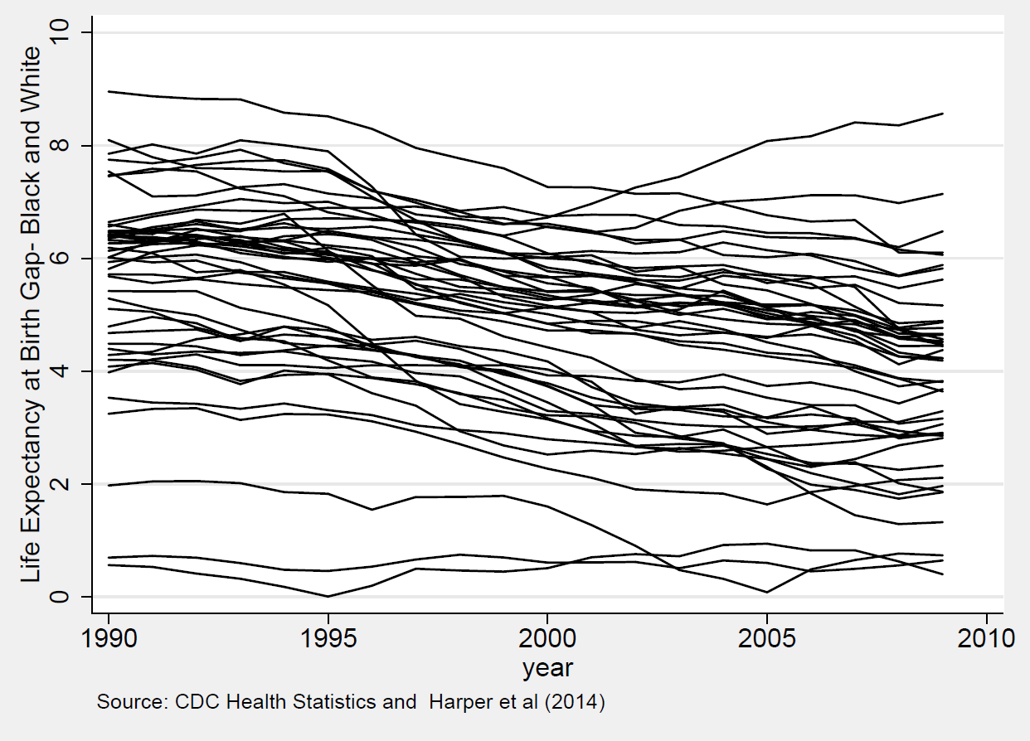
Figure 2a: Disparity between Black and White % of Population with at least High School Degree in the American States
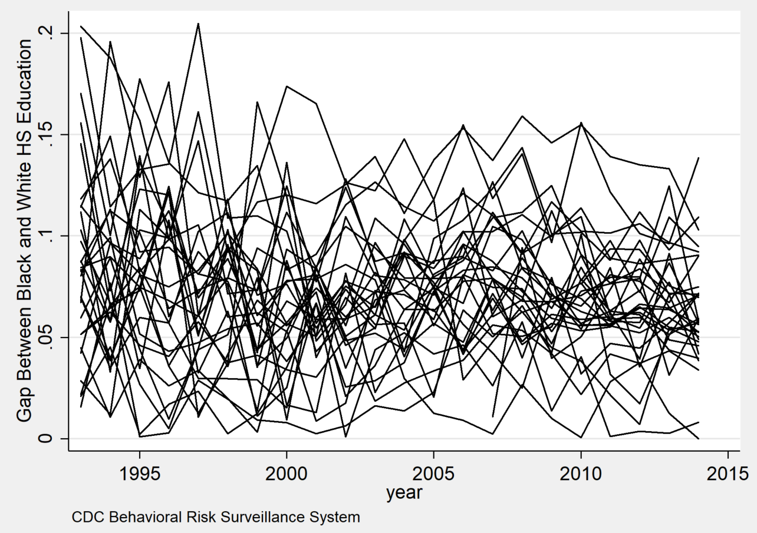

Figure 3a: Disparity between Black and White Poverty Rate in the American States
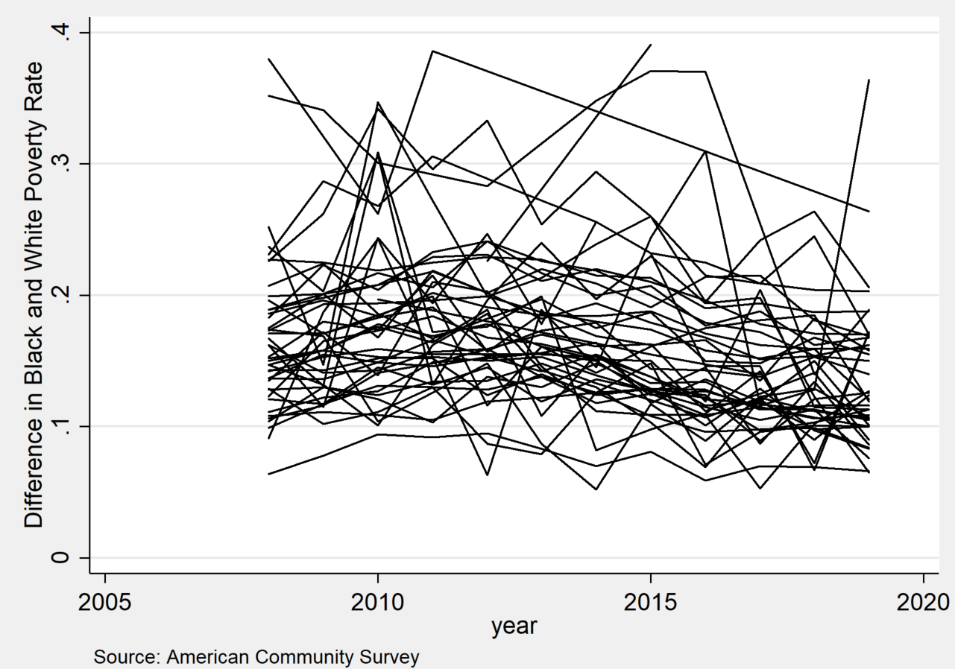

Figure 4a: Levels of Accountability Pressure- 1990
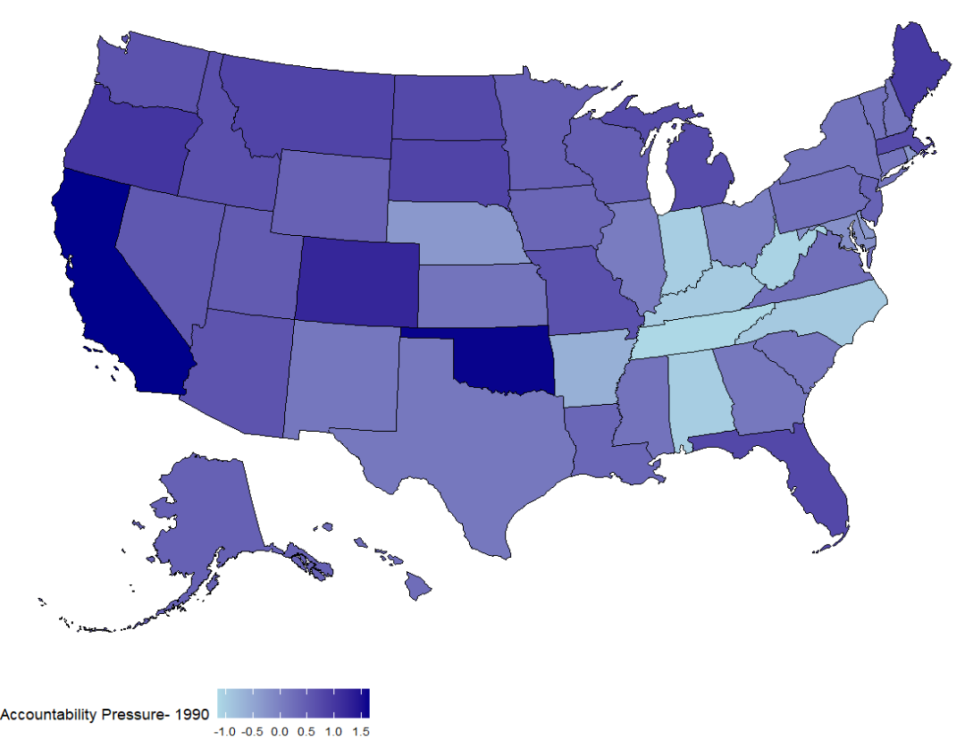
Figure 5a: Accountability Pressure 2016
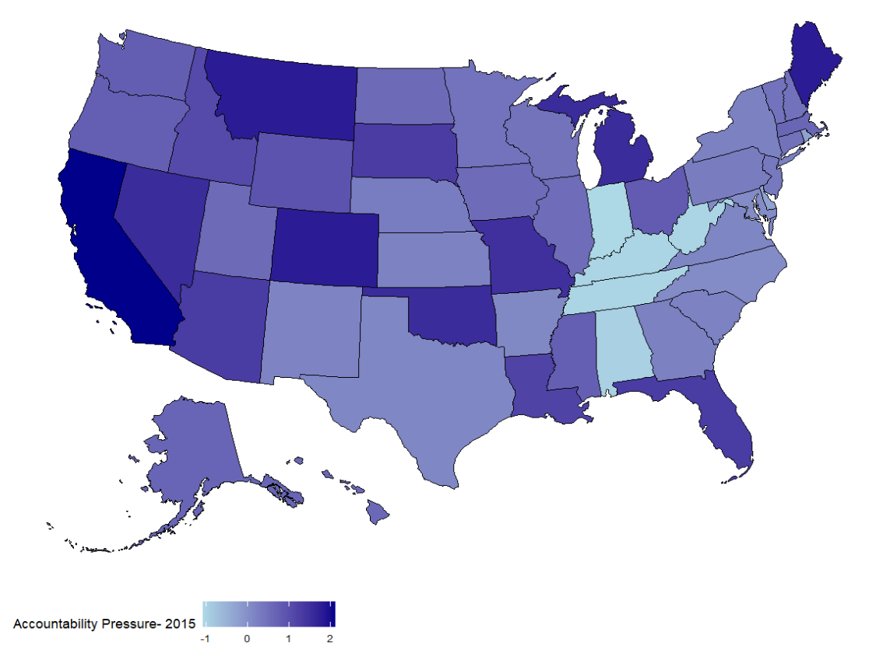

Figure 6a: National Accountability Pressure by Year
