Figure S1
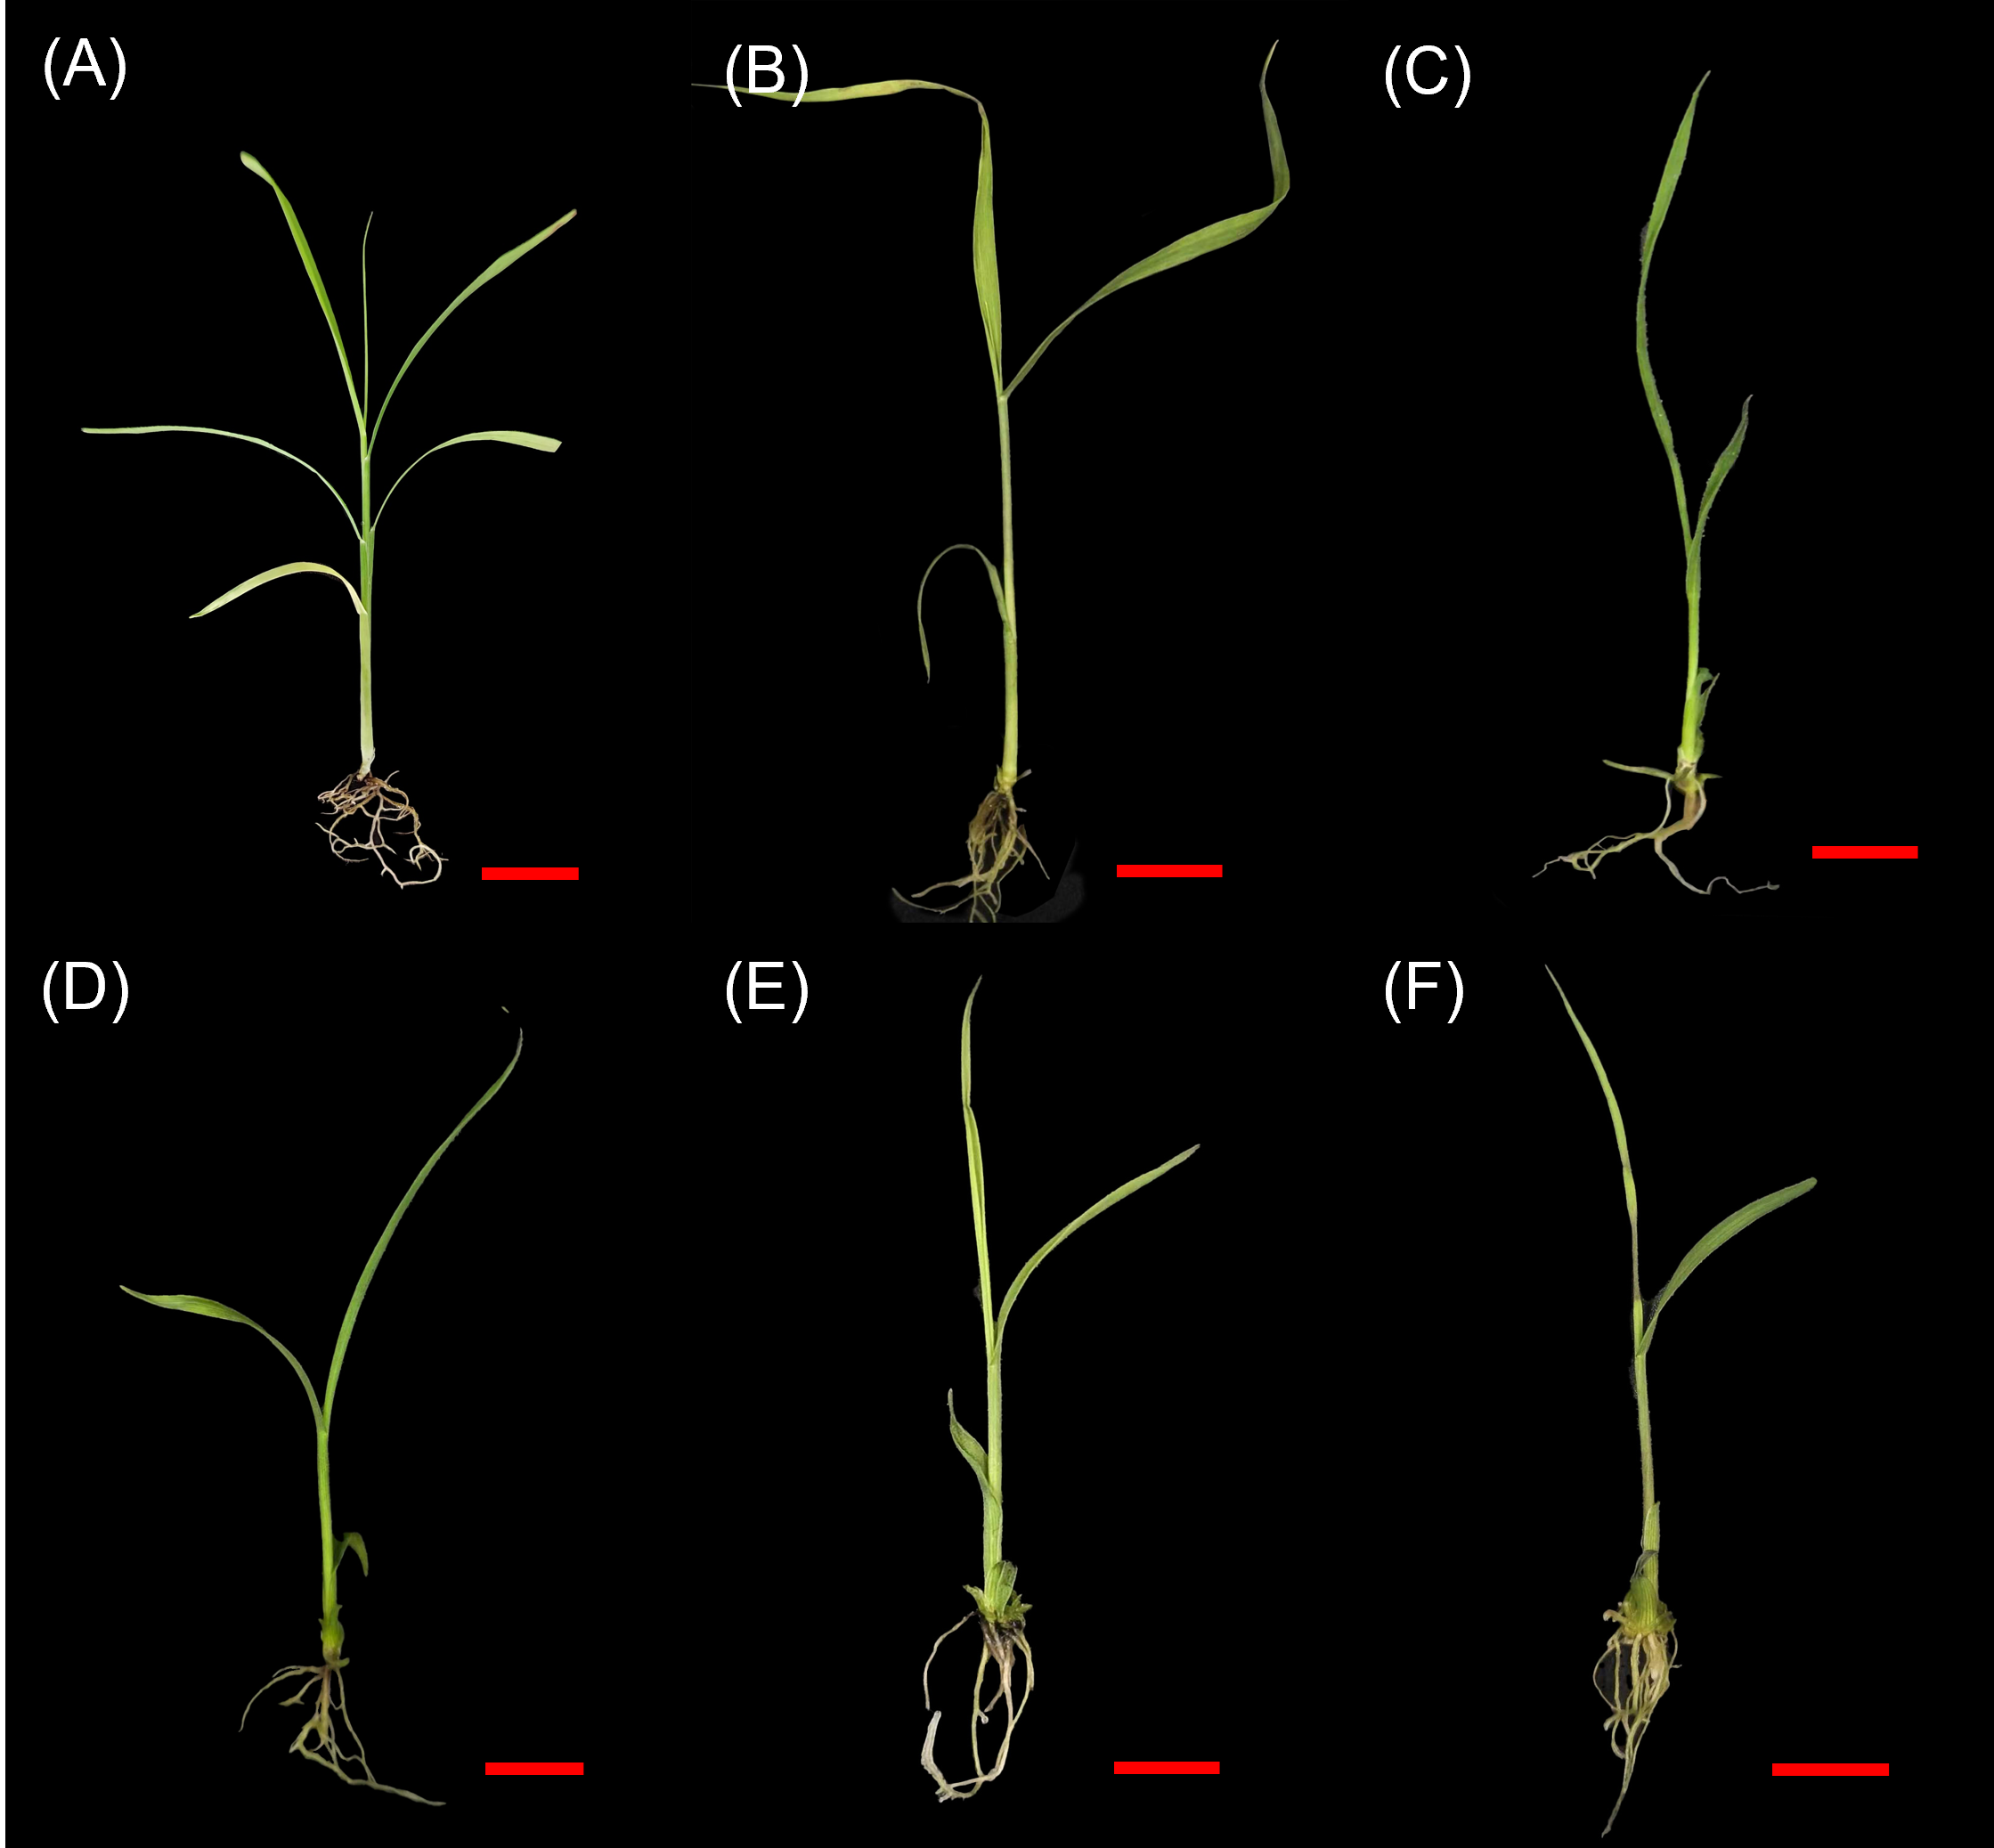
Figure S1 Regenerated plantlets with root systems of Saccharum barberi genotypes. Hathuni (A), Katha (B), Mungo (C), Nagans (D), Nargori (E), and Pansahi (F) were shown. Tissue culturing is described in the Materials and Methods. Scale bar = 1 cm.

