Supplementary Table 1. Analysis of molecular variance (AMOVA) within and among *Boehmeria nivea* (L.) Gaudich.var. *tenacissima* (Roxb.) Miq. populations based on GBS according to their six collection areas and DAPC clusters.

|  |  |  |  |  |  |  |  |
| --- | --- | --- | --- | --- | --- | --- | --- |
|  | SV1 | Df | SS | MS | Est. Var. | % | Fst |
| Site | Among population | 5 | 70193.2 | 14038.7 | 551.4 | 43.8 | 0.438** |
| Within population | 144 | 102020.0 | 708.5 | 708.5 | 56.2 |  |
| Total | 149 | 172213.3 | 1155.8 | 1259.9 | 100 |  |
| DAPC | Among population | 4 | 58793.7 | 14698.4 | 526.3 | 40.2 | 0.402** |
| Within population | 145 | 113419.6 | 782.2 | 782.2 | 59.8 |  |
| Total | 149 | 172213.3 | 1155.8 | 1308.5 | 100 |  |

1 SV, Source of variation; Df, Degrees of freedom; SS, Sum of squares; MS, Mean square; Est. Var., Estimated variance; %, Percentage of variation; DAPC, Discriminant Analysis of Principal Components; GBS, genotyping-by-sequencing ** p < 0.01.

Supplementary Table 2. Mean squares according to area, year, and area × year interactions

|  |  |  |  |
| --- | --- | --- | --- |
|  | Area (A) | Year (Y) | Interaction (A × Y) |
| TPC | 175.2*** | 142.6*** | 72.1*** |
| TFC | 8.1ns | 365.6*** | 6.7ns |

***, ns significant at p<0.001 and no significant, respectively.

Supplementary Table 3. Descriptive statistics of total polyphenol content (TPC) and total flavonoid content (TFC) of *Boehmeria nivea* (L.) Gaudich.var. *tenacissima* (Roxb.) Miq. for the six collection areas.

|  |  |  |  |  |  |
| --- | --- | --- | --- | --- | --- |
| Phytochemicals | Year | Area | Range | Mean1 | CV (%) |
| TPC | 2021 | GH | 2.5 – 22.0 | 8.08 ± 4.35 bc2 | 53.8 |
| HS | 2.2 – 4.90 | 3.16 ± 0.84 d | 26.4 |
| JD | 7.1 – 17.0 | 10.5 ± 2.65 ab | 25.2 |
| MP | 5.8 – 24.1 | 10.9 ± 3.93 a | 36.0 |
| UR | 4.0 – 30.3 | 9.17 ± 6.20 abc | 67.7 |
| YS | 5.0 – 11.3 | 7.29 ± 1.66 c | 22.7 |
| Total | | 2.2 – 30.3 | 8.52 ± 4.32 | 50.8 |
| 2022 | GH | 3.2 – 22.8 | 10.5 ± 3.91 b | 37.1 |
| HS | 6.9 – 13.2 | 9.17 ± 2.10 bc | 22.9 |
| JD | 7.2 – 19.4 | 13.4 ± 3.30 a | 24.6 |
| MP | 8.3 – 17.8 | 13.3 ± 3.25 a | 24.4 |
| UR | 3.6 – 10.1 | 6.46 ± 1.98 d | 30.7 |
| YS | 4.9 – 19.6 | 7.99 ± 2.95 cd | 36.9 |
| Total | | 3.2 – 19.6 | 9.22 ± 3.79 | 41.1 |
| TFC | 2021 | GH | 1.4 – 11.4 | 4.67 ± 2.44 b | 52.3 |
| HS | 1.2 – 13.8 | 4.69 ± 3.87 b | 82.5 |
| JD | 3.2 – 7.10 | 5.40 ± 1.05 ab | 19.5 |
| MP | 3.0 – 9.50 | 5.19 ± 1.57 ab | 30.2 |
| UR | 2.2 – 17.5 | 6.65 ± 3.97 a | 59.7 |
| YS | 2.7 – 9.80 | 4.60 ± 1.67 b | 36.4 |
| Total | | 1.2 – 17.5 | 5.10 ± 2.50 | 49.0 |
| 2022 | GH | 1.0 – 6.1 | 3.02 ± 1.00 a | 33.2 |
| HS | 1.7 – 2.8 | 2.25 ± 0.40 b | 17.6 |
| JD | 1.5 – 2.2 | 2.02 ± 0.20 b | 9.9 |
| MP | 2.5 – 3.6 | 2.89 ± 0.38 a | 13.0 |
| UR | 1.5 – 5.4 | 3.11 ± 0.97 a | 31.0 |
| YS | 1.6 – 3.9 | 2.57 ± 0.69 ab | 26.6 |
| Total | | 1.0 –  6.1 | 2.78 ± 0.86 | 31.0 |

1 Mean ± Standard deviation. GH, Goheung; HS, Heuksando; JD, Jindo; MP, Mokpo; UR, Ulleungdo; YS, Yeosu

2 The same letter in each column of each category indicates no significant difference according to Duncan’s multiple range test, p < 0.05.

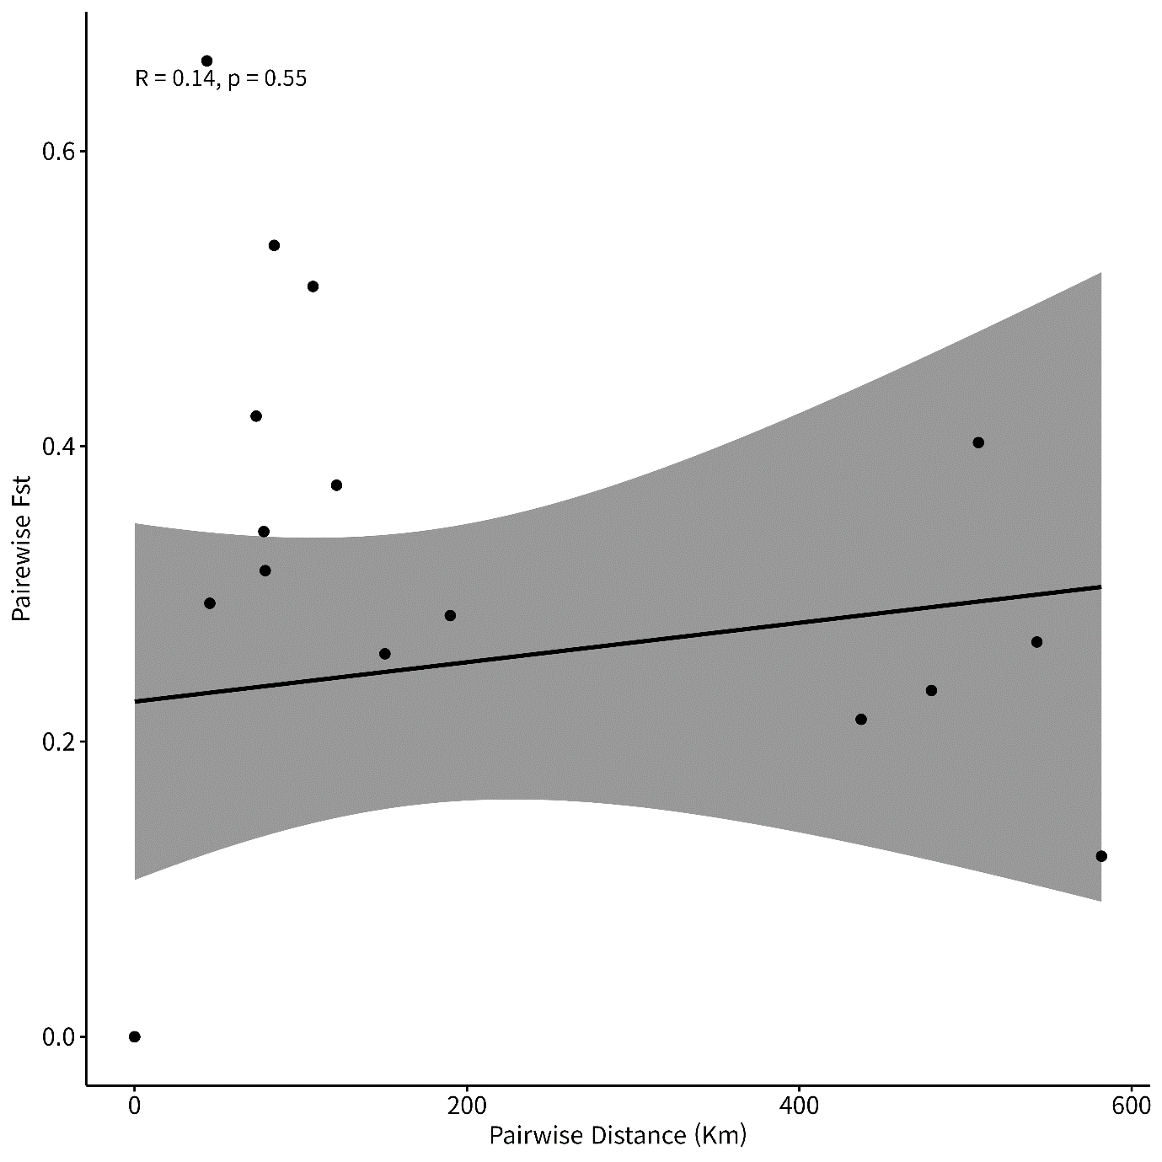

Supplementary Fig. 1. Correlation between the linearized pairwise Fst and geographical distance for the six *Boehmeria nivea* (L.) Gaudich.var. *tenacissima* (Roxb.) Miq. populations. The Mantel test revealed no significant genetic isolation based on geographical distances among six sampling areas (r = 0.14, p = 0.55).