Table S1. Variability of fatty acid composition and extra peaks

|  |  |  |  |  |  |  |
| --- | --- | --- | --- | --- | --- | --- |
| Trait | N | Mean | SD | Minimum | Maximum | MSD |
| Palmitic (C16:0) | 200 | 7.30 | 2.294 | 4.10 | 11.31 | 0.178 |
| Stearic (C18:0) | 200 | 1.97 | 0.455 | 0.86 | 4.46 | 0.125 |
| Oleic (C18:1) | 200 | 63.54 | 15.72 | 38.47 | 81.93 | 1.022 |
| Linoleic (C18:2) | 200 | 16.64 | 12.20 | 2.71 | 37.26 | 0.807 |
| Arachidic (C20:0) | 200 | 1.179 | 0.20 | 0.60 | 2.01 | 0.053 |
| Gadoleic (C20:1) | 200 | 2.41 | 0.64 | 1.38 | 4.60 | 0.103 |
| Behenic (C22:0) | 200 | 3.28 | 0.40 | 2.38 | 4.60 | 0.098 |
| Lignoceric (C24:0) | 200 | 2.18 | 0.25 | 1.58 | 3.06 | 0.066 |
| EPk1 | 200 | 0.66 | 0.68 | 0 | 1.86 | 0.057 |
| EPk2 | 200 | 0.85 | 0.91 | 0 | 2.91 | 0.095 |

N, sample number; SD, standard deviation; MSD, minimum significant difference; EPk, extra peak.

Table S2. Variation of seed germination rate, seedling emergence normality rate, and seedling growth normality rate between high and normal oleate genotypes

|  |  |  |  |
| --- | --- | --- | --- |
| Trait | Genotype | Mean (%) | Standard error |
| Seed germination rate | BB | 64.65 b | 0.1359 |
| bb | 89.11 a | 0.2846 |
| Seedling emergence normality rate | BB | 60.61 b | 0.1247 |
| bb | 89.11 a | 0.2846 |
| Seedling growth normality rate | BB | 28.29 b | 0.0631 |
| bb | 76.24 a | 0.1782 |

If followed by the different letters after mean percentage for each trait value, there were statistically significant differences between two genotypes (BB and bb).

Table S3. Pearson Correlation Coefficients and Probability for Seed Germination Rate, Seedling Emergence Normality Rate, Seedling Growth Normality Rate, and Fatty Acid Compositiona

|  | ERt | NRt | C16:1 | C18:0 | C18:1 | C18:2 | C20:0 | C20:1 | C22:0 | C24:0 | EPk1 | EPk2 |
| --- | --- | --- | --- | --- | --- | --- | --- | --- | --- | --- | --- | --- |
| GRt | 0.95 <.0001 | 0.58 <.0001 | -0.30 <.0001 | -0.03 0.7070 | 0.35 <.0001 | -0.36 <.0001 | -0.05 0.4673 | 0.09 0.2092 | -0.31 <.0001 | -0.13 0.0659 | -0.24 0.0007 | -0.27 <.0001 |
| ERt |  | 0.61 <.0001 | -0.53 <.0001 | -0.03 0.6784 | 0.39 <.0001 | -0.39 <.0001 | -0.07 0.3313 | 0.12 0.0922 | -0.35 <.0001 | -0.15 0.0405 | -0.28 <.0001 | -0.32 <.0001 |
| NRt |  |  | -0.53 <.0001 | -0.06 0.4063 | 0.56 <.0001 | -0.55 <.0001 | -0.12 0.0942 | 0.30 <.0001 | -0.33 <.0001 | 0.00 0.9674 | -0.49 <.0001 | -0.53 <.0001 |
| C16:1 |  |  |  | 0.16 0.0240 | -0.98 <.0001 | 0.98 <.0001 | 0.30 <.0001 | -0.83 <.0001 | 0.45 <.0001 | -0.34 <.0001 | 0.95 <.0001 | 0.94 <.0001 |
| C18:0 |  |  |  |  | -0.16 0.0205 | 0.12 0.0855 | 0.96 <.0001 | -0.39 <.0001 | 0.47 <.0001 | -0.24 <.0001 | 0.16 0.0236 | 0.09 0.1994 |
| C18:1 |  |  |  |  |  | -0.99 <.0001 | -0.30 <.0001 | 0.76 <.0001 | -0.51 <.0001 | 0.20 0.0042 | -0.96 <.0001 | -0.96 <.0001 |
| C18:2 |  |  |  |  |  |  | 0.26 0.0002 | -0.76 <.0001 | 0.46 <.0001 | -0.22 0.0002 | 0.95 <.0001 | 0.95 <.0001 |
| C20:0 |  |  |  |  |  |  |  | -0.50 <.0001 | 0.63 <.0001 | -0.25 0.0004 | 0.31 0.0668 | 0.23 0.0010 |
| C20:1 |  |  |  |  |  |  |  |  | -0.29 <.0001 | 0.64 <.0001 | -0.79 <.0001 | -0.73 <.0001 |
| C22:0 |  |  |  |  |  |  |  |  |  | 0.20 <.0001 | 0.48 <.0001 | 0.46 <.0001 |
| C24:0 |  |  |  |  |  |  |  |  |  |  | -0.24 0.0007 | -0.17 0.0199 |
| EPk1 |  |  |  |  |  |  |  |  |  |  |  | 0.97 <.0001 |

aGRt, germination rate; ERt, seedling emergence normality rate; NRt, seedling growth normality rate; EPk1, extra peak 1; EPk2, extra peak 2.

Figure S1 and S2

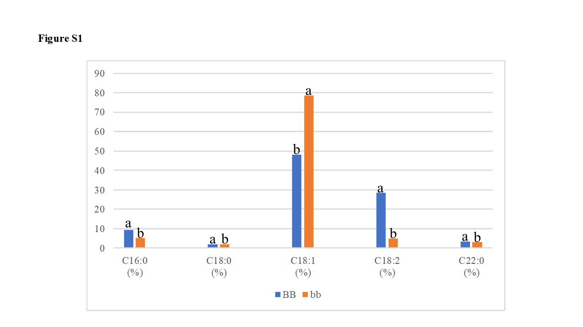

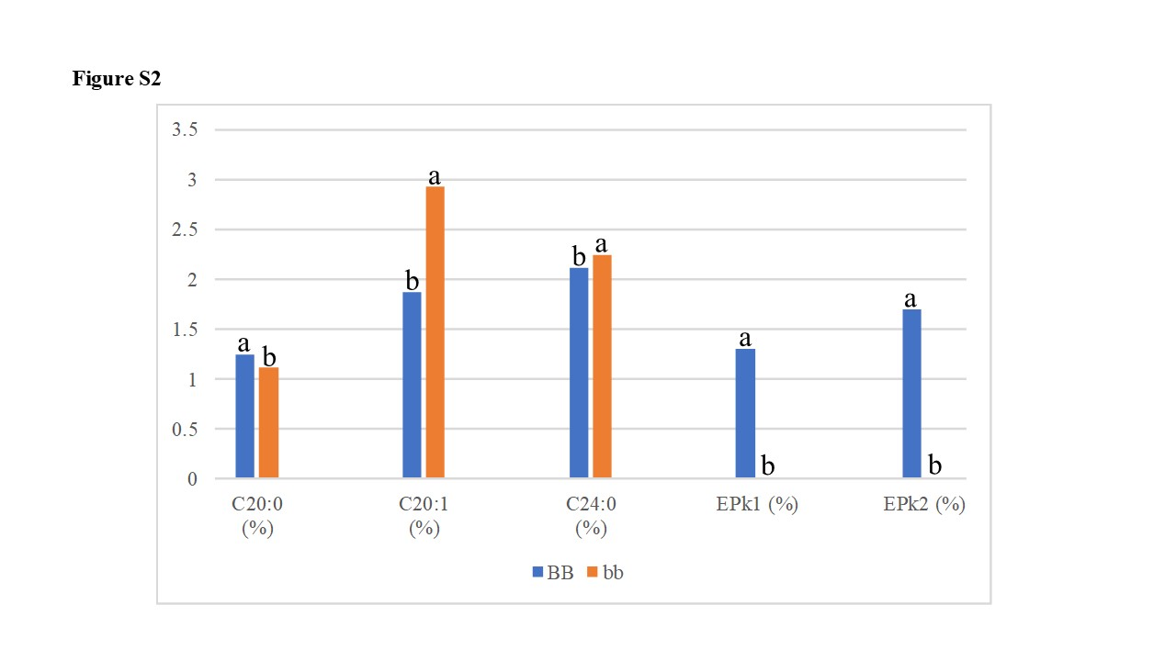

Figure S1 legend

Comparison of five major fatty acid composition between two genotypes. X-axis is different fatty acids, and Y-axis is the percentage of each fatty acid. If followed by the different letters above bars for each trait value, there were statistically significant differences between two genotypes.

Figure S2 legend

Comparison of three minor fatty acid composition and extra peak levels between two genotypes. X-axis is different fatty acids and extra peaks, and Y-axis is the percentage of each fatty acid and peak. If followed by the different letters above bars for each trait value, there were statistically significant differences between two genotypes.