**Supplementary Table 1.** Maize accessions used in this study.

|  |  |  |  |  |  |  |  |  |
| --- | --- | --- | --- | --- | --- | --- | --- | --- |
| Accession | Internal Code | Landrace name | Improvement status | Location | District | Department* | Race | Cluster |
| PM-421 | G1 | Astilla amarilla | Landrace | Los Ángeles de Cucharán | Daniel Hernandez | Huancavelica | San Geronimo Huancavelicano | 1 |
| PM-422 | G2 | Astilla blanca | Landrace | Los Ángeles de Cucharán | Daniel Hernandez | Huancavelica | San Geronimo Huancavelicano | 1 |
| PM-423 | G3 | Carhuay | Landrace | Santa María | Daniel Hernandez | Huancavelica | San Geronimo Huancavelicano | 1 |
| PM-424 | G4 | Carhuay | Landrace | Rundo | Daniel Hernandez | Huancavelica | San Geronimo Huancavelicano | 1 |
| PM-425 | G5 | Carhuay | Landrace | Anjara Pata | Quishuar | Huancavelica | San Geronimo Huancavelicano | 1 |
| PM-426 | G6 | Bolón | Landrace | Pachas | Quishuar | Huancavelica | San Geronimo Huancavelicano | 1 |
| PM-427 | G7 | Chullpi | Landrace | Yacutoclla | Quishuar | Huancavelica | Chullpi | 1 |
| PM-428 | G8 | Astilla blanca | Landrace | Gentil Pampas | Pampas | Huancavelica | San Geronimo | 1 |
| PM-429 | G9 | Astilla blanca | Landrace | Ahuayta Casay | Pampas | Huancavelica | San Geronimo Huancavelicano | 1 |
| PM-430 | G10 | Cusqueado | Landrace | Gentil Pampas | Pampas | Huancavelica | Cusco Gigante | 1 |
| PM-431 | G11 | Carhuay | Landrace | Mantacra | Pampas | Huancavelica | San Geronimo Huancavelicano | 1 |
| PM-432 | G12 | Astilla blanca-cusqueado | Landrace | Agua dulce, San Julián Alto | Colcabamba | Huancavelica | San Geronimo Huancavelicano | 1 |
| PM-433 | G13 | Astilla blanca-astilla amarilla | Landrace | Agua dulce, San Julián Alto | Colcabamba | Huancavelica | San Geronimo Huancavelicano | 1 |
| PM-434 | G14 | Almidón | Landrace | Buenos Aires | Santiago de Tucuma | Huancavelica | Cusco Gigante | 1 |
| PM-435 | G15 | Astilla blanca | Landrace | Huayrapire | Santiago de Tucuma | Huancavelica | San Geronimo Huancavelicano | 1 |
| PM-436 | G16 | Chullpi-Astilla blanca | Landrace | Vuelo Pata | Santiago de Tucuma | Huancavelica | Chullpi | 1 |
| PM-437 | G17 | Chullpi | Landrace | Usnupampa | Santiago de Tucuma | Huancavelica | Chullpi | 1 |
| PM-438 | G18 | Pistiada | Landrace | Muyupata | Pichos | Huancavelica | Piscorunto | 1 |
| PM-439 | G19 | Carhuay | Landrace | Muyupata | Pichos | Huancavelica | San Geronimo Huancavelicano | 1 |
| PM-440 | T1 | Choclero-101 | OP cultivar | EEA Baños de Inca-INIA | Baños del Inca | Cajamarca |  | 2 |
| PM-441 | T2 | INIA-603 Choclero | OP cultivar | EEA Baños de Inca-INIA | Baños del Inca | Cajamarca |  | 1 |
| PM-442 | T3 | INIA-601 | OP cultivar | EEA Baños de Inca-INIA | Baños de Inca | Cajamarca |  | 1 |
| PM-443 | T4 | Umutu | OP cultivar | EEA Baños de Inca-INIA | Baños de Inca | Cajamarca |  | 1 |
| PM-444 | T5 | Chauca semi blanco | OP cultivar | EEA Baños de Inca-INIA | Baños del Inca | Cajamarca |  | 1 |
| PM-445 | T6 | Chauca rojo | OP cultivar | EEA Baños de Inca-INIA | Baños del Inca | Cajamarca |  | 1 |

*Refers to a geographic region

**Supplementary Table 2**. Distribution of 29,332 SNPs across the 10 chromosomes of maize.

|  |  |  |  |  |
| --- | --- | --- | --- | --- |
| Chromosomes | No. of SNPs | %SNPs | Total length (Mb) | Density (Kb) |
| 1 | 4668 | 15.91 | 30.85 | 66.08 |
| 2 | 3750 | 12.78 | 24.37 | 64.98 |
| 3 | 3388 | 11.55 | 23.80 | 70.25 |
| 4 | 2741 | 9.34 | 25.03 | 91.33 |
| 5 | 3387 | 11.55 | 22.64 | 66.83 |
| 6 | 2237 | 7.63 | 18.14 | 81.07 |
| 7 | 2462 | 8.39 | 18.58 | 75.47 |
| 8 | 2491 | 8.49 | 18.24 | 73.23 |
| 9 | 2182 | 7.44 | 16.30 | 74.70 |
| 10 | 2026 | 6.91 | 15.24 | 75.24 |

**Supplementary Table 3.** Origin of the 25 Peruvian starchy maize accessions among two clusters inferred by the STRUCTURE analysis with 29,332 SNPs.

|  |  |  |  |
| --- | --- | --- | --- |
| Province | | Cluster 1 | Cluster 2 |
| Santiago de Tucuma | 4 |  |
| Colcabamba | 2 |  |
| Pampas | 4 |  |
| Pichos | 2 |  |
| Cajamarca | 5 | 1 |
| Daniel Hernandez | 4 |  |
| Quishuar | 3 |  |

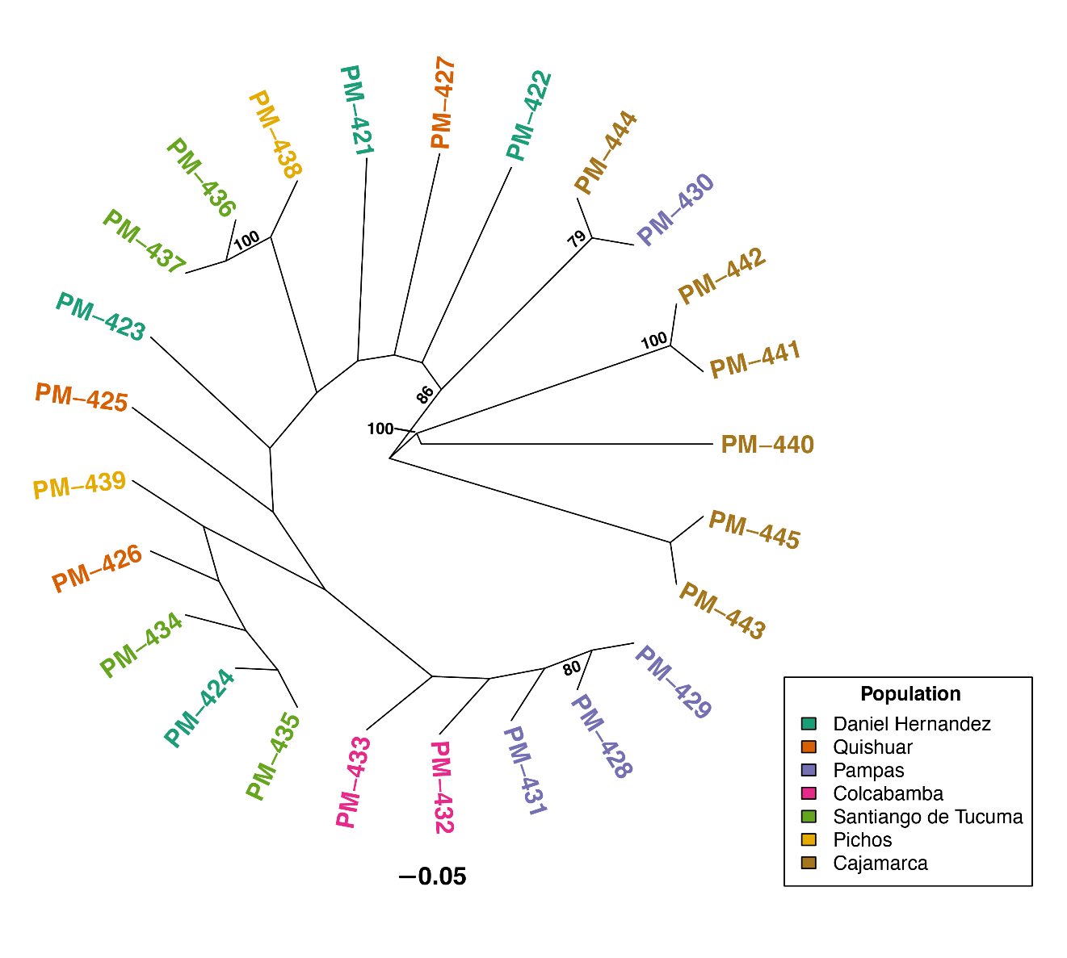

**Supplementary Figure 1.** UPGMA clustering based on Provesti’s genetic distance for 25 accessions of starchy maize from seven provinces of Peru using 29,332 SNP markers. Only bootstrap values greater than 80% are shown.

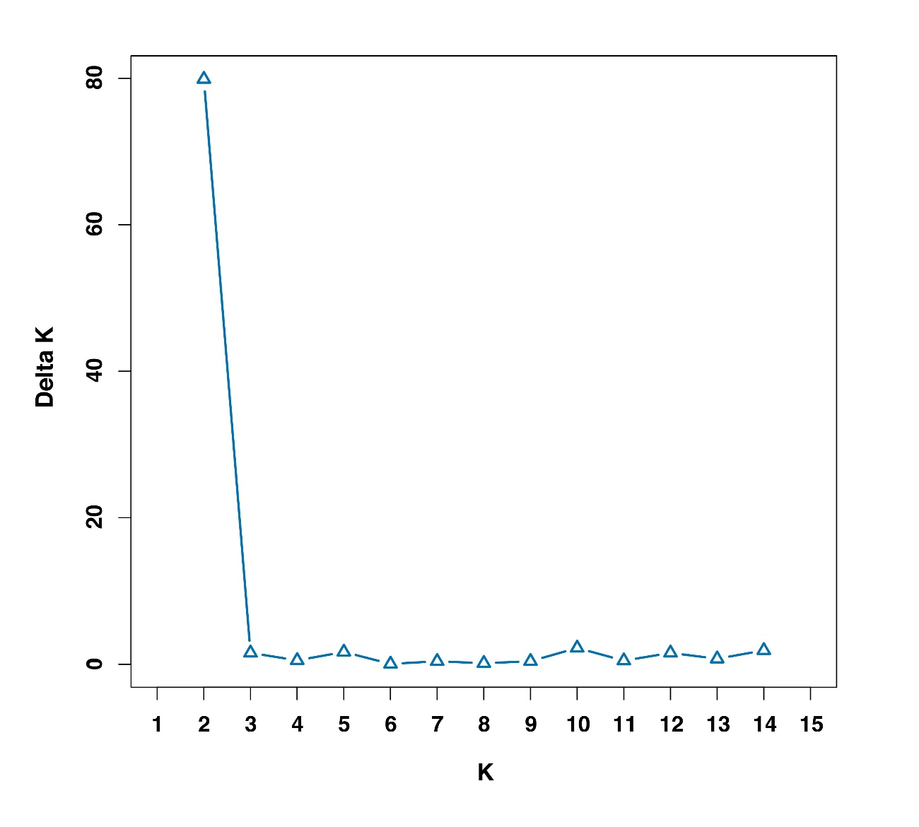

**Supplementary Figure 2.** Detection of the number of clusters (K) for 25 accessions of Peruvian maize germplasm using 29,332 SNP markers.