Supplementary material
Tables S1. Details of wood apple accessions with the sample code and geocoordinates (latitude & longitude).
S.No. |  | Site of Collection |  | Date of Collection | Latitude | Longitude | Status
1 | LA1 | Uttar Pradesh | CSIR-NBRI, Lucknow | 10/12/2017 | 26°51'32.6"N | 80°57'01.7"E | Planted
2 | LA2 | Uttar Pradesh | Mau Dist. | 20/09/2017 | 25°56'14.4"N | 83°34'15.7"E | Semi wild
3 | LA3 | Uttar Pradesh | Sultanpur Dist. | 07/03/2017 | 26°15'53.1''N | 82°4'21.7''E | Semi wild
4 | LA4 | Uttar Pradesh | Kannouj Dist. | 10/10/2017 | 27°02'35.6"N | 79°54'21.2"E | Semi wild
5 | LA5 | Uttar Pradesh | Sultanpur Dist. | 02/03/2017 | 26°15'09.1"N | 82°04'38.0"E | Semi wild
6 | LA6 | Uttar Pradesh | Sultanpur Dist. | 02/03/2017 | 26°16'17.0"N | 82°03'36.6"E | Semi wild
7 | LA7 | Uttar Pradesh | Lucknow Dist. | 07/04/2017 | 26°51'26.6"N | 80°55'37.5"E | Planted
8 | LA8 | Uttar Pradesh | Sitapur Dist | 03/09/2017 | 27°34'51.4"N | 80°41'00.2"E | Planted
9 | LA9 | Uttar Pradesh | Sitapur Dist | 02/03/2018 | 27°34'07.6"N | 80°41'04.1"E | Planted
10 | LA10 | Uttar Pradesh | Lucknow Dist. | 08/04/2017 | 26°54'11.4"N | 80°58'48.3"E | Wild
11 | LA11 | Uttar Pradesh | Lucknow Dist. | 08/04/2017 | 26°54'55.3"N | 80°58'09.4"E | Wild
12 | LA12 | Uttar Pradesh | Lucknow Dist. | 20/09/2017 | 26°55'13.2"N | 80°59'35.8"E | Wild
13 | LA13 | Uttar Pradesh | Sitapur Dist | 03/09/2017 | 27°33'31.9"N | 80°41'28.2"E | Planted
14 | LA14 | Uttar Pradesh | Lakhimpur | 03/09/2017 | 27°56'30.3"N | 80°47'19.9"E | Wild
15 | LA15 | Uttar Pradesh | Lakhimpur | 03/09/2017 | 27°57'32.0"N | 80°46'12.6"E | Wild
16 | LA16 | Uttar Pradesh | Lakhimpur | 03/09/2017 | 27°55'38.8"N | 80°46'24.6"E | Wild
17 | LA17 | Uttar Pradesh | Mirjapur | 02/11/2017 | 27°53'30.0"N | 80°38'56.6"E | Planted
18 | LA18 | Uttar Pradesh | Shahjahanpur | 21/09/2017 | 27°52'17.2"N | 79°54'56.8"E | Semi wild
19 | LA19 | Madhya Pradesh | Chitrakoot, Satna Dist. | 27/12/2018 | 25°12'56.2"N | 80°55'15.3"E | Semi wild
20 | LA20 | Madhya Pradesh | Chitrakoot, Satna Dist. | 28/12/2018 | 24°35'39.7"N | 80°49'53.5"E | Wild
21 | LA21 | Madhya Pradesh | Jabalpur Dist. | 27/06/2018 | 23°10'24.5"N | 79°58'45.8"E | Semi wild
22 | LA22 | Madhya Pradesh | Indore Dist | 14/04/2018 | 22°43'59.4"N | 75°51'13.3"E | Semi wild
23 | LA23 | Madhya Pradesh | Mehar Devi, Satna Dist. | 24/04/2017 | 24°15'57.8"N | 80°45'45.9"E | Wild
24 | LA24 | Madhya Pradesh | Hardua, Satna Dist. | 21/04/2017 | 24°11'21.4"N | 81°02'28.3"E | Wild
25 | LA25 | Madhya Pradesh | Kothi, Satna Dist. | 21/04/2017 | 24°44'54.5"N | 80°46'30.2"E | Wild
26 | LA26 | Madhya Pradesh | Pindara, Satna Dist. | 20/04/2017 | 24°58'26.4"N | 80°47'31.4"E | Wild
27 | LA27 | Madhya Pradesh | Chitrakoot, Satna Dist. | 20/04/2017 | 25°09'50.5"N | 80°51'06.4"E | Wild
28 | LA28 | Madhya Pradesh | Chitrakoot, Satna Dist. | 21/04/2017 | 25°09'22.1"N | 80°51'53.7"E | Wild
29 | LA29 | Madhya Pradesh | Chitrakoot, Satna Dist. | 21/04/2017 | 25°10'10.7"N | 80°52'32.3"E | Wild
30 | LA30 | Karnataka | IIHR Bangalore | 07/07/2018 | 13°08'23.6"N | 77°29'44.9"E | Planted
31 | LA31 | Karnataka | IIHR Bangalore | 07/07/2018 | 13°07'44.3"N | 77°29'34.2"E | Planted
32 | LA32 | Karnataka | IIHR Bangalore | 07/07/2018 | 13°08'06.5"N | 77°29'46.9"E | Planted
33 | LA33 | Karnataka | IIHR Bangalore | 07/07/2018 | 13°08'12.7"N | 77°30'00.6"E | Planted
34 | LA34 | Karnataka | IIHR Bangalore | 07/07/2018 | 13°08'19.6"N | 77°29'30.2"E | Planted
35 | LA35 | Karnataka | IIHR Bangalore | 07/07/2018 | 13°07'51.3"N | 77°29'54.1"E | Planted
36 | LA36 | Karnataka | GKVK Bangalore | 10/01/2018 | 13°04'59.0"N | 77°34'28.5"E | Planted
37 | LA37 | Karnataka | GKVK Bangalore | 10/01/2018 | 13°05'39.5"N | 77°33'55.1"E | Planted
38 | LA38 | Karnataka | GKVK Bangalore | 10/01/2018 | 13°05'07.6"N | 77°33'56.7"E | Planted
39 | LA39 | Karnataka | GKVK Bangalore | 10/01/2018 | 13°05'11.8"N | 77°34'41.8"E | Planted
40 | LA40 | Karnataka | IAIM Bangalore | 11/01/2018 | 13°07'33.3"N | 77°32'46.0"E | Planted
41 | LA41 | Karnataka | IAIM Bangalore | 11/01/2018 | 13°07'32.5"N | 77°32'47.2"E | Planted
42 | LA42 | Gujarat | (University) Ahmedabad Dist. | 24/12/2017 | 23°02'23.3"N | 72°33'22.2"E | Semi wild
43 | LA43 | Gujarat | Anand Dist. | 06/02/2018 | 22°32'08.9"N | 72°58'23.3"E | Planted
44 | LA44 | Gujarat | Anand Dist. | 06/02/2018 | 22°32'11.4"N | 72°58'30.4"E | Planted
45 | LA45 | Gujarat | Jamnagar Dist. | 05/02/2018 | 22°28'06.8"N | 70°01'46.1"E | Semi wild
46 | LA46 | Gujarat | Jamnagar Dist. | 05/02/2018 | 22°29'36.2"N | 70°02'17.0"E | Semi wild
47 | LA47 | Gujarat | (University) Ahmedabad, Dist. | 24/12/2017 | 23°02'21.8"N | 72°33'21.6"E | Semi wild
48 | LA48 | Gujarat | Vadodara Dist. | 03/03/2019 | 22°18'28.5"N | 73°10'25.3"E | Semi wild
49 | LA49 | Gujarat | Vadodara Dist. | 03/03/2019 | 22°17'14.0"N | 73°08'31.6"E | Semi wild
50 | LA50 | Gujarat | Vadodara Dist. | 03/03/2019 | 22°22'04.0"N | 73°09'08.9"E | Semi wild
51 | LA51 | Maharashtra | Aurangabad Dist. | 05/10/2018 | 19°51'57.2"N | 75°19'55.1"E | Wild
52 | LA52 | Maharashtra | Aurangabad Dist. | 05/10/2018 | 19°52'13.6"N | 75°21'23.3"E | Wild
53 | LA53 | Maharashtra | Aurangabad Dist. | 05/10/2018 | 19°54'09.7"N | 75°20'47.0"E | Wild
54 | LA54 | Maharashtra | Aurangabad Dist. | 05/10/2018 | 19°52'07.7"N | 75°19'32.9"E | Wild
55 | LA55 | Maharashtra | Chandrapur Dist. | 13/04/2017 | 19°58'21.2"N | 79°17'39.9"E | Semi wild
56 | LA56 | Maharashtra | Yavatmal Dist. | 05/04/2019 | 20°23'10.0"N | 78°07'53.1"E | Semi wild
57 | LA57 | Maharashtra | Yavatmal Dist. | 05/04/2019 | 20°22'48.2"N | 78°06'26.3"E | Semi wild
58 | LA58 | Maharashtra | Pune Dist. | 03/12/2017 | 18°30'42.9"N | 73°52'28.1"E | Planted
59 | LA59 | Maharashtra | Chandrapur Dist. | 13/04/2017 | 20°00'43.0"N | 79°17'33.3"E | Semi wild
60 | LA60 | Maharashtra | Pune Dist. | 13/02/2017 | 18°31'56.6"N | 73°49'30.7"E | Semi wild
61 | LA61 | Delhi | IARI Delhi | 08/07/2018 | 28°37'58.5"N | 77°09'09.5"E | Planted
62 | LA62 | Delhi | IARI Delhi | 08/07/2018 | 28°37'59.0"N | 77°09'11.0"E | Planted
63 | LA63 | Delhi | IARI Delhi | 08/07/2018 | 28°38'02.5"N | 77°09'09.8"E | Planted
64 | LA64 | Delhi | Panjabi bagh, Delhi | 19/10/2018 | 28°40'06.4"N | 77°07'45.7"E | Planted
65 | LA65 | Delhi | Delhi | 18/10/2017 | 28°38'51.0"N | 77°12'46.3"E | Planted
66 | LA66 | Delhi | Panjabi bagh, Delhi | 19/10/2018 | 28°39'55.3"N | 77°07'11.0"E | Planted
67 | LA67 | Odisha | Cuttack Dist. | 24/02/2019 | 20°27'51.8"N | 85°52'53.2"E | Wild
68 | LA68 | Odisha | Cuttack Dist. | 24/02/2019 | 20°28'49.7"N | 85°52'06.3"E | Wild
69 | LA69 | Odisha | Cuttack Dist. | 24/02/2019 | 20°28'45.0"N | 85°51'51.5"E | Wild
70 | LA70 | Assam | Kamrup Dist. | 06/03/2019 | 26°07'38.3"N | 91°38'48.1"E | Wild
71 | LA71 | Tamil Nadu | Padukottai Dist. | 08/11/2016 | 10°22'55.7"N | 78°47'58.4"E | Wild
72 | LA72 | Tamil Nadu | Padukottai Dist. | 08/11/2016 | 10°27'47.4"N | 78°49'22.8"E | Wild
73 | LA73 | Tamil Nadu | BooluvampattiDist | 06/01/2018 | 10°56'09.8"N | 76°42'50.9"E | Wild
74 | LA74 | Tamil Nadu | BooluvampattiDist | 16/01/2018 | 10°56'02.8"N | 76°41'14.7"E | Wild
75 | LA75 | Tamil Nadu | BooluvampattiDist | 16/01/2018 | 10°56'14.2"N | 76°41'32.1"E | Wild
76 | LA76 | Tamil Nadu | BooluvampattiDist | 16/01/2018 | 10°56'02.4"N | 76°40'57.3"E | Wild
77 | LA77 | Tamil Nadu | BooluvampattiDist | 16/01/2018 | 10°56'43.5"N | 76°40'30.8"E | Wild
78 | LA78 | Tamil Nadu | BooluvampattiDist | 16/01/2018 | 10°56'13.7"N | 76°40'31.1"E | Wild
79 | LA79 | Chhattisgarh | IGKV Raipur Dist. | 09/07/2018 | 21°14'05.4"N | 81°41'34.0"E | Planted
80 | LA80 | Telangana | Kothagudem Dist. | 04/03/2017 | 17°32'12.8"N | 80°37'13.3"E | Wild
81 | LA81 | Telangana | Kothagudem Dist. | 20/08/2017 | 17°33'00.0"N | 80°35'53.0"E | Wild
82 | LA82 | West Bengal | HooglyDist | 27/06/2017 | 22°54'46.9"N | 88°23'13.8"E | Planted
83 | LA83 | West Bengal | Hoogly Dist. | 27/06/2017 | 22°43'35.1"N | 88°20'48.1"E | Planted
84 | LA84 | West Bengal | Hoogly Dist. | 27/06/2017 | 22°43'35.4"N | 88°20'22.4"E | Planted
85 | LA85 | West Bengal | Hoogly Dist. | 27/06/2017 | 22°43'57.9"N | 88°19'19.6"E | Planted
86 | LA86 | Kerala | Trivendrum | 26/01/2018 | 8°31'15.8"N | 76°55'58.3"E | Planted
87 | LA87 | Kerala | Trivendrum | 26/01/2018 | 8°34'08.3"N | 76°54'59.8"E | Planted
88 | LA88 | Kerala | Trivendrum | 26/01/2018 | 8°33'58.5"N | 76°53'53.0"E | Planted
89 | LA89 | Kerala | Trivendrum | 26/01/2018 | 8°33'17.0"N | 76°53'53.0"E | Planted
90 | LA90 | Kerala | Trivendrum | 27/01/2018 | 8°33'34.1"N | 76°53'55.5"E | Planted
91 | LA91 | Kerala | Trivendrum | 27/01/2018 | 8°33'12.1"N | 76°53'58.0"E | Planted
92 | LA92 | Haryana | Karnal | 20/10/2017 | 29°41'47.6"N | 77°01'13.3"E | Planted
93 | LA93 | Andhra Pradesh | Hyderabad | 09/01/2018 | 17°20'39.1"N | 78°29'32.2"E | Wild
94 | LA94 | Andhra Pradesh | Hyderabad | 09/01/2018 | 17°32'56.6"N | 78°27'52.0"E | Wild
95 | LA95 | Andhra Pradesh | Hyderabad | 09/01/2018 | 17°32'44.8"N | 78°27'39.7"E | Wild
96 | LA96 | Rajasthan | Jaipur | 25/01/2018 | 26°51'55.6"N | 75°47'19.8"E | Semi wild

Table S2. Quantification of quercetin, stigmasterol, psoralen and niloticin in the methanolic extracts of wood apple.
Sample (10μI) | Niloticin (%) | Psoralen (%) | Quercetin (%) | Stigmasterol (%)
LA1 | 0.021 | 0.001 | 0.006 | 0.029
LA2 | 0.013 | 0.009 | 0.009 | 0.053
LA3 | 0.003 | 0.008 | 0.001 | 0.093
LA4 | 0.035 | 0.009 | 0.005 | 0.096
LA5 | 0.027 | 0.055 | 0.014 | 0.052
LA6 | 0.074 | 0.018 | 0.015 | 0.065
LA7 | 0.068 | 0.045 | 0.007 | 0.107
LA8 | 0.03 | 0.022 | 0.006 | 0.008
LA9 | 0.075 | 0.036 | 0.006 | 0.017
LA10 | 0.157 | 0.035 | 0.003 | 0.036
LA11 | 0.112 | 0.032 | 0.007 | 0.133
LA12 | 0.041 | 0.035 | 0.006 | 0.067
LA13 | 0.008 | 0.029 | 0.005 | 0.034
LA14 | 0.007 | 0.039 | 0.008 | 0.082
LA15 | 0.041 | 0.007 | 0.018 | 0.057
LA16 | 0.052 | 0.009 | 0.018 | 0.158
LA17 | 0.028 | 0.005 | 0.025 | 0.122
LA18 | 0.058 | 0.011 | 0.006 | 0.076
LA19 | 0.17 | 0.09 | 0.006 | 0.022
LA20 | 0.12 | 0.021 | 0.006 | 0.072
LA21 | 0.191 | 0.034 | 0.009 | 0.006
LA22 | 0.019 | 0.028 | 0.013 | 0.129
LA23 | 0.022 | 0.036 | 0.007 | 0.089
LA24 | 0.024 | 0.013 | 0.008 | 0.091
LA25 | 0.015 | 0.004 | 0.007 | 0.101
LA26 | 0.013 | 0.002 | 0.012 | 0.165
LA27 | 0.021 | 0.001 | 0.009 | 0.065
LA28 | 0.028 | 0.004 | 0.002 | 0.045
LA29 | 0.076 | 0.002 | 0.006 | 0.093
LA30 | 0.031 | 0.001 | 0.011 | 0.116
LA31 | 0.011 | 0.002 | 0.012 | 0.051
LA32 | 0.011 | 0.001 | 0.011 | 0.089
LA33 | 0.004 | 0.001 | 0.009 | 0.051
LA34 | 0.005 | 0.001 | 0.008 | 0.076
LA35 | 0.003 | 0.001 | 0.007 | 0.069
LA36 | 0.019 | 0.001 | 0.006 | 0.052
LA37 | 0.018 | 0.002 | 0.007 | 0.062
LA38 | 0.014 | 0.002 | 0.001 | 0.103
LA39 | 0.011 | 0.007 | 0.003 | 0.117
LA40 | 0.011 | 0.003 | 0.005 | 0.109
LA41 | 0.003 | 0.001 | 0.004 | 0.009
LA42 | 0.022 | 0.006 | 0.003 | 0.003
LA43 | 0.112 | 0.023 | 0.006 | 0.022
LA44 | 0.029 | 0.005 | 0.005 | 0.126
LA45 | 0.041 | 0.004 | 0.001 | 0.056
LA46 | 0.015 | 0.026 | 0.004 | 0.127
LA47 | 0.014 | 0.001 | 0.003 | 0.054
LA48 | 0.012 | 0.003 | 0.001 | 0.043
LA49 | 0.008 | 0.008 | 0.008 | 0.087
LA50 | 0.081 | 0.007 | 0.008 | 0.03
LA51 | 0.129 | 0.021 | 0.011 | 0.063
LA52 | 0.129 | 0.025 | 0.008 | 0.068
LA53 | 0.156 | 0.032 | 0.004 | 0.07
LA54 | 0.187 | 0.014 | 0.004 | 0.071
LA55 | 0.112 | 0.009 | 0.008 | 0.113
LA56 | 0.033 | 0.011 | 0.004 | 0.077
LA57 | 0.057 | 0.009 | 0.007 | 0.03
LA58 | 0.004 | 0.001 | 0.005 | 0.052
LA59 | 0.013 | 0.001 | 0.007 | 0.063
LA60 | 0.03 | 0.011 | 0.005 | 0.059
LA61 | 0.013 | 0.006 | 0.005 | 0.04
LA62 | 0.027 | 0.004 | 0.009 | 0.062
LA63 | 0.024 | 0.006 | 0.007 | 0.006
LA64 | 0.003 | 0.004 | 0.011 | 0.004
LA65 | 0.013 | 0.011 | 0.011 | 0.052
LA66 | 0.012 | 0.011 | 0.003 | 0.02
LA67 | 0.041 | 0.007 | 0.001 | 0.072
LA68 | 0.193 | 0.013 | 0.003 | 0.039
LA69 | 0.022 | 0.007 | 0.001 | 0.019
LA70 | 0.017 | 0.008 | 0.006 | 0.02
LA71 | 0.011 | 0.002 | 0.007 | 0.027
LA72 | 0.021 | 0.001 | 0.009 | 0.025
LA73 | 0.032 | 0.011 | 0.014 | 0.042
LA74 | 0.064 | 0.015 | 0.007 | 0.064
LA75 | 0.038 | 0.016 | 0.013 | 0.071
LA76 | 0.116 | 0.028 | 0.009 | 0.046
LA77 | 0.271 | 0.044 | 0.004 | 0.043
LA78 | 0.018 | 0.002 | 0.001 | 0.031
LA79 | 0.016 | 0.001 | 0.007 | 0.121
LA80 | 0.159 | 0.042 | 0.005 | 0.14
LA81 | 0.097 | 0.025 | 0.004 | 0.042
LA82 | 0.15 | 0.033 | 0.006 | 0.111
LA83 | 0.053 | 0.009 | 0.009 | 0.137
LA84 | 0.045 | 0.005 | 0.006 | 0.061
LA85 | 0.075 | 0.023 | 0.004 | 0.166
LA86 | 0.15 | 0.044 | 0.023 | 0.126
LA87 | 0.068 | 0.032 | 0.008 | 0.073
LA88 | 0.012 | 0.079 | 0.012 | 0.101
LA89 | 0.338 | 0.078 | 0.017 | 0.101
LA90 | 0.156 | 0.039 | 0.007 | 0.091
LA91 | 0.265 | 0.045 | 0.002 | 0.119
LA92 | 0.024 | 0.006 | 0.011 | 0.074
LA93 | 0.055 | 0.018 | 0.008 | 0.047
LA94 | 0.079 | 0.026 | 0.007 | 0.134
LA95 | 0.102 | 0.026 | 0.003 | 0.018
LA96 | 0.108 | 0.046 | 0.003 | 0.017

Table S3. Assignment of 96 accessions of wood apple in six clusters based on their four quantitative traits.

S.No | Clusters No. | Total number of accessions | List of accessions
1 | Cluster-I | 13 | LA-1, LA-72, LA-78, LA-71, LA-66, LA-70, LA-69, LA-13, LA-41, LA-64, LA-42, LA-63, LA-8
2 | Cluster-II | 20 | LA-2, LA-65, LA-36, LA-47, LA-33, LA-58, LA-31, LA-48, LA-61, LA-27, LA-37, LA-59, LA-92, LA-60, LA-62, LA-28, LA-73, LA-45, LA-84, LA-15
3 | Cluster-III | 10 | LA-4, LA-24, LA-56, LA-67, LA-75, LA-32, LA-49, LA-3, LA-34, LA-35
4 | Cluster-IV | 5 | LA-5, LA-12, LA-14, LA-23, LA-88
5 | Cluster-V | 15 | LA-16, LA-83, LA-85, LA-94, LA-22, LA-46, LA-25, LA-38, LA-40, LA-39, LA-79, LA-30, LA-44, LA-17, LA-26
6 | Cluster-VI | 18 | LA-6, LA-74, LA-18, LA-87, LA-29, LA-7, LA-57, LA-93, LA-50, LA-9, LA-43, LA-95, LA-96, LA-76, LA-81, LA-51, LA-52, LA-20
7 | Cluster-VII | 12 | LA-10, LA-53, LA-54, LA-68, LA-19, LA-21, LA-11, LA-55, LA-80, LA-86, LA-82, LA-90
8 | Cluster-VIII | 3 | LA-77, LA-91, LA-89

Table S4. Inter and intra-cluster distance between 96 accessions of wood apple.

Cluster No. | I | II | III | IV | V | VI | VII | VIII
I | 6.83 | 10.81 | 11.49 | 12.87 | 12.68 | 15.84 | 16.96 | 17.25
II |  | 0.00 | 16.06 | 7.09 | 17.94 | 8.66 | 7.59 | 15.02
III |  |  | 0.00 | 17.38 | 5.53 | 17.62 | 21.74 | 12.50
IV |  |  |  | 0.00 | 17.10 | 6.37 | 6.38 | 13.96
V |  |  |  |  | 0.00 | 18.18 | 22.52 | 13.14
VI |  |  |  |  |  | 0.00 | 6.64 | 10.09
VII |  |  |  |  |  |  | 0.00 | 16.47
VIII |  |  |  |  |  |  |  | 0.00
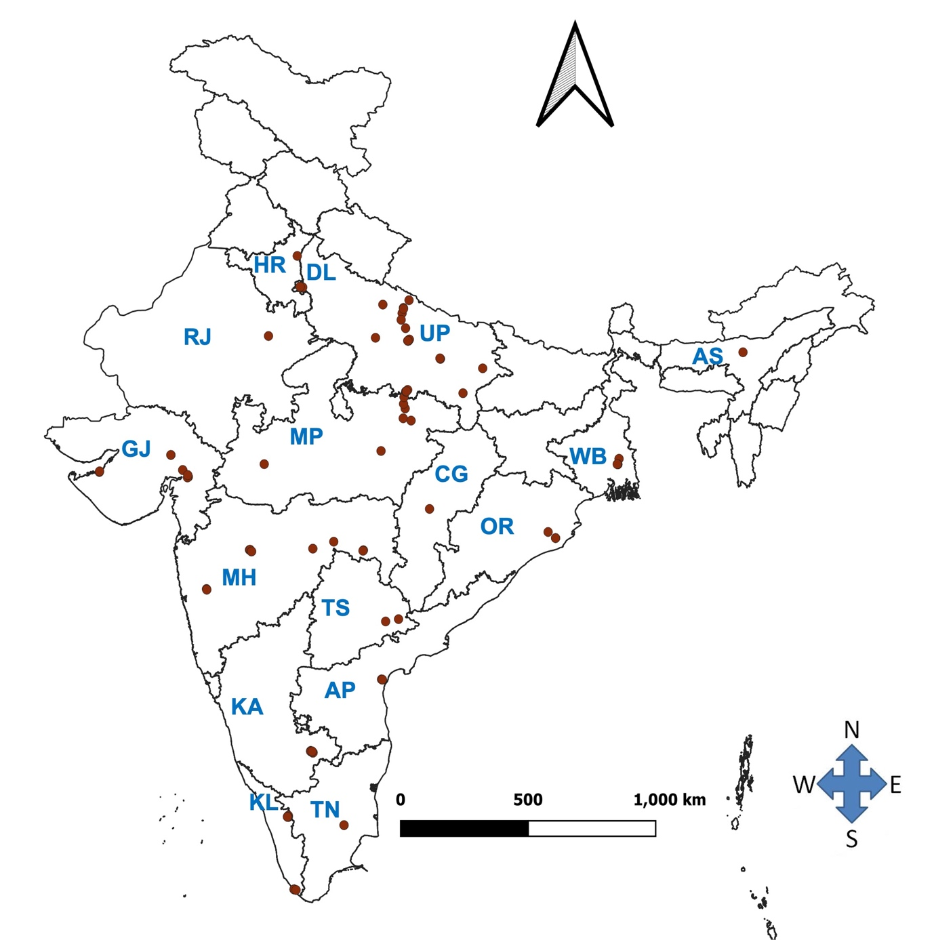
Figure S1. Map showing geographic distribution of wood apple in different states of India.

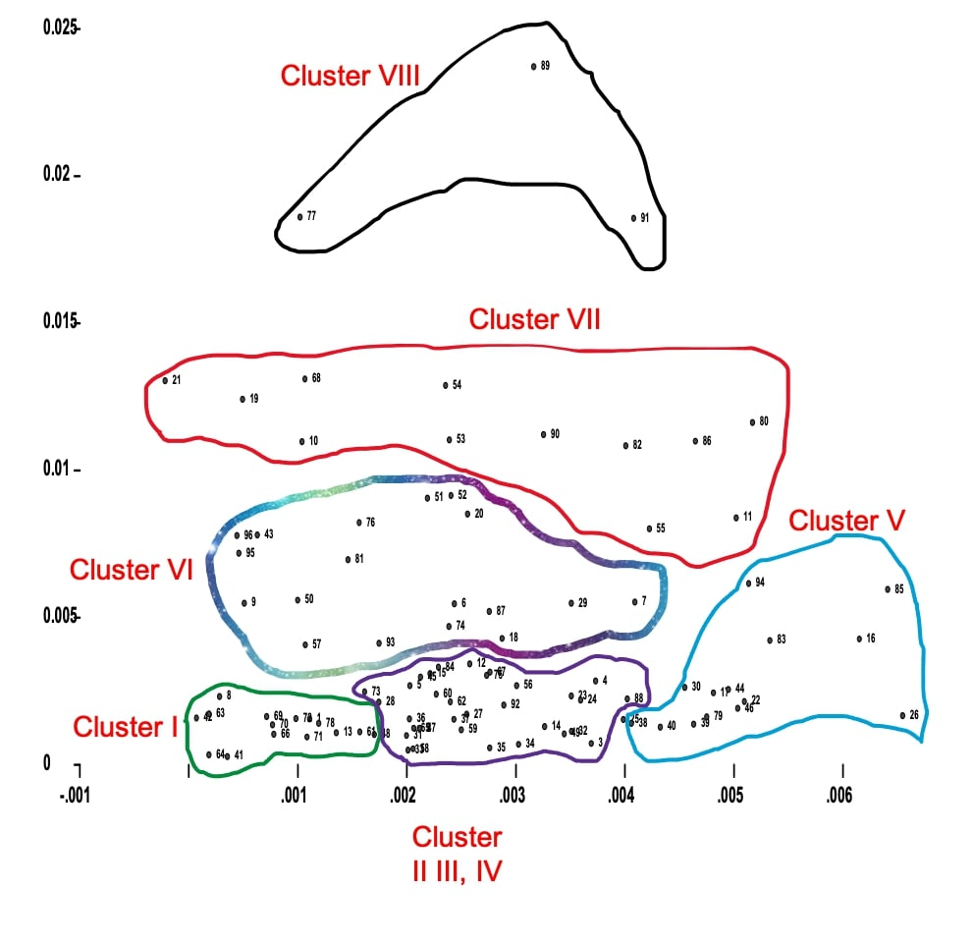
Figure S2. Two-dimensional plot of Principal Component Analysis (PCA) based on chemotypic trait of wood apple accessions.

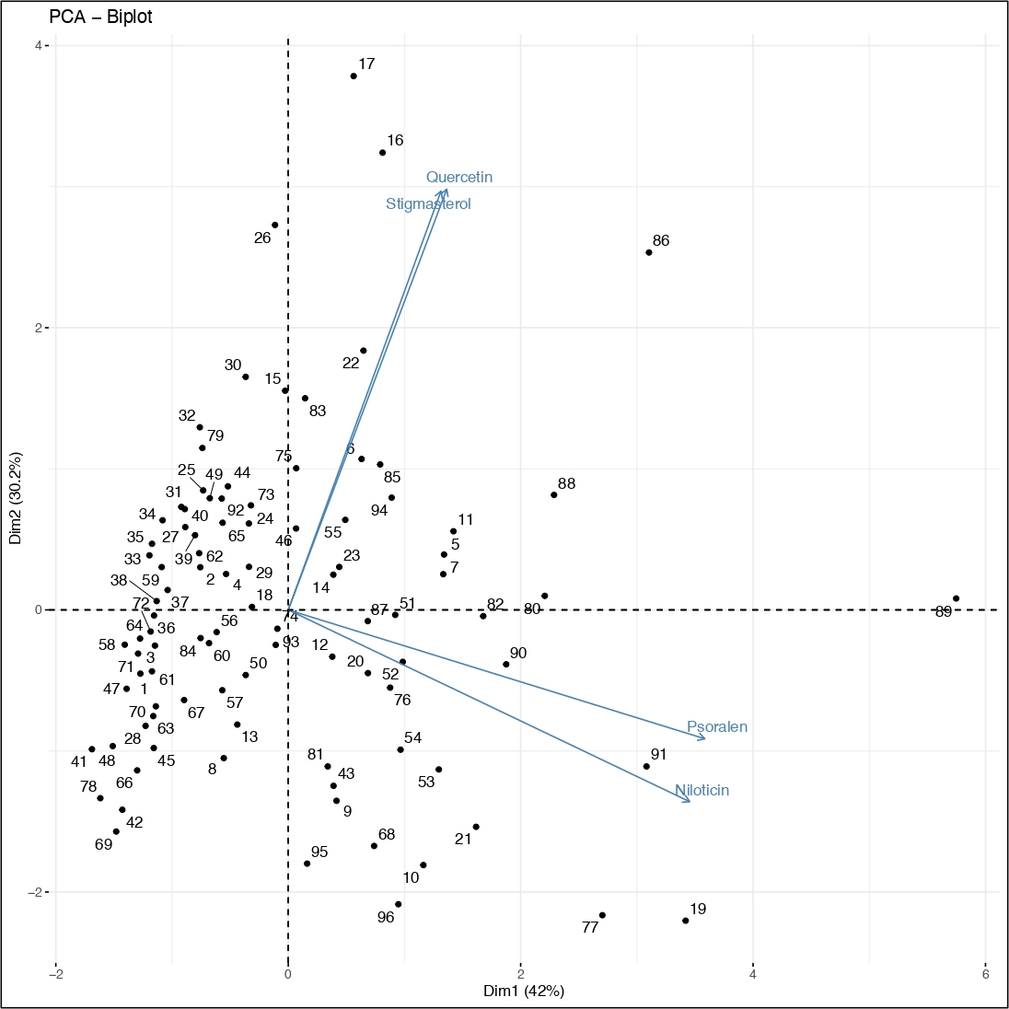

Figure S3. Principal component biplot: two-dimensional orientations of wood apple accessions for different chemotypic traits.

