|  |  |  |  |  |  |  |  |  |  |
| --- | --- | --- | --- | --- | --- | --- | --- | --- | --- |
| State | District | Survey period | No of trees | Latitude | Longitude | Altitude | Climatic Zone | MAT | MAP |
|  |  |  |  |  |  | (m) |  | (0C) | (mm) |
| Chhattisgarh | Bastar | March -April 2019 | 88 | 19° 33´ | 81° 40´ | 624 | Dry Sub-Humid | 26.8 | 1386 |
| Chhattisgarh | Bastar | March -April 2020 | 52 | 19° 33´ | 81° 40´ | 624 | Dry Sub-Humid | 26.8 | 1386 |
| Chhattisgarh | Bastar | March -April 2021 | 29 | 19° 33´ | 81° 40´ | 624 | Dry Sub-Humid | 26.8 | 1386 |
| Chhattisgarh | Bastar | March -April 2022 | 29 | 19° 33´ | 81° 40´ | 624 | Dry Sub-Humid | 26.8 | 1386 |

S1: Location coordinates, abbreviation, sample size, altitude, climatic zone, mean annual temperature (MAT) and mean annual precipitation (MAP) of selected study site

|  |  |  |  |  |  |  |  |  |  |  |
| --- | --- | --- | --- | --- | --- | --- | --- | --- | --- | --- |
| Collector ID | Location | Pod length (cm) | Pod breadth (mm) | Pod weight (g) | Pulp weight (g) | Pulp percent | Shell weight (g) | Fiber weight (g) | No. of seed | Seed weight (g) |
| B1 | Ghatpadmun | 7.57 | 20.57 | 36.1 | 13.203 | 36.57 | 8.078 | 0.67 | 13.6 | 10.893 |
| B2 | Ghatpadmun | 12.08 | 12.05 | 21.97 | 6.633 | 30.19 | 4.992 | 0.82 | 7.1 | 7.595 |
| B3 | Ghatpadmun | 9.85 | 14.42 | 39.18 | 16.952 | 43.27 | 7.749 | 1.09 | 10.5 | 10.786 |
| B4 | Bellar | 6.36 | 11.94 | 35.57 | 15.988 | 44.95 | 8.092 | 0.57 | 11.9 | 8.457 |
| B5 | Bellar | 15.06 | 13.38 | 30.31 | 13.743 | 45.34 | 3.895 | 1.32 | 10.1 | 9.836 |
| B6 | Guniya | 7.77 | 17.05 | 21.24 | 8.873 | 41.77 | 3.287 | 0.64 | 8.6 | 6.939 |
| B7 | Guniya | 7.56 | 17.65 | 32.32 | 12.159 | 37.62 | 7.766 | 0.93 | 12.5 | 9.519 |
| B8 | Bhainsgaon | 11.48 | 15.24 | 31.07 | 12.453 | 40.08 | 5.464 | 1.52 | 10.1 | 8.572 |
| B9 | Bhainsgaon | 13.44 | 16.89 | 17.16 | 5.524 | 32.19 | 3.998 | 1.10 | 4.3 | 4.426 |
| B10 | Bhainsgaon | 5.3 | 13.13 | 11.2 | 3.306 | 29.52 | 2.106 | 0.34 | 4.7 | 3.542 |
| B11 | Raikot | 6.08 | 14.97 | 15.6 | 4.245 | 27.21 | 3.836 | 0.23 | 7.4 | 3.022 |
| B12 | Raikot | 7.34 | 16.93 | 22.24 | 9.183 | 41.29 | 6.444 | 0.51 | 5.8 | 4.741 |
| B13 | Raikot | 9.79 | 15.14 | 48.93 | 19.594 | 40.04 | 10.65 | 1.52 | 12.6 | 12.146 |
| B14 | Raikot | 9.08 | 12.8 | 26.15 | 9.655 | 36.92 | 4.978 | 0.82 | 8.4 | 7.606 |
| B15 | Raikot | 7.91 | 13.74 | 39.53 | 14.975 | 37.88 | 10.375 | 0.93 | 12.4 | 10.396 |
| B16 | Raikot | 8.18 | 15.11 | 30.03 | 13.724 | 45.7 | 5.513 | 1.03 | 7.9 | 6.665 |
| B17 | Kattekalan | 6.52 | 14.33 | 27.32 | 12.98 | 47.51 | 5.36 | 0.57 | 6.3 | 6.358 |
| B18 | Bade Mama | 10.71 | 8.29 | 52.83 | 27.568 | 52.18 | 4.245 | 2.38 | 23.7 | 21.408 |
| B19 | Nangur | 7.2 | 13.27 | 25.33 | 11.666 | 46.06 | 4.992 | 0.50 | 9.1 | 6.797 |
| B20 | Nangur | 11.26 | 21.03 | 29.08 | 12.74 | 43.81 | 5.325 | 1.05 | 8.5 | 8.111 |
| B21 | Pushpal | 15.39 | 21.06 | 32.2 | 12.112 | 37.61 | 6.787 | 0.63 | 15.7 | 10.989 |
| B22 | Bijapur | 9.83 | 13.58 | 15.74 | 6.837 | 43.44 | 2.783 | 0.57 | 5 | 4.174 |
| B23 | Talnar | 4.11 | 11.96 | 38.21 | 10.097 | 26.43 | 2.7 | 0.49 | 14.3 | 6.113 |
| B24 | Bakawon | 5.2 | 12.7 | 38.21 | 17.594 | 46.05 | 7.222 | 0.49 | 14.3 | 11.399 |
| B25 | Bakawon | 8 | 12.28 | 27 | 11.882 | 44.01 | 4.801 | 0.80 | 8 | 6.854 |
| B26 | Bakawon | 10.43 | 13.71 | 9.11 | 3.288 | 36.09 | 1.761 | 0.28 | 2.6 | 2.314 |
| B27 | Dharmapur | 6.17 | 13 | 10.46 | 3.669 | 35.08 | 2.479 | 0.36 | 3.1 | 2.546 |
| B28 | Palli | 6.77 | 9.55 | 16.12 | 8.249 | 51.17 | 2.42 | 0.37 | 4.9 | 4.022 |
| B29 | Palli | 6.42 | 14.18 | 23.76 | 10.269 | 43.22 | 5.769 | 0.46 | 8.7 | 6.594 |

|  |  |  |  |  |  |  |  |  |  |  |  |  |  |  |  |  |  |  |
| --- | --- | --- | --- | --- | --- | --- | --- | --- | --- | --- | --- | --- | --- | --- | --- | --- | --- | --- |
| Collector ID | Vit C (mg/100g) | Phenols (mg GAE/g fw) | Flavonoid (mg QE/ 100g fw) | FRAP (mg AEAC/100g) | DPPH (mg AEAC/100g) | Acidity (%) | Reducing Sugar (%) | Total sugar (%) | N (%) | Protein (%) | P(%) | K(%) | Ca(%) | Mg(%) | Cu(ppm) | Zn(ppm) | Fe(ppm) | Mn(ppm) |
| B1 | 76.00 | 123.96 | 134.09 | 159.65 | 59.96 | 9.20 | 46.67 | 48.48 | 0.42 | 2.63 | 0.08 | 0.97 | 0.63 | 0.45 | 9.10 | 17.80 | 36.80 | 5.10 |
| B2 | 74.50 | 192.37 | 111.78 | 147.09 | 63.74 | 10.20 | 41.79 | 51.61 | 0.63 | 3.94 | 0.10 | 2.02 | 0.35 | 0.24 | 10.20 | 10.50 | 31.10 | 5.20 |
| B3 | 61.00 | 202.62 | 144.81 | 251.63 | 72.38 | 8.70 | 47.86 | 53.33 | 0.77 | 4.81 | 0.15 | 1.52 | 0.22 | 0.17 | 8.70 | 11.60 | 34.40 | 7.00 |
| B4 | 77.50 | 153.86 | 155.31 | 180.88 | 65.28 | 8.00 | 45.53 | 47.66 | 1.26 | 7.88 | 0.11 | 1.69 | 0.17 | 0.15 | 6.40 | 9.20 | 41.80 | 5.20 |
| B5 | 79.00 | 209.30 | 159.91 | 357.47 | 65.45 | 8.40 | 48.70 | 50.68 | 0.77 | 4.81 | 0.06 | 1.77 | 0.39 | 0.33 | 10.60 | 10.40 | 40.60 | 6.40 |
| B6 | 79.50 | 199.45 | 118.13 | 229.23 | 68.04 | 6.40 | 42.11 | 43.92 | 0.70 | 4.38 | 0.01 | 1.85 | 0.41 | 0.21 | 10.80 | 13.40 | 28.00 | 5.90 |
| B7 | 76.00 | 296.40 | 126.22 | 198.57 | 58.14 | 8.30 | 42.42 | 53.85 | 0.77 | 4.81 | 0.06 | 2.16 | 0.22 | 0.21 | 9.00 | 22.90 | 38.50 | 17.20 |
| B8 | 76.50 | 152.62 | 109.16 | 195.48 | 68.43 | 8.80 | 41.48 | 44.62 | 0.63 | 4.68 | 0.23 | 2.50 | 0.42 | 0.20 | 18.70 | 9.40 | 125.70 | 6.80 |
| B9 | 90.50 | 207.89 | 150.28 | 200.06 | 68.99 | 9.60 | 42.11 | 42.91 | 0.91 | 5.69 | 0.09 | 1.63 | 0.29 | 0.22 | 8.60 | 10.20 | 28.50 | 6.50 |
| B10 | 78.00 | 265.14 | 182.88 | 189.89 | 68.25 | 7.20 | 24.67 | 24.89 | 0.70 | 4.38 | 0.05 | 1.65 | 0.23 | 0.14 | 12.60 | 13.80 | 42.00 | 7.30 |
| B11 | 78.00 | 185.01 | 158.59 | 329.19 | 77.42 | 5.60 | 47.06 | 50.00 | 0.56 | 3.50 | 0.15 | 1.60 | 0.23 | 0.21 | 11.50 | 19.40 | 35.90 | 7.80 |
| B12 | 72.50 | 175.04 | 137.16 | 239.21 | 57.58 | 5.90 | 46.28 | 47.46 | 0.42 | 2.63 | 0.11 | 1.32 | 0.46 | 0.35 | 10.90 | 11.40 | 51.40 | 6.90 |
| B13 | 92.00 | 187.67 | 280.88 | 274.07 | 68.11 | 7.30 | 38.10 | 46.47 | 0.70 | 4.38 | 0.14 | 1.95 | 0.45 | 0.31 | 7.10 | 10.10 | 36.10 | 7.30 |
| B14 | 82.50 | 251.72 | 256.38 | 306.46 | 68.43 | 8.40 | 38.62 | 47.26 | 0.56 | 3.50 | 0.12 | 2.27 | 0.40 | 0.16 | 16.50 | 11.90 | 26.60 | 8.00 |
| B15 | 74.50 | 180.82 | 204.09 | 300.25 | 74.83 | 5.70 | 68.29 | 78.87 | 0.70 | 4.38 | 0.10 | 1.66 | 0.23 | 0.15 | 18.60 | 14.10 | 27.50 | 8.70 |
| B16 | 75.50 | 171.65 | 116.59 | 192.08 | 69.97 | 8.30 | 42.75 | 43.08 | 0.91 | 5.69 | 0.19 | 1.66 | 0.25 | 0.24 | 11.60 | 11.40 | 28.20 | 7.70 |
| B17 | 78.00 | 198.21 | 110.69 | 198.80 | 63.60 | 8.90 | 45.16 | 51.14 | 0.56 | 3.50 | 0.18 | 1.51 | 0.21 | 0.21 | 8.10 | 10.90 | 31.00 | 8.50 |
| B18 | 76.50 | 135.69 | 167.56 | 189.09 | 52.33 | 7.80 | 50.00 | 53.85 | 0.63 | 3.94 | 0.08 | 1.19 | 0.51 | 0.37 | 10.10 | 9.90 | 49.50 | 9.90 |
| B19 | 61.00 | 222.10 | 127.09 | 207.15 | 72.66 | 8.90 | 46.28 | 47.06 | 0.49 | 3.06 | 0.18 | 2.04 | 0.20 | 0.14 | 7.40 | 10.30 | 32.70 | 6.80 |
| B20 | 73.00 | 142.76 | 185.50 | 228.11 | 65.28 | 8.20 | 38.89 | 50.45 | 0.35 | 2.19 | 0.14 | 1.45 | 0.25 | 0.16 | 10.50 | 13.40 | 46.00 | 7.60 |
| B21 | 54.50 | 170.00 | 101.06 | 160.67 | 60.17 | 5.30 | 52.83 | 55.45 | 0.70 | 4.38 | 0.19 | 2.40 | 0.25 | 0.20 | 8.10 | 9.60 | 36.70 | 5.40 |
| B22 | 73.00 | 180.42 | 100.41 | 231.61 | 63.84 | 7.10 | 45.90 | 46.28 | 0.63 | 3.94 | 0.15 | 1.63 | 0.21 | 0.17 | 12.30 | 11.70 | 54.20 | 8.20 |
| B23 | 78.50 | 270.69 | 130.38 | 186.48 | 64.44 | 7.10 | 42.75 | 45.34 | 0.56 | 3.50 | 0.15 | 1.67 | 0.20 | 0.20 | 9.00 | 15.40 | 36.30 | 19.70 |
| B24 | 75.00 | 161.00 | 133.88 | 168.19 | 63.84 | 6.70 | 42.42 | 47.66 | 0.70 | 4.38 | 0.16 | 2.12 | 0.48 | 0.50 | 6.20 | 7.10 | 32.30 | 8.30 |
| B25 | 76.50 | 208.57 | 121.63 | 219.47 | 66.54 | 6.20 | 44.09 | 47.06 | 0.56 | 3.26 | 0.31 | 2.59 | 1.28 | 0.48 | 20.00 | 7.70 | 96.20 | 2.70 |
| B26 | 79.50 | 278.11 | 173.47 | 227.55 | 76.34 | 5.40 | 34.15 | 47.46 | 0.56 | 3.50 | 0.14 | 1.99 | 0.19 | 0.16 | 6.80 | 8.40 | 35.10 | 5.90 |
| B27 | 82.50 | 116.83 | 81.81 | 157.55 | 64.16 | 12.60 | 50.45 | 50.45 | 0.70 | 4.38 | 0.13 | 2.03 | 0.30 | 0.18 | 7.20 | 10.70 | 54.50 | 8.50 |
| B28 | 89.00 | 185.52 | 174.34 | 258.77 | 69.93 | 9.10 | 50.45 | 50.68 | 0.77 | 4.81 | 0.15 | 1.25 | 0.54 | 0.23 | 9.40 | 13.70 | 31.50 | 11.90 |
| B29 | 77.50 | 51.53 | 75.91 | 61.13 | 36.93 | 7.20 | 42.42 | 46.32 | 0.63 | 3.94 | 0.20 | 1.76 | 0.15 | 0.12 | 9.90 | 10.70 | 31.00 | 7.70 |

S2: Physico- chemical characteristics of 29 tamarind genotypes

|  |  |  |  |  |  |  |
| --- | --- | --- | --- | --- | --- | --- |
| Trait |  |  |  |  | H' | Normalized |
| "Shannon | Diversity | Index | ove | rall: | 3.35 | 0.92 |
| "Shannon | Diversity | Index | for | Pod_length: | 3.32 | 0.68 |
| "Shannon | Diversity | Index | for | Pod_breadth: | 3.35 | 0.89 |
| "Shannon | Diversity | Index | for | Pod_weight: | 3.29 | 0.48 |
| "Shannon | Diversity | Index | for | Pulp_percent | 3.35 | 0.94 |
| "Shannon | Diversity | Index | for | Shell_weight | 3.27 | 0.37 |
| "Shannon | Diversity | Index | for | Fiber_weight | 3.22 | 0.00 |
| "Shannon | Diversity | Index | for | No. of seeds | 3.26 | 0.29 |
| "Shannon | Diversity | Index | for | Seed_weight: | 3.25 | 0.23 |
| "Shannon | Diversity | Index | for | Vit_C: | 3.36 | 1.00 |
| "Shannon | Diversity | Index | for | Phenols : | 3.33 | 0.76 |
| "Shannon | Diversity | Index | for | Flavonoid: | 3.32 | 0.72 |
| "Shannon | Diversity | Index | for | FRAP: | 3.33 | 0.76 |
| "Shannon | Diversity | Index | for | DPPH: | 3.36 | 0.98 |
| "Shannon | Diversity | Index | for | Acidity: | 3.35 | 0.89 |
| "Shannon | Diversity | Index | for | Reducing_Sug | 3.35 | 0.95 |
| "Shannon | Diversity | Index | for | Total_sugar: | 3.35 | 0.95 |
| "Shannon | Diversity | Index | for | N: | 3.34 | 0.81 |
| "Shannon | Diversity | Index | for | Protein: | 3.34 | 0.81 |
| "Shannon | Diversity | Index | for | P: | 3.26 | 0.31 |
| "Shannon | Diversity | Index | for | K: | 3.34 | 0.87 |
| "Shannon | Diversity | Index | for | Ca: | 3.22 | 0.01 |
| "Shannon | Diversity | Index | for | Mg: | 3.28 | 0.45 |
| "Shannon | Diversity | Index | for | Cu: | 3.31 | 0.66 |
| "Shannon | Diversity | Index | for | Zn: | 3.33 | 0.78 |
| "Shannon | Diversity | Index | for | Fe: | 3.28 | 0.39 |
| "Shannon | Diversity | Index | for | Mn: | 3.29 | 0.51 |

S3: Shannon diversity index for tamarind fruit traits

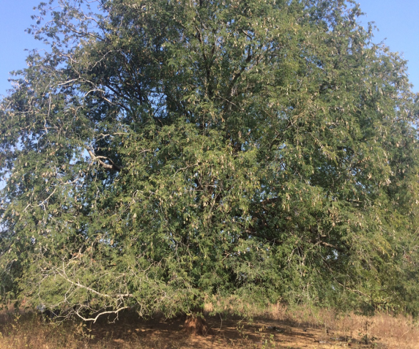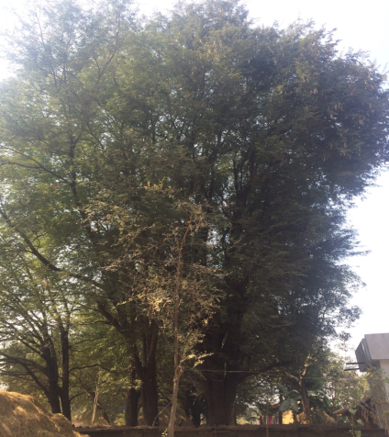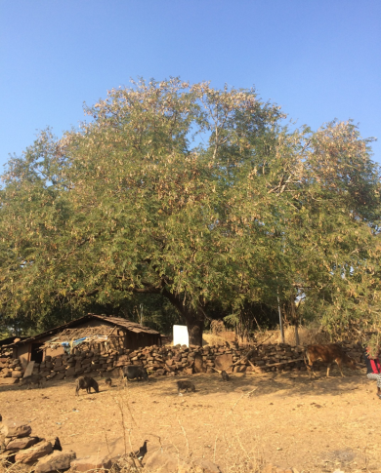

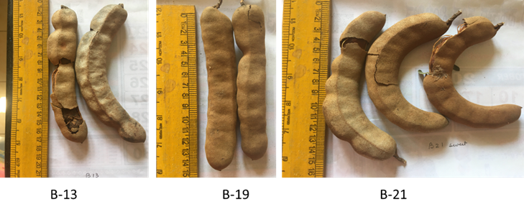

Supplementary Fig 1: Elite genotype trees with pods from left to right B15, B26, and B21