**Table S1**  Mean values and their respective standard errors for agro-morphological and biochemical characters of colchiploid genotypes of *Stevia rebaudiana* Bertoni *cv*. CIM-Mithi

|  |  |  |  |  |  |  |  |  |  |  |  |
| --- | --- | --- | --- | --- | --- | --- | --- | --- | --- | --- | --- |
| Genotype | Ploidy Level | Plant height (cm) | No. of branches per plant | Internodal length (cm) | Leaf thickness (mm) | Leaf | Leaf fresh weight per plant(g) | Fresh weight of stem per plant (g) | Leaf dry weight per plant (g) | Rebaudioside A (%) | Stevioside (%) |
| area (cm2) |
| ST ­­1 | 2n = 3x = 33 | 46.90 ± 1.08b-d | 23.00 ± 5.13a-d | 3.00 ± 0.11a-c | 0.28 ± 0.00b-f | 52.35 ± 12.34c-e | 50.33 ± 8.41a-c | 53.00 ± 15.39a-c | 15.67 ± 1.85cd | 0.80 ± 0.001d | 12.32 ± 0.138a |
| ST 2 | 2n = 4x = 44 | 52.33 ± 1.20bc | 16.67 ± 1.85b-e | 1.50 ± 0.17c | 0.33 ± 0.01a-e | 50.31 ± 5.66c-e | 62.67 ± 2.40a-c | 43.67 ± 6.76a-d | 16.67 ± 1.20cd | 0.82 ± 0.006d | 11.85 ± 0.012b |
| ST 6 | 2n = 4x = 44 | 53.00 ± 1.73bc | 22.67 ± 6.76a-e | 2.83 ± 0.44a-c | 0.28 ± 0.00b-f | 59.58 ± 5.66b-e | 34.67 ± 7.26bc | 18.33 ± 0.88cd | 6.00 ± 0.577de | 8.32 ± 0.015a | 7.10 ± 0.058j |
| ST 9 | 2n = 4x = 44 | 55.00 ± 7.63b | 29.00 ± 8.38a-c | 2.40 ± 0.87a-c | 0.41 ± 0.02ab | 81.50 ± 7.69a-d | 53.67 ± 18.40a-c | 70.00 ± 24.06a | 17.33 ± 6.83cd | 0.83 ± 0.006d | 11.06 ± 0.009e |
| ST 10 | 2n = 4x = 44 | 51.33 ± 0.66bc | 20.67 ± 1.33b-e | 2.33 ± 0.08a-c | 0.40 ± 0.00a-c | 66.66 ± 13.18a-e | 65.67 ± 7.83ab | 32.33 ± 7.62a-d | 16.00 ± 1.52cd | 0.98 ± 0.006c | 12.27 ± 0.007a |
| ST 11 | 2n = 4x = 44 | 53.00 ± 0.57bc | 11.67 ± 0.33c-e | 2.30 ± 0.05a-c | 0.37 ± 0.00a-e | 88.25 ± 9.47a-c | 66.74 ± 0.81ab | 23.85 ± 0.22b-d | 22.41 ± 1.24bc | 0.61 ± 0.007f | 12.46 ± 0.019a |
| UK 3 | 2n = 4x = 44 | 42.33 ± 1.33cd | 22.33 ± 5.23a-e | 2.00 ± 0.00bc | 0.35 ± 0.02a-e | 72.78 ± 15.37a-e | 56.00 ± 18.14ab | 31.67 ± 7.35a-d | 13.67 ± 4.05c-e | 0.46 ± 0.006h | 11.37 ± 0.006d |
| UK 4 | 2n = 4x = 44 | 55.00 ± 0.57b | 24.00 ± 2.88a-d | 2.90 ± 0.00a-c | 0.25 ± 0.00d-f | 102.69 ± 7.95a | 58.00 ± 3.46ab | 63.37 ± 0.37ab | 14.50 ± 0.86c-e | 0.38 ± 0.003j | 11.60 ± 0.058c |
| UK 61 | 2n = 4x = 44 | 36.33 ± 2.02d | 3.33 ± 1.85e | 2.00 ± 0.57bc | 0.26 ± 0.01c-f | 70.50 ± 4.40a-e | 13.67 ± 3.48c | 7.33 ± 0.88e | 3.00 ± 1.52e | 0.40 ± 0.001ij | 10.57 ± 0.009fg |
| UK 63 | 2n = 4x = 44 | 68.00 ± 0.57a | 32.00 ± 0.57ab | 3.90 ± 0.05a-c | 0.24 ± 0.01ef | 42.38 ± 0.44a | 85.14 ± 0.58a | 29.78 ± 1.22a-d | 34.81 ± 1.81a-c | 0.56 ± 0.007g | 11.27 ± 0.006de |
| UK 65 | 2n = 4x = 44 | 73.15 ± 0.64a | 10.11 ± 0.61c-e | 3.00 ± 0.06a-c | 0.25 ± 0.01d-f | 75.76 ± 1.08a-e | 80.52 ± 3.27a | 25.16 ± 0.59b-d | 35.88 ± 0.88a | 0.66 ± 0.003e | 9.15 ± 0.006h |
| UK 68 | 2n = 4x = 44 | 50.71 ± 0.91bc | 41.67 ± 0.88a | 2.63 ± 0.08a-c | 0.45 ± 0.01a | 55.71 ± 0.39de | 56.43 ± 1.24ab | 25.15 ± 0.64b-d | 15.14 ± 0.63c-e | 0.41 ± 0.006i | 10.74 ± 0.006f |
| UK 69 | 2n = 4x = 44 | 45.51 ± 0.36b-d | 22.76 ± 0.92a-e | 3.13 ± 0.06a-c | 0.28 ± 0.00b-f | 57.53 ± 0.35a-e | 47.82 ± 0.29a-c | 57.78 ± 0.82a-c | 12.13 ± 0.64c-e | 0.39 ± 0.003ij | 10.45 ± 0.017g |
| UK 70 | 2n = 4x = 44 | 44.00 ± 1.00b-d | 7.33 ± 2.40de | 2.10 ± 0.37bc | 0.39 ± 0.09a-e | 99.06 ± 3.90c-e | 27.00 ± 0.57bc | 15.67 ± 1.76cd | 6.00 ± 0.57de | 0.27 ± 0.003k | 8.54 ± 0.013i |
| Control | 2n = 2x = 22 | 52.58 ± 0.32bc | 16.42 ± 0.09b-e | 3.28 ± 0.02ab | 0.16 ± 0.00f | 38.92 ± 0.32a-b | 52.19 ± 0.02a-c | 25.25 ± 0.03b-d | 17.27 ± 0.03cd | 5.02 ± 0.006b | 5.36 ± 0.012k |

**Note:** a. Mean Values (Mean ± SE) and Significance Based on Tukey's Honestly Significant Difference (HSD) Test

b. Different lowercase letters for each genotype and parameter indicate significant differences at *P* ≤ 0.01

c. Means sharing the same letter are not significantly different



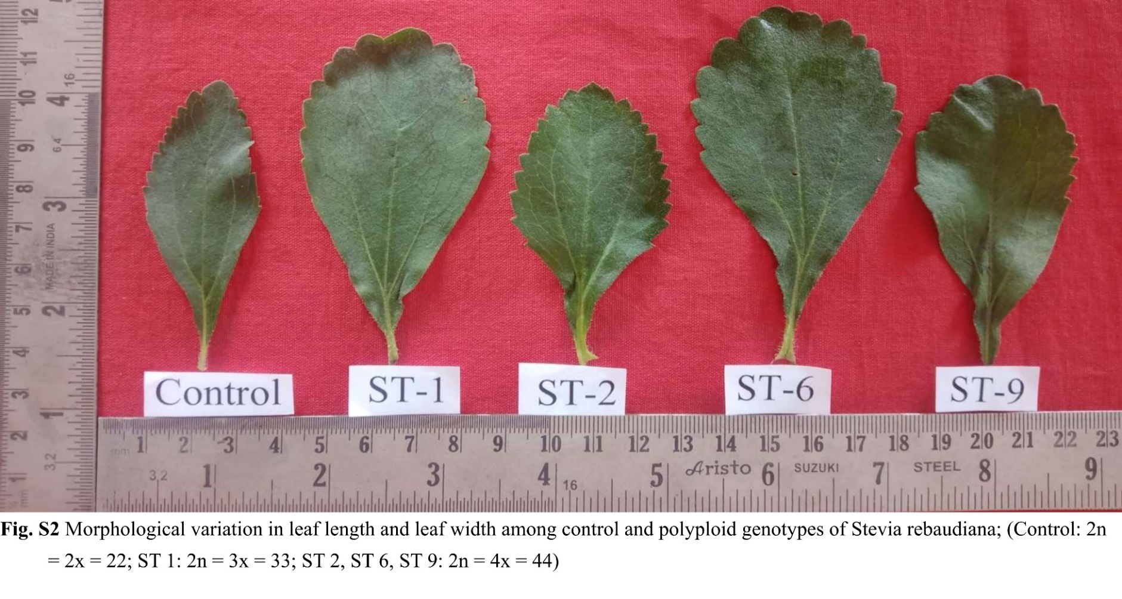



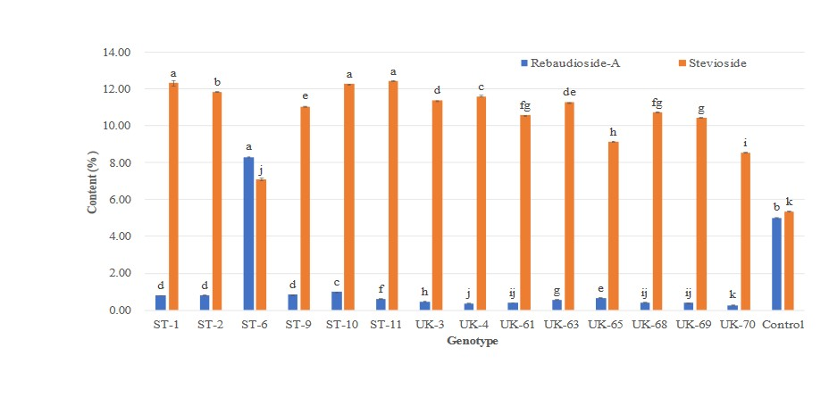

**Fig. S4** Rebaudioside A and Stevioside content in polyploidy genotypes and bars represents mean ± SE(standard error at *P* ≤ 0.05).