**Table S1: Details of wild rice accessions used in the study**

| **S.No.** | **Accessions** | **Species** | **S.No.** | **Accessions** | **Species** |
| --- | --- | --- | --- | --- | --- |
| 1 | IC581955 | *O. nivara* | 44 | IC582074 | *O. rufipogon* |
| 2 | IC581951 | *O. rufipogon* | 45 | IC582075 | *O. rufipogon* |
| 3 | IC581952 | *O. nivara* | 46 | IC582076 | *O. rufipogon* |
| 4 | IC521660 | *O. nivara* | 47 | IC591113 | *O. rufipogon* |
| 5 | IC521663 | *O. nivara* | 48 | IC521888 | *O. rufipogon* |
| 6 | IC521668 | *O. nivara* | 49 | IC582077 | *O. rufipogon* |
| 7 | IC521671 | *O. nivara* | 50 | IC582078 | *O. rufipogon* |
| 8 | IC521672 | *O. nivara* | 51 | IC582080 | *O. rufipogon* |
| 9 | IC521674 | *O. nivara* | 52 | IC582081 | *O. rufipogon* |
| 10 | IC598063 | *O. nivara* | 53 | IC582082 | *O. rufipogon* |
| 11 | IC581955 | *O. rufipogon* | 54 | IC582083 | *O. rufipogon* |
| 12 | IC521780 | *O. rufipogon* | 55 | IC582084 | *O. rufipogon* |
| 13 | IC521719 | *O. rufipogon* | 56 | EC861684 | *O. rufipogon* |
| 14 | IC521720 | *O. rufipogon* | 57 | EC861685 | *O. rufipogon* |
| 15 | IC581956 | *O. rufipogon* | 58 | EC861686 | *O. rufipogon* |
| 16 | IC521727 | *O. rufipogon* | 59 | EC861687 | *O. rufipogon* |
| 17 | IC521741 | *O. rufipogon* | 60 | EC861688 | *O. rufipogon* |
| 18 | IC521745 | *O. rufipogon* | 61 | EC861690 | *O. rufipogon* |
| 19 | IC581959 | *O. rufipogon* | 62 | EC861691 | *O. rufipogon* |
| 20 | IC582001 | *O. rufipogon* | 63 | EC861692 | *O. rufipogon* |
| 21 | EC861665 | *O. officinalis* | 64 | EC861694 | *O. rufipogon* |
| 22 | EC861666 | *O. officinalis* | 65 | IC521891 | *O. rufipogon* |
| 23 | EC861667 | *O. officinalis* | 66 | IC582125 | *O. rufipogon* |
| 24 | EC861668 | *O. officinalis* | 67 | IC521892 | *O. rufipogon* |
| 25 | EC861670 | *O. rufipogon* | 68 | EC861695 | *O. rufipogon* |
| 26 | EC861671 | *O. rufipogon* | 69 | EC861696 | *O. rufipogon* |
| 27 | EC861672 | *O. rufipogon* | 70 | EC861698 | *O. rufipogon* |
| 28 | EC861673 | *O. rufipogon* | 71 | EC861700 | *O. rufipogon* |
| 29 | EC861674 | *O. rufipogon* | 72 | EC861701 | *O. rufipogon* |
| 30 | EC861675 | *O. rufipogon* | 73 | EC861702 | *O. rufipogon* |
| 31 | EC861676 | *O. rufipogon* | 74 | EC861704 | *O. rufipogon* |
| 32 | EC861677 | *O. latifolia* | 75 | EC861705 | *O. rufipogon* |
| 33 | EC861678 | *O. latifolia* | 76 | EC861706 | *O. rufipogon* |
| 34 | EC861683 | *O. rufipogon* | 77 | EC861710 | *O. minuta* |
| 35 | EC861684 | *O. rufipogon* | 78 | EC861711 | *O. punctata* |
| 36 | EC861685 | *O. eichingeri* | 79 | EC861715 | *O. rhizomatis* |
| 37 | EC861686 | *O. eichingeri* | 80 | EC861714 | *O. longistaminata* |
| 38 | IC582067 | *O. punctata* | 81 | EC861716 | *O. barthii* |
| 39 | IC582068 | *O. rufipogon* | 82 | EC861719 | *O. australiensis* |
| 40 | IC582069 | *O. rufipogon* | 83 | EC861720 | *O. australiensis* |
| 41 | IC582071 | *O. rufipogon* | 84 | EC861721 | *O. australiensis* |
| 42 | IC582072 | *O. rufipogon* | 85 | EC861727 | *O. punctata* |
| 43 | IC582073 | *O. rufipogon* | 86 | EC861728 | *O. punctata* |
| 87 | EC861729 | *O. punctata* | 103 | EC861762 | *O. rhizomatis* |
| 88 | EC861737 | *O. minuta* | 104 | EC861763 | *O. longistaminata* |
| 89 | EC861738 | *O. eichingeri* | 105 | EC861766 | *O. barthii* |
| 90 | EC861739 | *O. latifolia* | 106 | EC861767 | *O. glumaepetula* |
| 91 | EC861740 | *O. latifolia* | 107 | EC861769 | *O. grandiglumis* |
| 92 | EC86174 | *O. alta* | 108 | EC861771 | *O. grandiglumis* |
| 93 | IC386941 | *O. australiensis* | 109 | EC861772 | *O. grandiglumis* |
| 94 | EC861748 | *O. alta* | 110 | EC861777 | *O. meridionalis* |
| 95 | EC861749 | *O. alta* | 111 | EC861778 | *O. ridleyi* |
| 96 | EC861755 | *O. longiglumis* | 112 | TRP232 | *O. rufipogon* |
| 97 | EC861756 | *O. australiensis* | 113 | BPT5204 | *O. sativa* |
| 98 | EC861750 | *O. alta* | 114 | ISM | *O. sativa* |
| 99 | EC861757 | *O. grandiglumis* | 115 | IR-64 | *O. sativa* |
| 100 | EC861759 | *O. rhizomatis* | 116 | PR114 | *O. sativa* |
| 101 | EC861760 | *O. rhizomatis* | 117 | FBR-15 | *O. sativa* |
| 102 | EC861761 | *O. rhizomatis* | 118 | IRBB-23 | *O. sativa* |
|  |  |  | 119 | IRBB-27 | *O. sativa* |

**Table S2: Mean lesion length caused by *Xoo* strain IX-020 on 113 rice accessions of different species**

| **S.No.** | **Accessions** | **14 days after inoculation** | | | | **21 days after inoculation** | | |
| --- | --- | --- | --- | --- | --- | --- | --- | --- |
| ***kharif* 2020** | ***rabi* 2020-21** | ***kharif* 2021** | **Mean** | ***rabi* 2020-21** | ***kharif* 2021** | **Mean** |
| 1 | IC581955 | 4.6 | 3.9 | 3.72 | 4.07 | 5.34 | 4.4 | 4.87 |
| 2 | IC581951 | 9.7 | 2.52 | 0.9 | 4.37 | 10.18 | 6.62 | 8.4 |
| 3 | IC581952 | 6.42 | - | 0.3 | 3.36 | - | 6.06 | 6.06 |
| 4 | IC521660 | 1 | 1.08 | 2.88 | 1.65 | 5.14 | 4.24 | 4.69 |
| 5 | IC521663 | 2.3 | 0.46 | 3.28 | 2.01 | 5.62 | 4.04 | 4.83 |
| 6 | IC521668 | 1.85 | 1.12 | 1.34 | 1.44 | 2.86 | 1.1 | 1.98 |
| 7 | IC521671 | - | 1.5 | 2.36 | 1.93 | 4.66 | 3.8 | 4.23 |
| 8 | IC521672 | 0.9 | 0.8 | 0.84 | 0.85 | 1.92 | 1.6 | 1.76 |
| 9 | IC521674 | 2.8 | 0.34 | 2.6 | 1.91 | 4.72 | 4.56 | 4.64 |
| 10 | IC598063 | - | 2.64 | 2.7 | 2.67 | 5.5 | 4.98 | 5.24 |
| 11 | IC581955 | 0.65 | 0.28 | 3.3 | 1.41 | 5.06 | 5.3 | 5.18 |
| 12 | IC521780 | - | 0.9 | 1.2 | 1.05 | 1.84 | 1.38 | 1.61 |
| 13 | IC521719 | - | 7.5 | 3.08 | 5.29 | 13.5 | 3.66 | 8.58 |
| 14 | IC521720 | - | 0.68 | 1.52 | 1.1 | 1.88 | 2.46 | 2.17 |
| 15 | IC581956 | - | 1.8 | 6.74 | 4.27 | 7.3 | 7.6 | 7.45 |
| 16 | IC521727 | 1.33 | 0.98 | 2.62 | 1.64 | 5.04 | 4.5 | 4.77 |
| 17 | IC521741 | - | 3.36 | 1.96 | 2.66 | 6.04 | 4.58 | 5.31 |
| 18 | IC521745 | 3 | 3.18 | 2.62 | 2.93 | 4.34 | 3.78 | 4.06 |
| 19 | IC581959 | 3.63 | 0.9 | 2.02 | 2.18 | 5.44 | 5.04 | 5.24 |
| 20 | IC582001 | 3.25 | 0.44 | 1.96 | 1.88 | 4.68 | 5.06 | 4.87 |
| 21 | EC861665 | 1.08 | 0.98 | 1.12 | 1.06 | 2.82 | 1.16 | 1.99 |
| 22 | EC861666 | 0.76 | 0.84 | 2.3 | 1.3 | 5.58 | 5.64 | 5.61 |
| 23 | EC861667 | 1 | 0.38 | 0.26 | 0.55 | 1.28 | 0.8 | 1.04 |
| 24 | EC861668 | 2.04 | 0.34 | 2.16 | 1.51 | 1.06 | 1.74 | 1.4 |
| 25 | EC861670 | 0.62 | 0.46 | 0.8 | 0.63 | 2.54 | 1.6 | 2.07 |
| 26 | EC861671 | 2.02 | 0.48 | 1.86 | 1.45 | 1.9 | 3.04 | 2.47 |
| 27 | EC861672 | 2.62 | 0.7 | 1.54 | 1.62 | 2.28 | 1.84 | 2.06 |
| 28 | EC861673 | 1.22 | 0.6 | 0.96 | 0.93 | 2 | 1.12 | 1.56 |
| 29 | EC861674 | 0.94 | 0.62 | 2.48 | 1.35 | 5.26 | 5.8 | 5.53 |
| 30 | EC861675 | 1.22 | 0.86 | 1.14 | 1.07 | 1.48 | 1.96 | 1.72 |
| 31 | EC861676 | 3.14 | 0.82 | 2.6 | 2.19 | 4.64 | 5.72 | 5.18 |
| 32 | EC861677 | 1.82 | 0.58 | 1.56 | 1.32 | 1.1 | 1.86 | 1.48 |
| 33 | EC861678 | 2.2 | 0.44 | 1.3 | 1.31 | 1.22 | 1.52 | 1.37 |
| 34 | EC861683 | 1.36 | 0.46 | 4.4 | 2.07 | 6 | 8.66 | 7.33 |
| 35 | EC861684 | 1 | 1.08 | 2.02 | 1.37 | - | 1.9 | 1.9 |
| 36 | EC861685 | 1 | 0.54 | 1.24 | 0.93 | 1.18 | 1.78 | 1.48 |
| 37 | EC861686 | 0.5 | 1.62 | 0.8 | 0.97 | - | 2.38 | 2.38 |
| 38 | IC582067 | 1.5 | 1.9 | 2.32 | 1.91 | 4.92 | 5.36 | 5.14 |
| 39 | IC582068 | 0.94 | 0.5 | 1.46 | 0.97 | 2.04 | 2.08 | 2.06 |
| 40 | IC582069 | 0.84 | 1.58 | 1.38 | 1.27 | 5.42 | 2.14 | 3.78 |
| 41 | IC582071 | 0.48 | - | 2.04 | 1.26 | - | 5.98 | 5.98 |
| 42 | IC582072 | 1.42 | 1.5 | 1.22 | 1.38 | 2.56 | 3.08 | 2.82 |
| 43 | IC582073 | 0.43 | 1.82 | 2.72 | 1.66 | 4.6 | 4.94 | 4.77 |
| 44 | IC582074 | 0.84 | 1.56 | 2.3 | 1.57 | 5.06 | 5.22 | 5.14 |
| 45 | IC582075 | 0.3 | 1.14 | 1.76 | 1.07 | 5.84 | 4.28 | 5.06 |
| 46 | IC582076 | 0.98 | - | 2.62 | 1.8 | - | 5.08 | 5.08 |
| 47 | IC591113 | 1.22 | 3.38 | 0.78 | 1.79 | 1.68 | 1.7 | 1.69 |
| 48 | IC521888 | 0.44 | 0.64 | 1.32 | 0.8 | - | 0.98 | 0.98 |
| 49 | IC582077 | 0.27 | 0.48 | 1.94 | 0.9 | 5.12 | 6.34 | 5.73 |
| 50 | IC582078 | 2.04 | 1.04 | 3.24 | 2.11 | 5.3 | 4.42 | 4.86 |
| 51 | IC582080 | 2.6 | 0.66 | 0.82 | 1.36 | 2.9 | 2.68 | 2.79 |
| 52 | IC582081 | 0.7 | 0.5 | 1.52 | 0.91 | 2.52 | 2.38 | 2.45 |
| 53 | IC582082 | 2.3 | 0.44 | 1.34 | 1.36 | 1.7 | 3.4 | 2.55 |
| 54 | IC582083 | 0.88 | 0.58 | 1.12 | 0.86 | 2.88 | 3.8 | 3.34 |
| 55 | IC582084 | - | 0.9 | 2.1 | 1.5 | 5.66 | 3.64 | 4.65 |
| 56 | EC861684 | 2.04 | 1.06 | 0.72 | 1.27 | 1.72 | 1.36 | 1.54 |
| 57 | EC861685 | - | 2.96 | 1.42 | 2.19 | 4.68 | 4.14 | 4.41 |
| 58 | EC861686 | - | 2.5 | 1.48 | 1.99 | 6.36 | 3.58 | 4.97 |
| 59 | EC861687 | - | 1.44 | 2.36 | 1.9 | 4.82 | 3.54 | 4.18 |
| 60 | EC861688 | 4.76 | 0.14 | 2.18 | 2.36 | 5.36 | 4.08 | 4.72 |
| 61 | EC861690 | - | 3.52 | 1.74 | 2.63 | 5.32 | 4.3 | 4.81 |
| 62 | EC861691 | 0.66 | 1.32 | 2.26 | 1.41 | 5.6 | 5.32 | 5.46 |
| 63 | EC861692 | 2.06 | 0.98 | 1.02 | 1.35 | 1.48 | 1.76 | 1.62 |
| 64 | EC861694 | 1.33 | 4.02 | 1.52 | 2.29 | 6.4 | 5.46 | 5.93 |
| 65 | IC521891 | 0.4 | 3.04 | 2.86 | 2.1 | 4.22 | 4.62 | 4.42 |
| 66 | IC582125 | 3.12 | 2.8 | 2.48 | 2.8 | 4.68 | 3.48 | 4.08 |
| 67 | IC521892 | 0.67 | 3.6 | 4.18 | 2.82 | 5.5 | 5.62 | 5.56 |
| 68 | EC861695 | 0.93 | 1.68 | 2.82 | 1.81 | 7.2 | 3.62 | 5.41 |
| 69 | EC861696 | 0.7 | 5.26 | 3.1 | 3.02 | 7.74 | 3.26 | 5.5 |
| 70 | EC861698 | 0.96 | 0.92 | 2.2 | 1.36 | 5.34 | 5.62 | 5.48 |
| 71 | EC861700 | 1.8 | 0.76 | 1.58 | 1.38 | 1.34 | 1.78 | 1.56 |
| 72 | EC861701 | - | 2.26 | 2.16 | 2.21 | 4.18 | 4.8 | 4.49 |
| 73 | EC861702 | - | 5.1 | 1.38 | 3.24 | 12.4 | 2.22 | 7.31 |
| 74 | EC861704 | 0.8 | 0.34 | 0.88 | 0.67 | - | 1.22 | 1.22 |
| 75 | EC861705 | 5.17 | 4.9 | 3.9 | 4.66 | 6.32 | 4.78 | 5.55 |
| 76 | EC861706 | - | 0.32 | 2.12 | 1.22 | 4.56 | 5.32 | 4.94 |
| 77 | EC861710 | 1.1 | 0.92 | 2.46 | 1.49 | 5.76 | 4.78 | 5.27 |
| 78 | EC861711 | 3.6 | 1.02 | 2.54 | 2.39 | 1.88 | 2.06 | 1.97 |
| 79 | EC861715 | 1.43 | 1.96 | 1.04 | 1.48 | 1.62 | 1.14 | 1.38 |
| 80 | EC861714 | 2.94 | 1.2 | 1.9 | 2.01 | 4.42 | 4.78 | 4.6 |
| 81 | EC861716 | 1.2 | 5.18 | 2.2 | 2.86 | 6.82 | 4.3 | 5.56 |
| 82 | EC861719 | 3.75 | 0.98 | 0.76 | 1.83 | 9 | 2.06 | 5.53 |
| 83 | EC861720 | 3.9 | 0.2 | 0.86 | 1.65 | 2.28 | 1.46 | 1.87 |
| 84 | EC861721 | 0.45 | 3 | 2.38 | 1.94 | 5.88 | 3.84 | 4.86 |
| 85 | EC861727 | 2.4 | 0.78 | 0.58 | 1.25 | 8.22 | 9.08 | 8.65 |
| 86 | EC861728 | 1.3 | 0.38 | 2.56 | 1.41 | 5.44 | 5.4 | 5.42 |
| 87 | EC861729 | 1.5 | 0.5 | 0.26 | 0.75 | 3.12 | 0.9 | 2.01 |
| 88 | EC861737 | 0.88 | 0.4 | 1.3 | 0.86 | 1.8 | 0.82 | 1.31 |
| 89 | EC861738 | 0.58 | 0.66 | 1.3 | 0.85 | 1.46 | 1.56 | 1.51 |
| 90 | EC861739 | 2.4 | 0.7 | 3.46 | 2.19 | 3.3 | 5.48 | 4.39 |
| 91 | EC861740 | 1.23 | 1.36 | 3.3 | 1.96 | 4.3 | 4.08 | 4.19 |
| 92 | EC86174 | 1.2 | 0.54 | 3.84 | 1.86 | 3.96 | 5.82 | 4.89 |
| 93 | IC386941 | 0.5 | 0.88 | 0.98 | 0.79 | 2 | 1.2 | 1.6 |
| 94 | EC861748 | 1 | 0.32 | 1.4 | 0.91 | 1.16 | 2.32 | 1.74 |
| 95 | EC861749 | 3 | 6.06 | 1.4 | 3.49 | 10.76 | 2.2 | 6.48 |
| 96 | EC861755 | 4.5 | 0.38 | 1.9 | 2.26 | 6.1 | 3.58 | 4.84 |
| 97 | EC861756 | 4.1 | 0.32 | 1.16 | 1.86 | 2 | 2.44 | 2.22 |
| 98 | EC861750 | - | 3.64 | 1.9 | 2.77 | 7.9 | 4.08 | 5.99 |
| 99 | EC861757 | - | - | 0.88 | 0.88 | - | 1.64 | 1.64 |
| 100 | EC861759 | 0.8 | 0.88 | 2.9 | 1.53 | 4.44 | 6.02 | 5.23 |
| 101 | EC861760 | 7 | 1.58 | 1.48 | 3.35 | 3.3 | 3.42 | 3.36 |
| 102 | EC861761 | 2.83 | 1.54 | 5.2 | 3.19 | 9.2 | 5.6 | 7.4 |
| 103 | EC861762 | 1.67 | 1.22 | 3.06 | 1.98 | 11.8 | 8.46 | 10.13 |
| 104 | EC861763 | 2 | 0.42 | 2.06 | 1.49 | 4.9 | 5.22 | 5.06 |
| 105 | EC861766 | 4.5 | 1.86 | 1.4 | 2.59 | 5.34 | 3.76 | 4.55 |
| 106 | EC861767 | 2.33 | 4.1 | 4.28 | 3.57 | 6.8 | 2.88 | 4.84 |
| 107 | EC861769 | - | 2.36 | 1.96 | 2.16 | 3.48 | 4.34 | 3.91 |
| 108 | EC861771 | 5.33 | 5.46 | 1.5 | 4.1 | - | 3.22 | 3.22 |
| 109 | EC861772 | 3.5 | 0.82 | 1.7 | 2.01 | 4.64 | 4.64 | 4.64 |
| 110 | EC861777 | 1.6 | 1.06 | 1.88 | 1.51 | 5.92 | 4.58 | 5.25 |
| 111 | EC861778 | 2 | 1.72 | 3.02 | 2.25 | 5.8 | 4.1 | 4.95 |
| 112 | TRP232 | 0.93 | 0.26 | 1.12 | 0.77 | 1.9 | 1.54 | 1.72 |
| 113 | BPT-5204 | 9.46 | 10.8 | 9.78 | 10.01 | 16.92 | 8.68 | 12.8 |
|  | **Mean** | 2.21 | 1.84 | 2.52 | - | 4.80 | 4.47 | - |
|  | **SD** | 1.92 | 1.61 | 1.36 | - | 2.34 | 1.68 | - |
|  | **SE** | 0.20 | 0.16 | 0.13 | - | 0.24 | 0.18 | - |

Note: “ -” not inoculated

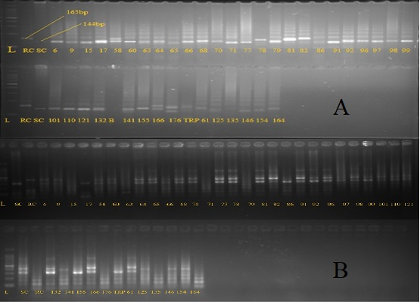

**Figure S1 (A, B): Genotyping of BB resistant accessions for the presence of *Xa4* & *xa5***

A) *Xa4* gene using RM224 marker; L= 100bp ladder; RC= IR64 (Resistant Check); SC= Samba Mahsuri (Susceptible Check); 6-16 = wild accessions

B) *xa*5 gene using xa5FM marker; L = 100bp ladder; RC= ISM (Resistant Check); SC= Samba Mahsuri (Susceptible Check); 6-164= wild accessions

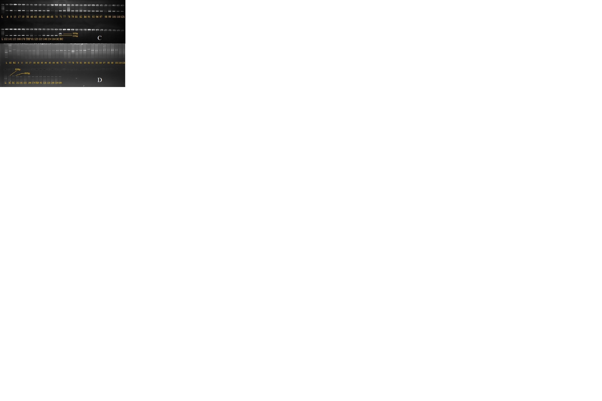

**Figure S1 (C, D): Genotyping of BB resistant accessions for the presence of *Xa13* & *Xa21***

C) *xa13* gene using xa13 promoter marker; L= 100bp ladder; RC= ISM (Resistant Check); SC= Samba Mahsuri (Susceptible Check); 6-164= wild accessions

D) *Xa21* gene using pTA248 marker; L= 100bp ladder; RC= ISM (Resistant Check); SC= Samba Mahsuri (Susceptible Check); 6-164= wild accessions

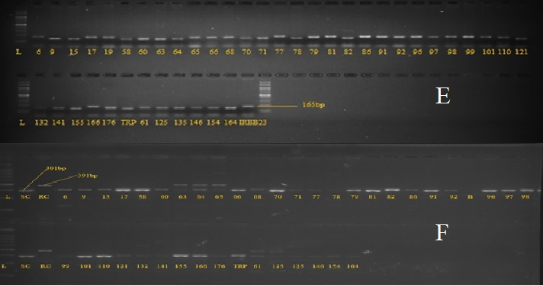

**Figure S1 (E, F): Genotyping of BB resistant accessions for the presence of *Xa23* & *Xa27(t)***

E) *Xa23* gene using RM254 marker; L= 100bp ladder; RC= IRBB-23 (Resistant Check); SC= Samba Mahsuri (Susceptible Check); 6-164= wild accessions

F) *Xa27(t)* gene using BDTG-19 marker; L= 100bp ladder; RC= IRBB27 (Resistant Check); SC= Samba Mahsuri (Susceptible Check); 6-164= wild accessions

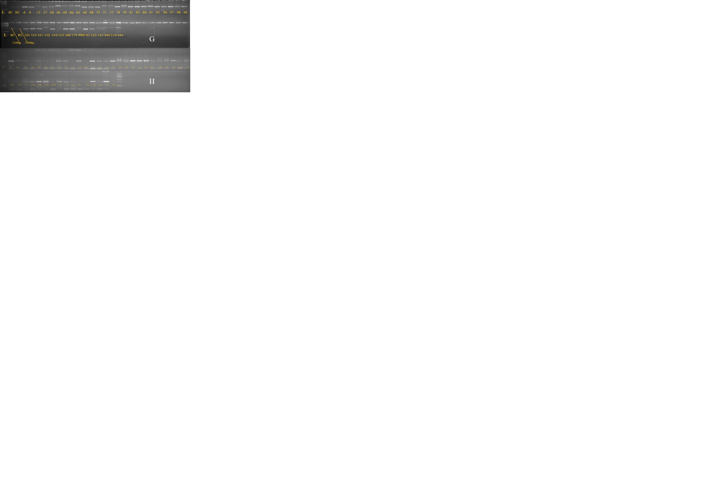

**Figure S1 (G, H): Genotyping of BB resistant accessions for the presence of *Xa33* & *Xa35(t)***

G) *Xa33* gene using RMWR7.6 marker; L= 100bp ladder; RC= FBR1-15 (Resistant Check); SC= Samba Mahsuri (Susceptible Check); 6-164= wild accessions

H) *Xa35(t)* gene using RM144 marker; L= 100bp ladder; SC= Samba Mahsuri (Susceptible Check); 6-164= wild accessions

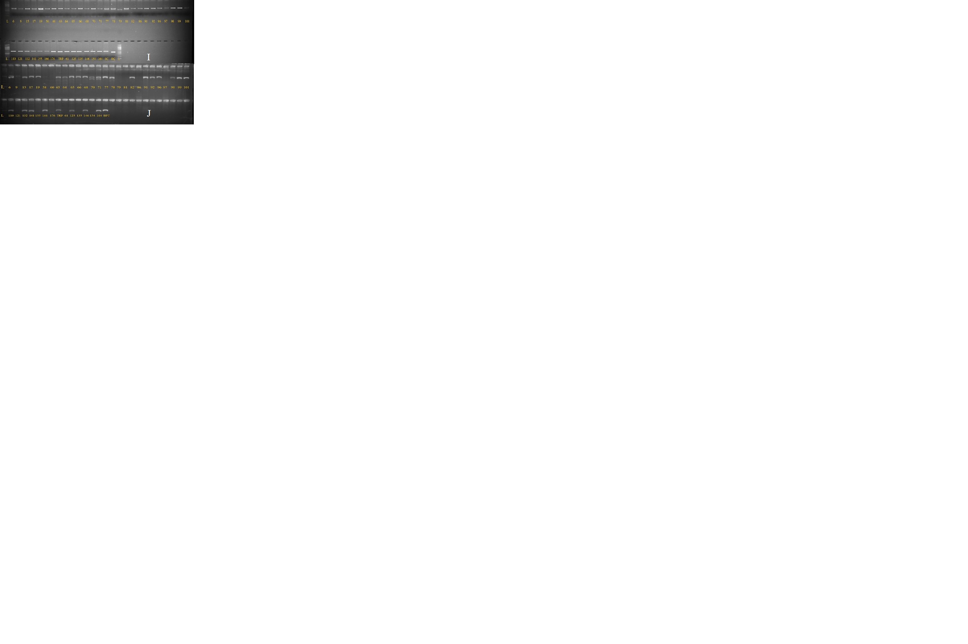

**Figure S1 (I, J): Genotyping of BB resistant accessions for the presence of *Xa38* & *xa41***

I) *Xa38* gene using Oso4g53050-1 marker; L= 100bp ladder; RC= PR-114 (Resistant Check); SC= Samba Mahsuri (Susceptible Check); 6-164= wild accessions

J) *xa41* gene using OSweet-14 marker; L= 100bp ladder; SC= Samba Mahsuri (Susceptible Check); 6-164= wild accessions