Table S1 List of ISSR primers used and their sequences
Sl no: | Primer Name | Sequence | Annealing Temperature
1 | IS 02 | GAGAGAGAGAGAGAGAGAC | 52.9℃
2 | IS 10 | BDBTCCTCCTCCTCCTCCTCCT | 56.6℃
3 | IS 11 | HVHTCCTCCTCCTCCTCCTCC | 59℃
4 | ISSR 01 | CACACACACACACAA | 45℃
5 | ISSR 02 | AGTGAGTGAGTG | 43.7℃
6 | ISSR 03 | GACAGACAGACAGACA | 45℃
7 | ISSR 04 | ACACACACACACACACC | 50.4℃
8 | ISSR 05 | CTCTCTCTCTCTCTTG | 46.5℃
9 | ISSR 07 | GAGAGAGAGAGAGAGAG | 46.5℃
10 | ISSR 09 | CTCTCTCTCTCTCTCTG | 45℃
11 | ISSR 10 | ACACACACACACACACG | 50.4℃
12 | ISSR 12 | CACCACCACGC | 46.5℃
13 | ISSR 14 | AGCAGCAGCAGCGT | 51.7℃
14 | ISSR 15 | TCCTCCTCCTCCTCC | 51.7℃
15 | ISSR 16 | GAGAGAGAGAGAGAGAT | 43.9℃
16 | ISSR 17 | CACACACACACACACAG | 43.9℃
17 | AAG ₅CC | AAGAAGAAGAAGAAGCC | 45.5℃
18 | AAG ₅GC | AAGAAGAAGAAGAAGGC | 48.5℃
19 | UBC 807 | AGAGAGAGAGAGAGAGT | 45℃
20 | UBC 808 | AGAGAGAGAGAGAGAGC | 48℃
21 | UBC 810 | GAGAGAGAGAGAGAGAT | 43.7℃
22 | UBC 811 | GAGAGAGAGAGAGAGAC | 43.7℃
23 | UBC 812 | GAGAGAGAGAGAGAGAA | 43.7℃
24 | UBC 815 | CTCTCTCTCTCTCTCTG | 45℃
25 | UBC 826 | ACACACACACACACACC | 50.4℃
26 | UBC 829 | TGTGTGTGTGTGTGTGC | 50.4℃
27 | UBC 834 | AGAGAGAGAGAGAGAG | 51.7℃
28 | UBC 836 | AGAGAGAGAGAGAGAGYA | 49℃
29 | UBC 844 | CTCTCTCTCTCTCTCTRC | 46.5℃
30 | UBC 847 | CACACACACACACACARC | 49.7℃
31 | UBC 848 | CACACACACACACACARG | 49.7℃
32 | UBC 849 | TGTGTGTGTGTGTGTGYA | 47℃
33 | UBC 851 | GTGTGTGTGTGTGTGTYG | 52.7℃
34 | UBC 855 | ACACACACACACACACYT | 50.4℃
35 | UBC 859 | TGTGTGTGTGTGTGTGRG | 51.4℃

Table S2 Female flower, fruit, seed and mace characteristics of four varieties of nutmeg
 | IISR Viswashree | IISR Keralashree | Sindhushree | MN
Flower Characters
The shape of Female Flower | Shortly Elliptical | Ovate | Shortly Elliptical | Long Elliptical
Fruit characters
Length (cm) | 6 cm | 6.3 cm | 6 cm | 5.7 cm
Width (cm) | 4.8 cm | 4.4 cm | 5 cm | 4.6 cm
Shape | Elliptic | Shortly elongated | Ovate | Ovate
Presence of neck | Presence | Present | Absent | Present
Shape of ventral shoulder | Rounded downward | Sloping downward | Sloping downward | Rounded upward
Shape of dorsal shoulder | Rounded downward | Rounded downward | Sloping downward | Rounded downward
Presence of stylar scar | Present | Present | Present | Present
Shape of stylar scar | Rounded | Pointed | Pointed | Pointed
Seed and Mace characteristics
Mace Covering Pattern | Entire Reticulate | Entire Reticulate | Entire Reticulate | Entire Reticulate
Seed Shape | Rounded | Obovate | Elliptic | Trapezoid
Seed Color | Brownish black | Brownish black | Brownish black | Brownish black

Table S3 Essential oil, Oleoresin and Nutmeg butter content (%)

 | Plant part used | IISR Viswashree | IISR Keralashree | Sindhushree | MN
Essential oil | Nut | 11.00 | 10 .00 | 7 .00 | 11 .00
Essential oil | Mace | 10.00 | 11 .00 | 11.00 | 12 .00
Essential oil | Leaves | 1.72 | 1.12 | 0.92 | 1.76
Oleoresin | Nut | 14.90 | 19.10 | 14.19 | 16.49
Oleoresin | Mace | 18.05 | 24.67 | 18.49 | 21.79
Butter | Nut | 26.79 | 29.35 | 30.57 | 31.18

Table S4 DUS Fingerprints of four nutmeg varieties using 18 informative traits

Character | Status | Accessions/Varieties
Character | Status | IISR Viswashree | IISR Keralashree | Sindhushree | Monoecious  Nutmeg (MN)
Leaf blade length | Short (<10cm)
Leaf blade length | Medium  (10 -20 cm.)
Leaf blade length | Long  (>20 cm.)
Leaf blade width | Narrow  (< 4 cm.)
Leaf blade width | Medium  (4 -8 cm.)
Leaf blade width | Wide (>8 cm.
Leaf shape | Elliptic
Leaf shape | Oblong
Leaf shape | Ovate
Leaf margin | Entire
Leaf margin | Wavy
Shape of leaf apex | Shortly acuminate
Shape of leaf apex | Acuminate
Shape of leaf apex | Acute
Shape of leaf base | Obtuse
Shape of leaf base | Acute
Shape of female flower | Shortly elliptical
Shape of female flower | Long Elliptical
Shape of female flower | Ovate
Fruit length | Short  (< 50 mm.)
Fruit length | Medium (50-70) mm.)
Fruit length | Long  (> 70 mm.)
Fruit width | Short  (< 40 mm.)
Fruit width | Medium  (40-50 mm.)
Fruit width | Long  (> 50 mm)
Fruit shape | Elliptic
Fruit shape | Shortly elongated
Fruit shape | Ovate
Fruit shape | Circular
Presence of fruit neck | Present
Presence of fruit neck | Absent
Shape of ventral shoulder of fruit | Rounded downward
Shape of ventral shoulder of fruit | Rounded upward
Shape of ventral shoulder of fruit | Sloping downward
Shape of dorsal shoulder of fruit | Rounded downward
Shape of dorsal shoulder of fruit | Sloping downward
Presence of Stylar scar | Present
Presence of Stylar scar | Absent
Shape of stylar scar | Rounded
Shape of stylar scar | Pointed
Mace covering pattern | Entire reticulate
Mace covering pattern | Compact
Seed shape | Rounded
Seed shape | Obovate
Seed shape | Elliptic
Seed shape | Trapezoid
Seed colour | Black
Seed colour | Brownish black

Table S5 Result of polymorphic bands in nine ISSR primers
Sl.no | Primer | Unique bands |  |  | Name of variety
Sl.no | Primer | Band Presence | Band Absence | Unique bands | Name of variety
1 | IS 02 | 1 | - | IS-02₈₀₀ | Sindhushree
2 | ISSR 12 | 1 | - | ISSR-12₇₀₀ | Sindhushree
3 | ISSR 05 | 1 | - | ISSR-05₁₂₀₀ | Sindhushree
4 | ISSR 14 | 1 | - | ISSR-14₅₀₀ | IISR-Keralashree
5 | ISSR 14 | 1 | - | ISSR-14₉₀₀ | Sindhushree
6 | ISSR 01 | - | 0 |  | IISR-Keralashree
7 | ISSR 01 | 1 | - | ISSR-1₅₀₀ | MN
8 | UBC 834 | 1 | - | UBC 834 ₅₅₀ | Sindhushree

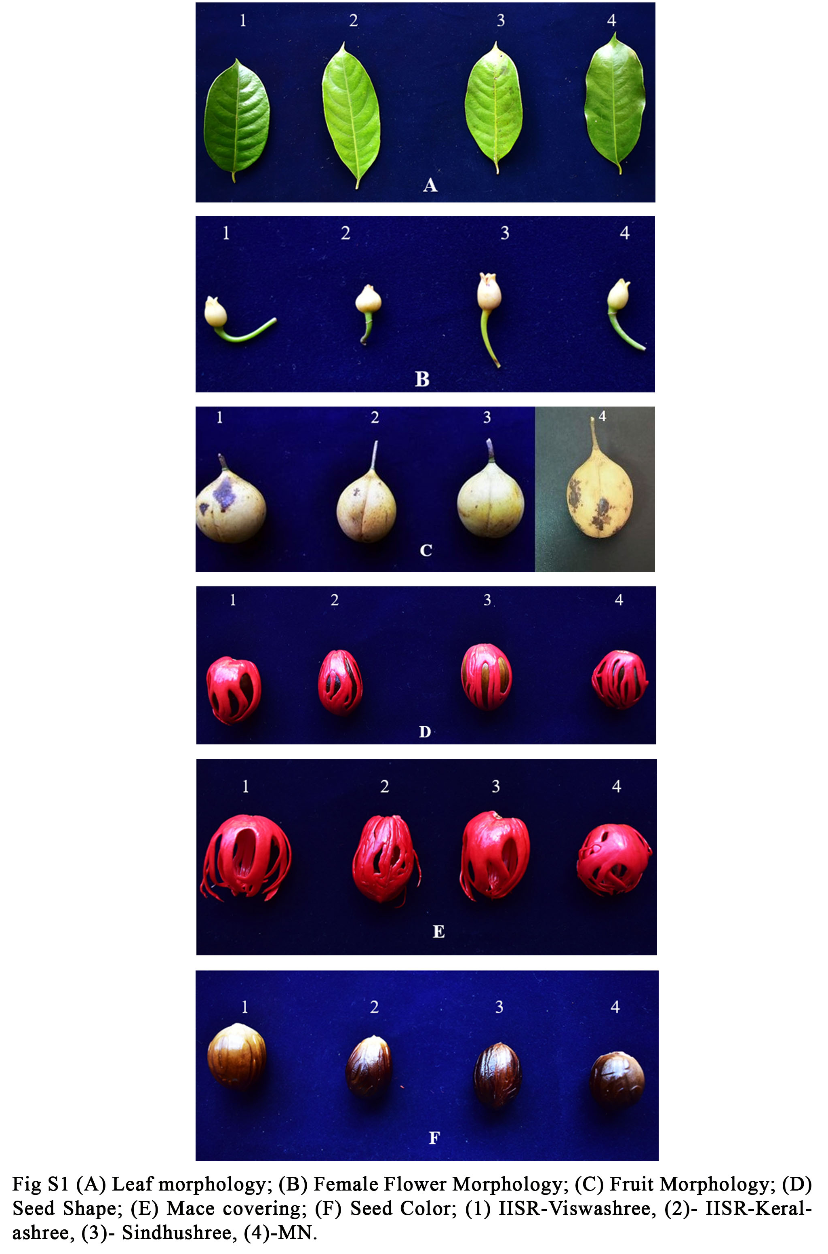

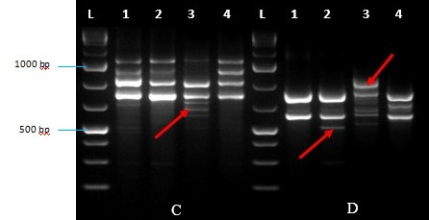
Fig.S2 Gel image depicting PCR amplification using primer ISSR 12 (C) and using primer ISSR 14 (D); L – Ladder (1 kb Plus) 1-IISR-Viswashree, 2-Keralashree, 3- Sindhushree 4-MN

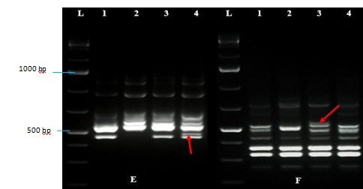

Fig.S3 Gel image depicting PCR amplification using primer ISSR 1 (E) and using primer UBC 834 (F); L – Ladder (1 kb Plus) 1-IISR-Viswashree, 2-IISR-Keralashree, 3- Sindhushree 4- MN.
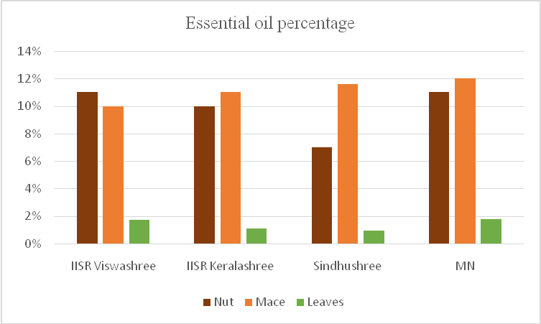

Fig.S4 Essential oil percentage in nutmeg varieties
4
4

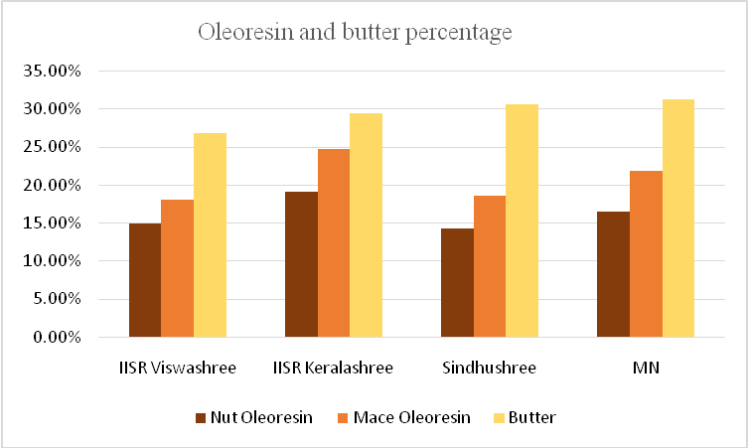
Fig.S5 Oleoresin and Butter percentage among nutmeg varieties

Biochemical Analysis Methods
Collection of samples
To estimate the essential oil, oleoresin and butter the following samples: fresh leaves, dried nut and mace of the four varieties were collected from ICAR-IISR Farm, Kozhikode and from a farmer’s field in Pollachi, Tamilnadu. Fresh leaves collected were washed and dried under shade.
Essential oil extraction
The characteristic odour of nutmeg is due to the presence of essential oil. The volatile oil present in nut and mace was extracted using Clevenger’s apparatus through the hydro distillation method ASTA 11.0 (1997) method. 10 g of powdered sample was mixed with distilled water and then fed into a round bottom flask attached to the Clevenger’s apparatus with a condenser. Then the flask was heated gently up to a temperature of 70°C - 80°C and continued for three hours. The oil was collected in the receiver end of the Clevenger apparatus and cooled to room temperature. To remove excess moisture a pinch of anhydrous sodium sulphate (Na₂SO₄) was added to the oil extracted and kept at 4℃. The volume of oil collected was expressed as percent volume per unit mass of the sample.
Oleoresin extraction
The oleoresin was extracted from nut and mace by using ASTA method 9.0 (1997). An empty beaker was taken and weighed. 10 g of dried powdered sample was transferred into a glass column plugged with cotton at one end. 50 ml of acetone was added to the extraction tube, and kept undisturbed overnight for percolation. The acetone was poured out and 30 ml of fresh acetone was added and kept for 1 hour and drained into the same beaker. Excess acetone was vaporised by keeping on hot water bath. The weight of beaker with oleoresin was taken and the percentage of oleoresin was calculated as per the following formula:
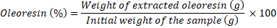

Extraction of butter from seeds
The butter was extracted from nut using ASTA method 9.0 (1997) through solvent extraction method with hexane. 10 g of dried powder of nut was taken in the extraction tube and 50 ml of hexane was added and kept undisturbed overnight. 30 ml of hexane was again added the next day and kept till no smell of hexane was found. The weight of beaker was taken and the percentage of butter was calculated using the given formula:
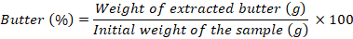
GC-MS Profiling
GC-MS analysis of oil extract were carried out using Shimadzu GC-QP 2010 under the following conditions split ratio 1:50; Rtx- 5 column 30m, 0.25 film thickness Column 60⁰C 2min; 60-220 ⁰C /min and 5 min hold at 220⁰C. The Injector and detector temperature were set at 240⁰C.

