**Scoring description of qualitative traits for the selection of plus trees**

|  |  |  |  |  |  |  |  |  |
| --- | --- | --- | --- | --- | --- | --- | --- | --- |
| **Score** | **Straightness** | **Apical dominance (% of clear bole)** | **Forking** | **Crookedness** | **Self-pruning ability** | **Stem damage** | **Bole swelling** | **Branching behavior** |
| **5** | Straight bole | >70% | Above 10 meters | <10% crooked | Poor branches exist above 1/4th of the total height | No damage | No swelling | Very light with diameter >1/3rd of main stem |
| **4** | Straight with one band | 55-69% | 10 to 7 meters | 10-25% | Poor branches exist above 2/4th and below 1/4th of the total height | 25% damage | Below 25% swelling | Light; one branch with diameter >1/3rd of main stem |
| **3** | Straight with two band | 40-54 % | 7 to 5 meters | 25-50% | Poor branches exist above 3/4th and below 2/4th of the total height | 25-50% damage | 25-50% swelling | Heavy; 2 branches with diameter >1/3rd of main stem |
| **2** | Crooked bole | 25-39 % | 5 to 3 meters | 50-75% | Poor branches exist below 3/4th of the total height | 50-75% damage | 50-75% swelling | Very heavy; >2 branches with diameter; >1/3rd of main stem |
| **1** | Very Crooked Bole | <25% | Below 3 meters | More than 75% | - | >75% damage | >75% swelling | - |

**Plate 1. Measurement of various parameters on a tree**

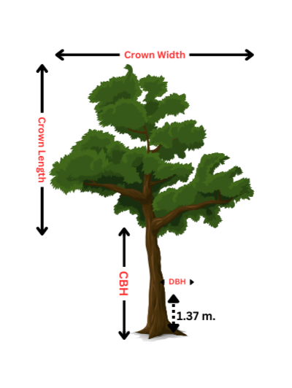

**Plate 2. Selected plus trees from Puri WL division 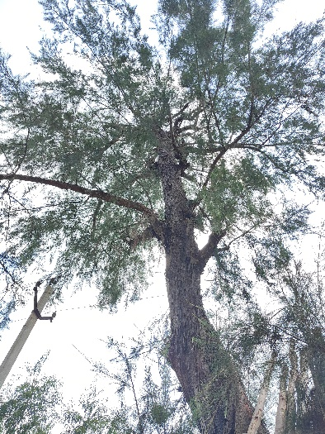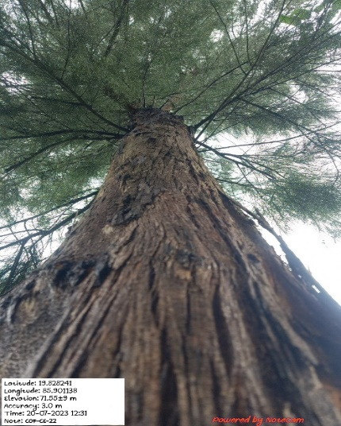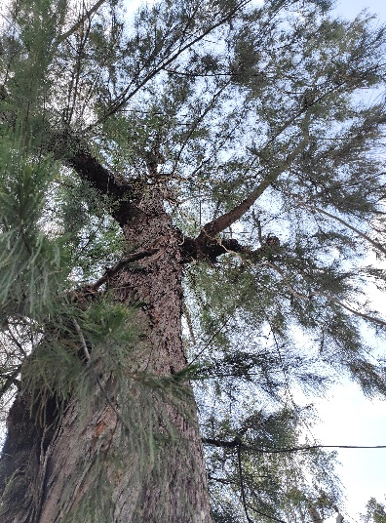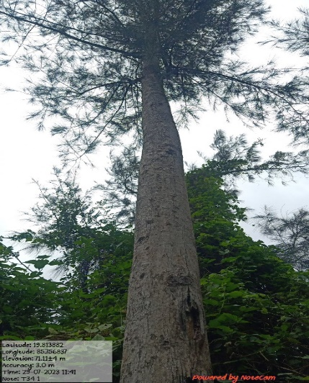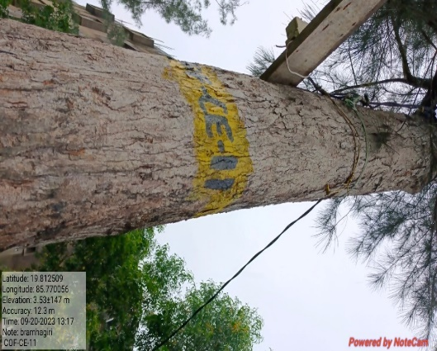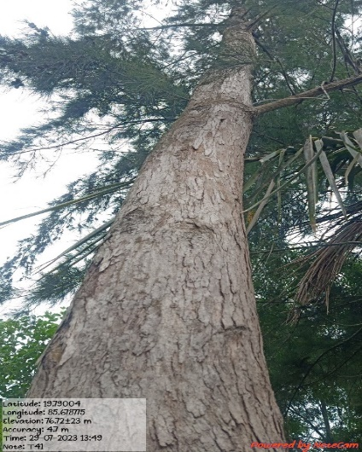**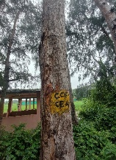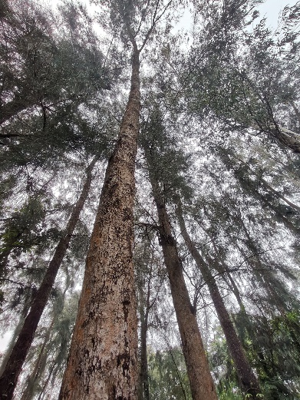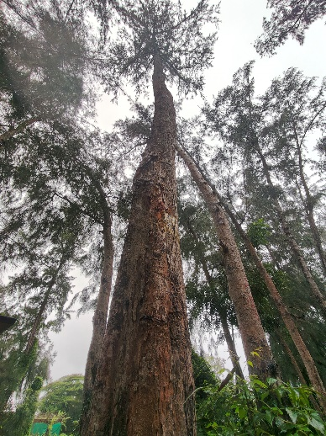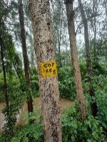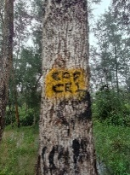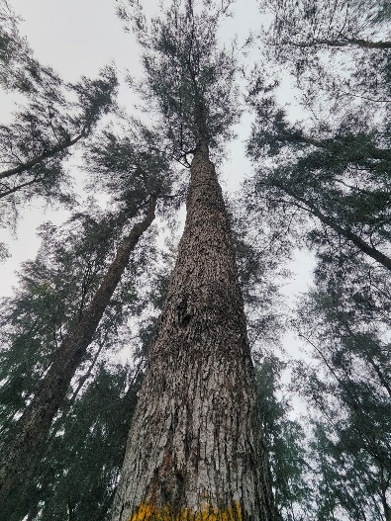

**COF-CE-21**

**COF-CE-18**

**COF-CE-14**

**COF-CE-12**

**COF-CE-11**

**COF-CE-09**

**COF-CE-07**

**COF-CE-04**

**COF-CE-01**

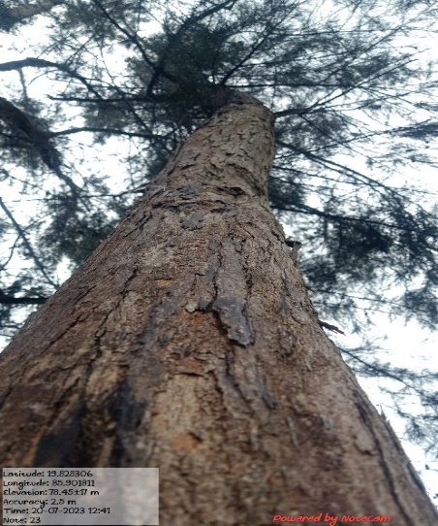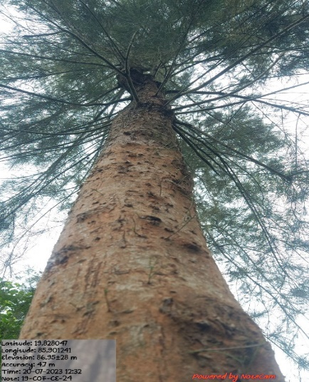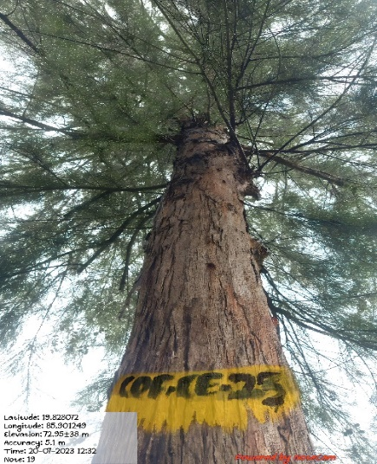

**COF-CE-25**

**COF-CE-26**

**COF-CE-24**

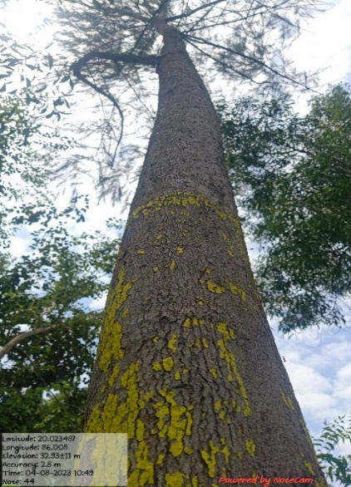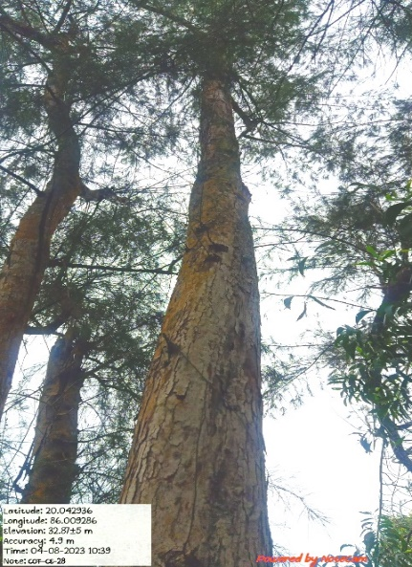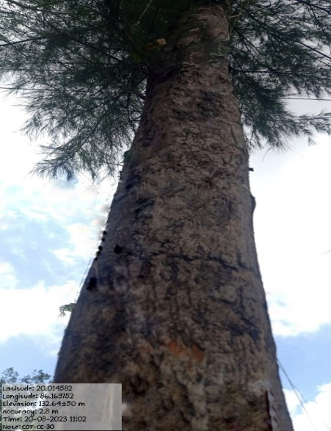

**COF-CE-30**

**COF-CE-29**

**COF-CE-28**