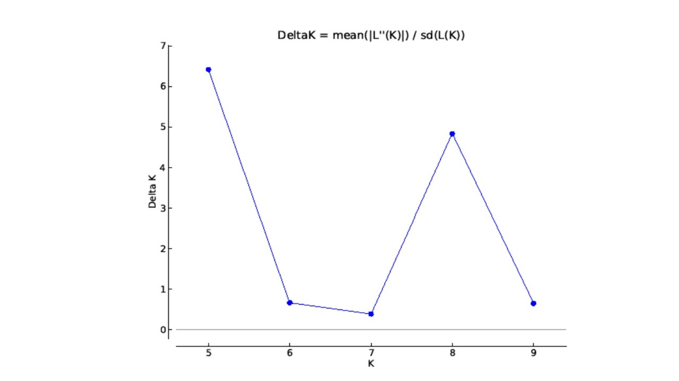

**Figure S1.** Estimating number of subpopulations using delta *K* values for *K* ranging from 4 to 10 using the method proposed by Evanno *et al*. (2005).