**Table 1S.** SCoT bands in *Citrus aurantium* populations (Populations 1-12 are according to Table 1).

|  |  |  |  |  |  |  |  |  |  |  |  |  |
| --- | --- | --- | --- | --- | --- | --- | --- | --- | --- | --- | --- | --- |
| Population | Pop1 | Pop2 | Pop3 | Pop4 | Pop5 | Pop6 | Pop7 | Pop8 | Pop9 | Pop10 | Pop11 | Pop12 |
| No. Bands | 25 | 18 | 22 | 21 | 24 | 21 | 20 | 23 | 22 | 20 | 21 | 18 |
| No. Bands Freq. >= 5% | 25 | 18 | 22 | 21 | 24 | 21 | 20 | 23 | 22 | 20 | 21 | 18 |
| No. Private Bands | 1 | 0 | 0 | 0 | 2 | 0 | 0 | 0 | 0 | 0 | 0 | 0 |
| No. LComm Bands (<=25%) | 3 | 3 | 5 | 2 | 2 | 0 | 0 | 1 | 1 | 0 | 0 | 0 |
| No. LComm Bands (<=50%) | 4 | 3 | 6 | 3 | 3 | 2 | 1 | 3 | 3 | 2 | 1 | 0 |
| Mean He | 0.145 | 0.009 | 0.028 | 0.110 | 0.137 | 0.024 | 0.009 | 0.072 | 0.119 | 0.082 | 0.063 | 0.015 |
| SE of Mean He | 0.035 | 0.009 | 0.018 | 0.033 | 0.034 | 0.012 | 0.009 | 0.025 | 0.033 | 0.026 | 0.027 | 0.015 |
| Mean uHe | 0.156 | 0.011 | 0.030 | 0.116 | 0.146 | 0.026 | 0.011 | 0.083 | 0.143 | 0.094 | 0.075 | 0.018 |
| SE of Mean uHe | 0.037 | 0.011 | 0.019 | 0.035 | 0.036 | 0.013 | 0.011 | 0.028 | 0.040 | 0.029 | 0.032 | 0.018 |

**Abbreviations:** No. Bands = No. of Different Bands, No. Bands Freq. >= 5% = No. of Different Bands with a Frequency >= 5%, No. Private Bands = No. of Bands Unique to a Single Population, No. LComm Bands (<=25%) = No. of Locally Common Bands (Freq. >= 5%) Found in 25% or Fewer Populations**,** No. LComm Bands (<=50%) = No. of Locally Common Bands (Freq. >= 5%) Found in 50% or Fewer Populations**,** He = Expected Heterozygosity, uHe = Unbiased Expected Heterozygosity.

C:\Users\az-sheidai\Desktop\SCOT1.tif

**Fig1S.** Gel photo of some orange samples using different primers (A: SCoT1, B: SCoT2, Populations 1-12 are according to Table 1).

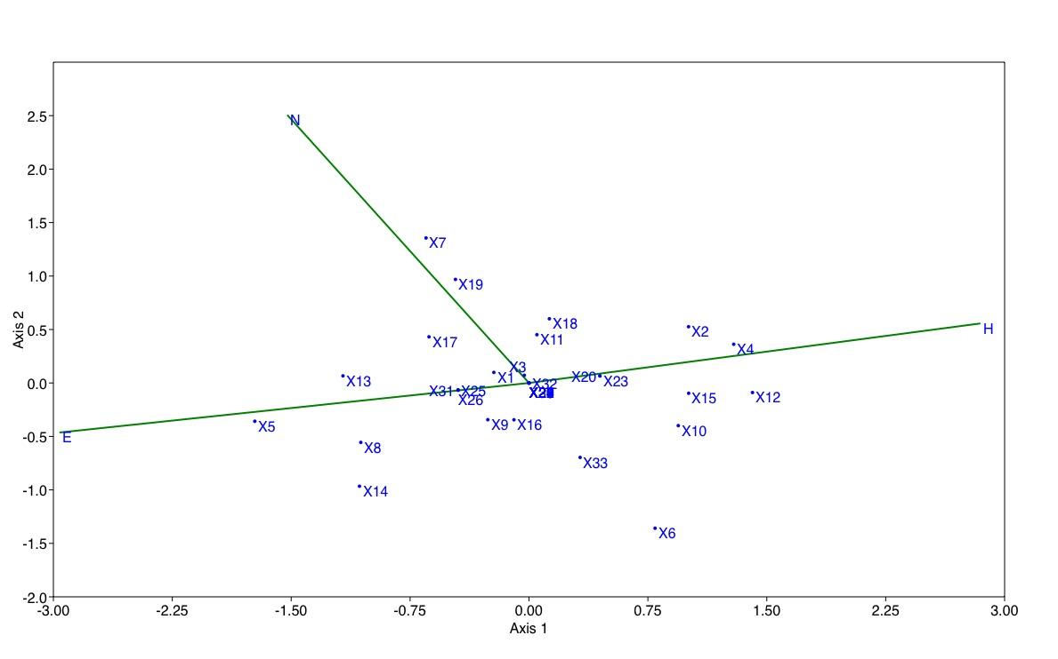

**Fig2S.** CCA plot of sour orange populations based on SCoT data (X1-X33, are SCoT loci obtained).