**Figure S1:** Scree plot showing explained variance and eigen values against principal components in HPW 89 in M2 and M3 generation

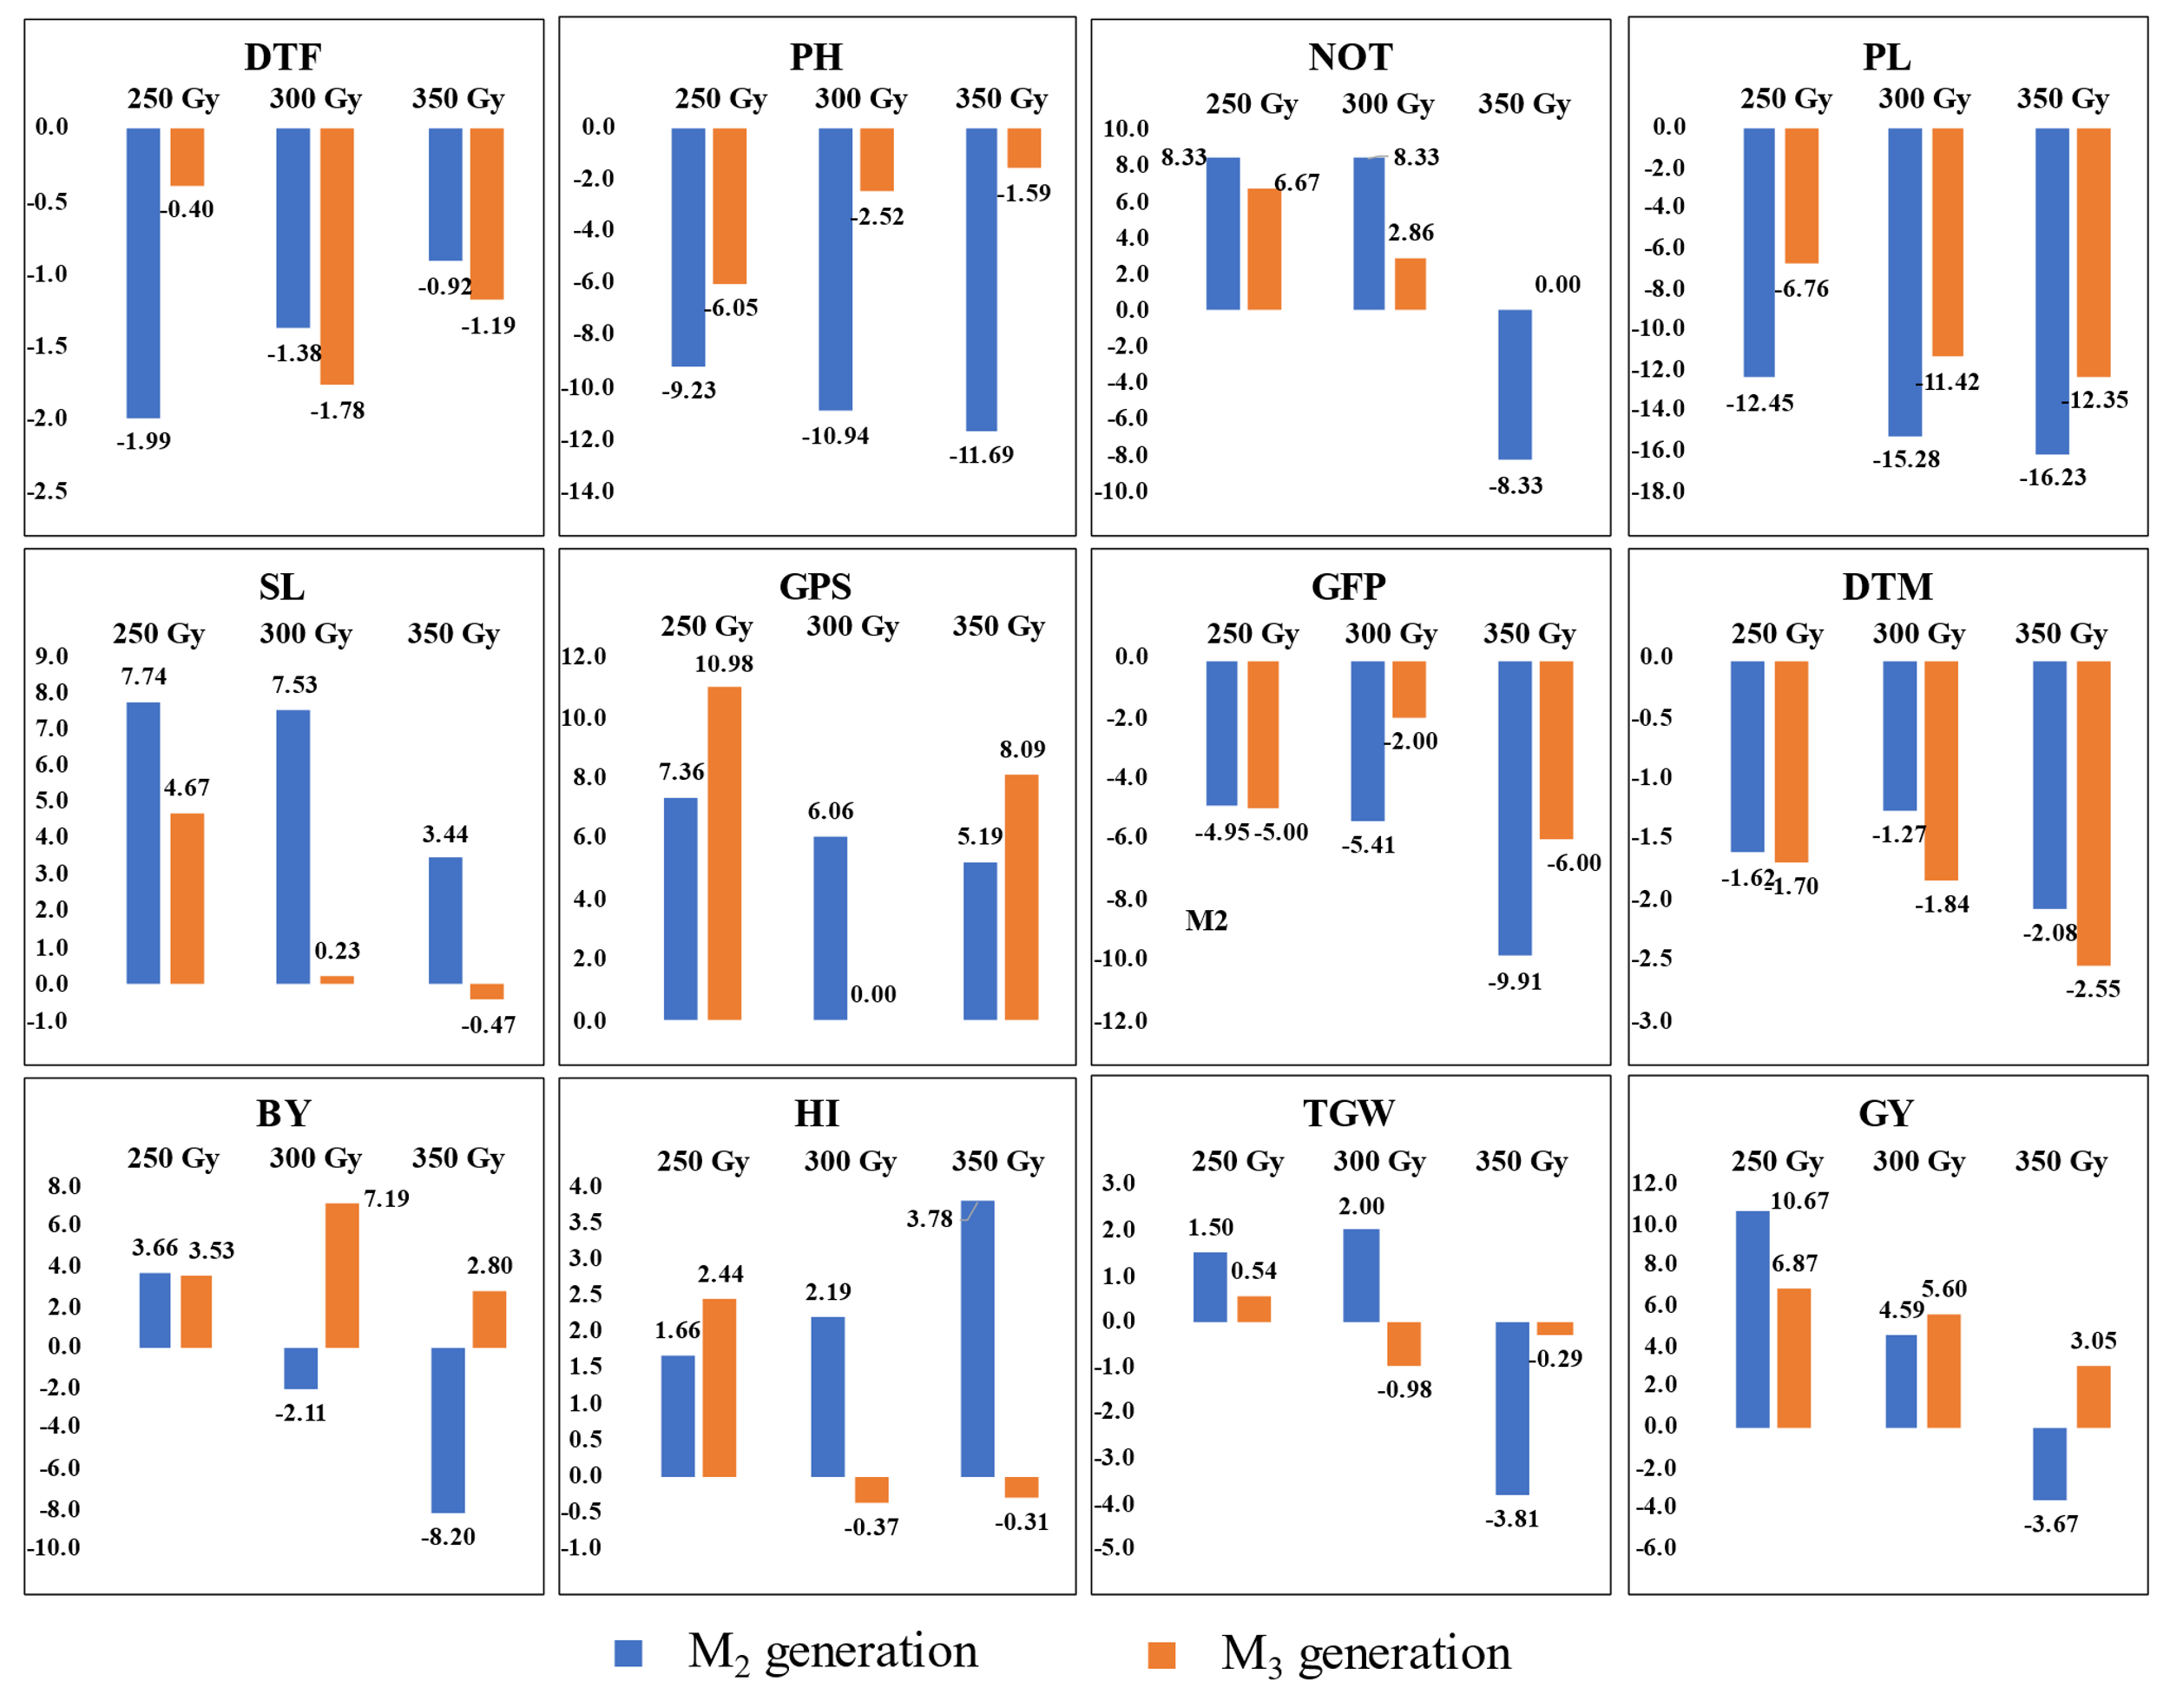

**Figure S2:** Differential dose wise mean percent response of agro-morphological traits in M2 and M3 generation of parent variety HPW 89

**Figure S3:** Summarized overview of the different mutant populations developed and strategy to improve agro-morphological traits and grain hardness