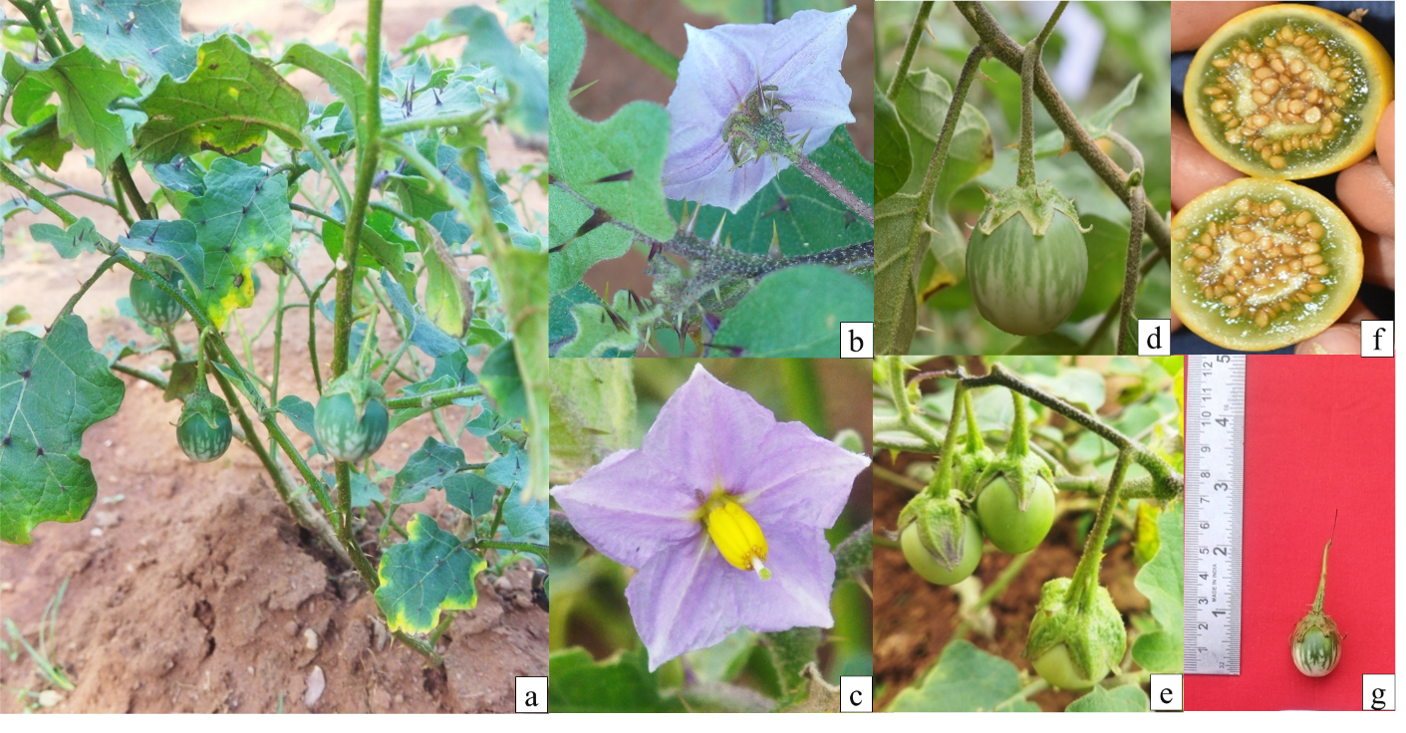Fig. S1 Morphological features of Solanum insanum (a) plant growth habit (b) Prickly stem leaf and calyx (c) Flower (d-e) Fruits (f) Fruit cross section (g) Fruit length

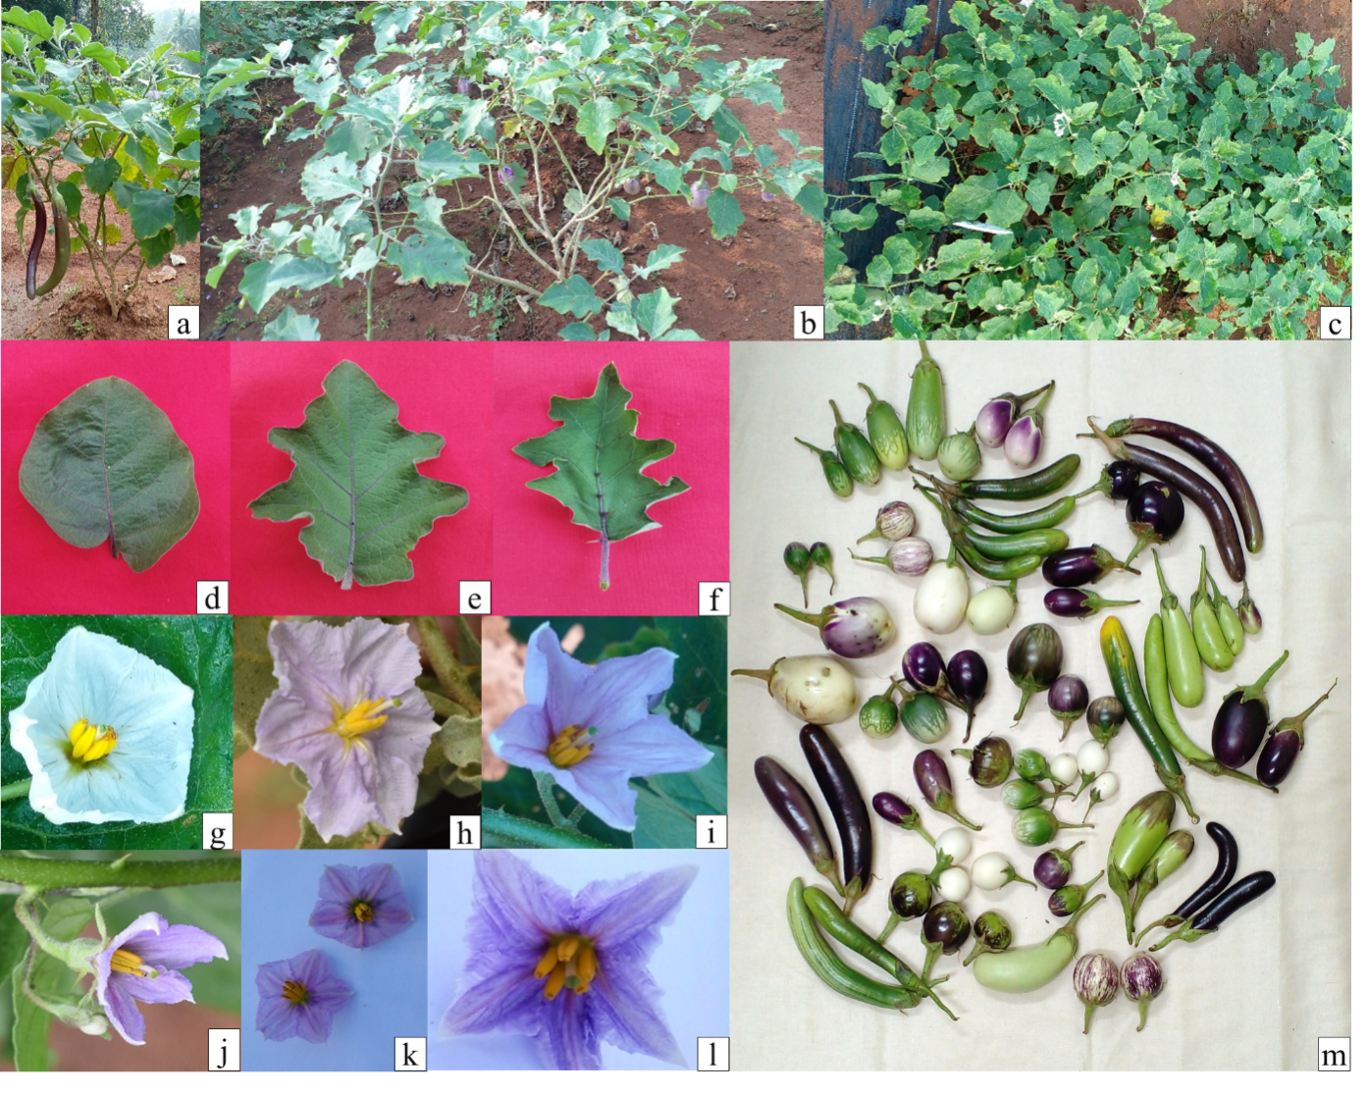
Fig. S2 Morphological variation in plant growth habit and shape, size and lobing pattern of leaves in different accessions of Solanum melongena (a) Upright growth habit (b-c) Intermediate to Spreading growth habit (d) Weak leaf lobing (e) Intermediate leaf lobing (f) Strong leaf lobing (g-l) Variation in corolla colour of flowers (m) Variation in fruit shape, size and colour of different accessions

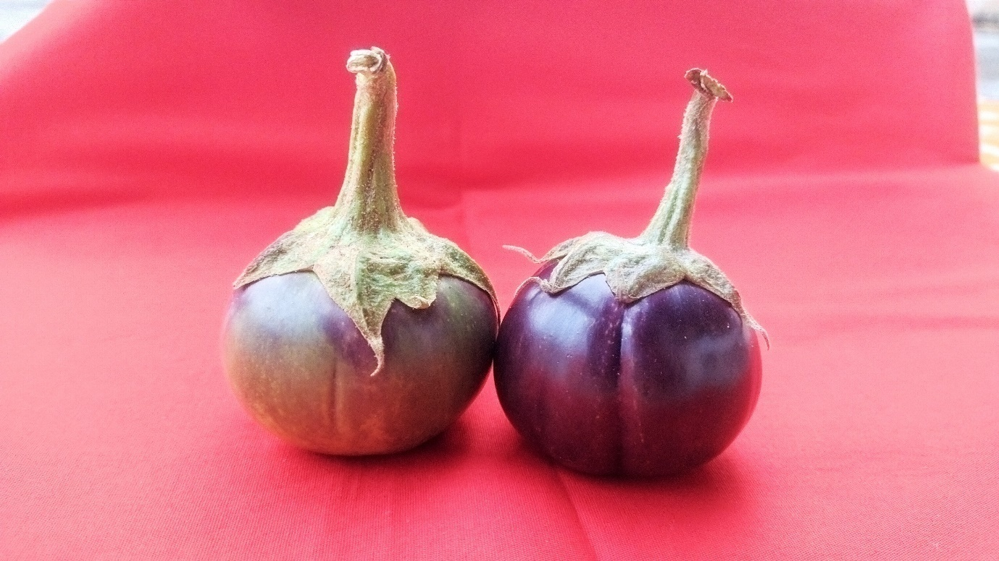
Fig. S3 Eggplant (Solanum melongena) with grooves in KPSC/22-Mis-78

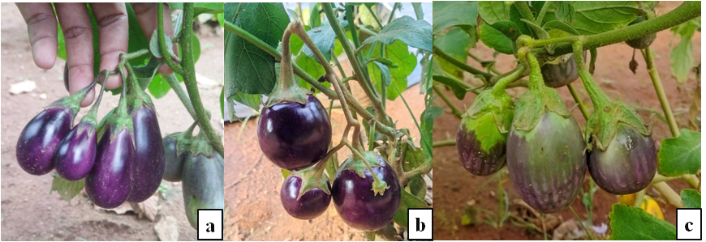
Fig. S4 Cluster bearing of Eggplant genotypes (a) Violet brinjal (b) Kurumbotribe (c) IC541210

Table S1. Passport details of the Eggplant genotypes
Si. No. | Genotypes | Place | District | State
Solanum melongena
1 | Arka Keshav | IIHR | Bangalore | Karnataka
2 | Arka Nidhi | IIHR | Bangalore | Karnataka
3 | Arunachal brinjal (104) |  |  | Arunachal Pradesh
4 | Arunachal brinjal (N11) |  |  | Arunachal Pradesh
5 | Arunachal brinjal (N12) |  |  | Arunachal Pradesh
6 | Cheruvazhuthina |  |  | Kerala
7 | D.NO. 293
8 | D.NO. 76
9 | D.NO. 78
10 | EC 111092
11 | EC 316227
12 | EC 393239
13 | EC 467274
14 | Haritha | Vellanikkara | Thrissur | Kerala
15 | IC 111010 | Bangalipada | Dhubri | Assam
16 | IC 111387 | Neriamangalam | Idukki | Kerala
17 | IC 113028 |  | Jammu | Jammu and kashmir
18 | IC 135912-B
19 | IC 169079
20 | IC 203587 | Vallathodenagar | Thrissur | Kerala
21 | IC 203588 | Nattianchina | Thrissur | Kerala
22 | IC 203604 | kallar, Mettupalayam | Coimbatore | Tamil Nadu
23 | IC 212564 | Kanhangad | Kannur | Kerala
24 | IC 233610
25 | IC 233611
26 | IC 241666 | Sudugattupara, Chinnampathy | Coimbatore | Tamil Nadu
27 | IC 241674 | Irumbupalam | Thrissur | Kerala
28 | IC 241675 | Vellanikkara | Thrissur | Kerala
29 | IC 253962 |  | Kozhikode | Kerala
30 | IC 255748 | Mangad | Thrissur | Kerala
31 | IC 255756 | Avinissery | Thrissur | Kerala
32 | IC 256161 | Palappallam, Chitoor | Palakkad | Kerala
33 | IC 256240 | Adichilthotty | Thrissur | Kerala
34 | IC 256708 | Melapattambi | Palakkad | Kerala
35 | IC 310884 | Kesharpura | Sabarkantha | Gujarat
36 | IC 324475 | Kozhinjampara | Palakkad | Kerala
37 | IC 350885 | Burman | Narsinghpur | Madhya Pradesh
38 | IC 354528
39 | IC 354651 |  | Ranchi | Jharkhand
40 | IC 374912
41 | IC 383102 | Bastar market | Bastar | Chattisgarh
42 | IC 383695 | Doranagiri | Uttar Kannad | Karnataka
43 | IC 410139 | Tirunelli | Wayanad | Kerala
44 | IC 413648 | Rapole | Rangareddy | Telangana
45 | IC 421190 | Byahatti | Dharwad | Karnataka
46 | IC 421191 | Byahatti | Dharwad | Karnataka
47 | IC 421194 | Takkalaki | Bagalkot | Karnataka
48 | IC 421593 | Mavinalla | Nilgiris | Tamil Nadu
49 | IC 424115
50 | IC 427002 | Pllalapalli | Krishnagiri | Tamil Nadu
51 | IC 427008 | Belramam | Vellore | Tamil Nadu
52 | IC 427478 | Athikottai | Thanjavur | Tamil Nadu
53 | IC 439566 | Bennikal | Krishnagiri | Tamil Nadu
54 | IC 522236 | Pongibalu jetty | Andaman | A&N Islands
55 | IC 531743 | Lower camp | Theni | Tamil Nadu
56 | IC 531748 | Sarkarpathy, Minorshett | Coimbatore | Tamil Nadu
57 | IC 531769 | Kittamadu, Attapady | Palakkad | Kerala
58 | IC 541210 | Veerapandi | Coimbatore | Tamil Nadu
59 | IC 541261 | Soorankotai | Ramnad | Tamil Nadu
60 | IC 545901 | Sunabeda | Koraput | Odisha
61 | IC 545919 | Damodarpur | Cuttack | Odisha
62 | IC 618016 |  | Phek | Nagaland
63 | IC 618022 | Phek town | Phek | Nagaland
64 | IC 618035 | Sirmour | Rewa | Madhya Pradesh
65 | IC 618046 | Gerui | Singrauli | Madhya Pradesh
66 | IC 618050 | Ramnagar | Chitrakoot | Uttar Pradesh
67 | IC 624210 | Campbell Bay | Nicobar | A&N Islands
68 | IC 624237 | Phek town | Phek | Nagaland
69 | IC 624238 | Meluri | Phek | Nagaland
70 | IC 624239 | Meluri | Phek | Nagaland
71 | IC 624240 | Kiphire village | Kiphire | Nagaland
72 | IC 624244 | Vithura | Thiruvananthapuram | Kerala
73 | IC 626119 | Bethel, Phek Town | Phek | Nagaland
74 | IC 627292 | Macachuam little nicobar | Nicobar | A&N Islands
75 | IC 628846 | Marayur | Idukki | Kerala
76 | IC 632110 | Kadamthala | South Andaman | A&N Islands
77 | IC 636521 | Yannyu | Mon | Nagaland
78 | IC 636522 | Changlangshu | Mon | Nagaland
79 | IC 636523 | Tobu | Mon | Nagaland
80 | IC 636524 | Gokul Kat | Kokrajhar | Assam
81 | IC 636525 | Karigaon | Kokrajhar | Assam
82 | IC 641514 | Manmou | Changlang | Arunachal Pradesh
83 | IC 641518 | Vellanikkara | Thrissur | Kerala
84 | IC 641519 | IIHR, Bangalore | Bangalore | Karnataka
85 | IC 646157 | Cheruthoni | Idukki | Kerala
86 | IC 646159 | IIHR Bangalore | Bangalore | Karnataka
87 | IC 89906 | Gopalapuram | West Godhavari | Andhra Pradesh
88 | IC 89989
89 | IC 90783 | Aghar | Hamirpur | Himachal Pradesh
90 | IC 90811 | Hassan | Hassan | Karnataka
91 | JB/12-185
92 | JL/18 |  |  | Karnataka
93 | JN/2016
94 | JP/13-34 | Cheruthoni | Idukki | Kerala
95 | Kotteppadam |  | Thrissur | Kerala
96 | KP/DRB/21-53 | Kanam | Thoothukudi | Tamil Nadu
97 | KP/SC-1578 | Yannyu | Mon | Nagaland
98 | KP/SC-1651 | Tobu | Mon | Nagaland
99 | KP/SC-22-11 | Panglian | Churachandpur | Manipur
100 | KP/SC-22-12 | Panglian | Churachandpur | Manipur
101 | KP/SC-22-27 | Hangsum | Churachandpur | Manipur
102 | KP/SC-22-MIS-52 | Lungthul | Churachandpur | Manipur
103 | KP/SC-22-MIS-78 | Ngope | Saitual | Mizoram
104 | Kurumbotribe |  | Ambalavayal | Kerala
105 | Local melongena
106 | Neelima | Thrissur | Thrissur | Kerala
107 | PKM/18-152 | Thrissur | Thrissur | Kerala
108 | PKM/18-52
109 | Ponni | Thrissur | Thrissur | Kerala
110 | PT/23-MIS-19 | Kalvarai | Erode | Tamil Nadu
111 | Pusaanupam | New Delhi | New Delhi | New Delhi
112 | Pusa purple cluster | New Delhi | New Delhi | New Delhi
113 | Pusa purple long | New Delhi | New Delhi | New Delhi
114 | S-11
115 | Surya | Thrissur | Thrissur | Kerala
116 | Vengeribrinjal | Thrissur | Thrissur | Kerala
117 | Violet brinjal
Solanum insanum
118 | IC 203609 | Mudakkayam East | Kottayam | Kerala
119 | IC 421202 | Tarekere | Chickmagalur | Karnataka
120 | IC 427477 | Roadside | Thanjavur | Tamil Nadu
121 | IC 439279 | Ariyankuppam | Pondicherry | Pondicherry
122 | IC 541258 | Kadayanallore | Tirunelveli | Tamil Nadu
123 | IC 599705 | Thenmala dam | Kollam | Kerala
124 | IC 638984 | Eachanari | Coimbatore | Tamil Nadu
125 | IC 641418 | Thekkady | Theni | Tamil Nadu
126 | IC 641489 | Vedaranyam | Nagapattinam | Tamil Nadu
127 | IC 641498 | Polachiammankulam | Thiruvallur | Tamil Nadu
Introgressed lines
128 | D.NO. 256
129 | IC 111019 | Bangalipada | Dhubri | Assam
130 | IC 203595 | Mavinalla | Nilgiris | Tamil Nadu
131 | IC 203610 | Thrissur | Thrissur | Kerala
132 | IC 241673 | Ambalamoola | Nilgiris | Tamil Nadu
133 | IC 253952 | Agali | Palakkad | Kerala
134 | IC 253957 | Kannur | Kannur | Kerala
135 | IC 253963 | Thenipalam | Malappuram | Kerala
136 | IC 253967 | Chellur | Malappuram | Kerala
137 | IC 260115 | Walayar | Palakkad | Kerala
138 | IC 265589 | Njeezhoor | Kottayam | Kerala
139 | IC 306171 | Mullu Gate | Coimbatore | Tamil Nadu
140 | IC 324556 | Ambalampuzha Beach | Alappuzha | Kerala
141 | IC 333527 | Aryankavu | Kollam | Kerala
142 | IC 421115
143 | IC 421463 | Konamuchi | Thrissur | Kerala
144 | IC 421596 | Irumbupalam | Thrissur | Kerala
145 | IC 424175
146 | IC 427978
147 | IC 446745 | Vadakkancherry | Palakkad | Kerala
148 | IC 539843 | Jayanthi | Nicobar | A&N Islands
149 | IC 599704 | Near Achankovil temple | Pathanamthitta | Kerala
150 | IC 618032 | Gaddi Road | Sidhi | Madhya Pradesh
151 | IC 636941 | Thengumarahada | Nilgiris | Tamil Nadu
152 | IC 641515 | Tikhaktapel | Changlang | Arunachal Pradesh
153 | IC 641520 | IIHR | Bangalore | Karnataka
154 | IC 89914 | Udhandapuram | Vishakhapatnam | Andhra Pradesh
155 | JJK/MISC
156 | JJK/Mylampara
157 | JL/181 | IIHR | Bangalore | Karnataka
IC-Indigenous collection, EC-Exotic collection; IIHR-Indian Institute of Horticultural Research; A&N-Andaman and Nicobar

Table S2. Range of variation for 6 quantitative traits of collected eggplant genotypes of 2022 and 2023 (all 157 genotypes; Introgressed lines; wild progenitor, S. insanum; and cultivated S. melongena genotypes)
Traits/ Parameters | LBL* | LBB | FL | FB | FLBR | MFW
All lines (157)
Min | 7.80 | 4.90 | 2.10 | 2.10 | 0.81 | 3.97
Max | 22.70 | 14.70 | 24.38 | 6.90 | 10.29 | 117.80
Mean | 12.26 | 9.10 | 6.83 | 3.63 | 2.00 | 40.87
SE(m) | 0.19 | 0.16 | 0.30 | 0.07 | 0.12 | 1.75
SD | 2.37 | 1.98 | 3.74 | 0.89 | 1.48 | 21.87
Skewness | 0.89 | 0.89 | 1.81 | 0.82 | 3.13 | 0.81
Kurtosis | 1.28 | 0.00 | 4.51 | 0.83 | 12.10 | 1.08
CV % | 19.37 | 21.70 | 54.73 | 24.54 | 73.87 | 53.50
Introgressed lines (30)
Min | 8.80 | 5.30 | 2.10 | 2.10 | 1.00 | 10.90
Max | 16.20 | 12.80 | 8.30 | 4.50 | 2.91 | 45.20
Mean | 12.02 | 8.61 | 4.75 | 3.29 | 1.45 | 25.50
SE(m) | 0.41 | 0.29 | 0.26 | 0.11 | 0.08 | 1.55
SD | 2.27 | 1.57 | 1.41 | 0.58 | 0.43 | 8.49
Skewness | 0.46 | 0.80 | 1.00 | 0.43 | 2.27 | 0.17
Kurtosis | -0.96 | 1.27 | 0.97 | -0.24 | 5.40 | -0.53
CV % | 18.90 | 18.25 | 29.75 | 17.69 | 29.80 | 33.29
Solanum insanum lines (10)
Min | 8.20 | 6.50 | 2.20 | 2.20 | 0.84 | 3.97
Max | 13.60 | 11.10 | 3.10 | 3.20 | 1.27 | 8.70
Mean | 11.13 | 8.31 | 2.70 | 2.58 | 1.05 | 6.20
SE(m) | 0.51 | 0.51 | 0.08 | 0.08 | 0.04 | 0.58
SD | 1.60 | 1.60 | 0.25 | 0.26 | 0.11 | 1.83
Skewness | -0.09 | 0.49 | -0.51 | 1.46 | 0.07 | 0.14
Kurtosis | 0.12 | -1.17 | 0.96 | 4.08 | 1.41 | -1.87
CV % | 14.40 | 19.22 | 9.23 | 9.97 | 10.82 | 29.57
Solanum melongena lines (117)
Min | 7.80 | 4.90 | 3.20 | 2.15 | 0.81 | 13.00
Max | 22.70 | 14.70 | 24.38 | 6.90 | 10.29 | 117.80
Mean | 12.42 | 9.30 | 7.71 | 3.81 | 2.22 | 47.78
SE(m) | 0.23 | 0.19 | 0.36 | 0.08 | 0.15 | 1.88
SD | 2.44 | 2.07 | 3.86 | 0.91 | 1.64 | 20.30
Skewness | 0.95 | 0.83 | 1.70 | 0.71 | 2.73 | 0.94
Kurtosis | 1.51 | -0.36 | 3.84 | 0.68 | 8.93 | 1.41
CV % | 19.63 | 22.25 | 50.02 | 23.81 | 73.70 | 42.48
*LBL- leaf blade length (cm); LBB- leaf blade breadth (cm); FL- fruit length (cm); FB- fruit breadth (cm); FLBR- fruit length/breadth ratio; MFW- mean fruit weight (g)

