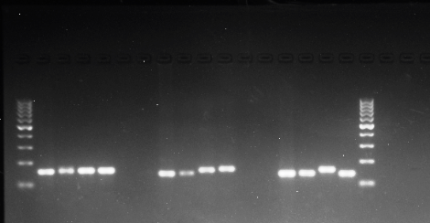

***Umc-1066***

***Phi-057***

***Phi-112***

**P1 P2 P3 P4**

**P1 P2 P3 P4**

**P1 P2 P3 P4**

**Fig: S1**. **Detection of polymorphic markers at *o2* locus for foreground selection (100-1000bp ladder)**

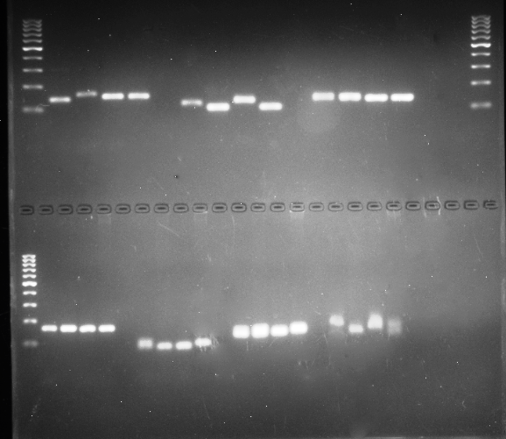

**P1 P2 P3 P4**

**P1 P2 P3 P4**

**P1 P2 P3 P4**

***Bnlg 1666***

***Umc 1728***

***Umc 2210***

***Umc 1293***

**P1 P2 P3 P4**

**P1 P2 P3 P4**

**P1 P2 P3 P4**

**P1 P2 P3 P4**

***Umc 1665***

***Umc 1029***

***Bnlg 1335***

**Fig: S2.** **Detection of polymorphic markers in Parents for Background selection (100bp-1kbp ladder)**

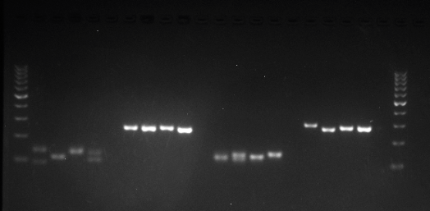

**P1 P2 P3 P4**

**P1 P2 P3 P4**

**P1 P2 P3 P4**

**P1 P2 P3 P4**

***Phi 056***

***Bnlg 198***

***Bnlg 240***

***Bnlg 166***

**Fig: S3.** **Detection of polymorphic markers in Parents for Background selection (100bp-1kbp ladder)**

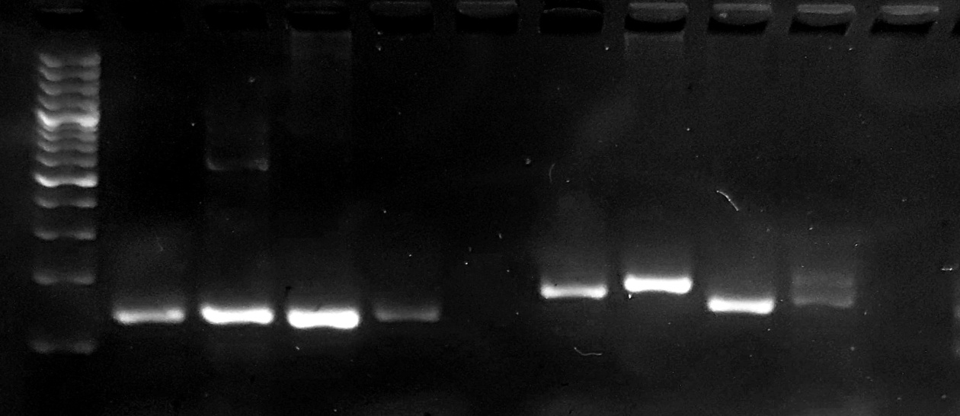

**P1 P2 P3 P4**

**P1 P2 P3 P4**

***Bnlg 1621***

***Umc 2144***

**Fig: S4. Detection of polymorphic markers in Parents for Background selection (100bp-1kbp ladder)**

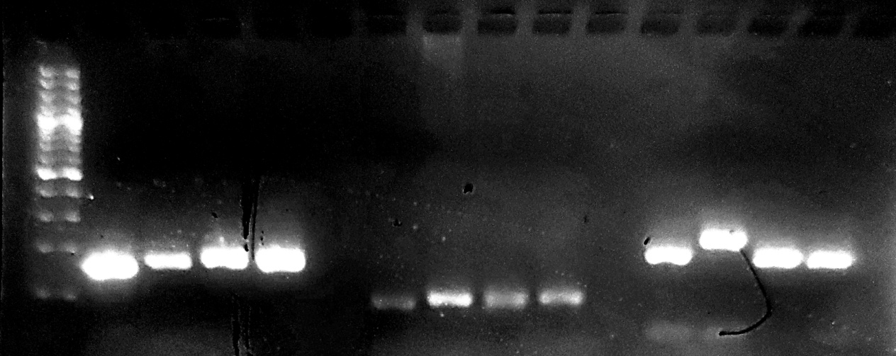

***Umc 1063***

***Umc 1708***

***Umc 1036***

**P1 P2 P3 P4**

**P1 P2 P3 P4**

**P1 P2 P3 P4**

**Fig: S5. Detection of polymorphic markers in Parents for Background selection (100bp-1kbp ladder)**

**P1 P2 P3 P4**

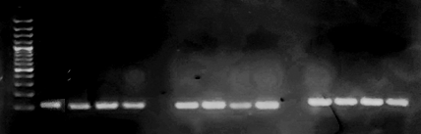

**P1 P2 P3 P4**

**P1 P2 P3 P4**

**P1 P2 P3 P4**

***Umc 1026***

***bnlg 1056***

***Umc 1018***

**Fig: S6. Detection of polymorphic markers in Parents for Background selection (100bp-1kbp ladder)**

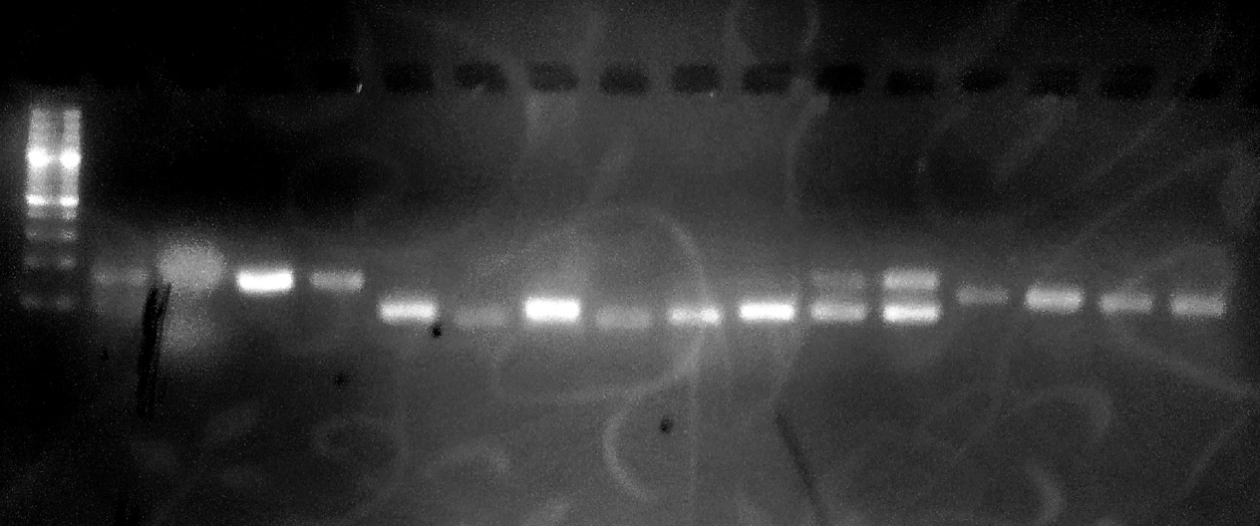

**P1 P2 P3 P4**

**P1 P2 P3 P4**

**P1 P2 P3 P4**

**P1 P2 P3 P4**

***Umc 1823***

***Umc 1594***

***Umc 1918***

***Umc 1147***

**Fig: S7.** **Detection of polymorphic markers in Parents for Background selection (100bp-1kbp ladder)**

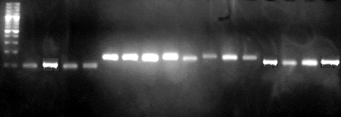

**P1 P2 P3 P4**

**P1 P2 P3 P4**

**P1 P2 P3 P4**

**P1 P2 P3 P4**

***Umc 1002***

***Umc 1786***

***Bnlg-1306***

***Phi-129***

**Fig: S8.** **Detection of polymorphic markers in Parents for Background selection (100bp-1kbp ladder)**

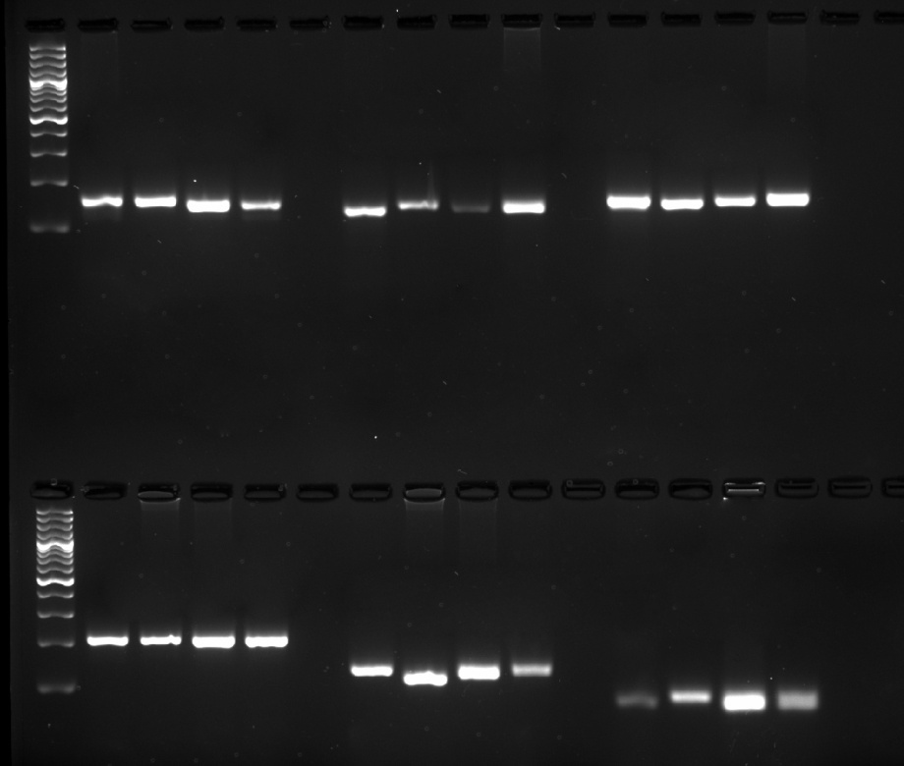

***Phi-067***

**P1 P2 P3 P4**

**P1 P2 P3 P4**

**P1 P2 P3 P4**

**P1 P2 P3 P4**

**P1 P2 P3 P4**

**P1 P2 P3 P4**

***Phi-452693***

***Phi-061***

***Umc 1762***

***Umc-1424***

***Umc-1478***

**Fig: S9.** **Detection of polymorphic markers in Parents for Background selection (100bp-1kbp ladder)**

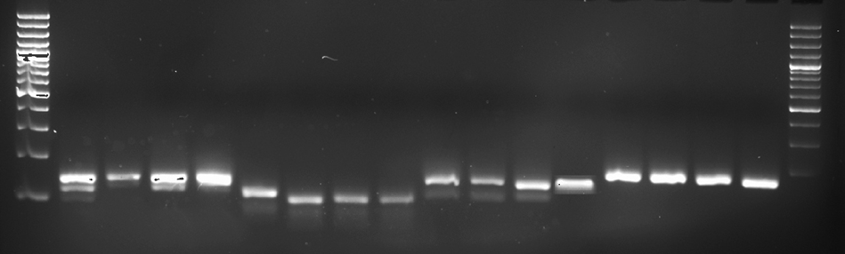

**P1 P2 P3 P4**

**P1 P2 P3 P4**

***Umc 1077***

**P1 P2 P3 P4**

**P1 P2 P3 P4**

***Phi-051***

***Umc 1141***

***Umc 1664***

**Fig: S10.** **Detection of polymorphic markers in Parents for Background selection (100bp-1kbp ladder)**

**C:\Users\SHAMSHIR\Desktop\pic6. 24-12-2021 (1) - Copy.tif**

**Fig. S11. Genotyping of *opaque 2* locus genotyping BC1F1 (A){ F1 x IML-187} (100bp-1kbp ladder) ( *O2o2 heterozygote*)**



**Fig. S12. Genotyping of *opaque 2* locus genotyping and phenotyping BC1F1 (B) { F1 x BML-6} (100bp-1kbp ladder) ( *O2o2 heterozygote*)**

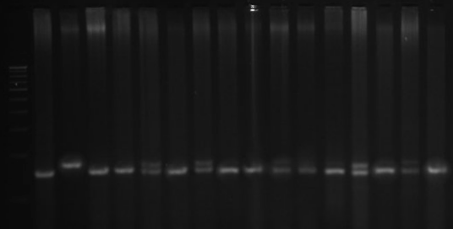

**Fig. S13: Genotyping of *opaque 2* locus fusing *phi 057* SSR in BC2F1 (A) (100bp-1kbp ladder) ( *O2o2 heterozygote*)**



**Fig. S14. Genotyping of *opaque 2* locus using *phi 057* SSR in BC2F1 (B) (100bp-1kbp ladder) ( *O2o2 heterozygote*).**

**C:\Users\SHAMSHIR\Desktop\pic6. 24-12-2021 (2) - Copy.tif**

**Fig. S15. Foreground selection in BC2F2 (A) plants for *o2o2* genome using SSR *Phi 057* (100bp-1kbp ladder)( 170bp *o2o2 recessive homozygote)***

**C:\Users\SHAMSHIR\Desktop\4th pic shamshir22-12-21 (1).tif**

**Fig. S16. Foreground selection in BC2F2 (B) plants for *o2o2* genome using SSR *Phi 057* (100bp-1kbp ladder) ( 170bp *o2o2; recessive homozygote)***

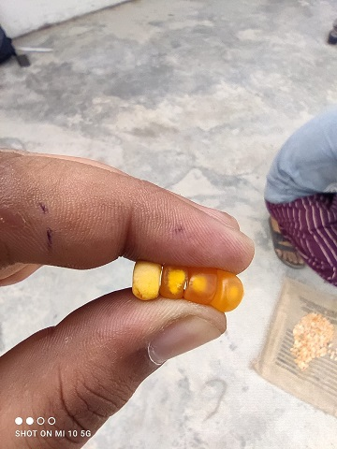

d

c

b

a

**Fig. S117: A representative picture of opaqueness gradient a)100-75%, b)75-50%, c)50-25% and d)<25% opaque in BC2F2 seed**