Appendix A Supplementary data
Supplementary Figure
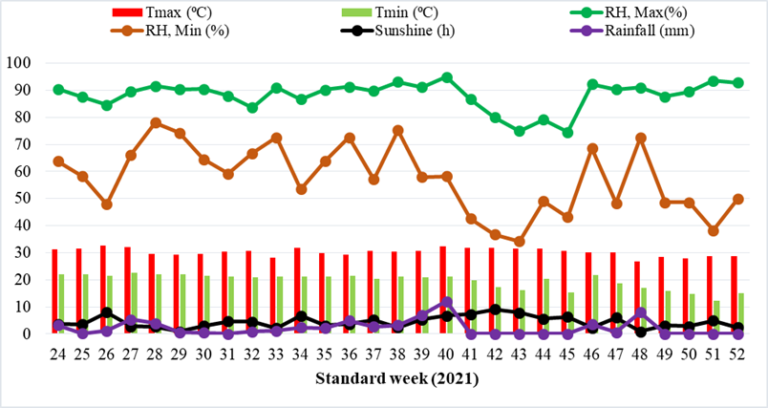
Fig. S1a: Agro-meteorological parameters prevailing during crop season 2021
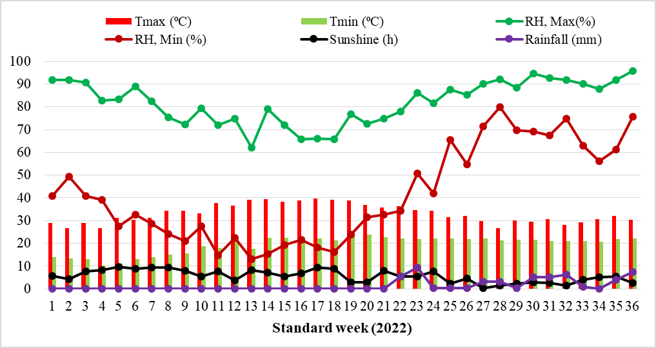
Fig. S1b: Agro-meteorological parameters prevailing during crop season 2022
Fig. S2. Frequency distribution of (a). Maximum temperature (⁰C) and (b). Bright sunshine hours (h) during six crop seasons and the peak represents the maximum duration of maximum temperature and sunshine distribution throughout the crop season

Supplementary Table
Table S1: Details of seventy-four chickpea variety/germplasm lines of different maturity groups and released for different agro-ecological zone used for drought tolerant early maturing photo-thermo-insensitivity main screening studies
 |  | Rabi 2020-21 |  | Kharif 2021
S.N | Genotypes | Yield (kg ha⁻¹) | Physiological maturity (duration) | Yield (kg ha⁻¹) | Physiological maturity (days)
1 | ICE 7550 | 1178±82 | Medium | 539±6 | 65±1
2 | ICE 15654-A | 947±89 | Early | 695±24 | 63±1
3 | ICE 15654-B | 742±62 | Early | 675±23 | 65±1
4 | ICE 15874-A | 989±49 | Early | 532±35 | 68±1
5 | ICE 6565 | 924±67 | Late | 0±0 | 79±2
6 | IPC 06-11 | 716±76 | Early | 700±19 | 63±1
7 | Digvijay | 871±62 | Late | 331±7 | 71±1
8 | SA 1 | 1058±97 | Late | 717±26 | 65±1
9 | GBM 2 | 1071±73 | Late | 372±24 | 73±2
10 | JG 11 | 1196±77 | Early | 804±18 | 65±1
11 | MNK 1 | 638±12 | Early | 467±12 | 73±2
12 | GNG 663 | 889±112 | Medium | 27±3 | 80±2
13 | SAKI 9516 | 1142±78 | Late | 520±60 | 71±2
14 | RSG 888 | 716±86 | Medium | 229±62 | 75±3
15 | Pusa 212 | 773±43 | Medium | 159±21 | 80±0
16 | JG 24 | 804±66 | Late | 186±22 | 80±1
17 | Pusa 244 | 809±89 | Late | 433±7 | 72±0
18 | BG 396 | 631±58 | Late | 33±4 | 80±0
19 | CSJ 515 | 1067±82 | Medium | 52±4 | 81±1
20 | BDG 75 | 836±82 | Medium | 290±16 | 79±1
21 | ICCV 96030 | 822±72 | Late | 458±10 | 70±1
22 | JG 12 | 944±125 | Medium | 358±31 | 73±1
23 | JG 315 | 951±95 | Medium | 250±29 | 71±0
24 | L 550 | 884±99 | Late | 156±16 | 79±1
25 | BG 276 | 986±35 | Medium | 148±16 | 79±1
26 | Pusa 240 | 756±56 | Late | 146±60 | 74±2
27 | RSG 896 | 836±125 | Medium | 488±17 | 76±5
28 | PG 5 | 927±31 | Medium | 692±61 | 70±2
29 | PG 186 | 1091±67 | Early | 29±3 | 80±0
30 | Pusa Green 112 | 813±113 | Late | 0±0 | 82±1
31 | JG 63 | 1089±105 | Medium | 310±62 | 72±2
32 | Vishal | 1347±104 | Early | 796±53 | 68±0
33 | ICC 4958 | 1178±107 | Medium | 443±10 | 69±1
34 | JG 16 | 1364±92 | Early | 820±13 | 69±1
35 | GNG 1581 | 844±80 | Late | 39±5 | 80±0
36 | GNG 1958 | 1254±35 | Late | 522±5 | 80±1
37 | PBG 5 | 1062±27 | Medium | 434±19 | 80±0
38 | ICCV 92944 | 1049±4 | Early | 942±30 | 66±1
39 | BGM 408 | 831±77 | Late | 0±0 | 81±1
40 | Pusa 1003 | 1129±93 | Medium | 408±22 | 79±1
41 | DCP 92-3 | 773±20 | Medium | 352±13 | 75±1
42 | Pusa 362 | 1138±100 | Late | 398±17 | 75±1
43 | Sadabhahar | 371±116 | Late | 0±0 | 82±1
44 | Annigeri | 622±69 | Medium | 206±6 | 78±0
45 | GG-2 | 618±75 | Medium | 247±33 | 76±2
46 | CSJD 8962 | 642±79 | Medium | 0±0 | 81±1
47 | Pusa 256 | 495±43 | Medium | 394±13 | 80±1
48 | Pusa 372 | 395±110 | Late | 117±17 | 79±1
49 | GNG 1488 | 662±113 | Early | 356±25 | 77±1
50 | Vaibhav | 593±4 | Medium | 14±14 | 81±1
51 | Vijay | 829±81 | Early | 702±27 | 68±2
52 | Pant G 114 | 600±118 | Early | 200±3 | 77±2
53 | JG 14 | 978±69 | Early | 811±13 | 72±1
54 | JG 74 | 649±46 | Medium | 573±35 | 71±1
55 | ICC 15614 | 651±104 | Medium | 622±22 | 68±2
56 | DCP 93-3 | 624±55 | Medium | 591±20 | 72±2
57 | ICC 8950 | 618±105 | Medium | 128±23 | 79±1
58 | PG 114 | 756±80 | Medium | 542±23 | 71±2
59 | KWR 108 | 489±33 | Medium | 404±21 | 70±2
60 | PG 96006 | 580±81 | Medium | 578±23 | 69±3
61 | GNG 2144 | 445±53 | Medium | 284±15 | 76±1
62 | GNG 2171 | 887±23 | Medium | 705±72 | 73±2
63 | L4 16 | 289±69 | Medium | 0±0 | 80±1
64 | L4 25 | 665±39 | Medium | 424±22 | 73±2
65 | IPC2014-56 | 353±62 | Late | 0±0 | 77±1
66 | IPC2014-92 | 151±31 | Medium | 0±0 | 81±1
67 | IPC2014-88 | 489±39 | Medium | 410±17 | 77±1
68 | IPC2014-55 | 493±84 | Late | 0±0 | 72±1
69 | IPC2015-44 | 400±37 | Late | 11±11 | 81±1
70 | IPC2011-33 | 400±74 | Late | 0±0 | 81±1
71 | IPC2014-99 | 722±47 | Medium | 604±16 | 73±1
72 | IPC2015-22 | 464±94 | Late | 0±0 | 81±1
73 | IPC2011-78 | 331±107 | Late | 0±0 | 80±1
74 | IPC2011-61 | 753±68 | Medium | 0±0 | 77±1
 | C.D. | 217.90 |  | 69.72 | 3.43
 | SE(m) | 77.877 |  | 24.683 | 1.216
 | SE(d) | 110.135 |  | 34.908 | 1.719
 | C.V. | 17.49 |  | 10.40 | 2.31

Table S2: Details of selected chickpea variety/germplasm lines and released for different agro-ecological zone used for drought tolerant early maturing photo-thermo-insensitivity studies
S.N | Variety/Germplasm | Desi/Kabuli | Maturity Duration (days) | Drought (tolerant/sensitive) | Heat (tolerant/sensitive) | Disease | Seed Shape | Duration | Released for | Released by
1 | MNK-1 | Kabuli | 100-105 | No earlier information, released for irrigated condition |  |  | Bold | Early | South Zone | Gulbarga, Karnataka
2 | ICE 15654-A | Desi | 100 | - |  |  | Small | Early | Germplasm line | NA
3 | IPC 06-11 | Desi | 100 | - |  |  | Bold | Early | Germplasm line | NA
4 | JG-11 |  | 110-115 | Tolerant |  | Wilt resistant & moderately resistant to root rot | Bold | Medium
5 | JG-14 | Desi | 100-105 | Tolerant | Tolerant | Wilt resistant | Bold | Early | Central India | JNKVV, Jabalpur
6 | JG-16 | Desi | 110 | Tolerant |  | Wilt resistant | Bold | Medium | Central India | ICAR-IARI, New Delhi
7 | Vishal | Desi | 110-115 | Tolerant |  |  | Bold | Medium | Western Maharashtra. | MPKV, Rahuri
8 | Vijay | Desi | 105-110 | Tolerant |  |  | Small | Medium | Maharashtra, Madhya Pradesh and Gujarat | MPKV, Rahuri

Table S3. Standard weekly agro-meteorological data during the crop seasons from June 2021-September 2022
Season | Standard week | Temperature (⁰C) |  | Relative Humidity (RH, %) |  | Bright Sunshine Hours  (h) | Rainfall  (mm) | Photoperiod
 |  | Max | Min | Max | Min |  |  | (h)
I. Kharif 2021  (Jun 19 to Aug 30) | 24 | 31.29 | 22.01 | 90.43 | 63.86 | 3.64 | 3.20 | 13.09
 | 25 | 31.57 | 22.11 | 87.57 | 58.29 | 3.49 | 0.20 | 13.10
 | 26 | 32.61 | 21.53 | 84.57 | 47.86 | 7.94 | 1.14 | 13.09
 | 27 | 32.01 | 22.69 | 89.43 | 66.14 | 2.87 | 5.40 | 13.06
 | 28 | 29.57 | 21.99 | 91.57 | 78.00 | 2.63 | 4.00 | 13.02
 | 29 | 29.23 | 21.93 | 90.29 | 74.29 | 0.94 | 0.60 | 12.96
 | 30 | 29.46 | 21.54 | 90.43 | 64.57 | 2.94 | 0.43 | 12.89
 | 31 | 30.50 | 21.24 | 88.00 | 59.14 | 4.59 | 0.03 | 12.80
 | 32 | 30.56 | 20.91 | 83.57 | 66.71 | 4.54 | 0.86 | 12.71
 | 33 | 28.20 | 21.27 | 91.00 | 72.57 | 2.11 | 1.17 | 12.60
 | 34 | 31.89 | 21.24 | 86.71 | 53.43 | 6.81 | 2.43 | 12.49
 | 35 | 29.93 | 21.19 | 90.14 | 63.86 | 3.14 | 2.09 | 12.38
II. Late Kharif 2021  (Aug 30 19 to Nov 22) | 36 | 29.33 | 21.41 | 91.29 | 72.57 | 3.70 | 4.94 | 12.26
 | 37 | 30.70 | 20.36 | 89.71 | 57.14 | 5.20 | 2.66 | 12.14
 | 38 | 30.26 | 21.20 | 93.14 | 75.29 | 2.36 | 3.31 | 12.01
 | 39 | 30.73 | 20.91 | 91.14 | 58.00 | 5.39 | 7.06 | 11.89
 | 40 | 32.27 | 21.26 | 94.86 | 58.29 | 6.70 | 12.06 | 11.77
 | 41 | 31.84 | 19.74 | 86.71 | 42.57 | 7.33 | 0.00 | 11.65
 | 42 | 31.91 | 17.36 | 80.00 | 36.71 | 9.16 | 0.00 | 11.53
 | 43 | 31.60 | 16.07 | 75.00 | 34.29 | 7.89 | 0.00 | 11.42
 | 44 | 31.44 | 20.21 | 79.14 | 49.00 | 5.56 | 0.00 | 11.32
 | 45 | 30.56 | 15.19 | 74.57 | 43.16 | 6.34 | 0.00 | 11.22
 | 46 | 30.24 | 21.61 | 92.29 | 68.57 | 2.27 | 3.49 | 11.13
III. Rabi 2021-22  (Nov 17 19 to Feb 12) | 47 | 30.17 | 18.76 | 90.29 | 48.29 | 6.01 | 0.63 | 11.06
 | 48 | 26.71 | 16.94 | 91.00 | 72.43 | 0.83 | 8.00 | 11.00
 | 49 | 28.41 | 15.89 | 87.71 | 48.57 | 3.17 | 0.00 | 10.96
 | 50 | 27.84 | 14.84 | 89.43 | 48.57 | 2.86 | 0.00 | 10.93
 | 51 | 28.77 | 12.37 | 93.57 | 38.29 | 4.94 | 0.00 | 10.92
 | 52 | 28.59 | 15.17 | 92.86 | 49.86 | 2.37 | 0.00 | 10.93
 | 1 | 29.01 | 13.79 | 91.71 | 40.71 | 5.57 | 0.00 | 10.95
 | 2 | 26.73 | 13.44 | 91.86 | 49.43 | 4.33 | 0.00 | 11.00
 | 3 | 28.94 | 13.07 | 90.57 | 40.86 | 7.79 | 0.00 | 11.06
 | 4 | 26.74 | 10.28 | 82.63 | 39.13 | 8.19 | 0.00 | 11.13
 | 5 | 31.16 | 11.21 | 83.43 | 27.43 | 9.77 | 0.00 | 11.22
 | 6 | 30.46 | 13.04 | 89.14 | 32.71 | 8.81 | 0.00 | 11.31
 | 7 | 31.34 | 14.00 | 82.43 | 28.71 | 9.43 | 0.00 | 11.42
IV. Summer 2022  (Feb 19 to Apr 26) | 8 | 34.21 | 14.96 | 75.43 | 24.00 | 9.34 | 0.00 | 11.53
 | 9 | 34.26 | 15.70 | 72.29 | 21.14 | 8.04 | 0.00 | 11.64
 | 10 | 33.21 | 18.83 | 79.29 | 27.43 | 5.34 | 0.06 | 11.76
 | 11 | 37.64 | 18.00 | 71.86 | 14.86 | 7.56 | 0.00 | 11.89
 | 12 | 36.67 | 21.73 | 74.86 | 22.43 | 3.79 | 0.00 | 12.01
 | 13 | 39.11 | 17.74 | 62.00 | 13.14 | 8.39 | 0.00 | 12.13
 | 14 | 39.36 | 22.37 | 79.00 | 15.29 | 7.17 | 0.00 | 12.25
 | 15 | 38.19 | 22.47 | 72.00 | 19.29 | 5.46 | 0.00 | 12.37
 | 16 | 38.79 | 22.73 | 65.86 | 21.57 | 6.91 | 0.14 | 12.49
 | 17 | 39.63 | 22.07 | 66.14 | 18.14 | 9.33 | 0.00 | 12.60
V. Early Kharif 2022  (Apr 26 to Jun 17) | 18 | 39.24 | 21.27 | 65.86 | 16.14 | 8.83 | 0.00 | 12.70
 | 19 | 38.90 | 23.46 | 76.86 | 23.86 | 2.94 | 0.11 | 12.80
 | 20 | 36.79 | 23.76 | 72.57 | 31.57 | 2.99 | 0.00 | 12.88
 | 21 | 35.76 | 22.70 | 74.86 | 32.57 | 8.06 | 0.00 | 12.96
 | 22 | 36.30 | 22.07 | 78.00 | 34.43 | 5.53 | 5.46 | 13.02
 | 23 | 34.49 | 21.99 | 86.29 | 50.71 | 5.30 | 9.34 | 13.06
 | 24 | 34.40 | 22.24 | 81.71 | 42.00 | 7.81 | 0.23 | 13.09
VI. Kharif 2022  (Jun 23 to Sep 07) | 25 | 31.39 | 22.21 | 87.57 | 65.43 | 2.33 | 0.34 | 13.10
 | 26 | 32.06 | 21.87 | 85.29 | 54.71 | 4.43 | 0.23 | 13.09
 | 27 | 29.81 | 22.03 | 90.14 | 71.43 | 0.39 | 3.06 | 13.06
 | 28 | 26.53 | 21.30 | 92.00 | 80.00 | 1.50 | 3.03 | 13.02
 | 29 | 30.04 | 21.70 | 88.57 | 69.71 | 2.27 | 0.34 | 12.96
 | 30 | 29.63 | 21.43 | 94.71 | 69.29 | 2.94 | 5.09 | 12.89
 | 31 | 30.57 | 21.07 | 92.57 | 67.43 | 2.66 | 5.17 | 12.80
 | 32 | 28.10 | 20.91 | 91.71 | 74.86 | 1.57 | 6.17 | 12.71
 | 33 | 29.33 | 20.97 | 90.14 | 63.00 | 4.13 | 0.80 | 12.60
 | 34 | 30.54 | 20.66 | 87.86 | 56.00 | 5.20 | 0.06 | 12.49
 | 35 | 32.09 | 21.84 | 91.71 | 61.14 | 5.39 | 4.06 | 12.38
 | 36 | 30.41 | 22.07 | 95.86 | 75.57 | 2.54 | 7.51 | 12.26

Table S4. Days to first flower and 50% flower of chickpea genotypes in all six seasons
Season | I. Kharif 2021  (Jun 19 to Aug 30) |  | II. Late Kharif 2021  (Aug 30 19 to Nov 22) |  | III. Rabi 2021-22  (Nov 17 19 to Feb 12) |  | IV. Summer 2022  (Feb 19 to Apr 26) |  | V. Early Kharif 2022  (Apr 26 to Jun 17) |  | VI. Kharif 2022  (Jun 23 to Sep 07)
Temperature (⁰C) | 34.5/19.7 |  | 33.6/11.4 |  | 32.9/9.3 |  | 40.3/12.8 |  | 41.4/18.9 |  | 34.2/19.6
Photoperiod (h) | 12.8 |  | 11.53 |  | 11.06 |  | 12.37 |  | 13.02 |  | 12.80
Parameter→  ↓Genotype | Days to 1st flower | Days  to 50  % flower | Days to 1st flower | Days to 50 % flower | Days to 1st flower | Days to 50 % flower | Days to 1st flower | Days to 50 % flower | Days to 1st flower | Days to 50 % flower | Days to 1st flower | Days to 50 % flower
MNK-1MNK 1 | 40.5ª | 43.0^{abc} | 43.0^{b} | 48.0^{b} | 44.5^{b} | 52.5^{ab} | 33.5^{c} | 37.5e | 34.0^{bc} | 36.0e | 31.0^{c} | 35.0^{d}
ICE 15654-A | 39.0^{b} | 41.5^{c} | 39.0^{c} | 42.3^{c} | 41.0^{d} | 50.5^{b} | 34.0^{c} | 38.0de | 33.0^{cd} | 38.5^{d} | 30.5^{cd} | 37.5^{c}
IPC 06-11 | 40.5ª | 41.5^{c} | 37.0e | 49.0^{ab} | 40.5^{d} | 50.5^{b} | 34.0^{c} | 40.0^{c} | 32.0^{d} | 38.5^{d} | 26.5e | 34.0^{d}
JG-11 | 39.0^{b} | 42.0^{bc} | 47.0ª | 50.5ª | 40.5^{d} | 52.5^{ab} | 33.0^{c} | 39.0^{cd} | 33.0^{cd} | 40.5^{ab} | 39.0ª | 42.0^{b}
JG-14 | 40.0^{ab} | 44.0^{ab} | 37.0^{d} | 48.5^{ab} | 40.0^{d} | 52.0^{ab} | 32.0^{d} | 40.0^{c} | 32.5^{d} | 39.0^{cd} | 28.5de | 36.0^{cd}
JG-16 | 41.0ª | 45.0ª | 47.5ª | 50.5ª | 48.5ª | 54.5ª | 41.0^{ab} | 45.0ª | 34.5^{ab} | 40.0^{bc} | 33.5^{b} | 43.5^{b}
Vishal | 40.5ª | 44.0^{abc} | 44.5^{b} | 49.5^{ab} | 42.5^{c} | 52.0^{ab} | 42.0ª | 44.0^{ab} | 35.5ª | 41.5ª | 35.5^{b} | 47.5ª
Vijay | 40.5ª | 45.0ª | 47.5ª | 49.5^{ab} | 43.5^{bc} | 53.5ª | 40.0^{b} | 43.0^{b} | 35.5^{ab} | 41.5ª | 38.5ª | 42.5^{b}
C.D (0.05) | 1.2 | 2.0 | 2.4 | 2.4 | 1.3 | 2.6 | 1.3 | 1.4 | 1.0 | 1.2 | 2.4 | 2.4
SE(m) | 0.3 | 0.0 | 0.7 | 0.7 | 0.4 | 0.8 | 0.4 | 0.4 | 0.3 | 0.4 | 0.7 | 0.7
SE(d) | 0.5 | 1.0 | 1.0 | 1.0 | 0.5 | 1.1 | 0.5 | 0.6 | 0.5 | 0.5 | 1.0 | 1.0
C.V. | 1.24 | 2.3 | 2.4 | 2.1 | 1.2 | 2.1 | 1.5 | 1.5 | 1.4 | 1.3 | 3.0 | 2.5
Note: Different letter in the same column indicate significant differences at p≤0.05

Table S5. Days to first pod and 50% pod of chickpea genotypes in all six seasons
Season | I. Kharif 2021  (Jun 19 to Aug 30) |  | II. Late Kharif 2021  (Aug 30 19 to Nov 22) |  | III. Rabi 2021-22  (Nov 17 19 to Feb 12) |  | IV. Summer 2022  (Feb 19 to Apr 26) |  | V. Early Kharif 2022  (Apr 26 to Jun 17) |  | VI. Kharif 2022  (Jun 23 to Sep 07)
Temperature (⁰C) | 34.5/19.7 |  | 33.6/11.4 |  | 32.9/9.3 |  | 40.3/12.8 |  | 41.4/18.9 |  | 34.2/19.6
Photoperiod (h) | 12.8 |  | 11.53 |  | 11.06 |  | 12.37 |  | 13.02 |  | 12.80
Parameter→  ↓Genotype | Days to 1st pod | Days to 50 % pod | Days to 1st pod | Days to 50 % pod | Days to 1st pod | Days to 50 % pod | Days to 1st pod | Days to 50 % pod | Days to 1st pod | Days to 50 %  pod | Days to 1st pod | Days to 50 % pod
MNK 1 | 47.0ª | 49.0^{ab} | 50.0^{d} | 56.0^{b} | 53.0^{b} | 56.0^{bc} | 40.5^{c} | 45.5^{c} | 37.0^{c} | 41.5^{d} | 38.5^{c} | 43.0e
ICE 15654-A | 44.0^{d} | 46.5^{c} | 42.3e | 47.8^{c} | 48.5^{c} | 55.0^{c} | 40.5^{c} | 44.0^{c} | 37.0^{c} | 42.0^{d} | 44.5^{b} | 52.0^{b}
IPC 06-11 | 45.0^{bcd} | 47.5^{bc} | 51.0^{cd} | 56.0^{b} | 47.0^{c} | 55.5^{bc} | 40.5^{c} | 44.5^{c} | 38.0^{c} | 42.0^{d} | 38.0^{c} | 45.0de
JG-11 | 44.5^{cd} | 46.5^{c} | 53.5^{abc} | 60.0ª | 48.5^{c} | 56.5^{bc} | 44.5^{b} | 49.0^{b} | 41.0^{ab} | 44.0^{c} | 44.5^{b} | 46.0^{cd}
JG-14 | 46.0^{abc} | 48.0^{bc} | 49.5^{d} | 55.5^{b} | 46.5^{c} | 57.0^{b} | 37.0^{d} | 43.5^{c} | 40.0^{b} | 45.0^{bc} | 38.5^{c} | 48.0^{c}
JG-16 | 46.5^{ab} | 50.5ª | 55.5ª | 60.5ª | 55.5ª | 60.0ª | 49.5ª | 54.0ª | 42.0ª | 46.5ª | 47.5ª | 55.0ª
Vishal | 47.5ª | 47.0^{bc} | 52.0^{bcd} | 59.0ª | 48.5^{c} | 57.0^{b} | 50.5ª | 54.0ª | 41.0^{ab} | 46.0^{ab} | 45.0^{b} | 53.0^{ab}
Vijay | 47.5ª | 48.0^{bc} | 54.0^{ab} | 59.0ª | 51.0^{b} | 59.0ª | 50.5ª | 55.5ª | 41.0^{ab} | 45.0^{bc} | 44.5^{b} | 51.0^{b}
C.D (0.05) | 1.6 | 2.2 | 2.8 | 2.4 | 2.4 | 1.8 | 2.72 | 2.8 | 1.8 | 1.5 | 2.2 | 2.3
SE(m) | 0.5 | 0.6 | 0.8 | 0.72 | 0.7 | 0.5 | 0.8 | 0.8 | 0.5 | 0.4 | 0.7 | 0.7
SE(d) | 0.8 | 0.9 | 1.1 | 1.02 | 1.0 | 0.8 | 1.1 | 1.2 | 0.8 | 0.6 | 0.9 | 1.0
C.V. | 1.4 | 1.9 | 2.3 | 1.80 | 2.0 | 1.3 | 2.6 | 2.4 | 1.9 | 1.4 | 2.2 | 2.0
Note: Different letter in the same column indicate significant differences at p≤0.05

