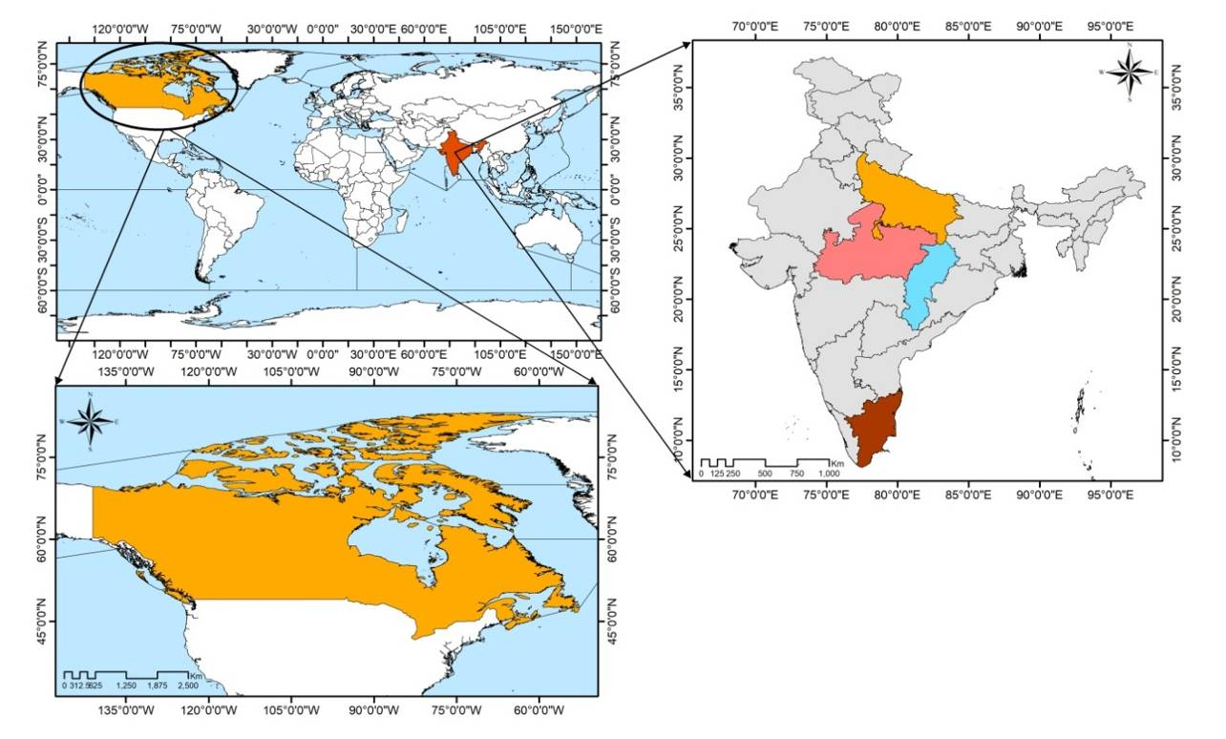
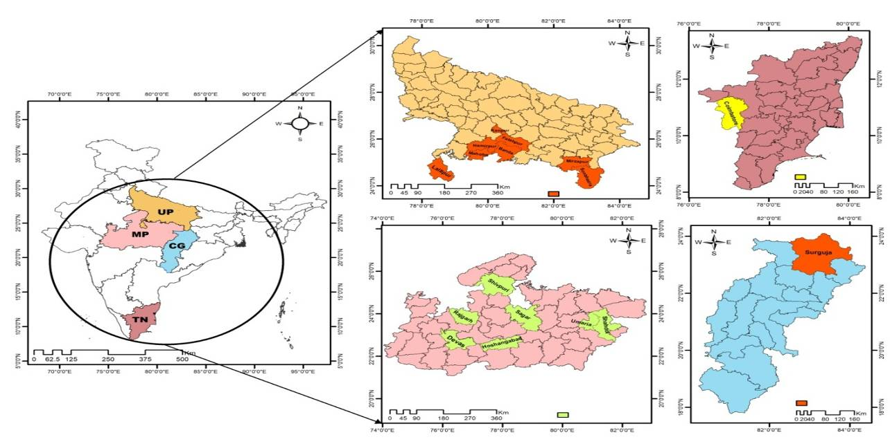
Supplementary Figure 1: Geographical location of sorghum germplasm collection from Canada and various states of the India. UP= Uttar Pradesh; MP=Madhya Pradesh; CG= Chhattisgarh; TN=Tamil Nadu

Supplementary Figure 2: Summary of disease reaction of sorghum germplasm to zonate leaf spot disease. HR= highly resistant; score 1.R= Resistant; score 2 to 4. MR= moderately resistant; score 4 to 6. S= Susceptible; score 6 to 7 and HS= Highly susceptible; score>7.

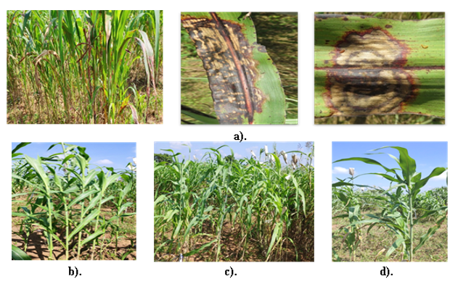
Supplementary Figure 3: a). Field photographs showing Zonate Leaf Spot disease response highly susuceptible check MP-Chari on leaves. b-d). Resistant genotypes reaction of EC-512397 against zonate leaf spot during two consecutive wet seasons at hotspot Jhansi, U.P. (India)

