Supplementary Table:
Table S1: Pedigree and Origin of 158 lentil germplasm lines used in the study
Sr.no. | Germplasm | Pedegree/Key feature/Method | Origin
1 | IC 560181 | Indian germplasm lines | NBPGR, New Delhi, India
2 | P13119 | ICARDA Nursery selection | ICARDA, Aleppo, Syria
3 | L7920 | Resistance to Fusarium | IARI, New Delhi, India
4 | DPL15 | Resistance to rust disease | -
5 | IG69568 | Advanced breeding lines | ICARDA, Aleppo, Syria
6 | KLS218 | Resistance to rust disease | CSAU, Kanpur
7 | P14105 | ICARDA Nursery selection | ICARDA, Aleppo, Syria
8 | P3235 | ICARDA Nursery selection | ICARDA, Aleppo, Syria
9 | P3234 | ICARDA Nursery selection | ICARDA, Aleppo, Syria
10 | P8112 | ICARDA Nursery selection | ICARDA, Aleppo, Syria
11 | PL639 | high yielder with more protein percentage | GBPUAT, Pantnagar, India
12 | NDL1 | High Yielding variety | India
13 | LL1122 | Elite breeding line (DPL15 × No. 303) | India
14 | L4649 | Advanced breeding lines | IARI, New Delhi, India
15 | ILWL118 | Advanced breeding lines | -
16 | ILL10832 | Mediterranean landraces | ICARDA, Aleppo, Syria
17 | P117 | Advanced breeding lines | GBPUAT, Pantnagar, India
18 | IC346092 | High Zn content | NBPGR, New Delhi, India
19 | 10-3-1-26 | Advanced breeding lines | -
20 | P13133 | Advanced breeding lines | ICARDA, Aleppo, Syria
21 | P13145 | ICARDA Nursery selection | ICARDA, Aleppo, Syria
22 | P15111 | ICARDA Nursery selection | ICARDA, Aleppo, Syria
23 | P14903 | ICARDA Nursery selection | ICARDA, Aleppo, Syria
24 | P13122 | ICARDA Nursery selection | ICARDA, Aleppo, Syria
25 | P16205 | ICARDA Nursery selection | ICARDA, Aleppo, Syria
26 | P8103 | ICARDA Nursery selection | ICARDA, Aleppo, Syria
27 | P13123 | ICARDA Nursery selection | ICARDA, Aleppo, Syria
28 | P14109 | ICARDA Nursery selection | ICARDA, Aleppo, Syria
29 | P13107 | ICARDA Nursery selection | ICARDA, Aleppo, Syria
30 | P13108 | ICARDA Nursery selection | ICARDA, Aleppo, Syria
31 | IPL321 | Resistance to Wilt | AICRP MULLaRP, IIPR, Kanpur India
32 | MC6 | Advanced breeding lines | India
33 | PL97 | Advanced breeding lines | GBPUAT, Pantnagar, India
34 | LH7-26 | Resistance to Wilt | India
35 | P13135 | ICARDA Nursery selection | ICARDA, Aleppo, Syria
36 | P3236 | ICARDA Nursery selection | ICARDA, Aleppo, Syria
37 | P15213 | ICARDA Nursery selection | ICARDA, Aleppo, Syria
38 | P13138 | ICARDA Nursery selection | ICARDA, Aleppo, Syria
39 | P13112 | ICARDA Nursery selection | ICARDA, Aleppo, Syria
40 | P13143 | ICARDA Nursery selection | ICARDA, Aleppo, Syria
41 | P15115 | ICARDA Nursery selection | ICARDA, Aleppo, Syria
42 | P13142 | ICARDA Nursery selection | ICARDA, Aleppo, Syria
43 | P13130 | ICARDA Nursery selection | ICARDA, Aleppo, Syria
44 | P15104 | ICARDA Nursery selection | ICARDA, Aleppo, Syria
45 | L11-223 | Advanced breeding lines | AICRP MULLaRP, IIPR, Kanpur India
46 | P13115 | ICARDA Nursery selection | ICARDA, Aleppo, Syria
47 | P15121 | ICARDA Nursery selection | ICARDA, Aleppo, Syria
48 | P8110 | ICARDA Nursery selection | ICARDA, Aleppo, Syria
49 | P13157 | ICARDA Nursery selection | ICARDA, Aleppo, Syria
50 | EC223212-A | Exotic germplasm | -
51 | EC223209-B | Exotic germplasm | -
52 | EC223207 | Exotic germplasm | -
53 | EC223205-B | Exotic germplasm | -
54 | EC223201 | Exotic germplasm | -
55 | P13109 | ICARDA Nursery selection | ICARDA, Aleppo, Syria
56 | P13128 | ICARDA Nursery selection | ICARDA, Aleppo, Syria
57 | L11-292 | Advanced breeding lines | AICRP MULLaRP, IIPR, Kanpur India
58 | P15207 | ICARDA Nursery selection | ICARDA, Aleppo, Syria
59 | P13131 | ICARDA Nursery selection | ICARDA, Aleppo, Syria
60 | EC78414 | Exotic germplasm | ICARDA, Aleppo, Syria
61 | EC78426 | Exotic germplasm | ICARDA, Aleppo, Syria
62 | EC223199-B | Exotic germplasm | ICARDA, Aleppo, Syria
63 | EC223197-A | Exotic germplasm | ICARDA, Aleppo, Syria
64 | EC223197-B | Exotic germplasm | ICARDA, Aleppo, Syria
65 | EC223191 | Exotic germplasm | ICARDA, Aleppo, Syria
66 | EC223150 | Exotic germplasm | ICARDA, Aleppo, Syria
67 | EC223221 | Exotic germplasm | ICARDA, Aleppo, Syria
68 | EC223220 | Exotic germplasm | ICARDA, Aleppo, Syria
69 | EC223215 | Exotic germplasm | ICARDA, Aleppo, Syria
70 | EC78545 | Exotic germplasm | ICARDA, Aleppo, Syria
71 | EC78543 | Exotic germplasm | ICARDA, Aleppo, Syria
72 | EC78541-A | Exotic germplasm | ICARDA, Aleppo, Syria
73 | EC78539 | Exotic germplasm | ICARDA, Aleppo, Syria
74 | EC78532 | Exotic germplasm | ICARDA, Aleppo, Syria
75 | EC78529 | Exotic germplasm | ICARDA, Aleppo, Syria
76 | EC78528 | Exotic germplasm | ICARDA, Aleppo, Syria
77 | EC267634 | Exotic germplasm | ICARDA, Aleppo, Syria
78 | EC78395 | Exotic germplasm | ICARDA, Aleppo, Syria
79 | EC78408 | Exotic germplasm | ICARDA, Aleppo, Syria
80 | EC78453 | Exotic germplasm | ICARDA, Aleppo, Syria
81 | EC78446 | Exotic germplasm | ICARDA, Aleppo, Syria
82 | EC78441-B | Exotic germplasm | ICARDA, Aleppo, Syria
83 | EC78438 | Exotic germplasm | ICARDA, Aleppo, Syria
84 | EC78437 | Exotic germplasm | ICARDA, Aleppo, Syria
85 | EC78434 | Exotic germplasm | ICARDA, Aleppo, Syria
86 | EC139824-A | Exotic germplasm | ICARDA, Aleppo, Syria
87 | EC78933 | Exotic germplasm | ICARDA, Aleppo, Syria
88 | EC78554 | Exotic germplasm | ICARDA, Aleppo, Syria
89 | EC329166 | Exotic germplasm | ICARDA, Aleppo, Syria
90 | EC267709 | Exotic germplasm | ICARDA, Aleppo, Syria
91 | EC267696 | Exotic germplasm | ICARDA, Aleppo, Syria
92 | EC223230 | Exotic germplasm | ICARDA, Aleppo, Syria
93 | EC223229-B | Exotic germplasm | ICARDA, Aleppo, Syria
94 | EC223229-A | Exotic germplasm | ICARDA, Aleppo, Syria
95 | EC223226 | Exotic germplasm | ICARDA, Aleppo, Syria
96 | EC223223 | Exotic germplasm | ICARDA, Aleppo, Syria
97 | EC223222 | Exotic germplasm | ICARDA, Aleppo, Syria
98 | EC78459 | Exotic germplasm | ICARDA, Aleppo, Syria
99 | EC267641 | Exotic germplasm | ICARDA, Aleppo, Syria
100 | EC267638 | Exotic germplasm | ICARDA, Aleppo, Syria
101 | EC267636 | Exotic germplasm | ICARDA, Aleppo, Syria
102 | EC267628-A | Exotic germplasm | ICARDA, Aleppo, Syria
103 | EC267625-C | Exotic germplasm | ICARDA, Aleppo, Syria
104 | EC267609 | Exotic germplasm | ICARDA, Aleppo, Syria
105 | EC267604 | Exotic germplasm | ICARDA, Aleppo, Syria
106 | EC267605 | Exotic germplasm | ICARDA, Aleppo, Syria
107 | EC267595-C | Exotic germplasm | ICARDA, Aleppo, Syria
108 | EC267567 | Exotic germplasm | ICARDA, Aleppo, Syria
109 | EC78498 | Exotic germplasm | ICARDA, Aleppo, Syria
110 | EC267676 | Exotic germplasm | ICARDA, Aleppo, Syria
111 | EC267544-A | Exotic germplasm | ICARDA, Aleppo, Syria
112 | EC78511 | Exotic germplasm | ICARDA, Aleppo, Syria
113 | EC78513 | Exotic germplasm | ICARDA, Aleppo, Syria
114 | EC78509 | Exotic germplasm | ICARDA, Aleppo, Syria
115 | EC78506 | Exotic germplasm | ICARDA, Aleppo, Syria
116 | EC78505 | Exotic germplasm | ICARDA, Aleppo, Syria
117 | EC78499 | Exotic germplasm | ICARDA, Aleppo, Syria
118 | EC255491 | Exotic germplasm | ICARDA, Aleppo, Syria
119 | EC2675770 | Exotic germplasm | ICARDA, Aleppo, Syria
120 | EC267573 | Exotic germplasm | ICARDA, Aleppo, Syria
121 | EC2675471 | Exotic germplasm | ICARDA, Aleppo, Syria
122 | EC267569-B | Exotic germplasm | ICARDA, Aleppo, Syria
123 | EC267569-A | Exotic germplasm | ICARDA, Aleppo, Syria
124 | EC267563 | Exotic germplasm | ICARDA, Aleppo, Syria
125 | EC267557-D | Exotic germplasm | ICARDA, Aleppo, Syria
126 | EC267554 | Exotic germplasm | ICARDA, Aleppo, Syria
127 | EC267545-D | Exotic germplasm | ICARDA, Aleppo, Syria
128 | EC225501 | Exotic germplasm | ICARDA, Aleppo, Syria
129 | EC223242 | Exotic germplasm | ICARDA, Aleppo, Syria
130 | EC223188 | Exotic germplasm | ICARDA, Aleppo, Syria
131 | EC78551-A | Exotic germplasm | ICARDA, Aleppo, Syria
132 | EC267540 | Exotic germplasm | ICARDA, Aleppo, Syria
133 | EC223397 | Exotic germplasm | ICARDA, Aleppo, Syria
134 | EC267539 | Exotic germplasm | ICARDA, Aleppo, Syria
135 | EC267536 | Exotic germplasm | ICARDA, Aleppo, Syria
136 | EC267533 | Exotic germplasm | ICARDA, Aleppo, Syria
137 | EC267529 | Exotic germplasm | ICARDA, Aleppo, Syria
138 | EC78488 | Exotic germplasm | ICARDA, Aleppo, Syria
139 | EC78474 | Exotic germplasm | ICARDA, Aleppo, Syria
140 | EC78472 | Exotic germplasm | ICARDA, Aleppo, Syria
141 | EC78542-A | Exotic germplasm | ICARDA, Aleppo, Syria
142 | EC78477-A | Exotic germplasm | ICARDA, Aleppo, Syria
143 | EC78476 | Exotic germplasm | ICARDA, Aleppo, Syria
144 | EC78425 | Exotic germplasm | ICARDA, Aleppo, Syria
145 | EC78423 | Exotic germplasm | ICARDA, Aleppo, Syria
146 | EC78421 | Exotic germplasm | ICARDA, Aleppo, Syria
147 | EC241476 | Exotic germplasm | ICARDA, Aleppo, Syria
148 | EC78397 | Exotic germplasm | ICARDA, Aleppo, Syria
149 | EC78524-A | Exotic germplasm | ICARDA, Aleppo, Syria
150 | EC78520 | Exotic germplasm | ICARDA, Aleppo, Syria
151 | EC78519 | Exotic germplasm | ICARDA, Aleppo, Syria
152 | EC78518 | Exotic germplasm | ICARDA, Aleppo, Syria
153 | EC78517 | Exotic germplasm | ICARDA, Aleppo, Syria
154 | EC78515 | Exotic germplasm | ICARDA, Aleppo, Syria
155 | EC78487 | Exotic germplasm | ICARDA, Aleppo, Syria
156 | EC78495 | Exotic germplasm | ICARDA, Aleppo, Syria
157 | EC78491 | Exotic germplasm | ICARDA, Aleppo, Syria
158 | EC78490 | Exotic germplasm | ICARDA, Aleppo, Syria
Table S2: Estimates of general statistical parameters such as range, means, slandered error, standard deviation, skewness and kurtosis for different characters
Trait | Min | Max | Mean | Standard deviations | Standard errors | Skewness | Kurtosis
Plant height (cm) | 35.01 | 43.44 | 38.48 | 1.57 | 0.13 | -0.17 ^{ns} | 4.10*
Days to 50% flowering | 67 | 90 | 77 | 5.42 | 0.43 | 0.58** | 2.54 ^{ns}
Days to maturity | 109 | 122 | 115 | 2.58 | 0.21 | -0.27 ^{ns} | 5.34**
Number of pods per plant | 33 | 110 | 58 | 14.5 | 1.15 | 0.71** | 3.41 ^{ns}
Hundred seed weight (g) | 1.69 | 2.68 | 2.11 | 0.21 | 0.02 | 0.27 ^{ns} | 2.38*
Grain yield per plant (g) | 0.86 | 3.67 | 1.6 | 0.48 | 0.04 | 1.00** | 4.53**
Note: ^{ns}Nonsignificant, *Significant at 5% probability level, **Significant at 1% probability level.

Table S3: Cluster composition for clusters constructed using hierarchical clustering
Cluster | Accessions
Cluster I | P13130, EC78395, MC6, EC223191, IG69568, KLS218, P8110, EC223229-A, L4649, EC329166, EC223197-B, EC241476, L7920, P13157, L11-292, EC78437, P3235, EC78532, EC225501, EC78551-A, EC78490, EC78541-A, EC267625-C, EC223229-B, PL97, EC78423, EC267676, EC78472, EC78453, EC267605, EC223215, EC223188, EC78524-A, EC78511, EC267545-D, P13131, EC78488, EC78414, EC78477-A, P16205, P13109, 10-3-1-26, P13107, P13123, ILL10832, P15207, L11-223, ILWL118, EC223220, EC78528, PL639, P13122, P13135, EC78554, EC78543, P13145, EC78542-A, EC78434, EC267628-A, EC267709, EC78397, EC78495, EC78426, EC78539, EC78421, EC223226, IC 560181, EC78499, EC78545, P14903, P117 and EC267569-B.
Cluster II | EC267563, EC223209-B, EC223230, EC78506, EC223222, EC267567, EC255491, EC267569-A, EC267536, EC78441-B, EC223223, EC78515, EC78487, EC78519, EC78933, EC267638, EC267573, EC267554, EC78474, EC267595-C, EC78446, EC78520, P8112, EC223197-A, EC267696, EC223242, EC267557-D, EC267529, P14109, EC78425, EC223205-B, EC267634, EC267609, EC267533, EC267540, EC78505, EC267539, EC267641, EC2675770, EC78459, EC78517, EC267636, EC78518, EC139824-A, EC2675471, EC223199-B, EC223207, EC78476, EC223397, EC267604, EC78509, EC223150, EC78513, EC78529, LH7-26, EC223221, P13119, P15104, P13108, P3236, LL1122, EC223212-A, DPL15, EC223201, EC267544-A, P15213, P15115, P15121, P13128, P8103, P13138, IC346092, P13133, P13142, P3234 and P15111.
Cluster III | EC78438
Cluster IV | EC78491, EC78408, P13112, EC78498, P13115, DL1, P13143, P14105 and IPL321.

Variable | PC1 | PC2 | PC3 | PC4 | PC5 | PC6
Plant height | 19.38 | 2.37 | 8.84 | 69.11 | 0.13 | 0.17
Days to 50% flowering | 22.53 | 17.26 | 4.16 | 7.96 | 47.65 | 0.45
Days to maturity | 27.15 | 12.79 | 0.45 | 8.67 | 49.03 | 1.92
Number of pods per plant | 15.30 | 27.46 | 10.49 | 0.18 | 0.95 | 45.62
Hundred seed weight | 3.27 | 3.30 | 75.36 | 13.38 | 0.52 | 4.17
Grain yield per plant | 12.37 | 36.82 | 0.71 | 0.70 | 1.73 | 47.68
Table S4: Summarizing the percentage contribution of variables for principal component.

Supplementary Figure:

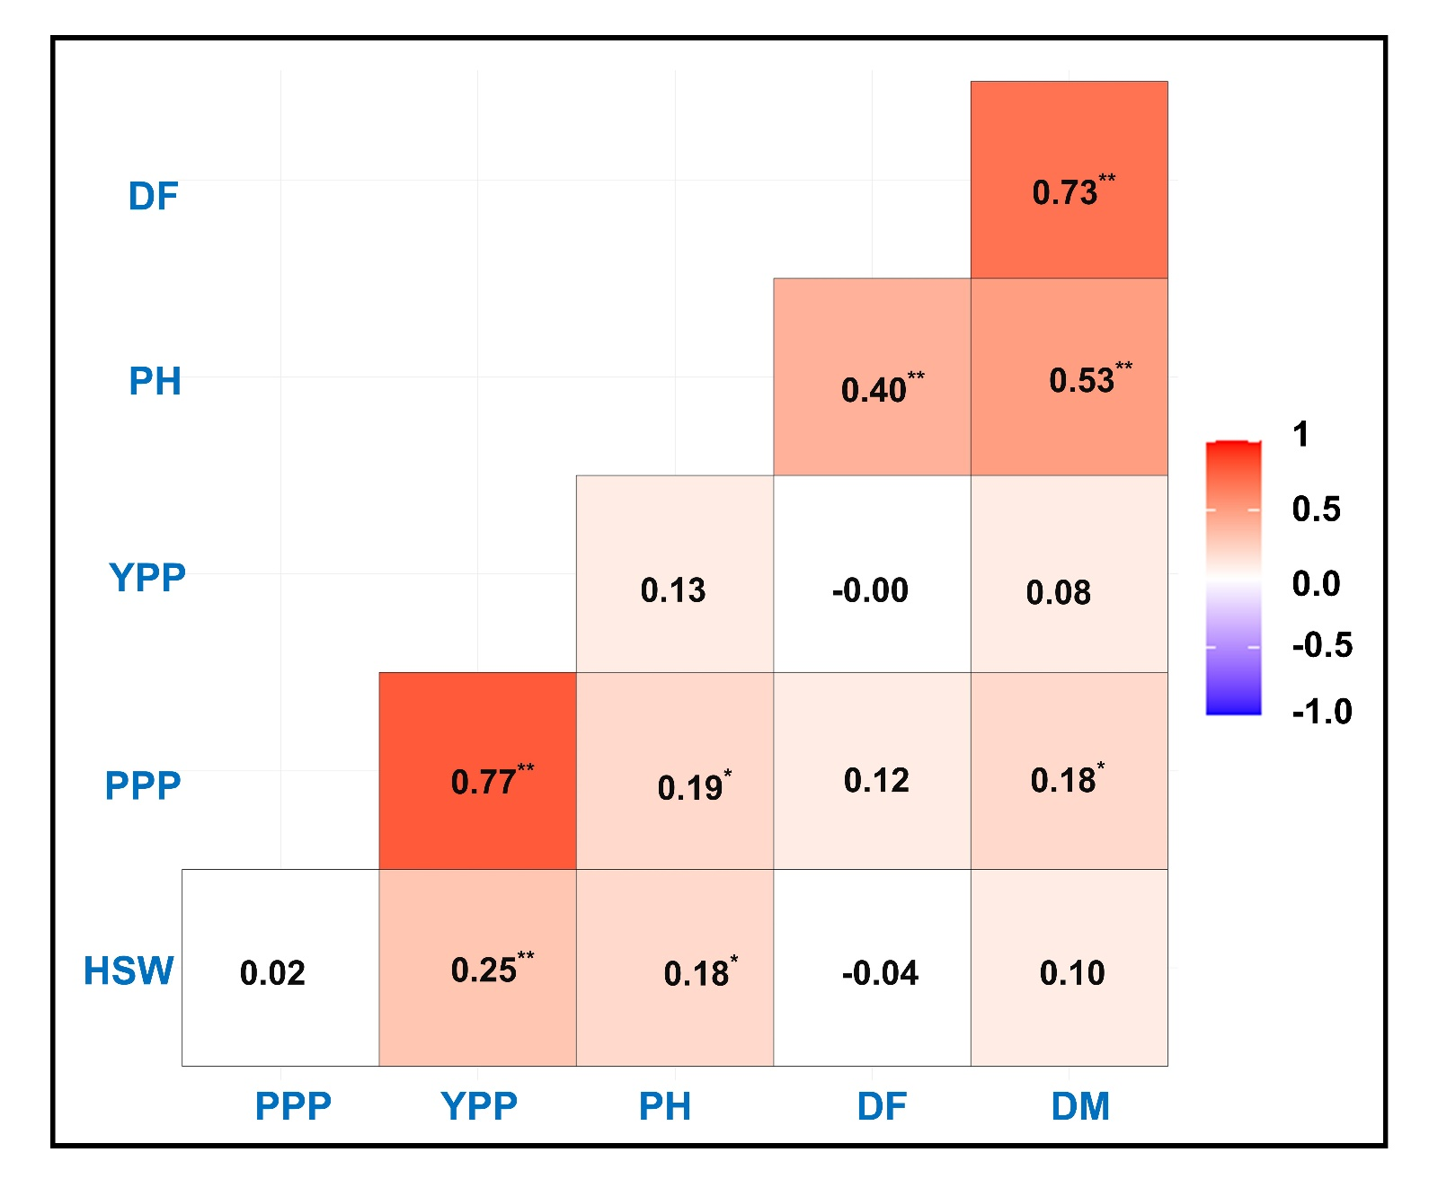
Figure S1: Pearson correlation matrix for pair-wise combinations of six traits among 158 lentil accessions. The color denotes the correlation, where 1 represents a complete positive correlation (dark orange) and −1 represents a complete negative correlation (dark purple) between two traits. Values indicate the magnitude of association and * represents the significance level. * and **Significant at 5% and 1% probability, respectively. Note: Plant height (PH), Days to 50% flowering (DF) Days to maturity (DM), Number of pods per plant (PPP), Hundred seed weight (HSW), Grain yield per plant (YPP).

