Table S1. Origin and maturity groups of soybean germplasm
Accessions | Origin | MG
A1 | Niedersachsen, Germany | 000
A2 | Minnesota, United States | 00
A3 | Ontario, Canada | 00
A4 | Ontario, Canada | 00
A5 | Ontario, Canada | 00
A6 | United States | 00
A7 | Ontario, Canada | 0
A8 | France | 0
A9 | United States | 0
A10 | Minnesota, United States | 0
A11 | United States | 0
A12 | Amur, Russian Federation | 0
A13 | United States | 0
A14 | North Dakota, United States | 0
A15 | Minnesota United States | 0
A16 | United States | 0
A17 | Minnesota United States | 0
A18 | Esfahan, Iran | I
A19 | Bosnia and Herzegovina | I
A20 | United States | I
A21 | Dnipropetrovsk, Ukraine | I
A22 | Jilin Sheng, China | I
A23 | Wisconsin, United States | I
A24 | United States | I
A25 | Kyonggi, Korea South | I
A26 | United States | I
A27 | Minnesota, United States | I
A28 | Unknown | I
A29 | Russian Federation | I
A30 | United States | I
A31 | United States | I
A32 | United States | I
A33 | United States | I
A34 | United States | I
A35 | United States | I
A36 | United States | I
A37 | United States | I
A38 | China | I
A39 | United States | I
A40 | United States | I
A41 | United States | I
A42 | Wisconsin, United States | II
A43 | United States | II
A44 | United States | II
A45 | United States | II
A46 | Indiana, United States | II
A47 | Illinois, United States | II
A48 | United States | II
A49 | United States | II
A50 | United States | II
A51 | United States | II
A52 | Illinois, United States | II
A53 | United States | II
A54 | United States | II
A55 | United States | II
A56 | United States | II
A57 | United States | II
A58 | United States | II
A59 | Unknown | Unknown
A60 | United States | Unknown
A61 | Illinois, USA | IV
A62 | Kentucky, USA | IV
A63 | North Carolina, USA | IV
A64 | Ohio, USA | III
A65 | United States | II
A66 | Indiana, USA | II
A67 | Ohio, USA | III
A68 | Nebraska, USA | III
A69 | United States | IV
A70 | United States | III
A71 | Unknown | Unknown
A72 | Illinois, USA | Unknown
A73 | Illinois USA | Unknown
A74 | Mississippi, USA | Unknown
A75 | Illinois, USA | IV
A76 | Missouri, USA | Unknown
A77 | North Carolina, USA | Unknown
A78 | Illinois, USA | Unknown
A79 | Illinois, USA | IV
A80 | Nebraska, USA | III
A81 | Ohio, USA | III
A82 | Illinois, USA | IV
A83 | Indiana, USA | IV
A84 | Maryland, USA | Unknown
A85 | Maryland, USA | Unknown
A86 | Minnesota, USA | 0
A87 | United States | II
A88 | Ohio, United States | II
A89 | Illinois, USA | III
A90 | Maryland, USA | IV
A91 | Iowa, USA | III
A92 | Ontario, Canada | II
A93 | Iowa, USA | III
A94 | Kansas, USA | IV
A95 | Delaware, USA | IV
A96 | Missouri, USA | IV
A97 | Unknown | Unknown
A98 | Unknown | Unknown
A99 | Illinois, United States | IV
A100 | Iowa, USA | III
A101 | United States | III
A102 | Illinois, United States | III
A103 | United States | III
A104 | United States | III
A105 | United States | III
A106 | United States | IV
A107 | China | IV
A108 | Illinois, United States | IV
A109 | United States | IV
A110 | United States | IV
A111 | Ohio, United States | IV
A112 | Ohio, United States | IV
A113 | Ohio, United States | IV
A114 | Ohio, United States | IV
A115 | Heilongjiang Sheng, China | IV
A116 | Hukusimia, Japan | IV
A117 | Ajmeri (Local)
A118 | Faisal Soy (Local)
A119 | Malakand (Local)
A120 | NARC-II (Local)
A121 | Rawal (Local)
A122 | Swat-18 (Local)
A123 | William (Local)

Table S2. Summary of six agro-morphological traits of soybean germplasm.
 | Year 2020 |  |  |  |  | Year 2021
 | Range | Mean | Var. (n) | SD (n) | CV % | Range | Mean | Var. (n) | SD (n) | CV %
PH | 10.9-72 | 32.143 | 108.131 | 10.399 | 32.351 | 7.9-74 | 32.17 | 134.397 | 11.593 | 36.02
Pods | 9-119 | 35.435 | 408.72 | 20.217 | 57.053 | 5-115 | 35.6 | 344.8 | 18.57 | 52.15
Seeds | 17-249 | 70.043 | 1577.711 | 39.72 | 56.708 | 4-225 | 71.9 | 1282.8 | 35.8 | 49.75
HSW | 7.5-17.6 | 12.43 | 4.452 | 2.11 | 16.974 | 5-21.6 | 12.44 | 11.93 | 3.45 | 27.76
YPP | 1.6-38.7 | 9.916 | 46.114 | 6.791 | 68.485 | 1.04-36.2 | 10.06 | 35.64 | 5.97 | 59.29
DM | 96-133 | 114.5 | 58.276 | 7.634 | 6.666 | 95-133 | 114.5 | 60.29 | 7.76 | 6.78
SD: Standard deviation, CV: Variation coefficient, Var: Variance, PH: Plant height, Pods: Number of pods, Seeds: Number of seeds, HSW: 100 seed weight, YPP: Yield per plant, DM: Days to maturity.

Figure S1. Mean comparison of plant height and number of pods of soybean accessions for the years 2020 and 2021 on both plantation dates

Figure S2. Mean comparison of seeds and 100-seed weight of soybean accessions for the years 2020 and 2021 on both plantation dates.

Figure S3. Mean comparison of yield per plant and days to maturity of soybean genotypes for the years 2020 and 2021 on both plantation dates.

Figure S4: Climatic diagrams across the study period of 2020 and 2021.

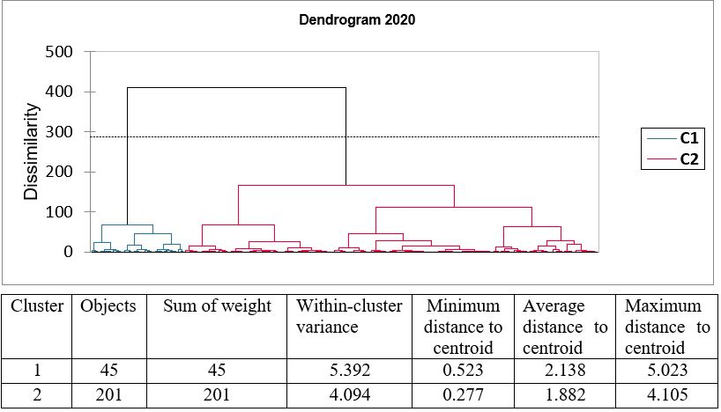

Figure S5. Combined cluster analysis of 123 Soybean genotypes of both plantation dates for the year 2020.

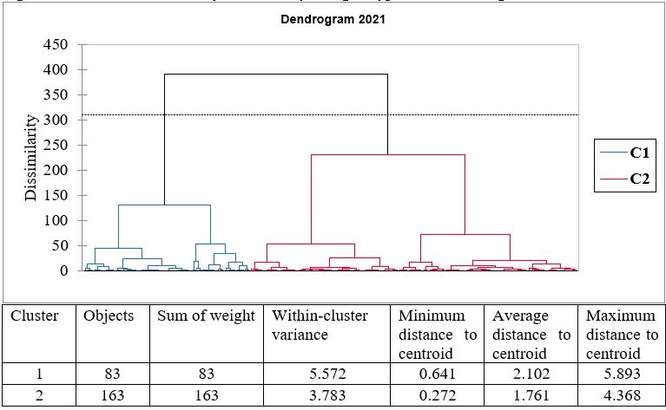
Figure S6: Combined cluster analysis of 123 Soybean genotypes of both plantation dates for the year 2021.

