Table S1. Sample size, location information, and ADMIXTURE cluster information for each collection site.
Site | No. samples | Latitude | Longitude | K1¹ | K2
S1 | 15 | 34.38444 | 126.7967 | 7 | 8
S2 | 12 | 34.33806 | 125.9994 | 4 | 8
S3 | 28 | 34.83861 | 126.1436 | 10 | 18
S4 | 14 | 34.84528 | 126.255 | 12 | 2
S5 | 16 | 34.9365 | 126.3241 | 10 | 6
S6 | 11 | 34.28389 | 126.0494 | 7 | 4
¹ ADMIXTURE clusters

Table S2. Analysis of molecular variance (AMOVA) results among and within the population in the six samples and the sub-population, as derived from the ADMIXTURE analysis.
 |  | Df | SS | MS | Est. Var. | % | PhiPT | p value
Collection  Site | Among population | 5 | 659.7 | 131.9 | 0.7 | 0.60 | 0.0056 | 0.04
 | Within population | 90 | 10913.1 | 121.3 | 121.3 | 99.40
 | Total | 95 | 11572.8 | 121.8 | 121.9 | 100.00
ADMIXTURE | Among population | 5 | 659.7 | 131.9 | 0.7 | 0.56 | 0.0056 | 0.03
 | Within population | 90 | 10913.1 | 121.3 | 121.3 | 99.44
 | Total | 95 | 11572.8 | 121.8 | 121.9 | 100.00
1 df, degree of freedom; SS, sum of squares; MS, mean squares; Est. Var., estimates of variance; %, percent of variance

Table S3. Pairwise F_{st} values for the Centella asiatica samples analyzed in this study.
 | S1 | S2 | S3 | S4 | S5
S2 | 0.000031
S3 | 0.000448 | -0.00025
S4 | 0.000308 | 0.000451 | 0.00001
S5 | 0.000368 | 0.000303 | 0.00023 | 0.000672
S6 | 0.000306 | 0.000284 | -0.00017 | 0.000385 | 0.00034

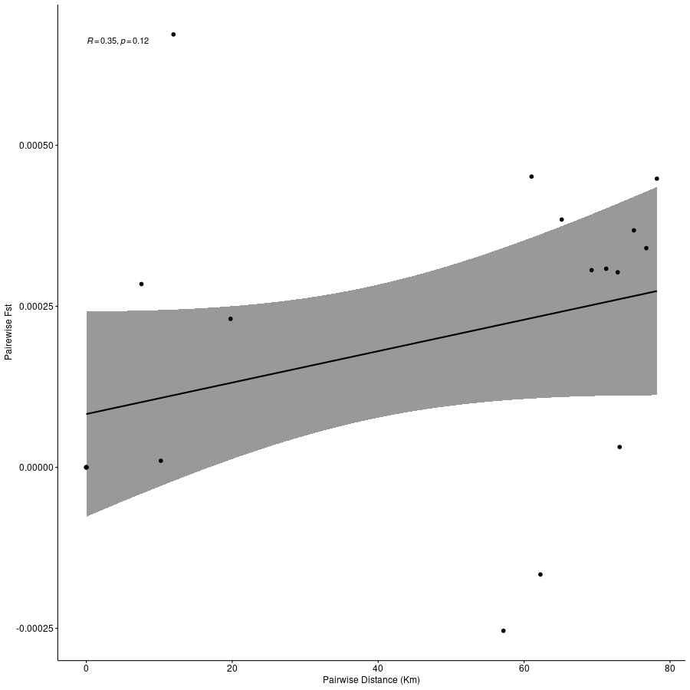
Figure S1. Isolation-by-distance (IBD) patterns for Centella asiatica determined using the Mantel test. The regression of the standardized genetic differentiation F_{st} vs. the geographic distance (km) is not significant.

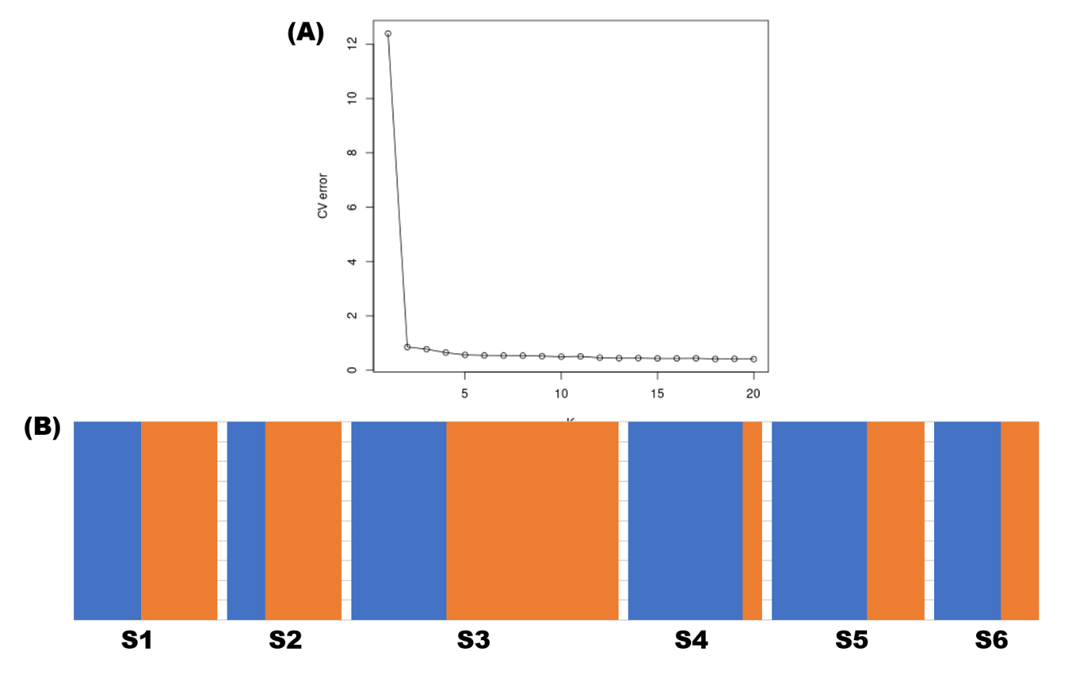
Figure S2. Genetic admixture of the Centella asiatica samples analyzed in this study. (A) Optimal clusters as determined using the Bayesian information criterion (BIC). The optimal K value for admixture is two based on 10 replicates of K 1–20, determined using a cross-validation method. (B) Bar plots of the membership probabilities at K = 2.

