Table S1. Germplasm accessions used in the study
S. No. | Genotype | Origin
 | Pole type
 | VRSEM 06 | Tripura, India
 | VRSEM 11 | Tripura, India
 | VRSEM 101 | Meghalaya, India
 | VRSEM 109 | Rajgarh, Chattisgarh, India
 | VRSEM 186 | Gorakhpur, U.P., India
 | VRSEM 201 | Meghalaya, India
 | VRSEM 734 | Indian Institute of Vegetable Research, U.P., India
 | VRSEM 797 | Gadiya
 | VRSEM 815 | Navsari, Gujarat, India
 | VRSEM 890 | Navsari, Gujarat, India
 | VRSEM 891 | Navsari, Gujarat, India
 | VRSEM 902 | Navsari, Gujarat, India
 | Swarna Utkrist | ICAR-RCER, Ranchi, India
 | VRDB-01 | Indian Institute of Vegetable Research, U.P., India
 | RP-08-50
 | VRSEM 916
 | VRSEM 941
 | VRSEM 950
 | VRSEM 1000
 | Bush type
 | VRBSEM-1 | Indian Institute of Vegetable Research, U.P., India
 | Kashi Kaushal (VRBSEM-3)
 | VRBSEM-8
 | VRBSEM-9
 | VRBSEM-10
 | VRBSEM-14
 | VRBSEM-15
 | VRBSEM-16
 | VRBSEM-17
 | VRBSEM-18
 | VRBSEM-19
 | VRBSEM-28
 | VRBSEM-29
 | VRBSEM-35
 | VRBSEM-200
 | VRBSEM-201
 | VRBSEM-202
 | VRBSEM-203
 | VRBSEM-204
 | VRBSEM-205
 | VRBSEM-206
 | VRBSEM-207
 | VRBSEM-208
 | VRBSEM-209
 | VRBSEM-744
 | Arka Soumya | Indian Institute of Horticultural Research, Karnataka, India
 | Konkan Bhushan | Konkan Krishi Vidyapeeth, Maharashtra, India
 | Ankur Goldy | Ankur Seeds Pvt. Ltd., Maharashtra, India

Table S2. Dolichos bean genotypes used in the study and their copper, iron, manganese, zinc contents and yield attributes
Sr. No. | Genotypes | Cu (mg/Kg) | Fe (mg/Kg) | Mn  (Mg/Kg) | Zn  (mg/Kg) | Pod Length (cm) | Pigmentation on Pod | Yield/plant (Kg)
 | Pole types
 | VRDB-01 | 18.10 ± 0.28 | 292.85 ± 0.12 | 34.60 ± 0.64 | 68.33 ± 0.51 | 10.46 ± 1.12 | Absent | 2.13 ± 0.10
 | RP-08-50 | 18.55 ± 0.58 | 154.73 ± 4.86 | 29.48 ± 0.48 | 62.25 ± 0.72 | 5.57 ± 0.79 | Absent | 2.34 ± 0.17
 | VRSEM 06 | 16.40 ± 0.17 | 86.90 ± 1.99 | 22.78 ± 0.19 | 56.90 ± 0.00 | 12.81± 0.66 | Present | 2.39 ± 0.15
 | VRSEM 11 | 19.95 ± 0.09 | 116.20 ± 3.20 | 37.15 ± 0.12 | 79.70 ± 10.93 | 13.09 ± 0.91 | Present | 2.29 ± 0.19
 | VRSEM 101 | 16.55 ± 0.26 | 175.40 ± 3.55 | 34.48 ± 0.16 | 62.03 ± 0.25 | 8.76 ± 0.80 | Present | 3.10 ± 0.20
 | VRSEM 109 | 18.40 ± 0.43 | 230.48 ± 7.69 | 35.50 ± 0.43 | 59.55 ± 1.36 | 8.88 ± 0.93 | Absent | 1.76 ± 0.20
 | VRSEM 186 | 16.08 ± 0.53 | 77.13 ± 3.22 | 27.63 ± 1.08 | 53.20 ± 0.20 | 13.89 ± 0.62 | Absent | 2.47 ± 0.16
 | VRSEM 201 | 12.85 ± 1.33 | 93.88 ± 6.91 | 32.53 ± 1.60 | 42.03 ± 1.69 | 9.50 ± 0.94 | Present | 2.57 ± 0.13
 | VRSEM 734 | 16.85 ± 0.28 | 111.98 ± 4.98 | 31.15 ± 1.04 | 63.13 ± 0.79 | 10.62 ± 1.00 | Absent | 3.18 ± 0.23
 | VRSEM 797 | 15.33 ± 0.10 | 118.53 ± 2.32 | 39.78 ± 0.51 | 62.98 ± 1.05 | 8.63 ± 0.92 | Absent | 2.76 ± 0.19
 | VRSEM 815 | 18.25 ± 0.35 | 100.40 ± 1.04 | 32.25 ± 0.09 | 64.23 ± 0.59 | 6.76 ± 0.75 | Absent | 3.73 ± 0.23
 | VRSEM 890 | 12.55 ± 0.26 | 113.15 ± 6.09 | 29.40 ± 0.43 | 56.13 ± 0.13 | 8.47 ± 0.85 | Absent | 3.17 ± 0.21
 | VRSEM 891 | 18.40 ± 0.43 | 122.93 ± 0.88 | 28.73 ± 0.04 | 69.48 ± 0.51 | 9.54 ± 0.85 | Absent | 1.25 ± 0.20
 | VRSEM 902 | 19.18 ± 0.36 | 121.20 ± 2.11 | 35.50 ± 0.92 | 66.78 ± 0.62 | 5.63 ± 0.66 | Absent | 0.24 ± 0.02
 | VRSEM 916 | 16.10 ± 0.35 | 96.38 ± 3.05 | 36.80 ± 0.23 | 60.58 ± 0.42 | 8.68 ± 1.04 | Absent | 2.36 ± 0.17
 | VRSEM 941 | 19.48 ± 0.71 | 99.93 ± 2.87 | 36.20 ± 1.15 | 62.18 ± 2.44 | 8.17 ± 0.96 | Present | 1.17 ± 0.15
 | VRSEM 950 | 15.00 ± 0.63 | 95.33 ± 2.64 | 31.83 ± 0.07 | 58.45 ± 0.20 | 7.08 ± 0.82 | Absent | 0.67 ± 0.14
 | VRSEM 1000 | 10.10 ± 0.63 | 331.93 ± 6.08 | 46.40 ± 0.03 | 102.85 ± 0.69 | 14.17 ± 0.61 | Present | 1.87 ± 0.25
 | Swarna Utkrist | 12.10 ± 0.56 | 85.93 ± 1.66 | 22.98 ± 0.56 | 54.28 ± 0.51 | 11.13 ± 0.61 | Absent | 1.43 ± 0.21
Bush types
 | VRBSEM-1 | 8.20 ± 0.92 | 57.15 ± 0.72 | 34.35 ± 1.20 | 39.65 ± 1.38 | 6.82 ± 0.19 | Absent | 0.48 ± 0.04
 | VRBSEM-3 | 17.90 ± 0.83 | 99.30 ± 0.58 | 34.95 ± 0.97 | 56.60 ± 0.99 | 12.26 ± 0.49 | Absent | 0.45 ± 0.03
 | VRBSEM-8 | 15.10± 0.87 | 59.15 ± 0.59 | 36.60 ± 0.87 | 53.70 ± 0.76 | 9.47 ± 0.43 | Absent | 0.42 ± 0.03
 | VRBSEM-9 | 18.50 ± 0.92 | 66.85 ± 0.91 | 38.30 ± 1.25 | 58.05 ± 1.05 | 9.65 ± 0.48 | Absent | 0.61 ± 0.04
 | VRBSEM-10 | 15.10 ± 1.07 | 70.35 ± 1.01 | 35.65 ± 0.84 | 60.50 ± 0.98 | 9.51 ± 0.44 | Absent | 0.46 ± 0.04
 | VRBSEM-14 | 17.25 ± 0.61 | 71.90 ± 1.12 | 29.85 ± 1.08 | 60.35 ± 1.13 | 9.76 ± 0.56 | Absent | 0.56 ± 0.03
 | VRBSEM-15 | 14.45 ± 0.94 | 72.35 ± 0.58 | 34.80 ± 1.01 | 60.95 ± 0.95 | 11.58 ± 0.40 | Absent | 0.41 ± 0.03
 | VRBSEM-16 | 14.75 ± 1.08 | 64.30 ± 0.79 | 30.55 ± 1.06 | 56.60 ± 0.81 | 11.90 ± 0.49 | Absent | 0.27 ± 0.03
 | VRBSEM-17 | 16.00 ± 0.70 | 67.10 ± 0.68 | 37.20 ± 0.66 | 49.35 ± 1.27 | 9.14 ± 0.55 | Absent | 0.38 ± 0.04
 | VRBSEM-18 | 12.90 ± 0.72 | 66.85 ± 0.96 | 34.80 ± 0.74 | 51.95 ± 1.09 | 9.75 ± 0.71 | Present | 0.44 ± 0.04
 | VRBSEM-19 | 14.15 ± 0.64 | 71.60 ± 0.87 | 37.45 ± 0.98 | 63.25 ± 1.25 | 9.86 ±0.47 | Present | 0.38 ± 0.03
 | VRBSEM-28 | 10.70 ± 1.15 | 65.90 ± 1.03 | 34.50 ± 0.80 | 44.85 ± 1.43 | 6.71 ± 0.40 | Present | 0.45 ± 0.03
 | VRBSEM-29 | 11.65 ± 0.84 | 63.10 ± 0.95 | 25.90 ± 1.15 | 48.05 ± 0.87 | 9.71 ± 0.44 | Absent | 0.27 ± 0.03
 | VRBSEM-35 | 12.60 ± 1.09 | 82.20 ± 0.92 | 34.50 ± 1.13 | 51.80 ± 1.41 | 5.13 ± 0.38 | Absent | 0.24 ± 0.03
 | VRBSEM-200 | 15.10 ± 0.67 | 81.00 ± 1.14 | 33.40 ± 0.85 | 61.25 ± 1.24 | 10.44 ± 0.39 | Absent | 0.47 ± 0.04
 | VRBSEM-201 | 11.65 ± 0.33 | 73.85 ± 0.73 | 28.75 ± 1.07 | 52.10 ± 1.15 | 11.04 ± 0.46 | Absent | 0.41 ± 0.03
 | VRBSEM-202 | 12.25 ± 0.41 | 54.75 ± 0.90 | 27.90 ± 0.78 | 45.30 ± 0.91 | 11.35 ± 0.48 | Absent | 0.32 ± 0.03
 | VRBSEM-203 | 15.40 ± 0.62 | 61.55 ± 1.06 | 42.40 ± 1.09 | 44.00 ± 1.02 | 7.61 ± 0.43 | Absent | 0.37 ± 0.03
 | VRBSEM-204 | 11.00 ± 0.95 | 51.20 ± 0.72 | 32.80 ± 1.31 | 38.75 ± 0.97 | 7.24 ± 0.38 | Absent | 0.21 ± 0.02
 | VRBSEM-205 | 10.40 ± 0.72 | 70.35 ± 1.09 | 27.60 ± 1.09 | 46.60 ± 0.97 | 7.97 ± 0.45 | Absent | 0.17 ± 0.03
 | VRBSEM-206 | 17.25 ± 0.88 | 64.70 ± 0.94 | 31.25 ± 0.87 | 52.25 ± 1.19 | 10.22 ± 0.49 | Absent | 0.42 ± 0.03
 | VRBSEM-207 | 13.50 ± 0.56 | 51.60 ± 0.91 | 25.65 ± 1.07 | 38.50 ± 1.37 | 11.41 ± 0.57 | Absent | 0.51 ± 0.04
 | VRBSEM-208 | 8.20 ± 0.78 | 63.90 ± 0.90 | 33.50 ± 1.25 | 37.15 ± 1.18 | 5.10 ± 0.40 | Absent | 0.25 ± 0.04
 | VRBSEM-209 | 12.60 ± 0.48 | 71.85 ± 0.69 | 53.25 ± 1.22 | 52.85 ± 0.96 | 6.66 ± 0.47 | Absent | 0.12 ± 0.01
 | VRBSEM-744 | 10.10 ± 0.26 | 50.80 ± 0.59 | 30.55 ± 0.68 | 44.85 ± 1.15 | 8.20 ± 0.30 | Absent | 0.31 ± 0.02
 | Arka Soumya | 13.20 ± 0.95 | 56.75 ± 0.89 | 39.70 ± 0.85 | 46.75 ± 0.93 | 11.22 ± 0.41 | Absent | 0.31 ± 0.02
 | Konkan Bhushan | 12.90 ± 0.45 | 68.75 ± 0.58 | 33.40 ± 1.23 | 44.85 ± 1.02 | 9.42 ± 0.47 | Absent | 0.31 ± 0.03
 | Ankur Goldy | 11.65 ± 0.93 | 77.80 ± 0.91 | 33.50 ± 1.30 | 50.05 ± 1.12 | 10.09 ± 0.45 | Absent | 0.43 ± 0.03

Table S3. Micronutrient contents of selected Dolichos genotypes in comparison to released varieties (Check)
Sr. No. | Genotypes | Cu (mg/Kg) | Fe (mg/Kg) | Mn  (Mg/Kg) | Zn  (mg/Kg)
 | Pole types
 | VRDB-01 | 18.10 ± 0.28 | 292.85 ± 0.12 | 34.60 ± 0.64 | 68.33 ± 0.51
 | VRSEM 109 | 18.40 ± 0.43 | 230.48 ± 7.69 | 35.50 ± 0.43 | 59.55 ± 1.36
 | VRSEM 1000 | 10.10 ± 0.63 | 331.93 ± 6.08 | 46.40 ± 0.03 | 102.85 ± 0.69
 | Swarna Utkrist | 12.10 ± 0.56 | 85.93 ± 1.66 | 22.98 ± 0.56 | 54.28 ± 0.51
 | Bush types
 | VRBSEM-3 | 17.90 ± 0.83 | 99.30 ± 0.58 | 34.95 ± 0.97 | 56.60 ± 0.99
 | VRBSEM-35 | 12.60 ± 1.09 | 82.20 ± 0.92 | 34.50 ± 1.13 | 51.80 ± 1.41
 | VRBSEM-200 | 15.10 ± 0.67 | 81.00 ± 1.14 | 33.40 ± 0.85 | 61.25 ± 1.24
 | Arka Soumya | 13.20 ± 0.95 | 56.75 ± 0.89 | 39.70 ± 0.85 | 46.75 ± 0.93
 | Konkan Bhushan | 12.90 ± 0.45 | 68.75 ± 0.58 | 33.40 ± 1.23 | 44.85 ± 1.02
 | Ankur Goldy | 11.65 ± 0.93 | 77.80 ± 0.91 | 33.50 ± 1.30 | 50.05 ± 1.12

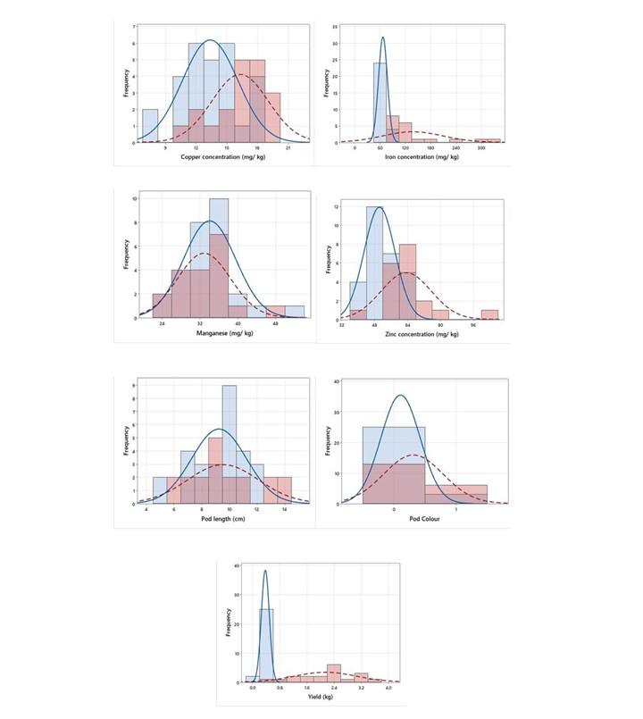Fig. S1: Frequency distribution of 19 pole and 28 bush genotypes of Dolichos bean for micronutrient contents and yield attributing traits. Plain curve represents distribution of bush genotypes while dotted curve denotes pole genotypes. X-axis denotes number of genotypes; the Y-axis represents concentrations.

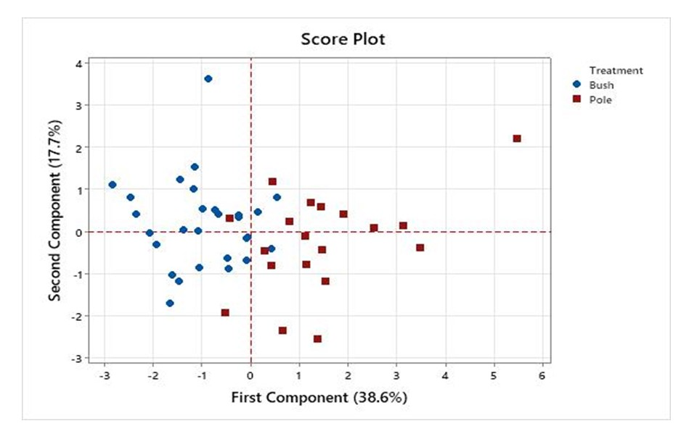Fig. S2: Scatterplot of first versus second principal component showing grouping of 19 pole types and 28 bush types Dolichos bean genotypes.

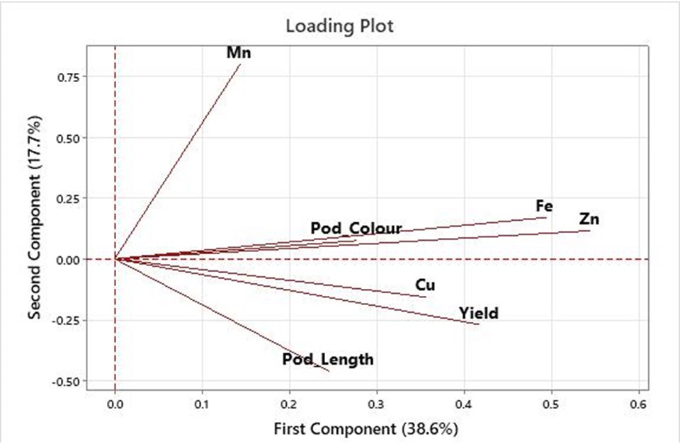Fig. S3: Principal component analysis loading plot based on correlation matrix of micronutrients and yield attributes recorded on 19 pole and 28 bush types Dolichos bean genotypes.

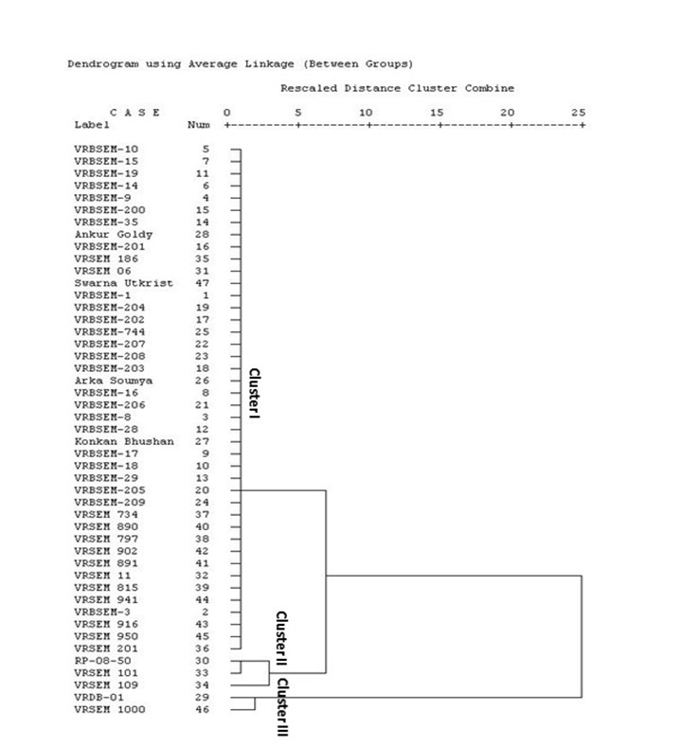Fig. S4: Two-dimensional dendrogram of 19 pole and 28 bush types Dolichos bean genotypes based on micronutrient contents.

