|  |  |  |  |  |  |  |  |
| --- | --- | --- | --- | --- | --- | --- | --- |
| **Table S1**.Morphological description of the sweet potato accessions | | | | | | | |
| Sl. No. | Genotypes | Source | Tuber shape | Peel colour | General outline of the leaf | Type of leaf lobes | No of lobes |
| 1 | Kokrajhar Red | Assam | Oblong | Red | Lobed | Deep | 5.0 |
| 2 | Kokrajhar Local | Assam | Round | Red | Cordate | Very Slight ( teethed) | 2.0 |
| 3 | MLSPC-1 | Meghalaya | Elliptic | White | Cordate | Moderate | 3.0 |
| 4 | MLSPC-2 | Meghalaya | Long Elliptic | Red | Lobed | Moderate | 3.0 |
| 5 | MLSPC-3 | Meghalaya | Ovate | Red | Cordate | Very Slight (teethed) | 2.0 |
| 6 | MLSPC-4 | Meghalaya | Elliptic | White | Cordate | Very Slight ( teethed) | 2.0 |
| 7 | MLSPC-5 | Meghalaya | Round | Red | Cordate | Very Slight (teethed) | 2.0 |
| 8 | ST 14 (Bhu Sona) | CTCRI, Kerala | Ovate | Orange | Cordate | Slight | 3.0 |
| 9 | Gauri | CTCRI, Kerala | Elliptic | Red | Cordate | Slight | 3.0 |
| 10 | X-24 | CTCRI, Kerala | Elliptic | Red | Cordate | Very Slight (teethed) | 2.0 |
| 11 | ARSPC-1 | Arunachal Pradesh | Long Elliptic | White | Lobed | Deep | 5.0 |
| 12 | MZCP-1 | Mizoram | Round Elliptic | Red | Cordate | Very Slight ( teethed) | 2.0 |
| 13 | MZCP-2 | Mizoram | Elliptic | White | Cordate | Very Slight (teethed) | 2.0 |
| 14 | MZCP-3 | Mizoram | Ovate | White | Lobed | Moderate | 3.0 |
| 15 | S-107 | CTCRI, Kerala | Elliptic | Red | Cordate | Slight | 3.0 |
| 16 | Meghalaya Local | Meghalaya | Long Elliptic | Red | Lobed | Deep | 5.0 |
| 17 | SPC-1 | Meghalaya | Long Elliptic | Red | Cordate | Slight | 2.0 |
| 18 | SPC-2 | Meghalaya | curved | Red | Cordate | Slight | 2.0 |
| 19 | SPC-3 | Meghalaya | Long Elliptic | Red | Cordate | Slight | 2.0 |
| 20 | SPC-4 | Meghalaya | Elliptic | White | Lobed | Moderate | 3.0 |
| 21 | SPC-5 | Meghalaya | Long Elliptic | Red | Lobed | Deep | 5.0 |
| 22 | SPC-6 | Meghalaya | Curved | Red | Cordate | Very Slight (teethed) | 2.0 |
| 23 | SPC-7 | Meghalaya | Long Elliptic | White | Cordate | Very Slight (teethed) | 2.0 |
| 24 | BRC-1 | Meghalaya | Long Elliptic | White | Lobed | Deep | 5.0 |
| 25 | BRC-2 | Meghalaya | Long Elliptic | Red | Lobed | Deep | 5.0 |
| 26 | BRC-3 | Meghalaya | Elliptic | Orange | Lobed | Moderate | 3.0 |
| 27 | MWC-1 | Meghalaya | Elliptic | Red | Lobed | Moderate | 3.0 |
| 28 | MWC-2 | Meghalaya | Long Elliptic | Red | Lobed | Deep | 5.0 |
| 29 | MWC-3 | Meghalaya | Long Elliptic | White | Lobed | Deep | 5.0 |
| 30 | MWC-4 | Meghalaya | Long Elliptic | White | Lobed | Moderate | 3.0 |
| 31 | TSP-12-10 | CTCRI, Kerala | Long Elliptic | White | Cordate | Slightly | 3.0 |
| 32 | TSP-12-12 | CTCRI, Kerala | Long Elliptic | Orange | Lobed | Deep | 5.0 |

|  |  |  |  |  |  |  |  |
| --- | --- | --- | --- | --- | --- | --- | --- |
| **Table S2.** Details of SSR markers used for analysis in sweet potato | | | | | | | |
| Locus | Size of alleles (bp) | Ar | Ae | Ho | He | PIC | I |
| IBR-03 | 220-280 | 9 | 1.45 | 0.35 | 0.31 | 0.31 | 0.83 |
| IBS-07 | 160 -175 | 4 | 1.53 | 0.37 | 0.35 | 0.33 | 0.76 |
| IBR-12 | 260-325 | 9 | 2.14 | 0.55 | 0.53 | 0.51 | 1.27 |
| IBR-16 | 155-230 | 9 | 1.73 | 0.45 | 0.42 | 0.41 | 1.08 |
| IBR-19 | 170-220 | 6 | 2.02 | 0.53 | 0.51 | 0.49 | 1.13 |
| IBICP-13 | 305-340 | 8 | 1.48 | 0.35 | 0.32 | 0.32 | 0.84 |
| GDaas-0039 | 80-130 | 9 | 2.23 | 0.58 | 0.55 | 0.53 | 1.34 |
| GDaas-0274 | 160-230 | 8 | 2.58 | 0.63 | 0.61 | 0.59 | 1.41 |
| GDaas-0066 | 130-170 | 8 | 1.47 | 0.35 | 0.32 | 0.32 | 0.84 |
| GDaas-0156 | 75-140 | 14 | 2.28 | 0.60 | 0.56 | 0.55 | 1.53 |
| GDaas-0274 | 160-260 | 7 | 1.75 | 0.46 | 0.43 | 0.42 | 1.04 |
| GDaas-0288 | 90-140 | 10 | 2.41 | 0.62 | 0.58 | 0.57 | 1.46 |
| GDaas-0293 | 130-165 | 7 | 2.23 | 0.58 | 0.55 | 0.53 | 1.29 |
| GDaas-0333 | 220-260 | 9 | 1.57 | 0.39 | 0.36 | 0.35 | 0.93 |
| GDaas-0570 | 145-175 | 7 | 1.65 | 0.42 | 0.39 | 0.38 | 0.96 |
| GDaas-0575 | 125-160 | 5 | 1.84 | 0.48 | 0.46 | 0.44 | 1.04 |
| GDaas-0522 | 145-170 | 6 | 2.56 | 0.63 | 0.61 | 0.58 | 1.30 |
| GDaas-0589 | 125-155 | 7 | 1.91 | 0.50 | 0.48 | 0.46 | 1.14 |
| GDaas-0593 | 90-120 | 5 | 2.12 | 0.55 | 0.53 | 0.51 | 1.19 |
| GDaas-0615 | 185-225 | 8 | 2.29 | 0.59 | 0.56 | 0.54 | 1.31 |
| GDaas-0698 | 120-155 | 8 | 2.21 | 0.57 | 0.55 | 0.53 | 1.33 |
| GDaas-0704 | 70-120 | 8 | 1.49 | 0.35 | 0.33 | 0.32 | 0.83 |
| GDaas-0751 | 125-160 | 8 | 2.15 | 0.56 | 0.54 | 0.51 | 1.25 |
| GDaas-0757 | 240-305 | 8 | 1.88 | 0.49 | 0.47 | 0.46 | 1.16 |
| GDaas-0816 | 70-115 | 10 | 1.82 | 0.49 | 0.45 | 0.44 | 1.19 |
| GDaas-0817 | 100-130 | 7 | 2.52 | 0.62 | 0.60 | 0.57 | 1.34 |
| GDaas-0882 | 145-165 | 5 | 2.21 | 0.57 | 0.55 | 0.52 | 1.19 |
| GDaas-0897 | 135-170 | 8 | 1.50 | 0.36 | 0.33 | 0.33 | 0.86 |
| GDaas-0922 | 160-260 | 6 | 2.57 | 0.63 | 0.61 | 0.58 | 1.30 |
| GDaas-0930 | 130-160 | 9 | 3.83 | 0.75 | 0.74 | 0.71 | 1.73 |
| **Mean** |  | **7.77** | **2.05** | **0.51** | **0.49** | **0.47** | **1.16** |
| Note: Ar : Allelic richness, Ae= effective number of alleles, Ho =Observed heterozygosity, He =Expected heterozygosity, PIC= Polymorphism information content and I = Shannon's Information Index for each marker | | | | | | | |

|  |  |  |  |  |  |  |  |  |  |  |  |  |  |  |  |  |  |  |  |  |  |  |  |  |
| --- | --- | --- | --- | --- | --- | --- | --- | --- | --- | --- | --- | --- | --- | --- | --- | --- | --- | --- | --- | --- | --- | --- | --- | --- |
| **Table S3.** AMMI stability analysis for yield attributing traits in Sweet potato | | | | | | | | | | | | | | | | | | | | | | | | |
| Genotype | Tuber length (cm) | | | | | | Tuber diameter (cm) | | | | | | Tuber weight (g) | | | | | | Tuber yield (t ha-1) | | | | | |
| Y | ASV | SIPC | EV | ZA | WAAS | Y | ASV | SIPC | EV | ZA | WAAS | Y | ASV | SIPC | EV | ZA | WAAS | Y | ASV | SIPC | EV | ZA | WAAS |
| 1 ARSPC-1 | 16.70 | 7.90 | 0.53 | 0.03 | 0.15 | 0.53 | 6.19 | 1.46 | 0.37 | 0.02 | 0.09 | 0.17 | 111.00 | 48.60 | 1.43 | 0.03 | 0.16 | 1.43 | 11.4 | 0.87 | 0.95 | 0.04 | 0.11 | 0.33 |
| 2 BRC-1 | 11.90 | 4.91 | 0.33 | 0.01 | 0.09 | 0.33 | 4.63 | 0.22 | 0.14 | 0.01 | 0.02 | 0.03 | 96.60 | 20.40 | 0.60 | 0.00 | 0.07 | 0.60 | 8.66 | 0.50 | 0.54 | 0.01 | 0.07 | 0.22 |
| 3 BRC-2 | 10.20 | 0.93 | 0.06 | 0.00 | 0.02 | 0.06 | 3.73 | 0.77 | 0.21 | 0.01 | 0.05 | 0.09 | 99.30 | 28.10 | 0.83 | 0.01 | 0.09 | 0.83 | 17.7 | 1.77 | 1.19 | 0.03 | 0.19 | 0.66 |
| 4 BRC-3 | 12.40 | 15.60 | 1.04 | 0.10 | 0.30 | 1.04 | 4.59 | 6.71 | 0.78 | 0.08 | 0.35 | 0.70 | 134.00 | 249.00 | 7.32 | 0.72 | 0.83 | 7.32 | 9.58 | 1.11 | 0.64 | 0.01 | 0.11 | 0.39 |
| 5 Gauri | 10.80 | 1.36 | 0.09 | 0.00 | 0.03 | 0.09 | 4.34 | 0.44 | 0.07 | 0.00 | 0.02 | 0.05 | 145.00 | 32.20 | 0.95 | 0.01 | 0.11 | 0.95 | 8.25 | 0.94 | 0.66 | 0.01 | 0.11 | 0.36 |
| 6 Kokrajhar Local | 9.64 | 15.60 | 1.04 | 0.10 | 0.30 | 1.04 | 3.95 | 5.97 | 0.70 | 0.06 | 0.31 | 0.62 | 89.70 | 3.18 | 0.09 | 0.00 | 0.01 | 0.09 | 13.2 | 3.25 | 1.79 | 0.09 | 0.31 | 1.11 |
| 7 Kokrajhar Red | 13.10 | 18.40 | 1.23 | 0.14 | 0.35 | 1.23 | 3.06 | 3.36 | 0.42 | 0.02 | 0.18 | 0.35 | 85.80 | 32.90 | 0.97 | 0.01 | 0.11 | 0.97 | 16.5 | 0.67 | 0.69 | 0.01 | 0.09 | 0.30 |
| 8 Meghalaya local | 16.10 | 6.70 | 0.44 | 0.02 | 0.13 | 0.44 | 4.42 | 1.04 | 0.62 | 0.10 | 0.09 | 0.15 | 89.20 | 19.40 | 0.57 | 0.00 | 0.06 | 0.57 | 18.4 | 0.47 | 0.38 | 0.00 | 0.06 | 0.19 |
| 9 MLSPC-1 | 11.40 | 2.95 | 0.20 | 0.00 | 0.06 | 0.20 | 5.77 | 2.12 | 0.35 | 0.01 | 0.12 | 0.23 | 104.00 | 11.80 | 0.35 | 0.00 | 0.04 | 0.35 | 15.3 | 3.55 | 2.72 | 0.17 | 0.42 | 1.41 |
| 10 MLSPC-2 | 12.70 | 0.99 | 0.07 | 0.00 | 0.02 | 0.07 | 4.23 | 0.40 | 0.07 | 0.00 | 0.02 | 0.04 | 107.00 | 18.70 | 0.55 | 0.00 | 0.06 | 0.55 | 24.7 | 1.01 | 1.07 | 0.04 | 0.14 | 0.44 |
| 11 MLSPC-3 | 15.70 | 9.79 | 0.66 | 0.04 | 0.19 | 0.66 | 6.29 | 1.52 | 0.20 | 0.00 | 0.08 | 0.16 | 129.00 | 16.60 | 0.49 | 0.00 | 0.06 | 0.49 | 23.9 | 0.53 | 0.54 | 0.01 | 0.07 | 0.23 |
| 12 MLSPC-4 | 13.70 | 8.96 | 0.60 | 0.03 | 0.17 | 0.60 | 4.60 | 5.74 | 0.70 | 0.06 | 0.30 | 0.60 | 103.00 | 26.40 | 0.78 | 0.01 | 0.09 | 0.78 | 9.27 | 1.28 | 0.81 | 0.02 | 0.13 | 0.46 |
| 13 MLSPC-5 | 14.20 | 5.84 | 0.39 | 0.01 | 0.11 | 0.39 | 5.04 | 0.24 | 0.05 | 0.00 | 0.01 | 0.03 | 134.00 | 9.05 | 0.27 | 0.00 | 0.03 | 0.27 | 11.2 | 0.46 | 0.33 | 0.00 | 0.05 | 0.18 |
| 14 MWC-1 | 11.70 | 3.94 | 0.26 | 0.01 | 0.08 | 0.26 | 6.05 | 4.60 | 0.61 | 0.04 | 0.25 | 0.49 | 115.00 | 30.90 | 0.91 | 0.01 | 0.10 | 0.91 | 25.1 | 1.86 | 0.87 | 0.03 | 0.16 | 0.59 |
| 15 MWC-2 | 15.10 | 9.06 | 0.61 | 0.03 | 0.17 | 0.61 | 5.78 | 9.86 | 1.33 | 0.17 | 0.53 | 1.05 | 103.00 | 40.50 | 1.19 | 0.02 | 0.13 | 1.19 | 17.8 | 1.20 | 1.00 | 0.02 | 0.15 | 0.49 |
| 16 MWC-3 | 12.80 | 6.29 | 0.42 | 0.02 | 0.12 | 0.42 | 4.76 | 1.31 | 0.19 | 0.00 | 0.07 | 0.14 | 83.50 | 14.50 | 0.43 | 0.00 | 0.05 | 0.43 | 20 | 0.77 | 0.61 | 0.01 | 0.09 | 0.31 |
| 17 MWC-4 | 11.40 | 6.12 | 0.41 | 0.02 | 0.12 | 0.41 | 4.75 | 0.29 | 0.04 | 0.00 | 0.02 | 0.03 | 77.90 | 27.20 | 0.80 | 0.01 | 0.09 | 0.80 | 9.92 | 0.11 | 0.09 | 0.00 | 0.01 | 0.04 |
| 18 MZCP-1 | 12.40 | 0.50 | 0.03 | 0.00 | 0.01 | 0.03 | 4.74 | 0.22 | 0.04 | 0.00 | 0.01 | 0.02 | 106.00 | 29.20 | 0.86 | 0.01 | 0.10 | 0.86 | 12.3 | 2.90 | 2.32 | 0.13 | 0.35 | 1.17 |
| 19 MZCP-2 | 15.20 | 16.10 | 1.08 | 0.11 | 0.31 | 1.08 | 4.81 | 1.62 | 0.20 | 0.00 | 0.08 | 0.17 | 84.30 | 10.50 | 0.31 | 0.00 | 0.03 | 0.31 | 17.5 | 0.88 | 0.44 | 0.01 | 0.08 | 0.29 |
| 20 MZCP-3 | 12.60 | 10.40 | 0.69 | 0.04 | 0.20 | 0.69 | 5.44 | 1.35 | 0.19 | 0.00 | 0.07 | 0.14 | 107.00 | 43.40 | 1.28 | 0.02 | 0.14 | 1.28 | 8.93 | 0.90 | 0.43 | 0.01 | 0.08 | 0.29 |
| 21 S-107 | 13.90 | 12.50 | 0.84 | 0.06 | 0.24 | 0.84 | 4.82 | 0.89 | 0.11 | 0.00 | 0.05 | 0.09 | 125.00 | 9.28 | 0.27 | 0.00 | 0.03 | 0.27 | 17.2 | 1.01 | 0.62 | 0.01 | 0.10 | 0.36 |
| 22 SPC-1 | 14.30 | 7.51 | 0.50 | 0.02 | 0.14 | 0.50 | 4.24 | 0.22 | 0.05 | 0.00 | 0.01 | 0.03 | 118.00 | 21.50 | 0.63 | 0.01 | 0.07 | 0.63 | 23.6 | 1.58 | 1.57 | 0.07 | 0.21 | 0.69 |
| 23 SPC-2 | 12.90 | 12.40 | 0.83 | 0.06 | 0.24 | 0.83 | 4.39 | 3.52 | 0.44 | 0.02 | 0.19 | 0.37 | 73.80 | 0.58 | 0.02 | 0.00 | 0.00 | 0.02 | 16.5 | 0.69 | 0.41 | 0.00 | 0.07 | 0.24 |
| 24 SPC-3 | 13.00 | 7.01 | 0.47 | 0.02 | 0.13 | 0.47 | 4.80 | 0.35 | 0.07 | 0.00 | 0.02 | 0.04 | 147.00 | 28.50 | 0.84 | 0.01 | 0.09 | 0.84 | 17.4 | 1.15 | 0.88 | 0.02 | 0.14 | 0.46 |
| 25 SPC-4 | 12.90 | 5.54 | 0.37 | 0.01 | 0.11 | 0.37 | 3.83 | 0.25 | 0.04 | 0.00 | 0.01 | 0.03 | 113.00 | 36.20 | 1.06 | 0.02 | 0.12 | 1.06 | 13 | 2.89 | 1.37 | 0.07 | 0.26 | 0.92 |
| 26 SPC-5 | 11.30 | 2.45 | 0.16 | 0.00 | 0.05 | 0.16 | 4.81 | 0.30 | 0.07 | 0.00 | 0.02 | 0.04 | 95.70 | 23.40 | 0.69 | 0.01 | 0.08 | 0.69 | 15.5 | 1.31 | 1.41 | 0.07 | 0.18 | 0.57 |
| 27 SPC-6 | 13.60 | 7.82 | 0.52 | 0.03 | 0.15 | 0.52 | 5.12 | 0.11 | 0.06 | 0.00 | 0.01 | 0.02 | 94.70 | 29.70 | 0.87 | 0.01 | 0.10 | 0.87 | 9.81 | 1.93 | 1.20 | 0.04 | 0.20 | 0.70 |
| 28 SPC-7 | 12.40 | 4.60 | 0.31 | 0.01 | 0.09 | 0.31 | 4.29 | 0.83 | 0.14 | 0.00 | 0.05 | 0.09 | 114.00 | 30.00 | 0.88 | 0.01 | 0.10 | 0.88 | 16.9 | 1.15 | 0.86 | 0.02 | 0.13 | 0.45 |
| 29 ST 14 | 12.60 | 1.33 | 0.09 | 0.00 | 0.03 | 0.09 | 5.62 | 2.94 | 0.35 | 0.01 | 0.15 | 0.31 | 77.40 | 47.50 | 1.40 | 0.03 | 0.16 | 1.40 | 11.5 | 2.33 | 1.55 | 0.05 | 0.24 | 0.86 |
| 30 TSP-12-10 | 12.80 | 11.30 | 0.76 | 0.05 | 0.22 | 0.76 | 5.36 | 3.92 | 1.16 | 0.21 | 0.26 | 0.48 | 85.00 | 22.50 | 0.66 | 0.01 | 0.07 | 0.66 | 15.8 | 0.28 | 0.30 | 0.00 | 0.04 | 0.12 |
| 31 TSP-12-12 | 12.10 | 4.60 | 0.31 | 0.01 | 0.09 | 0.31 | 5.81 | 0.88 | 0.75 | 0.17 | 0.09 | 0.13 | 131.00 | 42.50 | 1.25 | 0.02 | 0.14 | 1.25 | 26.1 | 1.54 | 1.06 | 0.02 | 0.16 | 0.58 |
| 32 X-24 | 15.10 | 0.76 | 0.05 | 0.00 | 0.01 | 0.05 | 4.24 | 0.25 | 0.05 | 0.00 | 0.01 | 0.03 | 182.00 | 14.60 | 0.43 | 0.00 | 0.05 | 0.43 | 20.3 | 0.51 | 0.41 | 0.00 | 0.06 | 0.20 |

|  |  |  |  |  |  |  |  |  |  |  |  |  |
| --- | --- | --- | --- | --- | --- | --- | --- | --- | --- | --- | --- | --- |
| **Table S4.** Factors linked to correlated traits, selection differential, response to selection and indicators for sweet potato traits | | | | | | | | | | | | |
| Traits | FA1 | FA2 | FA3 | FA4 | FA5 | Xo | Xs | SD | SD percent | R | Communality | Uniquenesses |
| Vine length (cm) | 0.21 | 0.10 | **-0.74** | -0.06 | 0.12 | 298 | 317 | 18.90 | 6.35 | 17.96 | 0.62 | 0.38 |
| Internodal length (cm) | 0.01 | 0.00 | -0.20 | -0.16 | **0.88** | 7.44 | 8.77 | 1.34 | 18.00 | 1.29 | 0.84 | 0.16 |
| Petiole length (cm) | -0.50 | 0.14 | 0.30 | -0.29 | **-0.55** | 13.00 | 12.2 | -0.73 | -5.66 | 1.17 | 0.74 | 0.26 |
| No of leaves/plant | -0.27 | 0.03 | **-0.81** | 0.19 | 0.10 | 220 | 276 | 55.10 | 25.00 | 52.35 | 0.78 | 0.22 |
| Leaf length (cm) | **-0.89** | 0.00 | -0.08 | 0.16 | -0.18 | 11.2 | 11.7 | 0.45 | 4.01 | 0.45 | 0.86 | 0.14 |
| Leaf breadth (cm) | **-0.69** | 0.09 | 0.18 | 0.13 | 0.04 | 11.8 | 11.5 | -0.31 | -2.67 | -0.31 | 0.54 | 0.46 |
| Leaf area | **-0.82** | -0.17 | -0.25 | -0.21 | -0.02 | 75.9 | 93.2 | 17.30 | 22.80 | 17.30 | 0.80 | 0.20 |
| Tuber length (cm) | -0.02 | **-0.77** | -0.07 | -0.22 | -0.07 | 13.0 | 14.4 | 1.39 | 10.60 | -0.37 | 0.65 | 0.35 |
| Tuber diameter (cm) | 0.01 | **-0.56** | -0.44 | -0.06 | 0.05 | 4.83 | 4.88 | 0.04 | 1.03 | 0.02 | 0.51 | 0.49 |
| Tuber weight (g) | -0.06 | 0.02 | 0.14 | **-0.82** | 0.07 | 108 | 140 | 32.00 | 29.60 | 27.52 | 0.71 | 0.29 |
| Tuber yield (t/ha) | 0.31 | -0.26 | -0.12 | **-0.57** | -0.01 | 15.7 | 20.5 | 4.76 | 30.30 | 4.14 | 0.51 | 0.49 |
| Dry matter content (% ) | -0.02 | **-0.61** | 0.41 | 0.05 | 0.52 | 31.6 | 31.7 | 0.06 | 0.20 | 0.06 | 0.80 | 0.20 |
| Total sugar % | 0.53 | 0.43 | -0.10 | -0.18 | -0.33 | 4.9 | 4.86 | -0.03 | -0.65 | -0.02 | 0.62 | 0.38 |
| Starch (%) | -0.03 | **-0.84** | 0.24 | 0.05 | 0.08 | 22.8 | 22.9 | 0.12 | 0.55 | 0.10 | 0.78 | 0.22 |
| Where: **FA** = factors; **Xo** = The mean value for the trait in base population; **Xs** = The mean value for the trait in a population with selected genotypes; **SD** = The selection differential and **R**= Response to selection | | | | | | | | | | | | |

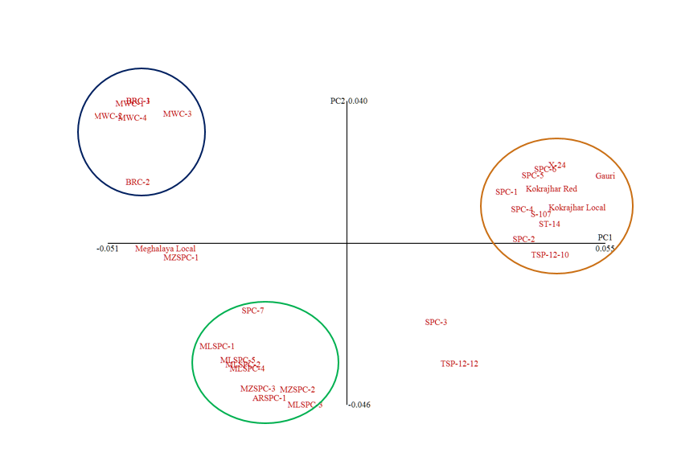

**Figure S1.** Principal coordinate analysis (PCoA) plot of sweet potato genotypes based on SSR markers

**Figure S2**. Correlation between morphological and molecular diversity among the genotypes of the sweet potato

C:\Users\DELL\Desktop\Picture1.tif

**Figure S3.** Multi-trait stability Index (MTSI) for genotype ranking and selection of genotypes considering 10% selection intensity. **a**. Selection based on yield attributing traits **b**. Selection based on all the traits. The selected genotypes are shown in red color and the red circle represents the cutpoint according to the selection intensity.

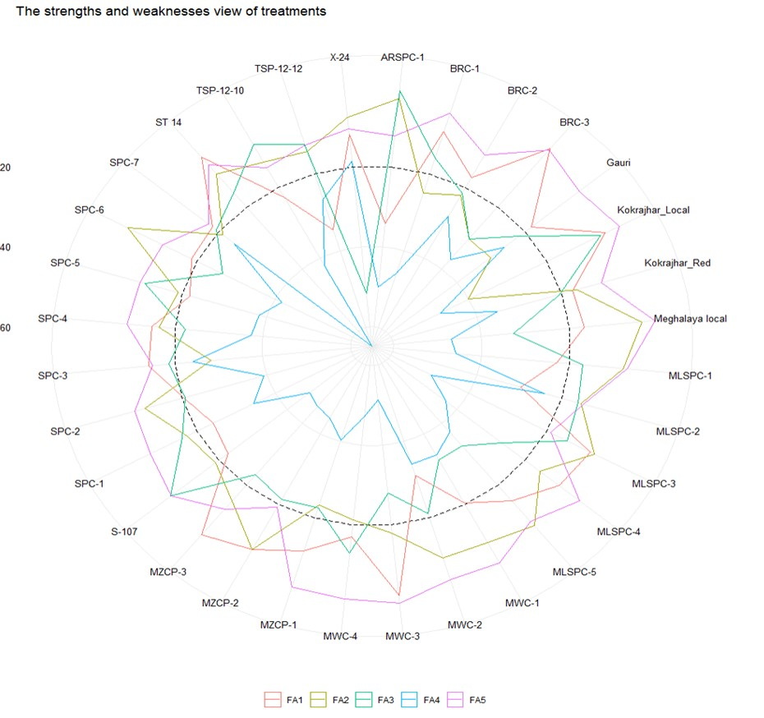

**Figure S4.** Strengths and weaknesses view of the selected genotypes is shown as the proportion of each factor on the computed MGIDI index. The smallest the proportion explained by a factor (closer to the external edge), the closer the traits within that factor are to the ideotype. The dashed line indicates the theoretical value if all factors had contributed equally.