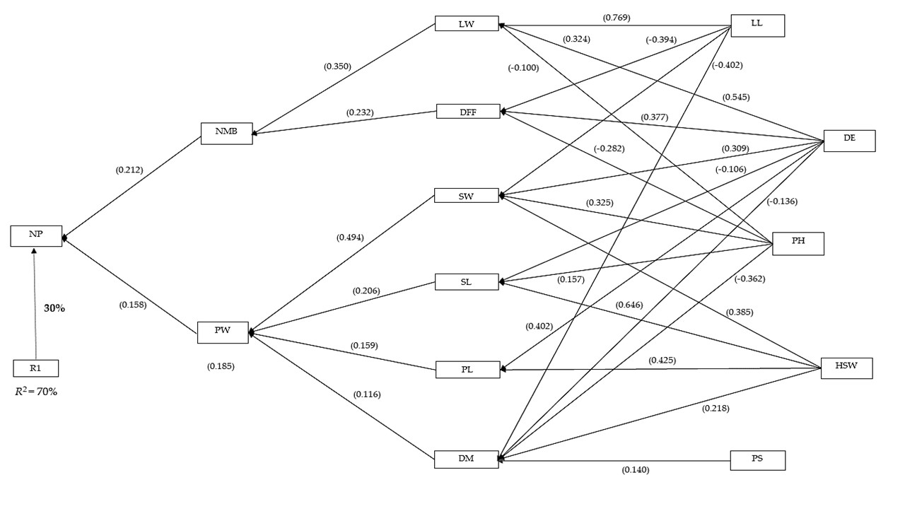
Figure S1: Sequential path analysis diagram depicting causal relationship among 14 measured traits in a diverse set of groundnut accessions. Note: Value in bold is the error effect; the direct path coefficients are values in parenthesis. R1 is error effects, R 2 = coefficient of determination.

