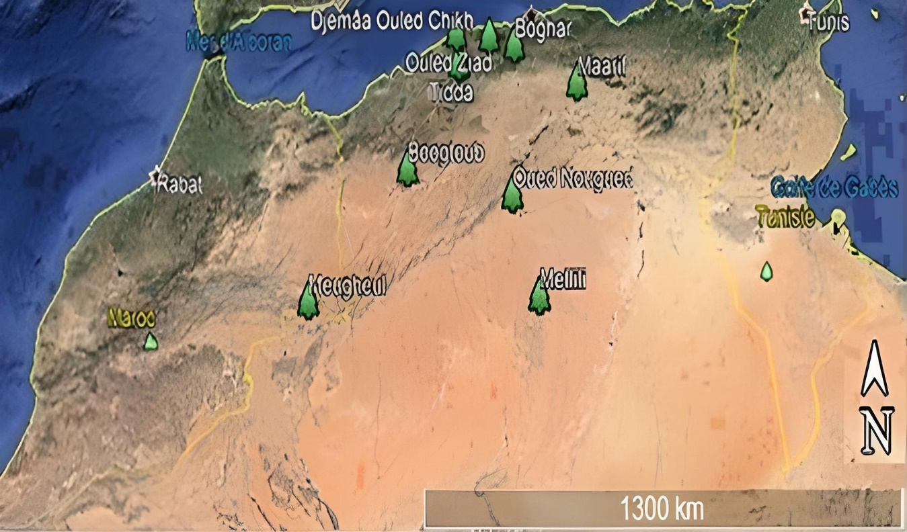
Figure S1: Distribution of Z. lotus fruits sampling sites, in different climatic stages in Algeria.
Table S1: Description of the selected sites of the nine natural populations of Z. lotus in Algeria.
Pop. | Ouled Ziad | Djemâa Ouled Chikh | Boghar | Tidda | Maarif | Bougtob | Oued Nougued | Metlili | Mougheul
Position
Locations | Chlef | Ain Defla | Medea | Tiaret | M’Sila | El Bayadh | Laghouat | Ghardaia | Bechar
Long. | 1°6’E | 2°1’E | 2°42’E | 1°14’E | 4°18’E | 0°7’E | 2°59’E | 3°33’E | 2°12’W
Lat. (N) | 36°6’ | 36°6’ | 35°57’ | 35°40’ | 35°22’ | 33°59’ | 33°49’ | 32°18 | 32°1’
Alt. (m) | 106 | 516 | 853 | 705 | 410 | 1038 | 772 | 526 | 1023
Climate
AAT. | 20.5 | 19.1 | 16.5 | 15.7 | 21.7 | 20.2 | 20.1 | 23.2 | 22.5
TA. | 12.6 | 10.2 | 8.8 | 14.5 | 13 | 13.4 | 13.3 | 12.2 | 13.8
TD. | 31 | 28.1 | 28.4 | 35.8 | 36.3 | 35.3 | 37.1 | 33.9 | 37.8
P. | 404.85 | 807.23 | 773.62 | 334.03 | 172.21 | 218.65 | 198.2 | 17.51 | 107.95
Climate | Semiarid | Semiarid | Semiarid | Semiarid | Dry steppe | Dry steppe | Dry steppe | Saharan | Saharan
Soil
CaCO₃ % | 24 | 3.5 | 0 | 2.6 | 24.97 | 19.1 | 8.8 | 4.11 | 7.5
OM. % | 1.2 | 1.51 | 1.3 | 0.92 | 2.01 | 1 | 0.78 | 0.75 | 0.49
pH | 7.9 | 8 | 6.5 | 7.88 | 8.61 | 7.8 | 7.97 | 8.4 | 7.85
Clay % | 27 | 31 | 34.4 | 12.3 | 9.76 | 9.8 | 9.4 | 0.4 | 0.96
Silt % | 46.8 | 50.6 | 39.9 | 38.8 | 13.68 | 43.6 | 16.73 | 8.6 | 16.62
Sand % | 26.2 | 18.4 | 25.7 | 48.9 | 76.56 | 46.6 | 73.87 | 91 | 82.42
Soils | Clay loam | Loamy clay | Clay loam | Loam | Sandy loam | Sandy loam | Sandy loam | Sandy | Sandy
Long.: Longitude; Lat.: Latitude; Alt.: Altitude; AAT.: Average annual temperature; TD.: Temperature difference between the warmest and coldest months; P.: Precipitations; OM.: Organic matter.

