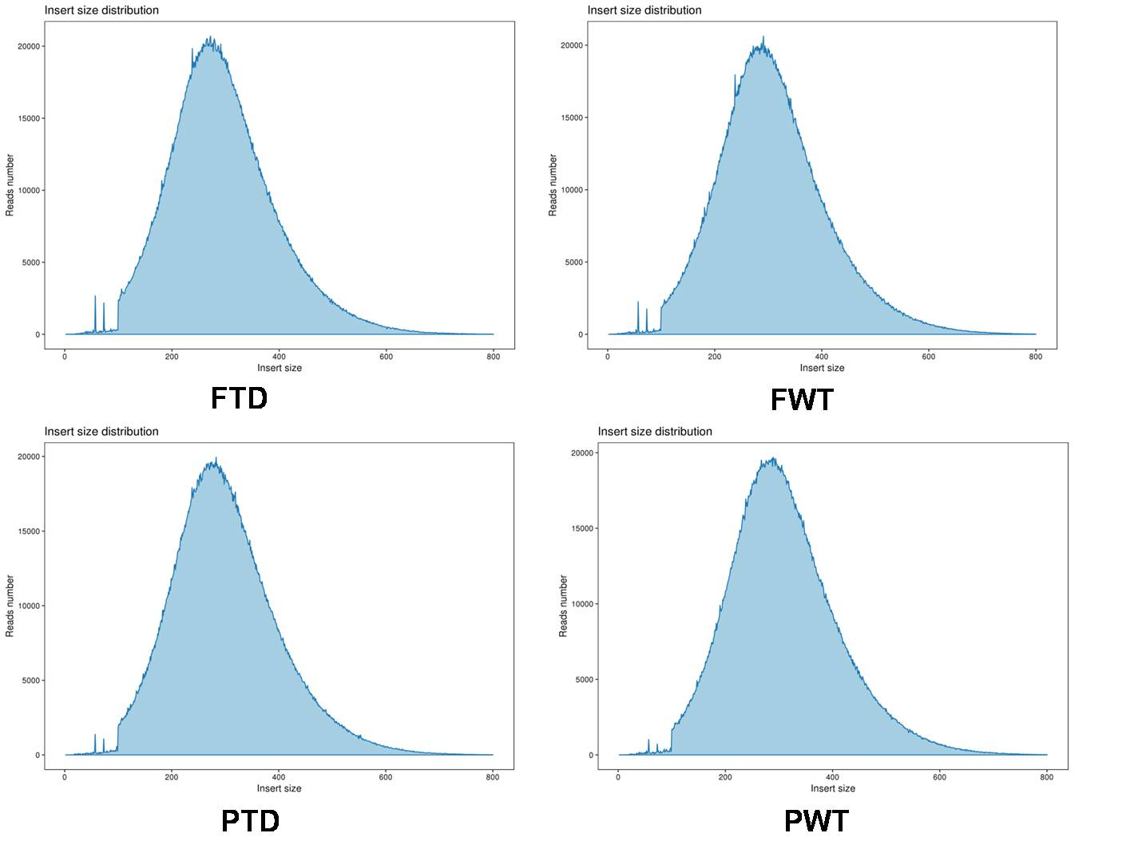
Figure S1 Insert fragment distribution statistics of FTD, FWT, PTD and PWT.

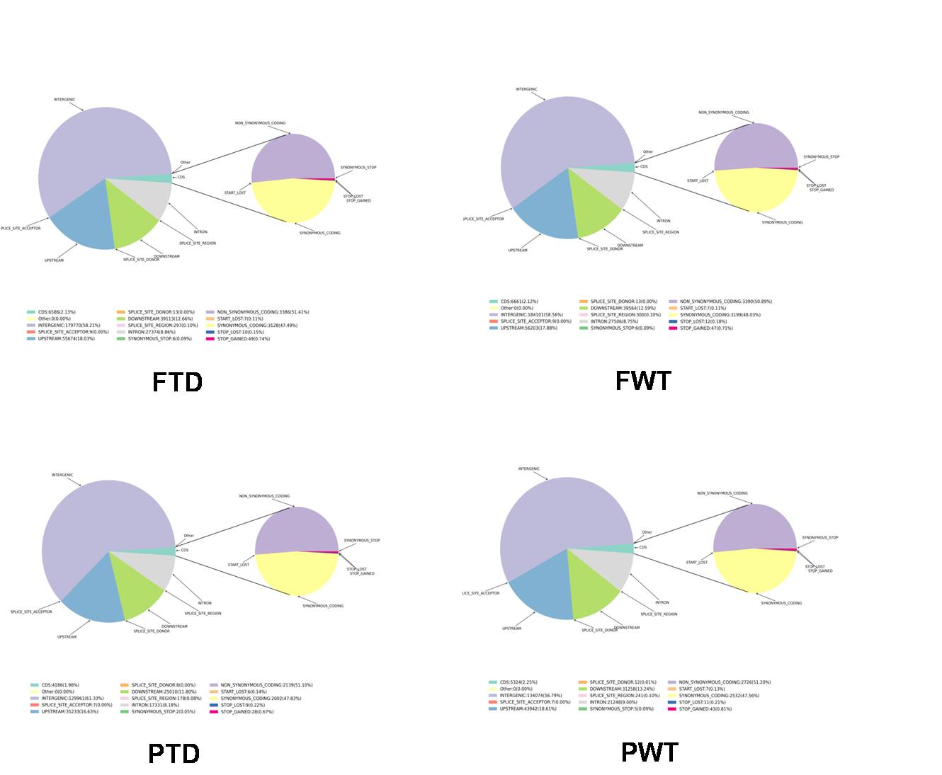

Figure S2 SNP comment results of FTD, FWT, PTD and PWT.

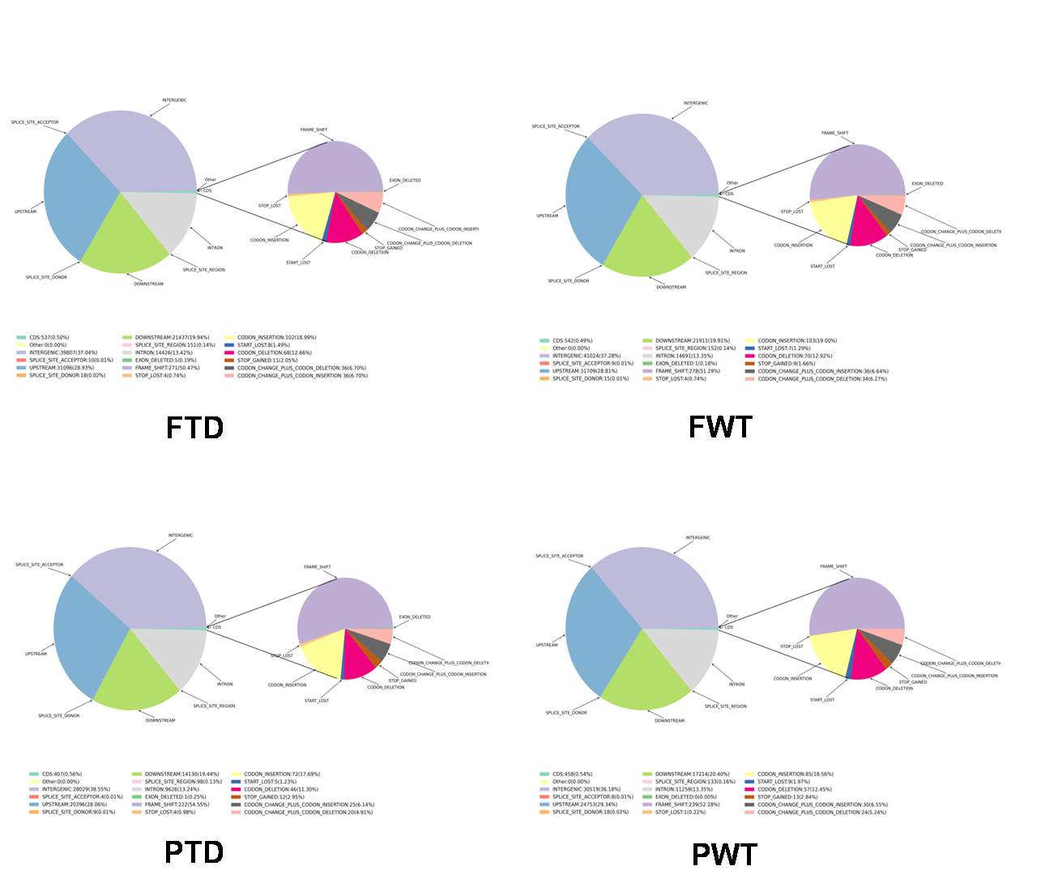
Figure S3 Small InDel detection comment results of FTD, FWT, PTD and PWT.

Table S1 Primers used in this study
Primers | Sequences(5'to3')
18S-F | CAACCATAAACGATGCCGA
18S-R | AGCCTTGCGACCATACTCC
Cla97C06G126670-F | CGCATAGGATTGAGTGATTACC
Cla97C06G126670-R | GTTGGACGGATTCTGAAGATTC
Cla97C06G127120-F | ACGGTGTTGGTGCTATTG
Cla97C06G127120-R | TACATCGGCGGTGATCTT
Cla97C06G127130-F | ATGTGTTCTTCTGGCTGTTA
Cla97C06G127130-R | ATTCCATAGCACGAGCAATA
Cla97C06G127140-F | TCCACGCAACTATTCCTC
Cla97C06G127140-R | CCACGGACTGATTCTGAA
Cla97C06G127150-F | GTGCTCAGAACCTTCAGAA
Cla97C06G127150-R | ATGGCAGGCAACATACAA
Cla97C06G127470-F | AGTTACCCGAATCTACCTGTC
Cla97C06G127470-R | ATTGGAACATTGAGCACTGTC

