Figure S1. Location map of Jamun collection sites in three districts of Himachal Pradesh
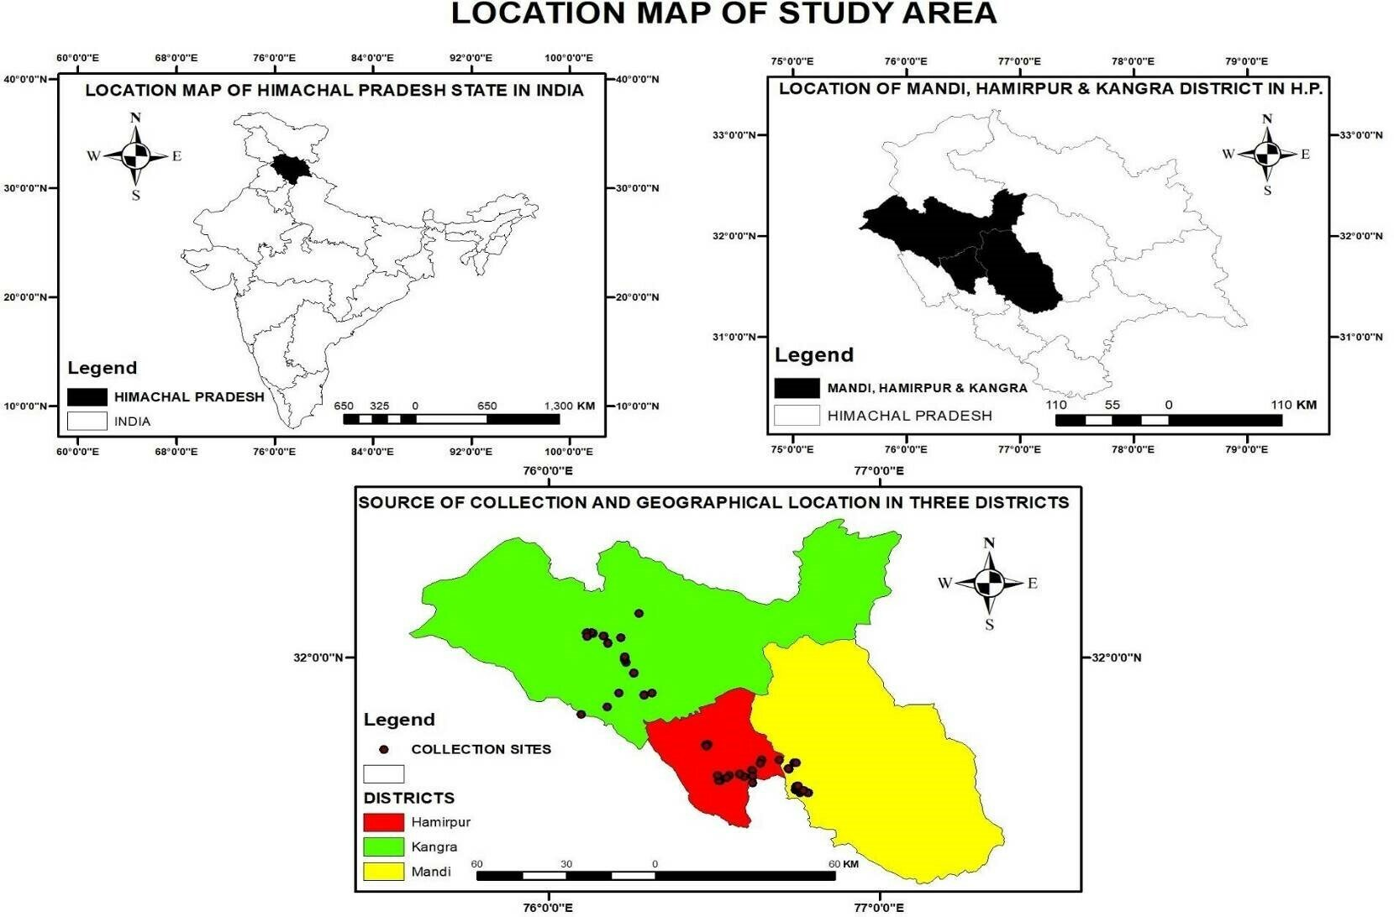

Figure S2. Geographical location map of superior seedling jamun genotypes
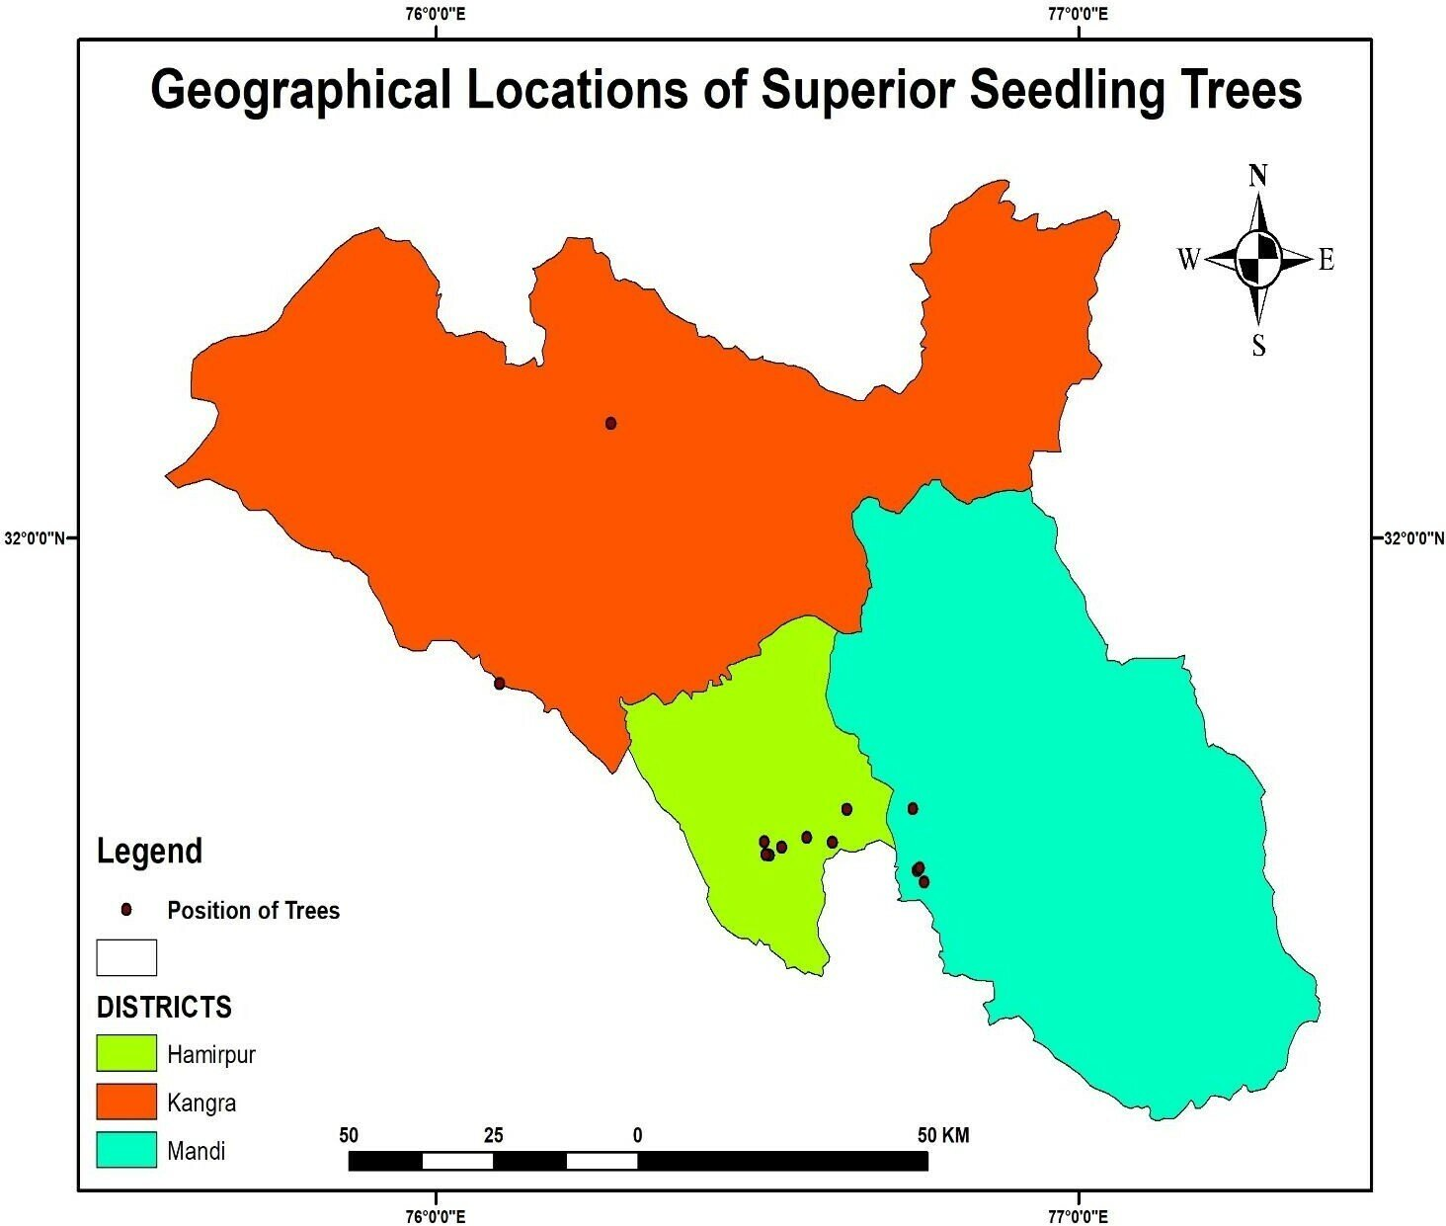

Figure S3. Agarose gel electrophoresis PCR amplified bands of fifteen superior jamun using RAPD primers (Lane M - 100b, 1 - tree 5, 2 - tree 13, 3 - tree 23, 4 - tree 29, 5 - tree 38, 6 - tree 39, 7 - tree 40, 8 - tree 43, 9 - tree 44, 10 - tree 48, 11 - tree 49, 12 - tree 52, 13 - tree 54, 14 - tree 60 and 15 - tree 63)
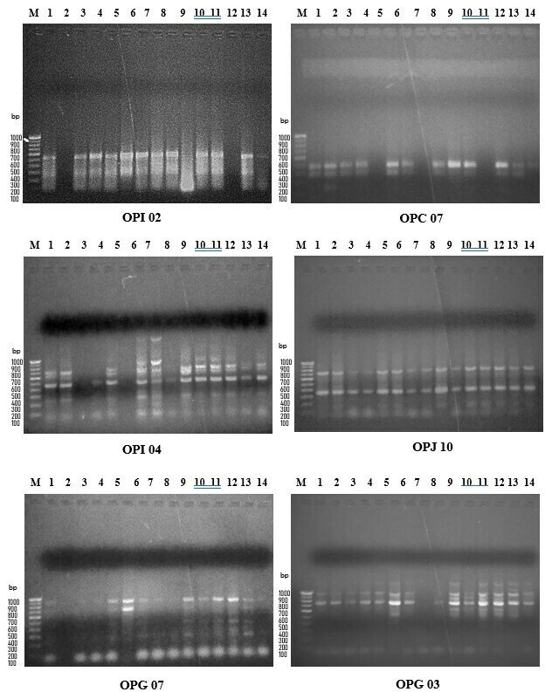

Figure S4. Agarose gel electrophoresis PCR amplified bands of fifteen superior jamun using ISSR primers (Lane M - 100bp, 1 - tree 5, 2 - tree 13, 3 - tree 23, 4 - tree 29, 5 - tree 38, 6 - tree 39, 7 - tree 40, 8 - tree 43, 9 - tree 44, 10 - tree 48, 11 - tree 49, 12 - tree 52, 13 - tree 54, 14 - tree 60 and 15 - tree 63)
