Supplementary table S1. Forward (F) and reverse (R) primers sequences for each marker locus designed for Ilex paraguariensis from whole-genome sequence data
Locus | Primer sequences (5′−3′)  Forward | Primer sequences (5′−3′)  Reverse
Ip100.1 | AGTCGCCACTGTTCTGTTCG | ACCACAGAGTACTTTACGGGC
Ip100.2* | CAACTTCATGCCTCCACGTC | CCAACTGCTTGCTAAGTCGC
Ip100.3 | GAGAGGTGGGTGGGTTTCTG | TGCCTTTCCATTCTTCTGCAC
Ip100.4 | GGGTTTCAGGAATGTCAAGTGTC | GTACCGGCATCCACTAAGGC
Ip100.5 | CTGTCACTCCCAATTACGTGC | TGGTTAACTTCTAGAAATGCTGGTG
Ip100.6* | GCGGAATAGTCATCCATTTCTGC | TTGCTCCGTCTGTGGTTAGG
Ip100.7 | GCCTTCGATTGACTGACTGAC | TTCGCTCATCTCAGTGCCTC
Ip100.8 | GACCACATTCCTATGCACACAC | AGAGCTTTCAATCAAATGGCCC
Ip100.9 | AAGCAGTCTCCTTCAGTGGC | GTGGCCGAACTTTGAGAACC
Ip100.10 | GGGTCAAAGTCGGGATTTAATCAAG | GCCTTCTCTCTCTACACTACTCC
Ip100.11* | ACACAATCTGATGCTGCGAAG | GTCATGTCATACAAGTGAGCCC
Ip100.12 | ACATGAATAAATGACAGAGCCCG | GTTCGGAAGTTGCCATCTCAAG
Ip100.13 | GGTCACTGCTCAGAGAGAAAGAG | CCATTGTATAGCTCACACACTGAC
Ip100.14 | TGACACACTGTAGGGCCAAG | TGGCTCCCGAAGATCTGATTG
Ip100.15 | TCCACCTCTACCTCCACCTC | CGCATGCCATCAAACAAAGC
Ip100.16 | CTGCAGACAGTTTGAGCACAC | TTGTTCTTTGGGCTTGACTTTGC
Ip100.17 | ACCTCCACCTCTACCTCCAC | CGCATGCCATCAAACAAAGC
Ip100.18 | TTCCTACCAGAAACACATTGCAC | TGCAGTATTTCCATGCACTTTCAG
Ip100.19 | CACAAACACCCACCCAACAG | TTGAGCCAGAGATGGAAGCC
Ip100.20* | ACCTTAACACTCCATCCATTTGC | TGGCAGGAAATTCGGGATCTC
Ip200.1 | ATTCATATTTGTGTGTGTTGTGTGC | TCTGTTTCACTTATTCTCAACTGCC
Ip200.3* | AGGCTCTCTATGTCCGCTTG | TATGCCGCAGAGATGGGTTG
Ip200.4 | CCTTGTTGCTTGACTAGACATGTG | AAGTGGCCAGTTTGCAAGTG
Ip200.5 | CATGTTTCCCAGGTTTGCGC | TTGGGAAGAAGTGGCTGAGC
Ip200.6 | TGAAGGCTCTCTATGTCCGC | TATGCCGCAGAGATGGGTTG
Ip200.7 | CATCAGCTCACATAATCACTCCATC | GCCACGCACACATAACACAG
Ip200.8* | GCCTCACTTCTCTCCATCCC | ATGTGTGTGTGCATGCGTTG
Ip200.9 | AACAAGGGAATCGCACTCAATG | ACCCAGCCATACTCAGGTTG
Ip200.11 | GGCTGAGCGAAGATTTGACG | GCGCCCATCAATGACACAAG
Ip200.12 | TACAGAAGTGCTAACAACAGGGAG | ACCGAGGCCAATTATAGTTACTCC
Ip200.13 | AATGAACTTTCCTTCCAACTCACC | CAGTAGTTGTAGCGTGACTTTCG
Ip200.16 | GCTGAAAGGTGCATTGTCTCAC | ACAGATCATTTGAGAGGGAAAGGG
Ip200.17* | GTAGCACGTTGTAGGCTAAGC | TTCGATCTTTGAGATTGTGGCG
Ip200.20 | TACATTGACTCTGCCTCCGG | AGCCCTGTCCAAACCTAAGC
*Locus used in multiplex amplifications

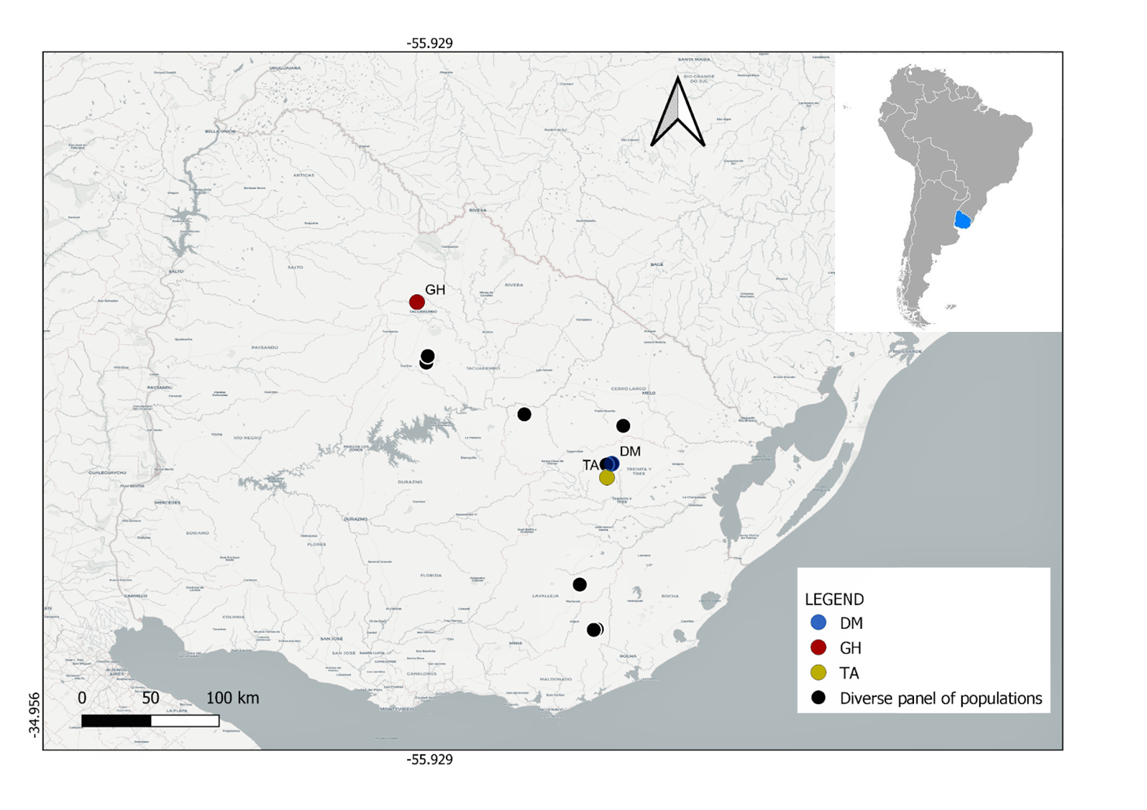
Supplementary Figure S1. Map with the locations of the Uruguayan populations of yerba mate included in this study. The 12 populations included in the diverse panel (one individual per population) are represented by black circles. For the population level analysis, Population Demicheli (DM) is represented by a blue circle, population Gruta de los Helechos (GH) by a yellow circle and population Tapera de Ayala (TA) by a red circle. The scale bar represents 100 km. Samples were collected by Pablo Hernández, Joaquín Garrido, Gabriela Jolochin, Luis Rodríguez and Rodrigo Olano

