Table S1 185 species and cultivars of Oxalis were tested.
No. | Latin name | No. | Latin name
1 | O. luteola | 94 | O. obtusa ‘Damask Rose × Rose 5’
2 | O. nortieri | 95 | O. obtusa ‘Deep Pink’
3 | O. ambigua | 96 | O. obtusa ‘Diva’
4 | O. annae | 97 | O. obtusa ‘Fairy’
5 | O. anomala | 98 | O. obtusa ‘Fanta’
6 | O. attaquana ‘Pink’ | 99 | O. obtusa ‘Harvest Moon’
7 | O. bicolor | 100 | O. obtusa ‘High Pink’
8 | O. orange ‘Pie’ | 101 | O. obtusa ‘High Yellow’
9 | O. ‘Blood’ | 102 | O. obtusa ‘Honey’
10 | O. bowiei | 103 | O. obtusa ‘Lady’
11 | O. brasliensis | 104 | O. obtusa ‘Lava Splash’
12 | O. brazil ‘Yellow’ | 105 | O. obtusa ‘Lemen Cream’
13 | O. callosa | 106 | O. obtusa ‘Lilac Grey’
14 | O.callosa ‘Damselfly’ | 107 | O. obtusa ‘Mist’
15 | O. callosa ‘Hmong Bride’ | 108 | O. obtusa ‘Moeran’
16 | O. cathara ‘Lemon Light’ | 109 | O. obtusa ‘Moonglow’
17 | O. cathara ‘White’ | 110 | O. obtusa ‘Orange Dream’
18 | O. cathara ‘Yellow’ | 111 | O. obtusa ‘Peach & Cream Red Form’
19 | O. clanwilliam | 112 | O. obtusa ‘Pink Champagne’
20 | O. clavifolia | 113 | O. obtusa ‘Pink Drangonfly’
21 | O. compressa | 114 | O. obtusa ‘Pinwheel’
22 | O. compressa ‘Double’ | 115 | O. obtusa ‘Polished Copper’
23 | O. convesula | 116 | O. obtusa ‘Primrose’
24 | O. corymbosa | 117 | O. obtusa ‘Red Hood’
25 | O. corymbosa ‘Aureo-reticulata’ | 118 | O. obtusa ‘Red Shadow’
26 | O. bifurca ‘Pink’ | 119 | O. obtusa ‘Rhodo’
27 | O. crispiflora | 120 | O. obtusa ‘Rice’
28 | O. dentata | 121 | O. obtusa ‘Rose’
29 | O. engleriana | 122 | O. obtusa ‘Rosey Breeze’
30 | O. exserta | 123 | O. obtusa ‘Saffower’
31 | O. fabaefolia | 124 | O. obtusa ‘Siberite’
32 | O. fergusoniae | 125 | O. obtusa ‘Spring Charm Orange’
33 | O. flabelifolia | 126 | O. obtusa ‘Spring Charm Pink’
34 | O. flava ‘Gifberg’ | 127 | O. obtusa ‘Strawberry Cream’
35 | O. flava ‘Large’ | 128 | O. obtusa ‘Striped Back’
36 | O. flava ‘Namaquensis’ | 129 | O. obtusa ‘Sugar and Spice’
37 | O. flava ‘Pakhuis Pass’ | 130 | O. obtusa ‘Summer Song’
38 | O. flava ‘Parama Pink’ | 131 | O. obtusa ‘Sun Halo’
39 | O. sp. ‘Fluorescent Yellow’ | 132 | O. obtusa ‘Sunbird’
40 | O. sp. ‘Forest Eye’ | 133 | O. obtusa ‘Sundisc’
41 | O. fireworks | 134 | O. obtusa ‘Sunset Large Form’
42 | O. fragrans | 135 | O. obtusa ‘Sunshine’
43 | O. glabra ‘Omar’ | 136 | O. obtusa ‘Twilight’
44 | O. glabra ‘Pinky White’ | 137 | O. obtusa ‘Veil’
45 | O. gold ‘Island’ | 138 | O. obtusa ‘Yellow River’
46 | O. goniorhiza | 139 | O. sp. ‘Orange Pie’
47 | O. gracilis | 140 | O. orbicularis
48 | O. haedulipes | 141 | O. pardalis ‘Whit’
49 | O. hawthornides | 142 | O. perdicaria
50 | O. helicoides | 143 | O. pes-caprae
51 | O. hirta ‘Adpressa’ | 144 | O. pes-caprae ‘Green Leaf’
52 | O. hirta ‘Cherry’ | 145 | O. phloxidiflora
53 | O. hirta ‘Blood Moon’ | 146 | O. polyphylla var. heptaphylla
54 | O. hirta ‘Candy’ | 147 | O. pulchella ‘Tricolor’
55 | O. hirta ‘Dark Eye’ | 148 | O. pulchella var. tomentosa
56 | O. hirta ‘Dark’ | 149 | O. sp. ‘Pumpkin Pie’
57 | O. hirta ‘Gothenburg’ | 150 | O. sp. ‘Puppy Love’
58 | O. hirta ‘Mauve’ | 151 | O. purpurea ‘Alba’
59 | O. hirta ‘Pale Lavender’ | 152 | O. purpurea ‘Carrol Jolly’
60 | O. hirta ‘Pale Pink’ | 153 | O. purpurea ‘Cherry’
61 | O. hirta ‘Peach’ | 154 | O. purpurea ‘Deep Rose’
62 | O. hirta ‘Pupu’ | 155 | O. purpurea ‘Garnet’
63 | O. hirta ‘Rosa’ | 156 | O. purpurea ‘High Bullitt’
64 | O. hirta var. tubiflora | 157 | O. purpurea ‘Lavender & White’
65 | O. latifolia | 158 | O. purpurea ‘Lavender’
66 | O. lily | 159 | O. purpurea ‘Pale Pink’
67 | O. livida | 160 | O. purpurea ‘Pink Giant’
68 | O. lobata | 161 | O. purpurea ‘Ribbon’
69 | O. lobata ‘Melanositicta’ | 162 | O. purpurea ‘Ruffles’
70 | O. luteola ‘Maculata’ | 163 | O. purpurea ‘Salmon’
71 | O. luteola ‘MV4960B’ | 164 | O. purpurea ‘Sunset’
72 | O. luteola ‘MV5885’ | 165 | O. purpurea ‘Taru’
73 | O. luteola ‘Splash’ | 166 | O. purpurea ‘Ulifoura’
74 | O. massoniana | 167 | O. purpurea ‘Yellow’
75 | O. massonorum | 168 | O. pusilla
76 | O. meisneri | 169 | O. rococo
77 | O. minuta | 170 | O. semiloba
78 | O. monophylla | 171 | O. simplex
79 | O. namaquana | 172 | O. sonderiana
80 | O. namaquana ‘New’ | 173 | O. stellata
81 | O. namibia | 174 | O. stenorrhyncha
82 | O. nidulans | 175 | O. sp. ‘Strawberry Cookie’
83 | O. nidulans ‘Pompom’ | 176 | O. susan
84 | O. obtusa ‘Amber’ | 177 | O. tale
85 | O. obtusa ‘Apple’ | 178 | O. tenella
86 | O. obtusa ‘Apricot Cream’ | 179 | O. tenuifolia
87 | O. obtusa ‘Aurora’ | 180 | O. triangularis ‘Green’
88 | O. obtusa ‘Burning Heart’ | 181 | O. triangularis ‘Purple White’
89 | O. obtusa ‘Caramel Glaze’ | 182 | O. versicolor
90 | O. obtusa ‘Ceres Salmon’ | 183 | O. yael
91 | O. obtusa ‘Cerise Stone’ | 184 | O. sp. ‘Yellow Vein’
92 | O. obtusa ‘Coral’ | 185 | O. zeekoevleyensis
93 | O. obtusa ‘Coral × Rose1’
Note: The experimental materials used in this table are listed in Latin name order.

Table S2 Observation table of characters of Oxalis.
Project Contents of the record
Date and place of observation: (1) Observation date: (2) Observation location:
Species/Breed Name: Latin name:
No:
Plant (1) Plant type: ① Upright type; ② Vine type; ③ Rosette-shaped; ④ Clustered type
(2) Plant: height (cm):
(3) Plant: crown width (cm):
(4) Plant: growth type: ① Annual; ② Perennial; ③ Bulb
Above-ground main stem: (1) Main stem above-ground: ① Without; ② With
(2) Main stem: above-ground thickness (mm):
(3) Main stem: above-ground length (cm):
(4) Main stem: inter-node length (cm):
(5) Main stem: the color of the above-ground: ① Yellow-green; ② Green;
③ Red; ④ Sorrel; ⑤ Maroon; ⑥ Brown
(6) Main stem: above-ground villi: ① Less; ② Medium; ③ Much
(7) Main stem: above-ground part of the branch: ① Less; ② Medium;
③ Much
Leaf (1) Leaf: occurrence location: ① Only the subterranean part of the main stem; ② Only the upper ground part of the main stem; ③ The main stem occurs simultaneously above ground and below ground
(2) Leaf: Type: ① Univalent; ② Compound leaf
(3) Only applicable to compound leaf varieties: Leaf type: ① Three-out leave;② Four-out leaves; ③Five-out leaves;④ Irregularities; ⑤ Pinnately Compound leaf
(4) Compound leaf: length (cm):
(5) Compound leaf: width (cm):
(6) Leaflets: shape: ① Y-shaped; ② Inverted long triangle; ③ Lanceolate; ④ Inverted-lanceolate; ⑤ Obovate; ⑥Oval; ⑦ Inverted heart; ⑧ Inverted triangle; ⑨ Rotundity
(7) Leaflets: apex shape: ① Sharp; ② Blunt; ③ Rotundity; ④ Flat cut;
⑤ Heart-shaped
(8) Leaflets apex: with or without: ① Without; ② With
(9) Leaflets apex: depth of concave: ① Shallow; ② Medium; ③ Deep
(10) Leaflets: base shape: ① Sharp; ② Blunt; ③ Rotundity
(11) Leaflets: length (cm):
(12) Leaflets: width (cm):
(13) Leaf: surface fold: ① Without; ② With
(14) Leaf: inverted along the midrib: ① Without; ② With
(15) Leaf: degree of inversion along the midrib: ① Weak; ② Medium;
③ Strong
(16) Leaf: upper surface villi: ① Without; ② With
(17) Leaf: lower surface villi: ① Without; ② With
(18) Leaf: marginal hair: ① Without; ② With
(19) Leaf: texture: ① Paper; ② Meat quality; ③ Velvet
(20) Leaf: closed at night: ① Without; ② With
(21) Leaf: upper surface color: ① Yellow ; ② Yellow-green; ③ Green;
④ Gray-green; ⑤ Dark-green; ⑥Red-purple
(22) Leaf: glossy: ① Without; ② With
(23) Leaf: thickness (mm):
(24) Leaf: spot: ① Without; ② With
(25) Leaf: spot type: ① Scatter point; ② Medium spot; ③ Veining;
④ leaflets base; ⑤ Leaflets center
(26) Leaf: number of spot colors: ①One；②Two；③ More than two
(27) Leaf: spot color: ① White; ② Gray-green; ③ Dark-green; ④ Red-purple; ⑤ Black-brown
(28) Leaf: spot stability: ① Without; ② With
(29) Leaf: the way of birth: ① Basal birth; ② Stem-growing
(30) Leaf: vein obviousness: ① None or extremely weak; ② Weak;
③ Medium; ④ Strong
(31) Only for varieties with moderate veins or above: obvious leaf vein color:
① Yellow; ② Light green; ③ Green; ④ Gray-green; ⑤ Brown-green;
⑥ Red-purple
(32) Leaf dorsal: heterochromatic: ① Without; ② With
(33) Leaf dorsal: heterochromatic color: ① Red; ② Red-purple; ③ Purple
(34) Young leaf: color: ① Yellow-green; ② Green; ③ Gray-green; ④ Red-purple
(35) Plants: number of leaves: ① Few; ② Medium; ③ Much
Petiole (1) Petiole: with or without: (1) Without; (2) With
(2) Petiole: thickness (mm):
(3) Petiole: length (cm):
(4) Petiole: basal color: ① Yellow; ② Yellow-green; ③ Green;
④ Green-brown; ⑤ Red; ⑥ Red-purple; ⑦ Red-brown
(5) Petiole: central color: ① Yellow; ② Yellow-green; ③ Green;
④ Green-brown; ⑤ Red; ⑥ Red-purple; ⑦ Red-brown
(6) Petiole: villi: ① Without; ② With
(7) Petiole: mark: ① Without; ② With
(8) Petiole: spot type: ① Scatter point; ② Medium spot; ③ Veining;
④ Leaflets base; ⑤ Leaflets center
(9) Petiole: number of spot colors: ①One；②Two；③ More than two
(10) Petiole: spot color: ① White; ② Gray-green; ③ Dark-green; ④Red-purple; ⑤ Black-brown
(11) Petiole: spot stability: ① Without; ② With
Inflorescence (1) Inflorescence: with or without：① Without; ② With
(2) Inflorescence: type: ① Single flower; ② Near umbrella
(3) Only applicable to varieties with inflorescence: Inflorescence: length (cm):
(4) Only applicable to varieties with inflorescence: Inflorescence: diameter (cm):
(5) Only applicable to varieties with inflorescence: Inflorescence: number of flowers:
(6) Only applicable to varieties with inflorescence: Inflorescence: quantity:
(7) Only for varieties with inflorescence: peduncle: length (cm):
(8) Only for varieties with inflorescence: peduncle: thickness (mm):
(9) Only for varieties with inflorescence: peduncle: hardness: ① Soft;
② Medium;③ Hard
(10) Only for varieties with inflorescence: peduncle: villi: ① Without;
② With
(11) Only for varieties with inflorescence: peduncle: villi: ① Without;
② With
(12) Only for varieties with inflorescence: peduncle color: ① Yellow;
② Yellow-green; ③ Green; ④ Brown-green; ⑤ Red; ⑥ Red and green; ⑦ Red-brown
(13) Only for varieties with inflorescence: peduncle color: ① Yellow;
② Yellow-green; ③ Green; ④ Brown-green; ⑤ Red; ⑥ Red and green; ⑦ Red-brown
Pedicel (1) Pedicel: length (cm):
(2) Pedicel: width (mm):
(3) Pedicel: color: ① Yellow-green; ② Green; ③ Red and green;
④ Yellow; ⑤ Red
(4) Pedicel: villi: ① Without; ② With
Flower (1) Only applicable to single-flower varieties: flower: the way of birth:
① Basal; ② Axillary
(2) Flower: status: ① Erect; ② Horizontal; ③ Sagging
(3) Flower: shape: ① Cup-shaped; ② Bell-shaped
(4) Flower: diameter (cm):
(5) Flower: number of colors: ① Monochromatic; ② Multicolored;
(6) Flower: secondary color: ① Edge; ② Other
(7) Flower: fragrance: ① Without; ② With
(8) Flower: flatness when fully open: ① Expand; ② Section expands
(9) Flower: type: ① Single petal; ② Double petal
(10) Flower: relative to leaf height: ① Below; ② Equal height; ③ Above
(11) Flower: closed at night: ① Without; ② With
Petal (1) Petal: vein: ① Not prominent; ② Prominent
(2) Petal vein color: ① White; ② Yellow; ③ Pink; ④ Orange; ⑤ Red; ⑥ Rose red; ⑦ Purple;⑧ Others
(3) Petal: overlapping: ① Without; ② With
(4) Petal: degree of overlap: ① Weak; ② Medium; ③ Strong
(5) Petal: upper surface color: ① White; ② Beige; ③ Yellow; ④ Pink; ⑤ Pink-purple; ⑥ Orange; ⑦ Rose red; ⑧ Red; ⑨ Purple
(6) Only applicable to multi-colored varieties: the main color of the upper surface of the petal: ①White; ② Yellow;
③ Beige; ④ Pink; ⑤ Pink-purple; ⑥ Orange; ⑦ Rose red; ⑧ Red; ⑨Purple
(7) Petal: lower surface color：① White; ② Beige; ③ Yellow; ④ Pink; ⑤ Pink-purple; ⑥ Orange; ⑦ Rose red;⑧ Red; ⑨ Purple
(8) Only suitable for multi-colored varieties: the main color of the lower surface of the petal: ① White; ② Yellow; ③ Beige; ④ Pink; ⑤ Pink-purple; ⑥ Orange; ⑦ Rose red; ⑧ Red; ⑨ Purple
(9) Petal: length (cm):
(10) Petal: width (cm):
(11) Petal: thickness (mm):
(12) Petal: shape: ① Obovate; ② Inverted triangle; ③ Rotundity
(13) Petal: tip shape: ① Blunt; ② Rotundity; ③ Flat cut
(14) Petal: spot: ① Without; ② With
(15) Petal: spot type: ① Scatter point; ② Medium spot; ③ Stripe; ④ Edge
(16) Petal: spot color: ① Red; ② Red-purple; ③ Purple
(17) Petal: number of spot colors: ① One；② Two；③ More than two
(18) Petal: spot stability: ① Without; ② With
(19) Petal: basal symphysis: ① Without; ② With
(20) Petal: wavy edge: ① Without; ② With
(21) Flower throat: color: ① White; ② Yellow; ③ Pink; ④ Orange;
⑤ Red; ⑥ Red-purple; ⑦ Purple
Male and female stamen (1) Male and female stamen: With or without ① Without; ② With
(2) Flower column: type: ① Distyly; ② Tristyly
(3) Flower column: relative to anther height: ① Higher than anthers; ② Equal height with anthers; ③ Between long and short anthers;④ Lower than short anthers; ⑤ Equal height with short anthers
(4) Stamens: quantity: ① Five long five short; ② Five out of five in length;
③ Five medium five short; ④ Less than ten
(5) Filigree: color: ① White; ② Yellow; ③ Yellow-green
(6) Flower column: color: ① White; ② Yellow; ③ Yellow-green
Calyx (1) Calyx: status: ① Spreading; ② Inverted volume
(2) Calyx: shape: ① Lanceolate; ② Oval
(3) Calyx: outer surface villi: ① Without; ② With
(4) Calyx: the way of basal growth: ① Grow separately; ② Grow together
(5) Calyx: length (cm):
(6) Calyx: width (cm):
(7) Calyx: thickness (mm):
(8) Calyx: arrangement: ① Shingled arrangement; ② Tweezers arranged;
③ One piece is completely inside and one is completely outside
(9) Calyx: color: ① Yellow-green; ② Green; ③ Red and green;④ Red and yellow; ⑤ Red-purple and green; ⑥ Red-brown and green
Flower volume (1) Whole flower: quantity: ① ≥20 flowers; ② ≤20 flowers;
(2) Only applicable to single-flower varieties: the number of single-flowers
Florescence (1) Flowering period: ① Early; ② Medium; ③ Late
(2) Flower: Flowering season: ① Spring; ② Autumn; ③ Winter; ④ Four seasons
Seed bulb (1) Seed bulb: width (cm):
(2) Seed bulb: length (cm):
(3) Seed bulb: shape: ① Lanceolate; ② Oval; ③ Elliptic; ④ Spherical;
⑤ Cylindrical; ⑥ Long strips; ⑦ The two ends are pointed and rounded in the middle
(4) Seed bulb: color: ① Light yellow; ② Light brown; ③ Yellow-brown;
④ Brown; ⑤ Brown
(5) Seed bulb: reproductive ability: ① Weak; ② Medium; ③ Strong

Table S3Statistical analysis of QN.
No. |  | Characteristic |  | Max. | Min. | Mean value | Median | Standard deviation | CV between species/varieties |  | CV within species/varieties
1 | Plant: height (cm) |  | 29.60 |  | 2.00 | 7.82 | 6.90 | 4.58 | 58.57% | 13.58%
2 | Plant: crown width (cm) |  | 28.60 |  | 2.40 | 10.42 | 9.80 | 4.09 | 39.25% | 12.62%
3 | Main stem: above-ground thickness (mm) |  | 3.50 |  | 0.42 | 1.78 | 1.78 | 0.70 | 39.32% | 13.39%
4 | Main stem: above-ground length (cm) |  | 29.00 |  | 2.80 | 9.81 | 8.20 | 5.36 | 54.64% | 13.37%
5 | Main stem: above-ground inter-node length (cm) |  | 10.70 |  | 3.50 | 5.10 | 4.80 | 1.05 | 20.59% | 15.11%
6 | Compound leaf: width (cm) |  | 8.00 |  | 0.81 | 2.87 | 2.60 | 1.20 | 41.81% | 11.19%
7 | Compound leaf: length (cm) |  | 9.30 |  | 0.70 | 2.44 | 2.10 | 1.29 | 52.90% | 11.50%
8 | Leaflets: length (cm) |  | 6.60 |  | 0.42 | 1.77 | 1.50 | 0.96 | 54.24% | 13.21%
9 | Leaflets: width (cm) |  | 6.80 |  | 0.10 | 1.33 | 1.15 | 1.00 | 75.19% | 13.18%
10 | Leaflets: thickness (mm) |  | 0.79 |  | 0.06 | 0.27 | 0.24 | 0.12 | 44.44% | 10.44%
11 | Petiole: thickness (mm) |  | 2.88 |  | 0.11 | 0.86 | 0.74 | 0.48 | 55.10% | 10.83%
12 | Petiole: length (cm) |  | 21.80 |  | 0.50 | 5.15 | 4.60 | 3.03 | 58.83% | 14.52%
13 | Inflorescence: length (cm) |  | 7.00 |  | 1.00 | 3.62 | 3.60 | 0.99 | 27.35% | 13.17%
14 | Inflorescence: diameter (cm) |  | 9.60 |  | 1.50 | 5.09 | 5.00 | 1.86 | 36.54% | 21.80%
15 | Inflorescence: number of flowers |  | 8.00 |  | 2.00 | 5.07 | 5.00 | 1.83 | 36.10% | 19.51%
16 | Inflorescence: quantity |  | 35.00 |  | 3.00 | 11.37 | 9.00 | 7.70 | 67.72% | 27.28%
17 | Only for varieties with inflorescence: peduncle: length (cm) |  | 30.00 |  | 7.80 | 12.39 | 11.30 | 4.21 | 33.98% | 14.48%
18 | Only for varieties with inflorescence: peduncle: coarse (mm) |  | 3.20 |  | 0.86 | 1.58 | 1.51 | 0.45 | 28.48% | 14.25%
19 | Only for single-flower varieties: number of single-flowers |  | 234.00 |  | 2.00 | 20.69 | 13 | 25.18 | 97.85% | 31.20%
20 | Pedicel: length (cm) |  | 19.10 |  | 1.00 | 4.75 | 3.80 | 3.19 | 67.16% | 14.87%
21 | Pedicel: width (mm) |  | 1.95 |  | 0.10 | 0.89 | 0.85 | 0.32 | 36.37% | 9.15%
22 | Flower: diameter (cm) |  | 4.80 |  | 1.20 | 2.75 | 2.65 | 0.74 | 26.91% | 7.68%
23 | Petal: length (cm) |  | 4.30 |  | 0.80 | 2.12 | 2.10 | 0.59 | 27.83% | 8.71%
24 | Petal: width (cm) |  | 2.20 |  | 0.40 | 1.09 | 1.10 | 0.36 | 33.02% | 9.14%
25 | Petal: thickness (mm) |  | 0.14 |  | 0.02 | 0.06 | 0.06 | 0.02 | 33.33% | 11.99%
26 | Calyx: length (cm) |  | 1.30 |  | 0.20 | 0.66 | 0.65 | 0.21 | 31.82% | 9.14%
27 | Calyx: width (cm) |  | 0.42 |  | 0.10 | 0.20 | 0.20 | 0.06 | 30.00% | 13.34%
28 | Calyx: thickness (mm) |  | 0.25 |  | 0.03 | 0.11 | 0.11 | 0.05 | 45.46% | 13.57%

Table S4
The grade of quantitative characteristics.
Characteristic | Grade (cm)
 | 1 |  |  | 2 | 3 | 4 | 5
Plant: height | ≤1.93 |  |  | 1.94-5.40 | 5.41-10.22 | 10.23-13.69 | ≥13.70
Plant: crown width | ≤5.18 |  |  | 5.19-8.28 | 8.29-12.57 | 12.58-15.67 | ≥15.68
Main stem: above-ground thickness |  |  |  | ≤1.40 | 1.41-2.14 | ≥2.15
Main stem: above-ground length | ≤1.90 |  |  | 1.91-6.57 | 6.58-13.05 | 13.06-17.71 | ≥17.72
Compound leaf: width | ≤1.33 |  |  | 1.34-2.24 | 2.25-3.50 | 3.51-4.40 | ≥4.41
Compound leaf: length | ≤1.33 |  |  | 1.34-2.24 | 2.25-3.50 | 3.51-4.40 | ≥4.41
Leaflets: length | ≤0.54 |  |  | 0.55-1.27 | 1.28-2.28 | 2.29-3.01 | ≥3.02
Leaflets: width | ≤0.05 |  |  | 0.06-0.80 | 0.81-1.86 | 1.87-2.61 | ≥2.62
Leaflets: thickness | ≤0.10 |  |  | 0.11-0.19 | 0.20-0.33 | 0.34-0.42 | ≥0.43
Petiole: coarseness | ≤0.25 |  |  | 0.26-0.60 | 0.61-1.11 | 1.12-1.47 | ≥1.48
Petiole: length | ≤1.29 |  |  | 1.30-3.57 | 3.58-6.73 | 6.74-9.01 | ≥9.02
Inflorescence: length |  |  |  | ≤3.09 | 3.10-4.14 | ≥4.15
Inflorescence: diameter |  |  |  | ≤4.11 | 4.12-6.07 | ≥6.08
Inflorescence: number of flowers |  |  |  | ≤4 | 5-6 | ≥7
Inflorescence: quantity |  |  |  | ≤6 | 7-18 | ≥19
Peduncle: length |  |  |  | ≤10.17 | 10.18-14.60 | ≥14.61
Peduncle: coarseness | ≤0.99 |  |  | 1.00-1.33 | 1.34-1.82 | 1.83-2.16 | ≥2.17
Pedicel: length | ≤0.65 |  |  | 0.66-3.07 | 3.08-6.42 | 6.43-8.84 | ≥8.85
Pedicel: coarseness | ≤0.47 |  |  | 0.48-0.71 | 0.72-1.06 | 1.06-1.30 | ≥1.31
Flower: diameter | ≤1.80 |  |  | 1.81-2.36 | 2.37-3.14 | 3.15-3.70 | ≥3.71
Petal: length | ≤1.35 |  |  | 1.36-1.80 | 1.81-2.43 | 2.44-2.88 | ≥2.89
Petal: width |  |  |  | ≤0.89 | 0.90-1.28 | ≥1.29
Petal: thickness |  |  |  | ≤0.04 | 0.05-0.08 | ≥0.09
Calyx: length |  |  | ≤0.38 | 0.39-0.54 | 0.55-0.77 | 0.78-0.92 | ≥0.93
Calyx: width |  |  | ≤0.11 | 0.12-0.16 | 0.17-0.23 | 0.24-0.28 | ≥0.29
Calyx: thickness |  |  | ≤0.04 | 0.05-0.08 | 0.09-0.14 | 0.15-0.18 | ≥0.19

Table S5 Standard cultivars of Oxalis
No. | Latin name | No. | Latin name
1 | O. attaquana ‘Pink’ | 14 | O. luteola ‘Splash’
2 | O. brazil ‘Yellow’ | 15 | O. nidulans ‘Pompom’
3 | O. callosa ‘Hmong Bride’ | 16 | O. obtusa ‘Lemen Cream’
4 | O. cathara ‘White’ | 17 | O. obtusa ‘Primrose’
5 | O. cathara ‘Yellow’ | 18 | O. obtusa ‘Sundisc’
6 | O. corymbosa ‘Aureo-reticulata’ | 19 | O. pulchella ‘Tricolor’
7 | O. deppei ‘Iron Cross’ | 20 | O. purpurea ‘Alba’
8 | O. flava ‘Large’ | 21 | O. purpurea ‘Carrol Jolly’
9 | O. flava ‘Parama Pink’ | 22 | O. purpurea ‘Deep Rose’
10 | O. glabra ‘Pinky White’ | 23 | O. purpurea ‘Ulifoura’
11 | O. hirta ‘Blood Moon’ | 24 | O. sp. ‘Pumpkin Pie’
12 | O. hirta ‘Dark Eye’ | 25 | O. triangularis ‘Green’
13 | O. luteola ‘Maculata’ | 26 | O. triangularis ‘Purple White’

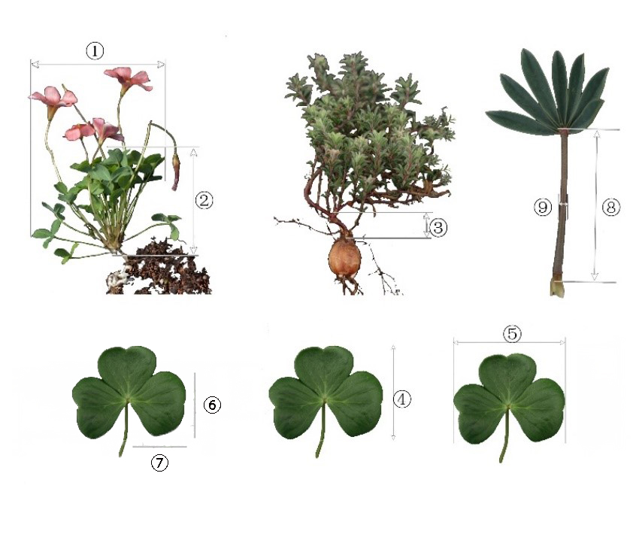
Fig. S1. Illustrations for individual characteristics
Note: ① Plant crown width; ② Plant height; ③ Above-ground thickness of main stems; ④ Compound leaf length;
⑤ Compound leaf width ; ⑥ Leaflets width; ⑦ Leaflets length; ⑧ Petiole length; ⑨ Petiole coarseness

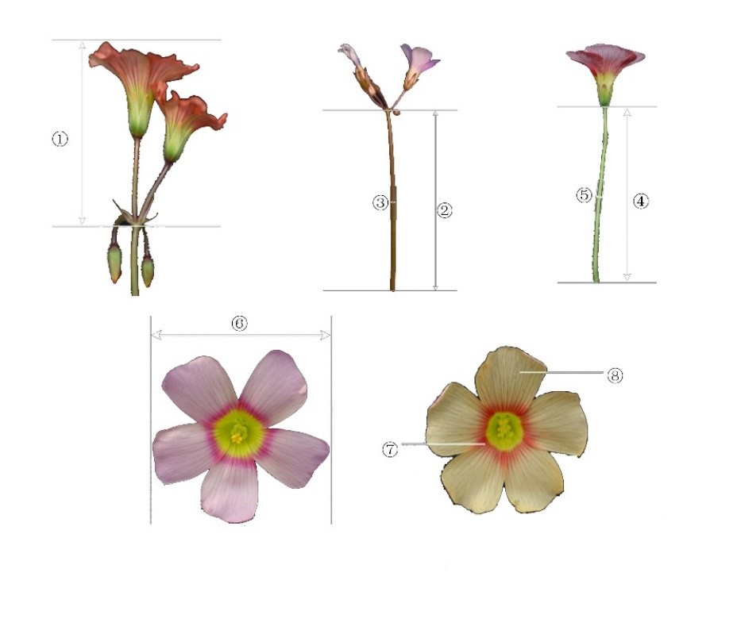
Fig. S2. Illustrations for individual characteristics
Note: ① Inflorescence length; ② Peduncle length; ③ Peduncle thickness; ④ Pedicel length; ⑤ Pedicel width;
⑥ Flower diameter; ⑦ Petals color; ⑧ Upper surface color of petals

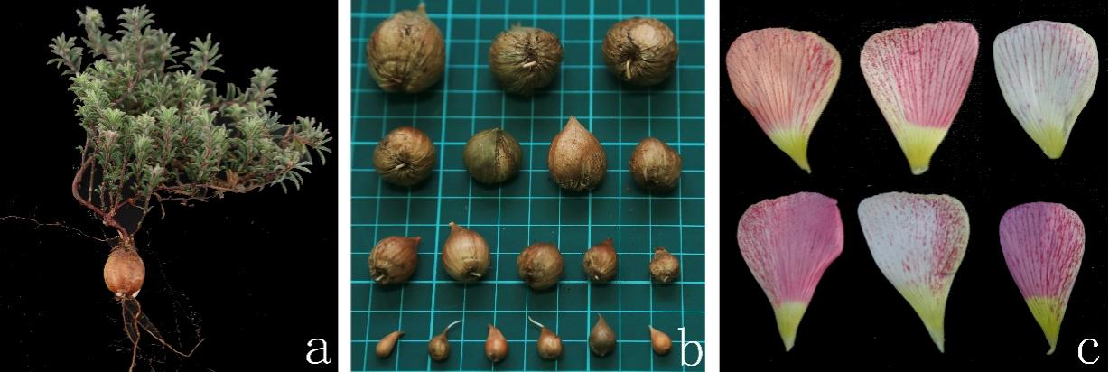
Fig. S3. Analysis of partial characteristics
Note: a: Growing plants; b: Bulb size of the same variety; c: Petal spots of the same color.

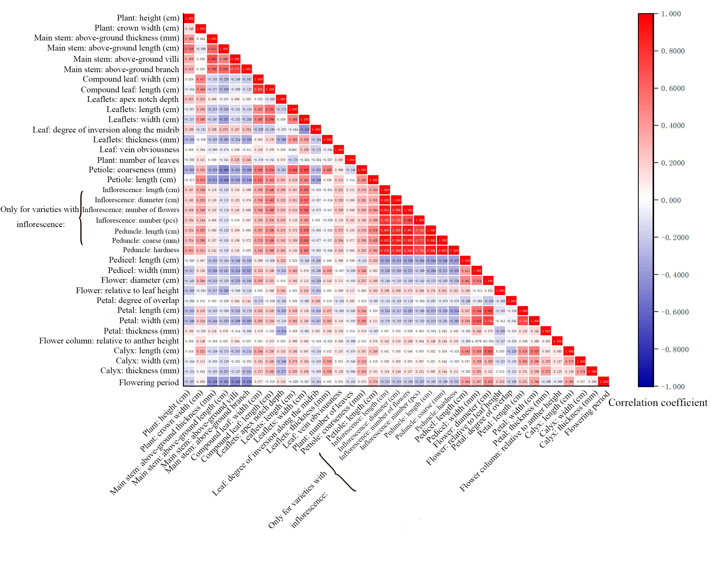
Fig. S4. Correlation coefficient matrix of 37 quantitative characteristics

Fig. S5. Correlation coefficient matrix of qualitative characteristics and pseudo-qualitative characteristics

