Supplementary Table. 1 Variation in leaf shapes of soybean genotypes evaluated against B. tabaci
Genotype | Leaf shape | Leaf colour | Growth habit | Response to IB. tabaci
DS 3105 | Oval | Green | Semi-errect | HS
SL 688 | Oval | Slight green | Semi-errect | S
SL 958 | Oval | Green | Semi-errect | S
SL 1113 | Oval | Green | Semi-errect | S
PS 1347 | Lanceolate | Green | Semi-errect | MS
PS 1572 | Lanceolate | Green | Semi-errect | MS
SL 1028 | Lanceolate | Green | Semi-errect | MR
SL 1074 | Broadly Lanceolate | Green | Semi-errect | MR

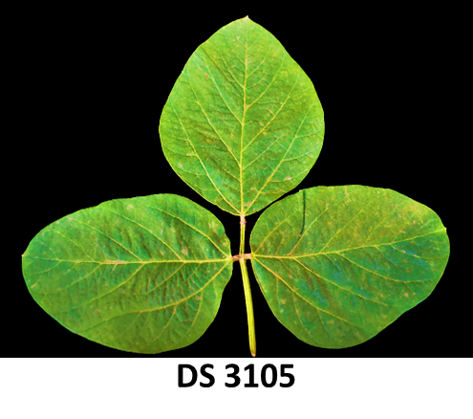
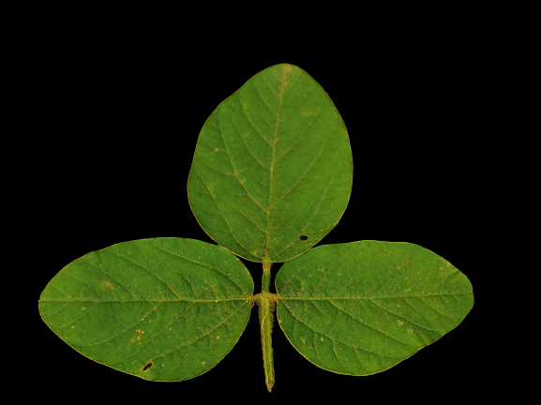
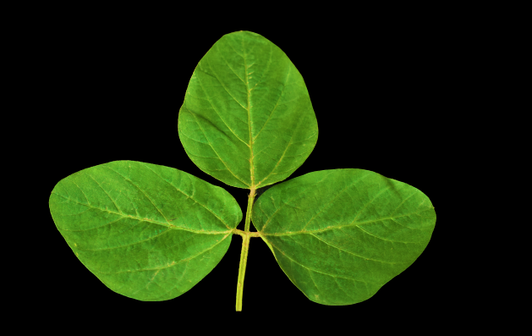
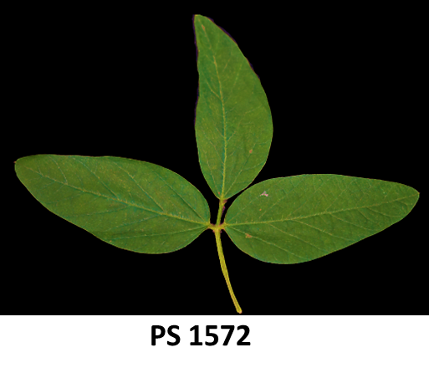
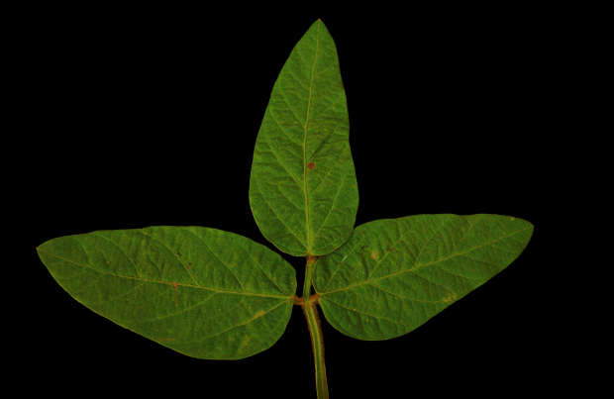
Leaf shapes of soybean genotypes (Ovate type)
SL 688
SL 958
SL 1113
SL 1028
SL 1074
PS 1572
PS 1347
Leaf shapes of soybean genotypes (Lanceolate type)
DS 3105
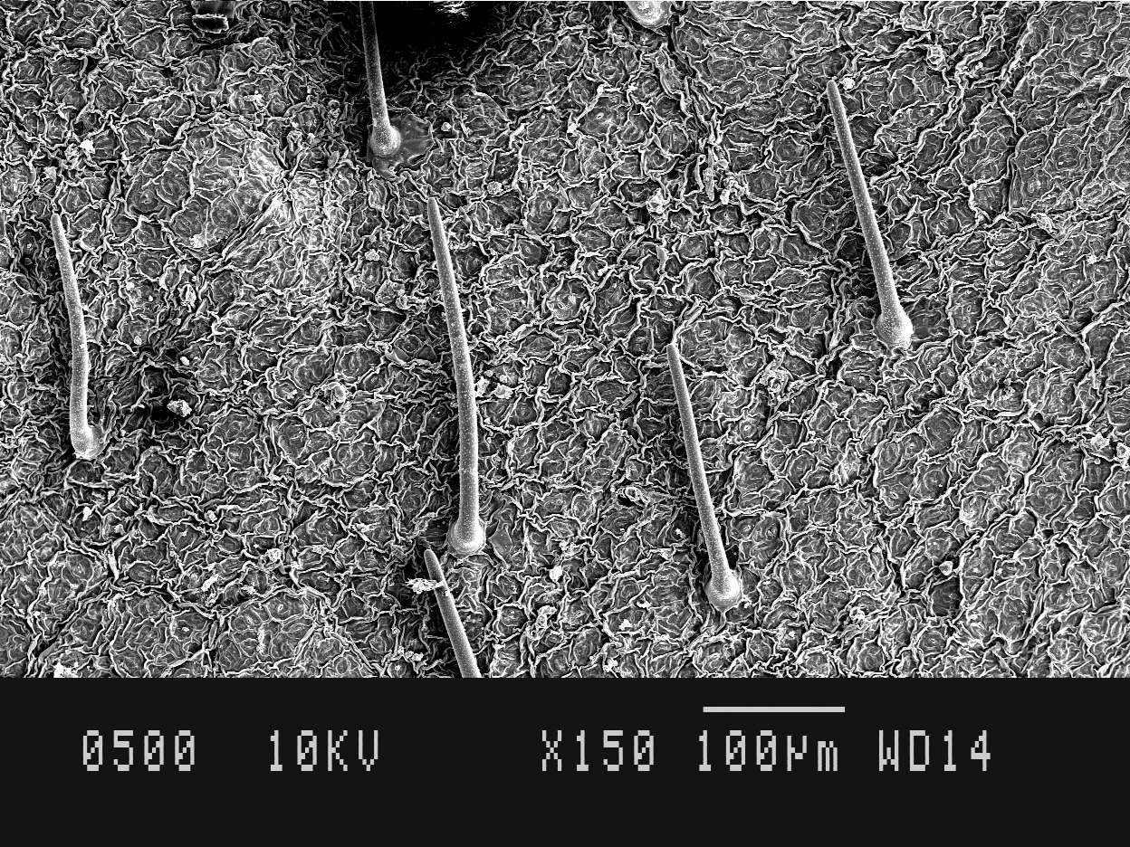
Trichome length and angle in moderately resistant genotype SL 1074 (Length=224 µm, Angle=50°)

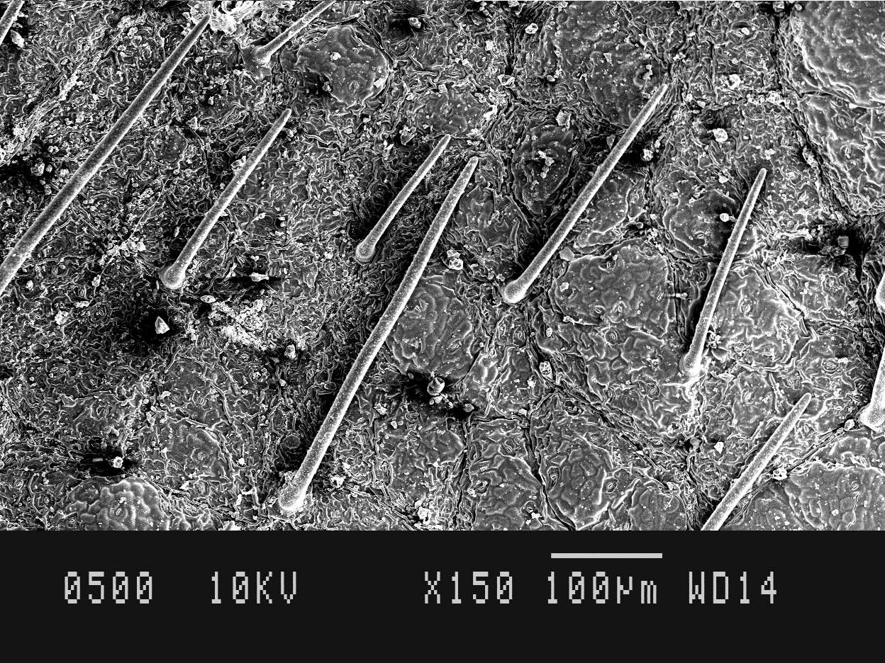
Trichome length and angle in highly susceptible genotype DS 3105 (Length=340 µm, Angle=70°)

