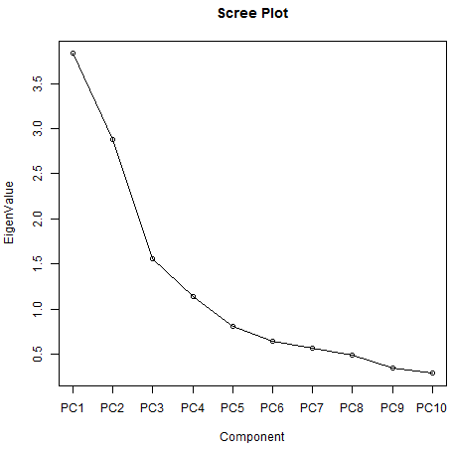
Figure S1. Screen plot of gerbera genotypes based on thirteen growth and floral traits

Table S1. Details of gerbera genotypes under open field conditions
Genotypes | Parentage | Characteristics
RCGH 1 |  | 52 A (Vivid Red), stalk length (35.98±1.53 cm), stalk diameter (4.13±0.11 mm), flowers (53.09±2.59), suckers (17.93±1.33), vase life (3.73±0.57 days)
RCGH-2 | 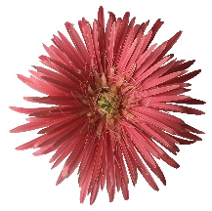 | 55 A (Deep Purplish Pink), stalk length (33.51±0.87 cm), stalk diameter (4.37±0.08 mm), suckers (20.84±3.81),  flowers (53.59±1.05), vase life (3.58±0.61 days)
RCGH 3 |  | 49 A (Strong Pink), stalk length (36.46±3.33 cm), stalk diameter (4.04±0.03 mm), suckers (21±2.03), flowers (53.47±1.56), vase life (3.62±0.66 days)
RCGH 5 |  | 19 B (Light Yellowish Pink), stalk length (38.18±1.24 cm), stalk diameter (4.35±0.07 mm), suckers (17.79±2.14), flowers (48.04±0.49), vase life (4.05±0.22 days)
RCGH 7 |  | 24 B (Strong Orange), stalk length (34.59±1.68 cm), stalk diameter (5.05±0.05 mm), suckers (14.14±1.31),  flowers (47.15±1.41), vase life (4.05±0.32 days)
RCGH 9 |  | 50 B (Deep Pink), stalk length (36.68±1.53 cm), stalk diameter (5.11±0.76 mm), suckers (16.27±1.17), flowers (47.2±1.19), vase life (4.8±0.2 days)
RCGH 10 |  | 52 C (Deep Pink), stalk length (37.08±0.77 cm), stalk diameter (5.06±0.30 mm), suckers (17.29±1.69), flowers (47.23±1.07), vase life (4.15±0.16 days)
RCGH 12 |  | 46D (Deep Yellowish Pink), stalk length (41.48±5.84 cm), stalk diameter (5.27±0.12 mm), suckers (16.88±0.84), flowers (45.33±2.31), vase life (5.43±0.31 days)
RCGH 19 | 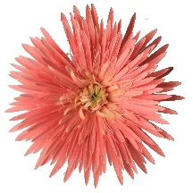 | 48 C (Strong Pink), stalk length (34.67±1.91 cm), stalk diameter (3.68±0.06 mm), suckers (17.41±2.06), flowers (52.39±0.99), vase life (3.71±0.04 days)
RCGH 20 |  | 48D (Strong Pink), stalk length (31.22±1.38 cm), stalk diameter (4.52±0.32 mm), suckers (15.27±1.19), flowers (46.7±2.38), vase life (4.34±0.17 days)
RCGH 22 | 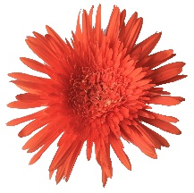 | 32 A (Vivid Reddish Orange), stalk length (44.13±2.26 cm), stalk diameter (5.15±0.27 mm), suckers (18.63±0.66), flowers (47.05±2.14), vase life (5.17±0.12 days)
RCGH 23 |  | 48 A (Deep Pink), stalk length (36.03±0.49 cm), stalk diameter (5.08±0.43 mm), suckers (18.98±1.12),  flowers (46.03±0.76), vase life (4.44±0.06 days)
RCGH 28 |  | N30 A (Vivid Reddish Orange), stalk length (28.33±1.07 cm), stalk diameter (5.26±0.13 mm), suckers (17.52±0.68), flowers (46.03±1.55), vase life (5.34±0.36 days)
RCGH 32 |  | 150A (Brilliant Yellow Green), stalk length (42.71±1.28 cm), stalk diameter (4.87±0.47 mm), suckers (15.26±0.23), flowers (48.41±1.69), vase life (4.75±0.23 days)
RCGH 33 |  | 1A (Brilliant Greenish Yellow), stalk length (40.67±0.08 cm), stalk diameter (4.86±0.17 mm), suckers (15.63±1.72), flowers (46.24±2.09), vase life (4.68±0.34 days)
RCGH 38 |  | 24C (Light Orange Yellow), stalk length (31.59±1.07 cm), stalk diameter (5.04±0.15 mm), suckers (13.58±0.96), flowers (47.89±1.42), vase life (4.52±0.02 days)
RCGH 42 |  | 42 A (Vivid Reddish Orange), stalk length (40.84±1.15 cm), stalk diameter (5.51±0.45 mm), suckers (13.26±1.87), flowers (46.03±1.58), vase life (5.17±0.1 days)
RCGH 51 |  | 51 1A (Strong Red), stalk length (34.06±1.35 cm), stalk diameter (5.09±0.21 mm), suckers (12.48±1.72), flowers (43.73±0.94), vase life (4.72±0.08 days)
RCGH 60 | 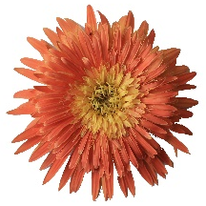 | 30 B (Vivid Yellowish Orange), stalk length (30.45±2.04 cm), stalk diameter (4.75±0.31 mm), suckers (13.53±1.14), flowers (47.45±2.83), vase life (4.58±0.43 days)
RCGH-65 | 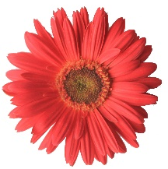 | 45 B (Moderate Red), stalk length (41.77±1.44 cm), stalk diameter (4.54±0.06 mm), suckers (12.16±1.25),  flowers (38.43±0.63), vase life (5.53±0.11 days)
RCGH 76 |  | 29 A (Brilliant Orange), stalk length (40.13±1.67 cm), stalk diameter (5.11±0.06 mm), suckers (13.58±2.75),  flowers (45.89±4.57), vase life (4.6±0.76 days)
RCGH 86 |  | N2 5A (Strong Orange, stalk length (34.73±1.00 cm), stalk diameter (4.94±0.22 mm), suckers (16.7±0.62),  flowers (46.48±1.54), vase life (4.81±0.44 days)
RCGH 89 |  | 10 B (Light Yellow), stalk length (35.19±2.17 cm), stalk diameter (5.12±0.17 mm), suckers (12.84±0.66),  flowers (43.81±1.87), vase life (4.87±0.11 days)
RCGH 90 |  | 47 C (Deep Yellowish Pink), stalk length (38.31±1.05 cm), stalk diameter (4.69±0.15 mm), suckers (12.43±1.24), flowers (48.84±1.93), vase life (3.77±0.57 days)
RCGH 93 |  | 30 C (Vivid Reddish Orange), stalk length (39.75±1.42 cm), stalk diameter (4.48±0.16 mm), suckers (13.93±3.54), flowers (48.46±1.49), vase life (4.22±0.08 days)
RCGH 95 | 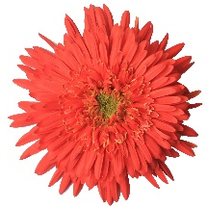 | 44 C (Vivid Reddish Orange), stalk length (37.07±1.14 cm), stalk diameter (4.60±0.22 mm), suckers (15.37±1.77), flowers (46.13±1.93), vase life (4.42±0.03 days)
RCGH 97 |  | 50 B (Deep Pink), stalk length (37.03±1.11 cm), stalk diameter (5.19±0.03 mm), suckers (13.16±3.07), flowers (52.03±1.22), vase life (3.38±0.24 days)
RCGH 100 | 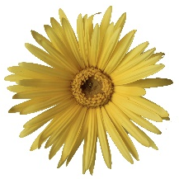 | 8 B (Light Greenish Yellow), stalk length (41.97±1.16 cm), stalk diameter (4.61±0.21 mm), suckers (11.31±1.76), flowers (48.97±1.42), vase life (3.81±0.03 days)
RCGH 109 |  | 13 B (Brilliant Yellow), stalk length (40.13±1.29 cm), stalk diameter (5.22±0.28 mm), suckers (10.98±1.84),  flowers (45.12±1.75), vase life (4.85±0.06 days)
RCGH 113 | 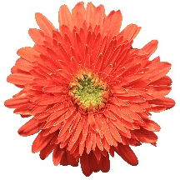 | N 30A (Vivid Reddish Orange), stalk length (39.77±1.72 cm), stalk diameter (5.32±0.10 mm), suckers (12.68±2.26), flowers (45.15±0.52), vase life (5.13±0.05 days)
RCGH 114 | 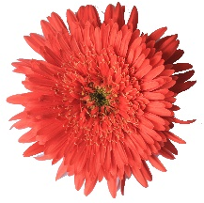 | 40 A (Vivid Reddish Orange), stalk length (42.77±3.28 cm), stalk diameter (5.23±0.12 mm), suckers (16.07±0.73), flowers (50±1.66), vase life (5.23±0.17 days)
RCGH 117 |  | 24 A (Strong Orange), stalk length (45.44±2.07 cm), stalk diameter (5.42±0.09 mm), suckers (18.33±1.04), flowers (48.32±1.18), vase life (5.71±0.17 days)
RCGH 128 |  | 44A (Vivid Red), stalk length (39.79±0.59 cm), stalk diameter (5.12±0.18 mm), suckers (14.56±2.23), flowers (43.2±0.97), vase life (5.03±0.82 days)
RCGH 172 | 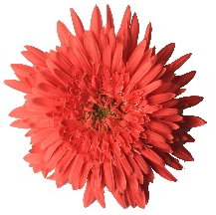 | 50A (Strong Red), stalk length (41.76±0.92 cm), stalk diameter (4.59±0.34 mm), suckers (12.28±2.59), flowers (46.18±2.03), vase life (4.38±0.02 days)
RCGH 226 |  | 13A-B (Vivid Brilliant Yellow), stalk length (31.11±1.51 cm), stalk diameter (4.72±0.39 mm), suckers (12.79±3.51), flowers (45.22±1.82), vase life (4.51±0.02 days)
Alesmera | 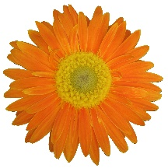 | N30 B (Vivid Reddish Orange), stalk length (44.97±4.57 cm), stalk diameter (6.12±0.31 mm), suckers (12.96±1.19), flowers (31.78±1.84), vase life (5.95±0.24 days)
CSA Collection |  | 44 A (Vivid Red), stalk length (34.58±1.02 cm), stalk diameter (3.94±0.14 mm), suckers (11.26±1.56), flowers (44.17±1.21), vase life (3.61±0.14 days)
Note: value for suckers and flowers indicated for number per plant per year.
sdg

C.D. (p ≤0.05) = 0.53
C.D. (p ≤0.05) = 3.59
Vase life (days)
Fig 2. Yield and vase life of gerbera genotypes under open field conditions

