Table S1. Principal components and agronomic trait contribution involving percent variability in 29 bean germplasm accessions.

PC | Eigenvalue | Percent variance | Cumulative percent variance
Dim.1 | 3.94 | 43.88 | 43.88
Dim.2 | 1.74 | 19.36 | 63.24
Dim.3 | 1.20 | 13.34 | 76.58
Dim.4 | 0.99 | 11.04 | 87.62
Dim.5 | 0.60 | 6.61 | 94.23
Dim.6 | 0.32 | 3.57 | 97.80
Dim.7 | 0.15 | 1.65 | 99.45
Dim.8 | 0.05 | 0.55 | 100.00
Dim.9 | 0.00 | 0.00 | 100.00

Fig.S1. Daily mean temperatures during common bean growing environment at IIPR, Kanpur and NBPGR, RS, Shimla.
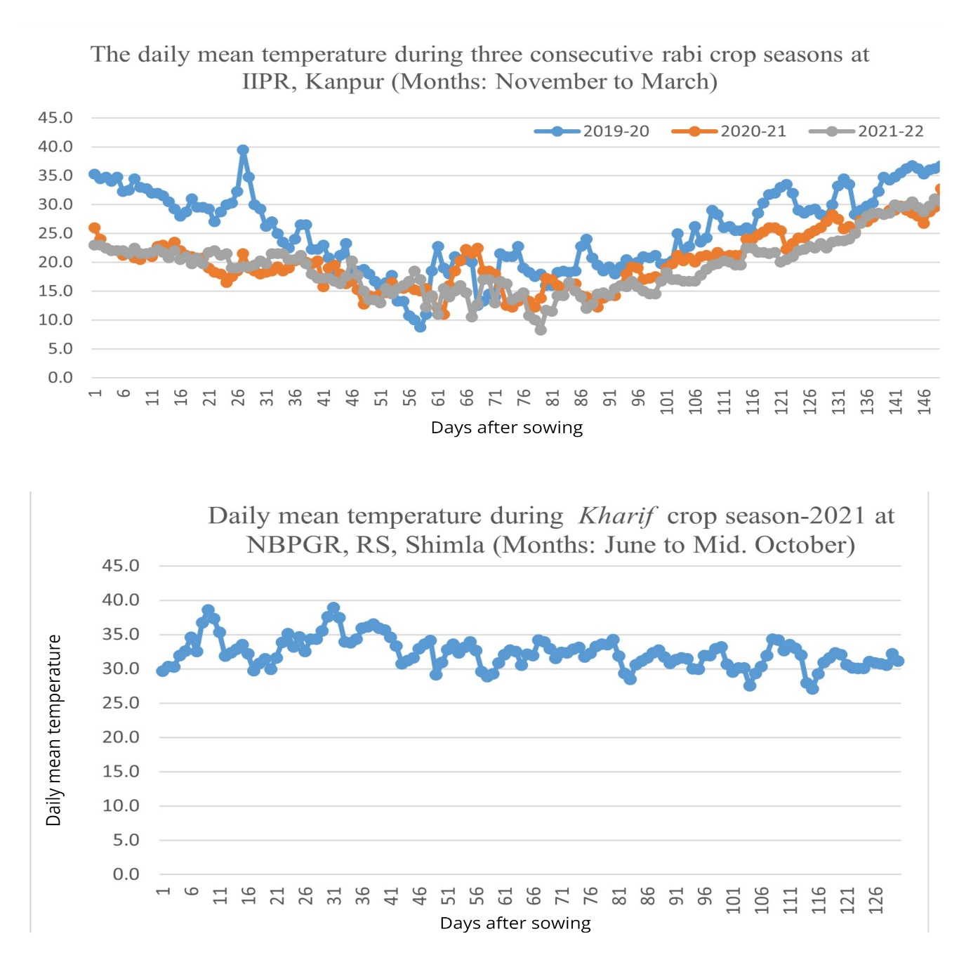

Fig. S2. Scree plot showing PCA components contribution of each trait to PC1 &2.

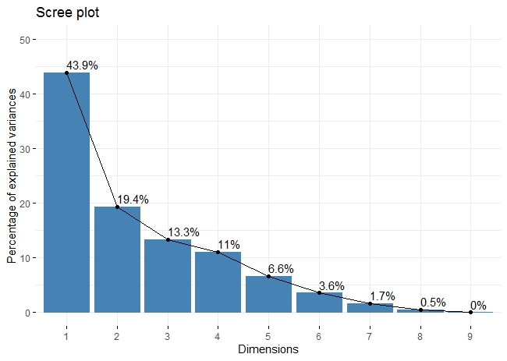

Fig.S3. Contributions of individuals to the first two principal components (PC1 and PC2).
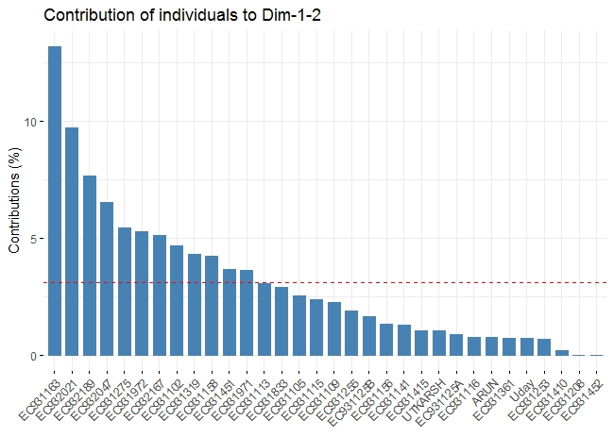
Fig.S4. k-means clustering analysis determines the optimal number of clusters in phenotypic data of 29 common bean accessions.
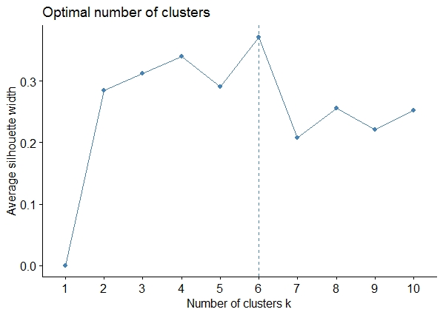
Fig.S5. Scatter plot depicting a relationship between days to maturing and seed yield (kg/ha).

