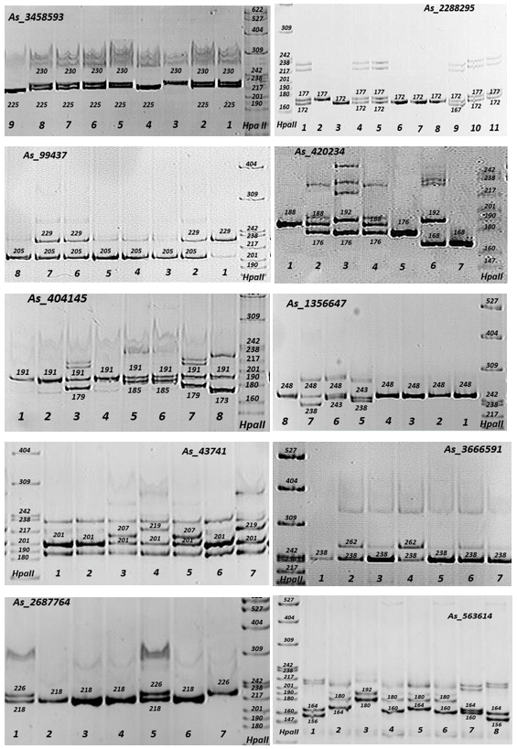
Fig. S1. Positive images of 6% polyacrylamide gels after electrophoresis in vertical electrophoresis chambers stained in a solution of ethidium bromide under ultraviolet light for 10 microsatellite markers in 1-9 samples of Abies sibirica. The single digit numbers depict the sample numbers underneath the images, and three digit numbers depict the fragment sizes within the images. DNA fragments of the pBR322 E. coli plasmid digested by the HpaII restriction enzyme were used as standard length markers and are presented on the edge lanes.
Table S5. Fixation Index (F_{IS}) for 14 microsatellite markers in four populations of Abies alba (A, B, C and D) and in a sample of Abies nordmanniana
Locus | A | B | C | D | Mean | A. nordmanniana
As_1898225 | 0.09 | -0.07 | -0.04 | 0.04* | 0.00 | 0.00
As_1356647 | 0.04 | 0.36 | 0.24 | -0.09 | 0.14 | -
As_404145 | -0.10 | 0.01 | 0.17 | 0.11 | 0.05 | -0.10
As_563614 | 0.38** | 0.31 | 0.45*** | 0.11* | 0.31 | -0.03
As_2612077 | 0.44** | 0.73 | 0.56 | 0.59 | 0.58 | 0.32**
As_2631734 | -0.03 | -0.30 | -0.03 | -0.33 | -0.17 | -
As_3458593 | -0.09 | 0.29 | -0.22 | -0.23 | -0.06 | -
As_3602348 | 0.71 | 0.44** | 0.76 | 0.69 | 0.65 | -
As_154813 | -0.04 | 0.02 | -0.03 | 0.10 | 0.01 | -0.08
As_2280886 | -0.14 | 0.25** | -0.02 | -0.10 | 0.00 | -0.21
As_420232 | -0.06 | 0.46 | -0.23 | #N/A | #N/A | -0.25
As_878430 | 0.20 | 0.24* | 0.37* | 0.23* | 0.26 | -
As_1089795 | 0.31* | 0.44*** | 0.37 | 0.42** | 0.39 | 0.46
As_1970306 | -0.21 | -0.37 | -0.03 | -0.27 | -0.22 | -1.00
Mean | 0.11 | 0.20 | 0.17 | 0.10 | 0.14 | -0.10
* P< 0.05, ** P< 0.01, *** P< 0.001
Table S6. Frequency of null alleles in four Abies alba populations (A, B, C and D) found by MICRO-CHECKER
Locus | A | B | C | D
As_1898225 | no | no | no | no
As_1356647 | no | no | no | no
As_404145 | no | no | no | no
As_563614 | 0.169 | no | 0.204 | no
As_2612077 | 0.223 | 0.348 | 0.263 | 0.276
As_2631734 | no | no | no | no
As_3458593 | no | no | no | no
As_3602348 | 0.316 | 0.206 | 0.346 | 0.296
As_154813 | no | no | no | no
As_2280886 | no | 0.125 | no | no
As_420232 | no | no | no | no
As_878430 | no | no | 0.181 | no
As_1089795 | 0.158 | 0.205 | 0.169 | 0.198
As_1970306 | no | no | no | no

